Smart Load Shedding Strategy for Minimized Supply Interruption
Qiteng Hong, Member, IEEE, Andrew J. Roscoe, Senior Member, IEEE, and Campbell D. Booth
Abstract-- Following large system disturbances, one of the solutions to limit the potential risk of occurrence and/or extent of the blackout is to intentionally create system islands such that the disturbed system elements are isolated and the supply to the created islands can be maintained. In order to sustain the created islands, generations within the islands are dispatched and if necessary local loads are shed to ensure that frequency and voltage remain within required limits. This paper presents a priority-based load shedding scheme implemented within a Local Power Controller (LPC) to assist the management of islanded microgrids so as to provide support to the main network during frequency deviation events while maintaining high level of security of supply to local critical loads. The load shedding scheme requires minimum instrumentation and uses frequency and rate of change of frequency (ROCOF) measurements to trigger the shedding processes, and it is most suitable for end-users with critical loads such as hospitals and data centers. The scheme is also equipped with a load addition mechanism that allows automatically switching on the shed loads when the system frequency recovers to a certain level. The scheme is tested and demonstrated in a laboratory microgrid environment under two operation modes, i.e. enabling load shedding process in advance of and subsequent to the islanded condition. The results show that the scheme is capable of sustaining the islands in both cases. Potential improvements to the scheme to incorporate demand-side information for a smarter and faster algorithm to minimize the interruption of supply are presented, and future activities to investigate the communication requirements to support the practical implementation of such a scheme are also discussed.

Index Terms—Distributed generation, islanding, load shedding, microgrids, smart grids.

Introduction
F
OLLOWING large system disturbances, such as a major frequency deviation event as reported in [1], one of the solutions to limit the risk of occurrence or potential extent of the blackout is to intentionally create system islands such that the disturbed elements of the system are isolated and the supply to the created islands can be maintained [2]. Load shedding has been widely used to prevent frequency degradation and assist in sustaining created islands [3]. Extensive research in the development of load shedding methods has been conducted [3]–[10]. Among these activities, [3], [5], [6], [9] present load shedding schemes that assist with the balancing of power generation and consumption within created islands. However, there appears little consideration of when (before or after entering the islanded condition) the load shedding scheme should be initiated so that the greatest levels of support to the network can be achieved while maintaining the local supply. Furthermore, most of the reported methods are only validated and tested using simulations.
This paper presents a Local Power Controller (LPC) that addresses the challenge of preventing total blackout by properly managing local networks with distributed generators (DGs), which are often termed microgrids. The LPC is equipped with a priority-based load shedding scheme that allows loads with low priorities to be shed first while ensuring supply to most critical loads – there may also be commercial arrangements between suppliers, network operators and customers that would also define the priority list used. Such a scheme requires minimum instrumentation and uses frequency and rate of change of frequency (ROCOF) measurements. The scheme is also equipped with a load addition mechanism that allows automatically switching on the shed loads when the system frequency recovers to a certain level. The load shedding scheme has been tested and demonstrated in a laboratory microgrid environment under two modes of operation: enabling the load shedding process in advance of and subsequent to the local system being islanded. The experimental results for both scenarios are presented and compared later in the paper. Such a scheme is particularly suitable for end users with critical loads and emergency backup generators, such as hospitals, data centers, and some industrial facilities.
Recent developments in smart grid technologies, e.g. smart metering, offer possibilities to further improve the scheme by controlling loads, as oppose to completely shedding them. Flexible loads (such as fridges, heating equipment, etc.) could be controlled to further reduce the supply interruption (even for low-priority loads) with no discernible impact on consumers. This paper investigates the potential improvements of the scheme by incorporation of such demand-side management elements. Future activities to investigate the communication requirements to support the practical implementation of the scheme and the impact of communication problems on the scheme operation are also discussed.
The paper is organized as follows. Section II provides an overview of the LPC system and introduces the developed load shedding algorithm. In Section III, the tests and demonstrations of the load shedding scheme in a laboratory microgrid environment are presented and the results are analyzed and discussed. Section IV presents the future work on the improvements of the developed scheme and the investigation of communication requirements to support the load shedding scheme.

Load Shedding Scheme within the Local Power Controller (LPC)

Overview of the LPC
The LPC is designed for the management of microgrids and contains a suite of control and protection algorithms. The main objective of the LPC is to provide support to the main network during system disturbances while ensuring high level of security of supply to local loads. This is mainly achieved by operating the microgrids (or potential microgrids) in either grid-connected or islanded mode to cater for various system conditions, properly dispatching the local DG(s), and shedding loads when necessary. In [11], the functionalities of the LPC are introduced and the ways that functional elements are coordinated to sustain microgrids during large system disturbances are demonstrated. In this paper, focus is placed on the demonstration of the load shedding scheme within the LPC and the investigation of the impacts upon the local and main networks when the scheme is enabled either before or after the local system is islanded.
As mentioned previously, the load shedding scheme is priority-based. There is currently provision for loads with nine different priority levels. This is shown in Fig. 2 later in the paper, where load 0 has the highest priority and should always remain on while load 8 has the lowest priority and will be shed first when needed.
The load shedding algorithm is largely a standalone element within the LPC. The main function of the element is to monitor the frequency of the local power system, and to shed loads as appropriate to keep the generator within its sustainable power range and switch on the shed loads when the system frequency recovers to a predefined level. There are two main operational modes for the load shedding scheme:
- enabling the load-shedding function in advance of an islanding event, and
- after an island is created, i.e. islanded mode.

Load shedding in advance of an islanded event
In the first mode, the network frequency and ROCOF are determined by the entire network and do not necessarily represent the balance between local load and local generation capacity. Therefore, a simple power-balancing network model is used to predict performance of the local network which would result if it became islanded. This is done by predicting the per-unit power output of the local generator, and its drooped frequency, based upon the known local load consumption and the known droop slope.
If the predicted generator power is >1pu, i.e. if the present load demand is higher than the generator active power rating, then loads will be shed using a slow load shedding process: i.e. shed one load (from the lowest-priority loads) at a time if a hold-off time of 3 s has elapsed since last load was shed.
The load shedding scheme is also equipped with a reconnection mechanism. If the generator power is <1pu, then the predicted drooped frequency in islanded mode is checked against the reconnection frequency threshold (typically 49.98 Hz). If frequency is above this value, and ROCOF is positive, loads would be reconnected one at a time with a minimum time interval between individual connections (typically 3 s).
Local loads can therefore be shed or reconnected even when the local system is still connected to the grid. This allows the local generation and loads to be matched as closely as possible prior to any islanded condition so that the impact of islanded on the islanded system would be minimal. This may lead to the risk of failure in detecting unexpected islanded conditions from only electrical measurements, but this can be addressed using advanced island detection methods, such as that reported in [12].

Load shedding subsequent to an islanded event
The islanded load shedding algorithm works by using thresholds of frequency and ROCOF to decide whether relatively slow load reduction, fast load reduction or load addition with a fixed (but configurable) interval is required. The actions are performed individually and sequentially, and a minimum wait time between actions is applied to allow the system to settle before the next action is permitted – the wait time and actions are flexible and can be configured. This is necessary due to the response times of the prime mover controllers and any inertia in the generation and/or load systems.
This mode of operation only allows shedding of loads when islands have been created, so the impact of islanded could be relatively more significant, potentially resulting in large ROCOF and frequency deviations in the island immediately following the island formation.
The islanded load shedding algorithm implemented in the LPC is illustrated in Fig. 1, and can be summarized as follows:

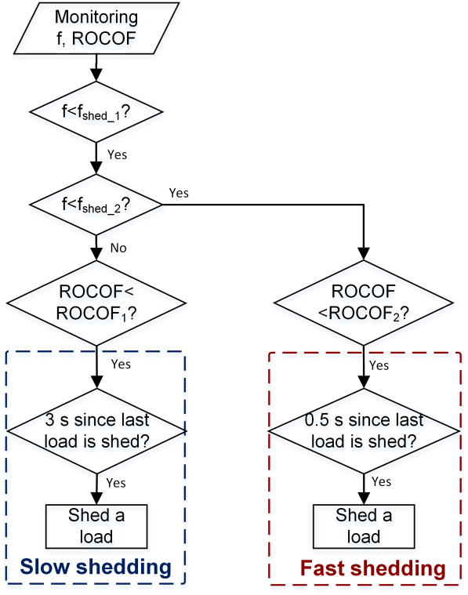
Fig. 1. The load shedding algorithm implemented in the LPC

- The frequency (f) and ROCOF are continuously monitored.
- If the frequency falls below f_{shed_1} (typical set as 49.2 Hz) but above f_{shed_2} (typically 48 Hz), and ROCOF is smaller than ROCOF₁ (typically -0.05 Hz/s), a slow load shedding process is triggered, i.e. shed one load (from the lowest-priority loads) at a time if a hold-off time of 3 s has elapsed since last load was shed.
- If f falls below f_{shed_2}, and ROCOF is negative (smaller than ROCOF₂ , which is typically 0 Hz/s), the fast load shedding process is triggered i.e. shedding loads with much smaller time interval (0.5 s in this case).
A reconnection mechanism is also available in this mode of load shedding, where if the frequency recovers to above a certain limit (typically 49.98 Hz) and ROCOF is positive, loads would be reconnected one at a time with a time interval between individual connections (typically 5 s).

Demonstration of the Load Shedding Scheme

Overview of the demonstration
The developed load shedding scheme presented in Section II has been tested in a laboratory microgrid environment, and a test schematic is shown in Fig. 2. The LPC requires measurements of voltages and currents at only two local points, i.e. at the DG terminals and at the point of common coupling (PCC). For the operation of the load shedding scheme, only measurements at the DG terminals are required. The algorithms reported in [13] have been used for the measurement function in system reported here. The LPC is implemented and executed on an MVME5500 processor card [14], which is embedded with a multi-processor rack [15] that allows logging of performance [11].

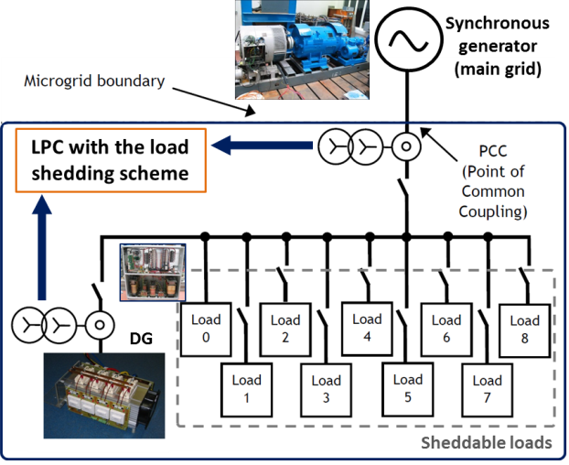
Fig. 2. Overview of laboratory arrangement for the demonstrations

In this arrangement, an 80 kVA synchronous generator (a controllable motor-generator set) is used to represent the main distribution grid where the microgrid is connected. By closely controlling the synchronous generator, appropriate voltages and frequencies can be produced to emulate disturbance events for the test scenarios. A load of 2 kW is permanently applied to this grid source to provide additional stability to the control of the 80 kVA generator. Between the grid source and the microgrid, an impedance is inserted to represent the transformer that interfaces the microgrid to the main grid. For the tests demonstrated in this section, the impedance is 16 mH per phase. This represents an impedance of 6.25 % at the 2 kVA level, and is therefore a realistic impedance to simulate an 11 kV to 400 V transformer at the microgrid to main grid interface, using power flows of the order of 2 kVA (the total load is around 2200 W, which is discussed later in this section).
Within the microgrid, there is a converter-interfaced DG with a maximum power output of 1500 W, which has been specially designed to behave as a synchronous generator and is capable of operating under islanded and grid-connected conditions. More details on this are reported in [16].
The local loads used are commensurate with the size of the generator. There are two main scenarios that may potentially be experienced by the microgrid in practice, i.e. the local load is smaller or larger than the DG’s capacity. In this paper, the scenario where the total load is substantially larger than the DG capacity is presented. The load is made up of a fixed load of 453 W and 8 sheddable loads of varying sizes, all at a notional power factor of 0.9 lagging. The total load is approximately 2200 W, of which the 4 lowest-priority loads must be shed in order to bring the total load below the nominal DG power output of 1500 W to preserve island stability.
In the demonstrations, a worst-case scenario is presented, where the local DG is not in operation when the disturbance occurs. Such a scenario is considered as the worst case since the DG is required to be dispatched “from cold”, which is more difficult to manage than the scenarios where DG is already dispatched and synchronized with the network.

Demonstration 1: load shedding enabled before islanded
In this test, the load shedding scheme is enabled before islanding occurs, i.e. the scheme is allowed to shed loads whenever the frequency and ROCOF fall into a pre-configured range, even when the microgrid remains connected to the main network.
As shown in Fig. 3, the 80 kVA synchronous generator is controlled to “play” the pre-defined frequency profile (50-47- 50 Hz frequency sag, with a fall time of 60 s, a hold time of 10 s, and a rise time of 30 s) to emulate a system frequency disturbance event.
At around 23 s, the frequency drops below 49.2 Hz (with the microgrid still connected to the distribution network), and the slow load shedding process is initiated, where loads are shed sequentially with 3 s of hold-off time. On close inspection of Fig 4, it is clear that there are four load steps corresponding to four loads being shed. At the same time, the DG is dispatched by the controller in the LPC so that it can provide support to the main grid. It can be seen from Fig. 4 that, from 28 s onwards, the local load is almost equal to the local DG generation. Therefore, the microgrid is providing support to the main network by importing minimum power from the grid.
However, the frequency continues to reduce below 47 Hz and the local system is intentionally islanded at around 48 s (shown in Fig. 3), after which the frequency of the microgrid is increased rapidly to around 49.7 Hz, while the frequency in the main network continues to decrease. This intentional islanding action allows the local frequency and voltage (as shown in Fig. 5) to be maintained within appropriate levels.
As mentioned previously, the local load and generation have been closely matched before the islanding operation. Therefore, the transition process from grid-connected mode to islanded mode is seamless, which is evident from observation of the frequency and voltage profiles as shown in Fig. 3 and Fig. 5 respectively.
The frequency of the network recovers to 49.75 Hz at around 105 s, and the local system is resynchronized and reconnected to the network, i.e. it exits islanded mode. Subsequently, as the frequency continues to recover, a load reconnection process is initiated. As shown in Fig. 4, the loads are reconnected from around 110 s individually and sequentially, and the local DG stands down (assuming it is more economic to import power from the grid than generating power locally in this case and the DG is instructed to reduce it output to zero).
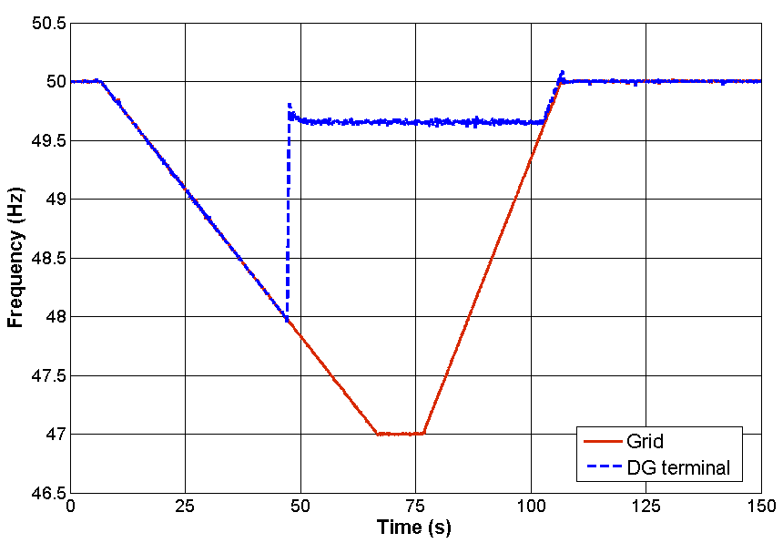
Fig. 3. The frequencies at the main grid and the DG terminal: load shedding before islanded

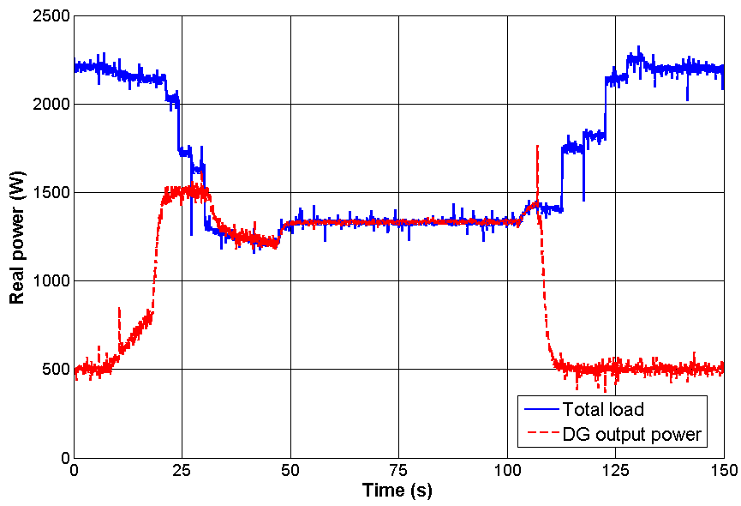
Fig. 4. The DG power output and the total load in the microgrid: load shedding before islanded

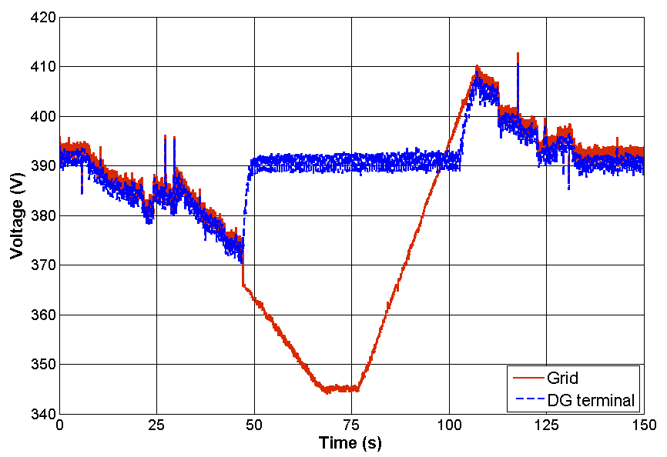
Fig. 5. The voltages at the main grid and the DG terminal: load shedding before islanded
From this test, it can be clearly seen that by properly dispatching the local DG and applying the proposed load shedding scheme, the microgrid can provide support to the main network by minimizing the power import before entering islanded mode. If such a step is not sufficient for the network to recover, the local system will transit to islanded mode seamlessly as the local load and generation is matched as close as possible before the islanding action is undertaken. The supply to the most critical loads (load 0-4) within the microgrid has been maintained. It is important to note that, in this case, the synchronous generator emulating the main grid is controlled to “play” the pre-defined frequency profile and there is only one microgrid is being tested, so the support from the microgrid to the network frequency by shedding low-priority loads is not obvious. However, if there are multiple microgrids involved during the process and the power released by the total shed loads in all these microgrids is comparable to the loss of generation that causes the disturbance, such support to the main network would be more obvious and could potentially help to bring the system back to a normal state without the need for islanded operation.

Demonstration 2: load shedding enabled subsequent to the islanded event
In this demonstration, the load shedding scheme is tested under the same frequency disturbance event, but is only enabled when the local system is islanded from the main network.
As shown in Fig. 6 and Fig. 7, when the frequency drops below 49.2 Hz at around 220 s, the local DG is dispatched to provide support to the main network. However, the load shedding process is not initiated at this time. The islanded operation is performed at around 245 s, and there is a power mismatch of around 700 W between the total local load the DG output in the island when this islanded occurs. When the local network gets islanded, the DG is switched to the islanded control mode and tries to increase its output to meet the local loads. However, since the load is significantly larger than the generator’s capacity, loads (4 local loads in total) have to be shed until the local system can be maintained stable. As shown in Fig. 6, it takes longer time for the local frequency to recover than in the scenario presented in the previous section, and the frequency recovery process involves multiple stages, which correspond to the steps where the loads are shed. Similar results can be observed in the voltage profile as shown in Fig. 8.
The reconnection process is similar to the previous scenario, where the local system is re-synchronized and reconnected to the main system when the frequency in the main network recovers above 49.75 Hz, after which the loads are reconnected and the DG stands down.
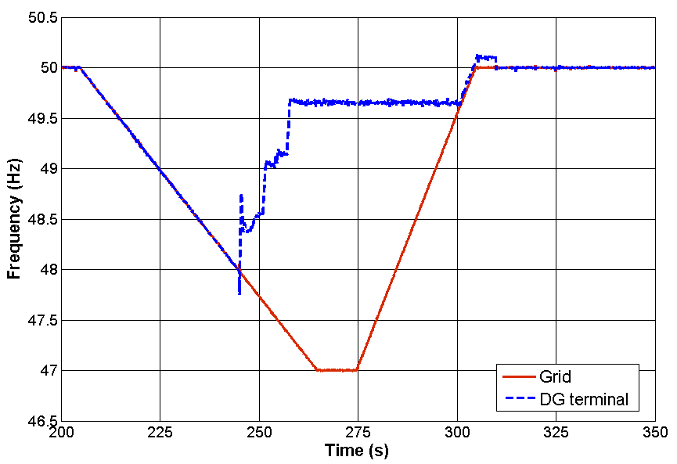
Fig. 6. The frequencies at the main grid and the DG terminal: load shedding after islanded

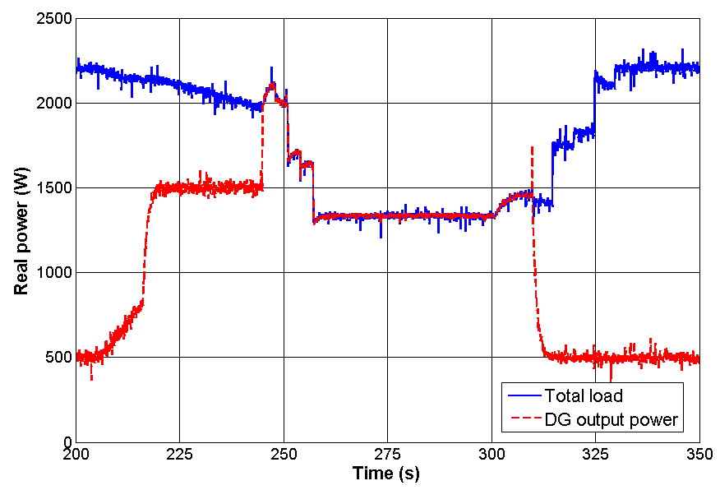
Fig. 7. The DG power output and the total load in the microgrid: load shedding after islanded

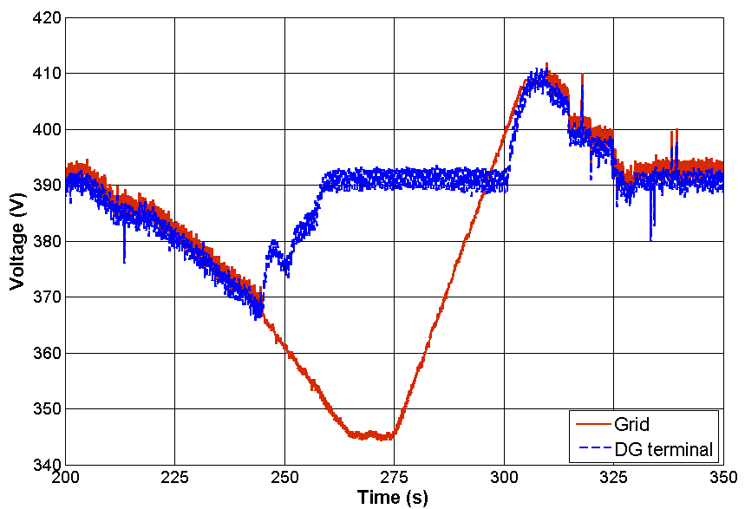
Fig. 8. The voltages at the main grid and the DG terminal: load shedding after islanded

Discussions of the demonstrations
From each of the two demonstrations presented in this paper, it is clear that the LPC is capable of maintaining the supply to the microgrid with the aid of the developed load shedding scheme. Although four low-priority loads have to be shed in both cases, the continuous supply to the most critical loads has been achieved.
In the first demonstration, the loads are shed before the island is created, so that the local load is matched as closely as possible to the generation within the “potential island”, which provides support to the main network by minimizing power import from the grid. This also allows a seamless transition to islanded mode. The disadvantage of this mode of operation is that some low- priority loads must be shed “early”, i.e. before the island is created, and sustained operation with these loads shed may not be desirable, as islanding may not occur in practice.
In the second demonstration, the loads are only shed when the island is created. This is beneficial in the cases where the main network is capable of recovering itself after a short period of time and the system is not required to switch to islanded mode, because the supply to all loads can be maintained. However, in a large system disturbance, as demonstrated in this paper, such an approach provides less support to the network since no loads are shed until the island is created. Furthermore, when transiting to the islanded mode, the local system may potentially experience a longer period of voltage and/or frequency instability before the system can settle.
In practice, these two modes of operation need to be selected carefully to meet the local microgrid’s needs. For example, if the critical loads in the microgrid are sensitive to frequency and/or voltage instability and shedding low- priority loads is tolerable when considering the importance of the critical loads, shedding loads before the creation of islands is more suitable.

Future Work
The developed load shedding scheme is designed to require minimum instrumentation so as to minimize the requirements for application in practice. If more measurements are available, a faster, more functional and more intelligent algorithm may be developed and implemented in practice.

Faster-responding algorithms
Presently, the load shedding algorithm only requires measurement from the DG terminal. The disadvantage of such an approach is that certain time intervals need to be applied between the shedding actions for system inertia effects to settle. If more instrumentation is available, e.g. to measure power flow to individual load branches, the system can determine the optimal combination of the loads need to be shed, so that a fast decision can be made and triggered, i.e. at speeds limited only by the time taken to measure the power flows and the time taken to open/close remote contractors. Furthermore, if there is net generation within a load connection and the information is available during the load shedding processes, such loads should clearly not be shed. However, such approaches require additional instrumentation, which may potentially increase the cost to implement the scheme and constrain its practical application.

Smarter algorithm by controlling flexible loads
Recent developments in smart grid technologies, e.g. smart metering, offer the possibility for further improvement of such a scheme by controlling, as oppose to shedding, flexible loads (e.g. fridges, heating equipment, etc.). When the network frequency degrades, a mechanism can be developed to analyze the available generation, existing and anticipated demand, loads that are flexible to be controlled, etc. The information can then be used for on-line decision making in terms of the actions to take to minimize user disruption and interruption. For example, flexible loads can potentially be controlled to release power so that they can contribute to the power balancing process without introducing inconvenience to end users. Only if the control over flexible loads is not adequate to sustain the island, priority-based load shedding will be initiated to provide further support to the local network.
Future work will investigate the feasibility of such an approach to be implemented in microgrids (or in distribution networks) and the associated instrumentation and other hardware required to support the scheme.

Communication requirements to support the load shedding scheme
To implement the load shedding scheme in practice, appropriate communication infrastructures are required. Future activities will also investigate such requirements. The bandwidth, latency, jitter, timing, security, reliability and availability of the required communications infrastructure will be exhaustively tested and quantified, with the aid of appropriate communications routers and traffic generators. The suitability of wired and wireless solutions for this application will be assessed.

Conclusions
This paper has presented a load shedding scheme implemented within a system termed LPC to assist the management of microgrids through appropriately shedding and reconnecting loads. Such a scheme requires minimum instrumentation for operation (only requiring measurement at the DG terminals), and is most suitable for end users with critical loads and DGs (e.g. hospitals). The objective of the LPC is to provide support to the main network and ensure high level of security of supply to the microgrid. The load shedding scheme plays an important role in balancing the generation and loads to ensure the frequency and voltage in the microgrid are within the required limits.
The developed load shedding scheme has been tested and demonstrated in a laboratory microgrid environment under two operation modes, i.e. enabling the load shedding before and after the island is created, and the results have been presented and compared. It has been shown that the load shedding scheme is capable of assisting sustaining the microgrid during large system disturbances in both modes. Shedding loads before entering islanded mode results in low-priority loads being disconnected relatively early, but can provide support to the main network by minimizing the power import from the grid. This also allows a seamless transition to the island mode, which is most suitable for local systems with critical loads that are very sensitive to frequency and/or voltage instability. Enabling load shedding after the island is created may avoid the disconnection of any loads if the main system recovers before the local system gets islanded, but it would potentially experience longer period of voltage and frequency instability when transiting to islanded mode during large system disturbances.
Future work will focus on the improvement of the developed load shedding scheme so that a faster responding time can be achieved and interruption to the supply can be minimized through the control of flexible loads. Communication requirements and their potential impacts to the load shedding scheme will also be investigated.

References
- National Grid, “Report of the National Grid Investigation into the Frequency Deviation and Automatic Demand Disconnection that occurred on the 27th May 2008,” 2009. [Online]. Available: http://www.nationalgrid.com/NR/rdonlyres/E19B4740-C056-4795-A567-91725ECF799B/32165/PublicFrequencyDeviationReport.pdf
- Y. Liu and Y. Liu, “Aspects on power system islanding for preventing widespread blackout,” in Networking, Sensing and Control, 2006. ICNSC ’06. Proceedings of the 2006 IEEE International Conference on, 2006, pp. 1090–1095.
- M. Ahsan, A. Chowdhury, S. Ahmed, I. Bhuyan, M. Haque, and H. Rah- man, “Technique to develop auto load shedding and islanding scheme to prevent power system blackout,” Power Systems, IEEE Transactions on, vol. 27, no. 1, pp. 198–205, Feb 2012.
- H. You, V. Vittal, and Z. Yang, “Self-healing in power systems: an approach using islanding and rate of frequency decline-based load shedding,” Power Systems, IEEE Transactions on, vol. 18, no. 1, pp. 174–181, Feb 2003.
- S. Ahmed, N. Sarker, A. Khairuddin, M. Ghani, and H. Ahmad, “A scheme for controlled islanding to prevent subsequent blackout,” Power Systems, IEEE Transactions on, vol. 18, no. 1, pp. 136–143, Feb 2003.
- D. Xu and A. Girgis, “Optimal load shedding strategy in power systems with distributed generation,” in Power Engineering Society Winter Meeting, 2001. IEEE, vol. 2, 2001, pp. 788–793 vol.2.
- V. Terzija, “Adaptive underfrequency load shedding based on the magnitude of the disturbance estimation,” Power Systems, IEEE Transactions on, vol. 21, no. 3, pp. 1260–1266, Aug 2006.
- V. Chuvychin, N. Gurov, S. Venkata, and R. Brown, “An adaptive approach to load shedding and spinning reserve control during underfrequency conditions,” Power Systems, IEEE Transactions on, vol. 11, no. 4, pp. 1805–1810, Nov 1996.
- P. Mahat, Z. Chen, and B. Bak-Jensen, “Underfrequency load shedding for an islanded distribution system with distributed generators,” Power Delivery, IEEE Transactions on, vol. 25, no. 2, pp. 911–918, April 2010.
- R. Faranda, A. Pievatolo, and E. Tironi, “Load shedding: A new proposal,” Power Systems, IEEE Transactions on, vol. 22, no. 4, pp. 2086–2093, Nov 2007.
- A. Roscoe, C. Bright, S. Galloway, and G. Burt, “Increasing security of supply by the use of a local power controller during large system disturbances,” in Innovative Smart Grid Technologies (ISGT Europe), 2011 2nd IEEE PES International Conference and Exhibition on, Dec 2011, pp. 1–7.
- A. Roscoe, G. Burt, and C. Bright, “Avoiding the non-detection zone of passive loss-of-mains (islanding) relays for synchronous generation by using low bandwidth control loops and controlled reactive power mismatches,” Smart Grid, IEEE Transactions on, vol. 5, no. 2, pp. 602– 611, March 2014.
- A. Roscoe, G. M. Burt, and J. McDonald, “Frequency and fundamental signal measurement algorithms for distributed control and protection applications,” Generation, Transmission Distribution, IET, vol. 3, no. 5, pp. 485–495, May 2009.
- Emerson Network Power, “MVME5500 VME with PowerPC Processor.” [Online]. Available: http://www.emersonnetworkpower.com
- Applied Dynamics International, “Real Time Station (RTS).” [Online]. Available: www.adi.com
- A. Roscoe, S. Finney, and G. Burt, “Tradeoffs between AC power quality and DC bus ripple for 3-phase 3-wire inverter-connected devices within microgrids,” Power Electronics, IEEE Transactions on, vol. 26, no. 3, pp. 674–688, March 2011.

This work is sponsored by EPSRC UK under the ACCEPT project. Qiteng Hong, Andrew J. Roscoe, and Campbell D. Booth are with the Department of Electronic and Electrical Engineering, University of Strathclyde, Glasgow, UK (e-mail: q.hong@strath.ac.uk).

