Assessing the hazard from viruses in wastewater recharge of urban sandstone aquifers

E. Joyce², K. Charles², H. Rahman¹, M. F. Aller¹,
V. Durand¹, M. S. Riley¹, R. B. Greswell¹, J. C. Renshaw¹, R. MACKAY¹, m. O. RIVETT¹, A. Hart³, s. pEDLEY² &
J. H. Tellam¹
1 Hydrogeology Research Group, Earth Sciences, School of Geography, Earth & Environmental Sciences, University of Birmingham, Birmingham B15 2TT, UK
j.h.tellam@bham.ac.uk
2 Robens Centre for Public and Environmental Health, University of Surrey, Guildford GU2 7XH, UK
3 Environment Agency, Solihull, West Midlands B92 7HX, UK

Abstract Increasing water demand in urban areas is focusing attention on the possibilities of the re-use of urban wastewaters, waters that often contain human and animal (including avian) viruses. In urban red-bed sandstone aquifers in the UK, which are predominantly matrix flow systems, evidence from well and piezometer monitoring shows that viable human viruses can be transported to depths of at least 80 m. The aim of the studies described here is therefore to determine the processes controlling the virus transport as a basis for risk assessment. Laboratory column experiments show that virus breakthrough is severely attenuated in synthetic groundwater solutions, some viruses remaining effectively irreversibly attached to the rock: attenuation capacity is only slowly reduced as more viruses are eluted. However, addition of silica colloids (which when injected by themselves are also severely attenuated) to the virus solutions, results in breakthrough of the injected virus particles and release of previously attached virus particles. Forced-gradient tracer field experiments suggest that (severely attenuated) virus breakthrough occurs, but only through specific pathways. Current fieldwork is aimed at determining the location, and hence the hydraulic and geochemical characteristics of these pathways. It appears, therefore, that virus attenuation is reduced by the presence of other colloidal matter, low ionic strength, and continuous virus loading, and that conditions for transport occur only in specific pathways. Future laboratory work will be aimed at further quantifying these processes and relating them to the petrographic and geochemical properties of the various sandstone (hydro)lithofacies which the field experiments indicate are important. This will provide the understanding necessary for a process-based risk assessment procedure.
Key words virus; phage; sandstone; artificial recharge; wastewater

INTRODUCTION

Increasing water demand in urban areas is focusing attention on the possibilities of the re-use of urban wastewaters. Urban wastewaters will often contain both human and animal (including avian) viruses, with concentrations up to at least 3500 Enterovirus particles per litre, and 10⁷ Norovirus particles per litre in the most polluted waters. If wastewaters are used in, for example, artificial recharge, it is therefore necessary that a risk assessment of virus hazard be undertaken. A particular issue is that only a few virus particles are needed to cause infection, unlike the case for most bacteria (e.g. Sair et al., 2002): this means that, as with highly toxic chemicals, even severe attenuation may not be sufficient to remove the hazard.
Although a risk assessment procedure could be based on empirical data acquired by undertaking extensive sampling of existing wells, a process-based procedure would be more flexible and would avoid reliance on mixed wellwater samples. In this paper we describe the progress made towards understanding the processes involved in virus movement in example continental red-bed sandstone aquifers.

THE AQUIFERS INVESTIGATED

The aquifers investigated are located within the UK Permo-Triassic Sandstone sequence (e.g. Barker & Tellam, 2006). This sequence comprises weakly to well-cemented fluvial and aeolian sandstones, with occasional thin, usually decimetre scale, mudstones and palaeosols (Fig. 1). The sandstones are typically dominated by quartz clasts, but also contain feldspars, micas, and lithic clasts. Carbonate cementation is common, though may be removed in the upper few tens of metres. Both detrital and authigenic clays are present, including smectites. Haematite coats all grains giving rise to the red colour of the rock. Matrix permeability is very variable, but averages around 1 m/d (e.g. Allen et al., 1997), with porosities averaging ~0.25. The sandstones are fractured (e.g. Hitchmough et al., 2007), and locally fracturing increases permeability. However, modelling suggests that the regional scale permeability is close to that of the matrix. Cation exchange capacities are typically 1–2 meq/100g (e.g. Carlyle et al., 2004), though occasionally up to 20 meq/100g. Median pore sizes are typically
10–50 μm, much larger than the diameter of virus particles (often <100 nm).
The UK Permo-Triassic sandstones are extensively used for water supply and underlie several major cities, including Birmingham, Nottingham, Liverpool and Manchester. In some places the sandstones are overlain by Quaternary sands, tills, clays and peat, but elsewhere (e.g. in Nottingham) they are exposed at surface. Water quality is usually good, though the urban aquifers often have high NO₃ and Cl

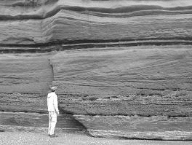
(a)
(b)
Fig. 1 (a) An outcrop of the sandstone showing both sedimentary structures and fractures. (b) An electron micrograph of an example “clean” sandstone.
concentrations (up to ~100 mg/L), and locally have elevated metal and chlorinated solvent concentrations (e.g. Shepherd et al., 2006; Tellam, 2007), the latter varying greatly from well to well (Tellam & Thomas, 2002).

EVIDENCE OF VIRUS TRANSPORT

Reconnaissance sampling by Powell et al. (2000) of a small number of UK urban sandstone aquifer abstraction boreholes, using glasswool traps, showed that viable human viruses were present, albeit at small concentrations (1 to 1000 plaque forming units (pfu)/L) in most of the wells sampled (Table 1). Given that the wells are 100–
200 m deep and cased over the upper few tens of metres, this result was not expected, it being usually assumed that the viruses would be rapidly attenuated by attachment to the rock, breakdown, and predation. Subsequent work on specially-installed multilevel piezometers by Powell et al. (2003) showed that viable human enteric viruses were found to depths of at least 80 m below ground level (Table 1). Again, concentrations are usually low and, not unexpectedly, less frequent. Concentrations varied considerably over the 1–2 years of the sampling.
These results demonstrate that viruses can penetrate a predominantly matrix flow aquifer system to some depth, and still remain viable. It also shows that the concentrations involved are low, implying severe, though not sufficient, attenuation. Our subsequent work has been aimed at determining the mechanisms for virus transport, and hence the likely pathways through the sandstones: in particular we are interested in determining the relative importance of geochemical and hydraulic factors. Two approaches have been adopted: laboratory investigation and field experimentation. The results are summarized in the following sections.

Table 1 Field detection of human enteric/rota- (Ent/Rot) viruses and coliphage (Coli) at sites in Nottingham (N) and Birmingham (B). Well indicates a pumped well sample (Powell et al., 2000); Sites 1 to 5 are multilevel piezometers (Powell et al., 2003).
Depth (m) | Well 8 | Well 10 | Well 17 | Well B1 | Well U2 | Site 1 | Site 2 | Site 3 | Site 4 | Site 5
 | N | N | N | B | B | N | N | N | B | B
Pumped | Ent | Ent+Rot | Ent | Rot
0–9
10–19 |  |  |  |  |  | Ent |  | Coli
20–29 |  |  |  |  |  | Ent
30–39 |  |  |  |  |  | Coli+Ent | Coli |  |  | Coli
40–49 |  |  |  |  |  | Coli+Ent | Coli | Ent |  | Coli
50–59
60–69
70–79
80–89 |  |  |  |  |  | Ent |  |  | Coli

LABORATORY INVESTIGATIONS

Experiments to determine the attenuation of viruses by interaction with the rock matrix have been carried out using 8–24 cm long intact sandstone cores taken from an
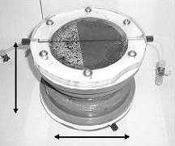
(a)
(b)
~10 cm
~15 cm

Fig. 2 (a) Column experiment layout. (b) Mounting of a half core (dark) showing upper transparent-topped manifold through which fluid was re-circulated to maintain mixing.

experimental site on the University of Birmingham campus. Virus and bacteriophage suspensions made up in particle-free synthetic groundwater were passed through the columns maintained at in situ groundwater temperature (12°C) at rates equivalent to field groundwater velocities (Fig. 2). The eluant was collected and analysed by plaque assay. Fluorescein was used to indicate un-reacting solute breakthrough.
Figure 3 shows typical breakthrough curves. In each case, a “top hat” injection of tracer was used. It is clear that although breakthrough is recorded, severe attenuation occurs, implying that over field scales attenuation would be effectively complete. Repeated application of virus suspensions, even though followed each time by extensive flushing with virus-free water, resulted in less attenuation (Fig. 5, below).
Real groundwater systems contain colloidal material which would be expected to interact with viruses. Previous work on the colloid concentrations within the sandstone groundwaters suggested around 10¹¹ particles/L, mainly silicate in origin (Stagg et al., 1997). To determine the effect of colloid/virus interaction, we have experimented with 100 nm diameter silica colloid suspensions.
Experiments were initially undertaken on the passage of virus-free silica colloid suspensions through intact sandstone columns of lengths from 7 to 12 cm. It was found that the colloids were almost unattenuated when made up in zero ionic strength solutions, but were almost completely removed when made up in synthetic groundwater (I~0.01) (Fig. 4). Over this ionic strength range, colloid ζ potentials change from ~–50 mV to ~–25 mV, though even in synthetic groundwater solutions, colloid suspensions are stable over much longer time spans than the experiments. Long-term experiments suggest the colloid retention capacity may be >2 kg/m³ rock (equivalent to <1% total rock surface area). The attachment is reversible in low ionic strength solutions.
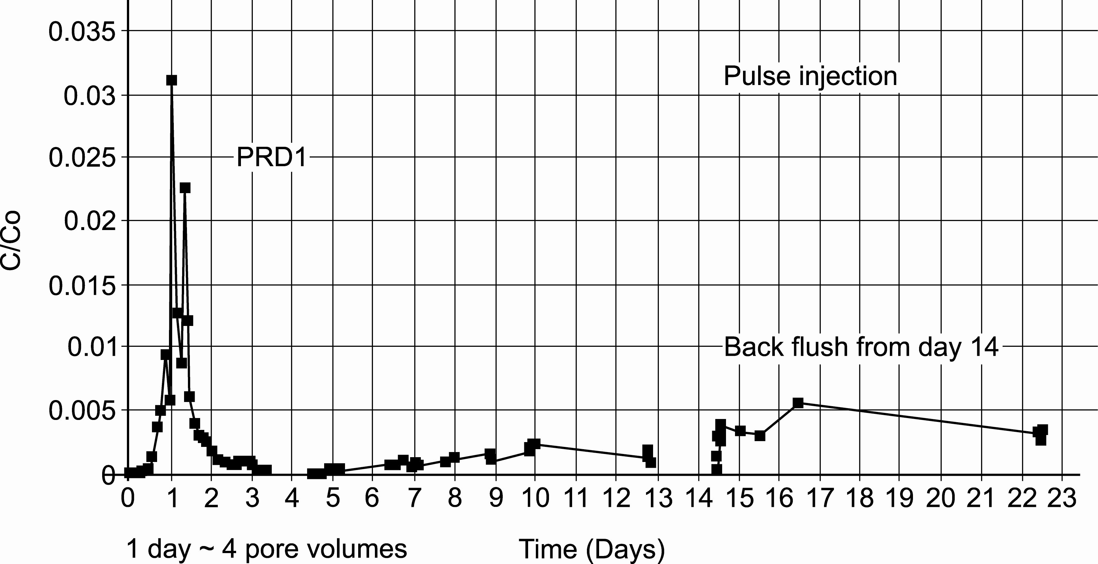
Fig. 3 Example virus (PRD1) breakthrough curve from pulsed, ‘top-hat’ injection of approximately a quarter of a day. C = concentration; Co = injection concentration.

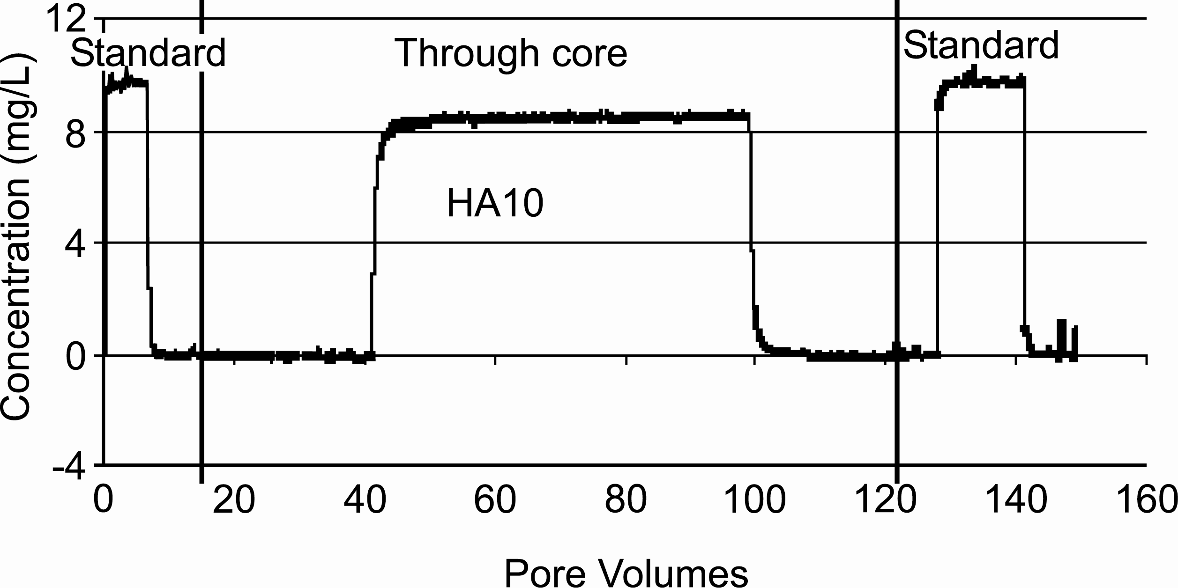
Fig. 4 Example 100nm diameter silica colloid breakthrough curve. Comparison with fluorescein (not shown) indicates little retardation.

Despite the severe attenuation of silica colloids, column experiments using combined phage and silica colloid suspensions made up in synthetic groundwater resulted not only in breakthrough of the injected phage, but also release of the phage which had not been eluted by extensive flushing following previous experiments (Fig. 5). One possible mechanism currently being investigated is that the colloid properties are sufficiently heterogeneous that a small proportion, below the detection limits of the light scattering device, are mobile, and that these aggregate with the much smaller viruses and facilitate their transport.

FIELD INVESTIGATIONS

To investigate the movement of viruses in field systems, forced gradient tracer tests have been carried out using the University of Birmingham campus field experiment
Fig. 5 Eluted mass (as indicated by pfu) as a function of time for 5 experiments on one column using the phage φX174.

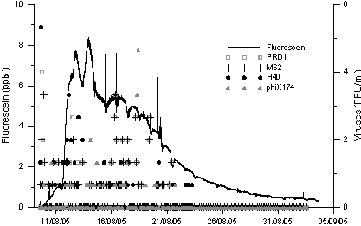

Fig. 6 Breakthrough of four phages and fluorescein at a pumping borehole following injection over the whole saturated depth of a second borehole 7 m distant.

facility (Joyce et al., 2007). The first series of experiments involved the injection of phage suspensions into 1-metre packered intervals, and abstracting from the same unit, also packered off, in a borehole 7 m away. Although the un-reacting tracer (fluorescein) was detected in all experiments, phage did not breakthrough, even when the interval tested contained a fracture. However, when the whole saturated depth of the borehole was tested, breakthrough of phage occurred at about the same time as breakthrough of the inert tracer (Fig. 6). The implication is that the phage transport is limited to certain pathways rather than occurring uniformly, but the experiments provide no indication of the location or nature of the pathways.
The next phase of the field experimentation is currently underway with the aim of identifying the pathway between the boreholes. To achieve this, the pump in the recovery borehole will be located just below the water level, and a series of sampling
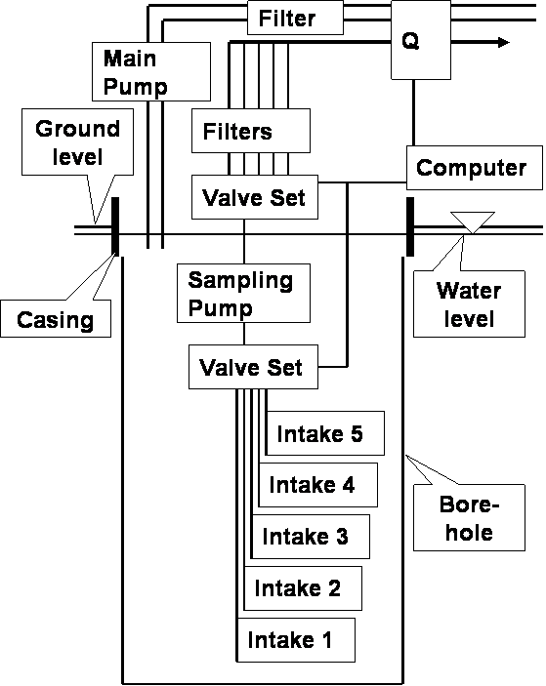

(b)

(a)
(b)

Fig. 7 (a) Test design to determine virus pathways between boreholes. (b) Preliminary results indicating borehole inflow variation with depth during pumping.

lines at different depths will feed water samples through special, charged-filter virus traps (Nanoceram) (Fig. 7(a)): the latter will be eluted and phage enumerated by plaque assay and epifluorescence microscopy. The flow rates in the recovery borehole will be measured by an impellor device (Fig. 7(b)), allowing the variation in phage influx with depth to be calculated and the exit point of the virus pathway to be determined.

CONCLUSIONS

The results of the studies described in this paper are summarized in Table 2. Piezometer sampling, well sampling, and forced-gradient tracer testing in red-bed sandstones of the UK indicate that it should not be assumed, even in predominantly matrix flow systems, that viruses are immobile. This has implications, especially for urban aquifers, particularly in the context of wastewater re-use.

Table 2 Summary of findings.
Method | Result
Field monitoring | Enteroviruses commonly found, but in low concentrations
Lab column expts: viruses | Virus breakthrough in synthetic groundwater severely attenuated
Lab column expts: SiO₂ colloids | Colloid breakthrough < detection limit in synthetic groundwater
Lab column expts: viruses + colloids | Complete breakthrough of viruses, & release of some previously attached
Field experiments | Virus mobility restricted to limited pathways.
Laboratory experimentation indicates that low ionic strength, previous exposure to viruses and, especially, increased concentrations of other types of colloidal particle are important factors in promoting virus mobility; in other circumstances, pH is also likely to be of importance.
As yet, field evidence on the role of fracture flow on virus movement in the sandstones considered here is sparse. Undoubtedly, given a large enough fracture, enhanced virus mobility will occur. But often the fractures in the sandstone are of small aperture, contain some filling material, are of limited lateral extent, and may well not be of significantly greater permeability than the host rock.
Field monitoring evidence (Powell et al., 2003) suggests sporadic occurrence of viruses both in space and time which is consistent with fracture flow; however, it is also consistent with variations in source strength and type, both of viruses and other particles. By undertaking experiments to identify the pathways taken by viruses between boreholes, we aim to determine the relative importance of these factors.

Acknowledgements We would like to thank the UK Natural Environment Research Council, Environment Agency, and Engineering and Physical Sciences Research Council for funding of the various components of this work. The new phase of work is being carried out under the EU Integrated project SWITCH (www.switchurbanwater.eu).

REFERENCES

Allen, D. J., Brewerton, L. J., Coleby, L. M., Gibbs, B. R., Lewis, M. A., Macdonald, A. M., Wagstaff, S. J. & Williams, A. T. (1997) The Physical Properties of Major Aquifers in England and Wales. British Geological Survey Technical Report WD/97/34, and Environment Agency R&D Publication 8.
Barker, R. D. & Tellam, J. H. (2006) Fluid Flow and Solute Movement in Sandstones: The Onshore UK Permo-Triassic Red Bed Sequence. Geological Society Special Publication 263, London, UK.
Carlyle, H. F., Tellam, J. H. & Parker, K. (2004) The use of laboratory-determined ion exchange parameters in the prediction of field-scale major cation migration over a 40 year period. J. Contam. Hydrol. 68, 55–81.
Powell, K. L., Barrett, M. H., Pedley, S., Tellam, J. H., Stagg, K. A., Greswell, R. B. & Rivett, M. O. (2000) Enteric virus detection in groundwater using glass wool. In: Groundwater: Past Achievements and Future Challenges (ed. by
O. T. N. Sililo et al.), 813–816. Balkema, Rotterdam, The Netherlands.
Hitchmough, A., Herbert, A. W., Riley, M. & Tellam, J. H. (2007) Estimating the hydraulic properties of the fracture network in a sandstone aquifer. J. Contam. Hydrol. 93, 38–57.
Joyce, E., Rueedi, J., Cronin, A., Pedley, S., Tellam, J. H. & Greswell, R. B. (2007) Fate and transport of phage and viruses in UK Permo-Triassic Sandstone aquifers. Environment Agency of England and Wales Science Report SC030217/SR. ISBN 978-1-84432-795-9.
Pedley S, & Howard G. (1997) The public health implications of microbiological contamination of groundwater. Quart. J. Engng Geol. 30, 179–88.
Powell, K. L., Taylor, R. G., Cronin, A. A., Barrett, M. H.., Pedley, S., Sellwood, J., Trowsdale, S. & Lerner, D. N. (2003) Microbial contamination of two urban sandstone aquifers in the UK. Water Res. 37, 339–352.
Shepherd, K. A., Ellis, P. A. & Rivett, M. O. (2006) Integrated understanding of urban land, groundwater, baseflow and surface-water quality – The City of Birmingham, UK. Sci. Total Environ. 360, 180–195.
Stagg, K. A , Kleinert, U. O., Tellam, J. H. & Lloyd, J. W. (1997) Colloidal populations in urban and rural groundwaters, UK. In: Urban Groundwater (ed. by J. Chilton et al.), , 187–192. Balkema, The Netherlands.
Tellam, J. H. (2007) Urban groundwater quality sustainability: the case of Birmingham, England. Zbl. Geol. Paläont.
Teil I, 71–86.
Tellam, J. H. & Thomas, A. (2002) Well water quality and pollutant source distributions in an urban aquifer. In: Current Problems in Hydrogeology in Urban Areas, Urban Agglomerates and Industrial Centres (ed. by K. W. F. Howard, & R. G. Israfilov), 139–158. NATO Science Series, IV. Earth and Environmental Sciences 8.

