VOLUMETRIC SCALE-UP OF SMOULDERING REMEDIATION OF CONTAMINATED MATERIALS

Christine Switzer^{a*}, Paolo Pironi^{b}, Jason I. Gerhard^{c}, Guillermo Rein^{b,d} and Jose L. Torero^{b,e}
ªDepartment of Civil and Environmental Engineering, University of Strathclyde, 107 Rottenrow, Glasgow G4 0NG, United Kingdom
^{b}BRE Centre for Fire Safety Engineering, Institute for Infrastructure and Environment, School of Engineering, University of Edinburgh, Edinburgh EH9 3JL, United Kingdom
^{c}Department of Civil and Environmental Engineering, University of Western Ontario, London, Ontario, N6A 5B9, Canada
^{d}Now at: Department of Mechanical Engineering, Imperial College London, Exhibition Road, South Kensington, London SW7 2AZ, United Kingdom
^{e}Now at: School of Civil Engineering, University of Queensland, St Lucia, 4072, Australia

*corresponding author (+44(0)141 548 4671, christine.switzer@strath.ac.uk)

ABSTRACT
Smouldering remediation is a process that has been introduced recently to address non-aqueous phase liquid (NAPL) contamination in soils and other porous media. Previous work demonstrated this process to be highly-effective across a wide range of contaminants and soil conditions at the bench scale. In this work, a suite of 12 experiments explored the effectiveness of the process as operating scale was increased 1000-fold from the bench (0.003m³) to intermediate (0.3m³) and pilot field-scale (3m³) with coal tar and petrochemical NAPLs. As scale increased, remediation efficiency of 97-99.95% was maintained. Smouldering propagation velocities of 0.6-14x10⁻⁵m/s at Darcy air fluxes of 1.54-9.15cm/s were consistent with observations in previous bench studies, as was the dependence on air flux. The pilot field-scale experiments demonstrated the robustness of the process despite heterogeneities, localised operation, controllability through airflow supply, and the importance of a minimum air flux for self-sustainability. Experiments at the intermediate scale established a minimum-observed, not minimum-possible, initial concentration of 12,000mg/kg in mixed oil waste, providing support for the expectation that lower thresholds for self-sustaining smouldering decreased with increasing scale. Once the threshold was exceeded, basic process characteristics of average peak temperature, destructive efficiency, and treatment velocity were relatively independent of scale.

Keywords: contaminant remediation; coal tar; petrochemical; process scale-up; smouldering combustion

1 INTRODUCTION
Smouldering remediation has been introduced recently to address non-aqueous phase liquid (NAPL) contamination in soils and other porous materials [1, 2]. High molecular weight NAPLs such as coal tar and crude oil are particularly recalcitrant and amenable to destruction within porous materials by smouldering if sufficient contamination is present [2].

Smouldering, an oxygen-limited, flameless form of combustion, requires the presence of a porous matrix that traps heat generated by the process and allows oxygen to reach reactions occurring at the fuel surface. The majority of previous research lies in the fire and combustion literature [3-6]. Familiar examples include charcoal, coal, and peat combustion, where the fuel is a porous solid. Smouldering remediation utilises NAPL as fuel within non-reactive porous media (e.g. soil), achieving oxidative destruction of contaminants within the media by consuming oxygen and organic liquids while producing primarily carbon dioxide, water vapour, and heat. In contrast, thermal remediation processes use heat primarily to volatilise and/or mobilise contaminants from soil and other materials [7, 8]. In some cases, thermal treatment processes harness heat released by chemical or biological degradation processes within the waste material [9-11]. Self-sustaining smouldering has been observed in coal waste spoil heaps [12, 13], though observed temperatures tend to be lower than smouldering of NAPL fuels. The two limiting factors in any smouldering reaction are oxidiser flux to and heat losses from the reaction zone [14, 15]. The extent to which heat losses affect smouldering can be linked to process scale [4, 16].

In order to initiate smouldering within NAPL-contaminated soil, external ignition and oxygen sources are required. Ignition protocols are adapted to suit test conditions, including soil and NAPL type [17], but generally involve a local, one-time introduction of heat and air to initiate smouldering, processes consistent with laboratory studies in other materials where ignition protocols are varied based on the fuel [18] and strength of ignition is linked to the fuel’s ability to support smouldering propagation [19]. After ignition is achieved locally, the surrounding porous medium traps heat released from smouldering NAPL and preheats adjacent contaminated material and the external energy source may be removed. The remediation process becomes self-sustaining, meaning that it provides all of the energy required to support itself, and propagates through the contaminated soil using energy produced by smouldering reactions. In previous studies, self-sustaining was evident by the smouldering front maintaining consistent peak-temperatures as it propagated through the NAPL-contaminated material [2, 17]. These stages are consistent with smouldering of porous solids [20].

Smouldering processes rely on complex heat transfer dynamics. Prior to ignition, the dominant mechanism is conduction or convection near the igniter, depending on ignition method. Some degree of radiation occurs within the porous material. After ignition, convection takes a dominant role as heat is transferred by the airflow that supports the smouldering process. The influence of radiation in the porous matrix is important. Radiation scales to the fourth power of temperature but its influence is limited to millimeters [4]. Radiation effectively traps much of the energy released by smouldering reactions, facilitating the self-sustaining nature of the process. Materials that shrink or move away from a heat source cannot smoulder [18]. The porous soil matrix serves dual purposes of restricting NAPL movement and trapping heat released by smouldering remediation.

Small-scale experiments demonstrated smouldering remediation across a range of conditions. Proof-of-concept work examined a laboratory-synthesised mixture of coal tar in sand, demonstrating the self-sustaining nature of the process and reducing contamination from 38,000mg/kg EPH to below the detection limit of 0.1mg/kg total extractable petroleum hydrocarbons (EPH) across the column [2]. In a follow-up study, the smouldering propagation velocity was found to be related to injected airflow rate [17]. Weak relationships were found linking propagation velocity to water content and NAPL saturation within the operating range. Self-sustaining smouldering was observed within a range of 28,000-142,000mg/kg NAPL content, 0-177,000mg/kg water content and Darcy air fluxes of 0.5-9.15 cm/s.

For any new remediation method, exploring links between results from small-scale studies to field-scale operation is essential to scale the process. All previously-cited work on smouldering remediation was operated at the bench scale (0.003m³), considered the most difficult scale to assess because the surface-area-to-volume ratio of the apparatus is at its highest and leads to significant heat loss. Sustainability of smouldering is directly affected by the ratio of heat retained to heat lost [8,9]. Increasing the experimental scale is expected to reduce heat losses, improve efficiency, and extend the range of operability (in terms of NAPL saturation, water content, airflow rate, and permeability). However, increasing scale reduces certain aspects of experimental control, potentially increases heterogeneity, and poses additional engineering challenges.

The objectives of this work are to demonstrate that smouldering remediation is viable across a wide range of operational scales, establish that remediation effectiveness is maintained with scale, and identify operating conditions that may challenge field-scale operation. A series of bench, intermediate and large-scale experiments is presented, representing scales of 1-, 100-, and 1000-fold volume increases relative to previous experiments. Scaling is evaluated for two contaminants: coal tar and mixed oil waste. The metrics for evaluating experimental performance include (i) contaminant concentrations before and after remediation, (ii) average smouldering velocity, (iii) average peak temperature, and (iv) self-sustainability. These results, and their relationship to previously-published laboratory data, are discussed with respect to sensitivity to scale. This work represents a demonstration of the scale-up of the process and provides insight into the suitability for future field-scale implementations.

2 EXPERIMENTAL
2.1. Materials and Preparation Methods
Two contaminated materials were tested at three experimental scales. Experiments were conducted on a synthesized mixture of coal tar in sand and a field-obtained mixed oil waste. Coal tar-contaminated material used commercial coal tar (10/15 EVT, Koppers, Scunthorpe Works, UK) and coarse sand (Leighton Buzzard 8/16 sand, Sibelco, UK; 1700kg/m³ bulk density, 1.34mm mean grain size, 1.35 coefficient of uniformity, 40% average porosity [2]). This material was manually or mechanically mixed. An initial concentration of 38,000mg/kg EPH (71,000mg/kg EPH) was used in the laboratory. Initial concentrations in intermediate and large-scale experiments (46,400 and 31,000 mg/kg EPH) were determined by chemical extraction after preparation (Table 1). The field mixture of oil industry wastes included upstream (crude oil) production and downstream (petroleum refining) sources and consisted of some parts soil (SureClean Ltd, Alness, UK). Its porous matrix had a mean grain size of 0.21mm and particle size distribution of a sandy clay loam or sandy loam according to the British Soil Classification System characterisation after remediation, though it was not a soil. High temperatures can have significant, irreversible effects on soils, particularly clays. Formation of fused aggregates has been observed at 1000°C through a hypothesised process of dehydration, aggregation, and sintering [21] and similar processes may have occurred in this material. The mixed oil waste was accepted and utilised as received without additional homogenization. Average initial EPH concentrations and moisture content measurements are listed in Table 1. Variations reflect different batches used for each set of experiments.

Experiments C1-C4 were carried out in a 0.003m³ (bench-scale) column, D5-D9 were carried out in a 0.3m³ (intermediate-scale) oversize chemical drum and B10-B11 were carried out in a 3m³ (pilot field-scale) bin (Table 1). Schematic diagrams of the experimental apparatuses are shown in Figure 1. Experiments C1, D5, and B10 with coal tar in sand represent scales of 1x, 100x, and 1000x previous bench-scale experiments while maintaining operating conditions of initial concentration and Darcy air flux consistent with those experiments [17]. Experiments with mixed oil waste explore one further change in parameter: initial concentration (D6-D9) and moisture content (B11).

Column experiments followed the same methods as previous experiments [2, 17]. An air diffuser, which consisted of a vertical pipe leading to a 3cm diameter central hub with 0.8cm diameter perforated pipes radiating outwards, was embedded at the base of a 0.003m³ quartz glass column (13.8cm diameter, 27.5cm height) and covered in a thin layer of clean sand. A 75cm inconel-sheathed cable heater (240V, 450W, Watlow Ltd, UK) was coiled and emplaced above the air diffuser. The contaminated soil was placed onto the igniter to a depth of 10cm and covered with a 5cm layer of clean sand (Figure 1). The top of the column was open to the atmosphere and operated under a high-power exhaust hood.

Drum (intermediate-scale) experiments were carried out in a 0.3m³ oversize chemical drum (63.5cm outer diameter, 104.1cm height) designed almost identically to the column, representing a 100-fold volumetric scale-up. An air diffuser, which consisted of a vertical air delivery pipe joined to a 7cm diameter stainless steel central hub with 2cm diameter perforated pipes radiating outward, was embedded at the base of the drum and covered with a thin layer of sand. Three coiled 3.8m inconel-sheathed heaters (240V, 2000W, Watlow Ltd, UK) were emplaced above the air diffuser. The drum was packed with contaminated material to a depth of 40cm and covered with 75kg of clean sand, a depth of approximately 10cm (Figure 1(b)). The top of the drum was open to the atmosphere and operated under a purpose-built exhaust hood.

Bin (large-scale) experiments utilised a 3m³ chain-lift style dumpster as the experimental vessel, representing a scale-up of 10-fold from the drum and 1000-fold from the column. The base was 168cm by 198cm and the horizontal cross-section increased to 168cm by 366cm at a height of 85cm (Figure 1). Four air diffusers, similar in design to the drum experiments, were employed (Figure 1(b)), effectively establishing the vessel as a four-quadrant simultaneous experiment for hardware installation and monitoring purposes; no physical divisions were embedded. The air diffusers were buried in a thin layer of clean sand layer. Twenty 3.8m inconel sheath cable heaters (240V, 2000W, Watlow Ltd, UK) were laid across the clean sand lengthwise across the base. Contaminated material was loaded to a height of 80cm. A clean sand layer of 5-15cm was placed on top and heaped toward the center. The top boundary was open to the atmosphere and operated under a purpose-built exhaust canopy.

The coal tar-sand mixture was prepared by manual mixing in the column experiments (one batch) and drum experiments (three batches). For the bin experiments, 66 batches of 5L coal tar and 75kg sand were prepared in a rotary mixer. Each batch was mixed for approximately 15min and interrupted twice for manual agitation. In this manner, 5tonne of sand was mixed with approximately 330L of coal tar. In the mixed oil waste experiments, material was transferred directly to the vessels. For all experiments, the contaminated material was placed into the vessel with no compaction.

Thermocouples (Type K inconel sheath, 0.3cm diameter, 30 or 200cm length, TC Direct, Uxbridge, UK) were used to monitor temperature evolution in space and time, which is the standard method of tracking a smouldering front, evaluating for self-sustainability, and monitoring peak temperatures [2, 17]. In the column experiments, the thermocouples were embedded along the centreline with 1cm spacing. In the drum experiments, thermocouples were inserted vertically along the centreline of the drum with 5cm spacing. In the bin experiments, approximately 80 thermocouples were divided into 16 vertical arrays of 5 sensors to avoid clusters of thermocouple rods forming large voids and preferential pathways that would disrupt the smouldering process. The first two thermocouples were spaced 10cm apart and the remaining thermocouples were spaced 20cm apart. Two arrays of thermocouples were placed at the center of each quadrant and the overall center of the bin, staggered to ensure thermocouples were present at 10cm intervals to a depth of 80cm; further single arrays were deployed at interfaces between each of the quadrants (Table 2, Figure 1(b)).

2.2. Operation
All experiments followed similar ignition protocols [2,10]. Heaters were operated until an appropriate ignition temperature was achieved at a predetermined distance from the heaters. In column experiments, this target was when the thermocouple 1cm above the heater achieved 400°C for coal tar and 350°C for mixed oil waste. The preheating period was approximately 70-90min in experiments C1-C4, 180-240min in D5-D9, and 300-500min in B10-B11. Drum and bin experiment ignition times were designed to be conservative to ensure a good ignition. After preheating, air injection was initiated at a fixed rate and continued until the end of the experiment. In the column experiments, air was delivered from a central compressed air system at an air injection volumetric flow rate of 5.8x10⁻⁴ m³/s at standard pressure and temperature, corresponding to a Darcy flux (volumetric rate divided by vessel cross-sectional area) of 9.15cm/s. In the drum and bin experiments, air was delivered from a 7bar two-tool compressor and regulated by flowmeters leading into the air injection device(s). In the bin experiments, flow from the two high-pressure outputs was split and routed into each of the quadrants. In the drum experiments, air injection volumetric flow rate at standard pressure was 8.3x10⁻³ m³/s (2.63 cm/s Darcy flux); in one case, air was supplied at 6.7x10⁻³ m³/s (2.11cm/s Darcy flux). In the bin experiment, air injection was 4.7x10⁻² m³/s (1.54cm/s Darcy flux) split between the four air diffusers; the Darcy flux effectively decreased with height because of the flared shape of the vessel (Figure 1(a)). Operating conditions are reported in Table 1.

2.3. Evaluation
Smouldering propagation velocity was calculated as a time lapse of arrival of the smouldering front, estimated as the average of the arrival time of 400°C, 500°C and 600°C [1, 2, 17]. In some of the mixed oil waste experiments, some of the recorded temperatures did not exceed 500°C and propagation velocity was calculated by front arrival at 400°C only.

Purpose-built covers channelled the process emissions to the filtration system for the drum and bin experiments. Emissions were monitored with a portable gas phase Fourier Transform Infrared (FTIR) Spectrometer (Dx-4000, Gasmet Oy, Helsinki, Finland).

EPH content in the soil samples before and after treatment was determined for all experiments. Accelerated Solvent Extraction (Dionex Corporation, Sunnyvale, California, USA) was used to extract 20g soil with 50mL of 90% dichloromethane and 10% acetone followed by analysis using a gas chromatograph equipped with flame ionization detector (Finnegan Focus GC, Thermo Electron Corporation, Hemel Hempstead, UK). Polycyclic aromatic hydrocarbon (PAH) content of samples before remediation was characterized by the presence of the 18 USEPA priority PAHs by gas chromatograph equipped with mass spectrometer (Thermo Quest Trace GC and Finnegan Trace MS, Thermo Electron Corporation, Hemel Hempstead, UK).

3. RESULTS AND DISCUSSION
3.1. Temperature Profiles
While process operating conditions varied by experiment, patterns of temperature evolution were similar through all experiments (Table 1, Figure 2). After an initial preheating period, smouldering was triggered by introduction of air. Initiation of the smouldering process was evident by the rapid increase in temperature to a peak temperature on the order of 600-1100°C as the process took hold. This peak was followed by a cooling period as the smouldering process destroyed NAPL contaminant and subsequent airflow cooled the remediated porous material. Although peak temperatures and times to achieve those peak temperatures varied based on contaminant and operating conditions, this behaviour was consistent across all experiments despite differences in contaminants, moisture content, porous material, and other heterogeneities.

A number of internal and external factors affect peak temperature during smouldering. Local thermodynamic equilibrium is not always achieved [22]. Local heterogeneities can affect oxidant consumption [23] and thus temperature achieved. Based on combustion gas monitoring [2], complete depletion of the NAPL content at a particular location seems to occur some time after the peak temperature at that location.

In the column, mixed oil waste was faster to ignite and experience smouldering propagation relative to coal tar in sand (Figures 2(a) and (d)), reflecting its lower density and energy content. In the drum, the initial mixed oil concentration was lower and moisture content was more variable, so a longer preheating time was used to ensure a good ignition. Average peak temperatures were higher in the coal tar than mixed oil waste (Figures 2(b) and (e)). The lag between initiation of airflow and rapid increase in temperature in drum and bin experiments reflected the distance between the igniters and first thermocouple, which was larger than the column experiments. Bundling of thermocouples into arrays maintained relative positions in case of errors in placement.

In the bin, moisture content of the mixed oil waste was significantly higher than the coal tar in sand, which had no added moisture, and the batches used for column and drum experiments. A longer ignition period was allowed, but initial rates of airflow were identical and ultimately behaviour in both experiments was very similar (Figures 2(c) and (f)). In experiment B11 (Figure 2(f)), a hole formed at the base of the bin, approximately centre between quadrants A and C, and resulted in a significant loss of airflow from the entire vessel (see Figure 1). Smouldering continued in quadrants B and D, hindered by reduced airflow and significant moisture content. These observations are consistent with laboratory studies [17], though conditions exceed the ranges explored within those studies. Regardless of scale and complications, self-sustaining smouldering was evident in all cases by the sustained high temperatures as the smouldering fronts propagated through porous materials destroying the contaminant in their paths.

3.2. Intermediate-scale (Drum) Experiments
In the mixed oil waste drum experiments (D6-D9), successful, self-sustaining smouldering was achieved in material with an initial concentration of 12,000±4000mg/kg EPH (4 samples) (Table 1, Figure 3). Experiments D6-D9 exhibited average peak temperatures of 550-755°C and propagation velocities of 2.8-3.7x10⁻⁵m/s (Table 1). Despite some variability in peak temperatures, excavation of the vessels showed visibly clean material throughout. Post-remediation contamination levels were an average of 37±9mg/kg EPH (4 samples) based on composite samples collected after each experiment, representing 99.7% reduction from the initial concentration.

Combustion gases were used to assist with ignition monitoring. Placement of the first thermocouple approximately 5cm from the igniters resulted in a lag between ignition and arrival of the smouldering front at this location. Rapid, sustained release of CO₂ and CO in the emissions showed that good ignitions had been achieved (Figure 3). Smouldering fronts had developed but not yet intersected any thermocouple locations. Some refinement was achieved with the ignition protocol for the mixed oil waste (Figure 3), though no effort was made to optimise the ignition protocol.

Based on the thermocouple profiles, experiment D5 with coal tar and experiments D7-D9 with mixed oil waste would be considered self-sustaining whereas experiment D6 may not be self-sustaining. Peak temperatures should be consistent as the smouldering front propagates throughout the material [2, 17] whereas a decline in peak temperatures was observed in D6. Typically, measurements from the first thermocouple are discounted to compensate for assistance from the igniter. Based on emissions profiles, only experiment D7 achieved steady-state CO₂ and CO concentrations. At steady-state, the CO₂ to CO ratio varied from 7.4 to 10 (Table S-1). These values are unusual for smouldering phenomena, which are known to be less complete than flaming combustion and typically have values closer to unity [4]; the higher ratios may reflect excess air supplied to the process. Perhaps with larger columns of material, similar steady-state emissions concentrations may have been achieved in the other experiments and self-sustaining smouldering may have been achieved in experiment D6 as well. There may also be some mobilisation of NAPL toward the igniters, which would result in more mass at the igniters when the process was initiated and lead to larger initial release of CO₂ and CO as well as higher peak temperatures [11] compared to the areas in the drum that were further away from the igniters.

Drum experiments formed the basis of the ignition methods used in the bin experiments where similar challenges of thermocouple placement relative to igniter location were present.

3.3. Large-scale (Bin) Experiments
Temperature profiles the large-scale (bin) experiment with the synthesised mixture of coal tar in sand (B10) are shown in Figure 4. Temperature profiles from the mixed oil waste experiment (B11) are shown in Figure S-1 in the Supporting Information.

In experiment B10, ignition was observed initially through CO₂ and CO evolution in the emissions indicating that a smouldering front had developed but not yet intersected any thermocouple locations. The characteristic temperature evolution was observed at all thermocouple locations throughout the vessel, but followed rather than accompanied the initial observations of combustion gases (Figure 4). Smouldering initiation was first apparent in quadrants A and B and seemed slower to take hold in quadrants C and D, most likely reflecting heterogeneities in packing and airflow delivery; it may also reflect some misalignment of thermocouple arrays. These imbalances were overcome as the smouldering front moved upward through the porous material, consistent with a previous experiment [24]. Peak temperatures ranged from 800-1000°C as self-sustaining smouldering propagated through the vessel for approximately 20hours before the reaction self-terminated when insufficient fuel remained. Complete smouldering was observed at all locations, indicating robustness of the process in the presence of sufficient fuel and oxygen. Air delivery continued beyond the point of self-termination to aid with cooling.

Excavation of experiment B10 showed visibly clean material throughout the vessel (Figure 5). Post-remediation contamination levels were an average of 17±3 mg/kg EPH (30 samples) throughout the vessel and 10±1 mg/kg EPH (20 samples) in the area that was initially contaminated. This reduction in concentration represents 99.95% remediation across the 3m³ vessel. Slightly elevated contamination levels were observed on the surface, but these were all below 100mg/kg EPH and likely related to condensation of volatiles in the clean sand cover.

In the UK, if this material was an excavated contaminated soil, it would be classified as non-hazardous waste [25] unless an End-of-Waste submission was granted for its reuse. In Australia, this material may be deemed safe to use as fill [26]. In Canada, this material would meet the Canada-wide remedial standard for petroleum hydrocarbons in soil for all potential uses [27]. In the USA, this material would meet the remediation requirements for most States [27], though individual requirements vary. In all cases, some form of reuse would be possible as long as no other contaminants (e.g. potentially toxic elements) were present at unsafe levels.

The second bin experiment (B11) in the mixed oil waste followed a similar ignition profile as experiment B11. The time to ignition was longer because of its high moisture content, but ignition was achieved. Smouldering was evident by CO₂ and CO evolution immediately after airflow was initiated, before thermocouple sensors showed any substantial response above 100°C. The dynamics of the experiment changed approximately 12-16 hours into the smouldering process. Although thermocouple signatures were not as strong as in B10, they had been evolving steadily. A rupture formed at the interface between the side wall and bottom of the vessel (Figures S-1 and S-2) and air was noticeably escaping the vessel. Inhibition of the process became apparent in the adjacent quadrants (A and C). On the opposite side of the vessel (quadrants B and D), smouldering remediation continued, albeit slowly, inhibited by the high moisture content of the material and some loss of airflow (Figures 2(f) and S-1).

The steady-state CO₂ to CO ratio of 1.4 in experiment B10 is similar to those observed other smouldering phenomena [4]. The elevated CO concentrations likely reflect process inefficiencies that could be overcome by supplying more air to the process. In experiment B11, the CO₂ to CO ratio of 7.4 is similar to experiments D6-D9 (Table S-1), but the effects of dilution from entrained ambient air may be influencing the measurement. Further study on the process emissions is necessary to establish links between combustion gases, process efficiency, and levels of contamination remaining in the soil after remediation.

Visual examination of material after excavation showed that the extent of remediation reflected the strength of the smouldering process evident in the temperature profiles (Figure S-2). Significant remediation was achieved in quadrants B and D whereas limited remediation was achieved in quadrants A and C. An average concentration of 1100±500mg/kg EPH (4 samples) remained in quadrants B and D and an average concentration of 24,000±10000mg/kg EPH (6 samples) remained in quadrants A and C. Areas in quadrants B and D experienced as much as 97-99% remediation (460-1540mg/kg EPH) whereas the remainder of the vessel experienced 0-85% remediation (5000+mg/kg EPH remaining). Despite its apparent failure as a remediation exercise, experiment B11demonstrates the importance of airflow to the process, how localised the process operates, and its controllability.

3.4. Discussion
Smouldering remediation performed consistently well across all experimental scales for two representative contaminants and matrices despite significant heterogeneities in airflow delivery, material properties, and initial concentrations. Smouldering propagation velocities ranged from 0.6-14x10⁻⁵m/s (0.04-0.84cm/min) across all experiments (Table 2). These values represent averages across all of the thermocouples in which self-sustaining smouldering was observed (centreline profiles in experiments C1-C3 and D5-D9, all profiles in B10, and profiles in quadrants B and D of B11). Overall average propagation velocities were 3.4x10⁻⁵m/s (coal tar, dry conditions) and 1.3x10⁻⁵m/s (mixed oil waste, wet conditions). Based on these values, a 1m tall vessel could be remediated in 8hrs in dry conditions and 21hrs in wet conditions. The extremes of the full range translate to 2-46hrs to accomplish remediation. Remediation time can be controlled by the air injection rate, with higher rates leading to higher propagation velocities. This dependency appears to be relatively independent of scale (Figure 6). Doubling the air flow supplied to the process seems double the smouldering velocity within the range studied. This observation is consistent with other research that used a linear relationship between smouldering velocity and Darcy flux input [28] based on previous data [17]. Some variability in data presented here is not surprising considering the variations in contaminant types, initial concentrations, soil types, moisture contents, heterogeneous packing, heterogeneous air flow conditions, and experimental scales.

Heat transfer efficiency, the fraction of energy generated that is retained by the self-sustaining reaction, is expected to increase with scale as the larger-scale experiments benefit from insulation effects. Heat loss from oxidative smouldering reactions is one of the most significant barriers to smouldering propagation [3, 15]. The major pathways for heat losses are the free surfaces. As the scale increases, heat losses from exterior surfaces decrease relative to the amount of smouldering material; however, heat sinks remain in the form of soil moisture and NAPL outside the treatment area. The surface-area-to-volume ratio decreases from 0.3m⁻¹ in the column (0.003m³) to 0.06m⁻¹ in the drum (0.3m³) and 0.02m⁻¹ in the bin (3m³). During self-sustaining smouldering, these heat losses are overcome and the process works equally well at all scales. Remediation effectiveness, peak temperature, and smouldering velocity seem to be relatively independent of scale in such cases.

Although not explored in this work, the limits of self-sustaining smouldering are a function of heat losses and thus expected to be dependent upon scale. The initial concentration of 12,000±4000mg/kg EPH (4 experiments) for smouldering initiation in D6-D9 represents the minimum-observed initial concentration to date, not the minimum possible. It is significantly less than the observed lower bounds of 28,400mg/kg for coal tar and 31,200mg/kg for crude oil in bench-scale experiments [17] and matches expectations that the minimum concentration required for self-sustaining smouldering will decrease as the scale increases. The EPH measurement represents the extracted hydrocarbon content, which previous studies have shown to be 1/3 to 1/2 of known quantities in fresh samples [17]; total contaminant load is likely higher than 12,000mg/kg. At the drum scale or larger, the minimum initial concentration for coal tar may be even lower than for mixed oil waste because of its higher density, wider range of polycyclic and heterocyclic hydrocarbon constituents, and higher energy content.

Based on the observations in this work, bench-scale treatability studies with contaminated site soil should be conservative and representative. If self-sustaining smouldering is observed then similar results (self-sustaining, air flux-velocity relationship, peak temperatures, remediation completeness) should be expected at larger scales. What must be evaluated at larger scales are large-scale features such as heterogeneity in soil properties and NAPL distribution, air distribution, and operational factors. Heat transfer efficiency is particularly beneficial to in situ operation where surrounding soil maintains insulation, though other operational factors may work against this energetic gain. The results of this work show that smouldering remediation offers significant promise in both in situ and ex situ applications. A number of pilot studies are underway in both settings.

4. CONCLUSIONS
A suite of 12 experiments demonstrated the effectiveness of smouldering remediation as operating scale is increased 1000-fold from the laboratory (0.003m³) to pilot field-scale (3m³) with coal tar and mixed oil waste contaminants. Remediation completeness was maintained as operating scale increased and observed smouldering propagation velocities of 0.6-14 x 10⁻⁵m/s remained consistent with observations in previous studies. Smouldering velocity was dependent on air flux in a manner consistent with bench-scale experiments. Increases in experimental scales led to reduced heat losses, allowing efficiency to be maintained in leaner conditions. In a 3m³ experiment, the remediation front eventually reached the entire contaminated volume, indicating a robust process capable of self-correcting even when presented with preferential treatment channels. A second experiment at this scale demonstrated its controllability through localised operation of the process, responsiveness, and controllability through airflow supplied. Experiments at the intermediate (0.3m³) scale established a minimum-observed initial concentration of 12,000mg/kg EPH in mixed oil waste, a threshold that may be lower still for this contaminant and more energetic contaminants such as coal tar, particularly at larger operational scales. Large-scale operation, particularly in situ, may allow for further improvements in process efficiency through reduced heat losses. Ongoing and future work is exploring further scale-up of smouldering remediation to field operation as well as research questions about the limitations of the process, the influences of heterogeneity, and other site-specific considerations.

ACKNOWLEDGEMENTS
This work was funded by Scottish Enterprise, the Engineering and Physical Sciences Research Council (EPSRC), and WRAP in the United Kingdom. The authors gratefully acknowledge logistical support from Environmental Reclamation Services, Ltd, and SureClean, Ltd. Smouldering combustion of liquids is a patented remediation process (e.g USA 8132987 with others pending, PCT Application PCT/GB2006/004591, priority date 10th December 2005, and PCT/US2012/035248, priority date 29 April 2011).

REFERENCES
[1] P. Pironi, C. Switzer, G. Rein, J.I. Gerhard, J.L. Torero, A. Fuentes, Small-Scale Forward Smouldering Experiments for Remediation of Coal Tar in Inert Media, Proceedings of the Combustion Institute, 32 (2009) 1957-1964.
[2] C. Switzer, P. Pironi, J.I. Gerhard, G. Rein, J.L. Torero, Self-Sustaining Smoldering Combustion: A Novel Remediation Process for Non-Aqueous-Phase Liquids in Porous Media, Environmental Science & Technology, 43 (2009) 5871-5877.
[3] T.J. Ohlemiller, Smoldering Combustion, in: M. Quincy, P. DiNenno, C.L. Beyler, R.L.P. Custer, W.D. Walton (Eds.) SFPE Handbook of Fire Protection Engineering, National Fire Protection Association, 1995, pp. 2/171-179.
[4] G. Rein, Smouldering Combustion Phenomena in Science and Technology, International Review of Chemical Engineering, 1 (2009) 3-18.
[5] A. Bar-Ilan, G. Rein, A.C. Fernandez-Pello, J.L. Torero, D.L. Urban, Forced forward smoldering experiments in microgravity, Experimental Thermal and Fluid Science, 28 (2004) 743-751.
[6] J. Buckmaster, D. Lozinski, An elementary discussion of forward smoldering, Combustion and Flame, 104 (1996) 300-310.
[7] S. Gan, E.V. Lau, H.K. Ng, Remediation of soils contaminated with polycyclic aromatic hydrocarbons (PAHs), Journal of Hazardous Materials, 172 (2009) 532-549.
[8] M. Zilberchmidt, M. Shpirt, K. Komnitsas, I. Paspaliaris, Feasibility of thermal treatment of hugh sulfur coal wastes, Minerals Engineering, 17 (2004) 175-182.
[9] M. Della Zassa, A. Biasin, M. Zerlottin, D. Refosco, P. Canu, Self-heating of dried industrial wastewater sludge: Lab-scale investigation of supporting conditions, Waste Management, 33 (2013) 1469-1477.
[10] M. Zerlottin, D. Refosco, M. Della Zassa, A. Biasin, P. Canu, Self-heating of dried wastewater sludge, Waste Management, 33 (2013) 129-137.
[11] H.G. Kelly, H. Melcer, D.S. Mavinic, Autothermal thermophilic aerobic digestion of municipal sludges: A one-year, full-scale demonstration project, Water Environment Research, 65 (1993) 849-861.
[12] K. Torrance, G. Rein, C. Switzer, R. Carvel, R. Hadden, C.M. Belcher, Self-Sustained Smoldering Combustion of a Coal-Waste Heap in Central Scotland, in: A.P. G.B. Stracher, and E.V. Sokol (Ed.) Coal and Peat Fires: A Global Perspective, Elsevier Geoscience, 2012.
[13] D. Nichol, N.P. Tovey, Remediation and monitoring of a burning coal refuse bank affecting the Southsea Looproad at Brymbo, North Wales, Engineering Geology, 50 (1998) 309-318.
[14] A. Bar-Ilan, G. Rein, D.C. Walther, A.C. Fernandez-Pello, J.L. Torero, D.L. Urban, The effect of buoyancy on opposed smoldering, Combustion Science and Technology, 176 (2004) 2027-2055.
[15] T.J. Ohlemiller, Modeling of smoldering combustion propagation, Progress in Energy and Combustion Science, 11 (1985) 277-310.
[16] F.A. Williams, Mechanisms of Fire Spread, Proceedings of the Combustion Institute, 16 (1977) 1281-1294.
[17] P. Pironi, C. Switzer, J.I. Gerhard, G. Rein, J.L. Torero, Self-sustaining Smoldering for NAPL Remediation: Laboratory Evaluation of Process Sensitivity to Key Parameters, Environmental Science & Technology, 45 (2011) 2987-2993.
[18] D. Drysdale, An Introduction to Fire Dynamics, Third Edition, John Wiley & Sons, Ltd., Chichester, UK, 2011.
[19] D.C. Walther, R.A. Anthenien, A.C. Fernandez-Pello, Smolder ignition of polyurethane foam: effect of oxygen concentration, Fire Safety Journal, 34 (2000) 343-359.
[20] M.K. Anderson, R.T. Sleight, J.L. Torero, Downward smolder of polyurethane foam: ignition signatures, Fire Safety Journal, 35 (2000) 131-148.
[21] S.G. Zihms, C. Switzer, M. Karstunen, A. Tarantino, Understanding the Effects of High Temperature Processes on the Engineering Properties of Soils, in: Proceedings of the 18th International Conference on Soil Mechanics and Geotechnical Engineering, Paris, France, 2013.
[22] G. Debenest, V.V. Mourzenko, J.-F. Thovert, Smouldering in fixed beds of oil shale grains: governing parameters and global regimes, Combustion Science and Modelling, 9 (2005) 301-321.
[23] C. Lu, Y.C. Yortsos, Dynamics of Forward Filtration Combustion at the Pore-Network Level, AIChE Journal, 51 (2005) 1279-1296.
[24] C. Switzer, P. Pironi, G. Rein, J.L. Torero, J.I. Gerhard, Experimental Studies of Self-Sustaining Thermal Aquifer Remediation (STAR) for Non-Aqueous Phase Liquid (NAPL) Sources, in: ConSoil 2008, Milano, Italy, 2008.
[25] EA(UK), Hazardous waste: Interpretation of the definition and classification of hazardous waste (3rd Edition), in, Natural Resources Wales, Scottish Environment Protection Agency, Northern Ireland Environment Agency, and Environment Agency, 2013.
[26] EPA(Australia), EPA Publication 448 Classification of Wastes, in: E.P. Authority (Ed.), 2007.
[27] CCME, Canada-Wide Standard for Petroleum Hydrocarbons (PHC) in Soil: Scientific Rationale Supporting Technical Document, in, Canadian Council of Ministers of the Environment, 2008.
[28] S.L. MacPhee, J.I. Gerhard, G. Rein, A novel method for simulating smoldering propagation and its application to STAR (Self-sustaining Treatment for Active Remediation), Environmental Modelling & Software, 31 (2012) 84-98.

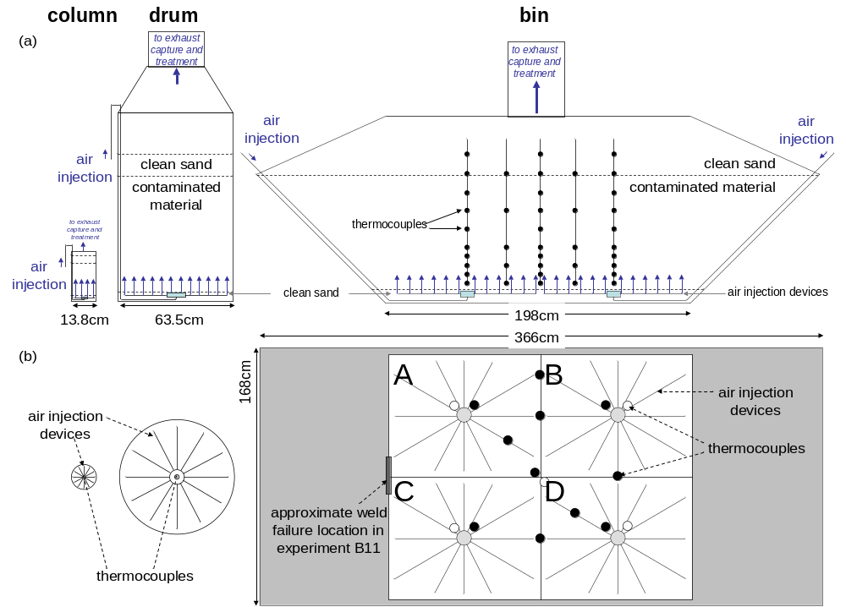
Figure 1. Schematic diagrams detailing the setup of column, drum, and bin experiments with (a) side views showing geometry and layers of material and (b) top views showing air injection patterns and thermocouple locations (●○).

Figure 2. Smouldering remediation experiments for (a) coal tar in sand (0.003m³), (b) coal tar in sand (0.3m³), (c) coal tar in sand (3m³), (d) mixed oil waste (0.003m3), (e) mixed oil waste (0.3m³), and (f) mixed oil waste (3m³).
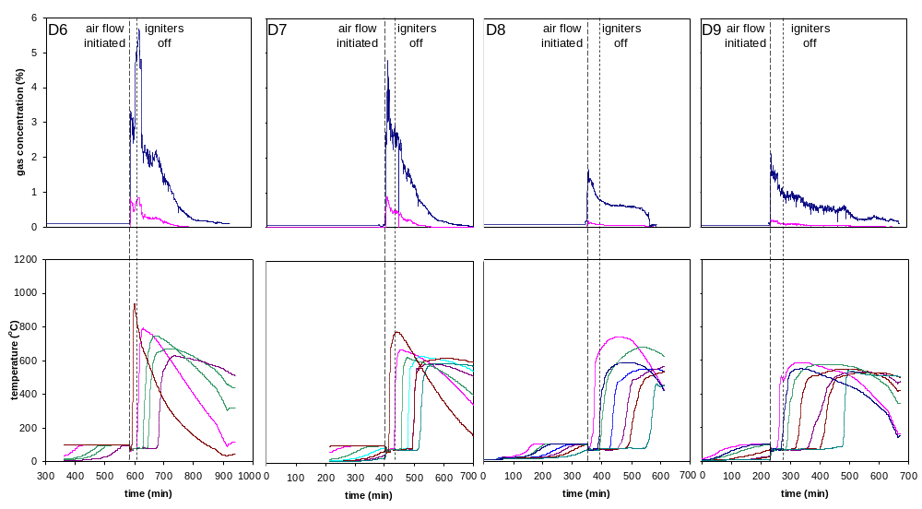
Figure 3. Combustion gas and temperature profiles versus time for mixed oil waste drum experiments (D6-D9).

Figure 4. Temperature evolution versus time in experiment B10 (coal tar in sand, 3m³).

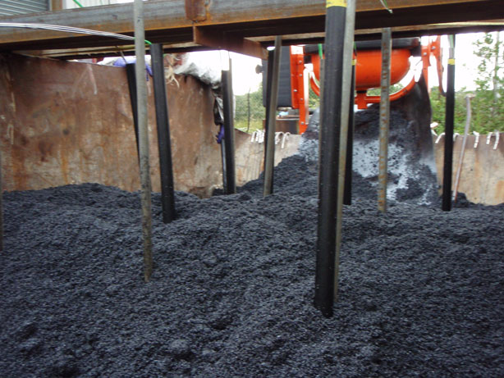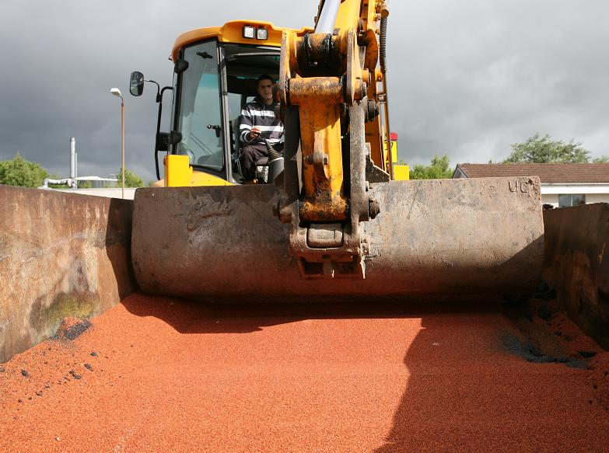
Figure 5. Experiment B10 (3m³). (a) Coal tar mixed with coarse sand before remediation, with thermocouple insertion sleeves visible. (b) Clean sand after remediation (99.95+% concentration reduction).

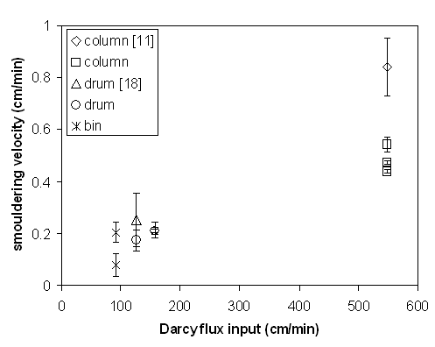
Figure 6. Smouldering velocity relative to Darcy flux input for coal tar and mixed oil waste contaminants. Error bars represent 95% confidence intervals.
Table 1. Contaminant type, characteristics, and results of all experiments.
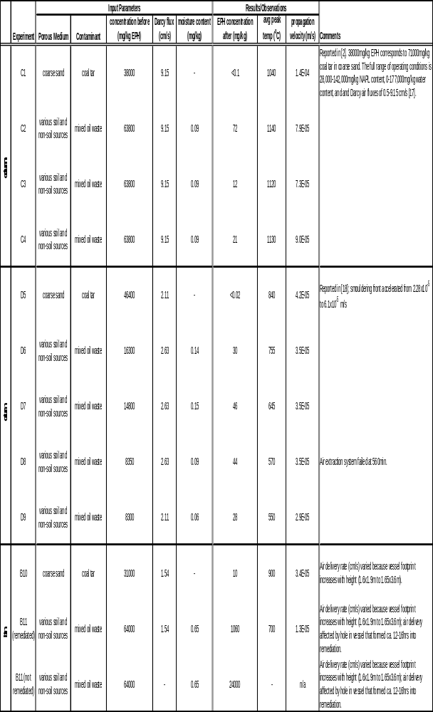
Table 2. Smouldering velocity relative to position in the bin experiments as well as column and drum experiments. 

