Preliminary evaluation of optically-interrogated Rogowski coils: compliance with power system protection classes

G. Fusiek¹, P. Orr¹, P. Niewczas¹, A. Dyśko¹, C.D. Booth¹, F. Kawano³, P. Beaumont², G. Baber², T. Nishida³

¹Institute for Energy and Environment, University of Strathclyde, Glasgow, UK, g.fusiek@strath.ac.uk

²Toshiba International (Europe), UK, philb@til.toshiba-global.com

³Toshiba Corporation, Japan, fumio.kawano@toshiba.co.jp

Keywords: Rogowski coil, optical sensor, piezoelectric transducer, fibre Bragg grating, power system protection.

Abstract
In this paper we report on recent investigations into the performance of an optically-interrogated Rogowski coil designed for power system protection applications. Preliminary evaluation of the pre-prototype device shows that the amplitude and phase errors at its rated current of 1 kA and at rated frequency are around 0.1 % and 0.1° respectively. Based on the experimental results it can be concluded that the proposed approach of Rogowski coils monitored passively by distributed optical sensors has the potential to ensure conformance with the 5P protection and 0.5 standard classes specified by IEC 60044-8, while introducing a host of benefits that result from the passive and dielectric nature of the interrogation technique.

1 Introduction
In contrast to conventional current transformers (CTs), Rogowski coils (or linear couplers) offer a linear response and do not suffer from saturation or hysteresis effects. Low inductance, light weight, the ability to measure very large currents, and a very high dynamic range make them highly suited to power system protection applications. However, due to their relatively low mutual inductance (coupling) between the primary conductor and the secondary winding, Rogowski coils produce a very low output voltage which requires sensitive integration in order to reconstruct the measured (primary) current waveforms. Traditional electronic integrator circuits require dc power sources to be available near the measurement location, or require a form of energy scavenging. This prohibits the long-distance interrogation of Rogowski coils, and introduces sensitivity to EMI and other environmental factors which can contribute to significant measurement errors.

The concept of an optically-interrogated Rogowski coil (ORC) has been recently proposed by the authors [1], and this is described in more detail in this paper. The novel approach relies on the use of a low voltage piezoelectric transducer (multilayer stack) with a fibre Bragg grating (FBG) sensor attached to its surface, forming a robust hybrid optical low-voltage sensor capable of monitoring the Rogowski coil output voltage. The hybrid optical voltage sensor is interrogated remotely by a high-resolution interrogation system, ensuring that no additional electrical power is required at the ORC location. It has already been demonstrated that such hybrid techniques can offer remote passive current measurements over long distances and can be applicable to a wide range of metering and protection applications such as multi-terminal protection, UHV transformer protection, wide-area backup protection, fibre-enabled synchrophasors without GPS networks, and centralised management of smart grids [1-3]. In this paper, we focus on the possibility of remote and passive interrogation of Rogowski coil current sensors, and demonstrate their capability to comply with relevant IEC standards.

2 Current and Voltage Transducers
In this section, a brief description of the components utilized in the proposed approach is provided.

2.1 Rogowski Coil
Traditional Rogowski coils are wound on a non-magnetic former (µ_{r}=1) which is placed around a conductor carrying the current to be measured, as shown in Figure 1. Such coils are characterised by a linear response and lack of saturation, thus offering a high dynamic range.

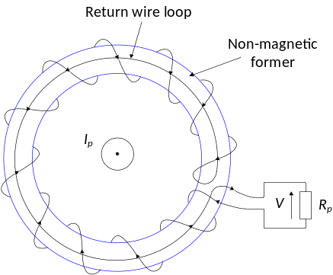

Figure 1: Rogowski coil principle.

The output voltage of the coil is proportional to the rate of change of the primary (measured) current according to the equation: v(t) = - M⋅di(t)/dt, where M=Anµ₀ is the mutual inductance of the coil, A is the cross-section area of the former, n is the turn density, and µ₀ is the permeability of air [4, 5].

As the Rogowski coil output is proportional to the differential of the primary current, the phase displacement between the primary current and the secondary voltage is approximately 90°. To recover the measured current, the coil output voltage needs to be integrated using either analogue integrator circuits or digital integration based on signal processing algorithms. Since a burden connected to the coil output forms a voltage divider with the coil resistance, burdens with high input impedance are required to achieve high accuracy response [4, 5].

Due to the use of non-magnetic cores, the mutual inductance of Rogowski coils is low and the coils require special design to ensure a high quality of current measurement. To minimise the influence of external fields and the position of the primary conductor inside the coil, a single-layer coil with return wire loop (Figure 1) or multi-layer coils wound in opposite directions are commonly available [4, 5].

The Rogowski coil used in this study was a commercially-available component having the specifications summarized in Table 1.

Rogowski coil / Linear coupler specifications
Outer diameter (cm) | 12
Loop cross-sectional area (cm²) | 8.4
Number of turns | 990
Mutual inductance M (μH) | 3.17
Self-inductance L (mH) | 3.14
Resistance of the coil R_{c} (Ω) | 47.5
Self-capacitance C_{c} (pF) | 896
Self-resonant frequency f_{r} (kHz) | 94.90
Direct output at 1 kA 50 Hz primary current (V) | 0.9962
Table 1: Specifications of the Rogowski coil utilised in this study.

2.2 Optically-interrogated Rogowski coil
An optically-interrogated Rogowski coil (ORC) is formed by connecting a low voltage piezoelectric transducer to the Rogowski coil output, as shown in Figure 2, and purely optical interrogation is used to obtain the primary current measurements [1].

A new-generation low voltage stack (P-885.91 PICMA® from Physik Instrumente Ltd (PI) [6]) comprising fused piezoelectric layers was utilised in this study to monitor the Rogowski coil output. The stack has a square cross-section profile and a length of 36 mm formed by the parallel connection of 600 layers of 60 µm thickness.
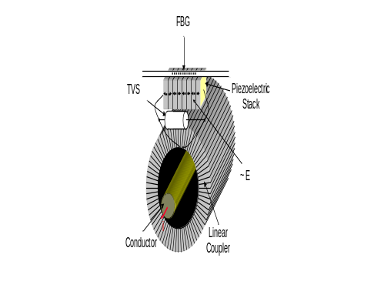
Figure 2: Hybrid current sensor employing Rogowski coil.

The stacks have a maximum ac operating voltage of 30 V_{pk} (21.21 V_{rms}). Since subjecting the stack to voltages above rated values may lead to the piezoelectric material depolarisation, a transient voltage suppression (TVS) diode is required to be connected between the device terminals to protect it from degradation due to spikes above the rated voltage. The stack specifications at room temperature are summarized in Table 2.

Piezoelectric multilayer stack specifications
Cross-sectional area (mm²) | 25
Length (mm) | 36
Maximum displacement (µm) (at 0-120 V) ± 10 % | 38
Resistance R_{p} (MΩ) | 100
Capacitance C_{p} (μF) ± 20 % | 3.1
Piezoelectric coefficient (με/V) | 8.8
Maximum ac operating voltage (V_{pk}) | 30
Resonant frequency (kHz) ± 20 % | 40
Table 2: Specifications of the piezoelectric transducer utilised in this study.

A standard 5 mm long FBG with a central wavelength of 1550 nm was epoxied to the piezoelectric material using the high temperature adhesive EPOTEK 353ND. The stack was protected against overvoltage condition with a 30 V TVS diode.

2.3 Interrogation system
As indicated in the previous sections, the Rogowski coil used in this study is characterised by relatively low output, offering approximately 1000A/1V ratio at 50 Hz. According to the specifications of the piezoelectric stack and the coil, the maximum primary current that can be measured by the ORC device is 20 kA_{rms} producing approximately 28 V_{pk} on the stack. Due to the low voltage output of the coil, a high-resolution optical interrogator employing an unbalanced Mach-Zehnder interferometer (MZI) with a ratiometric output configuration was employed in this study. Only a brief summary of the principle of operation of the optical interrogation system is presented below; more detailed information on the technique can be found elsewhere [1, 7-9].
Figure 3 illustrates the unbalanced MZI module with integrated photodetectors that is used in this scheme. The system exploits a passive, instantaneous technique for phase demodulation based on the physical characteristics of single-fusion 3×3 couplers (an optical power coupler for three fibres produced by a single glass-fusing operation). By fabricating a Mach-Zehnder interferometer (MZI) with a known path difference between a 2×2 and a 3×3 coupler, the phase difference may be calculated ratiometrically based on the photodetected outputs of all three channels [1, 7-9].

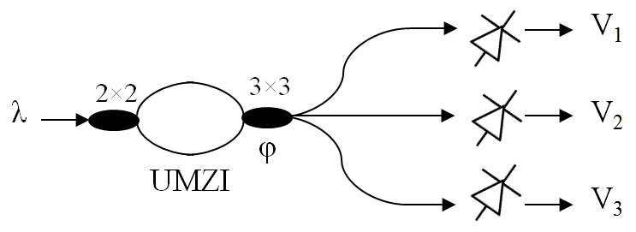
Figure 3: Interferometric demodulation platform.

The phase difference ϕ between MZI paths is related to the input optical wavelength λ (in this scheme the reflected Bragg wavelength) by the expression: Δφ=2πnd/λ, where n is the MZI core index and d is the physical path difference, and nd is defined as the optical path difference (OPD) [7]. The corresponding voltage on the photodetector outputs can be expressed as a function of phase change Δφ. Using this technique, an optical wavelength guided to the input of the MZI can be determined immediately from a single sample on each V₁₋₃. This capability for immediate calculation of the reflected wavelength from an FBG sensor is key to the operation of the multiplexing technique for this system [1, 7-9].

The longitudinal strain in the grating, Δε, is related to the change in the phase difference between MZI paths, Δφ, by the expression: Δλ=λΔφ/2πndζ, where λ is the Bragg wavelength and ζ = (δλ/δε)/λ is the stress-optic coefficient (0.78 × 10⁻⁶ με⁻¹ [7]). The change in wavelength can be calculated from the change in phase by Δλ=λ²Δφ/2πnd, which for an FBG having a central wavelength of 1550 nm and at the nd of 3 mm can be calculated using the formula Δλ=127.45 pm/rad⋅Δφ. The above equations were implemented in a dedicated LabVIEW program, described in more detail in the following sections, to allow for recording of the sensor wavelength response to voltage/current.

3 Preliminary tests
In order to evaluate the optically-interrogated Rogowski coil performance, a series of tests was performed at room temperature and the contribution of each system component to the amplitude and phase errors for different input current levels was investigated.

3.1 Experimental setup
A diagram of the experimental circuit used for the sensor testing is shown in Figure 4. A super fluorescent source (SFS) covering the wavelength range 1525-1575 nm was used to illuminate an FBG sensor. The optical signals reflected from the sensor were converted to electrical signals by three photodetectors (PDs) connected to the MZI output ports. The outputs of three PDs together with the reference voltage/current were captured by a PXIe data acquisition unit and processed in a PC in order to allow for real-time comparison between the applied primary signal and the optically-interrogated measurement signal.

A PXIe-8102 controller and a 16-bit PXIe-6259 data acquisition card (both from National Instruments) were used for generating signals for and acquiring them from the tested devices. The card offers 16 analogue inputs that can be scanned at a maximum sampling rate of 1.25 MS/s and 4 analogue outputs with a maximum update rate of 2.8 MS/s. The maximum dc voltage range for the input and output channels is ±10 V.

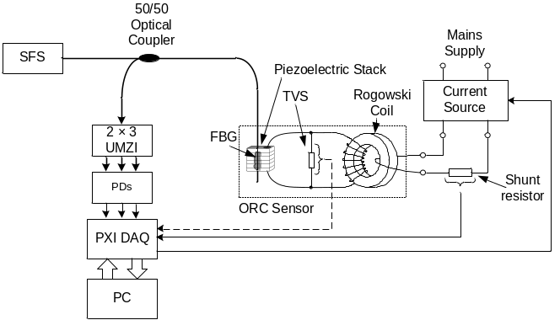

Figure 4: Circuit diagram for the ORC calibration and testing procedure.

To characterise the low voltage sensor an ac voltage source was used to supply voltage across the piezoelectric transducer with an FBG attached to its surface. The voltage characterisation was performed on the sensor in approximately 1 V steps up to 5 V rms, which was the limitation due to the maximum voltage range of the data acquisition card. The data acquisition rate was set to 10 kS/s. A dedicated program created in LabVIEW was used to process the raw sensor response in the form of instantaneous FBG wavelengths and the acquired reference voltage waveforms. The number of samples acquired by the PXIe card was set to 1000 ensuring that 5 periods of 50-Hz waveforms could be buffered and recorded.

To characterise the Rogowski coil, an ac current source (APTS3 power amplifier, Relay Engineering Services Ltd.) was used to supply primary current to the coil. The voltage sensor was connected to the coil output as a burden. During the coil characterisation, the current waveforms were obtained from voltage waveforms generated using the PXIe unit and amplified by the amplifier with a gain of 5 A/V. To monitor primary current and to allow for comparison of the input and output signals of the coil, a shunt resistor was connected to the primary circuit and the voltage across this was used as the reference signal. The resistor was an oil-filled 0.1 Ω resistance standard with a maximum allowed current of 22 A. Due to the shunt resistor current limit, the maximum primary current of 20 A could be used. To allow the coil to measure currents up to 1 kA, 50 turns of primary conductor was wound around the coil cross-section and along its circumference. The coil input and output signals were then acquired by the PXIe unit. The data acquisition and generation rates were set to 100 kS/s.

To complement the characterisation of the piezoelectric transducer and the Rogowski coil with the piezoelectric burden, the combined optically-interrogated Rogowski coil (ORC) was calibrated and tested for primary currents up to 1 kA. The sensor performance in terms of amplitude and phase errors at a fundamental frequency of 50 Hz was compared with the requirements for protection classes [10].

3.2 Amplitude and phase errors
The amplitude error was calculated according to the following equation: ε(%) = 100⋅(I_{p} – I_{rec})/I_{p}, where I_{p} is the rms value of primary current and I_{rec} is the rms value of reconstructed current. The reconstructed signals were obtained by integrating the acquired output signals in LabVIEW using Simpson’s rule.

The phase error was calculated as the difference in phase between the primary current phasor and the secondary output (reconstructed current) phasor, ϕ = ϕ_{p} – ϕ_{s}, where ϕ_{p} and ϕ_{s} are respectively the primary and secondary phase displacements. The phase displacements were estimated using LabVIEW’s Amplitude and Phase Spectrum. The algorithm employs the discrete Fourier transform to obtain the single-sided amplitude spectrum and to find the maximum magnitudes of the input signals. The phase difference was then calculated at the frequencies corresponding to the maximum magnitudes and converted from radians to degrees using the following equation: ϕ(°) = ϕ(rad)⋅180/π.

3.3 Sensor characterisation
The measurement data recorded during experiments was analysed using a dedicated LabVIEW program that plotted the recorded waveforms against each other and calculated the phase displacement (error) between the signals.

Hysteretic behaviour of the low voltage sensor can be clearly seen in Figure 5 where the ac FBG peak wavelengths are plotted against the ac voltages applied to the stack. The width of hysteresis increases with voltage magnitude, contributing to the phase displacement between the input and output signals. Phase errors (displacements) as a function of applied voltages at room temperature are shown in Figure 6. The phase displacement increases almost linearly with an increase in the voltage magnitude. The sensitivity of the phase displacement to voltage estimated from the data presented in Figure 6 is approximately 0.5°/V.

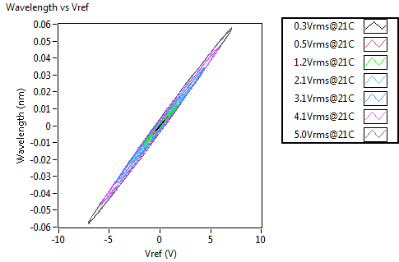
Figure 5: Low voltage sensor input-output characteristic for a range of voltages applied at room temperature.

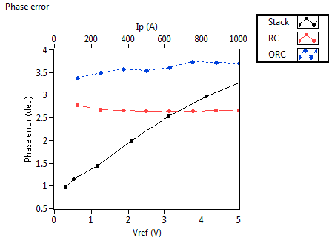
Figure 6: Phase errors of the piezoelectric stack, RC and ORC components for different input signal levels at room temperature.

Due to the high capacitance of the stack (3.1 μF), the piezoelectric burden contributes to the phase displacement between the input and output signals of the Rogowski coil. As shown in Figure 6, the phase error of the coil is around 2.6° at a primary current of 1 kA. The phase displacement between the primary current and optical signal of the ORC is a combination of the two mentioned errors and the resulting total error is approximately 3.6° at a primary current of 1 kA. The sensitivities of the phase error to current are around 0.2°/kA and 0.3°/kA for the Rogowski coil and the ORC device, respectively. The maximum primary current that can be measured by the ORC device considered in this study is 20 kA producing approximately 20 V on the stack, and resulting in a phase displacement of approximately 11° between the optical and voltage phasors at room temperature for the low voltage sensor. As the capacitance of the piezoelectric stack increases with voltage magnitude [6], larger phase errors can be expected when the ORC is driven at the maximum primary current. Therefore, for the sensor to comply with the protection classes requirements concerning phase errors, the hysteresis effect in the stack must be compensated by employing one of the known techniques [11-13].

3.4 Sensor calibration and hysteresis compensation
The sensor calibration with hysteresis compensation was realised based on the method proposed in [13]. The technique uses an aggregate 3D arrangement of the captured hysteresis loops and applies a surface fitting algorithm based on the Levenberg-Marquardt method to create 3D lookup functions, which are then used to derive the instantaneous values of the measured current.

The wavelength and reference primary current waveforms together with the rms values of the optical signals plotted in a 3D space are shown in Figure 7. The separation of the hysteresis loops and surface fitting procedure was realised in a dedicated LabVIEW program. To prepare data for the fitting procedure and to ensure better fitting results, waveforms from 50 periods of the reference and optical signals were captured and stored in a data file. The waveforms were then averaged so that every point of the final trace was an average of 50 points for each primary current level. The resulting hysteresis loops were divided into top and bottom parts to allow the fitting process to be applied. A fourth-order polynomial was fitted in the loops to create top and bottom surfaces as shown in the figure, and the polynomial coefficients were estimated by the Levenberg-Marquardt algorithm [13].
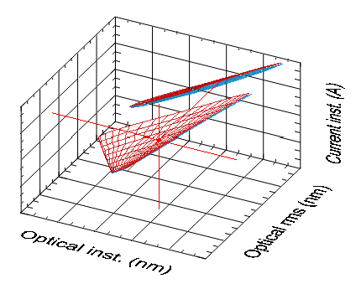
Figure 7: Illustration of the signal recovery method.

Following the surface fitting process, the resultant polynomial equations for top and bottom surfaces were implemented in a LabVIEW program used for the ORC testing. The selection of the proper equation required implementation of another routine previously proposed in [13], in which the selection of the top and bottom surfaces is realised by tracing the optical signal and detecting the zero-crossing instants. The logical value 0 or 1 is assigned accordingly as the signal crosses zero from a negative to positive value or the reverse, and is used to select the top or bottom surface. Since the zero-crossing instants are shifted by a phase of π/2 versus the moments when the surface switching should occur, the switching signal requires to be shifted towards the future by π/2. Assuming that the voltage signal frequency is largely unchanged within ¼ of a period, a switching instant (switching control signal) may be predicted by means of shifting the data in the register into the future by the exact number of samples [13]. To synchronise the surface switching instants with the zero-crossing instants the data is shifted by ¼ of a period according to the equation: n_{π/2} = [S/4f], where S is the data acquisition sampling rate, f is the fundamental frequency of the measured current, and the brackets [] denote rounding to the nearest integer value.

It should be noted that at very low signal levels, where noise constitutes a significant proportion of the optical signal, this method may operate erroneously. Therefore, a cut-off point corresponding to an experimentally evaluated input voltage level must be used below which the method is switched off.

3.5 Calibrated sensor response at 50 Hz
After implementing the hysteresis compensation procedure described above, the measurements were repeated for primary current range of 1 kA in approximately 125 A steps, and the waveforms of the reference primary and reconstructed current were captured and stored in a data file. The measurements were recorded at a sampling rate of 100 kS/s. The number of samples acquired by the PXIe card was set to 10,000 so that 5 periods of 50-Hz waveforms could be buffered and recorded in a data file. A dedicated LabVIEW program was used to calculate amplitude and phase errors as previously.

Figure 8 shows the reconstructed and primary current waveforms plotted against each other. Clearly, the hysteresis effect has been compensated and the relationship between the signals is linear.

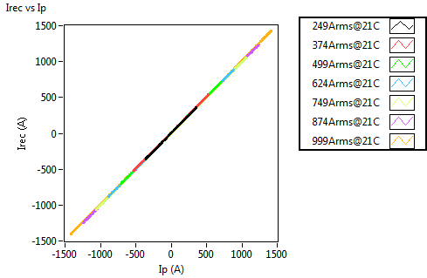
Figure 8: Recovered optical output versus measured primary current at room temperature.

The amplitude and phase errors for the ORC device within the measured current range of 1 kA at room temperature are shown in Figure 9. The scales on the y axes are set to the maximum permissible amplitude and phase error values at rated primary current for 5P protection class. For the rated primary current of 1 kA, these errors are below 0.1 % and 0.1°, respectively.

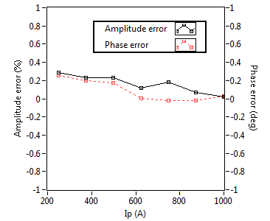
Figure 9: Amplitude and phase errors for the ORC sensor for different primary currents at room temperature.

It should be noted that due to the lack of an appropriate current source capable of generating 20 kA ac current, it was not possible to estimate the composite error at rated accuracy limit primary current. These tests will be carried out as part of future work.

4 Conclusions
In this paper we have reported on recent investigations into the performance of an optically-interrogated Rogowski coil (ORC) to confirm compliance with the accuracy requirements for protection classes set out by the IEC 60044-8 standard. In the proposed approach, a low-voltage sensor employing a fibre Bragg grating attached to a piezoelectric transducer has been utilised to monitor passively the output of a commercially available Rogowski coil. Due to the low voltage levels generated at the output of the coil, a high-resolution interrogation system based on a Mach-Zehnder interferometer has been used for the FBG peak wavelength tracking. Preliminary evaluation of the device shows that the amplitude and phase errors at a rated current of 1 kA and at rated frequency are around 0.1 % and 0.1° respectively. Based on the experimental results it can be concluded that the proposed approach of Rogowski coils monitored optically has the potential to ensure conformance with the 5P protection and 0.5 standard classes specified by IEC 60044-8.

Future work will concentrate on investigation into sensor performance at higher harmonics and at the operating temperature ranges specified by the IEC 60044-8 standard. Relevant tests for the composite error estimation will be carried out once an appropriate current source capable of generating 20 kA is available.

Acknowledgements
The authors acknowledge the funding and collaboration of Toshiba International (Europe) and Toshiba Corporation.

References
- P. Orr, P. Niewczas, C. Booth, G. Fusiek, A. Dyśko, F. Kawano, T. Nishida, P. Beaumont, “An Optically-Interrogated Rogowski Coil for Passive, Multiplexable Current Measurement”, IEEE Sensors Journal letters, Vol. 13, No 6, June 2013
- P. Orr, C. Booth, G. Fusiek, P. Niewczas, A. Dysko, F. Kawano, P. Beaumont, "Distributed photonic instrumentation for smart grids," Applied Measurements for Power Systems (AMPS), 2013 IEEE International Workshop on , vol., no., pp.63,67, 25-27 Sept. 2013
- P. Orr, G. Fusiek, C.D. Booth, P. Niewczas, A. Dysko, F. Kawano, P. Beaumont, T. Nishida, "Flexible protection architectures using distributed optical sensors," Developments in Power Systems Protection, 2012. DPSP 2012. 11th International Conference on , vol., no., pp.1,6, 23-26 April 2012
- “IEEE Guide for the Application of Rogowski Coils Used for Protective Relaying Purposes,” IEEE Std. C37.235-2007, Feb 2008
- “Practical Aspects of Rogowski Coil Applications to Relaying,” IEEE PSRC Special Report, IEEE Power Engineering Society, Sep 2010
- Physik Instrumente Ltd. website: http://www.physikinstrumente.com/en/products/prspecs.php?sortnr=100810 (Accessed 19/12/2013)
- M. D. Todd et al, “A novel Bragg grating sensor interrogation system utilizing a scanning filter, a Mach-Zehnder interferometer and a 3×3 coupler”, Meas. Sci. Technol. 12 771 2001
- M. D. Todd, M. Seaver, and F. Bucholtz, “Improved, operationally-passive interferometric demodulation method using 3×3 coupler,” Electronics Letters 38(15):784–786 (2002)
- P. Orr and P. Niewczas, “High-Speed, Solid State, Interferometric Interrogator and Multiplexer for Fiber Bragg Grating Sensors,” IEEE/OSA Journal of Lightwave Technology 29(22):3387–3392, Nov 2011
- IEC, “Instrument transformers – Part 8: Electronic current transformers,” First Edition (2002)
- G. Fusiek, P. Niewczas, L. Dziuda, J. R. McDonald, “Hysteresis Compensation for a Piezoelectric Fibre-Optic Voltage Sensor”, Optical Engineering, Vol. 44, No. 11, pp 114402-1-6, November 2005
- L. Dziuda, P. Niewczas, G. Fusiek, G. M. Burt, J. R. McDonald, “Laboratory evaluation of the hybrid fiber-optic current sensor,” Sensors and Actuators A: Physical, 136:184–190, December 2007
- G. Fusiek, P. Niewczas, J.R. McDonald, “Improved Method of Hysteresis Compensation for a Piezoelectric Fiber-Optic Voltage Sensor”, Optical Engineering, Vol. 46, Issue 3, pp. 034401-1-8, March 2007

