Fast demand response in support of the active distribution network

Pamela MacDougall, Peter Heskes Paul Crolla, Graeme Burt Cor Warmer
TNO, NL University of Strathclyde, UK Warmer Smart Grids, NL
Pamela.Macdougall@tno.nl p.crolla@strath.ac.uk warmer@smartinpower.nl

ABSTRACT
Demand side management has traditionally been investigated for “normal” operation services such as balancing and congestion management. However they potentially could be utilized for Distributed Network Operator (DNO) services. This paper investigates and validates the use of a supply and demand response technology for secondary services, namely, frequency control.

introduction

The large scale control of demand, distributed generation and electricity storage will be crucial for power systems management in the future. A proven technology, the PowerMatcher, integrates demand and supply flexibility in the operation of the electricity system through the use of dynamic pricing. Recent field experiments and simulation studies show the potential of the technology for network operations (e.g. congestion management and black-start support), for market operations (e.g. virtual power plant operations), and integration of large-scale wind power [2].

The next logical step for agent based supply and demand response is to contribute to frequency control. Frequency control can be aided by utilizing the flexibility of distributed energy resources (DERs) in response to frequency deviations, provided this control is exercised in a timely fashion. Experimentation in the European project SmartHouse/SmartGrid has shown that devices using the PowerMatcher technology can respond in the order of a minute – and are thus fast enough to be able to contribute to secondary frequency control[1]. In this paper we investigate in a lab setting, simulating, a real world system event in which the disconnection of two large generators caused a frequency drop, whether PowerMatcher based demand response is able to react adequately to this event.

Distributed Coordination of Supply & Demand
The intelligent distributed coordination technology called
PowerMatcher, is a multi-agent based system that uses electronic exchange markets to coordinate a cluster of devices that produce or consume electricity. A multi-agent
system is a structured framework for implementing complex, distributed, scalable and open ICT systems in which multiple software agents are interacting in order to reach a system goal.

Such a software agent is a self-contained software program
that acts as representative of something or someone (in this
case a device or an energy demand from the user). The
different PowerMatcher agents and their interactions are shown in figure 1.

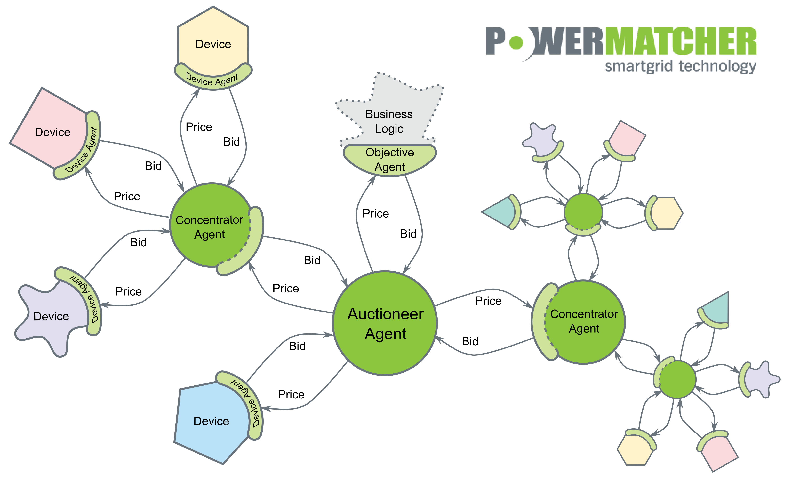
Figure 1: Schematic overview of the PowerMatcher concept.

Every device in a cluster is represented by a device
agent, a piece of software that looks after the interests of that device. Such agents attempt to operate its associated processes in an economically optimal way, whereby no central optimization algorithm is necessary. An electronic market (the auctioneer) in the multi-agent system allows the agents to trade resources, i.e. electricity, that are necessary for the agent to carry out its task. The only information that is exchanged between the agents and the auctioneer are bids. These bids express to what degree an agent is willing to pay or be paid for a certain amount of electricity. Bids can thus be seen as the priority or willingness of a device to turn itself on or off.

Bids are sent at irregular (event-based) intervals, i.e. only if
the local state changes, resulting in a new agent bid. This
keeps the communication between PowerMatcher entities to
a minimum. The auctioneer collects the bids and calculates
the market clearing price. This is the price at which the sum
of all bids is zero, such that there is no net consumption or
production. The market clearing price is communicated back to the device agents, which react appropriately by either starting to produce or consume electricity, or wait until the market price or device priority (state) changes.

Distribution Network and Protection laboratory (D-NAP)
The University of Strathclyde’s experimental facility "Distribution Network and Protection Laboratory", D-NAP comprises a 100kVA micro-grid that can operate grid connected or variously islanded, integrated with a real-time digital network simulator and protection injection laboratory. The facility offers hardware-in-the-loop capability, and incorporates induction machines, programmable load banks and various 1/3 - phase inverters. The network and components are controlled by a custom built control software system running on a pair of Real-Time Stations from ADI. The underlying software was constructed in MATLAB Simulink [3], [4].

UK Power/Frequency Model

The model of the UK’s power system is based on aggregating each type of generation into one synchronous machine with the per unit inertia and droop curve response of each generator type. The model requires the following inputs; for each generator, per-unit inertia (H), maximum real power capacity (MW), real power set-point (MW), initial state (on/off), droop, on/off times and under/over frequency off setting (Hz); as well as the nominal system frequency. The model then calculates the total system inertia (J, kg m2), the total energy in the rotating masses (Joules), the rate of change of frequency (ROCOF, Hz s-1), and the new system frequency. This new frequency is used to set the frequency of the generator. This then continues ad infinitum or until the process is stopped.

The simulated system event was the one which took place on the 26th May 2008 where two large thermal generators disconnected from the National Grid and then some small generators disconnected due to the frequency drop. The total generation lost was almost 2GW in approximately 3 minutes. The use of fast acting demand management could have prevented the system dropping below 48.8Hz and allowed the system more time to recover the frequency to 50 Hz.

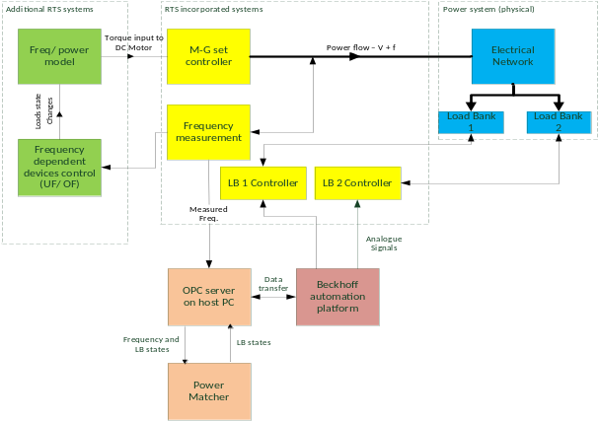
Figure 2: Links between the different controllers and hardware for the RT-PHIL demonstration of PowerMatcher. Blue means physical network infrastructure, Yellow is the main original controllers in the RTS system, Green boxes are additional controllers developed

Objective
The aim of the work is to investigate the PowerMatchers’ potential to contribute to frequency control of the power system. Specifically, focusing on the case of an event to avoid cascading tripping of generators in the first place and contribute to the restoration of the frequency towards 50Hz in the second place. To be able to see the effect, laboratory simulation of such an event, that incorporates the risk of running towards a black-out, need to be done with and without the PM control.

Experiment Setup
Under the European DERri project and using the University of Strathclyde’s Distribution Network and Protection laboratory (D-NAP), an experiment investigated the impact of the agent-based demand supply coordination (the PowerMatcher) in more critical scenarios. This work was based upon a real-world event which saw successive generator tripping and sympathetic loss of distributed generation in response to the subsequent large frequency drop. The experiment setup can be seen below.

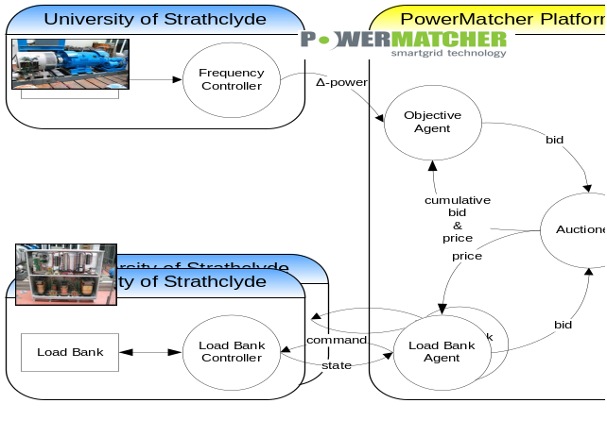
Figure 3: D-Nap Experiment Setup

The integration of the PowerMatcher software within the laboratory to demonstrate response to a simulated real-world frequency trace was achieved through a number of steps. First, a frequency/ power model of the UK grid was created in MATLAB Simulink; this model gives a first order frequency response to changes in the generation to demand ratio. This was compiled using MATLAB Simulink Coder into real-time C code after integration with the laboratory control system.

The frequency output from the model was used to set the frequency of the DC motor and hence the islanded network frequency, the real frequency of the network is then used to set the reference frequency of the model thus setting up a closed loop to control the network frequency. With changing load/ generation ratios the frequency varies and this is used by a software algorithm to calculate the likely required change in load to maintain system frequency within operational limits.

This value of electrical power is sent to the PowerMatcher algorithm using an interface created in Python. PowerMatcher negotiates with the available loads as to which one will adjust its power requirements and this is transmitted to the load bank controllers via the Host PC, Beckhoff Automation platform’s analogue outputs and the analogue inputs of the Real-Time Station. The response is routed back to PowerMatcher via the Host PC and Python interface software. In this way the network frequency response to the ramping of the load banks can be observed and the usability of supply demand response in more critical scenarios can be evaluated.

Results
The Strathclyde micro-grid provided an environment in which frequency excursions could be enforced on a local power network, to which the PowerMatcher system responded by controlling load banks in the network. This tested the extent to which the PowerMatcher was able to avoid the sympathetic tripping of generators and contribute to the rapid restoration of the frequency. As a result it was demonstrated that the PowerMatcher can significantly assist in the support of frequency during such system disturbances and thus reduce the risk of subsequent black out.

Figure 4 below shows the Rate of Change of Frequency (ROCOF) starting at T=0, the moment frequency deviation tents to stabilize at T=35, a second generation loss is simulated and frequency drops down to 49.1Hz. In real practice a national Low Frequency Demand Disconnection (LFDD) scheme automatically disconnects demand to contain any incident and prevent a total or partial shutdown. However, suppose the PowerMatcher algorithm would support frequency control during this simulated event, i.e. the PowerMatcher would be able to shut down a part of the local loads via market-based control, what would be the result then? The answer is given in Figure 5 below. In this figure the event starts at T=25, because of manual activation during the experiments. About 30 seconds later, being the algorithm latency, the PowerMatcher is able to strongly affect the ROCOF. Although the frequency drop after the first generation lost is limited to 49,8Hz, the second generation loss was also simulated. The result however is that the frequency drops only down to 49.6Hz and restoration toward 50Hz takes place. This early experiment demonstrate the extent to which agent based demand response can aid in critical situations.

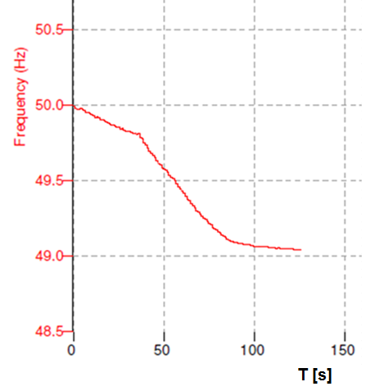
Figure 4: Freq. - Time response without PowerMatcher.

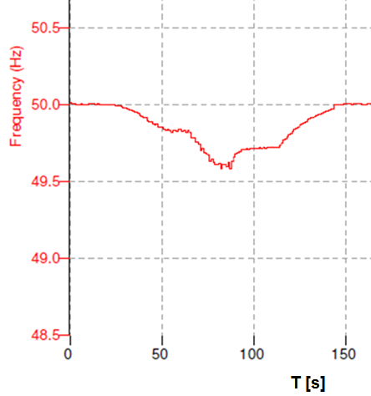
Figure 5: Freq. - Time (s) response with PowerMatcher.

Conclusions & Future Work
This early experiment demonstrates the extent to which agent based demand response can aid in critical situations. The PowerMatcher algorithm is beside market-based also event-based and responds on actual Power levels, therefore the system latency depends on only communication. In this work a communication latency of about 30s was simulated. If this performance could be incorporated in real practice and large numbers of loads and DERs offer their flexibility to the system, the role of the national Low Frequency Demand Disconnection (LFDD) scheme, that automatically disconnects demand to prevent a total or partial shutdown, could be less essential.

The value of such systems can only be fully captured when operational and planning decisions takers are convinced of the reliable provision of such power system services. The paper will therefore conclude with a consideration of the ongoing field trial and laboratory work that is providing evidence of the capabilities of this scheme to support frequency and provide other system services such as black start.

Attention to this work has already been paid by UK DNOs. Next steps therefore will be a project to demonstrate and experimentally validate PowerMatcher applications for Demand Side Management (DSM) in selected use cases for a DNO. This must be done from both a technical and a commercial perspective to understand the implications to prepare for a large-scale demonstration. This will be done by computer modeling and simulations on a dynamic and flexible laboratory-scaled micro grid, as well as at the Power Network Demonstration Centre, a new research facility in Scotland for researching and developing state of the art electrical transmission, distribution and generation innovation. Further, confirming the findings with real demand side managed devices in a small field experiment would further prove the usability of demand side management for secondary services.

Acknowledgments

Thanks Paul Booij, the PowerMatcher and D-Nap team for all assistance in this work.

REFERENCES

[1] Hommelberg, M. P. F., C. J. Warmer, et al. (2007). Distributed Control Concepts using Multi-Agent technology and Automatic Markets: An indispensable feature of smart power grids. Power Engineering Society General Meeting, 2007. IEEE.

[2] J.K. Kok, B. Roossien, et al (2012). “Dynamic Pricing by Scalable Energy Management Systems- field Experiences and Simulation Results using PowerMatcher,” IEEE PES 2012 – IEEE PES Meeting, San Diago, CA, July 2012.

[3] Roscoe, A. J., A. Mackay, et al. (2010). "Architecture of a Network-in-the-Loop Environment for Characterizing AC Power-System Behavior." Industrial Electronics, IEEE Transactions on 57(4): 1245-1253.

[4] Steurer, M., F. Bogdan, et al. (2007). Controller and Power Hardware-In-Loop Methods for Accelerating Renewable Energy Integration. Power Engineering Society General Meeting, 2007. IEEE.

