ARC PRESSURE AND WELD METAL FLUID FLOW WHILST USING ALTERNATING SHIELDING GASES – PART 1: ARC PRESSURE MEASUREMENT

S.W. Campbell¹, A.M. Galloway¹ and N.A. McPherson²

¹Department of Mechanical & Aerospace Engineering, University of Strathclyde, Glasgow
²BAE Systems Surface Ships Limited, 1048 Govan Road, Glasgow

Abstract
As part of an ongoing process to fully evaluate the effects of an alternating shielding gas supply on gas shielded welding processes, a comparison between the arc pressures generated using argon, helium, alternating shielding gases and pulsed GTAW has been conducted. Arc pressure variation and peaking are two of the fundamental phenomena produced during the alternating shielding gas process and are said to help create a stirring action within the liquid weld metal. However, there is no published data on arc pressure measurements during an alternating shielding gas supply and, consequently, these phenomena are based solely on theoretical assumptions. The experimental measurements made have shown that alternating shielding gases produces considerably higher arc pressures than argon, helium and pulsed GTAW due to a surge at weld initiation. The transient arc pressure measurements made when using alternating shielding gases are also considerably different from the theoretical assumptions previously reported.

List of Symbols
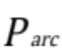 Arc pressure (stagnation pressure at anode) (N/m²),
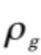 Density of the shielding gas (kg/m³)
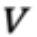 Velocity (m/s)
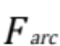 Arc force (N)
 Radius of arc (m)
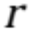 Distance in the radial direction (m)
Welding current (A)
Current density (A/m²)

Introduction
Due to their ability to produce high quality welds, gas tungsten arc welding (GTAW) and gas metal arc welding (GMAW) are essential fusion welding processes for a variety of industrial applications. The arc pressure produced as a result of the plasma impinging on the weld pool surface is one of the major contributing factors influencing the depth of penetration and the size and shape of the weld bead. A high welding current is desirable for increasing productivity, however, high welding currents increase the possibility of weld defects such as humping, undercutting, split bead, parallel humping and tunnel porosity [1]; the relationship between welding current and arc pressure will be discussed. Choi et al. [2] demonstrated that the arc pressure causes oscillations in the weld pool; and a higher arc pressure resulted in weld pool depression in the centre and a hump towards the outer portion. While Tsai and Kou [3] used computational modelling to individually simulate the effects of various driving forces, stating that the electromagnetic (or Lorentz) force caused a slight depression at the outer portion of the weld pool and a corresponding hump in the central portion.
A number of experimental and computational studies have been conducted [4-10], investigating how various parameters (including welding current, shielding gas composition and pressure, tungsten electrode tip geometry, arc length and nozzle outlet diameter) influence the peak pressure and the pressure distribution in the arc column.
It has been shown that the welding current has a significant effect on the maximum arc pressure recorded, with Lin and Eager [4] reporting a linear relationship between the maximum arc pressure and the welding current, which was in agreement with data they displayed for a study by Yamauchi and Taka. Studies [5-7] have shown that the current density increases approximately linearly with increasing current, whilst Fan and Shi [8] stated that the electromagnetic force is the driving force for fluid flow in the arc plasma and increases with increasing current density, thus the electromagnetic force will increase with increasing arc pressure.
A number of studies have been conducted to investigate the effect of the tungsten electrode geometry [4,6,8], predominantly looking at the effects of the vertex angle. Data has been presented for vertex angles of 30-120°; a narrower vertex angle increasing the peak pressure, with Fan and Shi [8] showing a peak pressure of approximately 1150 Pa for a 60° vertex angle and approximately 200 Pa for a 120° vertex angle, both for a 200 A welding current. Fan et al. [9] investigated the effect of varying the size a flat surface (truncation diameter) at the electrode tip, showing that the smaller the truncation diameter, the higher the arc pressure.
The shielding gas composition is known to have a substantial effect on the arc pressure, argon producing a considerably higher maximum pressure than helium [4,7]. Lin and Eager [4] found that the arc length has a negligible effect on the peak arc pressure when using argon as a shielding gas, however when using helium, as the arc length increased, the peak pressure decreased linearly. This was attributed to the lower density and higher viscosity of helium at high temperatures when compared to argon. Whilst Oh et al. [7] reported that a shielding gas mixture Ar/33%He reduced the maximum pressure by a factor of approximately three when compared to a pure argon shielding gas for a 5 mm arc length.
Ham et al. [10] reported on the effects that the shielding gas pressure and nozzle diameter have on the arc shape, arc pressure and gas pressure measurements. It was determined that a higher shielding gas pressure or narrower nozzle diameter decreased the diameter of the arc due to a thermal pinch effect. They also concluded that the shielding gas pressure did not have an effect on the arc pressure measurement but did influence the gas stagnation pressure.
A relatively novel method of alternately supplying shielding gases to the welding region to take advantage of the beneficial properties of each gas has been investigated [11-16]. The alternating shielding gas process has been reported to produce benefits including an increase in the permitted travel speed whilst maintaining weld geometry [13-16], a reduction in weld porosity [11-14], and improved mechanical properties [13,14]. In addition to the direct benefits of implementing alternating shielding gases, there are other associated advantages. For example, as a result of the faster travel speed permitted, an overall production saving of approximately 20% was achieved [13], in addition to a reduction in weld induced distortion due to the reduction in heat input [13-15]. The process benefits achieved thus far are based upon three independent phenomena [11]: a) variation in weld pool fluidity, b) arc pressure variation, and c) arc pressure peaking.
Although studies have reported [4-10] on the arc pressures produced when using argon, and to a limited extent for helium and argon-helium mixtures, no data has been published for the pressure produced during the alternating shielding gas process. As a result, the objective of this study was to determine the transient arc pressure variation whilst using this novel method of shielding gas delivery, and to compare this to pressures produced for conventional argon and helium shielding gases, and the previous assumptions for the alternating shielding gas arc pressure. In addition, a comparison of arc pressures produced during the alternating shielding gas process and those produced for pulsed GTAW (GTAW-P) has been presented.

Experimental Setup
A schematic diagram of the experimental set up is shown in Figure 1. A 200 x 150 x 6 mm thick water-cooled copper plate was used as the anode, this thickness was based upon work by Lin and Eager [4] who stated that a thicker plate produced too shallow an axial temperature gradient whilst thinner plate did not provide the same level of radial heat dissipation. The experimental setup is shown in Figure 2.
Two shielding gas supplies were used throughout the trials, argon and helium, controlled using a dedicated electronic control unit. The basis of the unit being two 555 timing circuits, the output from which controlled a solenoid valve on each supply line. When set in ‘astable’ mode, the circuits produce a continuous square wave at a given frequency, the accuracy of which is monitored using an oscilloscope. A shielding gas flow rate of 10 l/min was used throughout and was set when each gas was flowing continuously. This meant that when using alternating gases, due to the 50% duty cycle, the flow rate would also be 10 l/min. An alternating frequency of 2 Hz was used throughout the arc pressure measurements.
A 2.4 mm diameter, 2% thoriated tungsten electrode was used throughout, with a 45° vertex angle and 2 mm arc length. All trials were performed using DC electrode negative (DCEN) with a welding current of 200A. GTAW-P trials were performed with a peak and background current of 200 and 100 A respectively, set at a frequency of 2 Hz and a duty cycle of 50% as this best represented the alternating shielding gas method.
As shown in Figure 1 and 2, a 1 mm diameter hole, as used in previous studies [4,7,10], was drilled through the centre of a copper plate, beneath which a piezoelectric pressure sensor was mounted to detect the arc pressure in the form of a voltage difference. The voltage obtained from the piezoelectric pressure sensor was then converted to a real-time pressure reading using LabVIEW.
The arc pressure was recorded every 20 ms with steady-state values reported once the arc had stabilised, i.e. after the initial surge of pressure at weld initiation. Measurements were taken at the centre of the 1 mm diameter hole, and in 0.5 mm intervals until 6 mm in the radial direction by incremental step changes to the torch location, with the measurements being sequentially repeated three times allowing the maximum steady-state pressure to be recorded. Whilst the arc pressures recorded were within approximately 5% of the reported values, the maximum value has been selected rather than the average of the three measurements, as any misalignment with respect to the 1 mm hole would result in a difference in the pressure measured thus ensuring that the error was minimised.

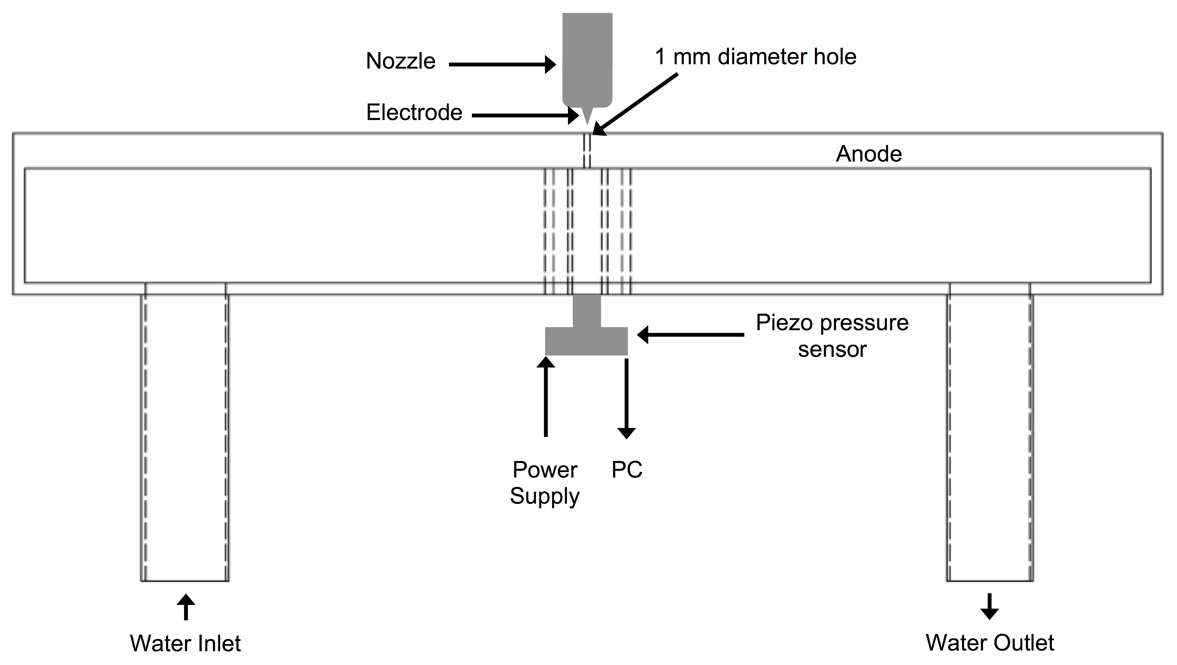
Figure 1: Schematic diagram of experimental setup
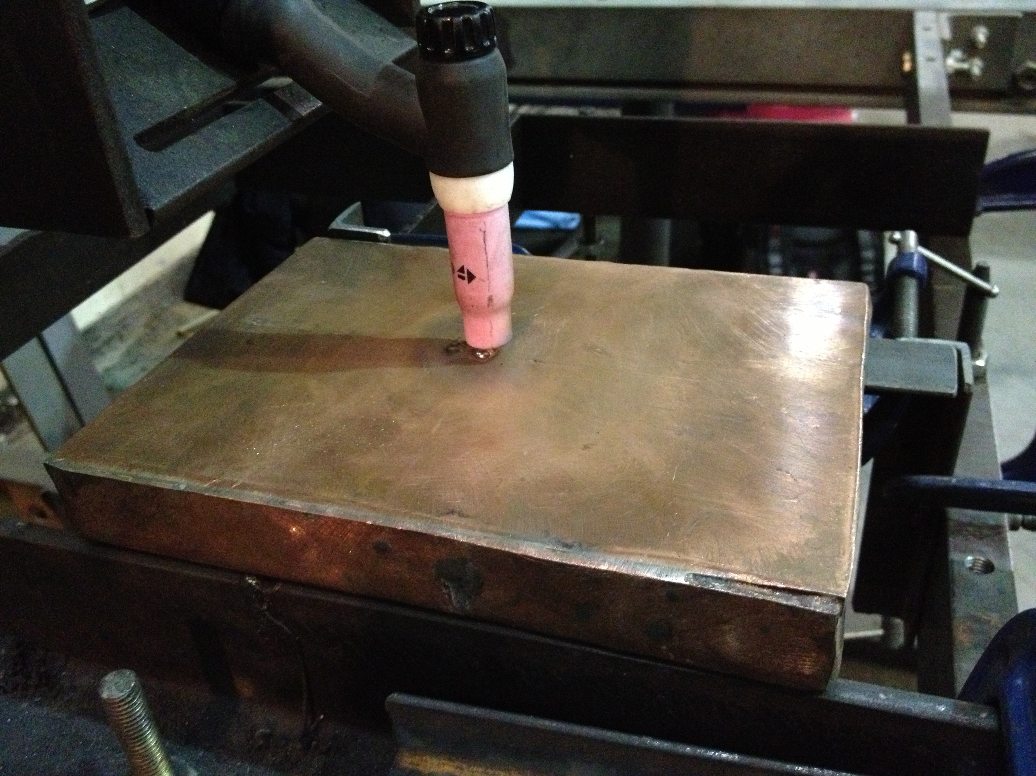
Figure 2: Experimental setup

Results and Discussion
Figure 3 shows the radial pressure distribution with respect to the arc centreline for argon and helium shielding gases. The peak pressure at the arc centreline (~1900 N/m²) and the pressure distribution for argon are, accounting for variables such as current and vertex angle, in line with previous publications [4,7-10]. This was also considerably higher than the peak steady-state arc pressure at the arc centreline for helium (~800 N/m²). Whilst other research groups [4-10] do not stipulate what their peak pressure is referring to, it can be assumed, based on their experimental setup (generally a u-tube manometer) and computational methods, that the pressure recorded is for steady-state, i.e. after the initial surge (discussed later) due to the time taken for pressure equalisation.
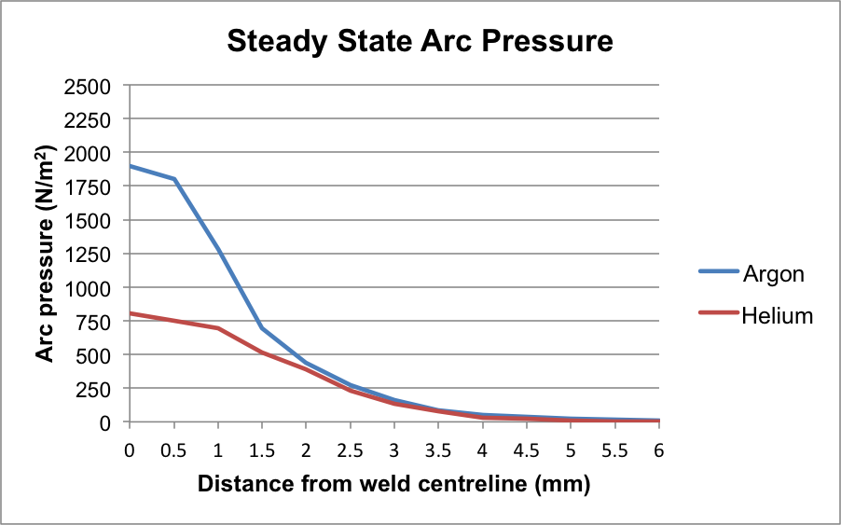
Figure 3: Steady-state arc pressure measurements
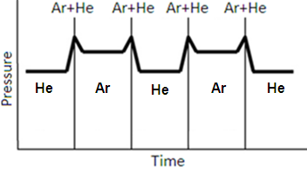
Figure 4: Theoretical arc pressure vs. time [12]
Kang [12] presented Figure 4, which shows the theoretical arc pressure when alternating between argon and helium based upon the steady-state pressure produced by argon and helium. It was based on an alternating shielding gas system that incorporated a slider valve that meant there was a period of time when both argon and helium were present and combined with an assumption that a pressure impulse would occur at this time due to a build up in line pressure was presented (indicated by a series of “spikes” on the graph).
Figure 5 shows the transient measurement of arc pressure at the arc centreline when using alternating shielding gases, delivered at an alternating frequency of 2 Hz. The maximum (~2410 N/m²) and minimum (~1010 N/m²) arc pressures for alternating shielding gases are substantially greater than the maximum steady-state pressure obtained for argon and helium respectively at the corresponding arc centreline location shown in Figure 3. It can be observed when comparing Figures 4 and 5 that there is a considerable difference between the previously reported theoretical arc pressure (Figure 4) to that generated through experimental transient pressure measurements (Figure 5) and can be explained due to a pressure impulse at arc initiation. Figure 6 shows a transient pressure measurement at weld initiation at the arc centreline for argon and helium. As can be seen there is a significant (~25%) pressure surge at weld initiation that corresponds to the pressures measured during alternating shielding gases. It can also be observed that the time taken for the arc pressure to reach steady-state is approximately 3-5 seconds. However, when using alternating shielding gases at 2 Hz, each gas is only supplied for 0.25 seconds before changing to the other gas, thus the entire time either gas is supplied is within the arc initiation pressure impulse. The addition of helium to an argon-based mixture has been shown to considerably reduce the resulting arc pressure [7], thus the non-deliberate intermixing of argon and helium between the welding unit and welding torch resulted in a ‘smoothing’ of the peak pressures. This, coupled with the information that the shielding gas pressure has a negligible effect on the arc pressure [10], shows that the theoretical peaks shown in Figure 4 when alternating between gases do not exist.
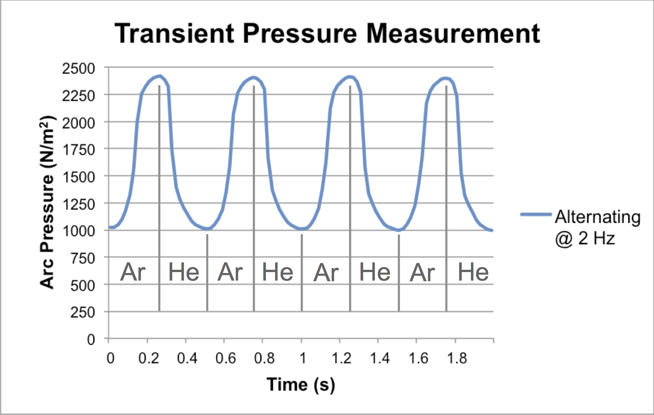
Figure 5: Transient arc pressure measurement of alternating shielding gases
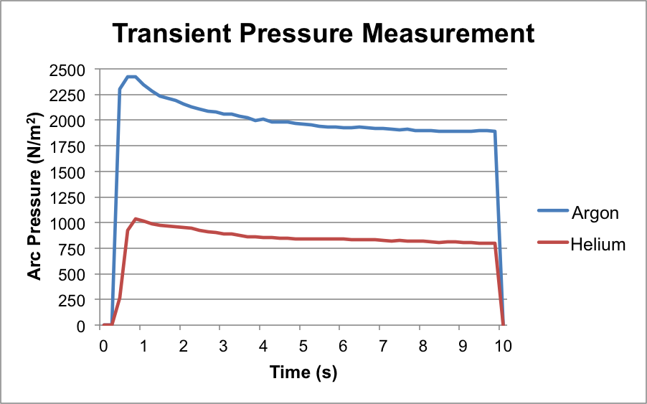
Figure 6: Transient arc pressure measurement at weld initiation
The comparison of arc pressure measurements at the arc centreline for alternating shielding gases and GTAW-P are shown in Figure 7; a background current of 100 A was selected as this produced the best correlation to the steady-state helium pressure measurements.
As can be observed, the argon phase in alternating shielding gases produced a higher arc pressure than the peak current phase in the GTAW-P process, this can be attributed to the surge at weld initiation discussed previously. This surge is not present within the GTAW-P process, as an arc is not being re-established; the power source is simply changing the magnitude of the supply current. The arc pressure also has a more instantaneous decline to the background current phase than the equivalent drop in pressure in alternating shielding gases when helium is present. This is due to a degree of intermixing of shielding gases in the gas lines stated previously, whereas the change from peak to background current in GMAW-P is more sudden. While the arc pressure measurements conducted for alternating shielding gases and GTAW-P are similar in form, the difference in these processes necessitates in the forces acting on the liquid weld metal as discussed in Part 2.
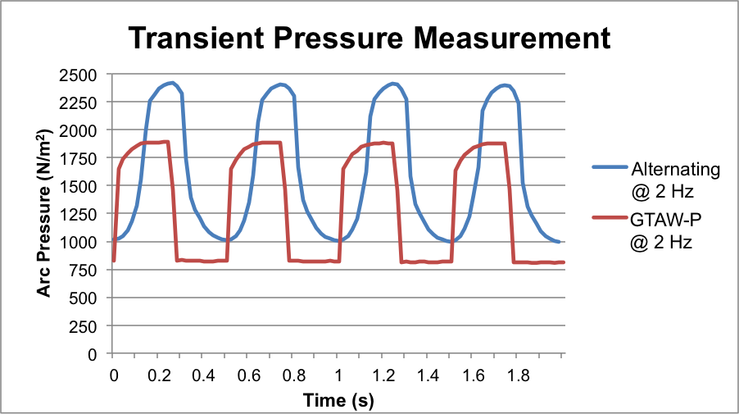
Figure 7: Comparison of transient arc pressure measurements during alternating shielding gases and GTAW-P
The arc pressure distribution allows for the derivation of the current density distribution. Since the arc pressure measurement is essentially the stagnation pressure of the plasma jet arrested at the anode plate surface, the velocity of the plasma jet can be determined using Bernoulli’s theorem, equation (1).
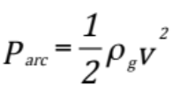 (1)
The arc force can be determined by integrating the arc pressure distribution [10]:
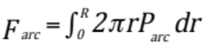 (2)
Fan et al. [9] stated that the welding current can also be calculated by the same method, i.e. integrating the current density distribution:
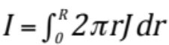 (3)
The current density distribution can therefore also be calculated using equation (4), derived by combining equations (2) and (3). As can be seen, the current density is dependant not only on welding current and arc pressure but also on the arc force, which has been determined by the numerical integration of the arc pressure, equation (2).
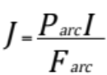 (4)
The current density distributions for argon and helium based upon their respective steady-state arc pressure measurements are shown in Figure 8. As can be seen, argon produces a high current density at the arc centreline (~21 A/mm²), which quickly drops in the radial direction, while helium produces a lower peak current density at the arc centreline (~14 A/mm²), but produces a higher current density than argon as the radial distance increases.

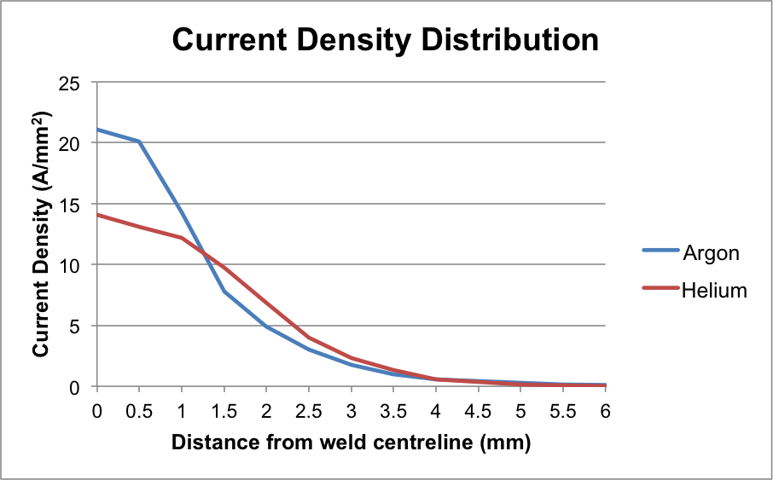
Figure 8: Current density distribution
Figure 9 shows the profile of the arc column, with the alternating shielding gas fluctuating between the argon and helium arc profiles, and allowed the effective diameter of the arc to be determined, i.e. the diameter of the arc in contact with the plate surface. A diameter of 7.5 mm and 6.5 mm for argon and helium respectively was measured using image analysis software. The practical welding current can be compared to the derived current through numerical integration using equation (5) [7]:
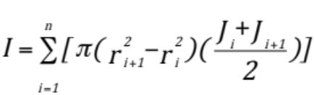 (5)
It was determined that the numerically derived current was within 1% of the practical welding current for both argon and helium.

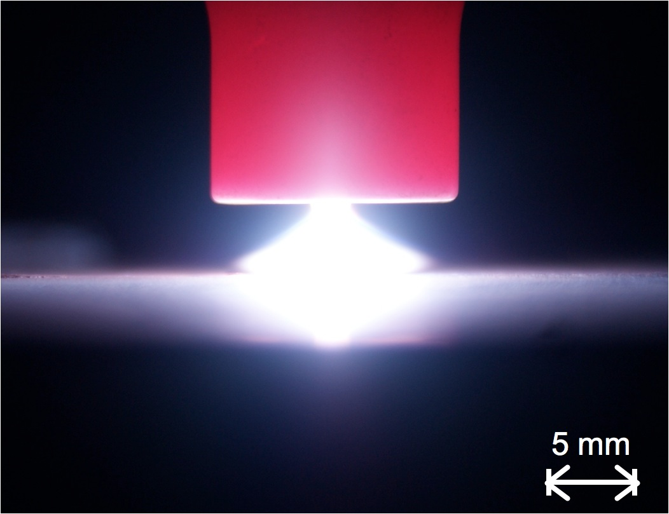(a) 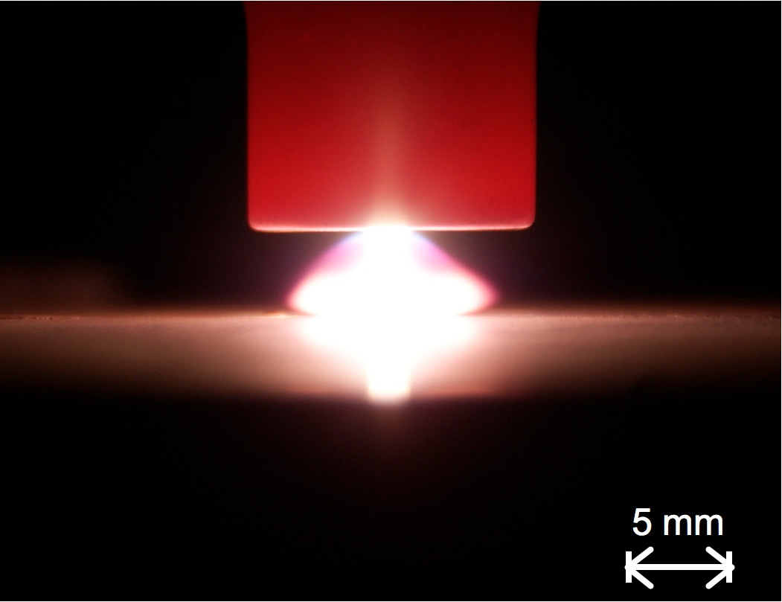(b)
Figure 9: Arc profile produced using (a) Argon, and (b) Helium
Conclusions
A piezoelectric pressure sensor has been implemented for the transient arc pressure measurement whilst using argon, helium, alternating shielding gases and GTAW-P. The conclusions may be summarised as follows:
- Arc pressure for argon is considerably more than that for helium.
- The arc pressure for alternating shielding gases at the arc centreline is substantially higher (~25%) than that of the steady-state pressure measurements for argon and helium, and has been attributed to a pressure impulse at arc initiation.
- The transient pressure measurement of alternating shielding gases has been shown to be considerably different to the previous theoretical assumptions:
  - Due to a pressure impulse at arc initiation, the arc pressure does not have enough time to stabilise and is constantly in this phase; hence there is no steady-state pressure.
  - There is no peak pressure “spikes” whilst alternating between gases; the addition of helium reduces the steady-state arc pressure, whilst the gas setting pressure has been reported to be negligible.
- The transient pressure measurement of GTAW-P has been shown to be similar in form to that produced during alternating shielding gases. However, the pressure measured during the ‘peak’ and ‘background’ current phases are lower (~25%) than the corresponding argon and helium phases respectively in the alternating shielding gas process.
- Argon produces a high core current density whilst helium has a broader distribution
- The numerically derived welding current was in good agreement with the practical welding current

Acknowledgements
The authors would like to acknowledge the funding provided by BAE Systems Surface Ships Limited, which has made this research possible.

References
- P.F. Mendez and T.W. Eagar: ‘Penetration and defect formation in high-current arc welding’, Welding Journal, 2003, 82(10), 296-306.
- S.H. Ko, S.K. Choi and C.D. Yoo: ‘Effects of surface depression on pool convection and geometry in stationary GTAW’, Welding Journal, 2001, 80(2), 39-45.
- M.C. Tsai and S. Kou: ‘Electromagnetic-force-induced convection in weld pools with a free surface’, Welding Journal, 1990, 69(6), 241-246.
- M. L. Lin and T.W. Eager: ‘Pressures produced by gas tungsten arcs’, Metallurgical Transactions B, 1986, 17B, 601-607.
- R.T.C. Choo, J. Szekely and R.C. Westhoff: ‘On the calculation of the free surface temperature of gas-tungsten-arc weld pools from first principles: part 1. modeling the welding arc’, Metallurgical Transactions B, 1992, 23B, 357-369.
- S.Y. Lee and S.J. Na: ‘Analysis of TIG welding using boundary-fitted coordinates’, Proceedings of the Institution of Mechanical Engineers, Part B: Journal of Engineering Manufacture, 1995, 209, 153-164.
- D.-S. Oh, Y.-S. Kim and S.-M. Cho: ‘Derivation of current density distribution by arc pressure measurement in GTA welding’ Science and Technology of Welding and Joining, 2005, 10(4), 442-446.
- H.G. Fan and Y.W. Shi: ‘Numerical simulation of the arc pressure in gas tungsten arc welding’, Journal of Materials Processing Technology, 1996, 61(1996), 302-308.
- D. Fan, M. Ushio and F. Matsuda: ‘Numerical computation of arc pressure distribution’, Transactions of JWRI, 1986, 15(1), 1-5.
- H.-S. Ham, D.-S. Oh and S.-M. Cho: ‘Measurement of arc pressure and shield gas pressure effect on surface of molten pool in TIG welding’, Science and Technology of Welding and Joining, 2012, 17(7), 594-600.
- Y.H. Chang: ‘Improve GMAW and GTAW with alternating shielding gases’, Welding Journal, 2006, 85(2), 41-43.
- B.Y. Kang, Y.K.D.V. Prasad, M.J., Kang, K.J., Kim and I.S. Kim: ‘Characteristics of alternate supply of shielding gases in aluminium GMA welding’, Journal of Materials Processing Technology, 2009, 209(2009), 4716-4721.
- S.W. Campbell, A.M., Galloway and N.A. McPherson: ‘Techno-economic evaluation on the effects of alternating shielding gases for advanced joining processes’, Proceedings of the Institution of Mechanical Engineers, Part B: Journal of Engineering Manufacture, 2011, 225(10), 1863-1872.
- S.W. Campbell, A.M. Galloway and N.A. McPherson: ‘Evaluation of gas metal arc welding with alternating shielding gases for use on AA6082T6’, Proceedings of the Institution of Mechanical Engineers, Part B: Journal of Engineering Manufacture, 2012, 226(6), 992-1000.
- B.Y. Kang, Y.K.D.V. Prasad, M.J., Kang, K.J. Kim and I.S. Kim: ‘The effect of alternate supply of shielding gases in austenite stainless steel GTA welding’, Journal of Materials Processing Technology, 2009, 209(2009), 4722-4727.
- S.W. Campbell, A.M., Galloway and N.A. McPherson: ‘Artificial neural network prediction of weld geometry performed using GMAW with alternating shielding gases’, Welding Journal, 2012, 91(6), 174-181.

