effect of offset web holes on web crippling strength of cold-formed steel CHANNEL sections under END-TWO-FLANGE LOADING condition
Asraf Uzzamanª, James B.P Lim^{b}, David Nashª, Jim Rhodesª, Ben Young^{c}
a Department of Mechanical and Aerospace Engineering, The University of Strathclyde, 75 Montrose Street, Glasgow G1 1XJ
b SPACE, David Keir Building, Queen’s University, Belfast, BT9 5AG, UK
c Department of Civil Engineering, The University of Hong Kong, Pokfulam Road, Hong Kong

Abstract
A combination of experiments and non-linear finite element analyses are used to investigate the effect of offset web holes on the web crippling strength of cold-formed steel channel sections under the end-two-flange (ETF) loading condition; the cases of both flanges fastened and unfastened to the support are considered. The web holes are located at the mid-depth of the sections, with a horizontal clear distance of the web holes to the near edge of the bearing plate. Finite element analysis results are compared against the laboratory test results; good agreement was obtained in terms of both strength and failure modes. A parametric study was then undertaken to investigate both the effect of the position of holes in the web and the cross-section sizes on the web crippling strength of the channel sections. It was demonstrated that the main factors influencing the web crippling strength are the ratio of the hole depth to the depth of the web, and the ratio of the distance from the edge of the bearing to the flat depth of the web. Design recommendations in the form of web crippling strength reduction factors are proposed in this study.

Keywords
Cold-formed steel; Web crippling; Finite element analysis; Web hole; Channel section; Reduction factor; Design recommendations;

Nomenclature
A | Web holes ratio;
a | Diameter of circular web holes;
b_{f} | Overall flange width of section;
b_{l} | Overall lip width of section;
COV | Coefficient of variation;
DL | Dead load;
d | Overall web depth of section;
E | Young’s modulus of elasticity;
FEA | Finite element analysis;
F_{m} | Mean value of fabrication factor;
f_{y} | Material yield strength;
h | Depth of flat portion of web;
L | Length of specimen;
LL | Live load;
M_{m} | Mean value of material factor;
N | Length of bearing plate;
P | Experimental and finite element ultimate web crippling load per web;
P_{EXP} | Experimental ultimate web crippling load per web;
P_{FEA} | Web crippling strength per web predicted from finite element (FEA);
P_{m} | Mean value of tested-to-predicted load ratio;
R | Reduction factor;
R_{P} | Proposed reduction factor;
r_{i} | Inside corner radius of section;
t | Thickness of section;
V_{F} | Coefficient of variation of fabrication factor;
V_{M} | Coefficient of variation of material factor;
V_{P} | Coefficient of variation of tested-to-predicted load ratio;
x | Horizontal clear distance of web holes to near edge of bearing plate;
X | Web holes distance ratio;
β | Reliability index;
ε_{f} | Elongation (tensile strain) at fracture;
φ | Resistance factor;
σ_{0.2} | Static 0.2% proof stress; and
σ_{u} | Static ultimate tensile strength.

Introduction
Web crippling at points of concentrated load or reaction is well-known to be a significant problem, particularly in thin-walled beams (see Fig. 1). To improve the buildability of buildings composed of cold-formed steel channel sections, openings in the web are often required to allow ease of installation of electrical or plumbing services. For such sections with holes, web crippling needs to be taken into account.
The authors have previous described a combination of experiments and numerical analyses on cold-formed steel sections with circular web openings in which the web holes were located at the mid-depth of the webs and centred beneath the bearing plates; both interior-two flange (ITF) and end-two flange (ETF) loading conditions were considered (see Fig. 2 (a) and (b)). In addition, the authors have also previously considered ITF with the web hole offset from the center of the bearing plates (see Fig. 2 (c)). In all these studies, the cases of both flanges fastened and unfastened to the support were considered.
Yu and Davis , Sivakumaran and Zielonka , LaBoube et al and Chung have all also conducted research on the effects of web openings on the web crippling strength of cold-formed steel channel sections. However, only the case of interior-one-flange (IOF) loading condition was covered.
Zhou and Young have recommended web crippling strength reduction factors for aluminium alloy square hollow sections under interior-two-flange (ITF) and end-two-flange (ETF) loading conditions. In the main design standards, only the North American specification for cold-formed steel sections provides similar web hole reduction factors for interior-one-flange (IOF) and end-one-flange (EOF) web crippling loading conditions. However, no design recommendations are available for cold-formed steel sections with offset web openings subjected to web crippling under ETF loading condition, where the hole is located offset from the center of the bearing plate.
In this paper, a combination of experiments and non-linear finite element analyses (FEA) are used to investigate the effect of offset circular web holes on the web crippling strength of lipped channel sections for the end-two-flange (ETF) loading condition (see Fig. 3); the cases of both flange fastened and unfastened to the support are considered.
The general purpose finite element program ANSYS was used for the numerical investigation. A good agreement between the experiments and finite element analyses was obtained. The finite element model was then used for the purposes of a parametric study of the effect of different sizes and position of holes in the web. Design recommendations in the form of web crippling strength reduction factors are proposed, that are conservative to both the experimental and finite element results.

Experiment investigation

Test specimens
A test programme was conducted on lipped channel sections, as shown in Fig. 4, with circular web holes subjected to web crippling. The size of the web holes was varied in order to investigate the effect of the web holes on the web crippling strength. The circular holes with nominal diameters (a) ranging from 40 to 240 mm were considered in the experimental investigation. The ratio of the diameter of the holes to the depth of the flat portion of the webs (a/h) was 0.2, 0.4, 0.6 and 0.8. All test specimens were fabricated with web holes located at the mid-depth of the webs. The horizontal clear distance of the web holes to the near edge of the bearing plate (x) is shown in Fig. 3.
Channel sections without holes were also tested. The test specimens comprised five different section sizes, having nominal thicknesses ranging from 1.3 to 2.0 mm; the nominal depth of the webs and the flange widths ranged from 142 to 302 mm. The measured web slenderness (h/t) values of the channel sections ranged from 112 to 170. The specimen lengths (L) were determined according to the NAS Specification . Generally, the distance from the edge of the bearing plate to the end of the member was set to be 1.5 times the overall depth of the web (d) rather than 1.5 times the depth of the flat portion of the web (h), the latter being the minimum specified in the specifications. Tables 1 and 2 shows the measured test specimen dimensions for the flange unfastened and fastened conditions, respectively, using the nomenclature defined in Figs 4 and 5 for the ETF loading condition. The bearing plates were fabricated using high strength steel having a thickness of 25 mm. Two lengths of bearing plates (N) were used: the full flange width of the channel section and the half width of the channel section.

Specimens labelling
In Tables 1 and 2, the specimens were labelled such that the loading condition, the nominal dimension of the specimen and the length of the bearing, as well as the ratio of the diameter of the holes to the depth of the flat portion of the webs (a/h), could be identified from the label. For example, the labels “202x65x13-t1.4N32.5A0FR” and “202x65x13-t1.4N32.5A0FX are explained as follows:
- The first four notations define the nominal dimensions (d×b_{f}×b_{l}–t1.4) of the specimens in millimetres (i.e. 202×65×13-t1.4 means d = 202 mm; b_{f} = 65 mm; b_{l} = 13 mm and t = 1.4 mm).
- ''N32.5'' represents the length of bearing in millimetres (i.e. 32.5 mm).
- ''A0.2'', ''A0.4'', ''A0.6'' and ''A0.8'' represent for the ratios of the diameter of the holes to the depth of the flat portion of the webs (a/h) were 0.2, 0.4, 0.6 and 0.8, respectively (i.e. A0.2 means a/h = 0.2; A0.8 means a/h = 0:8). Ten tests were conducted on the channel section specimens without web holes that are denoted by ''A0''.
- “FR” represents flanges unfastened to the support and “FX” means flanges fastened to the support.

Material properties
Tensile coupon tests were carried out to determine the material properties of the channel specimens. The tensile coupons were taken from the centre of the web plate in the longitudinal direction of the untested specimens. The tensile coupons were prepared and tested according to the British Standard for Testing and Materials for the tensile testing of metals using 12.5 mm wide coupons of a gauge length 50 mm. The coupons were tested in a MTS displacement controlled testing machine using friction grips. Two strain gauges and a calibrated extensometer of 50 mm gauge length were used to measure the longitudinal strain. The material properties obtained from the tensile coupon tests are summarised in Table 3, which includes the measured static 2% proof stress (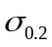), the static tensile strength (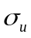) and the elongation after fracture (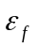) based on gauge length of 50 mm.

Test rig and procedure
The specimens were tested under the end-two-flange (ETF) loading condition specified in the NAS Specification , as shown in Figs 5 (a), 6 (a) and 7 (a). For the ETF loading conditions, two identical bearing plates of the same width were positioned at the end and the mid-length of each specimen, respectively. Hinge supports were simulated by two half rounds in the line of action of the force. A servo-controlled Tinius-Olsen testing machine was used to apply a concentrated compressive force to the test specimens. Displacement control was used to drive the hydraulic actuator at a constant speed of 0.05 mm/min for all the test specimens. The load or reaction force was applied by means of bearing plates. The bearing plates were fabricated using a high strength steel. All the bearing plates were machined to specified dimensions, and the thickness was 25 mm. The bearing plates were designed to act across the full flange widths of the channel sections. The flanges of the channel section specimens were fastened and unfastened to the bearing plates during testing is shown in Figs 5 (b) and 5 (c). In the flanges fastened test setup, the flanges were bolted to the bearing plate.

Test results
A total of 56 specimens were tested under the end-two-flange (ETF) loading condition. The experimental ultimate web crippling loads per web (P_{EXP}) for the flanges unfastened and fastened condition are given in Tables 1 and 2, respectively. Fig. 8 shows the typical failure mode of web crippling of the specimens. A typical example of the load-defection curve obtained from a specimen both without and with web holes, and the comparisons with the numerical results is shown in Figs 9 and 10.

Numerical investigation

General
The non-linear general purpose finite element program ANSYS was used to simulate the channel sections with and without holes subjected to web crippling. The bearing plates, the channel section with circular holes and the interfaces between the bearing plates and the channel section have been modelled. In the finite element model, the measured cross-section dimensions and the material properties obtained from the tests were used. The model was based on the centreline dimensions of the cross-sections. Specific modelling issues are described in the following subsection.

Geometry and material properties
One-quarter of the test set-up was modelled using symmetry about both the vertical transverse and horizontal planes, as shown in Figs 6 (b) and 7 (b). Contact surfaces are defined between the bearing plate and the cold-formed steel section.
The value of Young’s modulus was 203 kN/mm² and Poisson’s ratio was 0.3. The material non-linearity was incorporated in the finite element model by specifying ‘true’ values of stresses and strains. The plasticity of the material was determined by a mathematical model, known as the incremental plasticity model; the true stress (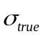) and plastic true strain (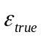) were calculated as per the method specified in the ANSYS manual .

Element type and mesh sensitivity
Figs 6 (b) and 7 (b) shows details of a typical finite element mesh of the channel section and the bearing plate. The effect of different element sizes in the cross-section of the channel section was investigated to provide both accurate results and reduced computation time. Depending on the size of the section, the finite element mesh sizes ranged from 3×3 mm (length by width) to 5×5 mm.
It is necessary to finely mesh the corners of the section due to the transfer of stress from the flange to the web. Nine elements were used around the inside corner radius that forms the bend between the flange and web. Three elements were used at the rounded corners between the flange and lip of the section. The number of elements was chosen so that the aspect ratio of the elements was as close to one as possible. Where holes were modelled, finer mesh sizes were used around the web holes. Mesh sensitivity analyses were performed to verify the number of elements.
The channel sections were modelled using the 4-noded shell element SHELL181. The bearing plates were modelled using the eight-noded solid element SOLID45. CONTACT173 and TARGET170 elements were used for modelling contact between the flanges and the load bearing plates.

Loading and boundary conditions
The nodes of the cold-formed section and the bearing plate were restrained to represent the vertical and horizontal symmetry condition. The interface between the bearing plate and the cold-formed steel section were modelled using the surface-to-surface contact option. The bearing plate was the target surface, while the cold-formed steel section was the contact surface. The two contact surfaces were not allowed to penetrate each other.
The vertical load applied to the channel sections in the laboratory tests was modelled using the displacement control method; an imposed displacement is applied to the nodes of the top bearing plate where the vertical load is applied. The top bearing plate was restrained against all degrees of freedom, except for the translational degree of freedom in the Y direction. In the flanges fastened condition, the node coupling method was used in the region where the flanges were connected to the bearing plates. The nodes were coupled together in all degrees of freedom.

Verification of finite element model
In order to validate the finite element model, the experimental failure loads were compared against the failure load predicted by the finite element analysis. The main objective of this comparison was to verify and check the accuracy of the finite element model. A comparison of the test results (P_{EXP}) with the numerical results (P_{FEA}) of web crippling strengths per web is shown in Tables 4 and 5. Load-deflection curves comparing the experimental results and the finite element results are shown in Figs 9 and 10 covering the cases of both with and without the web holes. It can be seen that good agreement has been achieved between both results for all specimens. The mean value of the ratio P_{EXP}/P_{FEA} is 0.98 and 0.98 for the flanges unfastened and fastened condition, respectively; the corresponding coefficient of variation (COV) was 0.05 and 0.04, respectively. A maximum difference of 9% and 10% was observed between the experimental and the numerical results for the specimen 172x65x13-t1.3N65A0FR and 142x60x13-t1.3N60A0.6FX, respectively. The web crippling failure mode observed from the tests has been also verified by the finite element model for the ETF loading conditions, as shown in Figs 6 and 7 respectively. It is shown that good agreement is achieved between the experimental and finite element results for both the web crippling strength and the failure mode.

Parametric study
The finite element model developed closely predicts the behaviour of the channel sections with circular web holes subjected to web crippling. Using this model, parametric studies were carried out to study the effects of web holes and cross-section sizes on the web crippling strengths of channel sections subjected to web crippling.
The web crippling strength predicted was influenced primarily by the ratio of the hole depth to the flat portion of the web, a/h, and the location of the hole as defined by the distance of the hole from the edge of the bearing divided by the flat portion of the web, x/h. In order to find the effect of a/h and x/h on the web crippling strength of channel-sections with web holes, two separate parametric studies were carried out considering the web holes, the cross-section sizes and location of the holes .
The specimens consisted of two different section sizes, having thicknesses (t) ranging from 1.4 to 6.0 mm and web slenderness (h/t) values ranging from 31.8 to 176.9. The ratios of the diameter of the holes (a) to the depth of the flat portion of the webs (h) were 0.2, 0.4, 0.6 and 0.8. The ratio of the distance of the web holes (x) to the depth of the flat portion of the webs (h) were 0.2, 0.4 and 0.6.
A total of 140 specimens was analysed in the parametric study investigating the effect of the ratio a/h. The cross-section dimensions as well as the web crippling strengths (P_{FEA}) per web predicted from the FEA are summarised in Table 6.
A total of 160 specimens was analysed in the parametric study investigating the effect of x/h. The cross-section dimensions as well as the web crippling strengths (P_{FEA}) per web predicted from the FEA are summarised in Table 7.
The effect of the ratios a/h and x/h on the web crippling strength on the reduction factor is shown in Figs 11 and 12 for the C202 Specimen. It is seen from these graphs that the parameter a/h and x/h noticeably affects the web crippling strength and the reduction factor.

Reliability analysis
The reliability of the cold-formed steel section design rules is evaluated using reliability analysis. The reliability index (β) is a relative measure of the safety of the design. A target reliability index of 2.5 for cold-formed steel structural members is recommended as a lower limit in the NAS Specification . The design rules are considered to be reliable if the reliability index is greater than or equal to 2.5. The load combination of 1.2DL + 1.6LL as specified in the American Society of Civil Engineers Standard was used in the reliability analysis, where DL is the dead load and LL is the live load. The statistical parameters are obtained from Table F1 of the NAS Specification for compression members, where M_{m} = 1.10, F_{m} = 1.00, V_{M} = 0.10, and V_{F} = 0.05, which are the mean values and coefficients of variation for material properties and fabrication factors.
The statistical parameters P_{m} and V_{P} are the mean value and coefficient of variation of load ratio are shown in Tables 10 and 11, respectively. In calculating the reliability index, the correction factor in the NAS Specification was used. Reliability analysis is detailed in the NAS Specification . In the reliability analysis, a constant resistance factor (φ) of 0.90 was used. It is shown that the reliability index (β) is greater than the target value of 2.5 as shown in Tables 10 and 11. Comparison of experimental and numerical results with current design strengths for cold-formed steel sections without web holes

Comparison of experimental and numerical results with current design strengths for cold-formed steel sections without web holes
As mentioned earlier, the current cold-formed design standards do not provide design recommendations for cold-formed steel sections with web holes subjected to web crippling under ETF loading conditions. The web crippling strengths predicted from test and FEA results were compared with the web crippling strengths obtained from design codes. According to Beshara and Schuster , NAS specification design expressions has limitation in the parameters. Design equation for the case of flanges fastened to the support, specimen thicknesses ranged from 1.16 to 1.45 mm and yield stresses ranged from 323 to 448 MPa. Design equation for the case of flanges unfastened to the support, specimen thicknesses ranged from 1.194 to 1.326 mm and yield stress ranged 301.8 to 324.6 MPa. However, it should be noted that the above range of specimens were considered for the results comparison.
In the case of flanges unfastened, Table 8 shows the comparison of web crippling strength with design strength for ETF loading condition. The NAS specification design strength was not considered as the r_{i}/t ratio limit was greater than 3. In the British Standard and Eurocode comparison, the mean values of ratio are 0.99 and 0.99 with the corresponding coefficients if variation (COV) of 0.08 and 0.08, and the reliability indices (β) of 2.46 and 2.46, respectively.
In the case of flanges fastened, Table 9 shows the comparison of web crippling strength with design strength for ETF loading condition. British Standards and Eurocode provides unreliable web crippling strengths predictions for flanges fastened case. A comparison of these values with the corresponding experimental and numerical values indicates that although the British Standard and Eurocode values are lower bound, that they are about 74% lower than the experimental and numerical failure loads. For the NAS specification comparison, the mean values of ratio are 0.79 with the corresponding coefficients of variation (COV) of 0.06 and the reliability indices (β) of 1.58. It is noted that for the unfastened case agreement is very good, however, for the fastened case, the comparison is less reliable due to the post buckling strength effect not being fully considered in the design codes.

Proposed strength reduction factors
Comparing the failure loads of the channel sections having web holes with the sections without web holes, as shown in Tables 1, 2, 6 and 7, it can be seen that, as expected, the failure load decreases as the size of the web holes increases and the failure load increases as the distance of the web holes increases. For each series of specimens, the web crippling strengths of the sections without the web holes were obtained. Thus, the ratio of the web crippling strengths for sections with the web holes divided by the sections without the web holes, which is the strength reduction factor (R), was used to quantify the degrading influence of the web holes on the web crippling strengths under the end-two-flange loading condition. Evaluation of the experimental and the numerical results show that the ratios a/h and x/h are the primary parameters influencing the web crippling behaviour of the sections with web holes. Therefore, based on both the experimental and the numerical results obtained from this study, two strength reduction factor (R_{p}) are proposed using bivariate linear regression analysis for the end-two- flange loading condition.

For the case where the flanges are unfastened to supports,
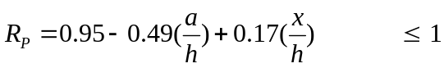 (1)
For the case where the flanges are fastened to supports,
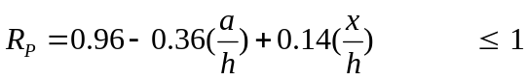 (2)

The limits for the reduction factor in equations (1) and (2) are 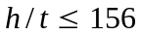, 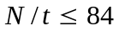, 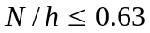, 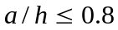, and 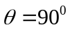.

Comparison of experimental and numerical results with proposed reduction factor
The values of the strength reduction factor (R) obtained from the experimental and the numerical results are compared with the values of the proposed strength reduction factor (R_{p}) calculated using Eqs. (1) and Eqs. (2), as plotted against the ratios a/h and h/t in Figs 13 and 14, respectively. Tables 10 and 11 summarizes a statistical analysis to define the accuracy of the proposed design equations. The values of the proposed reduction factor are generally conservative and agree well with the experimental and the numerical results for ETF loading conditions. It is shown that the proposed reduction factor are generally conservative and agree with the experimental and numerical results for both cases. The mean value of the web crippling reduction factor ratios are 1.00 and 1.00 for the flanges are unfastened and fastened conditions, respectively. The corresponding values of COV are 0.05 and 0.06, respectively; similarly, the reliability index values are (β) of 2.56 and 2.56, respectively. Thus, the proposed strength reduction factor equations are able to predict the influence of the web holes on the web crippling strengths of channel sections for the ETF loading condition.

Conclusions
A test programme on cold-formed steel lipped channel sections having offset circular web holes subjected to the end-two-flange (ETF) web crippling loading condition have been presented. The web slenderness values of the test specimens ranged from 31.8 to 176.9; the diameter of the web holes was also varied in order to investigate the influence of the web holes on the web crippling strength. The cases of the flanges of the channel sections being fastened and unfastened to the bearing plates were also considered.
A finite element model that incorporated the geometric and material nonlinearities has been developed and verified against the experimental results. The finite element model was shown to be able to predict the web crippling behaviour of the channel sections for both with and without circular web holes. A parametric study was carried out to study the effects of the different sizes of the cross-sections and web holes on the web crippling strengths of the channel sections. It is shown that the ratios a/h and x/h are the primary parametric relationships influencing the web crippling behaviour of the sections with web holes.
Web crippling strength reduction factor equations were proposed for the ETF loading conditions for both cases of flanges unfastened and fastened to the supports. It is shown that the proposed strength reduction factors are generally conservative and agree well with the experimental and the numerical results.

Acknowledgements
The authors gratefully acknowledge the help given by Metsec Plc, UK, in supplying the materials and Capital Steel Buildings Ltd. The authors also wish to thank Mr Chris Cameron and Mr Andrew Crockett for their assistant in the preparation of the specimens and carrying out the tests.

References

[1] J. Rhodes, D. Nash, An investigation of web crushing behaviour in thin-walled beams, Thin-Walled Structures, 32 (1998) 207-230.

[2] A. Uzzaman, J.B.P. Lim, D. Nash, J. Rhodes, B. Young, Cold-formed steel sections with web openings subjected to web crippling under two-flange loading conditions—Part I: Tests and finite element analysis, Thin-Walled Structures, 56 (2012) 38-48.

[3] A. Uzzaman, J.B.P. Lim, D. Nash, J. Rhodes, B. Young, Cold-formed steel sections with web openings subjected to web crippling under two-flange loading conditions—Part II: Parametric study and proposed design equations, Thin-Walled Structures, 56 (2012) 79-87.

[4] A. Uzzaman, J.B.P. Lim, D. Nash, J. Rhodes, B. Young, Web crippling behaviour of cold-formed steel channel sections with offset web holes subjected to interior-two-flange loading, Thin-Walled Structures, 50 (2012) 76-86.

[5] W.W. Yu, C.S. Davis, Cold-formed steel members with perforated elements, Journal of the Structural Division, 99 (1973) 2061-2077.

[6] K.S. Sivakumaran, K.M. Zielonka, Web crippling strength of thin-walled steel members with web opening, Thin-Walled Structures, 8 (1989) 295-319.

[7] R.A. LaBoube, W.W. Yu, S.U. Deshmukh, C.A. Uphoff, Crippling Capacity of Web Elements with Openings, Journal of Structural Engineering, 125 (1999) 137-141.

[8] K.F. Chung, Structural perfomance of cold formed sections with single and multiple web openings.(part-1 Experimental investigation), The Structural engineer, Vol 73 (1995).

[9] F. Zhou, B. Young, Web crippling of aluminium tubes with perforated webs, Engineering Structures, 32 (2010) 1397-1410.

[10] NAS, North American Specification for the Design of Cold-Formed Steel Structural Members, American Iron and Steel Institute, AISI S100-2007, AISI Standard, 2007.
[11] ANSYS, User’s manual, revision 11.0, in, Swanson Analysis System, 2011.

[12] EN, 10002-1: 2001. Tensile testing of metallic materials. Method of test at ambient temperature, British Standards Institution, (2001).

[13] ASCE, Minimum design loads for buildings and other structures, in, American Society of Civil Engineers Standard, New York, 2005.

[14] Eurocode-3, Design of steel structures: Part 1.3: General rules — Supplementary rules for cold-formed thin gauge members and sheeting, in: ENV 1993-1-3, European Committee for Standardization, Brussels, Belgium, 1996.

[15] BS5950, Structural use of steelwork in buildings, in: Part 5 Code of practice for the design of cold-formed sections, British Standards Institution, London, 1998.

[16] B. Beshara, R. M. Schuster, Web crippling data and calibrations of cold formed steel members, in, University of waterloo, Canada, 2000.

Table 1 Measured specimen dimensions and experimental ultimate loads for flanges unfastened condition
Specimen | Web, d (mm) | Flange, b_{f} (mm) | Lip, b_{l} (mm) | Thickness, t (mm) | Fillet, r_{i} (mm) | Holes, a (mm) | Length, L (mm) | Exp. Load per Web, P_{EXP} (kN)
142x60x13-t1.3N30A0FR | 142.15 | 58.57 | 15.85 | 1.23 | 4.75 | 0.00 | 275.40 | 1.68
142x60x13t1.3N30A0.2FR | 142.15 | 58.57 | 15.85 | 1.23 | 4.75 | 27.88 | 275.40 | 1.62
142x60x13t1.3N30A0.4FR | 142.15 | 59.48 | 16.32 | 1.25 | 4.75 | 55.81 | 275.59 | 1.44
142x60x13t1.3N30A0.6FR | 142.15 | 59.48 | 16.32 | 1.25 | 4.75 | 83.64 | 275.59 | 1.30
142x60x13t1.3N30A0.8FR | 142.15 | 59.48 | 16.32 | 1.25 | 4.75 | 111.52 | 275.59 | 1.08
142x60x13-t1.3N60A0FR-1 | 141.75 | 58.94 | 15.56 | 1.24 | 4.75 | 0.00 | 300.56 | 1.95
142x60x13-t1.3N60A0FR-2 | 141.75 | 58.94 | 15.56 | 1.24 | 4.75 | 0.00 | 300.56 | 1.83
142x60x13-t1.3N60A0FR-3 | 141.75 | 58.94 | 15.56 | 1.24 | 4.75 | 0.00 | 300.56 | 1.91
142x60x13-t1.3N60A0.2FR | 141.75 | 58.94 | 15.56 | 1.24 | 4.75 | 27.88 | 301.91 | 1.68
142x60x13-t1.3N60A0.4FR-1 | 141.33 | 58.84 | 16.29 | 1.24 | 4.75 | 55.72 | 301.91 | 1.64
142x60x13-t1.3N60A0.4FR-2 | 141.33 | 58.84 | 16.29 | 1.24 | 4.75 | 55.72 | 301.91 | 1.61
142x60x13-t1.3N60A0.4FR-3 | 141.33 | 58.84 | 16.29 | 1.24 | 4.75 | 55.72 | 301.91 | 1.60
142x60x13-t1.3N60A0.6FR | 141.33 | 58.84 | 16.29 | 1.24 | 4.75 | 83.64 | 301.91 | 1.53
172x65x13-t1.3N32.5A0FR | 172.76 | 64.05 | 15.61 | 1.27 | 5.00 | 0.00 | 327.41 | 1.70
172x65x13-t1.3N32.5A0.4FR | 172.26 | 63.55 | 15.49 | 1.27 | 5.00 | 67.64 | 326.85 | 1.55
172x65x13-t1.3N65A0FR | 172.58 | 64.28 | 15.25 | 1.28 | 5.00 | 0.00 | 356.39 | 1.88
172x65x13-t1.3N65A0.4FR | 172.26 | 63.55 | 15.49 | 1.27 | 5.00 | 67.74 | 326.85 | 1.64
202x65x13-t1.4N32.5A0FR | 202.06 | 63.11 | 17.51 | 1.45 | 5.00 | 0.00 | 375.84 | 1.98
202x65x13-t1.4N32.5A0.4FR | 202.69 | 64.25 | 16.32 | 1.45 | 5.00 | 79.53 | 376.29 | 1.82
202x65x13-t1.4N65A0FR | 202.44 | 64.20 | 16.50 | 1.45 | 5.00 | 0.00 | 400.91 | 2.39
202x65x13-t1.4N65A0.4FR | 202.58 | 64.09 | 16.54 | 1.46 | 5.00 | 79.66 | 399.57 | 1.98
262x65x13-t1.6N32.5A0FR | 263.43 | 63.35 | 14.42 | 1.56 | 5.50 | 0.00 | 450.93 | 2.04
262x65x13-t1.6N32.5A0.4FR | 262.75 | 63.42 | 14.69 | 1.55 | 5.50 | 103.40 | 450.32 | 1.82
262x65x13-t1.6N65A0FR | 262.39 | 64.05 | 15.33 | 1.55 | 5.50 | 0.00 | 497.18 | 2.19
262x65x13-t1.6N65A0.4FR | 262.47 | 63.76 | 14.45 | 1.54 | 5.50 | 103.38 | 498.19 | 2.00
302x90x18-t2N44A0FR | 305.47 | 86.78 | 20.77 | 1.94 | 5.00 | 0.00 | 549.73 | 3.96
302x90x18-t2N44A0.4FR | 303.33 | 86.45 | 20.50 | 1.94 | 5.50 | 119.00 | 601.78 | 3.35
302x90x18-t2N90A0FR | 303.55 | 87.06 | 21.29 | 1.97 | 5.50 | 0.00 | 596.45 | 4.30
Note: 1 kip = 4.45 kN

Table 2
Measured specimen dimensions and experimental ultimate loads for flanges fastened condition
Specimen | Web, d (mm) | Flange, b_{f} (mm) | Lip, b_{l} (mm) | Thickness, t (mm) | Fillet, r_{i} (mm) | Holes, a (mm) | Length, L (mm) | Exp. Load per Web, P_{EXP} (kN)
ETF142x60x13-t1.3N30A0FX | 143.48 | 59.82 | 15.80 | 1.24 | 4.75 | 0.00 | 275.52 | 2.96
ETF142x60x13t1.3N30A0.2FX | 143.48 | 59.82 | 15.80 | 1.24 | 4.75 | 27.88 | 275.52 | 2.80
ETF142x60x13t1.3N30A0.4FX | 142.14 | 57.99 | 16.14 | 1.25 | 4.75 | 55.71 | 275.52 | 2.53
ETF142x60x13t1.3N30A0.6FX | 142.14 | 57.99 | 16.14 | 1.25 | 4.75 | 83.64 | 275.52 | 2.27
ETF142x60x13t1.3N30A0.8FX | 142.14 | 57.99 | 16.14 | 1.25 | 4.75 | 111.52 | 275.52 | 1.93
ETF142x60x13-t1.3N60A0FX-1 | 142.96 | 61.01 | 14.88 | 1.21 | 4.75 | 0.00 | 302.46 | 3.32
ETF142x60x13-t1.3N60A0FX-2 | 142.96 | 61.01 | 14.88 | 1.21 | 4.75 | 0.00 | 302.46 | 3.31
ETF142x60x13-t1.3N60A0FX-3 | 142.96 | 61.01 | 14.88 | 1.21 | 4.75 | 0.00 | 302.46 | 3.27
ETF142x60x13-t1.3N60A0.2FX | 142.96 | 61.01 | 14.88 | 1.21 | 4.75 | 27.88 | 300.00 | 3.23
ETF142x60x13-t1.3N60A0.4FX-1 | 141.99 | 59.64 | 15.74 | 1.23 | 4.75 | 55.56 | 304.54 | 2.99
ETF142x60x13-t1.3N60A0.4FX-2 | 141.99 | 59.64 | 15.74 | 1.23 | 4.75 | 55.56 | 300.00 | 3.11
ETF142x60x13-t1.3N60A0.4FX-3 | 141.99 | 59.64 | 15.74 | 1.23 | 4.75 | 55.56 | 300.00 | 3.07
ETF142x60x13-t1.3N60A0.6FX | 141.99 | 59.64 | 15.74 | 1.23 | 4.75 | 83.64 | 300.00 | 2.64
ETF142x60x13-t1.3N60A0.8FX | 141.99 | 59.64 | 15.74 | 1.23 | 4.75 | 111.52 | 300.00 | 2.47
ETF172x65x13-t1.3N32.5A0FX | 173.22 | 63.48 | 15.36 | 1.26 | 5.00 | 0.00 | 325.01 | 2.88
ETF172x65x13-t1.3N32.5A0.4FX | 172.55 | 63.59 | 16.41 | 1.26 | 5.00 | 67.61 | 325.20 | 2.71
ETF172x65x13-t1.3N65A0FX | 173.27 | 64.29 | 14.64 | 1.26 | 5.00 | 0.00 | 351.45 | 3.31
ETF172x65x13-t1.3N65A0.4FX | 173.07 | 64.15 | 14.24 | 1.26 | 5.00 | 67.67 | 349.67 | 3.03
ETF202x65x13-t1.4N32.5A0FX | 202.43 | 63.97 | 16.19 | 1.38 | 5.00 | 0.00 | 376.43 | 3.63
ETF202x65x13-t1.4N65A0FX | 202.37 | 63.91 | 16.44 | 1.45 | 5.00 | 0.00 | 401.84 | 4.37
ETF202x65x13-t1.4N65A0.4FX | 202.59 | 64.17 | 16.48 | 1.45 | 5.00 | 79.61 | 400.10 | 3.80
ETF262x65x13-t1.6N32.5A0FX | 263.55 | 63.38 | 14.84 | 1.55 | 5.50 | 0.00 | 452.21 | 3.63
ETF262x65x13-t1.6N32.5A0.4FX | 262.81 | 63.25 | 15.22 | 1.53 | 5.50 | 103.28 | 451.37 | 3.16
ETF262x65x13-t1.6N65A0FX | 262.66 | 65.33 | 15.17 | 1.52 | 5.50 | 0.00 | 499.22 | 3.94
ETF262x65x13-t1.6N65A0.4FX | 262.67 | 63.42 | 15.26 | 1.55 | 5.50 | 103.31 | 496.82 | 3.68
ETF302x90x18-t2N44A0FX | 304.52 | 86.59 | 19.77 | 1.96 | 5.50 | 0.00 | 544.52 | 6.95
ETF302x90x18-t2N44A0.4FX | 303.17 | 87.23 | 20.99 | 1.96 | 5.50 | 119.06 | 545.36 | 6.03
ETF302x90x18-t2N90A0.4FX | 303.64 | 86.93 | 20.63 | 1.96 | 5.50 | 119.11 | 550.14 | 6.85
Note: 1 kip = 4.45 kN

Table 3
Material properties of specimens

Section | (MPa) | (MPa) | (%)
142 x 60 x 13 x 1.3 | 455 | 532 | 23
172 x 65 x 16 x 1.3 | 534 | 566 | 10
202 x 65 x 13 x 1.4 | 513 | 552 | 11
262 x 65 x 13 x 1.6 | 525 | 546 | 10
302 x 88 x 18 x 2.0 | 483 | 523 | 11

Table 4
Comparison of the web crippling strength predicted from the finite element analysis with the experiment results for unfastened condition
Specimen | Web slenderness, (h/t) | Ratio, (a/h) | Exp. Load per Web, P_{EXP} (kN) | Web crippling strength per web predicted from FEA, P_{FEA} (kN) | Comparison, P_{EXP} / P_{FEA}
ETF142x60x13-t1.3N30A0FR | 112.18 | 0.00 | 1.68 | 1.65 | 1.02
ETF142x60x13t1.3N30A0.2FR | 112.18 | 0.20 | 1.62 | 1.62 | 1.00
ETF142x60x13t1.3N30A0.4FR | 112.18 | 0.40 | 1.44 | 1.46 | 0.99
ETF142x60x13t1.3N30A0.6FR | 112.18 | 0.60 | 1.30 | 1.28 | 1.02
ETF142x60x13t1.3N30A0.8FR | 112.18 | 0.80 | 1.08 | 1.09 | 0.99
ETF142x60x13-t1.3N60A0FR | 112.50 | 0.00 | 1.95 | 2.02 | 0.97
ETF142x60x13-t1.3N60A0.2FR | 112.44 | 0.20 | 1.68 | 1.68 | 1.00
ETF142x60x13-t1.3N60A0.4FR | 112.44 | 0.40 | 1.64 | 1.65 | 0.99
ETF142x60x13-t1.3N60A0.6FR | 112.44 | 0.60 | 1.60 | 1.65 | 0.97
ETF142x60x13-t1.3N60A0.8FR | 112.44 | 0.80 | 1.53 | 1.56 | 0.98
ETF172x65x13-t1.3N32.5A0FR | 134.46 | 0.00 | 1.70 | 1.70 | 1.00
ETF172x65x13-t1.3N32.5A0.4FR | 134.07 | 0.40 | 1.55 | 1.47 | 1.05
ETF172x65x13-t1.3N65A0FR | 133.25 | 0.00 | 1.88 | 2.07 | 0.91
ETF172x65x13-t1.3N65A0.4FR | 134.07 | 0.40 | 1.64 | 1.77 | 0.93
ETF202x65x13-t1.4N32.5A0FR | 137.54 | 0.00 | 1.98 | 2.16 | 0.92
ETF202x65x13-t1.4N32.5A0.4FR | 137.98 | 0.40 | 1.82 | 1.85 | 0.98
ETF202x65x13-t1.4N65A0FR | 137.81 | 0.00 | 2.39 | 2.49 | 0.96
ETF202x65x13-t1.4N65A0.4FR | 136.94 | 0.40 | 1.98 | 2.20 | 0.90
ETF262x65x13-t1.6N32.5A0FR | 167.41 | 0.00 | 2.04 | 2.09 | 0.98
ETF262x65x13-t1.6N32.5A0.4FR | 167.52 | 0.40 | 1.82 | 1.75 | 1.04
ETF262x65x13-t1.6N65A0FR | 166.96 | 0.00 | 2.19 | 2.40 | 0.91
ETF262x65x13-t1.6N65A0.4FR | 168.21 | 0.40 | 2.00 | 2.03 | 0.99
ETF302x90x18-t2N44A0FR | 155.30 | 0.00 | 3.96 | 3.64 | 1.09
ETF302x90x18-t2N44A0.4FR | 154.19 | 0.40 | 3.35 | 3.32 | 1.01
ETF302x90x18-t2N90A0FR | 152.24 | 0.00 | 4.30 | 4.41 | 0.98
Mean |  |  |  |  | 0.98
COV |  |  |  |  | 0.05

Table 5
Comparison of the web crippling strength predicted from the finite element analysis with the experiment results for fastened condition

Specimen | Web slenderness, (h/t) | Ratio, (a/h) | Exp. Load per Web, P_{EXP} (kN) | Web crippling strength per web predicted from FEA, P_{FEA} (kN) | Comparison, P_{EXP} / P_{FEA}
ETF142x60x13-t1.3N30A0FX | 113.82 | 0.00 | 2.96 | 2.92 | 1.01
ETF142x60x13-t1.3N30A0.2FX | 113.82 | 0.20 | 2.80 | 2.84 | 0.99
ETF142x60x13t1.3N30A0.4FX | 113.82 | 0.40 | 2.53 | 2.66 | 0.95
ETF142x60x13t1.3N30A0.6FX | 113.82 | 0.59 | 2.27 | 2.34 | 0.97
ETF142x60x13t1.3N30A0.8FX | 113.82 | 0.79 | 1.93 | 2.00 | 0.97
ETF142x60x13-t1.3N60A0FX | 116.57 | 0.00 | 3.32 | 3.32 | 1.00
ETF142x60x13-t1.3N60A0.2FX | 116.57 | 0.20 | 3.23 | 3.20 | 1.01
ETF142x60x13-t1.3N60A0.4FX | 116.57 | 0.39 | 3.11 | 3.10 | 1.00
ETF142x60x13-t1.3N60A0.6FX | 116.57 | 0.59 | 2.64 | 2.94 | 0.90
ETF142x60x13-t1.3N60A0.8FX | 116.57 | 0.79 | 2.47 | 2.65 | 0.93
ETF172x65x13-t1.3N32.5A0FX | 135.48 | 0.00 | 2.88 | 2.96 | 0.97
ETF172x65x13-t1.3N32.5A0.4FX | 134.73 | 0.40 | 2.71 | 2.64 | 1.03
ETF172x65x13-t1.3N65A0FX | 135.30 | 0.00 | 3.31 | 3.56 | 0.93
ETF172x65x13-t1.3N65A0.4FX | 135.03 | 0.40 | 3.03 | 3.25 | 0.93
ETF202x65x13-t1.4N32.5A0FX | 144.69 | 0.00 | 3.63 | 3.40 | 1.07
ETF202x65x13-t1.4N65A0FX | 137.76 | 0.00 | 4.37 | 4.51 | 0.97
ETF202x65x13-t1.4N65A0.4FX | 137.33 | 0.40 | 3.80 | 4.15 | 0.92
ETF262x65x13-t1.6N32.5A0FX | 168.03 | 0.00 | 3.63 | 3.54 | 1.03
ETF262x65x13-t1.6N32.5A0.4FX | 170.00 | 0.40 | 3.16 | 3.10 | 1.02
ETF262x65x13-t1.6N65A0FX | 170.58 | 0.00 | 3.94 | 4.08 | 0.97
ETF262x65x13-t1.6N65A0.4FX | 167.90 | 0.40 | 3.68 | 3.88 | 0.95
ETF302x90x18-t2N44A0FX | 153.37 | 0.00 | 6.95 | 6.54 | 1.06
ETF302x90x18-t2N44A0.4FX | 152.36 | 0.40 | 6.03 | 5.98 | 1.01
ETF302x90x18-t2N90A0.4FX | 152.92 | 0.40 | 6.85 | 7.07 | 0.97
Mean |  |  |  |  | 0.98
COV |  |  |  |  | 0.04

Table 6
Dimensions and web crippling strengths predicted from finite element analysis of parametric study of a/h

Specimen | Web, d (mm) | Flange, b_{f} (mm) | Lip, b_{l} (mm) | Thickness, t (mm) | Length, L (mm) | FEA load per web, P_{FEA} (kN)
 |  |  |  |  |  | A0 | A0.2 | A0.4 | A0.6 | A0.8
ETF202x65x13-t1.4N32.5FR | 202.47 | 63.61 | 16.03 | 1.40 | 376.43 | 1.89 | 1.80 | 1.62 | 1.43 | 1.21
ETF202x65x13-t2.0N32.5FR | 202.47 | 63.61 | 16.03 | 2.00 | 376.43 | 5.46 | 5.18 | 4.68 | 4.08 | 3.43
ETF202x65x13-t4.0N32.5FR | 202.47 | 63.61 | 16.03 | 4.00 | 376.43 | 26.92 | 25.80 | 23.33 | 20.46 | 17.44
ETF202x65x13-t6.0N32.5FR | 202.47 | 63.61 | 16.03 | 6.00 | 376.43 | 62.16 | 60.39 | 54.94 | 48.22 | 41.05
ETF202x65x13-t1.4N65FR | 202.49 | 63.97 | 17.48 | 1.44 | 401.84 | 2.50 | 2.38 | 2.16 | 1.92 | 1.65
ETF202x65x13-t2.0N65FR | 202.49 | 63.97 | 17.48 | 2.00 | 401.84 | 6.30 | 6.01 | 5.46 | 4.82 | 4.16
ETF202x65x13-t4.0N65FR | 202.49 | 63.97 | 17.48 | 4.00 | 401.84 | 30.39 | 29.22 | 26.69 | 23.71 | 20.59
ETF202x65x13-t6.0N65FR | 202.49 | 63.97 | 17.48 | 6.00 | 401.84 | 70.17 | 68.11 | 62.59 | 55.55 | 48.03
ETF302x90x18-t2N44FR | 303.98 | 87.90 | 17.97 | 1.93 | 544.52 | 3.71 | 3.51 | 3.16 | 2.77 | 2.33
ETF302x90x18-t4.0N44FR | 303.98 | 87.90 | 17.97 | 4.00 | 544.52 | 23.95 | 22.79 | 20.48 | 17.79 | 14.95
ETF302x90x18-t6.0N44FR | 303.98 | 87.90 | 17.97 | 6.00 | 544.52 | 59.06 | 56.73 | 51.20 | 44.69 | 37.79
ETF302x90x18-t2N90FR | 303.85 | 88.83 | 18.66 | 1.96 | 601.78 | 4.26 | 4.07 | 3.70 | 3.29 | 2.84
ETF302x90x18-t4.0N90FR | 303.85 | 88.83 | 18.66 | 4.00 | 601.78 | 27.72 | 26.55 | 24.22 | 21.50 | 18.65
ETF302x90x18-t6.0N90FR | 303.85 | 88.83 | 18.66 | 6.00 | 601.78 | 66.98 | 64.30 | 59.75 | 53.41 | 46.55
ETF202x65x13-t1.4N32.5FX | 202.47 | 63.61 | 16.03 | 1.40 | 376.43 | 3.41 | 3.21 | 3.01 | 2.73 | 2.34
ETF202x65x13-t2.0N32.5FX | 202.47 | 63.61 | 16.03 | 2.00 | 376.43 | 8.88 | 8.58 | 7.98 | 7.06 | 6.20
ETF202x65x13-t4.0N32.5FX | 202.47 | 63.61 | 16.03 | 4.00 | 376.43 | 36.29 | 35.62 | 33.40 | 30.68 | 27.76
ETF202x65x13-t6.0N32.5FX | 202.47 | 63.61 | 16.03 | 6.00 | 376.43 | 75.15 | 74.76 | 71.60 | 66.43 | 60.47
ETF202x65x13-t1.4N65FX | 202.49 | 63.97 | 17.48 | 1.44 | 401.84 | 4.51 | 4.37 | 4.12 | 3.81 | 3.42
ETF202x65x13-t2.0N65FX | 202.49 | 63.97 | 17.48 | 2.00 | 401.84 | 10.48 | 10.18 | 9.59 | 8.79 | 8.03
ETF202x65x13-t4.0N65FX | 202.49 | 63.97 | 17.48 | 4.00 | 401.84 | 43.10 | 42.53 | 40.84 | 38.53 | 36.03
ETF202x65x13-t6.0N65FX | 202.49 | 63.97 | 17.48 | 6.00 | 401.84 | 92.01 | 91.20 | 88.25 | 83.56 | 77.98
ETF302x90x18-t2N44FX | 303.98 | 87.90 | 17.97 | 1.93 | 544.52 | 6.54 | 6.32 | 5.94 | 5.41 | 4.62
ETF302x90x18-t4.0N44FX | 303.98 | 87.90 | 17.97 | 4.00 | 544.52 | 35.30 | 34.40 | 32.07 | 29.17 | 26.07
ETF302x90x18-t6.0N44FX | 303.98 | 87.90 | 17.97 | 6.00 | 544.52 | 78.08 | 76.89 | 72.35 | 66.34 | 59.81
ETF302x90x18-t2N90FX | 303.85 | 88.83 | 18.66 | 1.96 | 601.78 | 7.87 | 7.65 | 7.24 | 6.72 | 6.04
ETF302x90x18-t4.0N90FX | 303.85 | 88.83 | 18.66 | 4.00 | 601.78 | 42.45 | 41.65 | 39.59 | 37.10 | 34.57
ETF302x90x18-t6.0N90FX | 303.85 | 88.83 | 18.66 | 6.00 | 601.78 | 94.15 | 93.08 | 89.79 | 85.07 | 79.64

Table 7
Dimensions and web crippling strengths predicted from finite element analysis of parametric study of x/h

Specimen | Web, d (mm) | Flange, b_{f} (mm) | Lip, b_{l} (mm) | Thickness, t (mm) | Length, L (mm) | FEA load per web, P_{FEA} (kN)
 |  |  |  |  |  | X0 | X0.2 | X0.4 | X0.6
ETF202x65x13-t1.4N32.5A0FR | 202.47 | 63.61 | 16.03 | 1.40 | 376.43 | 1.89 | 1.89 | 1.89 | 1.89
ETF202x65x13-t1.4N32.5A0.2FR | 202.47 | 63.61 | 16.03 | 1.40 | 376.43 | 1.64 | 1.70 | 1.75 | 1.79
ETF202x65x13-t1.4N32.5A0.4FR | 202.47 | 63.61 | 16.03 | 1.40 | 376.43 | 1.35 | 1.45 | 1.55 | 1.63
ETF202x65x13-t1.4N32.5A0.6FR | 202.47 | 63.61 | 16.03 | 1.40 | 376.43 | 1.10 | 1.24 | 1.38 | 1.50
ETF202x65x13-t1.4N32.5A0.8FR | 202.47 | 63.61 | 16.03 | 1.40 | 376.43 | 0.87 | 1.05 | 1.23 | 1.38
ETF202x65x13-t1.4N65A0FR | 202.49 | 63.97 | 17.48 | 1.44 | 401.84 | 2.50 | 2.50 | 2.50 | 2.50
ETF202x65x13-t1.4N65A0.2FR | 202.49 | 63.97 | 17.48 | 1.44 | 401.84 | 2.23 | 2.30 | 2.35 | 2.38
ETF202x65x13-t1.4N65A0.4FR | 202.49 | 63.97 | 17.48 | 1.44 | 401.84 | 1.89 | 2.02 | 2.13 | 2.21
ETF202x65x13-t1.4N65A0.6FR | 202.49 | 63.97 | 17.48 | 1.44 | 401.84 | 1.60 | 1.78 | 1.93 | 2.07
ETF202x65x13-t1.4N65A0.8FR | 202.49 | 63.97 | 17.48 | 1.44 | 401.84 | 1.35 | 1.57 | 1.77 | 1.94
ETF302x90x18-t2N44A0FR | 303.98 | 87.90 | 17.97 | 1.93 | 544.52 | 3.71 | 3.71 | 3.71 | 3.71
ETF302x90x18-t2N44A0.2FR | 303.98 | 87.90 | 17.97 | 1.93 | 544.52 | 3.21 | 3.34 | 3.43 | 3.50
ETF302x90x18-t2N44A0.4FR | 303.98 | 87.90 | 17.97 | 1.93 | 544.52 | 2.62 | 2.84 | 3.04 | 3.19
ETF302x90x18-t2N44A0.6FR | 303.98 | 87.90 | 17.97 | 1.93 | 544.52 | 2.11 | 2.41 | 2.69 | 2.93
ETF302x90x18-t2N44A0.8FR | 303.98 | 87.90 | 17.97 | 1.93 | 544.52 | 1.65 | 2.04 | 2.40 | 2.71
ETF302x90x18-t2N90A0FR | 303.85 | 88.83 | 18.66 | 1.96 | 601.78 | 4.26 | 4.26 | 4.26 | 4.26
ETF302x90x18-t2N90A0.2FR | 303.85 | 88.83 | 18.66 | 1.96 | 601.78 | 3.81 | 3.93 | 4.01 | 4.06
ETF302x90x18-t2N90A0.4FR | 303.85 | 88.83 | 18.66 | 1.96 | 601.78 | 3.24 | 3.45 | 3.62 | 3.77
ETF302x90x18-t2N90A0.6FR | 303.85 | 88.83 | 18.66 | 1.96 | 601.78 | 2.72 | 3.03 | 3.28 | 3.51
ETF302x90x18-t2N90A0.8FR | 303.85 | 88.83 | 18.66 | 1.96 | 601.78 | 2.28 | 2.66 | 3.00 | 3.29
ETF202x65x13-t1.4N32.5A0FX | 202.47 | 63.61 | 16.03 | 1.40 | 376.43 | 3.41 | 3.41 | 3.41 | 3.41
ETF202x65x13-t1.4N32.5A0.2FX | 202.47 | 63.61 | 16.03 | 1.40 | 376.43 | 3.09 | 3.12 | 3.15 | 3.19
ETF202x65x13-t1.4N32.5A0.4FX | 202.47 | 63.61 | 16.03 | 1.40 | 376.43 | 2.72 | 2.81 | 2.91 | 3.02
ETF202x65x13-t1.4N32.5A0.6FX | 202.47 | 63.61 | 16.03 | 1.40 | 376.43 | 2.29 | 2.48 | 2.66 | 2.84
ETF202x65x13-t1.4N32.5A0.8FX | 202.47 | 63.61 | 16.03 | 1.40 | 376.43 | 1.80 | 2.11 | 2.37 | 2.62
ETF202x65x13-t1.4N65A0FX | 202.49 | 63.97 | 17.48 | 1.44 | 401.84 | 4.51 | 4.51 | 4.51 | 4.51
ETF202x65x13-t1.4N65A0.2FX | 202.49 | 63.97 | 17.48 | 1.44 | 401.84 | 4.24 | 4.28 | 4.32 | 4.37
ETF202x65x13-t1.4N65A0.4FX | 202.49 | 63.97 | 17.48 | 1.44 | 401.84 | 3.85 | 3.95 | 4.07 | 4.19
ETF202x65x13-t1.4N65A0.6FX | 202.49 | 63.97 | 17.48 | 1.44 | 401.84 | 3.46 | 3.64 | 3.83 | 4.02
ETF202x65x13-t1.4N65A0.8FX | 202.49 | 63.97 | 17.48 | 1.44 | 401.84 | 3.03 | 3.31 | 3.58 | 3.83
ETF302x90x18-t2N44A0FX | 303.98 | 87.90 | 17.97 | 1.93 | 544.52 | 6.54 | 6.54 | 6.54 | 6.54
ETF302x90x18-t2N44A0.2FX | 303.98 | 87.90 | 17.97 | 1.93 | 544.52 | 6.03 | 6.11 | 6.20 | 6.30
ETF302x90x18-t2N44A0.4FX | 303.98 | 87.90 | 17.97 | 1.93 | 544.52 | 5.26 | 5.50 | 5.75 | 5.98
ETF302x90x18-t2N44A0.6FX | 303.98 | 87.90 | 17.97 | 1.93 | 544.52 | 4.41 | 4.89 | 5.29 | 5.66
ETF302x90x18-t2N44A0.8FX | 303.98 | 87.90 | 17.97 | 1.93 | 544.52 | 3.43 | 4.18 | 4.73 | 5.27
ETF302x90x18-t2N90A0FX | 303.85 | 88.83 | 18.66 | 1.96 | 601.78 | 7.87 | 7.87 | 7.87 | 7.87
ETF302x90x18-t2N90A0.2FX | 303.85 | 88.83 | 18.66 | 1.96 | 601.78 | 7.39 | 7.46 | 7.55 | 7.65
ETF302x90x18-t2N90A0.4FX | 303.85 | 88.83 | 18.66 | 1.96 | 601.78 | 6.69 | 6.89 | 7.12 | 7.34
ETF302x90x18-t2N90A0.6FX | 303.85 | 88.83 | 18.66 | 1.96 | 601.78 | 6.01 | 6.36 | 6.71 | 7.03
ETF302x90x18-t2N90A0.8FX | 303.85 | 88.83 | 18.66 | 1.96 | 601.78 | 5.26 | 5.79 | 6.27 | 6.70

Table 8
Comparison of experimental and numerical results with design strength for ETF loading condition under flanges unfastened case.

Specimen |  |  |  |  | Failure load (P_{EXP} and P_{FEA} ) | Web crippling strength predicted from Current design codes |  |  | Comparison
 | h/t | N/t | N/h | ri/t | P | P_{BS} | P_{EC3} |  | P/P_{BS} | P/ P_{EC3}
 |  |  |  |  | (kN) | (kN) | (kN)
ETF142x60x13-t1.3N30A0FR | 113.3 | 24.2 | 0.2 | 3.8 | 1.7 | 1.6 | 1.6 |  | 1.02 | 1.02
ETF142x60x13-t1.3N60A0FR | 113.3 | 48.4 | 0.4 | 3.8 | 2.0 | 2.0 | 2.0 |  | 0.99 | 0.99
ETF172x65x13-t1.3N32.5A0FR | 134.0 | 25.6 | 0.2 | 3.9 | 1.7 | 1.5 | 1.5 |  | 1.10 | 1.10
ETF172x65x13-t1.3N65A0FR | 134.0 | 51.2 | 0.4 | 3.9 | 1.9 | 1.9 | 1.9 |  | 1.01 | 1.01
ETF202x65x13-t1.4N32.5A0FR | 137.4 | 22.4 | 0.2 | 3.4 | 2.0 | 2.2 | 2.2 |  | 0.89 | 0.89
ETF202x65x13-t1.4N65A0FR | 137.4 | 44.8 | 0.3 | 3.4 | 2.4 | 2.6 | 2.6 |  | 0.91 | 0.91
Mean, P_{m} |  |  |  |  |  |  |  |  | 0.99 | 0.99
Coefficient of variation, V_{p} |  |  |  |  |  |  |  |  | 0.08 | 0.08
Reliability index, β |  |  |  |  |  |  |  |  | 2.46 | 2.46
Resistance factor, φ |  |  |  |  |  |  |  |  | 0.90 | 0.90

Table 9
Comparison of experimental and numerical results with design strength for ETF loading condition under flanges fastened case.

Specimen |  |  |  |  | Failure load (P_{EXP} and P_{FEA} ) | Web crippling strength predicted from Current design codes |  |  | Comparison
 | h/t | N/t | N/h | ri/t | P | P_{BS} | P_{EC3} | P_{NAS} | P/P_{BS} | P/ P_{EC3} | P/P_{NAS}
 |  |  |  |  | (kN) | (kN) | (kN) | (kN)
ETF142x60x13-t1.3N30A0FX | 113.3 | 24.2 | 0.2 | 3.8 | 3.0 | 1.6 | 1.6 | 3.44 | 1.80 | 1.80 | 0.86
ETF142x60x13-t1.3N60A0FX | 113.3 | 48.4 | 0.4 | 3.8 | 3.3 | 2.0 | 2.0 | 3.97 | 1.69 | 1.69 | 0.84
ETF172x65x13-t1.3N32.5A0FX | 134.0 | 25.6 | 0.2 | 3.9 | 2.9 | 1.5 | 1.5 | 3.88 | 1.87 | 1.87 | 0.74
ETF172x65x13-t1.3N65A0FX | 134.0 | 51.2 | 0.4 | 3.9 | 3.3 | 1.9 | 1.9 | 4.49 | 1.79 | 1.79 | 0.74
ETF202x65x13-t1.4N32.5A0FX | 137.4 | 22.4 | 0.2 | 3.4 | 3.6 | 2.2 | 2.2 | 4.72 | 1.64 | 1.64 | 0.77
ETF202x65x13-t1.4N65A0FX | 137.4 | 44.8 | 0.3 | 3.4 | 4.4 | 2.6 | 2.6 | 5.43 | 1.67 | 1.67 | 0.80
Mean, P_{m} |  |  |  |  |  |  |  |  | 1.74 | 1.74 | 0.79
Coefficient of variation, V_{p} |  |  |  |  |  |  |  |  | 0.05 | 0.05 | 0.06
Reliability index, β |  |  |  |  |  |  |  |  | 4.88 | 4.88 | 1.58
Resistance factor, φ |  |  |  |  |  |  |  |  | 0.90 | 0.90 | 0.90

Table 10
Statistical analysis for the comparison of the strength reduction factor for flanges unfastened condition

Statistical parameters | R (Test & FEA) / R_{p} ( 0.95-0.49 (a/h)+0.17 (x/h))
Mean, P_{m} | 1.00
Coefficient of variation, V_{p} | 0.05
Reliability index, β | 2.56
Resistance factor, φ | 0.90

Table 11
Statistical analysis for the comparison of the strength reduction factor for flanges fastened condition

Statistical parameters | R (Test & FEA) / R_{p} ( 0.96-0.36 (a/h)+0.14 (x/h))
Mean, P_{m} | 1.00
Coefficient of variation, V_{p} | 0.06
Reliability index, β | 2.56
Resistance factor, φ | 0.90

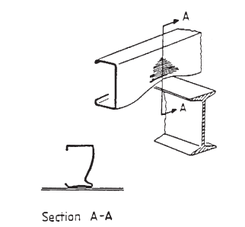

- Web crippling at a support point

d
N
≥ 1.5 d
≥ 1.5 d
L


a

(a) Interior-two-flange with hole centered beneath bearing plate

N
a
d
≥ 1.5 d
L
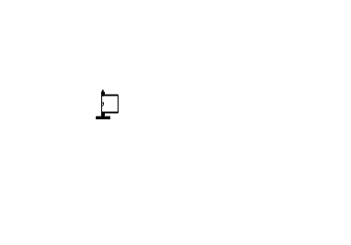

(b) End-two-flange with hole centered beneath bearing plate

N

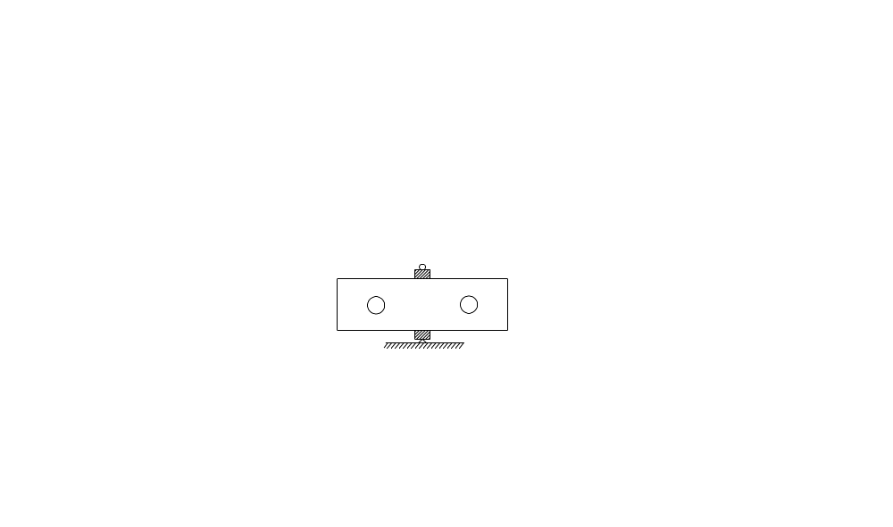
d
a
L
x
x
≥ 1.5 d
≥ 1.5 d

(c) Interior-two-flange with offset holes

- Loading conditions with web holes considered by Uzzaman et al

N
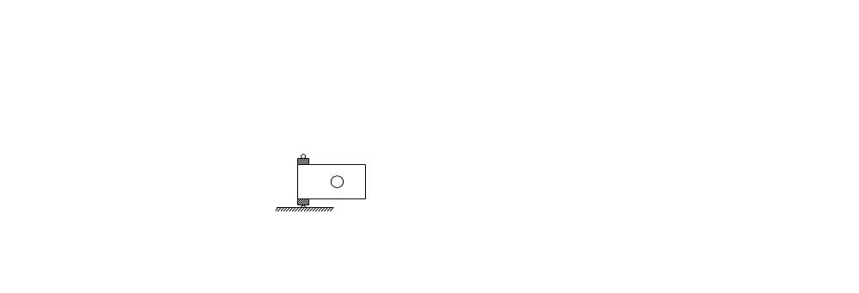
d
a
≥ 1.5 d
L
x

- End-two-flange loading condition with offset holes

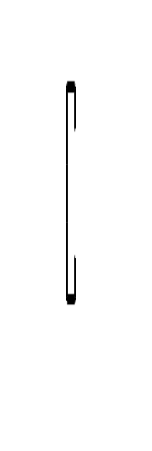
d
h
b_{f}
r_{i}
a
t
b_{l}

- Definition of symbols

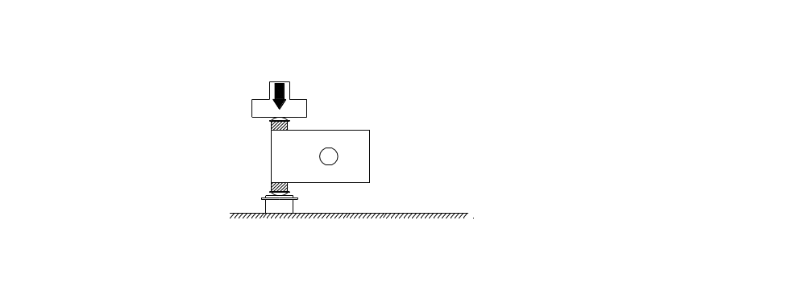
Loading Ram
Half Round
Bearing Plate
Support
Bearing Plate
Half Round
Test Specimen
a
25 mm
d
25 mm
≥ 1.5 d
L
N

x

(a) Front view

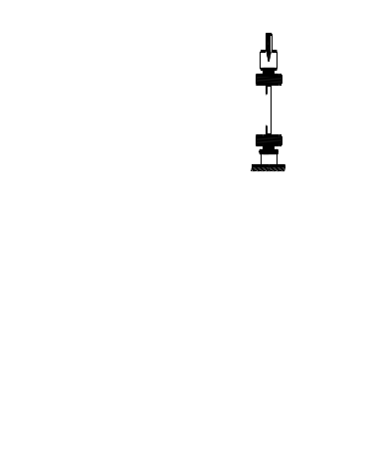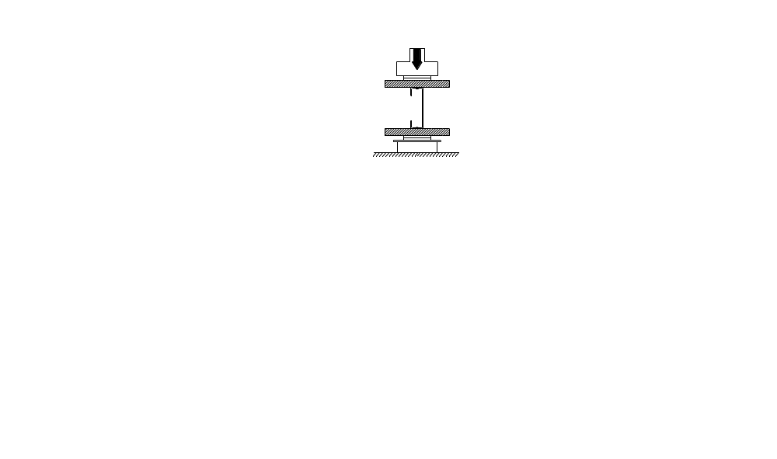
Loading Ram
Half Round
Bearing Plate
Support
Bearing Plate
Half Round
Test Specimen
Bolts
(b) End View (Unfastened flanges) (c) End View (Fastened flanges)

- Schematic view of test set-up

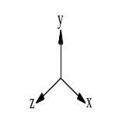
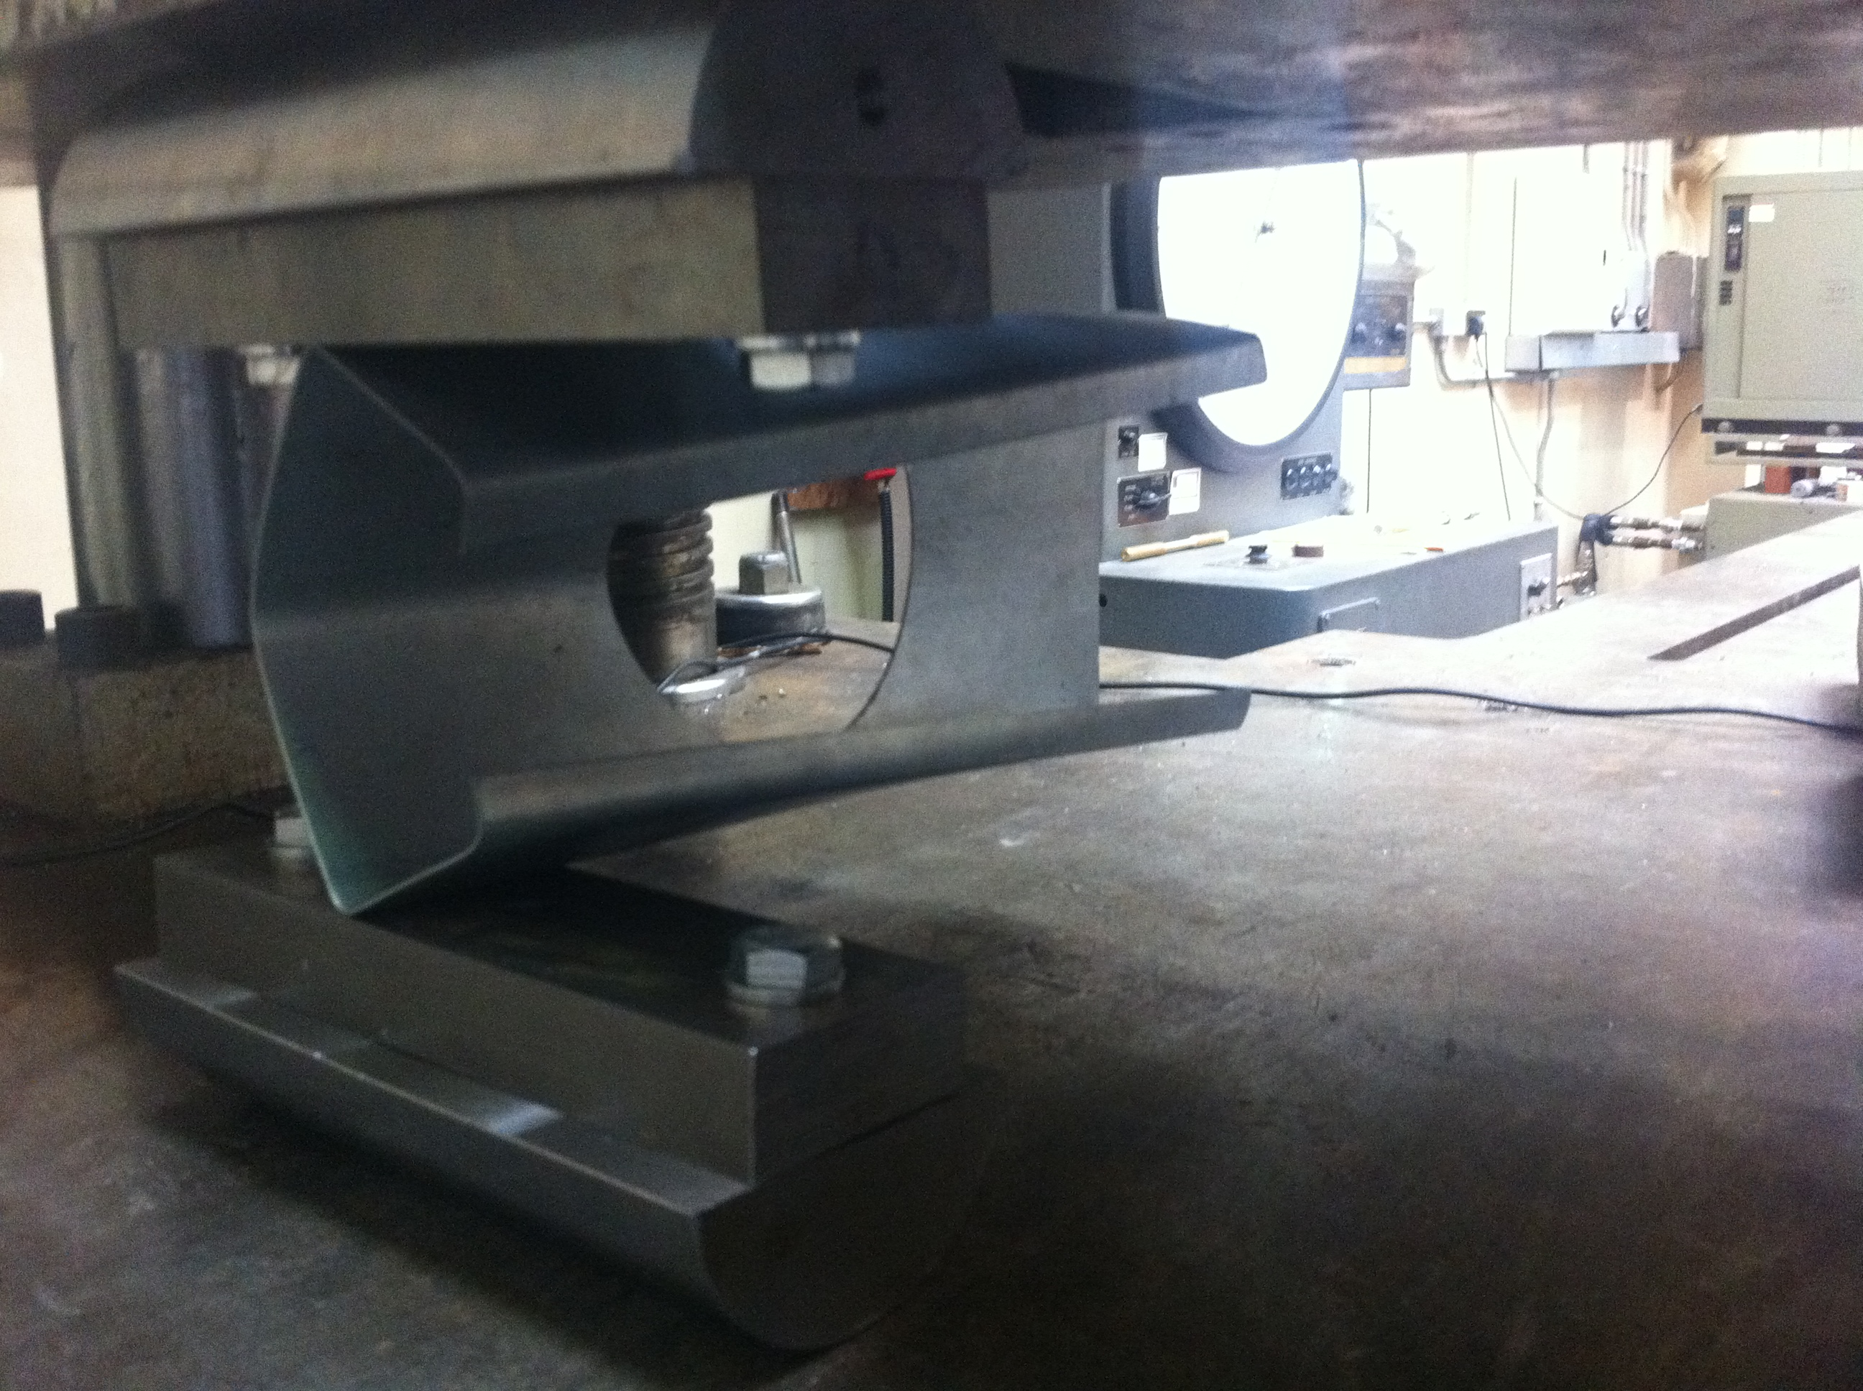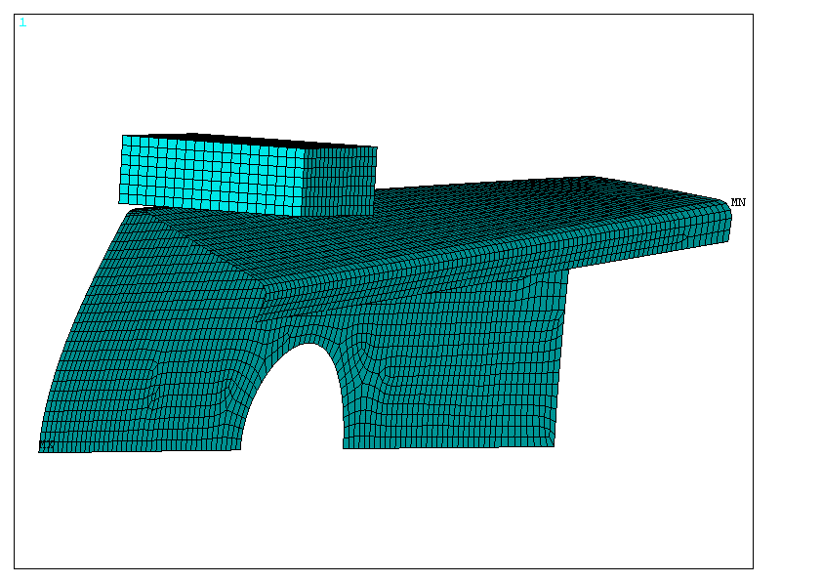
Half Round
Half Round
Bearing Plate
Bearing Plate
Specimen

(a) Experimental (b) FEA
- Comparison of experiment and finite element analysis for the flanges unfastened condition

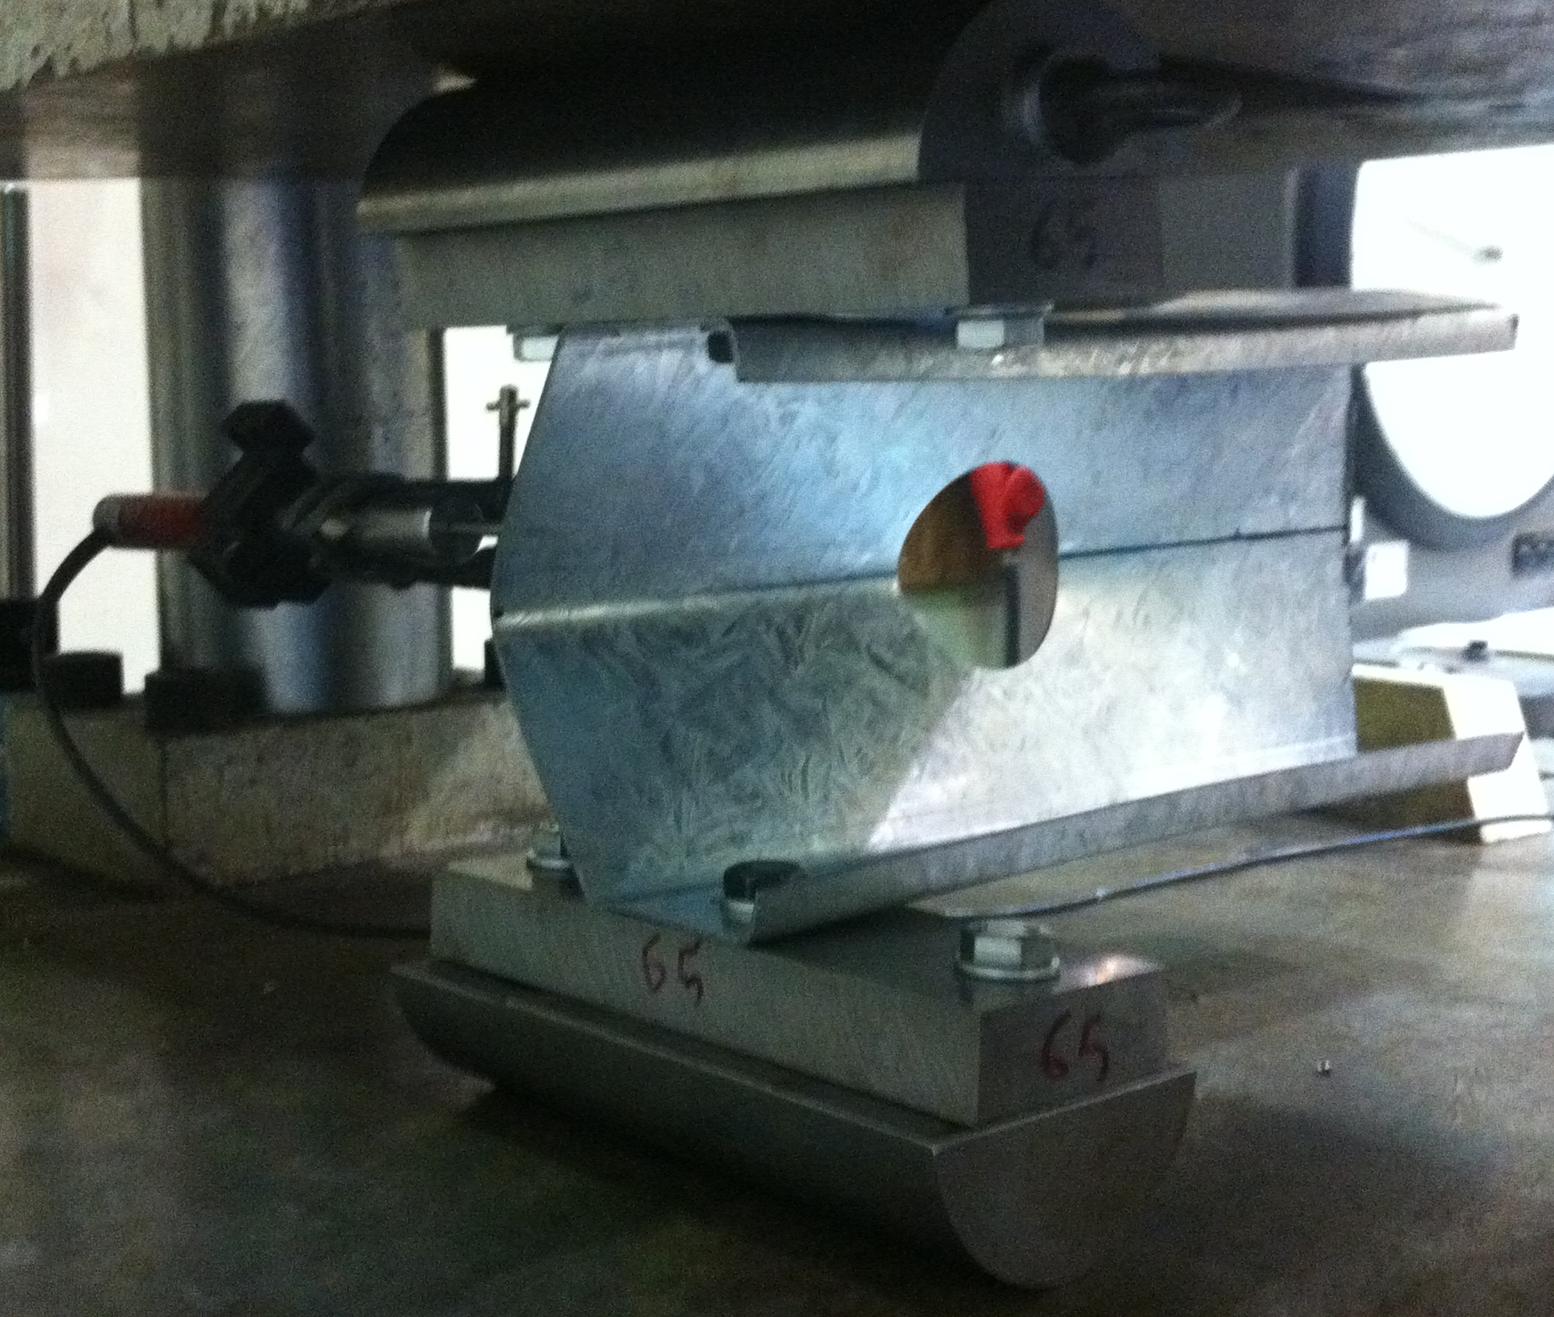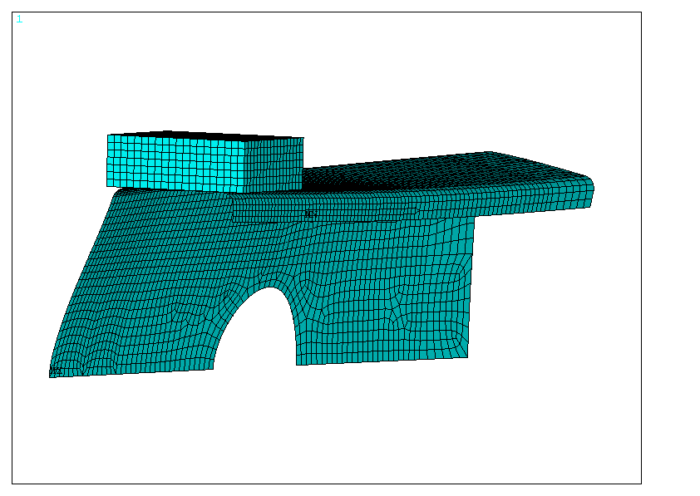
Specimen
Bearing Plate
Half Round
Bearing Plate
Half Round
Bolts
(a) Experimental (b) FEA

- Comparison of experiment and finite element analysis for the flanges fastened condition

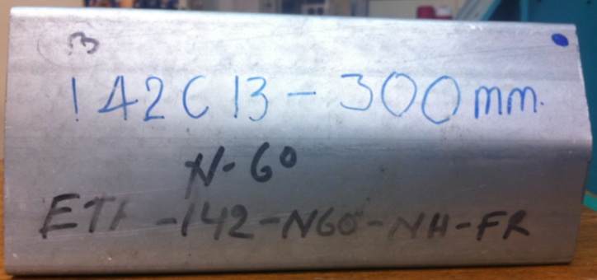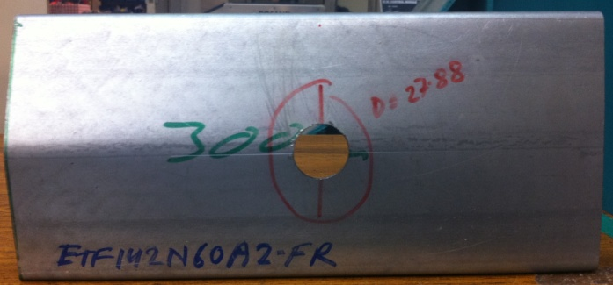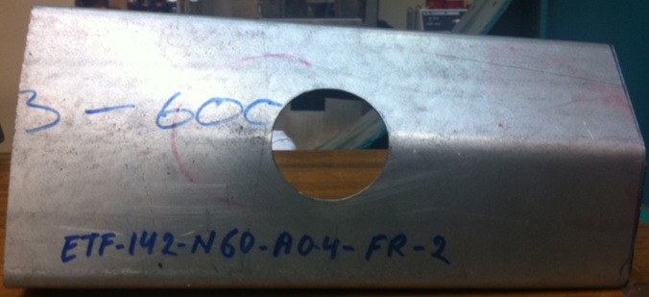

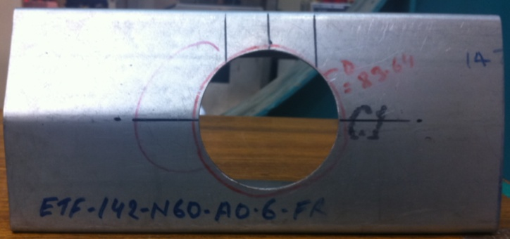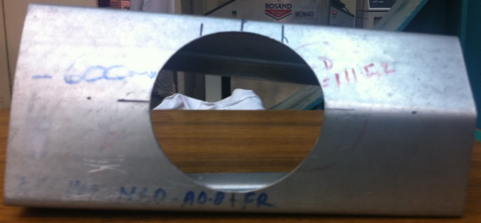

(a) Specimen for the flanges unfastened condition

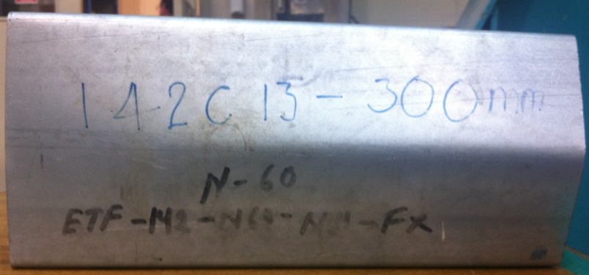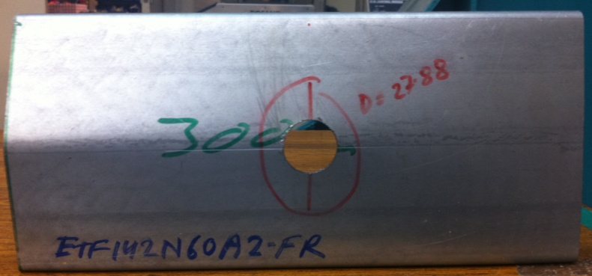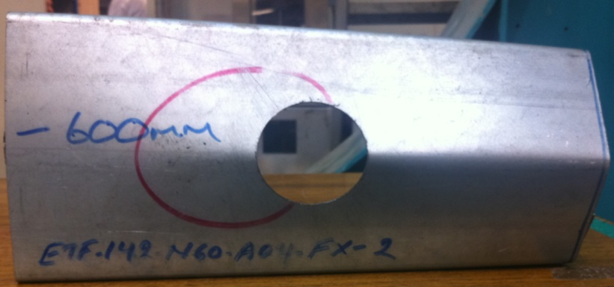

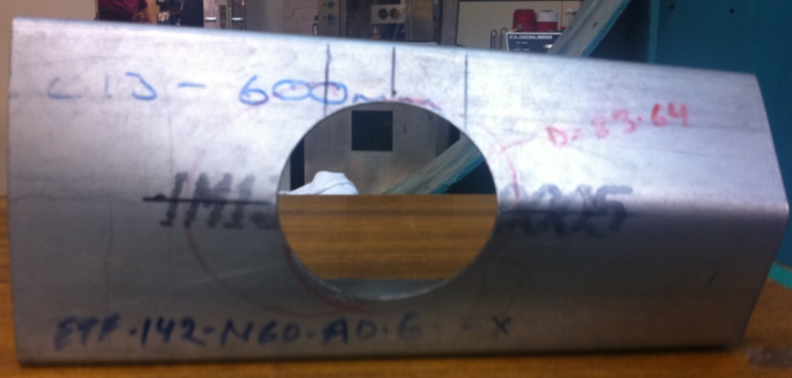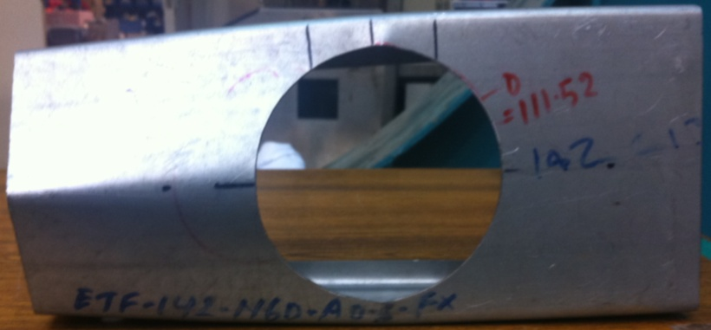

(b) Specimen for the flanges fastened condition

- Typical failure mode of the specimens

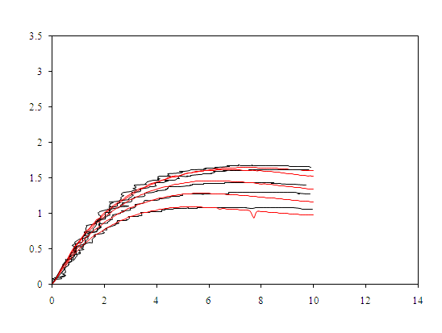
Displacement (mm)
Applied load per web (kN)
A0-Test
A0.6-FEA
A0-FEA
A0.6-Test
A0.2-FEA
A0.2-Test
A0.4-Test
A0.4-FEA
A0.8-Test
A0.8-FEA
- Comparison web deformation curves for specimen 142×60×13-t13N30FR

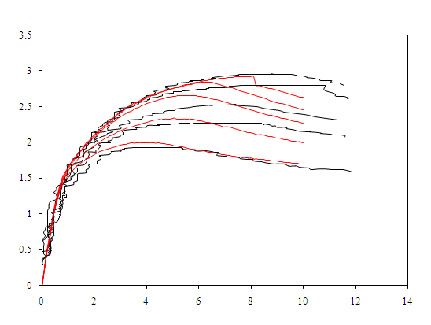
Applied load per web (kN)
A0-Test
A0.2-FEA
A0-FEA
A0.2-Test
Displacement (mm)
A0.8-FEA
A0.8-Test
A0.4-FEA
A0.4-Test
A0.6-FEA
A0.6-Test
- Comparison web deformation curves for specimen 142×60×13-t13N30FX

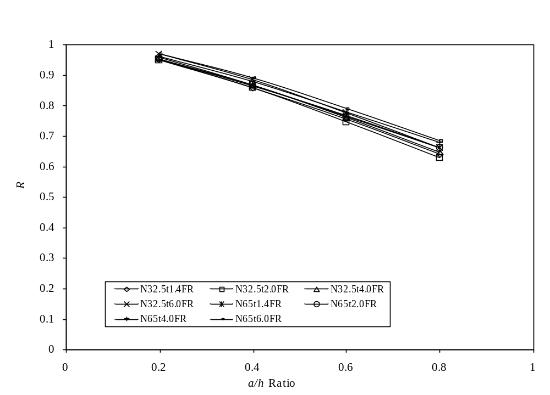
(a) Flanges unfastened condition
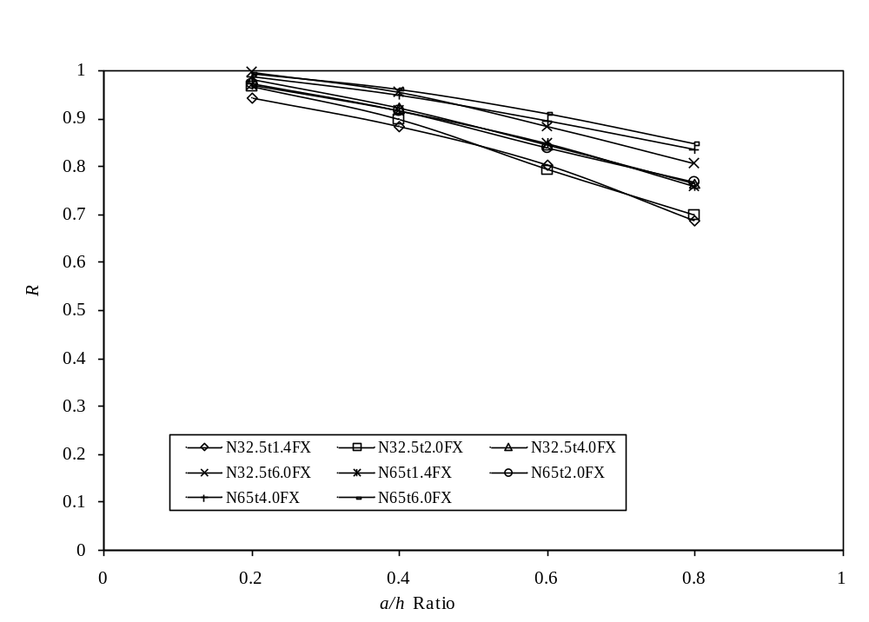
(b) Flanges fastened condition

- Variation in reduction factors with sizes of holes diameter ratio for C202 section

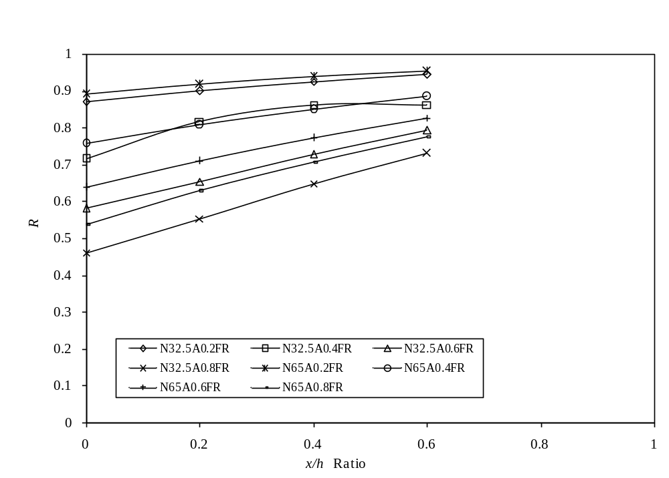
(a) Flanges unfastened condition
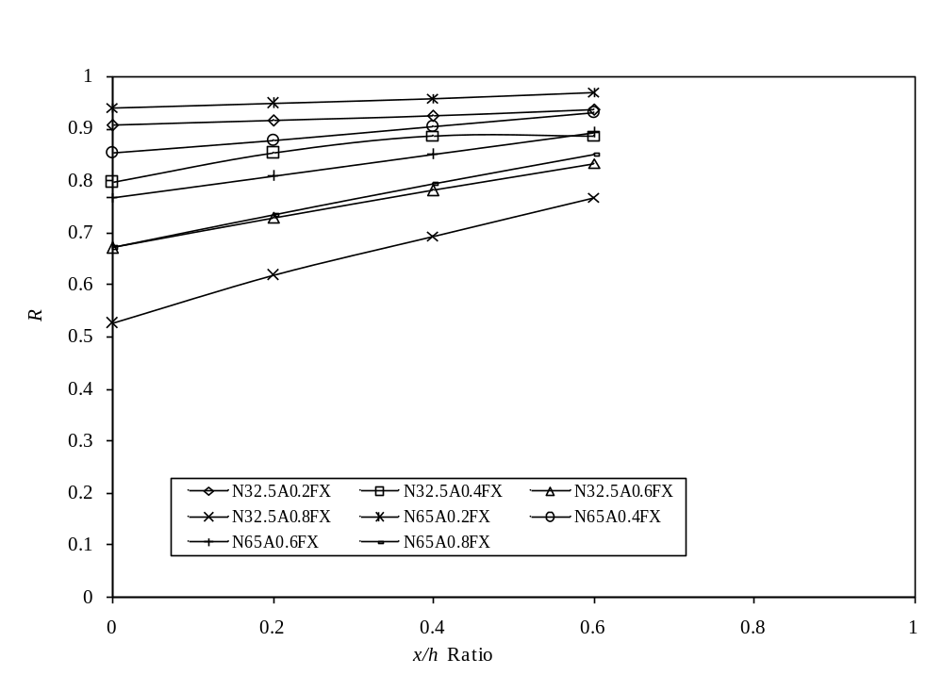
(b) Flanges fastened condition

- Variation in reduction factors with holes position ratio for C202 section

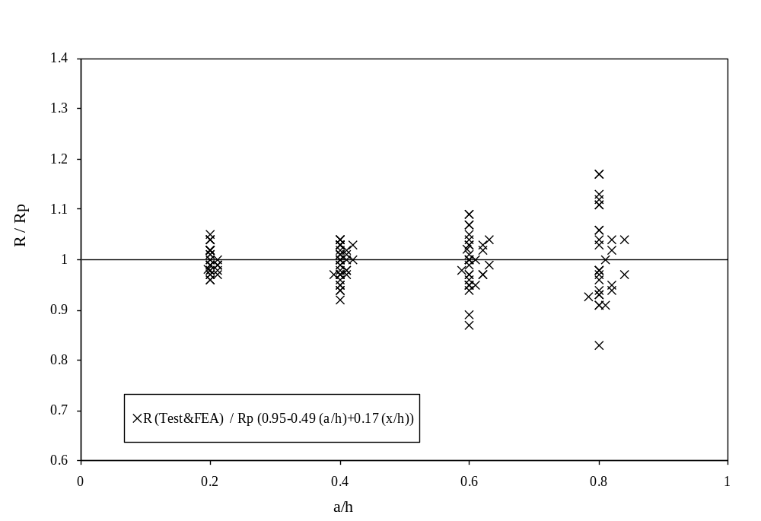
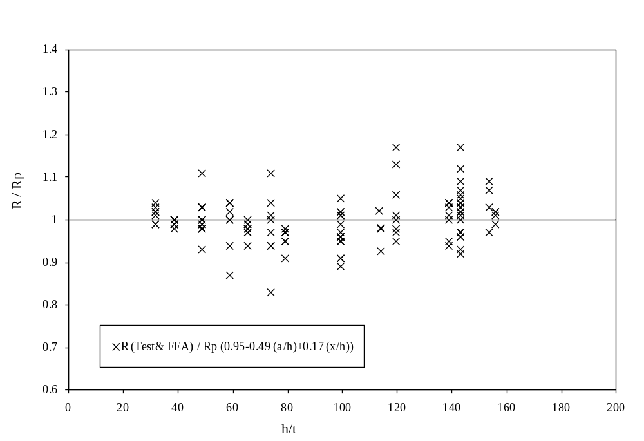

- Comparison of the strength reduction factor for the flanges unfastened condition

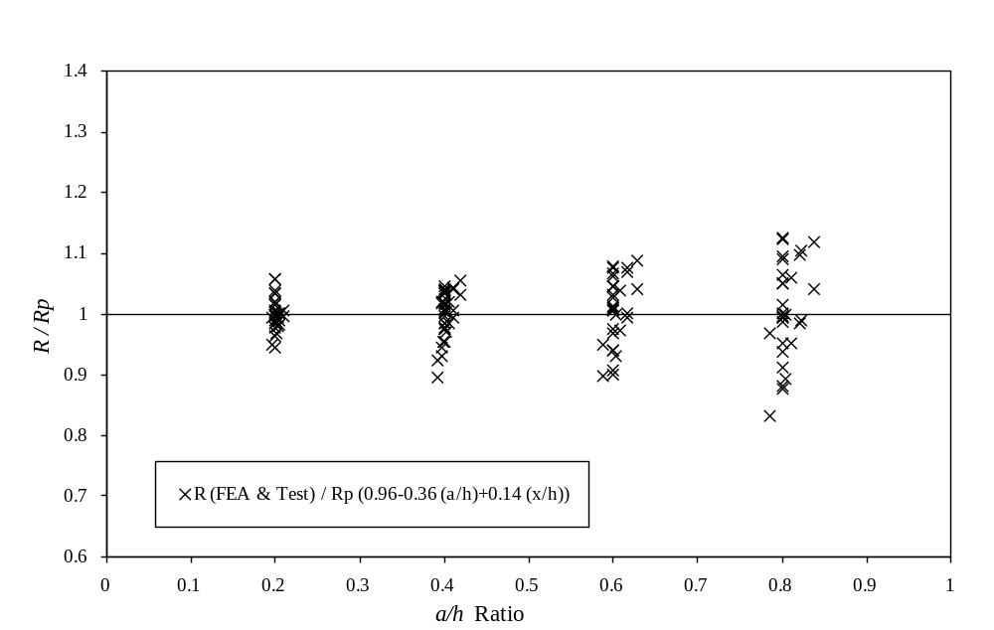
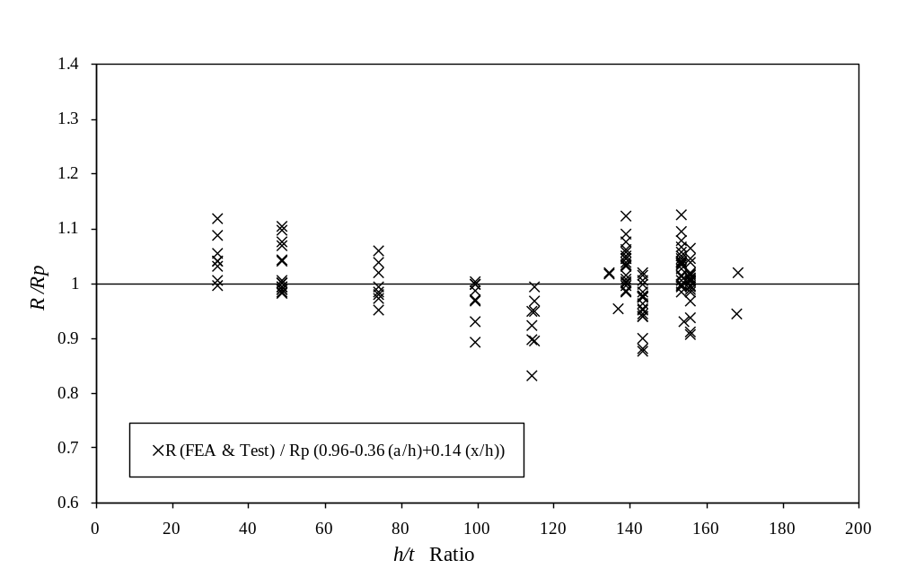
- Comparison of the strength reduction factor for the flanges fastened condition

