On the Application of Weibull Analysis to Experimentally Determined Single Fibre Strength Distributions
J. L. Thomason
University of Strathclyde, Department of Mechanical and Aerospace Engineering, 75 Montrose Street, Glasgow G1 1XJ, United Kingdom.
Abstract
The application of Weibull theory to the analysis of experimental data obtained from the tensile testing of reinforcement fibres is widespread in composites research and development. One basic assumption implicit in the use of Weibull analysis is that all values of fibre strength described by any set of unimodal or multimodal Weibull parameters are accessible experimentally. However, this is not the case, as a minimum level of fibre strength is necessary in order to be able to isolate, prepare and test any fibre. In this paper the consequences of this experimental limitation are explored in terms of the commonly applied Weibull graphical analysis method. It is demonstrated that this can result in significant curvature in a standard Weibull plot at the low strength end of the data. Furthermore, at low sampling numbers this effect can be misinterpreted as evidence of multiple defect populations. The phenomenon significantly affects the values of the Weibull parameters obtained from the graphical analysis and also from the average strength versus gauge length analysis. The presence of this lower limit presents a serious challenge to those wishing to support conclusions on the physics and mechanics of fibre fracture from Weibull analysis of single fibre tensile data.

Keywords: A Fibres, Carbon fibres, Glass fibres, B Strength, C Modelling
Author Nominated – Weibull Analysis
1.Introduction
Fibre-reinforced polymers composites continue to enjoy a rapid growth in their development and application in many areas of society due to their attractive mechanical performance to cost ratio. Much of the composite mechanical performance is derived from the use of reinforcement fibres with high levels of specific modulus and specific strength. Consequently there is continued high level of scientific interest in characterising the strength of the major reinforcement fibres. Reliable characterisation of the strength of reinforcement fibres is critical to many areas of composite research. Fibre strength not only directly determines the strength performance of continuous fibre reinforced laminates but also indirectly to the strength of discontinuous fibre reinforced composites. The determination of single fibre strength and the ability to extrapolate fibre strength at different lengths is essential in the micromechanical study of the fibre-matrix interface. Consequently the determination of the strength of single fibres and fibre bundles is critical to many areas of composites science and technology. Carbon fibre and glass fibre are probably two of the most industrially important reinforcement fibres and both of these are brittle fibres which exhibit a marked scatter in strength due to the presence of flaws introduced during processing and handling. Fibre strength is often described as following the weakest-link theory which assumes that a given volume of material will fail at the most detrimental flaw. The measured strength of brittle fibres normally exhibits a distribution, which may be analysed using different probabilistic approaches. However, data from this type of single fibre and bundle strength measurement is commonly subjected to further detailed analysis using Weibull statistical analysis [1,2]. The analysis relies on the assumption that the failure of fibres as a function of applied load is controlled by the random distribution of a single type of defect (unimodal Weibull) along the length of the fibres. This enables equations to be developed linking the probability of fibre failure (P_{F}) at a stress level (σ) during a tensile test with a certain test gauge length (or volume in the case of variable fibre diameter) and two parameters (σ₀ and m) which characterise the density and variability of flaws in the material. When the fibre gauge length and fibre diameter and therefore the tested volume is kept constant
$P_{F}=1−\text{exp}\left[−\frac{V}{V_{0}}{\left(\frac{σ−σ_{T}}{σ_{0}}\right)}^{m}\right]$ (1)
The parameter σ_{T} is included in the more general three parameter model where σ_{T} is defined as a threshold stress below which the failure probability is zero. It has been common practice to set the value of σ_{T} to zero for brittle materials [3-15] which significantly simplifies the analysis of equation 1.

The presentation of such an analysis will often depend on the goals of the investigators involved. The Weibull shape parameter m can be obtained from analysis of average fibre strength (<σ_{V} >) at different gauge lengths which then allows prediction of <σ_{V} > at gauge lengths outside of the easily accessible experimental range [3]. Weibull parameters are also commonly obtained from the analysis of a dataset obtained at a single gauge length. In this case equation 1 can be rearranged to give
$\text{ln}\left[−\text{ln}\left(1−P_{F}\right)\right]=m\text{ln}\left(σ\right)−m\text{ln}\left(σ_{0}\right)$ (2)
and the experimental fibre strength data plotted following equation 2 should give a straight line from whose equation the parameters σ₀ and m can be estimated using the Least Squares (LS) regression method. A number of authors have indicated application of the Maximum Likelihood (ML) analysis method to such single gauge length datasets produces better estimates of the underlying Weibull parameters than the LS method [16,17,18]. In both cases the more ambitious approach is then to apply a further interpretation of these parameters in terms of the physical state of the fibre surface in terms of flaw density and severity. In this context van der Zwaag stressed that the Weibull theory remains a statistical theory, which is not based on detailed physical models for the fracture process [16]. Consequently great care should be taken in using Weibull plots to draw conclusions on the physics or mechanics of any fracture process. Only if additional information is available should Weibull plots be used to support (not prove) new fracture models. Nevertheless, a cursory examination of the literature on single carbon and glass fibre testing reveals that the fitting of such unimodal Weibull distributions to experimental fibre strength results has become accepted common practice [3-14]. However, the quality of the linear relationship in some published unimodal Weibull analysis is frequently questionable. Indeed, further levels of structure can often be observed in Weibull plots of experimental fibre strength data. Some authors choose to ignore such deviations whereas others postulate these deviations as evidence of a more complex physical state of the test material.
One such deviation that has received significant attention is an increase in the slope of the line in a Weibull plot at low strength values. Beetz noted such a relationship in a Weibull analysis of single carbon fibre strength results [4,5] and more recently Zinck et al have noted similar effects in glass fibre strength data [3,6]. It has been postulated that this is evidence of multiple populations of defects on the fibres surface and consequently a bimodal Weibull cumulative density function should be applied to the data [3-6]. In this case P_{F} is given by:
$P_{F}=1−q\text{exp}\left[−{\left(\frac{σ}{σ_{\text{01}}}\right)}^{m_{1}}\right]−(1−q)\text{exp}{\left[−\left(\frac{σ}{σ_{\text{02}}}\right)\right]}^{m_{2}}$ (3)
where $q$ is a mixing parameter, the fraction of failures due to the population (1) of more severe flaws defined by shape parameter $m_{1}$ and scale parameter σ₀₁. The remaining fraction of failures is attributed to flaws in another type of population (2) defined by shape parameter $m_{2}$ and scale parameter σ₀₂. However, a number of authors have commented on aspects other than the physics of the material which may affect the appearance of a unimodal Weibull graph of experimental data [15-17]. One such aspect is the estimation of the probability parameter P_{F} from the experimental results. The investigation of the strength of brittle fibres requires numerous experiments since fracture is statistical. The experimental approach generally consists of determining the strength of N ﬁbre specimens of the same length taken from a large population of fibres such as a fibre roving. The N strength values are then ranked in ascending order and the probability of each strength is then estimated from the rank value i and N. The general form of the estimator is given by equation 4 where α=0.5 and β=0 is commonly used. The choice of α, β and N have been shown to affect the results of the Weibull graphical analysis [15-17].
$P_{F}\left(i\right)=\frac{\left(i−α\right)}{\left(N−β\right)}$ (4)
Those familiar with single fibre testing also know well that for every successful N test results there are a large number of fibres which break during sample preparation and mounting. The probability of any selected fibre breaking before testing depends on a complex combination of factors. Clearly the fibre strength distribution plays a role in defining the number of these “weak” fibres. Fibre breakage will also depend on the force required to remove the fibre from the bundle, in this case the properties and distribution of the fibre sizing plays a critical role. Finally, the experience and abilities of the operator play an important role in determining the minimum level of fibre strength required to isolate and prepare a test fibre without breaking it prior to testing. Consequently, for every population of fibres, there exists a lower limit on the individual fibre strength which is experimentally inaccessible. A review of results in the literature combined with our own experience shows that this limit for glass fibre may be anywhere from 1 GPa down to 0.3 GPa. Any fibres weaker than this limit which are selected from the population will not survive to end up in the strength results to be analysed. In a somewhat similar fashion the intrinsic material properties provide an upper limit to the experimentally obtainable strength values. For instance with E-glass fibre one does not obtain a room temperature strength above the accepted pristine fibre strength of approximately 3.5 GPa. Figure 1 shows unimodal Weibull cumulative probabilities for two pairs of Weibull parameters (m=2.16, σ₀ =1.09 GPa [6] and m=5.5, σ₀ =3.8 GPa [7]) which have been taken from the glass fibre literature. It can be seen that the left hand curve represents a population of fibres which has a significant fraction (17% at 0.5 GPa) of fibres which might be too weak to obtain an experimental strength value. In the case of the right hand curve the experimentally obtained Weibull parameters predict an E-glass fibre population with a significant fraction (52%) with strength above that of pristine E-glass fibre. In this paper we report the results of modelling the effects of such practical upper and lower limits on the analysis of experimental single fibre strength data using unimodal Weibull analysis.

2.Experimental
The model data presented in this paper were generated using Minitab 16 statistical software. The various sets of model Weibull distributed fibre strength data were randomly generated with the Calc:Probability Distribution(Weibull) function using the desired input values of N, m and σ₀. Graphical analysis of these data sets according to equation 2 was carried out using a Least Squares (LS) regression method with the Stat:Regression function. Where required, P_{F} were values were generated using equation 4 with α=0.5 and β=0. Maximum Likelihood (ML) analysis was performed on the various datasets using the Graph:Probability Plot (Weibull) function. Where appropriate, the Graph:Probability Plot function was also used to fit three parameter Weibull distributions. Upper and lower limits were applied to the ordered datasets by the simple expedient of deleting the unwanted values.

3.Results
3.1 Effects of the number of tested specimens N
Figure 2 presents a Weibull plot of five data sets randomly generated with Weibull parameters [7] σ₀ =3.88 and m =5.5 and different values of N, the data sets have been shifted vertically in steps of -1 for clarity. It can be observed that all data sets appear to give a reasonable straight line fit although as N decreases the spread of the data around the line becomes greater. It can also be seen that the Weibull parameters generated from these lines show some significant differences with the input values. The choice of the value of N is an important consideration in fibre strength measurements. N should be large enough to give confidence in the value of the Weibull parameters obtained but it is usually desired to keep N as low as possible to minimise the experimental resources required in any study. To further investigate N effects, ten data sets were generated for a range of N values (20-320) and for three different sets of Weibull parameters. The resultant “experimental” Weibull parameters were obtained using LS analysis of graphical method and the coefficients of variation (CoV) were calculated for σ₀ and m. The results from this exercise are presented in Figure 3. Similar trends are observed for all three sets of Weibull parameters studies and so the overall trend is illustrated by plotting the average values at each N value. It can be seen that the values of σ₀ obtained from Weibull plot analysis is much less variable than the values obtained for m. This is in line with results of a Monte Carlo simulation reported by Masson and Bourgain [18]. There is a general trend for the accuracy of the estimation of the Weibull parameters to improve as N is increased. However it can be seen that the accuracy of the estimation of the value for m improves steeply as N is increased up to 80. For N>80 the improvement is much less significant although the level of accuracy of the Weibull parameters does continue to improve slowly up to N=320. However, using such high numbers of actual single fibre samples would become prohibitive in terms of the resources required to carry out such tests where a number of different variables were to be investigated. Consequently it would appear that a value of N greater than 80 would seem to be a good recommendation for the number of fibres to be tested in a single fibre experiment. This is a significantly higher sample number than used by many authors [6,9,11,13,15,18].

As discussed above, the ML method of analysis has been proposed to improve the accuracy of the estimation of the Weibull parameters from experimental results. The 210 datasets used to generate Figure 3 were consequently also analysed using the ML method and the results for the overall average CoV’s from both methods are compared in Figure 4. It can be seen that, for the estimation of σ₀, the trends for both LS and ML methods are very similar. There is some indication that the ML method may provide a slightly more reliable estimation of σ₀ only when N<80. For the estimation of m the data in Figure 4 does appear to support the proposal that the ML method provides more accurate (lower CoV) results [18]. However, the general trend for the dependence of the m CoV on N is similar for both methods and even when using the ML method of analysis an experimental value of N≈80 is recommendable. Below this value of N the CoV of the estimation of m rises much more steeply than above.

3.2 Effects of upper and lower limits in the experimental data
Figure 5 shows the effects of introducing an upper limit (3.5 GPa) in the data points selected from the computer generated fibre strength distribution with the same Weibull parameters as the results in Figure 2. When N=20, and without any prior knowledge of the upper limit being in place, it seems likely that a simple straight line fit would be made to the data. For N=40, the least squares regression results in a straight line with an R²=0.97 which in most cases would also be found an acceptable fit. However, when N is sufficiently large, the data clearly becomes concave upwards as the strength approaches the upper limit. Given that many of the Weibull plots available in the literature have N<50 it seems likely that this potential effect may often be overlooked with the result that the m value obtained from a best straight line fit would be pushed higher.

In a similar manner Figure 6 shows the effect of introducing a lower limit to the strength of fibres randomly generated (N=320) using a Weibull strength distribution with σ₀ = 1 GPa and m=3. This is the equivalent of censoring all values which are too weak to survive the sample preparation and mounting process from the test results. It can be seen that as soon as a lower limit is introduced the data at the low strength end of the graph begins to curve downwards. The larger the lower limit the greater the deviation becomes. It is also interesting to note that the introduction of this lower limit actually influences the shape of the curve quite far up the strength axis with the deviation from linearity occurring at significantly higher strength values than the limit itself. These points of deviation from linearity are highlighted in Figure 6 and it was found that the strength value of this inflection point actually scales linearly with the magnitude of the lower limit introduced. The potential to misinterpret this effect is emphasised in Figure 7 which shows the results of five such computer experiments with N=80 and a lower limit of 0.5 GPa (which is considered quite representative of a real experimental situation with single glass fibres). The data in this Figure have been systematically shifted horizontally for clarity. It is clear from the results in Figure 6 that a large number of the fibres in a population are tested then the lower limit effect will be clearly seen as a curve continuously deviating from linearity. However, since only a small fraction of the available single fibre population is experimentally tested the data has a much more discrete form which would make identification of this curvature more difficult in a Weibull. In the absence of any previous knowledge of the continuously curving form that would be expected from such data, this allows the observer to see different regions of linearity with different slopes. This is illustrated with the lines added in Figure 7. Once again due to the selection of only a relatively low fraction of the population it is sometimes possible to see two linear regions and sometimes three.

Figure 8 illustrates the use of the lower limit model with some experimental data from single glass fibre testing where fibre breakage during sample preparation was a common issue. The data are taken from experiments on unsized glass fibres [19] and the same fibres after a heat treatment at 400°C [20]. In both cases these glass fibres are extremely sensitive to handling damage due to the absence of any protecting sizing on the fibre surface. Both experimental data sets display what appear to be two linear regions in the Weibull plot with the higher slope at low fibre strength. However, the Figure also shows the results from modelling experiments which show that both data sets can be fitted with the same Weibull modulus value and a similar lower strength limit (due to experimental limitations). The characteristic strength of the heat treated fibre is lower due to some change in the physical state of the glass fibres during the heat treatment [20]. As discussed above the actual lower limit on fibre strength is operator dependent and in this case the data were generated by two different operators. In fact the lower limit can potentially be different for each individual single fibre experiment given the operator variability during sample preparation may be different for each fibre. However, an experienced operator will eventually develop a skill level which should result in a relatively constant lower limit for an individual fibre bundle. The nature and distribution of the fibre sizing and the resultant effect on the fibre to fibre adhesion in a fibre bundle will still complicate data interpretation since this will produce different values of lower limit for differently sized fibre bundles and perhaps also for fibre bundles with different diameter distributions.

4.Discussion
The appearance of changes in curvature or “doglegs” in a unimodal two parameter Weibull analysis is a known phenomenon. As discussed above one possible interpretation of these situations is the presence of more than one possible failure mode in the material under test. However, these apparent changes in slope in a Weibull plot may also indicate that the σ_{T} parameter in equation 1 is non-zero and consequently the three parameter unimodal Weibull model should be applied [17,21]. It has become common practice to set σ_{T} to zero in brittle fibre analysis [3,6,22] and indeed many authors do not even refer to its existence when presenting a Weibull analysis of fibre strength data [4-7, 10-14]. However the recommendation to set σ_{T} to zero appears to be based on a single publication involving the flexural testing of the strengths of reaction-sintered silicon nitride macroscopic specimens which exhibit a rather small range of strengths [22]. This is already a very different test compared to tensile testing of single reinforcement fibres of a microscopic scale. Furthermore, in their analysis of the estimation of Weibull parameters these authors noted that “whatever criterion (value of σ_{T} in their analysis) is used there is clearly not much to choose between the distributions as regards their goodness of fit”. It should also be noted that veracity of the conclusions of this paper was the subject of further discussion [23]. Consequently the very general recommendation “that for brittle materials σ_{T} =0” made by Trustrum and Jayatilaka should be carefully considered in terms of the very specific (flexural) testing conditions, scale and single brittle material, used in their experiments. The use of Weibull analysis is widespread outside of the composites field and descriptions and procedure for the analysis of non-linear Weibull plots are well documented [17,21]. It is known that the three-parameter Weibull distribution will show a better fit than the two-parameter Weibull distribution fit simply because it is a more complex model. However if the following three criteria are met then the use of three-parameter Weibull is appropriate: a) the Weibull plot should show concave curvature; b) there should be a physical explanation of why failures cannot occur before σ_{T}; c) a larger sample size of at least 21 failures should be available [17]. From the above discussion it is clear that all three criteria are fulfilled in the case of the experimental lower strength limit in fibre testing and consequently this model should be applied in preference to a more complex multimodal analysis. It may at first appear counterintuitive to use of a threshold stress σ_{T} “below which the failure probability is zero” to model fibres which are so weak that they do not survive the sample preparation and mounting process. However, the result is the same in both cases, namely that those fibres do not appear in an experimental data set.

The application of the three parameter unimodal Weibull model to concave downwards data such as those presented in Figure 8 is relatively simple. The threshold stress must be lower than the lowest fibre strength measured σ_{min}. Consequently a value of σ_{T} slightly lower than σ_{min} can be initially chosen and this is subtracted from all experimental values of strength. The Weibull plot is constructed and the R² value of the fitted straight line is noted. The value of σ_{T} can then be changed and the procedure iterated until the highest value of R² is obtained. There are also a number of statistical analysis software packages available which will automatically perform a similar procedure to obtain the best fit of a three parameter unimodal Weibull distribution to a data set. The results of such an analysis of the data in Figure 8 using a three parameter unimodal Weibull approach (using a Minitab ML analysis) are shown in Figure 9. It can be seen that the use of a non-zero threshold stress σ_{T} related to the minimum fibre strength required to survive the sample preparation and mounting procedure prior to a single fibre test can give an excellent fit the downward concave nature of the data in a Weibull plot. Figure 10 shows the same data plotted against the modified strength parameter (σ−σ_{T}) of the three parameter model. The results now show an excellent linear relationship although the Weibull parameters obtained are significantly different from those in Figure 8. It should be stressed at this point that it is not immediately obvious that, despite the excellent fit to the data in Figures 9 and 10, using a three parameter Weibull analysis is the solution to obtain the Weibull parameters from an experimental data set with a lower experimental strength threshold since σ_{T} in this case is not purely a material characteristic. The three parameter unimodal Weibull distribution is just a good statistical predictor of this type of experimentally limited data set.

As previously mentioned such downward concave Weibull plots of the results of single glass fibre testing have been interpreted as evidence of multiple populations of defects [3,6]. It was postulated that multiple linear sections of Weibull plots could be observed and consequently a bimodal Weibull cumulative density function should be applied to the data based largely on a similar analysis of single carbon fibre testing by Beetz [4]. As observed in Figure 2 and 7 the relatively low sampling rate in most single fibre testing experiments can result in continuous strength functions such as a three parameter unimodal Weibull actually appearing to consist of multiple discrete sections. The single experimental data set for carbon fibres from Beetz [4] and a glass fibre data set from Zinck et al [3] are reproduced in Figure 11. The solid lines are three parameter Weibull distributions where the parameters have been obtained by a three parameter ML analysis. It can be seen that these data can be well described by the alternative three parameter Weibull model rather than the more complex five parameter bimodal Weibull model used in the original papers.
A further interesting observation with the application of the three parameter Weibull model to single fibre test data is in relation to the determination of the Weibull modulus m through two parameter unimodal analysis by the two commonly applied methods. It is well known that if fibre strength data are measured at multiple gauge lengths then the Weibull modulus m can be obtained from two analysis routes. The first is from analysis of data at individual gauge lengths using equation 2 as described above. The second is by analysis of average fibre strength (<σ_{V}>) at different gauge lengths using the relationship
$\text{ln}\left(\left\langle σ_{V}\right\rangle \right)=\frac{−1}{m}\text{ln}(V)+\text{constant}$ (5)
This method is frequently used by those researchers interested in obtaining an estimate of fibre strength at gauge lengths outside of the easily accessible experimental range [3,7,11,12]. A number of authors have compared the value of m obtained by these two methods and consistently report different values of m obtained from the average strength – gauge length method [3,7,11,19,24]. Equation 5 is obtained from the expression of the mean strength<σ_{V}> from equation 1 of a volume of material V (with V₀ set to unity) given by
$\left\langle σ_{V}\right\rangle =σ_{T}+σ_{0}V^{{−1}/m}Γ\left(1+\frac{1}{m}\right)$ (6)
By taking logarithm of equation 6 and setting σ_{T}=0 then equation 5 is obtained. Hence the application of equation 5 to obtain the Weibull modulus also depends critically on the assumption that σ_{T}=0. However, as shown above, the effect of a lower experimental limit in single fibre strength data can be modelled by using a non-zero value of σ_{T}, even though this is not strictly related to purely material parameters. Figure 12 shows results of the effect of assuming a non-zero value of σ_{T} in the analysis of m from single fibre experiments at different gauge lengths. The Figure shows the value obtained for m from such an analysis for various levels of experimental fibre strength threshold level for typical sets of input Weibull parameters σ₀ and m. It can be seen that the presence of such threshold strength in the experiments leads to significant increase in the value of m obtained from an average strength versus gauge length analysis. It is not immediately obvious how the value of m obtained from graphical analysis of equation 2 will be affected by this experimental lower strength limit and this will require further modelling. However, it is clear that it can no longer be expected that the two methods will result in an identical value for m. This is the situation consistently reported in the literature.

Consequently the use of a three parameter unimodal Weibull analysis of single fibre strength experiments, with a threshold level which can be physically related to the known experimental issue of the requirement of a minimum fibre strength to be able to prepare and mount the specimen, not only gives a simple explanation of the frequently observed downward concave curves observed in Weibull plots of such data but also provides a possible explanation for the consistently observed mismatch in the values of Weibull modulus obtained from the two commonly used graphical methods applied to such data. The consequences of this phenomenon are significant for the application of Weibull graphical analysis to the results of single fibre tensile testing of brittle fibres. Since the threshold value σ_{T} on the minimum measureable tensile strength of fibres extracted from a fibre population is not a purely material determined parameter, the values of m and σ₀ obtained from graphical analysis of equation 1 with an experimentally estimated non-zero value of σ_{T} may not be related simply to the nature of a flaw distribution of the fibre surface. If such a Weibull based analysis is still to be pursued it seems likely that it will be necessary to develop a method to correct the P_{F} values of the experimental data in order to account for the missing “weak” values which would have appeared in the data set were it possible to access those data experimentally.

5. Conclusions
The application of Weibull theory to the analysis of experimental data obtained from single fibre tensile testing is widespread. One basic assumption implicit in the use of Weibull analysis is that all values of fibre strength described by any set of unimodal or multimodal Weibull parameters are accessible experimentally. However, this is not the case, as a minimum level of fibre strength is necessary in order to be able to isolate, prepare and test any fibre. Fibres with strengths below this threshold strength do not appear in the experimental data. It is demonstrated that this results in curvature in a standard Weibull plot at the low strength end of the data which will only be recognised if a sufficiently high fraction of the fibre population is tested. At intermediate sampling levels the effects can appear to show two linear regions in a Weibull plot. The results of computer modelling revealed that, for a range of Weibull parameters found in the literature describing experimental glass fibre strength distributions, the sample number should be greater than 80 fibres in order to minimise the coefficient of variations of the estimation of Weibull parameters. Whatever sample number is tested, this phenomenon significantly affects the values of Weibull parameters obtained from the graphical analysis. In the case of a unimodal distribution the effect can be well represented by the use of the three parameter Weibull approach which is shown to fit very well with a number of curved experimental data sets. It is further shown that the presence of this lower limit has a significant effect on the Weibull modulus obtained using the method involving analysis of average fibre strength at different gauge lengths and that the two methods can no longer be expected to deliver the same value of Weibull modulus from the analysis of single fibre tensile testing data. The presence of this lower limit presents a serious challenge to those wishing to support conclusions on the physics and mechanics of a material fracture from Weibull analysis of single fibre tensile data.

References
- Weibull W. A Statistical Theory of the Strength of Materials. Handlingar, Royal Swedish Academy of Engineering Sciences 1939;151
- Weibull W. A statistical distribution function of wide applicability. Journal of Applied Mechanics 1951;18:293-297.
- Zinck P, Pays MF, Rezakhanlou R,Gerard JF. Extrapolation techniques at short gauge lengths based on the weakest link concept for fibres exhibiting multiple failure modes. Philosophical Magazine A 1999;79:2103-2122.
- Beetz Jr CP. The analysis of carbon fibre strength distributions exhibiting multiple modes of failure. Fibre Science and Technology 1982;16:45-59.
- Beetz Jr CP. A self-consistent weibull analysis of carbon fibre strength distributions. Fibre Science and Technology 1982;16:81-94.
- Zinck P, Mäder E,Gerard JF. Role of silane coupling agent and film former for tailoring glass fiber sizings from tensile strength measurements. J Mater Sci 2001;36:5245-5252.
- Andersons J, Joffe R, Hojo M,Ochiai S. Glass fibre strength distribution determined by common experimental methods. Composites Science and Technology 2002;62:131-145.
- Zinck P, Gérard JF,Wagner HD. On the significance and description of the size effect in multimodal fracture behavior. Engineering Fracture Mechanics 2002;69:1049-1055.
- Zinck P, Pay MF, Rezakhanlou R,Gerard JF. Mechanical characterisation of glass fibres as an indirect analysis of the effect of surface treatment. J Mater Sci 1999;34:2121-2133.
- Feih S, Thraner A,Lilholt H. Tensile strength and fracture surface characterisation of sized and unsized glass fibers. J Mater Sci 2005;40:1615-1623.
- K.L Pickering, T.L Murray, Weak link scaling analysis of high-strength carbon fibre, Composites Part A: Applied Science and Manufacturing, 1999;30:1017-1021.
- H. F. Wu and A. N. Netrwavali. Weibull analysis of strength-length relationships in single Nicalon SiC fibres. J Mater Sci 1992;27:3318-3324.
- Naito, K., Yang, J.-M., Tanaka, Y., Kagawa, Y. The effect of gauge length on tensile strength and Weibull modulus of carbon fibers . J Mater Sci 2012;47:632-642.
- W.J. Padgett, S.D. Durham, A.M. Mason. Weibull analysis of the strength of carbon fibers using linear and power law models. J Compos Mater, 1995;29:1873-1883.
- El. M. Asloun, J. B. Donnet, G. Guilpain, M. Nardin, J. Schultz. On the estimation of the tensile strength of carbon fibres at short lengths. J Mater Sci 1989;24:3504-3510.
- van der Zwaag, S., The Concept of Filament Strength and the Weibull Modulus. Journal of Testing and Evaluation, 1989;17:292-298.
- The new Weibull handbook, Robert B. Abernethy, : Distributed by Society of Automotive Engineers; New York, 1998.
- J. J. Masson and E. Bourgain. Some guidelines for a consistent use of the Weibull statistics with ceramic fibres. International Journal of Fracture 1992;55:303-319.
- Yang L, A physical approach to interfacial strength in fibre reinforced thermoplastic composites, PhD thesis, University of Strathclyde 2011.
- J. L. Thomason, J. Ure, L. Yang, C. C. Kao. Mechanical study on surface treated glass fibres after thermal conditioning. 15th European Conference on Composite Materials, ECCM15, Venice, Italy, 24-28 June 2012.
- Weibull analysis, British standard BS EN 61649:2008, BSI London 2008.
- Trustrum and A. De S. Jayatilaka. On estimating the Weibull modulus for a brittle material. J Mater Sci 1979;14:1080-1084.
- P. Kittl and O. Günther. Comments on “On estimating the Weibull modulus for a brittle material”. J Mater Sci 1982;17:922-923.
- M. G. Northolt and J. J. M. Baltussen. The tensile and compressive deformation of polymer and carbon fibers . Journal of Applied Polymer Science 2002;83:508–538.

List of Figures
Figure 1 Typical cumulative Weibull probability distributions for glass fibres
Figure 2 Effect of sample number on graphical Weibull analysis
Figure 3 Effect of sample number of the coefficient of variation of Weibull parameters obtained using LS method
Figure 4 Effect of sample number of the coefficient of variation of Weibull parameters obtained using ML and LS methods
Figure 5 Effect of an upper strength limit and sample number on graphical Weibull analysis
Figure 6 Effect of a lower strength limit on graphical Weibull analysis
Figure 7 Analysis of multiple generated fibre strength data sets with a lower strength limit
Figure 8 Comparison of lower limit model with experimental glass fibre strength data
Figure 9 ML three parameter Weibull distribution fit to experimental glass fibre strength data
Figure 10 Three parameter Weibull distribution fit to experimental glass fibre strength data
Figure 11 ML three parameter Weibull fit to published carbon fibre and glass fibre data
Figure 12 Effect of lower fibre strength threshold on Weibull modulus obtained from average strength versus gauge length analysis
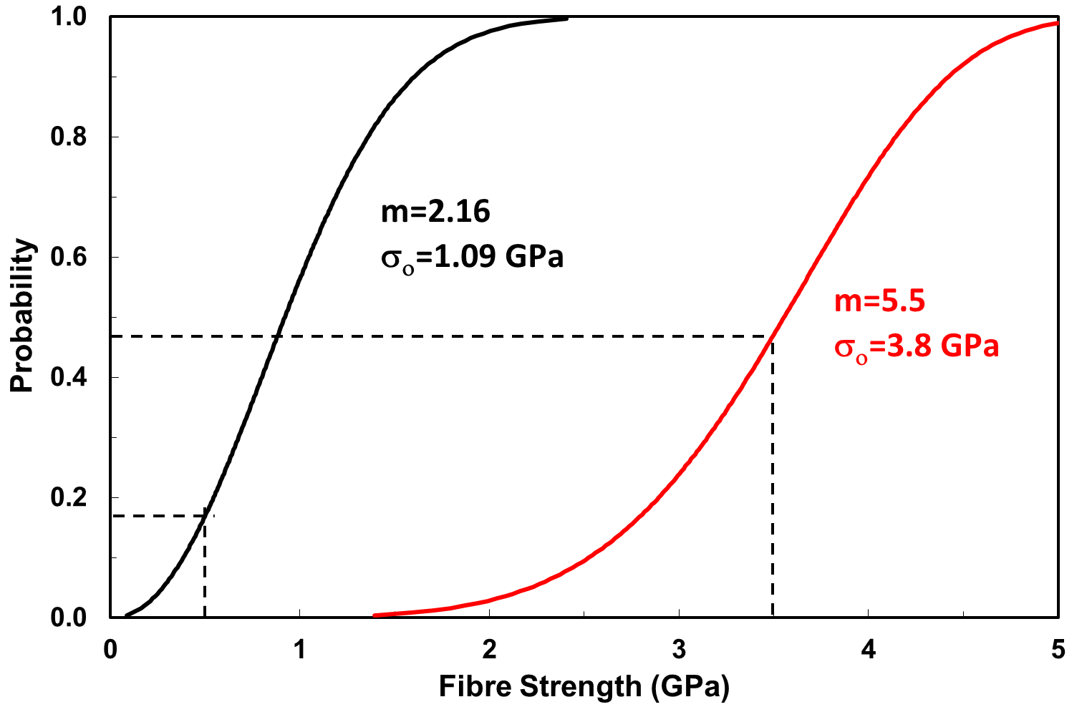Figure 1 Typical cumulative Weibull probability distributions for glass fibres

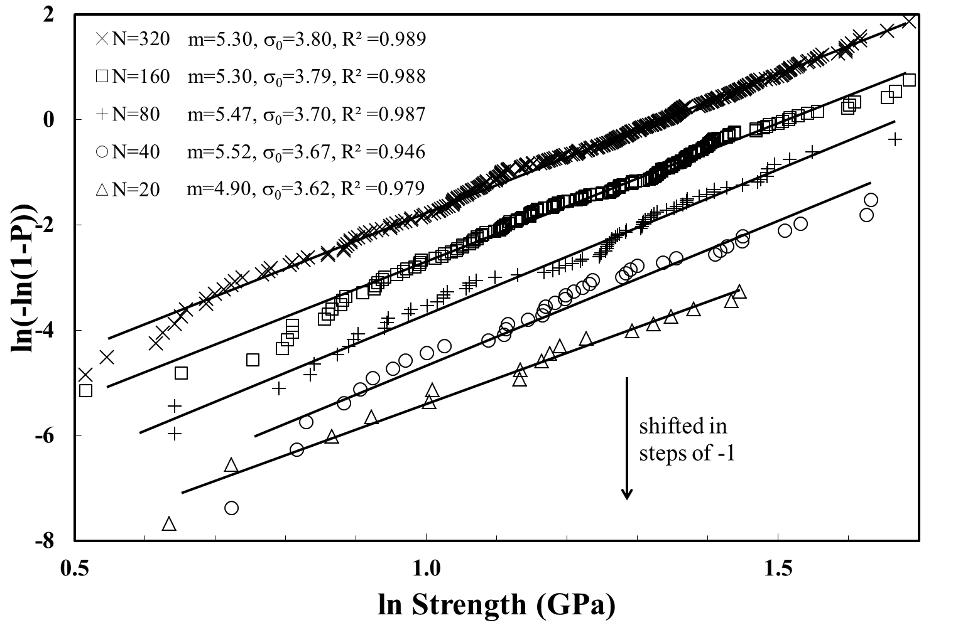Figure 2 Effect of sample number on graphical Weibull analysis

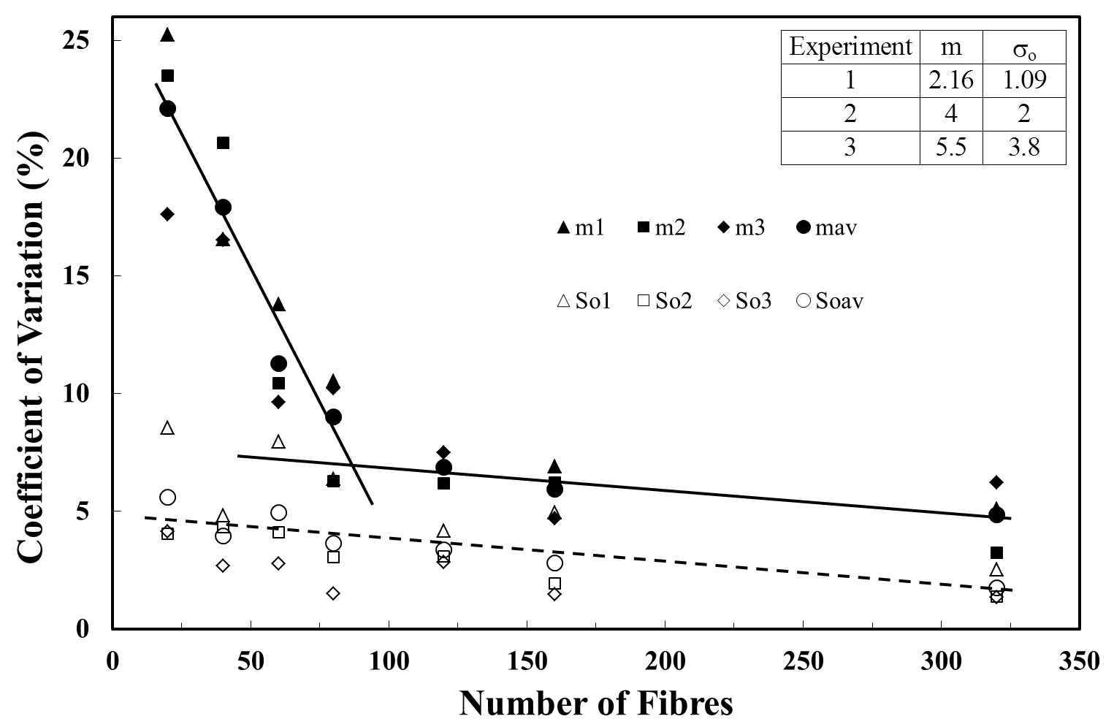Figure 3 Effect of sample number of the coefficient of variation of Weibull parameters obtained using LS method

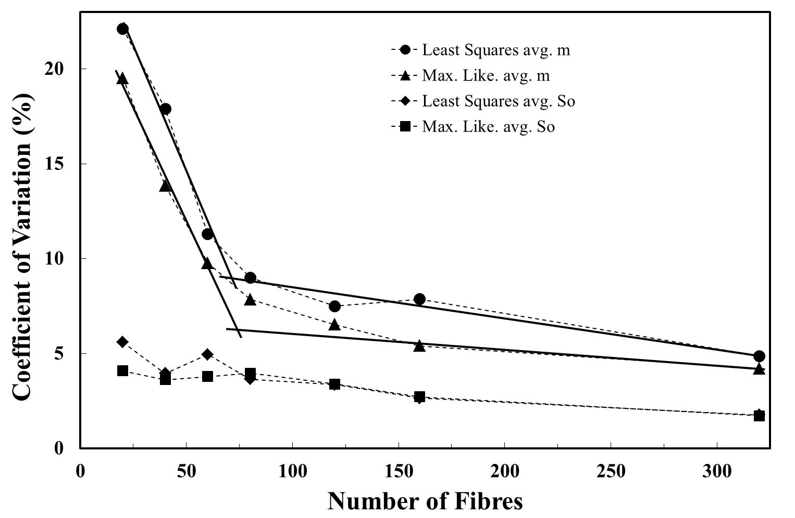
Figure 4 Effect of sample number of the coefficient of variation of Weibull parameters obtained using ML and LS methods
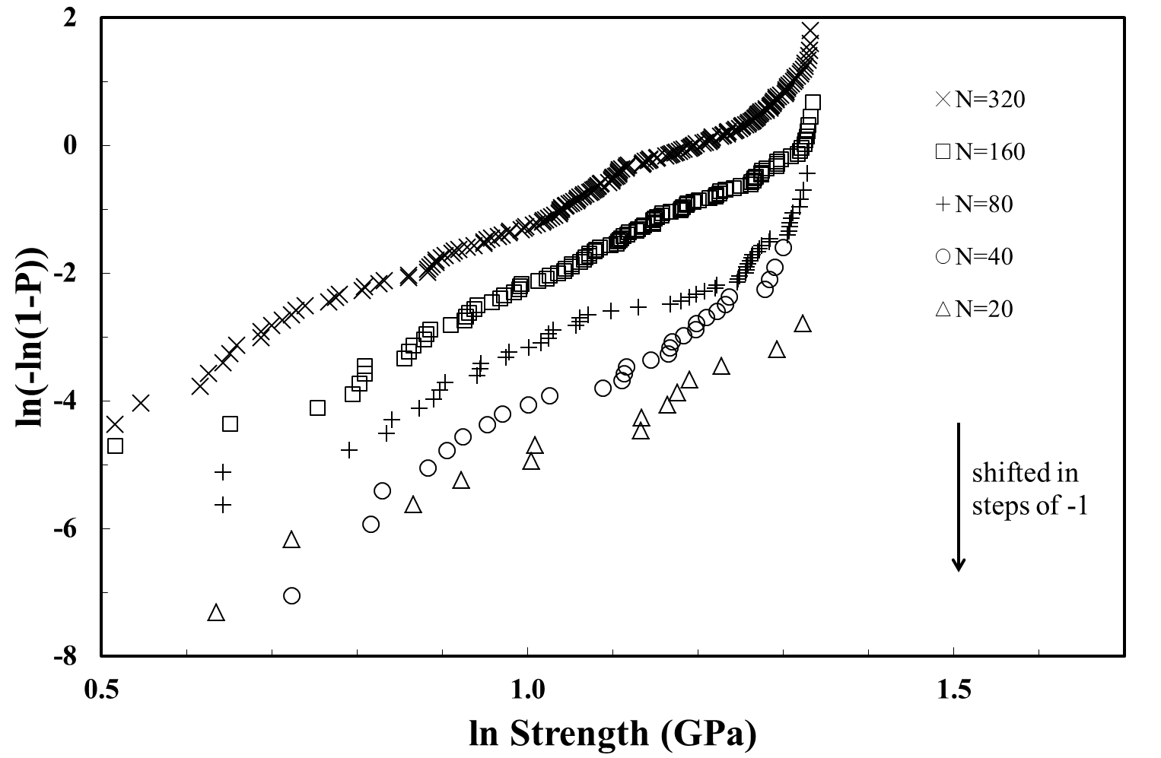Figure 5 Effect of an upper strength limit and sample number on graphical Weibull analysis

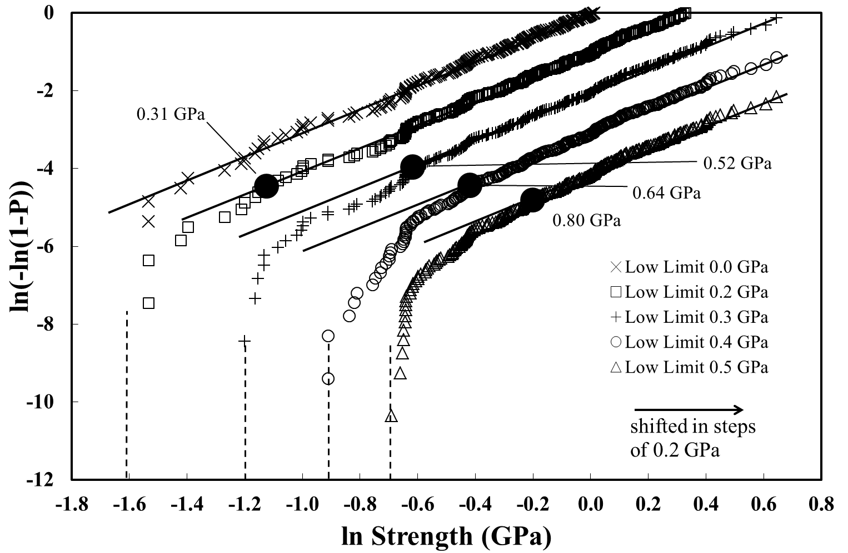
Figure 6 Effect of a lower strength limit on graphical Weibull analysis
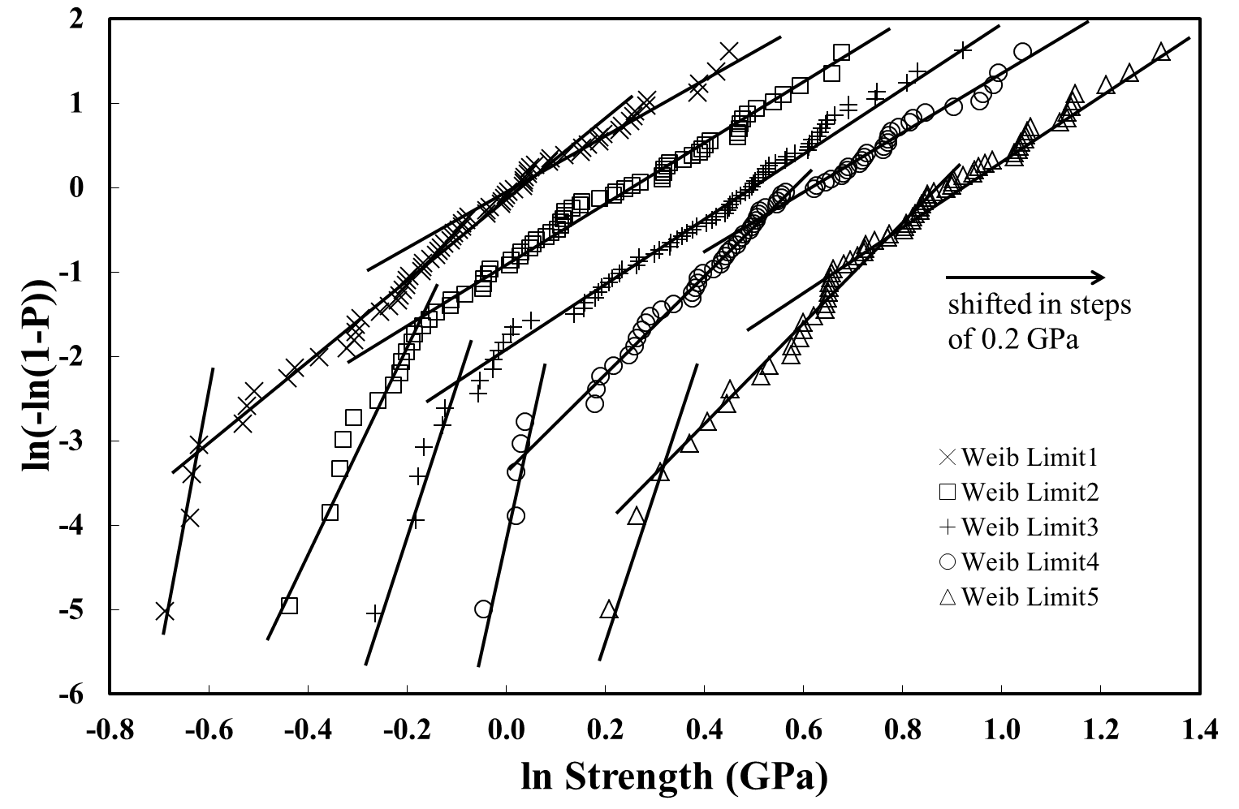Figure 7 Analysis of multiple generated fibre strength data sets with a lower strength limit

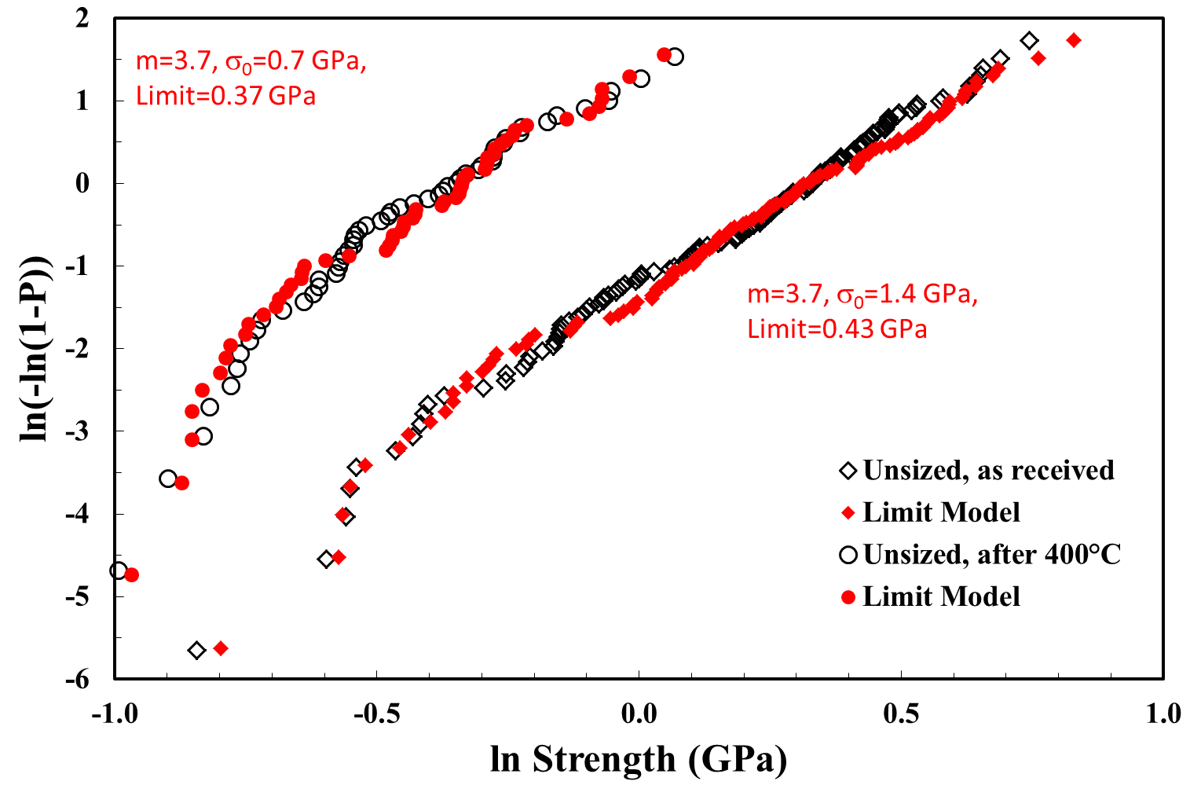
Figure 8 Comparison of lower limit model with experimental glass fibre strength data
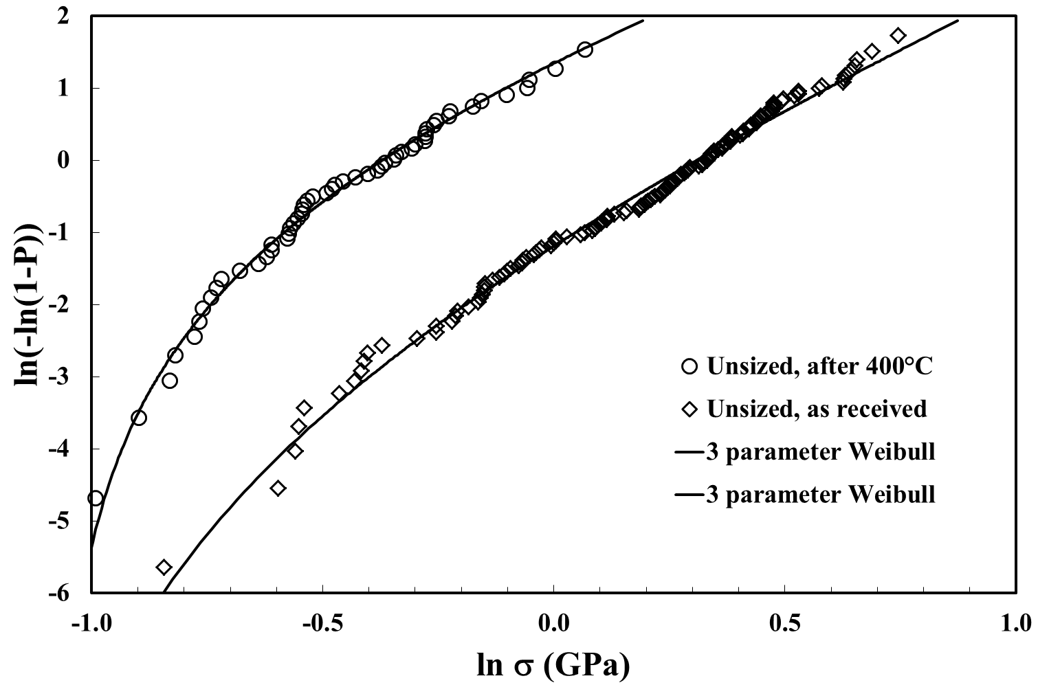Figure 9 ML three parameter Weibull distribution fit to experimental glass fibre strength data
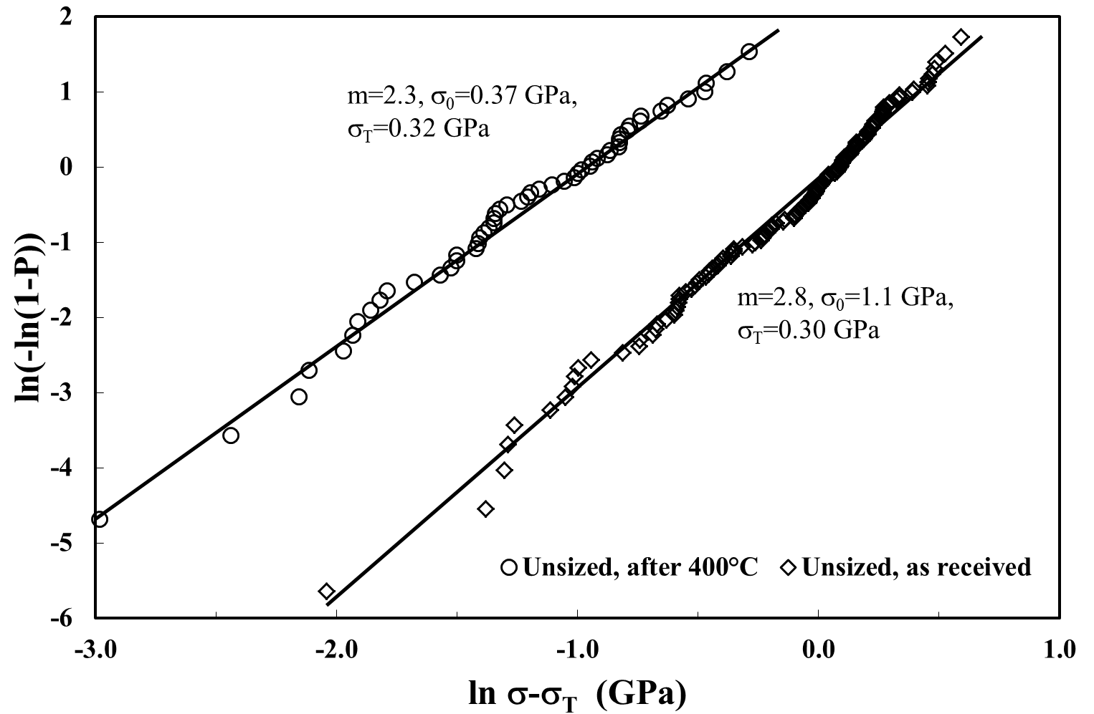Figure 10 Three parameter Weibull distribution fit to experimental glass fibre strength data

Figure 11 ML three parameter Weibull fit to published carbon fibre and glass fibre data
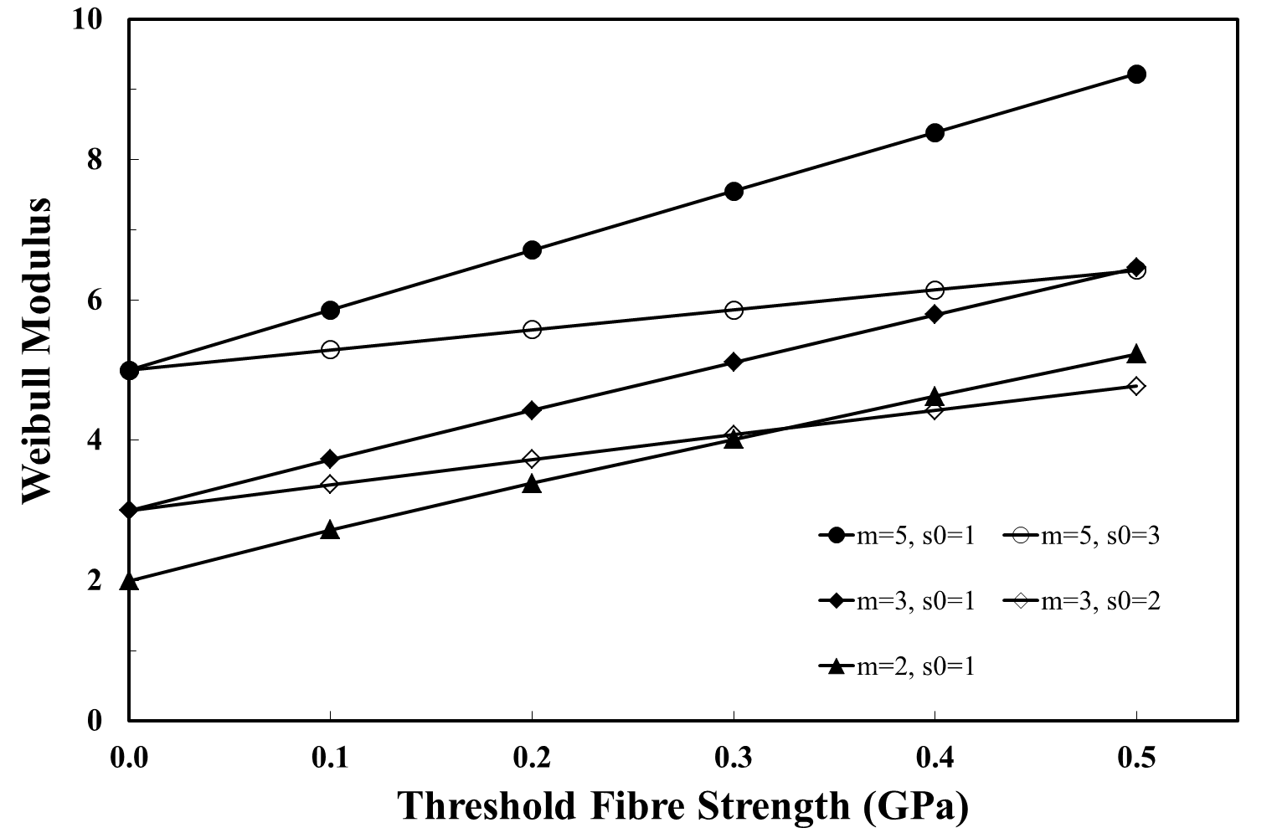
Figure 12 Effect of lower fibre strength threshold on Weibull modulus obtained from average strength versus gauge length analysis

