Ageing of Thermoplastic Umbilical Hose Materials
II – Nylon.
Monika Brodesser^{1, 2}, Richard A. Pethrick² and William M. Banks¹
1- Department of Mechanical and Aerospace Engineering,
University of Strathclyde, Weir Building, Montrose Street,
Glasgow G1 1XJ
2- WestCHEM, Department of Pure and Applied Chemistry
University of Strathclyde, Thomas Graham Building,
295 Cathedral Street, Glasgow G1 1XL.

ABSTRACT

Measurements of nylon 11 pipes subjected to ageing at 40⁰C, 70⁰C and 100⁰C in water, methanol and xylene using both a constant pressure of 200 bar and a cyclic pressure regime are reported. Gravimetric measurements indicate the rate at which the solvent is absorbed by the polymer and differential scanning calorimetry follows the changes in the crystallinity as the materials are aged. Dramatic changes in the tensile properties are observed when the pipes are subjected to high pressure and reflect a relaxation of the stress in the matrix introduced by the quenching process when the pipes were extruded. The magnitude of the change varies with the fluid and reflects their relative abilities to be absorbed by the polymer. Measurements of the relative viscosity for the polymer indicated that in the case of water and methanol, hydrolytic degradation of the polymer is taking place with time. The impact of the morphological changes on the dynamic mechanical properties revealed movement of the elasticity transition to higher temperatures and reduction in the chain mobility with time. Changes in the mechanical properties are a function of the initial stress relaxation and chain scission as a consequence of degradation and thermodynamically driven morphological changes increasing the crystallinity and embrittling the polymer. As the pipes aged so the burst pressures progressively decreased. Examination of the failure surfaces indicated brittle failure and clear evidence of environmental stress cracking. Whilst the data indicate the pipes might be used effectively for hydrophobic fluids, hydrophilic fluids and in particular methanol can significantly shorten their effective life.
Keywords Tensile tests, high pressure ageing, nylon 11, dynamic mechanical thermal analysis, gravimetric analysis, burst tests, differential scanning calorimetry, service life

INTRODUCTION
In a previous paper, a study of the ageing of high density polyethylene – HDPE, used in the construction of umbilical hoses was reported [1]. The initial application of high pressure induced relaxation of stresses locked into the hose during its production and led to significant changes in the morphology which resulted in variation of the physical properties. The changes which occurred were complex and depended on whether the pressure was applied in a stead or cyclically varying manner. Whereas water did not have a significant effect on the ageing behaviour, xylene and methanol both exhibited plasticization of the amorphous phase and facilitated changes in the crystallinity of the material. Ultimately these changes have an effect on the bursting pressure and indicate that HDPE should not be used with methanol or xylene.

The typical umbilical hose will consist of a number of pipes constructed from different polymeric materials. For certain applications, nylon is preferred over HDPE. Nylon is a polar polymer with crystallinity created by hydrogen bonding between amide group -NH-C=O- entities. Nylon 11 provides a balance between hydrophilic and hydrophobic properties and has 10 CH₂ bonds between the amide -NH-C=O- entities and exhibits a range of different morphologies [2]. The most stable structure at room temperature is the α-form which is characterised by a fully extended conformation and is obtained by isothermal melt crystallisation or solvent casting [3, 4]. Processing, such as extrusion, causes the α-form to be changed into the stable δ’-form when drawn at low temperatures (< 95°C), whereas higher temperatures favour the α-structure in which changes in the direction of the crystal growth plane are induced by flow alignment and stretching. At 80⁰C, the γ-phase becomes favoured and has a twisted or pleated chain conformation, in which the aliphatic segment is in an all-trans conformation, with a twist located between the amide group and the aliphatic segment. Transformation from α- to γ-phase involves plastic deformation of the spherulites, corresponding to reorientation of the chain axis and the hydrogen-bond direction along the draw direction and destruction of lamellae stacks which unravel to form microfibrils. Such transformations will be sensitive to the application of pressure and the presence of solvents. To aid processing Nylon 11 is modified by the addition of a plasticizer - butylbenzene-sulfonamide (BBSA). BBSA can disrupt the hydrogen bonds between the polymer amide groups by creating stronger hydrogen bonding with itself [5]. Nylon 11 plasticized with BBSA has plasticizer in both the amorphous and interlamellar regions. Ingress of fluids such as water, methanol and xylene, would facilitate morphological change in nylon 11. This study was carried establish the extent to which solvent and pressure can influence the ageing of the nylon umbilical pipes.

EXPERIMENTAL WORK
Materials
The polyamide – [PA11] supplied by Atofina as BESNO P40 TLO was plasticized with 12.5% of butylbenzenesulphonamide (BBSA). The PA11 has a density of 1.05 g/cm³ and a moisture content of less than 0.1 wt%. PA 11 is used for high pressure tube applications and was extruded in the form of a continuous pipe, which was sized and quenched by passing through a bath of water.

Experimental Methods
Accelerated Ageing Tests
The hose was aged at three different temperatures; 40⁰C, 70⁰C and 100⁰C and at constant and cyclic pressure. For each test, 10.5 or 13.5 metre lengths of hose were used, each having attached stainless steel end fittings. Three fluids were used; water methanol and xylene and tests were carried out at the National Engineering Laboratory at East Kilbride.

Constant Pressure Tests
A check valve was inserted into the hydraulic line to achieve a constant pressure of 200 bar. The pressure was released every time a hose was removed for a sample to be taken. The thermostatic control of the water bath was + 5⁰C. Test at 100⁰C used an oven with the connectors located outside. The lines were depressurised once a week for approximately one hour to allow samples to be taken.

Cyclic pressure tests
The test lines were connected to a reservoir of test fluid and immersed in a water bath held at 40⁰C or 70⁰C. The line was then subjected to the following pressure cycle: 5 minutes rise time to a pressure of 200 bar, held for 40 minutes, followed by a fall to atmospheric pressure over 5 minutes and then held at atmospheric pressure for 10 minutes.

Tensile Tests
Five tube samples, cut into dumb bell shaped coupons were used for each test. The measurements were conducted according to ISO 527 “Recommendation for Determination of Tensile Properties of Plastics”. The dumb bell shaped coupons had a length of 25 mm and width of 4 mm. The thickness was measured with a digital micrometer and the tests were performed using a Nene Tensile Test machine, fitted with Instron self aligning clamps and a load cell of 0.5 kN and operated at a speed of 50 mm per minute. The stress strain curves were used to determine the Young’s modulus, maximum stress (yield), stress at peak (ultimate tensile strength), and strain at break (% elongation). The Young’s modulus is conventionally determined from the tangent of the stress strain curve, however these materials exhibited significant curvature towards the strain axis and the values quoted were obtained using two defined strain values of 1 and 3.5% and the Young’s modulus (secant) is defined by the relation
$E=σ_{2}−{σ_{1}}/{ε_{2}}−ε_{1}$ (1)
where σ₁ is the stress measured at a strain value of ε₁ of 1% and σ₂ is the stress measured at a strain value ε₂ of 3.5%.

Shore D Hardness
The Shore hardness was determine by measurement of the resistance to indentation using Shore Durometer and the method prescribed in ASTM D2240 - 05(2010) Standard Test Method for Rubber Property-Durometer Hardness.

Dynamic Mechanical Thermal Analysis - DMTA
A Polymer Laboratories Dynamic Mechanical Thermal Analyser was used in single cantilever mode. Strips of material of length 5 cm, width between 4-6 cm and thickness 1 – 1.5 cm were subjected to forced oscillation at a frequency of 1 Hz, strain x 4 and a clamping torque of 20 N. The temperature was varied between -100⁰C and 150⁰C. The software gives values of the bending modulus E’ and tan δ. Samples were examined at various stages during the ageing process

Differential Scanning Calorimetry - DSC
DSC analysis was carried out using a DuPont 9900 DSC machine. A sample of between 5 and 15 mg was taken from test material and heated at 10⁰C per minute between 30⁰C to 200⁰C in an atmosphere of nitrogen.

Gravimetric Analysis
Gravimetric analysis was obtained by measuring the change in weight of samples aged in the test fluids at 40⁰C, 70⁰C or 100⁰C. Samples were taken on days 2, 4, 8, 16 etc, dried with a cloth and weighed and returned to the oven.

Viscosity Measurements
Viscosity measurements on PA11 dissolved in m-cresol were performed as a function of the polymer concentration. Solutions were prepared by refluxing a known amount of polymer in a defined volume of solvent for 1-2 hours at 100⁰C. The viscosity was measured using an Ubbelhode suspended level viscometer and the intrinsic viscosity determined from the intercept of the plot of the relative viscosity versus concentration. The average molar mass can be calculated using the Mark- Houwink – Sakurada equation [6]
$\left[η\right]=K\text{.}M^{α}$ (2)
where K and α are constants for the polymer and the solvent being used. The viscosities were measured using the test standard ASTM D 2857-95. The Ubbelhode viscometer was thermostated in a water bath at 20⁰C + 0.5⁰C; the concentrations used were between 0.002 g cm⁻³ and 0.005 g cm⁻³ and the flow times measured with a reproducibility of one second.

RESULTS AND DISCUSSION
The nylon pipes subjected to thermal and pressure ageing have an initial structure which is defined by the extrusion, quenching and cold drawing during the sizing process. The durability of the pipe will depend critically on the morphology which is generated [6-9]. Examination of the umbilical pipes was undertaken to establish whether the application of high hydrodynamic pressure combined with elevated temperatures has the effect of changing the physical properties of the pipes.

Gravimetric Study
Measurements were carried out as a function of time, ageing regime and temperature and are presented in Figure (1). They were carried out to establish to what extent the samples lost weight through leaching or absorption of fluids.
i)Water
At 40⁰C, the initial exposure to water did not produce any change in weight, however after 10 days there was a weight loss due to extraction of plasticizer, Figure (1A). The solubility parameter for PA 11 is 20.44 (J cm⁻³)^{1/2} compared with water which is 48.0 (J cm⁻³)^{1/2} which indicates a low solubility of the polymer in water. Increasing the temperature accelerates the rate at which this extraction occurs, until at 100⁰C there is a 2% loss after ~2 days. The ‘equilibrium’ level of extraction increases with increasing temperature reflecting the increased solubility of the plasticizer. At 70⁰C, an increase in weight at long times is attributed to water absorption in the amorphous phase and after 100 days becomes darker associated with hydrolysis of the amide link followed by oxidation of the amine to produce a conjugated – coloured structure. [10-13]. At 100⁰C, there is rapid loss of plasticizer followed by a slightly larger weight gain than that observed at 70⁰C.
ii) Methanol
In contrast to water, nylon, Figures (1B), initially takes up a significant amount of fluid. At all three temperatures, a yellowing of the material was observed indicative of polymer degradation. The solubility parameter for methanol is 29.7 (J cm⁻³)^{1/2}, which is closer to the solubility parameter of PA 11 (20.44 (J cm⁻³)^{1/2}) than that of water, consistent with a greater fluid uptake. However, ageing causes weight loss as plasticizer is extracted and a yellowing reflects degradation. The solubility parameter of BBSA is 22.3 (J/cm⁻³)^{1/2} which is closer to methanol (29.7 (J/cm⁻³)^{1/2}) than to that of water (48.0 (J/cm⁻³)^{1/2}) consistent with a higher leaching rate.
iii) Xylene
The solubility parameter of xylene is 18.1 (J cm⁻³)^{1/2}, which is closer to the solubility parameter of PA 11 than methanol. The amount of xylene absorbed was however less than the amount of methanol absorbed. Whereas methanol can form hydrogen bonds and be absorbed into the amorphous phase, xylene will be retained in the disordered alkane regions. Leaching of plasticizer occurs with accompanying weight loss.
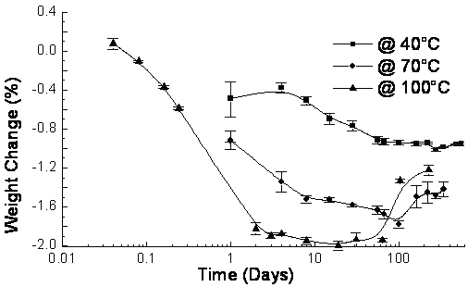
[A]
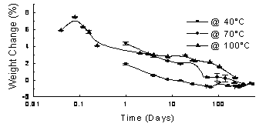
[B]
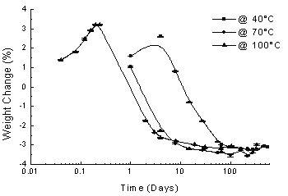
[C]
Figure (1) Gravimetric studies of Nylon as a function of temperature for [A] water, [B] methanol and [C] xylene.
The solubility parameter of BBSA is 22.3 (J cm⁻³)^{1/2}, which is quite close to that of xylene, which is 18.1 (J cm⁻³)^{1/2}. The major contribution of both fluids is due to the dispersion forces and increase in temperature does not have a significant effect. At 40°C no colour changes were observed and at 70˚C and 100⁰C the fluid changed colour as a result of the leaching of the BBSA.

Differential Scanning Calorimetry
In order to investigate changes in the crystallinity with time DSC measurements were performed on samples taken from the aged pipe, Figure (2).
Ageing at 40⁰C
A perfect polyamide 11 crystal has heat of fusion of 226 J g⁻¹ indicating the PA11 is initially ~ 21% crystalline [9]. At 40⁰C, exposure to water causes an increase to 24% by day 11, whereupon it remains fairly constant. The melting temperature increased by 2°C after two days and then showed a sudden drop after 253 days by about 4°C.The melting temperature changes with the type and size of crystallite formed. Methanol exhibits similar behaviour; however xylene appears to promote crystallization with an increase to 37% by the end of the ageing period. In all the fluids the melting point drops towards the end of the study. A melting point of ~190⁰C imparts high degree stability to the matrix and changes in crystallinity occur only if the amorphous phase undergoes swelling.
Ageing at 70⁰C
Ageing in water leads to an increase of the crystallinity from 21% to 25% by day 32, followed by a slight drop at day 64 followed by an increase to 27% at the end of the study, Figure (2B). The melting point increased slowly by about 5°C by day 122 and then dropped by about 3.5°C by day 365. In contrast, ageing in methanol causes an initial increase to ~30% within 32 days, then a drop to ~ 26% by day 64, before increasing to 35% by day 255 before dropping again. After 32 days, the melting point had increased by about 5% and then dropped to about its original value by day 122. Ageing in xylene, the crystallinity increases to 27% by day 16, then drops to 25% by day 64, before an increase to 28% by day 365. The melting point increased to 194⁰C by day 16 and then drops back to near its original value of ~190⁰C by day 122.

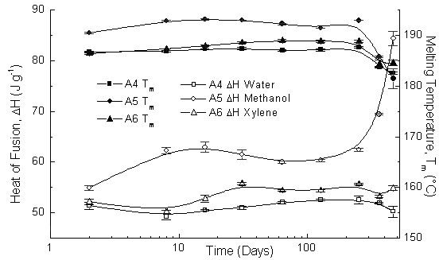
[A]
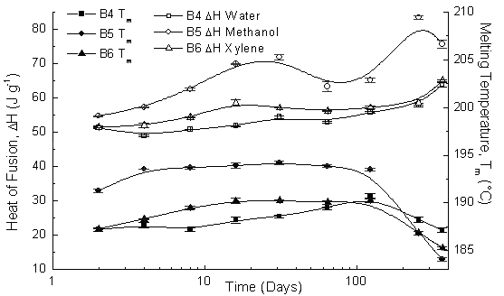
[B]
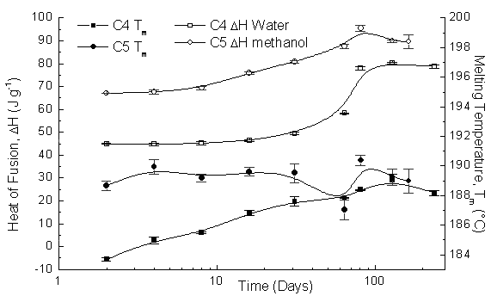

[C]
Figure (2) Variation of the Melting point and heat of fusion as a function of time and solvent, [A] 40⁰C, [B] 70⁰C and [C]100⁰C.
Ageing at 100⁰C
Ageing at 100⁰C in water, Figure (2C), the heat of fusion of the sample increased from 28% to 39% after 81 days of ageing and then levelled off at this value.

The melting point decreased by 1°C within the first two days and then increased by 5°C by day 128 and levelled off. Samples aged in methanol increased the crystallinity to 41% by day 81 and then decreased slowly to 38% by day 163. The melting point increased rapidly by ~ 4°C during the first two days, then dropped off by ~2°C by day 64, then increased again by 3°C but started to drop off at the end of the study. The DSC data indicate that ageing increases the level of crystallinity and changes in the morphology.

Constant Pressure Ageing –Tensile Testing
The tensile properties of the polyamide before ageing are summarised in Table (1).

Table 1. Tensile Properties of PA11
Material | Young’s Modulus (MPa) | Yield Strength (MPa) | Ultimate Tensile Strength (MPa) | Elongation at Break (%) | Shore D Hardness
PA 11 | 237 ± 4 | 33.1± 0.2 | 43 ± 1.0 | 255 ± 12 | 64 ± 0.6

Ageing at 40⁰C
Samples of pipe were removed periodically and their tensile properties measured, Figure (3).
i) Water
Changes to the tensile properties occurred immediately on application of pressure, Figure (3A). The Young’s modulus, yield strength and UTS dropped by about 25%, consistent with changes in crystallinity detected by DSC. The UTS increases slowly reaching a value -15% of its original value after 253 days. The yield strength recovered 20% in a wave-like fashion but after day 364 it started to drop. The modulus increased by about 55% by day 364 but then proceeded to fall. The

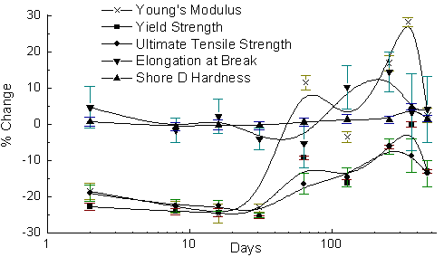
[A]
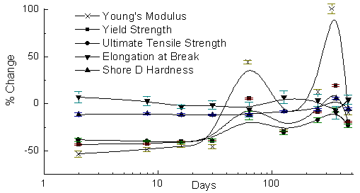
[B]
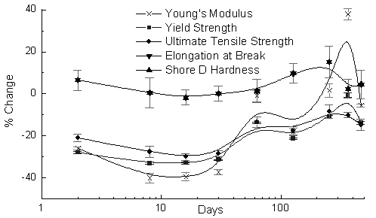
[C]
Figure (3) Tensile test data for PA11 aged in [A] water, [B] methanol and [C] xylene at 40⁰C and a constant pressure of 3000 psi.

elongation at break varied in a wave like manner. However the Shore D hardness remained constant.

ii) Methanol
The wavelike changes in properties observed in water are also observed with methanol but to a larger extent, Figure (3B). The Young’s modulus drops initially by 50% and then increases by 100% after 64 days before it again drops.
iii) Xylene
The modulus, yield strength and UTS drop initially by 40% and then recover to about 25% by day 64 and then a further 45% by day 364 and drop again to ~ 10% of its original value, Figure (3C). The Shore D hardness followed exactly the changes of the elongation at break with a maximum variations of about 10%.
The changes in the mechanical properties parallel those observed in the crystallinity and loss of plasticizer indicated by the gravimetric measurements.

Dynamic Mechanical Thermal Analysis - DMTA
DMTA measurements were carried out on the aged materials, Figure (4).
i) Water
The main features of the DMTA spectrum of nylon 11 are the significant drop in the modulus between 0⁰C and ~90⁰C and a tan δ peak located at ~ 25⁰C. The drop in the modulus is associated with the motion of the alkyl chain segment and the value of the modulus at ~100⁰C reflects the degree of the crystallinity in the material. Exposure to constant pressure immediately causes an increase in the bending modulus E’ at both low and high temperatures consistent with the effects on an increase in the crystallinity. The mobility of the alkane segment will be influenced buy the constraints imposed by the amide link and the crystalline regions. As the material ages shifts in the tan δ and lower temperature peaks will occur as the morphology changes restrict the motion of the -CH₂- groups. The relaxations below 0⁰C reflect the motion of the chain elements in the amorphous regions and are assigned the γ-transition at around –125˚C, the β-transition at around –75˚C to –55˚C. Throughout ageing, the γ–peak does not change in position or amplitude, however the β-peak shifted to lower temperatures after two days and did not change. For the first two days of ageing, the α-peak at 20⁰C did not change, but then shifted to higher temperatures up to day 253 before returning to its original position at 10⁰C by day 469.

[A]
[B]

[C]
Figure (4) DMTA traces for PA 11 as a function of time of exposure to [A] water.[B] methanol and [C] xylene

ii) Methanol
As ageing proceeds E’ increases, Figure (4B) up to day 253 whereupon it starts to drop and by day 469 the modulus had decreased again to near its original value. The α-peak moved from around 10˚C to 45˚C in two days and then shifted to 55˚C by day 16. Between days 364 and 469 the α-peak dropped to around 0˚C. The γ-peak stayed more or less constant over time, but it disappeared nearly completely by day 469. The β-peak did not change significantly its position over time but there was a change in its amplitude, showing a progressive increase with time.
iii) Xylene
The modulus and tan δ show shifts on initial exposure but these are not as dramatic as in methanol, Figure (4C). The γ-transition too stays constant over time, possibly decreasing in amplitude after 364 days of ageing. The α-transition moved slowly to higher temperatures and by day 364 it had moved from around 10˚C to nearly 50˚C and then dropped to just below its original value of 40⁰C by day 469. The β-transition did change significantly in its position or amplitude. The α- and β-transitions move closer together upon ageing and this effect became pronounced after about 253 days. By day 469, the β-peak can still be seen, but it had nearly completely merged with the α-peak. This merging of the α and β peaks reflects plasticization of the alkane chain motion.

Viscosity Measurements
Exposing a polyamide to water has the potential of inducing degradation. To assess whether degradation of the polymer was occurring viscosity measurements were undertaken, Table (2).

Table 2 Reduced Viscosity of Polyamide 11 – Constant Pressure Tests
Sample No. | Sample Description | Reduced Viscosity (cm³ g⁻¹)
A4-1 | PA11/H₂O aged for 2 days | 208.69 ± 0.35
A4-10 | PA11/H₂O aged for 469 days | 194.66 ± 0.23
A5-1 | PA11/CH₃OH aged for 2 days | 203.26 ± 0.19
A5-10 | PA11/CH₃OH aged for 469 days | 196.93 ± 0.10
A6-1 | PA11/Xylene aged for 2 days | 201.27 ± 0.64
A6-10 | PA11/Xylene aged for 469 days | 197.34 ± 0.30

Value for the constant K and α PA 610 in m-cresol at 20°C were K = 10.6x10⁻⁴, a = 0.71 [19] giving an initial value of M_{n} of 44,000 g mol⁻¹ which reduces to 38,000 g mol⁻¹ after ageing for 469 days in water.

Burst Pressure Tests
Bursting pressures measurements were performed at the end of the exposure. The acceptable lower limit for the burst test is 800 bar. For the pipes aged at 40⁰C, Table (3), the burst pressures were well within the typical range, only PA11 aged in methanol showed a significant drop in the value.
Table (3) Burst Pressures of PA 11 and HDPE – Constant Pressure Tests (1 bar =15psi)
Sample No. | Sample Description | Burst Pressure (psi)
PA 11 | Reference, unaged | 17540
A4-10 | PA11/H₂O aged for 470 days | 17300
A5-8 | PA11/CH₃OH aged for 253 days | 17250
A5-10 | PA11/CH₃OH aged for 470 days | 16800
A6-10 | PA11/CH₃OH aged for 470 days | 14700

Ageing at 70⁰C
DSC
DSC analysis was carried out on samples taken from the pipes aged at 70⁰C, Figure (5).
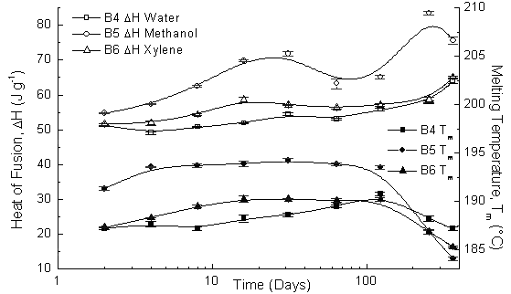

Figure (5) DSC data for PA11 aged at 70⁰C and a constant pressure of 200 bar.
i) Water
The ΔH increased by about 20% up to day 32, dropped slightly by day 64, only to slowly increase again by over 30% at the end. The melting point increased slowly by ~ 5°C up to day 122 and then dropped ~3.5°C by day 365. The changes in the melting point reflect increasing and decreasing lamellae size.
ii) Methanol
The ΔH increased by ~ 50% within the first 32 days, then dropped by ~ 20% up to day 64 and then increased a further 45% by day 255. By the end of the experiment, the ΔH had dropped again by ~ 20%. After 32 days, the melting point had increased by ~ 5% and then dropped to just below its original value between days 122 and 365.
iii) Xylene
The ΔH increased by around 30% by day 16, then dropped off by ~10% until day 64 and then slowly increased by another 20% until day 365. The melting point increased by ~ 3% until day 16 and dropped to near its original value between days 122 and 365.

In all the samples studied there is a general increase in the degree of crystallinity with ageing and the melting point rises before falling towards the end of the study.

Tensile Test Data Ageing at Constant Pressure of 200 bar and 70⁰C
Figure (6) shows the tensile changes for pipes aged at 70⁰C.
i) Water
There was an initial drop in modulus, yield strength and UTS, with the modulus dropping by more than 50% on ageing, Figure (6A). The yield strength recovered to 25% above its original value by day 253 and then dropped by 25% towards the end of the experiment. The UTS followed the same trend, although with smaller changes, ending up at around 10% below its original value. The modulus on the other hand increased by over 170% of its original value by day 253 but then dropped off to its original value towards the end of the study. The elongation at break followed the opposite trend of that of the modulus, exhibited a maximum of 15% above and 25% below its original value. The Shore D hardness dropped by about 10% initially, but then recovered by day 32 and remained constant.
ii) Methanol
Behaviour is similar to that for water except that the initial drop in the Young’s modulus was almost 55%, followed by an increase up to day 253 before falling again, Figure (6B).
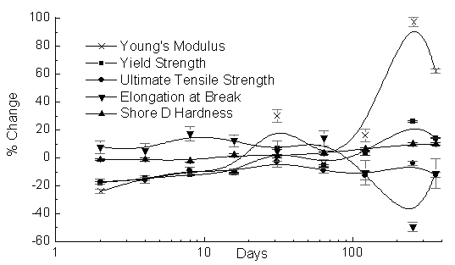
[A]
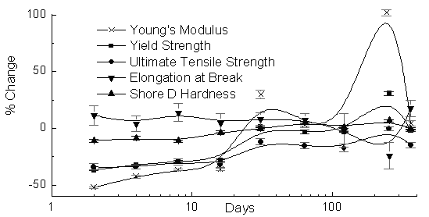

[B]
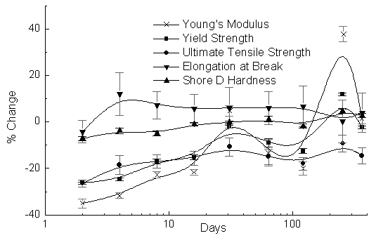
[C]
Figure (6) Tensile Test Data for PA1 aged at a constant pressure of 200 bar and at 70⁰C.
iii) Xylene.
Xylene ageing produces similar effects. The initial drop was less than 40%, with an oscillatory increase up to day 253 before falling off. Xylene appears not to promote the extreme changes as found with methanol.

DMTA
i) Water
Ageing in water, Figure (7A) leads to an initial shift in the tan δ and a small increase in the bending modulus E’ measured at 100⁰C. As ageing proceeds, the tan δ peak remains fairly constant up to day 64, and then moves to higher temperatures ~50˚C. The bending modulus parallels the shift in the tan δ, and is significantly higher at 100⁰C at the end. An increase in E’ is consistent with an increase in the crystallinity. The β-peak shifted slightly to lower temperatures after 255 days of ageing. The γ-peak became visible after only two days of ageing, but disappeared only to reappear after 255 days. The changes in the lower temperature peaks reflect changes in the more disordered regions.
ii) Methanol
The α-peak moved up to 40˚C after only two days and then moved to above 50˚C by day 4; Figure (7B). On day 255, the peak had dropped back to 50˚C. The β-peak moved to slightly higher temperatures and increased in size in relation to the α-peak. The γ-peak was visible after only two days of ageing, but had disappeared completely by day 365. The bending modulus at 100⁰C shows a progressing increase reflecting the increased crystallinity in the material.
iii) Xylene
Ageing in xylene, Figure (7C), follows similar trends. The α-peak became much broader after two days and by day 64 it had shifted to around 50˚C and then dropped back to around 40˚C by day 255.
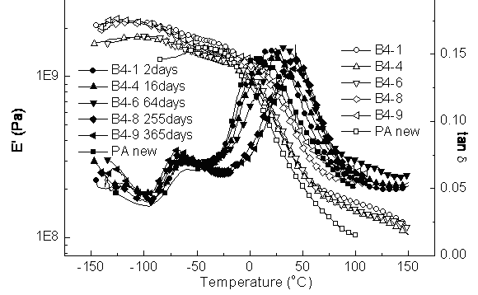

[A]
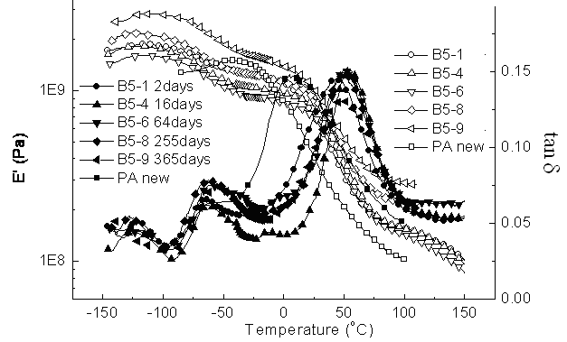
[B]
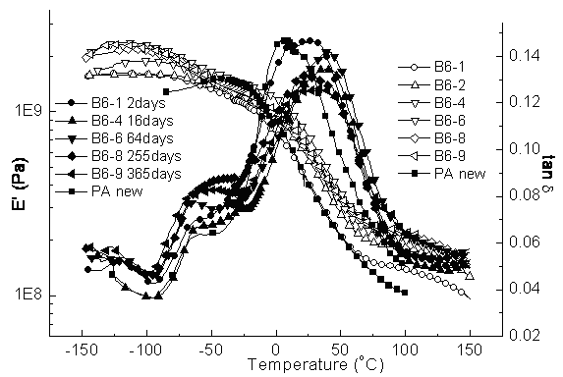
[C]
Figure (7) DMTA traces for PA11 aged 70⁰C and a constant pressure of 200 bar in [A] water, [B] methanol and [C] xylene.

The position of the β-peak did not change significantly over time and was not very well resolved, especially on day two, due to the broadness of the α-peak. As the α-peak, the β-transition seemed to broaden. The γ-peak was visible after two days and no significant changes occurred with further ageing.

Viscosity Measurements
The viscosities were measured and the data are presented in Figure (8).
Figure (8) variation of reduced viscosity with ageing time for water, methanol and xylene

The viscosity of polyamide 11 aged in water increased by nearly 20% up to day 64, whereupon it dropped steadily to the end of the experiment. An increase in the reduced viscosity would occur if the lower molecular weight fractions were hydrolysed preferentially, and this would effectively increase the average of the remaining polymer. After day 64, the viscosity dropped off steadily until by the end of the study where it had reduced by 50%. In methanol, the viscosity dropped by about 35% up to day 64, then increased by about 15% until day 122 and reflects an initial degradation of high molecular weight material and then a narrowing of the molecular weight distribution leading to an apparent increase. PA 11 aged in xylene showed a slow decrease dropping by nearly 20% at day 122 and then levelling up to day 255, whereupon it decreases a further 5% by day 365. The differences in behaviour reflect the way in which the different solvents are able to change the morphology and alter the accessibility of the polymer chains to hydrolytic or thermal oxidative degradation. In the case of xylene, thermal oxidative degradation will be occurring. The viscosity data show clear evidence of chain degradation occurring in all the fluids. There is the possibility of polycondensation which would increase the relative viscosity.

Burst Test Data
Burst test data was determined for pipes aged to different extents, Table (4).
Table 4 Burst Pressures for PA 11 aged at constant pressure (1 bar = 15psi)
Sample No. | Sample Description | Burst Pressure (psi)
PA 11 | Reference, unaged | 17540
B5-7 | PA11/H₂O aged for 122 days | 13600
B5-9 | PA11/CH₃OH aged for 365 days | 9400
B6-9 | PA11/CH₃OH aged for 365 days | 13000

All the aged pipes showed significant reductions in the values of the burst test and is consistent with hydrolytic degradation and changes in the morphology. Only the pipes aged in methanol had dropped below the acceptable lower limit of 12000 psi (800 bar) bursting pressure. The pipes show clear evidence of embattlement and environmental stress cracking ESC. Methanol appears to be more aggressive than either water or xylene and reflects the greater ability of methanol to swell the matrix and hence assist both the hydrolysis and recrystallization processes. The changes observed are similar to those at 40⁰C, but are larger in magnitude.

Ageing at 100⁰C
DSC studies
DSC measurements on samples aged in water and methanol are shown in Figure (9). In both water and methanol the heat of fusion increased with time. Ageing in water produced a nearly 80% change in ΔH over the first 81 days. The melting temperature decreased by 1°C within the first two days of ageing and then increased by 5°C until day 128 and then levelled off around this value. In methanol the ΔH increased rapidly by 110% up to day 81 and then decreased slowly by 10% until day 163. The melting temperature increased rapidly by nearly 4°C during the first two days of ageing, then dropped off by about 2°C until day 64, then increased again by 3°C and then started to slowly drop off being ~ 1°C by the end of the experiment.
Figure (9) DSC studies of PA11 aged in water and methanol at 100⁰C and a constant pressure of 200 bar.

The DSC data indicate that there is a significant increase in the crystallinity and change in the crystal structure on ageing.

Tensile Tests
i) Water
PA 11 aged in water, Figure (10A), shows the expected drop in the modulus, yield strength and UTS of ~ 15% to 20% on exposure to the constant pressure and elevated temperature. The Shore D hardness varied slightly, but remained around its original value overall. The elongation at break increased by ~ 10% initially, and then dropped off dramatically by 80% at the end of the test period. These changes were a very clear sign of embrittlement of the material.
ii) Methanol
The changes are more severe than in water, Figure (10B), the modulus dropping by 60% in only four days and yield strength and UTS dropped by about 40% over the same time. The Shore D hardness dropped by 10% and then remained constant, whereas the elongation at break increased by nearly 20% within the first eight days. The modulus had recovered about 20% by day 64, only to drop off again, the yield strength also recovered by about 20%, however the UTS remained constant after the initial drop.

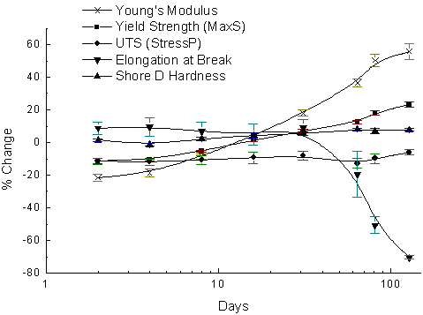
[A]
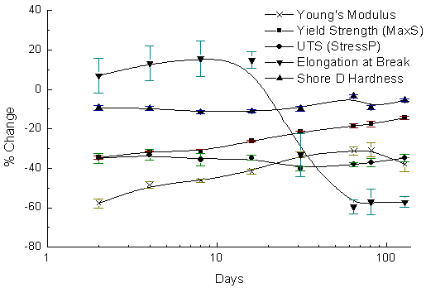
[B]
Figure (10) Tensile test data for PA11 aged in [A] water and [B] methanol at 100⁰C and a constant pressure of 200 bar.

The elongation at break exhibited the most severe changes: after the initial increase, it dropped off rapidly by about 70% between days 16 and 64 and then levelled off around this value. Again, the results were a clear sign of embrittlement.

DMTA
DMTA traces were obtained for samples aged in water and methanol, Figure (11).

[A]
[B]
Figure (11) DMTA traces for PA11 aged in [A] water and [B] methanol at 100⁰C and constant pressure 200 bar.
i) Water
The melting point of the PA 11 at ~185°C is well above the test temperature of 100°C; however changes in the crystallinity are clearly occurring and influencing the DMTA traces, Figure (11A). The tan δ peak moved from around 10°C to around 40°C in only two days and then stayed more or less constant, but decreased in amplitude with time.
ii) Methanol
Figure (11B) shows that the modulus drops over time and the peak in tan δ moves from around 10°C to around 60°C in only two days and then dropped slowly back to 40⁰C upon further ageing, decreasing in amplitude and becoming broader over time. The position of the β-transition changed without exhibiting a specific trend, but it became larger throughout ageing with respect to the α-transition. The γ-transition only became visible after 128 days of ageing and had nearly disappeared again completely by day 163.

Viscosity Measurements
Viscosity measurements, Figure (12) indicate, for both ageing in water and methanol, that degradation of the polymer is occurring, the rate and extent being greater in water and greater at 100⁰C than at lower temperatures.
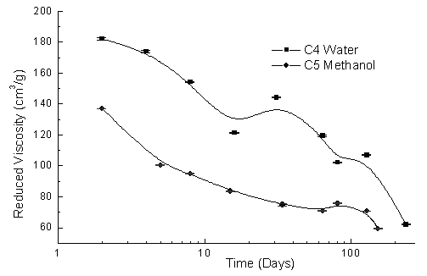
Figure (12) Change of reduced viscosity with time for PA11 aged in water and methanol at 200 bar.
Chain scission will allow stresses built in during production to be released and drive the material to a thermodynamically lower state but can potentially have a dramatic effect on the lifetime of the pipes.

Pipe Burst Tests
For both ageing in methanol and water, there is a dramatic reduction in the strength, reflected in the pressure at which bursting occurs, Table 5. Most of the bursts occur near to the swage fittings although some burst in the middle of the pipe. PA 11 has a molecular weight before ageing of 35,000 g mol-1 and this dropped to ~ 11,000 g mol-1 by the end of the tests. Examination of the failures indicated ESC.
Table 5: Burst Pressures of PA 11 (1bar = 15psi)
Sample No. | Sample Description | Burst Pressure (psi)
PA 11 | Reference, unaged | 17540
C4-9 | PA11/H₂O aged for 237 days | 500
C5-7 | PA11/CH₃OH aged for 81 days | 12000

Environmental stress cracking (ESC) [14]; is associated with absorption of the fluid allowing increases in crystalisation, and swelling of the polymer. The stresses created lead to crazing and failure. [15-17]. Water forms strong hydrogen bonds to the PU whereas methanol forms weaker hydrogen bonding but can plasticize the alkane region [18]. As a consequence ESC occurs sooner in methanol than in water.

Cyclic Pressure tests
The pipes will usually experience significant pressure variations rather than being held at constant pressure. Tests were carried out using a cyclic pressure regime.

DSC studies
The variation of ΔH and T_{m} with ageing time for PA11 subjected to cyclic ageing at 40⁰C is presented in Figure (13A). In the water aged samples, the ΔH increased by ~2% up to day 256 and then increased more rapidly increasing by ~15% before the end of the experiment. The melting point remained unchanged up to day 256 and then increased by 2°C by day 365.
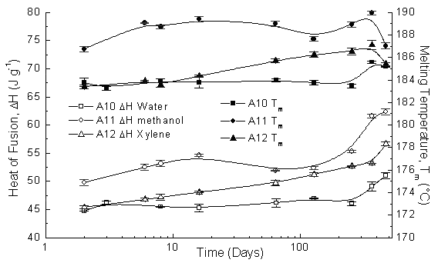
[A]
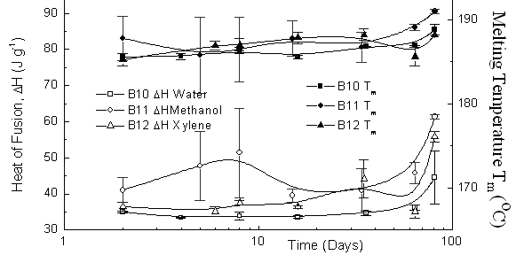
[B]
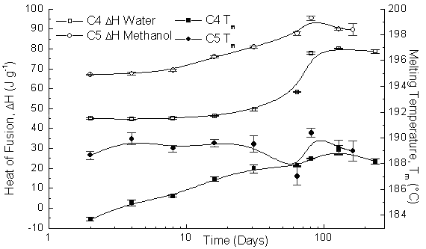
[C]

Figure (13) Variation of ΔH and T_{m} with ageing time for PA11 subjected to cyclic ageing at [A] 40⁰C, [B] 70⁰C and [C] 100⁰C.
In methanol, the ΔH which dropped initially then increased by over 20% by day 16, dropped off by 5% at day 64 and then steadily increased another 15% to 20% up to day 469. The melting point increased by around 4°C by day 16 and then decreased by 1.5°C up to day 123 before increasing by 2.5°C by day 365, but then dropped off again by 3°C. Ageing in xylene showed a slight decrease after two days and then increased steadily by ~25% up to day 469. The melting point dropped by 1.5°C after two days, then remained constant until day 8 and finally increased steadily by 3°C up to day 365, only to drop off again by 1.5°C by day 469. As in the case of the constant pressure study the DSC data show a slow restructuring of the matrix.
In methanol, Figure (13B), the ΔH had dropped by ~10% by day two, then increased by about 20% by day eight and by day 16 it had dropped again by over 20% before increasing by 50% before the end of the study. The T_{m} increased by ~2.5°C by day 2, and then dropped by ~2°C by day 4 before increasing by about 5°C by day 82. In xylene, the ΔH initially decreased by 25% and then increased slowly by about 15% up to day 35, after which it dropped again by 25% before increasing by 45% between days 64 and 82. The T_{m} exhibited wave-like changes, with a slight increase towards the end.
Ageing at 100⁰C, Figure (13C), indicates that in water the ΔH increased by nearly 80% during the first 81 days. The T_{m} decreased by 1°C within the first two days and then increased by 5°C by day 128. In methanol the ΔH increased rapidly by 110% by day 81 and then decreased slowly by 10% up to day 163. The T_{m} increased rapidly by nearly 4°C during the first two days, then dropped off by about 2°C up to day 64, then increased again by 3°C by the end of the study.

As with the study at constant pressure significant structural changes are occurring and there is a general increase in the crystallinity of the materials which would lead to embrittlement.

Tensile Tests
i) Water
The tensile behaviour using the cyclic pressure regime, Figure (14A), shows an initial change in the modulus, yield strength and UTS dropping by 25%. The yield strength and UTS levelled around this value, with wave-like fluctuations. The modulus exhibited wave-like fluctuations the values varying from –25% to +25% of its original value. The elongation at break dropped initially ~15% then fluctuated, although opposite to the modulus, with variations from –15% to +15%. Only between days 365 and 469 were modulus and elongation at break in phase again, and both increased. The Shore D hardness stayed more or less constant throughout the test period, with variations between 0 and +5%. Slight differences between constant and cyclic pressure ageing reflects the way in which pressure is able to restructure the matrix.
ii) Methanol
The tensile behaviour in methanol, Figure (14B) shows the initial drop in modulus, yield strength and UTS is larger than in the case of water and typically 40-50%. All three properties recovered by 120%, 40% and 20% respectively by day 128 and then dropped back to about 30% below the original value by day 253. The UTS levels off, whereas yield strength and modulus again recovered slightly. The elongation at break increased initially by 10% and dropped slowly by about 20% up to day 128, then increased again by 20%. The Shore D hardness decreased by 10% initially and then slowly increased back to its original value until day 128, before dropping by 10% at day 365 and then increasing marginally by day 469.
iii) Xylene
In xylene, Figure (14C), the modulus, yield strength and UTS decreased initially by 25% to 35%. The elongation at break decreased by 5% initially and then recovered by 15% straight away. The Shore D hardness decreased by 5% until day eight and then also exhibited wave-like changes between zero and -5%, in phase with the modulus. It increased back to its original value between days 253 and 469.

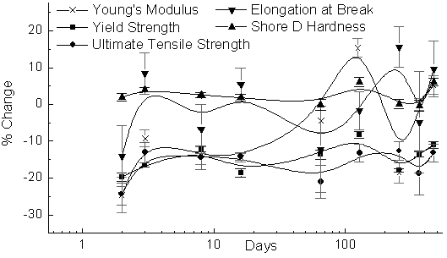
[A]
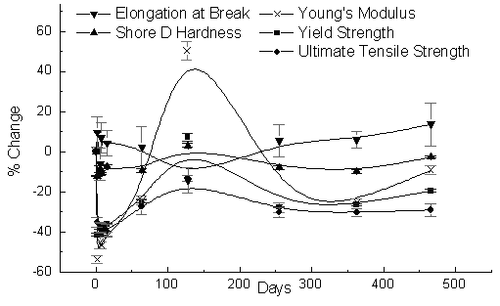
[B]
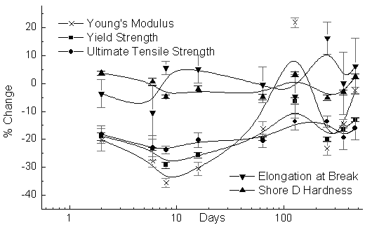
[C]
Figure (14) Ageing of PA using cyclic pressure regime in [A] water, [B] methanol and [C] xylene.

DMTA
i) Water
The modulus shows an initial increase and then a slow change, Figure (15A).
The tan δ peak shifts initially and then stays constant over the ageing period but there is a slight shift to lower temperatures on day 256, before returning to its original position by day 365. The onset of the β-transition moved to lower temperatures upon ageing and the transition seemed to increase in size in relation to the α- transition. The γ-transition could not be detected until day 256 and then became stronger with time.
ii) Methanol
The changes in methanol, Figure (15B), are similar to those in water. There is an initial increase in E’ and shift in the tan δ peak to higher temperatures. The position of the β-peak did not change significantly, the γ-transition only became visible after 256 days of ageing and then became stronger with time.
iii) Xylene
Xylene, Figure (15C), shows an initial jump and then progressive increase in the modulus E’ and shifts in the tan δ peak. A drop of modulus around the β-transition could be observed in the more aged samples. The β-peak increased in size in relation with the α-peak during ageing and reflects a change in the proportion of amorphous to crystalline material. The γ-peak only became visible after 256 days of ageing and then remained constant rather than increasing in size. These changes are consistent with an increase in the crystallinity of the material and an increase in the freedom in the amorphous region.

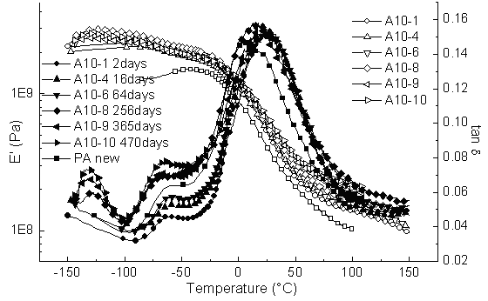
[A]
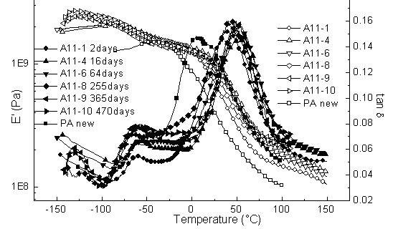
[B]
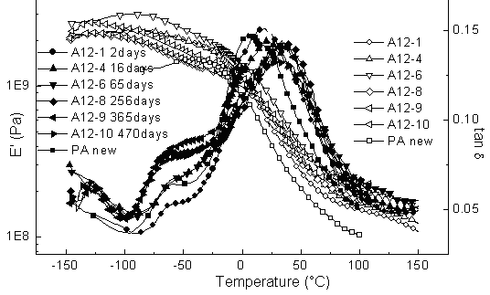
[C]
Figure (15) DMTA traces for ageing at 40⁰C using cyclic pressure regime [A] water, [B] methanol [C] xylene.

Viscosity Measurements
Changes in the viscosity of the PA 11 samples aged at 40°C are shown in Table (6). Only small changes are observed in the viscosity indicating that little degradation is occurring at 40⁰C.
Burst Pressure Tests
Aged pipes were subjected to burst pressure tests, Table (7). A reduction in the burst pressure was observed for all the samples, but the greatest loss was for the pipes aged in methanol. At the end of 470 days the pipes all passed the design limit of 800 bar (12000 psi).

Table 6 Reduced Viscosity of Polyamide 11 – Cyclic Pressure Tests
Sample No. | Sample Description | Reduced Viscosity (cm³ g⁻¹)
A10-1 | PA11/H₂O aged for 2 days | 206.34 ± 0.26
A10-10 | PA11/H₂O aged for 470 days | 200.15 ± 0.23
A11-1 | PA11/CH₃OH aged for 2 days | 218.72 ± 0.24
A11-10 | PA11/CH₃OH aged for 470 days | 224.77 ± 0.36
A12-1 | PA11/Xylene aged for 2 days | 210.48 ± 0.30
A12-10 | PA11/Xylene aged for 470 days | 211.64 ± 1.01

Table 7: Burst Pressures of PA 11 – Cyclic Pressure Tests (1bar = 15psi)
Sample No. | Sample Description | Burst Pressure (psi)
PA 11 | Reference, unaged | 17540
A10-10 | PA11/H₂O aged for 470 days | 16300
A11-10 | PA11/CH₃OH aged for 470 days | 13375
A12-10 | PA11/CH₃OH aged for 470 days | 15450

Ageing at 70⁰C -Tensile Test Data
i) Water
All properties drop within the first two days of ageing, Shore D only slightly, but modulus and UTS by about 15%, Figure (16A). The elongation at break recovered quickly on further ageing and the Shore D and modulus more slowly. At 70⁰C there is more thermal energy available to allow the morphology to rapidly react to an equilibrium value. The elongation at break recovered by day 8; it then dropped off again and by day 82 has a value of 25% below its original value. Shore D had recovered by day 16 and then remained constant. The modulus had also recovered by day 16, but then decreased again slowly by nearly 15% until day 64, and by nearly 30% by day 82. This behaviour is similar to the changes when constant pressure is used but the detail is different. After the initial drop, the yield strength remained constant at first and then recovered its original value. The UTS decreased a further 5% and then remained constant. The increase of modulus and decrease of elongation at break towards the end of the test is a clear indication of embrittlement of the material.
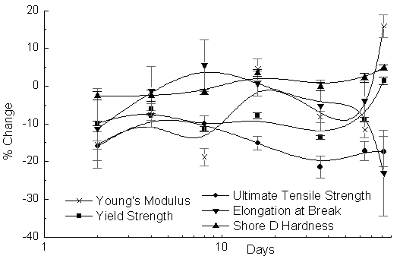
[A]
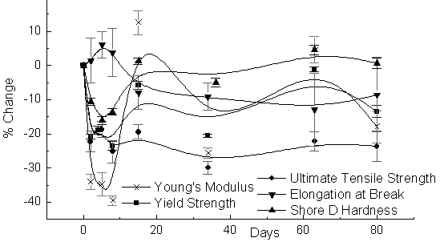
[B]
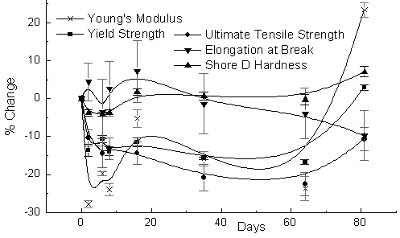
[C]
Figure (16) Tensile test data for PA11 cyclic pressure aged in [A] water, [B] methanol and [C] xylene.
ii) Methanol
The tensile behaviour of PA 11 aged in methanol, Figure (16B), shows a more severe initial drop in properties than that from the constant aging study, Figure (10B). The modulus dropped by 40% after only 8 days of ageing and the Shore D hardness had dropped by 15% after only 4 days. Yield strength and UTS both dropped by 20% to 25%, whereas the elongation at break increased by five percent. Shore D had recovered by day 16, whereas the modulus had increased by 60% and then decreased in a wave-like manner until the end of the test period. The yield strength continued to change in a wave-like manner, whereas the UTS settled around 25% below its original value. The elongation at break had dropped to 10% below its original value and remained constant with possibly a slight increase towards the end of the experiment.
iii) Xylene
There is an initial drop in the physical properties, Figure (16C), with only the elongation at break showing an overall increase by day 16. The modulus again exhibited a wave-like change with a very rapid increase of about 45% between days 64 and 82. Yield strength and UTS continued to decrease until day 64 and then increased quite rapidly by about 15%. The Shore D hardness had recovered by day 16, and then remained constant finally increasing in the last few days of ageing. After the initial slight increase of elongation at break, it then dropped to 10% below its original value at the end of the study.

DMTA
i) Water
The modulus increased dramatically at the beginning of the ageing experiment, Figure (17A) and then deceases slowly. The high temperature value however is fairly constant. The α-peak shifted gradually to higher temperatures during ageing, ending up around 50°C above its original value. The β-peak, although visible in the unaged sample, disappeared during the first few days of ageing, but had re-appeared by day 64. Due to the α-peak shift towards higher temperatures, the β-peak became better resolved.
ii) Methanol
In methanol Figure (17B), there is the initial increase in the modulus followed by a progressive increase over the whole of the ageing study.
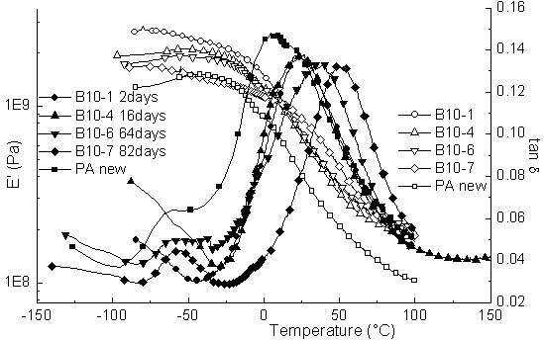
[A]
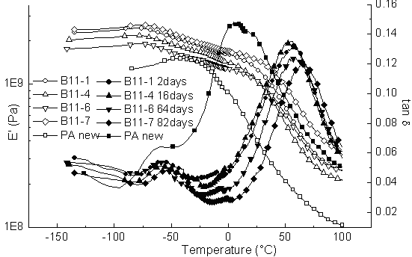
[B]
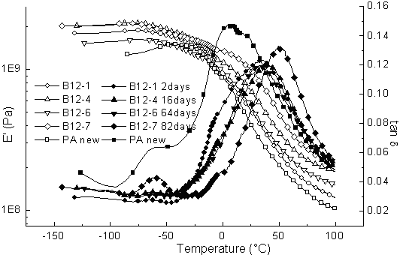
[C]
Figure (17) DMTA traces for PA11 aged at 70⁰C using a cyclic pressure regime in [A] water, [B] methanol and [C] xylene.
The α-peak shifted from around 10°C to 55°C in only two days and then remained more or less constant there until day 82, when it moved to around 65°C. A shift to higher temperatures also seemed to bring about a drop in amplitude of the transition. The β-peak was visible in all samples and due to the shift of the α-peak was more resolved in the aged samples.
iii) Xylene
The modulus increased both in terms of the low and higher temperature values through the whole of the experiment, Figure (17C). The α-peak shifted to higher temperatures during ageing, with the most severe changes occurring during the first two days and between days 64 and 82 moving eventually to 50°C. The β-peak nearly disappeared during the first few days and only becomes significant again by day 82.

Viscosity Measurements
The variation of the viscosity as a function of ageing time is shown in Figure (18). The viscosity of the sample aged in water increased by nearly 30% up to day 16, then dropped off to just below its original value between days 36 and 64, only to increase again by about 20% until day 82. The viscosity of the sample aged in methanol exhibited wave-like changes, but at the same time decreasing continuously by 60%. The viscosity of the aged sample in xylene increased by 70% up to day eight and then dropped off rapidly again to its original value by day 16. Polycondensation is possible with PA 11, leading to an increase in molecular weight but an apparent increase in viscosity would result if lower molecular weight fractions were preferentially hydrolysed or extracted. The viscosity data suggest at the higher temperature that chain extension may be competing with degradation.

Discussion of cyclic pressure tests
As with the ageing under constant pressure there are initial dramatic changes in the physical properties and subsequent changes in the structure of the material. At 40⁰C there is no evidence for hydrolytic degradation on the physical properties and the changes observed are purely a consequence of the relaxation of the stresses frozen in the material when it is formed.

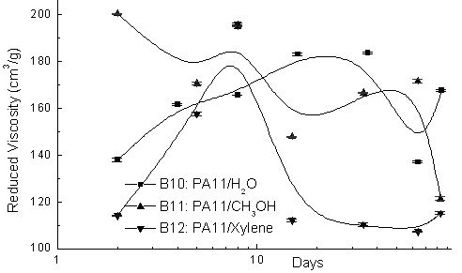
Figure 18 Variation of the viscosity with ageing time for PA11 aged using the cyclic pressure regime at 70⁰C.
Conclusions
Nylon PA11 aged using a constant pressure of 200 bar or a regime of cyclic pressure change leads to significant changes in mechanical properties. The initial changes in the tensile and dynamic mechanical properties are the result of release of stress built into the polymer when it is extruded and quenched. Subsequent changes depend on the fluid used. In the case of water hydrolysis explains ultimately the loss of mechanical properties; however before the pipes fail changes in crystallinity and plasticization cause improvement and loss of physical properties. Methanol behaves as a more aggressive solvent, allowing hydrolysis and also plasticization of the polymer which leads to larger changes than those found in water. Xylene is only able to plasticise the alkane chains and is less aggressive than water or xylene but does allow oxygen to enter the matrix and appears to promote oxidative degradation. The loss of mechanical properties is less with xylene. Differences are observed between the ageing under constant pressure and using a cyclic regime which reflects the way in which the pressure influences the changes in the crystalline structure and its resultant impact on the mechanical properties. In terms of the service life of nylon pipes, whilst xylene does not leads to major ESC water and methanol are clearly able to induce embrittlement and this is very pronounced at the higher temperatures investigated.
This study indicates that it is very difficult to be able to predict the long term behaviour of nylon PA 11 when used in an environment which will expose it to elevated pressure and temperature and under the influence of fluids with varying polarity. The loss of mechanical properties cannot be attributed to one single effect but are the result of relaxation of stresses built into the pipes on fabrication. The possible effects of degradation associated with hydrolysis and oxidation and the plasticisation of the amorphous phase assisting changes in the crsyatalline phase make the prediction of the ageing behaviour very difficult.

Acknowledgements
One of us MB wishes to acknowledge the support of the National Engineering Laboratory Ltd and DUCO Ltd throughout this project; in particular Bob Dunlop and Bobby Anderson from NEL, John Brown and Alan Dutton from DUCO.
.
References
1) Brodesser M., Pethrick R.A and Banks W.M. Submitted for publication to JMDA
2) Ladik JJ, The effect of rotations around all 11 single bonds in the unit cell of nylon-11 on the free energy of a disordered chain Journal of Molecular Structure (Theochem), Vol. 547, 2001, pp. 13-16
3) Moffatt S, Ajji A, Lotz B, Brisson J, Uniaxial deformation of nylon-6 and nylon-11: changes in orientation and crystal phase Can. J. Chem., Vol. 76, 1998, pp 1491-1500
4) Zhang Q, Mo Z, Zhang H, Liu S, Cheng SZD, Crystal transitions of Nylon 11 under drawing and annealing Polymer, Vol. 42, 2001, pp. 5543-5547
5) De Groote P, Jonas AM, Devaux J, Godard P, Melt properties and crystal morphology of polydodecamide plasticized by benzenesulfonamides Journal of Polymer Science: Part B: Polymer Physics, Vol. 39, 2001, pp. 2022-2034
6) Bandyopadhyay S, Brown H.R., Environmental-Stress Cracking and Morphology of Polyethylene Polymer, 1978, 19 (5) 589-592.
7) Bandyopadhyay S, Brown H.R., K-A Relationship in the Environmental-Stress Cracking of High Molecular-Weight Polyethylene, International Journal of Fracture, 1979, 15 (5) R175-R177.
8) Bandyopadhyay S, Brown H.R., Environmental-Stress Cracking of Low-Molecular Weight High-Density Polyethylene Polymer, 1981, 22 (2) 245-249.
9) Cheng J.J., Polak M. A., Penlidis A., Phase Interconnectivity and Environmental Stress Cracking Resistance of Polyethylene: A Crystalline Phase Investigation, Journal of Macromolecular Science, Part A: Pure and Applied Chemistry, 2009 46, 572–583.
10) Chaupart N, Serpe G, Verdu J, Molecular weight distribution and mass changes during polyamide hydrolysis Polymer, Vol. 39, No. 6-7, 1998, pp 1375-1380
11) Forsström D, Terselius B, Thermo oxidative stability of polyamide 6 films I. Mechanical and chemical characterisation Polymer Degradation and Stability, Vol. 67, 2000, pp. 69-78.
12) Serpe G, Chaupart N, Relaxation-structure relationship in bulk and plasticized polyamide 11 Journal of Polymer Science: Part B: Polymer Physics, Vol. 34, 1996, pp. 2351-2365
13) Kong X, Silveira MDLV, Zhao L, Choi P, A pseudo equation-of-state approach for the estimation of solubility parameters of polyethylene by inverse gas chromatography Macromolecules, Vol. 35, 2002, pp 8586-8590
14) Kim JH, Jang J, Zin WC, Thickness dependence of the melting temperature of thin polymer films Macromolecular Rapid Communications, Vol. 22, No. 6, 2001, pp. 386-389
15) Hansen CM, On predicting environmental stress cracking in polymers Polymer Degradation and Stability, Vol. 77, 2002, pp. 43-53
16) Wyzgoski MG, Novak GE, Stress Cracking Of Nylon Polymers In Aqueous Salt-Solutions .1. Stress-Rupture Behavior Journal of Materials Science, Vol. 22, 1987, pp. 1707-1714
17) Wu P, Siesler HW, Fourier transform NIR study of liquid diffusion processes in Nylon 11 films: Comparison of water with alcohols Chem. Mater., Vol. 15, 2003, pp. 2752-2756
18) Rao Y, Waddon AJ, Farris RJ, Structure-property relation in poly(p-phenylene terephthalamide) (PPTA) fibers Polymer, Vol. 42, 2001, pp. 5925-5935.
19) Cui, X.W., Liu, Z.J., Yan, D. Y., Synthesis and characterization of novel even-odd nylons based on undecanedioic acid European Polymer Journal (2004) 40 (6) 1111-1118.

