Ageing of Thermoplastic Umbilical Hose Materials
Polyethylene (HDPE)
Monika Brodesser^{1, 2}, Richard A. Pethrick² and William M. Banks¹
1- Department of Mechanical and Aerospace Engineering,
University of Strathclyde, Weir Building, Montrose Street,
Glasgow G1 1XS
2- WestCHEM, Department of Pure and Applied Chemistry
University of Strathclyde, Thomas Graham Building,
295 Cathedral Street, Glasgow G1 1XL.
.
Abstract
This study of the behaviour of high density polyethylene umbilical hoses subjected to constant and cyclic variation of pressure and temperatures attempts to simulate the effects of experience in off shore operations. Measurements are reported for exposure between 40⁰C and 100⁰C in water, methanol and xylene and using an applied pressure of 200 bar (3000psi). The changes in the physical properties of the hose were monitored by measurement of the tensile properties, dynamic mechanical thermal analysis, differential scanning calorimetry and gravimetric uptake of the fluids. Significant changes occur immediately on application of pressure and reflect changes in crystallinity. The rates and extent of the modifications depend primarily on the ageing temperature but is also influenced by the fluid. Water has little effect on the rate at which ageing occurs, whereas xylene, which is a potential solvent for HDPE, exhibits characteristics of plasticization. Methanol behaves as a weak solvent and shows characteristics intermediate between xylene and water. Burst tests carried out on the aged material show that significant loss in strength is only observed with the highest temperatures and most aggressive solvent systems. The study indicates that engineers should use pressure aged rather than initial materials data when designing umbilical hose systems.

Key words:- high density polyethylene, differential scanning calorimetry, tensile properties, dynamic mechanical thermal analysis, gravimetric measurements, bust tests, offshore application.

INTRODUCTION
Umbilical systems are used both to provide hydraulic control and convey fluids to wellheads and subsea production facilities. The typical umbilical may carry optical fibre, power cables, hydraulic controls and fluid supplies and where possible is constructed from single continuous pipework. The umbilical line must be sufficiently flexible to accommodate the tidal rise and fall, yet be sufficiently rigid to allow the accurate transmission of hydraulic pressure to the well head. One of the materials used in this type of application is high density polyethylene (HDPE). Polyethylene is widely used in gas distribution networks and has an anticipated lifetime greater than 25 years. In gas distribution systems, pipework is usually buried in the soil and hence subject to little or no movement or temperature fluctuation and the prime concern is environmental stress cracking (ESC). Gas and its components in principle can induce ESC by changes in the polymer morphology of the surface layer [1].

Umbilical lines may be expected to carry water, hydrocarbons and liquid of intermediate dielectric constant, such as alcohols. The environmental stress crack resistance (ESCR) of the polymer will vary with the nature of the fluid. The umbilical may be significantly above ambient temperature and subject to cyclic stresses as a consequence of tidal forces on the lines. In this study the changes in the physical characteristics of HDPE used in the construction of umbilical lines are examined.

Polyethylene used in gas distribution networks has to be able to develop not only a crystalline structure but the crystallites must be intimately connected by tie molecules [2-10]. Whilst HDPE has a high ESCR when exposed to water, the addition of surfactant to water increases its permeability into the matrix and substantially reduces the ESCR. Alcohols, which have both hydrophobic and hydrophilic characteristics, are therefore potentially more aggressive than water or pure hydrocarbons as ESCR agents. This study explores how temperature, pressure and cyclic stresses may influence the physical properties of a typical HDPE.

Experimental Work
Materials
The HDPE used in this study had a melt flow index of 18.0g/10 min at a load of 21.6 kg and a melt viscosity of 1 x 10⁴ Pas at 190⁰C and a shear rate of100 s⁻¹. The polymer was a copolymer based on C6 hexane as a co-monomer and produced by a continuous low pressure slurry polymerization process. Hexane co-monomer will influence the melt viscosity and the degree of crystallinity. A yellow quinophthalone pigment and hindered amines were incorporated as antioxidant at ~0.7% level. The polymer was extruded in the form of a continuous pipe, which was sized and then quenched by passing through a bath of water at ambient temperature.

Accelerated Ageing Tests
The ageing of the hose was carried out at the test facility of the National Engineering Laboratory at East Kilbride. Tests were carried out at three different temperatures; 40⁰C, 70⁰C and 100⁰C and constant and cyclic pressure. For each test 10.5 or 13.5 metre lengths of hose were used, each having attached stainless steel end fittings. Three fluids were used; water, methanol and xylene.

Cyclic Pressure Tests
The test lines were connected to a reservoir of test fluid and immersed in a water bath at 40⁰C or 70⁰C. The line was then subjected to the following pressure cycle: 5 minutes rise time to a pressure of 200 bar, held for 40 minutes, followed by a fall to atmospheric pressure over 5 minutes and then held at atmospheric pressure for 10 minutes and the cycle was then repeated. The thermostatic control of the water bath was + 5⁰C.

Constant Pressure Tests
A check valve was inserted into the hydraulic line to achieve a constant pressure of 200bar. The pressure was released every time a hose was removed for a sample to be taken.

100⁰C Oven Tests
Tests carried out at 100⁰C were conducted using an oven modified to allow the ends of the tubes to be located outside the oven. No samples were pre-cut or pre-swaged, so that no fittings were inside the oven avoiding the possibility of bursting occurring at the strainless steel fittings. The lines were depressurised once a week for approximately one hour to allow samples to be taken. Samples were removed on a regular basis over a period of one year.

Test Procedures Used
Tensile Test
Five tube samples were cut into dumb bell shaped coupons, a length of 25 mm and a width across the bridge of 4 mm. The measurements were conducted according to ISO 527 “Recommendation for Determination of Tensile Properties of Plastics”. The thickness was measured using a digital micrometer and tested using a Nene tensile test machine using Instron self aligning clamps and a load cell of 0.5 kN at a speed of 50 mm per minute. Young’s modulus was obtained from the stress strain curves as were the yield stress, stress at peak (ultimate tensile strength), and strain at break (% elongation). The Young’s modulus is determined from the tangent of the stress strain curve; however these materials exhibited significant curvature towards the strain axis and the values quoted were obtained using two defined strain values of 1 and 3.5% and the Young’s modulus is defined by the relation
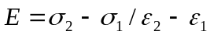 (1)
where σ₁ is the stress measured at a strain value of ε₁ of 1% and σ₂ is the stress measured at a strain value ε₂ of 3.5% and is a secant rather than a true Young’s modulus.

Shore D Hardness
The Shore hardness measurements, determined by the resistance to indentation, were performed using a Shore Durometer using the method ASTM D2240 - 05(2010) Standard Test Method for Rubber Property-Durometer Hardness.

Gravimetric Analysis
Gravimetric analysis was carried by monitoring the weight of samples aged in the test fluids at 40⁰C, 70⁰C or 100⁰C, for 2, 4, 8, 16 etc days. The samples were dried with a cloth and weighed. After weighing, the samples were returned to the ageing environment. Desorption tests were carried out by heating the test samples at 70⁰C in an oil bath for one week, dried with a cloth and kept in sealed plastic bags. The weight was monitored over the course of a month.

Differential Scanning Calorimetry -DSC
Samples taken at regular intervals were subjected to DSC analysis using a DuPont 9900 DSC. A sample of between 5 and 15 mg was taken from the test sample and analysis was carried out using a heating rate of 10⁰C per minute over the temperature range from 30⁰C to 200⁰C in an atmosphere of nitrogen.

Dynamic Mechanical Thermal Analysis -DMTA
A Polymer Laboratories DMTA was used in single cantilever mode. The tube was cut into strips 5 cm in length and width between 4 - 6 cm and thickness 1 – 1.5 cm. The measurements were carried out at 1 Hz, strain x 4 and a clamping torque of 20 N. The temperature was varied between -100⁰C and 150⁰C. The software gives values of the bending modulus E’ and tan δ. Samples were examined at various stages during the ageing process.

Results and Discussion
The umbilical pipes are produced by injection moulding and the morphology created depends on the extrusion temperature, rate and quenching procedure. The molten extruded tube is sized by passing through an air cooled mandrel and is then quenched in a water bath at ambient temperature. During this quenching process, the molten polymer undergoes rapid crystallization and cold drawing which will improve its mechanical properties. The durability of the pipe will depend critically on the morphology which is generated during the quenching process [2-6, 11]. The size of the crystallites formed depends on the rate of quenching of the tube. However it is the preponderance of tie molecules which span the crystalline regions which will ultimately dictate the ESCR and this is controlled by the method used for the polymer synthesis [12-15]. The type of catalyst used influences the polymer chain structure and can also act to seed crystal growth [16]. A narrow low molecular weight and absence of tie molecules in the crystalline material all lead to low values of the ESCR. The presence of hexyl units not only reduces regular chain folding but also reduces crystal thickness; a favourable factor for the generation of tie chains. Examination of the umbilical pipes was undertaken to establish whether the application of high hydrodynamic pressure combined with elevated temperatures has the effect of changing the physical properties of the pipes.

Gravimetric Studies
The uptake of the immersions fluids was investigated at various temperatures

i) Water Uptake
Water with a solubility parameter of 47.9 (J cm⁻³)^{1/2} would not be expected to be absorbed by polyethylene with a solubility parameter of 18 (J cm⁻³)^{1/2} [17]. The data obtained at 40⁰C and 70⁰C shows little or no weight change over the period of the ~280 days immersion, Figure (1A). However at 100⁰C there is a very significant and surprising increase in the weight consistent with water absorption. The small weight losses observed at the lower temperatures can be attributed to the leaching of pigment and antioxidant, which was confirmed by GC-MS analysis of the immersion fluid. At the higher temperature structural changes occur in the polymer matrix that allows the polar pigment and antioxidant to absorb water. The polymer was observed to have become brittle after 100 days exposure in water at 100⁰C. No chemical reaction would have occurred and this implies that the changes are morphological in nature.

ii) Xylene Uptake
Xylene is a non polar solvent with a solubility parameter of (18.1 (J cm⁻³)^{1/2}) and has the capability of interacting with polyethylene and can swell the matrix, Figure (1B), and is absorbed by the HDPE and rapidly reaches equilibrium values of 11% at 40⁰C and 18% at 70⁰C. . In contrast at 100⁰C, there is an initial very large uptake of xylene and then a progressive decrease to an equilibrium value of 38%. The xylene is entering into a relatively open matrix which then appears to be collapsing, causing the amount of fluid absorbed to be reduced. The HDPE when extruded and quenched will have no equilibrium morphology and adsorbed xylene allows reorganization of chains allowing a lower energy more crystalline state to be achieved. The data indicate that the ability for the matrix to undergo facile change is triggered by being raised to a temperature above 70⁰C which would coincide with the melting point of smaller crystallites.

iii) Methanol Uptake
Methanol with a solubility parameter of 29.7 (J cm⁻³)^{1/2} has thermodynamic characteristics which place it between water and xylene and its adsorption characteristics are intermediate between the two systems, Figure (1C). At 40⁰C there is weight loss which is compatible with the leaching of the antioxidant/ pigment from the matrix.

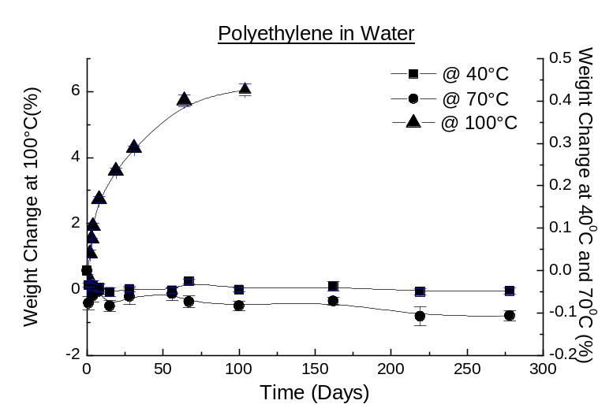
[A]
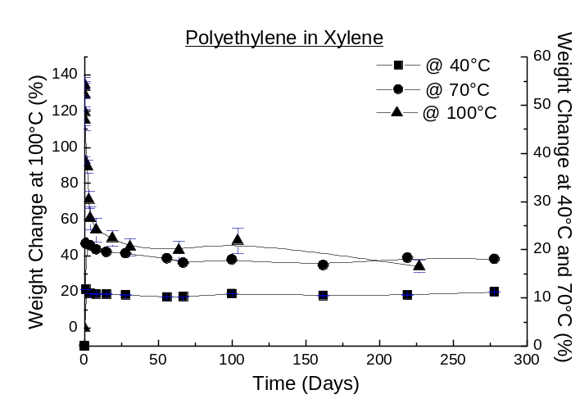
[B]
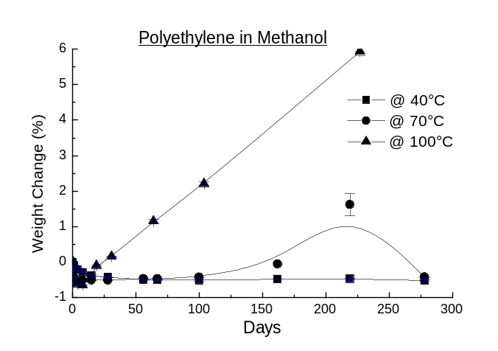
[C]
Figure (1) Weight changes on exposure to [a] water, [b] xylene and [c] methanol.

Initially at 70⁰C there is little absorption; however a significant uptake is observed after ~200 days, but this is followed by a decrease consistent with morphological change occurring in the samples. At 100⁰C, there is a continuing and steady increase in fluid uptake consistent with the initial behaviour observed in xylene. However, methanol is thermodynamically a poorer solvent than xylene and unable to promote the densification of the matrix observed with xylene.

The gravimetric data indicate that at higher temperatures the ingress of fluid into the matrix can promote morphological change. Visually the samples are observed to become brittle as ageing proceeds which is consistent with the conversion of amorphous to crystalline material.

Differential Scanning Calorimetry [DSC] Analaysis
DSC analysis of the initial material before exposure to pressure gave a value for the ΔH of fusion of 139 J/g⁻¹ and a melt temperature T_{m} of 110⁰C. Assuming that the ΔH of fusion of pure polyethylene crystal is 290 J/g⁻¹, this implies that the material is 48% crystalline [18-20]. The gravimetric data suggest significant morphological changes are being induced by exposure to the fluids. Studies of the heat of fusion of the HDPE and melt temperature, Figure (2), indicate that there is an initial increase in crystallinity on application of pressure to a value of 60%, exposure to water at 40⁰C producing a negligible change to the ΔH of fusion. The melting point, T_{m}, which is an indication of the lamellae structure, similarly after an increase from 110⁰C to a value of 128⁰C does not change over a period of 50 days, but then slowly drops. The increase in T_{m} is consistent with an increase in the crystal dimensions, implying that not only is the crystalline content increasing but also the size of the crystals. After 400 days, both ΔH and T_{m} decrease indicating that morphological rearrangement is once more taking place and the crystallinity has decreased to ~54%. Xylene shows an initial increase in ΔH corresponding to a degree of crystallinity of ~54%, the melt temperature initially increases to 126⁰C indicating lamellae thickening. There is an initial increase in the ΔH of fusion for methanol to a value of crystallinity of 55%; however the melting point does not change significantly. Little change in the values of ΔH and T_{m} are observed over the ageing period.
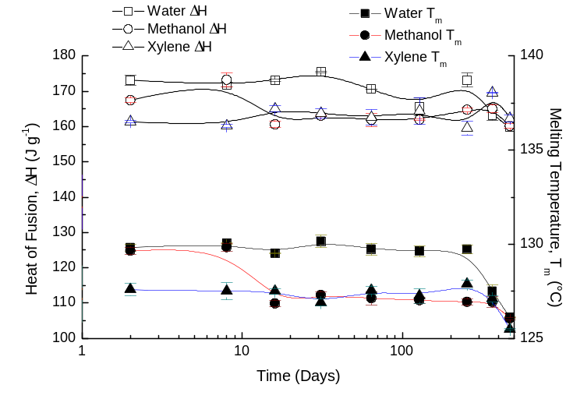
[A]
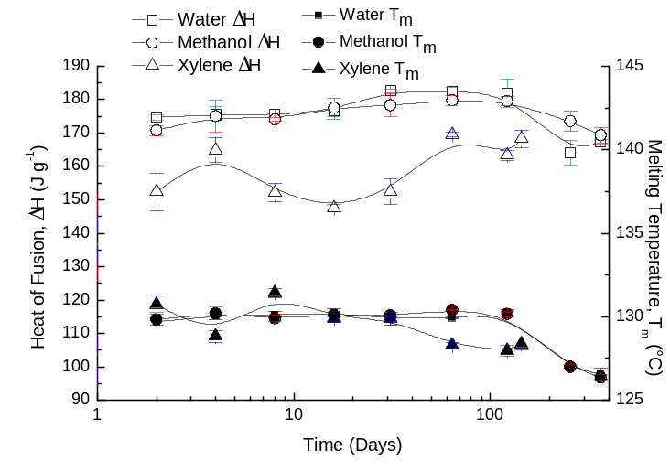
[B]
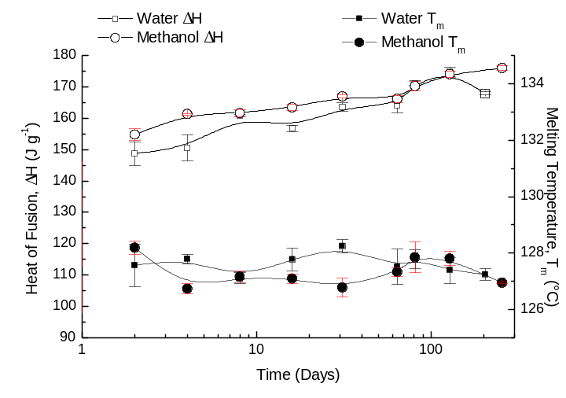
[C]
Figure (2) DSC analysis of HDPE exposed to water, methanol and xylene at [A] 40⁰C, [B] 70⁰C and [C] 100⁰C.
Studies at 70⁰C, Figure (2B), are similar to those at 40⁰C, the changes induced by exposure to water being slower than those caused by methanol or xylene. The rate of change reflects the solubility of the fluid in the matrix and its ability to induce morphological change. Interestingly, xylene initially causes a smaller increase in the degree of crystallinity to a value of ~51% and then oscillates with time rising to a value of 56%. Water and methanol have initial values of ~59% which rise to ~ 62% before falling to values of ~ 56%. The values of T_{m} remain fairly steady for 200 days.

At 100⁰C, exposure to water and methanol, Figure (2c) produces a progressive increase in the ΔH and lowering of T_{m} the melting point. Whilst pressure indicates initial changes in the degree of crystallinity, it is required that the materials are raised above 70⁰C to allow the progressive morphological change but the crystal size and fraction are lower than observed at lower temperatures.

The degree of crystallinity in the pristine material is ~48% and increases to 62% on the initial application of pressure, before dropping to a value of 55% and then increasing to a final value of 58% [18]. Studies on the crystallization of HDPE in various solvents have shown that the morphology can influence the lamellae thickness and that melting points of crystal mats have been reported which are as low as 80⁰C [19]. The differences in the rate and type of morphological change which occur are a reflection on the rate at which the chains in the amorphous phase can rearrange and the extent to which solvent can aid this process.

Ageing Studies at Constant Pressure
Ageing studies were carried out on pipes held at constant pressure filled with water, methanol and xylene and pressurised to 200 bar and carried out at 40⁰C, 70⁰C and 100⁰C. The initial values of the mechanical properties before pressurization are listed in Table(1).
Table (1) Tensile Properties of HDPE pipe material
Material | Young’s Modulus (MPa) | Yield Strength (MPa) | Ultimate Tensile Strength (MPa) | Elongation at Break (%) | Shore D Hardness
HDPE | 340 ± 5 | 21 ± 0.2 | 29 ± 0.8 | 692 ± 27 | 58 ± 0.4

Ageing at 40⁰C

Irrespective of the fluid used the Young’s modulus, yield strength and ultimate tensile strength (UTS), all dropped initially, Figure (3). The pipes will have a significant in built thermal stress resulting from the manufacturing quenching process which will rapidly relax on exposure to a temperature above ambient and a pressure of 200 bar. DSC analysis of unaged and aged materials showed similar changes consistent with rapid morphological changes occurring in the material. The largest changes have occurred before the first mechanical measurements were undertaken.
i) Exposure to Water
For exposure to water the Shore D hardness does not change over the aging period which is consistent with the degree of crystallinity remaining constant. The decrease in the Young’s modulus, yield strength and UTS are consistent with there having been a rearrangement of the amorphous structure of the HDPE. After the initial drop these properties show a progressive increase over the period of study, the elongation to break increasing by about 10%.

ii) Exposure to methanol
As can be seen in Figure (3B), the ageing behaviour in methanol was very similar to that in water; however the modulus recovers slightly more quickly in the case of methanol. This is consistent with the greater solvating characteristics of methanol compared with water.

iii Exposure to Xylene
Xylene has a more severe impact on HDPE than water or methanol, Figure (3C). The Young’s modulus, yield strength and UTS dropped more rapidly than with the other fluids falling by over 50% after only two days of ageing. The elongation at break increased slightly during the first four days and then dropped back to its original value and the Shore D hardness dropped by about 5% during the first two weeks and then remained constant throughout most of the test period. Xylene is clearly acting as a plasticizing solvent for the amorphous phase.

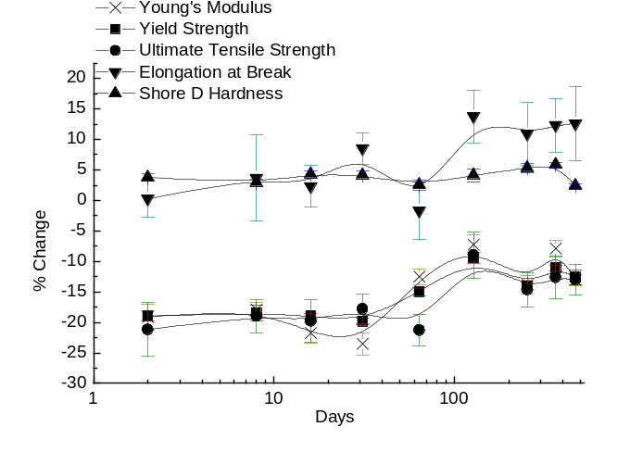
[A]
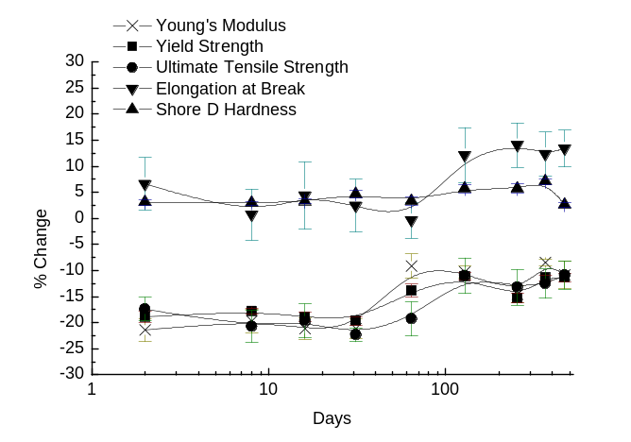
[B]
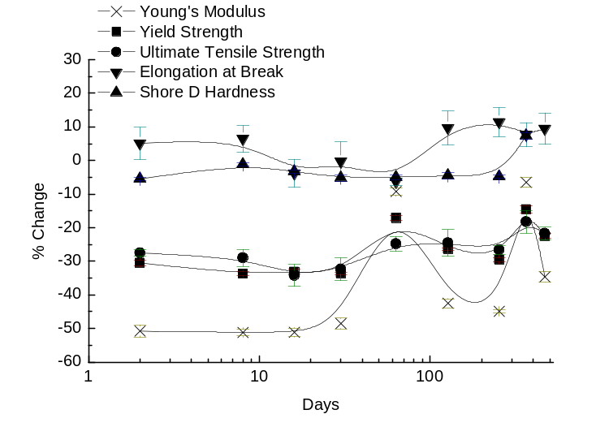
[C]
Figure (3) Variation of Young’s modulus, Yield strength, Ultimate Tensile strength, elongation to break and Shore D hardness as a function of time of exposure to [A] water, [B] methanol and [C] xylene at 40⁰C and 200 bar.

Dynamic Mechanical Thermal Analysis at 40C
DMTA allows changes in the dynamic of the amorphous phase to be investigated.
i) Water
DMTA traces obtained as a function of ageing time are shown in Figure (4A). Consistent with the tensile measurements a significant change is observed over the first two days ageing at 40⁰C, with a marked increase in the bending modulus (E’) and a shift of the peak in tan δ to higher temperatures consistent with the effects of increasing crystallinity. Further ageing does not lead to significant changes in either the modulus or tan δ. As with the tensile measurements, after 469 days there is a lowering of the modulus and a shift to a lower temperature of the tan δ peak.
ii) Xylene
There is an initial increase in the magnitude of E’ and shift of the peak in tan δ to higher temperature reflecting a stiffening of the matrix. However over longer time, the tan δ peak shifts to lower temperature reflecting a greater mobility of the polymer chains in the amorphous matrix to move consistent with plasticization.
iii) Methanol
The behaviour in methanol at 40˚C was very similar to that in water, Figure (4C). The bending modulus increased dramatically after two days and then remained constant for a period, but like xylene there is a downward shift in tan δ and ultimately a drop in E’ after 460 days.

In conclusion, ageing at 40⁰C is dominated by the initial release of stresses introduced during production of the pipes. The subsequent ageing in water has a negligible effect on the physical properties and a small but noticeable effect in the case of xylene and to a lesser extent methanol. These observations imply that provided account of the changes which occur during the initial pressurization are taken into account then the subsequent changes reflect the ability of the fluid to induce morphological changes.
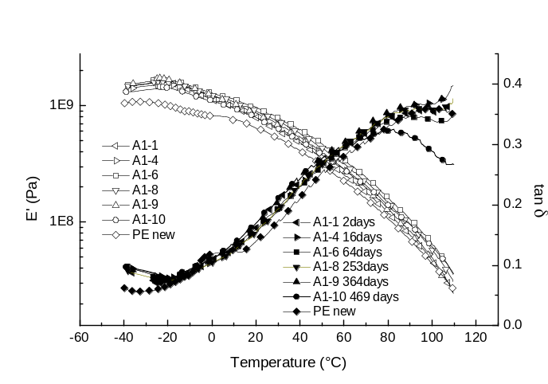
[A]
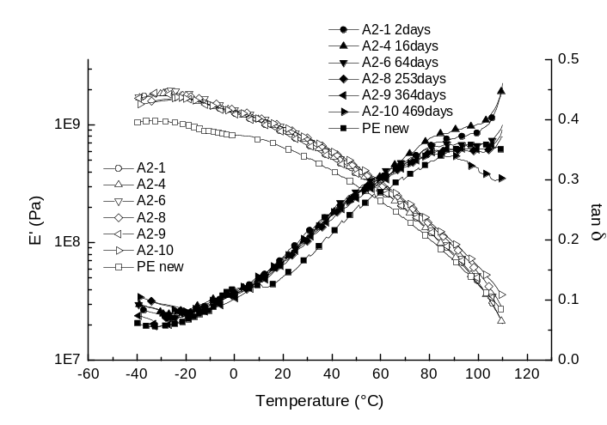
[B]
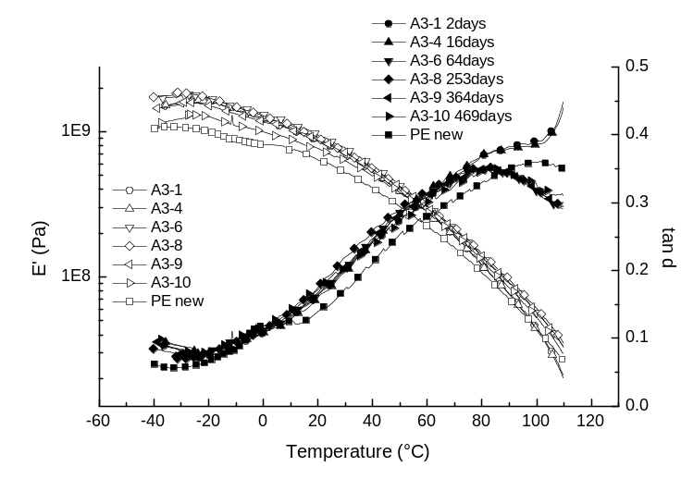
[C]
Figure (4) DMTA traces for HDPE exposed to [A] Water, [B] xylene and [C] methanol at 40⁰C.

Ageing at 70⁰C
i) Water
The Young’s modulus, yield strength and ultimate tensile strength (UTS) dropped by 15% to 20% after only two days of ageing, Figure (5A). Whereas modulus and yield strength slowly recovered by ~10%, the UTS dropped further until day 64, before slowly recovering until the end of the experiment. The elongation at break increased by about 10% initially and then remained constant around this value. The Shore D hardness increased by 5% in the first eight days and then also remained constant. The initial changes in the tensile properties were similar to those observed at 40⁰C except that the elongation to break and Shore D hardness were slightly greater, Figure (5A). The higher temperature in combination with the pressure is allowing faster morphological changes than at 40⁰C and the equilibrium structure will be different reflecting the higher temperature. In general, the changes are similar to those observed at the lower temperature with the recovery in physical properties occurring to a greater extent at 70⁰C. The gravimetric data, Figure (1) and DSC data, Figure (2) had shown little change and this is consistent with the observations of the tensile properties.
ii) Methanol
In methanol, Figure 5(B), the Young’s modulus, yield strength and UTS decreased by ~15% over the first two days, whereas the modulus and yield strength increased respectively by 4 and 10%. The UTS varied in an oscillatory manner for the first 100 days and finally dropped 20% of its original value. The UTS reflects the effectiveness of the tie molecules in the system. Increase in the elongation to break is associated with an increase in the amorphous content of the material allowing a greater degree of chain movement before failure occurs. Changes in the Young’s modulus and Shore D hardness reflect changes in the crystallinity of the material.
iii) Xylene
The initial changes are similar to those with the other liquids, showing very significant drops in the modulus, yield strength and ultimate tensile strength. The modulus apparently increasing after 31 days and probably reflects the solvent assisted rearrangement of the matrix; however this increase is lost as the value returns rapidly to a lower value. The most striking difference is the magnitude of the changes observed, the Young’s modulus dropping by ~ 55%, the ultimate tensile strength and yield strength dropping by ~35%, compared with the drops of approximately half these values in water and methanol.
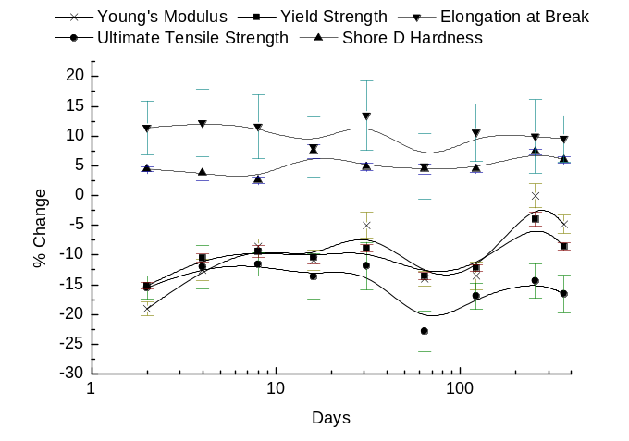
[A]
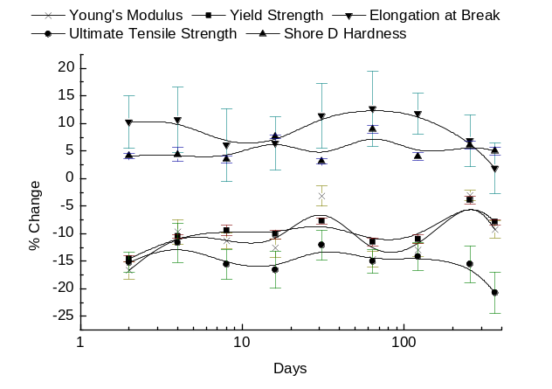
[B]
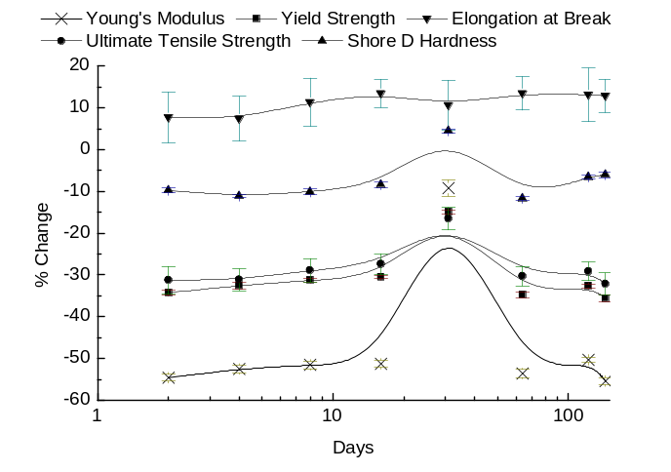
[C]
Figure (5) Tensile test data for [A] water, [B] methanol and [C] xylene at 70⁰C and 200 bar.

DMTA at 70C
i) Water
The DMTA, Figure (6A) shows an increase in the bending modulus E’ after two days and a very significant reduction in temperature of the tan δ peak reflecting a greater mobility of the polymer chains in the amorphous phase, and are consistent with the increased elongation to break, Figure (5A). The shift of the tan δ peak to higher temperatures on ageing result from an increasing restriction on chain motion as some of the chains in the amorphous phase are incorporated into new crystalline structures as indicated by the DSC data Figure (2). These changes are thermally activated and do not require the influence of water permeation into the matrix.
ii) Methanol
A similar pattern of shifts in the tan δ and E’ are observed with methanol, Figure (6B). Very significant changes occur in the first two days followed by the characteristic movement of the tan δ peak to higher temperatures on ageing. It is observed that the amplitude of the tan δ peak reduces at longer times, reflecting a reduction of the proportion of chains in the amorphous phase as the new crystalline structure is formed. As the structural rearrangement proceeds so the bending modulus drops and the tan δ peak moves to higher temperatures, indicative of a stiffening of the matrix.
iii) Xylene
As in the case of water and methanol the initial changes occur over the first two days, Figure (6C). The bending modulus increases and the tan δ peak shifts to lower temperatures indicative of plasticization. The magnitude of tan δ increases to a value which is greater than that observed with water or methanol reflecting the plasticization of the matrix by xylene. However as with the other fluids, at longer times the tan δ decreases reflecting the tightening of the matrix and a reduction in the extent to which chain motion occurs.

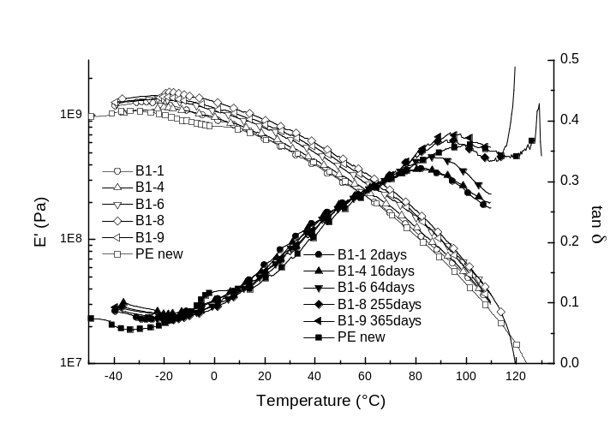
[A]
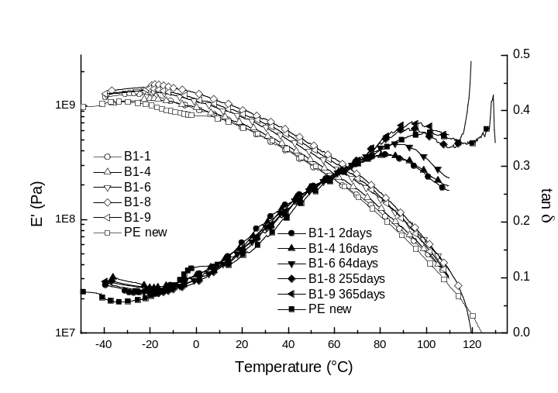
[B]
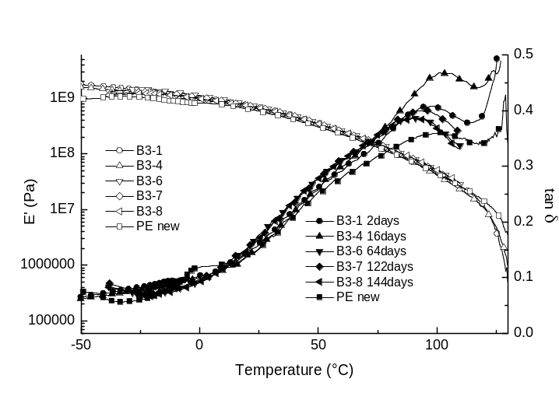
[C]
Figure (6) DMTA traces for HDPE aged at 70ºC at a constant pressure of 200 bar in [A] water, [B] methanol and [C] xylene.

Ageing at 100⁰C
Ageing was carried out in water and methanol at 100⁰C. The tests with xylene had to be terminated shortly after ageing was started because of failure at the stainless steel connectors.

Tensile Testing
i) Water
As with exposure at lower temperature ageing at 100⁰C, Figure (7) produced the expected drop in the Young’s modulus, reduction in yield strength and ultimate tensile strength and an increase in the elongation to break. However the Shore D Hardness did not change significantly. The magnitude of the change was slightly larger than at the lower temperatures but significantly smaller than when the ageing was carried out in xylene. The modulus slowly increases with time and the ultimate tensile strength slowly decreases. After about 80 days the elongation to break drops and continues to drop further after 200 days.

ii Methanol
The behaviour observed with methanol, Figure (7B), is similar to that with water except that the increase in the modulus is faster and the elongation to break does not undergo the dramatic drop observed with water after 80 days. These observed differences in behaviour are consistent with the ability of the methanol to plasticise the motion of the polymer and reflects the gravimetric data which show a significant solvent uptake at 100⁰C. Clearly the rearrangement of the matrix is occurring leading to changes in physical properties but the methanol is able to interact with the amorphous phase and assist segmental motion of the polymer chains. It is noticeable that the drop in elongation to break observed with water is not observed with methanol. The methanol is able to plasticize the amorphous phase more effectively and retain the mechanical properties.

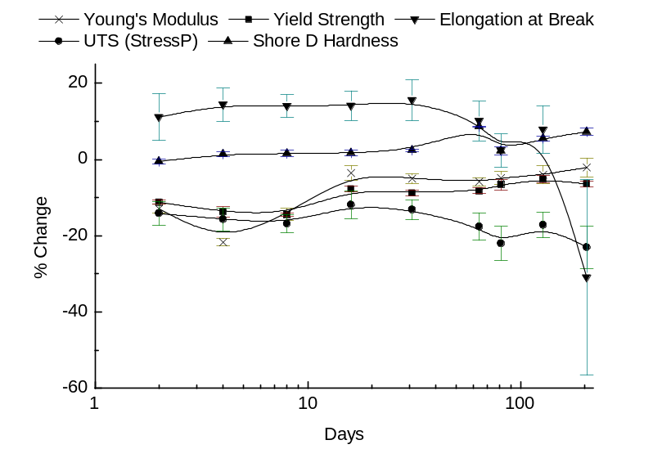
[A]
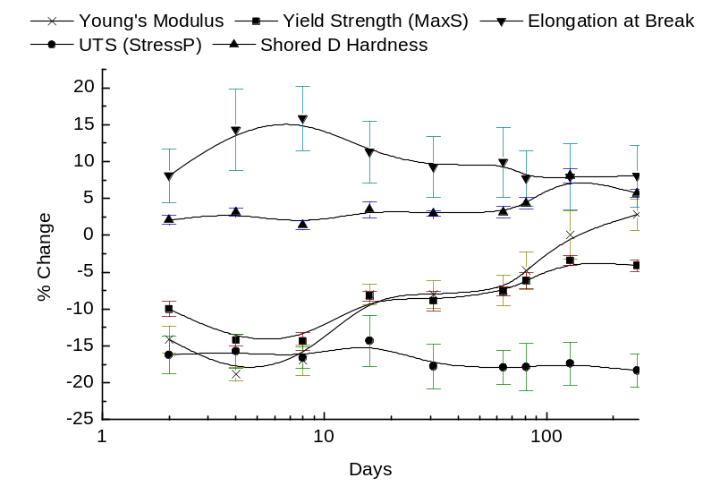
[B]
Figure (7) Tensile test data for HDPE aged at 100⁰C for [A] water and [B] methanol.

DMTA at 100C
i) Water
After 2 days exposure to water at 100⁰C, the bending modulus E’ and tan δ have respectively decreased and increased, Figure (8A). Further aging produces only a small decrease in the modulus but there are further increases in tan δ consistent with increased chain mobility. The shift of the tan δ peak to higher temperatures indicates that restrictions on chain motion by the crystalline phase are increasing as the morphology changes. The increase in the crystallinity will lead to the observed reduction of the elongation to break which is indicative of a decrease in the critical mechanical properties.
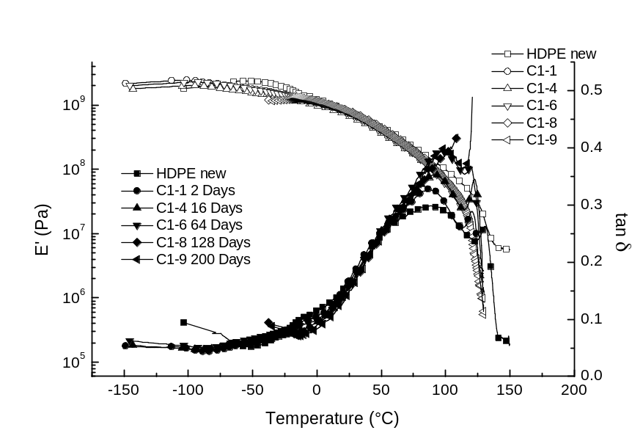
[A]
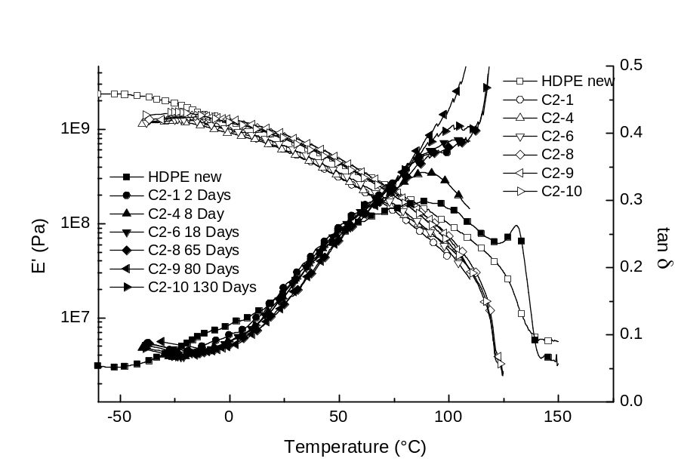
[B]
Figure (8) DMTA traces for HDPE aged at 100⁰C for [A] water and [B] methanol.

ii) Methanol
Exposure to methanol at 100⁰C produces a drop in the bending modulus E’ after two days, Figure (8B). This is in contrast to the behaviour observed at lower temperatures where an increase was observed. The gravimetric data indicate that methanol is being rapidly absorbed into the matrix and the drop is consistent with plasticization of the amorphous phase. As ageing proceeds, so the amplitude of the tan δ curve increases reflecting an increase in polymer chain motion. Plasticization is also reflected in the tensile data, Figure (7) where physical properties were retained longer than when the HDPE was exposed to water.

DISCUSSION OF THE CONSTANT PRESSURE TEST DATA
The initial application of pressure to the samples unlocks stresses built into the matrix as a result of quenching and these in turn lead to changes in the crystalline phases, which increase in thickness and total content. Changes are also possible in the amorphous phase and xylene and methanol are effective plasticizers for the polymer chain motion. The proportion of crystalline to amorphous material changes with the fluid but also with the ageing temperature. Interestingly, xylene which is effective at promoting morphological change is forced out of the matrix, as reflected in gravimetric measurements, by these changes. The data reflect a balance being achieved by the ability of the fluid to solvate the polymer and thermodynamic equilibrium structure dictated by the ageing temperature.

Cyclic Pressure Tests
In practice, the pressure on the pipes will change and the cyclic ageing test was undertaken to simulate these conditions. The regime used involved raising the pressure to 200 bar over a period of 5 minutes, holding for 40 minutes and then lowering over a 5 minutes period, holding at atmospheric pressure for 40 minutes and then repeating the cycle.

Ageing at 40⁰C
Tensile Properties
i) Water
In contrast to the ageing at 40⁰C under constant pressure, Figure (3A) significant variations in the tensile properties are observed, Figure (9A). The magnitude of the initial changes are comparable. However under constant pressure the values of the parameters remain constant for a significant period of time, in the case of the cyclic pressure study these parameters show significant variation in the first few days. The application and release of pressure is promoting different morphological changes to those which are occurring when constant pressure is used.
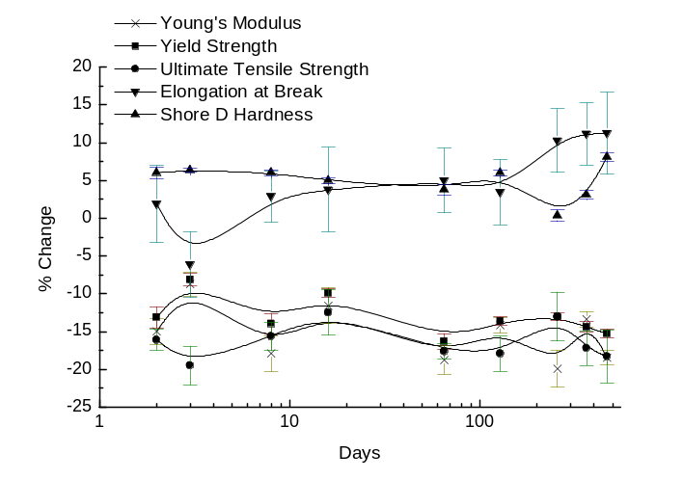
[A]
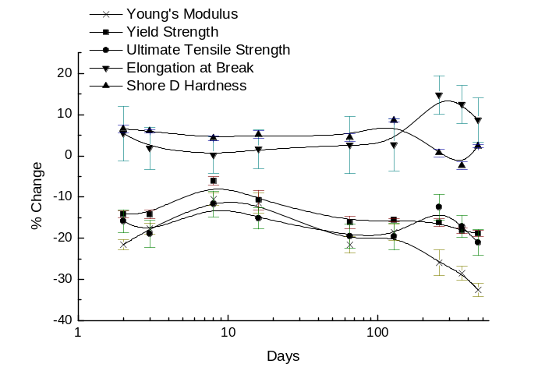
[B]
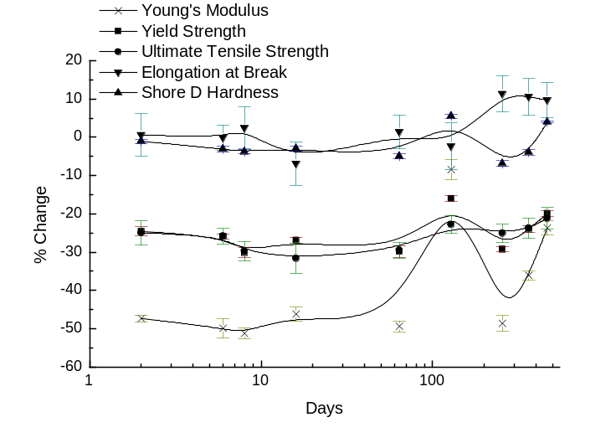
[C]
Figure (9) Tensile test data obtained at 70⁰C using a cyclic pressure regime for exposure to [A] water, [B] methanol and [C] xylene.

This is reflected in the Shore D hardness and yield strength, Young’s modulus and UTS. At longer times the Shore D hardness increases as does the elongation to break. The cyclic pressure ageing is creating a morphology which is better suited to retention of the mechanical properties than that produced if only constant pressure were used.

ii Methanol
Cyclic ageing in methanol, Figure (9B) shows similar behaviour to that in water, Figure (9A) except that towards the end of the period studied the elongation to break, Young’s modulus, UTS and yield strength are all showing a downward trend. This is in contrast to the behaviour at 40⁰C, where the physical properties were essentially constant or slightly increasing over this period which is different from that observed using a constant pressure regime.

iii) Xylene
Xylene has a greater thermodynamic capacity of being absorbed by HDPE and this is reflected in the almost immediate loss of the 50% of the value of the Young’s modulus and reductions in the UTS and yield strength. As at 40⁰C, Figure (3C), there was observed an increase followed by a decrease in the Young’s modulus with time and comparable changes are observed under cyclic ageing. It is well known that PE can strain harden and it is clear that the morphological changes being induced are essentially similar to this effect.

Tensile Test Data at 70⁰C
To parallel the constant pressure ageing data, measurements were carried out using the cyclic pressure regime at 70⁰C, Figure (11). Comparison with the variation observed when the pipes were aged at constant pressure, Figure (3), indicates significant differences between the constant and cyclic ageing behaviour.

i) Water
Whilst the magnitude of the initial changes are comparable, Figure (10A) whereas there was a general increase in the tensile properties observed on ageing at constant pressure, with cyclic ageing the tensile properties initially increase but then drop over the ageing period.

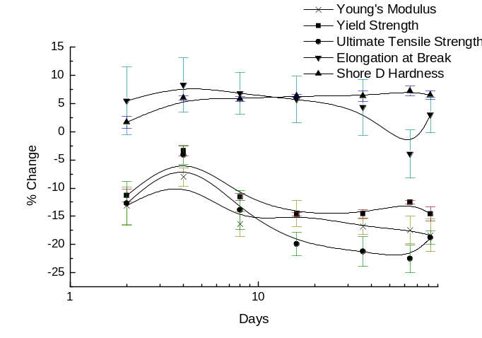
[A]
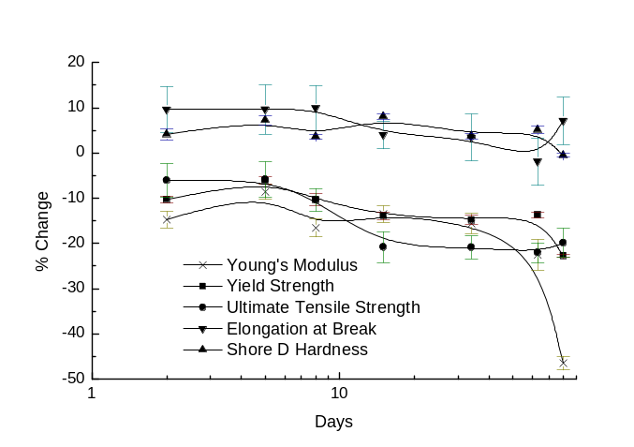
[B]
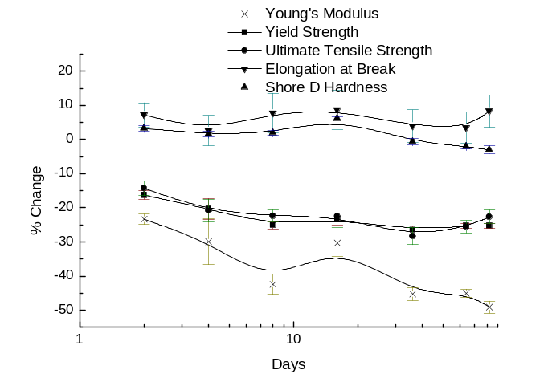
[C]
Figure (10) Tensile properties for samples aged using the cyclic pressure regime in [A] water, [B] methanol and [C] xylene.

The Young’s modulus which initially dropped by 12%, has fallen by -15% compared with its initial value, whereas under constant pressure ageing the value had recovered to -5%.

ii) methanol
HDPE aged in methanol, figure (10B) showed a very similar trend to that found for ageing in water, showing a drop in properties over the whole period and the Young’s modulus dropping to 50% towards the end of the period. This is in contrast to the constant ageing data where the tensile properties maintained their values through the major part of the ageing period, Figure (5B).

iii) Xylene
The initial reduction in tensile properties with cyclic ageing are smaller than those observed using constant pressure ageing, Figure (5). The Young’s modulus under constant ageing drops by 55%, whereas with cyclic ageing it only falls 25%. However at the end of the aging period the modulus has now decreased to a value which is comparable to that for constant pressure ageing.

DSC Data
DSC measurements taken on sample of the HDPE subjected to cyclic ageing, Figure (11) show similar trends to those found under constant pressure exposure, Figure (2A), except that the initial loss in crystallinity is more marked with the cyclic regime. The crystallinity rises with ageing and the morphological restructuring leads to a reduction of the lamellae thickness as reflected in the reduction in the melting point. The changes are larger in the case of the exposure to xylene, where there is an initial thickening of the lamellae, before a progressive thinning is observed.
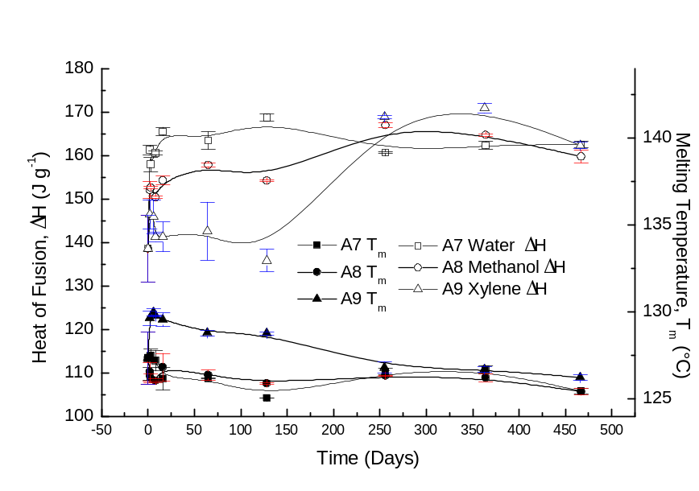
[A]
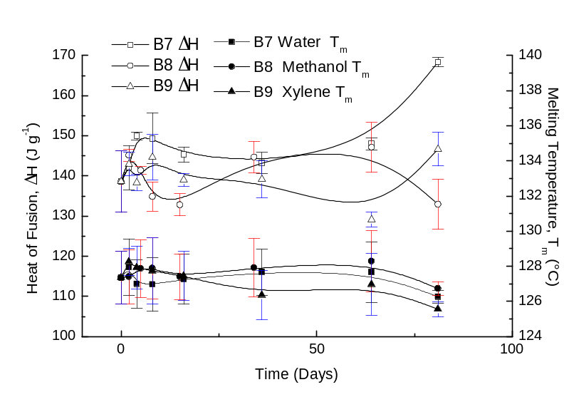
[B]
Figure (11) DSC data for samples aged using the cyclic pressure regime at [A] 40⁰C and [B] 70⁰C.

DMTA study
The temperature variation of the bending modulus E’ and the tan δ are shown in Figure (12) for ageing at 40⁰C.
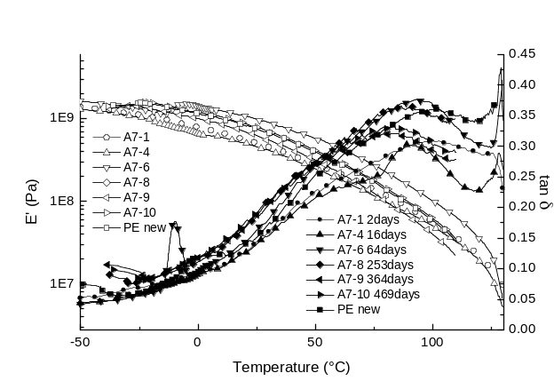
[A}
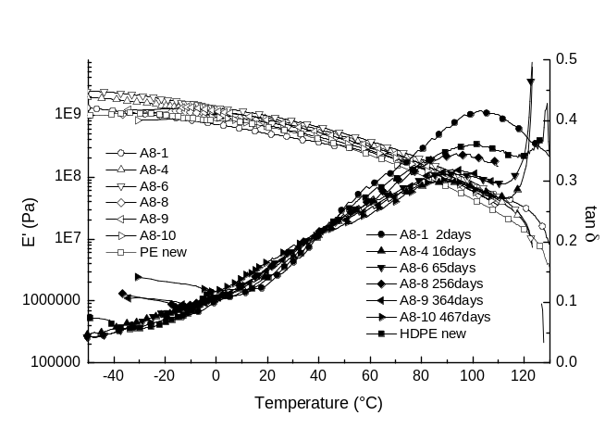
[B]
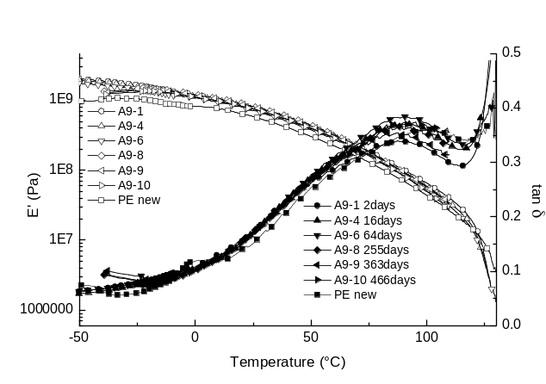
[C]
Figure (12) DMTA traces for HDPE aged at 40⁰C using the cyclic pressure regime in [A] Water, [B] methanol and [C] xylene.

i) Water
The tan δ peak moves to lower temperatures immediately on exposure to the pressure cycle, Figure (12A). As in the ageing at constant pressure, Figure (6A), there is an immediate change in the value of E’. As ageing continues, the tan δ shifts to higher temperatures but not quite to the same extent as in the case of constant pressure ageing. The data suggest that the chain motion is retained to a larger extent in the cyclic aged material.

ii) Methanol
Similar initial changes are observed to those observed with water, except that in the case of the methanol aging, Figure (12B) the tan δ peak retains its amplitude and does not shift to as high a temperature. The increased amplitude and the smaller shift imply that the methanol is plasticising the chain motion which is being retained to a larger extent than in the case of the water ageing. As ageing proceeds the tan δ peak drops in amplitude consistent with a tightening of the matrix.

iii) Xylene
Once more xylene exhibits slightly different behaviour from that of water and methanol; the tan δ peak retains its amplitude and location during the entire period of ageing, which implies that the xylene is plasticizing the amorphous phase. These small differences are consistent with the variations which have been observed in the tensile tests.

Ageing at 70⁰C
i) Water
As at 40⁰C, there is a very significant change on the initial exposure to the cyclic pressure regime, Figure (13A). After the initial change the tan δ peak moves to a higher temperatures on ageing but the amplitude is higher than at 40⁰C implying that there is a greater ability for chain motion to occur. This is consistent with embrittlement and stress induced crystallisation.
ii) Methanol
The ageing in methanol is similar to that in water, Figure (13B). The main difference is that the magnitude of the tan δ peak after 64 days is much larger than that observed in the case of water. The methanol is being an effective plasticizer of the motion. Subsequently the tan δ peak falls to a value which is comparable to that found in water.
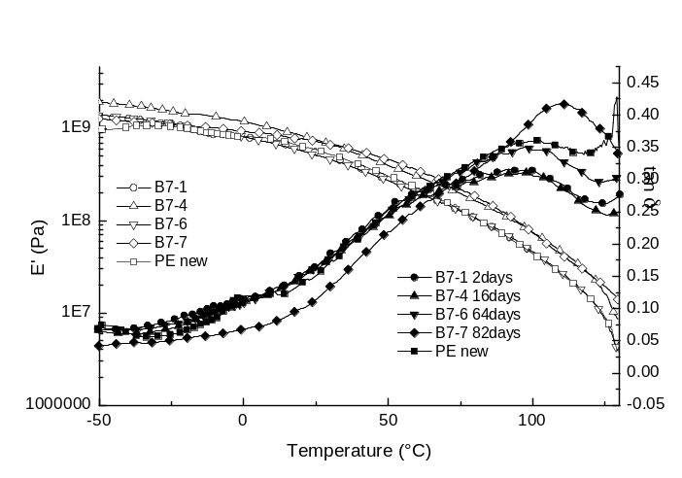
[A]
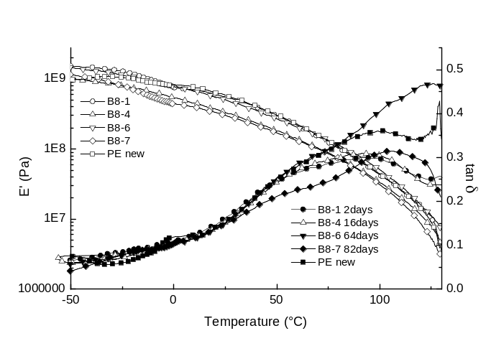
[B]
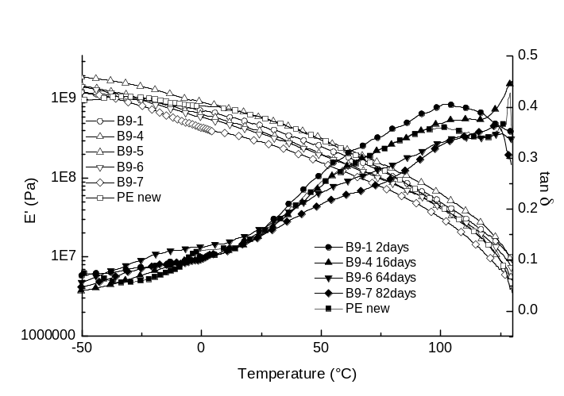
[C]
Figure (13) DMTA analysis of HDPE aged using the cyclic pressure regime in [A] water, [B] methanol and [C] xylene at 70⁰C.

iii) Xylene
The plasticizing effect of xylene is evident in the variation of the tan δ peak which retains its amplitude up to the end of the ageing studies, Figure (13C). It is however noticeable that the value of the bending modulus is progressively dropping, implying that that matrix is becoming softer.

Discussion - Cyclic Pressure Tests
The principal difference between the cyclic and constant pressure ageing reflect the difference in ability of the two regimes to achieve stress relaxation in the initial stages and the ability to promote changes in the crystalline and amorphous structure. The cyclic application of pressure leads to a morphology with better mechanical properties than those resulting form constant pressure aging. However in both cases dramatic changes in all physical properties are observed when the pressure is applied. A detailed morphological characterisation of the materials was beyond the scope of this study. In both cases differences in the long term behaviour reflect the differing solvation power of the fluids and their ability to promote morphological change and plasticise the amorphous matrix. Whilst the ageing in both regimes showed similar trends, in certain cases ageing at constant pressure appears to allow a recovery of some physical properties whereas cyclic ageing does not.

BURST TESTS
The ultimate test of the ageing of the pipes is the burst test which was carried out on the aged materials, Table (2). The pressure was raised in the pipe and the maximum value achieved recorded. The pristine pipes are designed to fail at four times the maximum working pressure which is 200 bar and values of between 1000 and 1200 bar were observed initially. The tests at constant pressure were carried out at longer times than those using the cyclic pressure regime. Surprisingly the burst tests data did not reflect as dramatically the changes which had been observed in the tensile tests, DMTA or DSC measurements. Water ageing at 40⁰C leads to no reduction in the burst pressure over the test period, however at 70⁰C a reduction of 30% is observed over a period of a year. Ageing at 100⁰C produces a comparable reduction in properties. As indicated above, the morphological changes which are induced are a complex function of solvent used and temperature. The lowest value observed was with methanol aged at 100⁰C. With xylene failures occurred at the swaging connectors and the values were ~ 47 bar which were not considered to truly represent the ageing of the pipes.

Table (2) Burst Pressure test data (psi (15psi=1bar; working pressure = 3000psi)) measured using different ageing regimes.
Temperature | 40⁰C |  | 70⁰C | 100⁰C
Ageing Regime | Constant Pressure | Cyclic Pressure | Constant Pressure | Constant Pressure
HDPE unaged | 16885 | 16885 | 16885 | 16885
Water @ 253 days | 17050 | 16500 | - | -
Water @ 122 days | - | - | 14400 | -
Water @ 365 days | - | - | 11750 | 12250
Water @ 470 days | 16700 | 16900 | - | -
Methanol @ 365 days | - | - | 15400 | 10200
Methanol @ 470 days | 16300 | 16750 | -
Xylene @ 122 days |  |  | 17500 | -
Xylene @ 253 days | 17000 | - |  | -
Xylene @ 365 days |  |  | 13700 | -
Xylene @ 470 days | 16750 | 16700 |  | -

CONCLUSIONS
Whilst the burst tests data show only small variations with test conditions very significant changes in the morphology and tensile properties of the pipes are occurring over the period of study. These changes will ultimately lead to a loss in mechanical properties and significant reductions in the service life of the pipes. Differences are observed between cyclic and constant pressure ageing and lead to the conclusion that the regimes promoted the development of different types of morphology which influence the mechanical properties in different ways. In general, ageing leads to an increase in the crystalline content of the material and a consequent reduction in the amorphous phase. Plasticization of the amorphous phase, (while this process can assist in the material retaining elastic properties), will also increase the rate at which morphological change occurs. Increase in crystallinity is visually observed as the material embrittling and demonstrates a greater tendency to failure.

ACKNOWLEDGEMENTS
One of us MB wishes to acknowledge the support of the National Engineering Laboratory Ltd and DUCO Ltd throughout this project; in particular Bob Dunlop and Bobby Anderson from NEL, John Brown and Alan Dutton from DUCO.

REFERENCES
1) Pethrick R.A. Polymer Science and Technology for Engineers and Scientists, Wiley Interscience, New York 2010.
2) Bandyopadhyay S, Brown H.R., Environmental-Stress Cracking and Morphology of Polyethylene Polymer, 1978, 19 (5) 589-592.
3) Bandyopadhyay S, Brown H.R., K-A Relationship in the Environmental-Stress Cracking of High Molecular-Weight Polyethylene, International Journal of Fracture, 1979, 15 (5) R175-R177.
4) Bandyopadhyay S, Brown H.R., Environmental-Stress Cracking of Low-Molecular Weight High-Density Polyethylene Polymer, 1981, 22 (2) 245-249.
5) Cheng J.J., Polak M. A., Penlidis A., Phase Interconnectivity and Environmental Stress Cracking Resistance of Polyethylene: A Crystalline Phase Investigation, Journal of Macromolecular Science, Part A: Pure and Applied Chemistry, 2009 46, 572–583.
6) Choi B-H, Weinhold J, Reuschle D., Kapur M., Modeling of the Fracture Mechanism of HDPE Subjected to Environmental Stress Crack Resistance Test, Polymer Engineering and Science 2009 2086 -2091.
7) Maxwell A.S., Pilkington G., Prediction of Environmental Stress Cracking
Resistance in Linear Low Density Polyethylenes, Polymer Engineering and Science 2008 360 -364.
8) Chudnovsky A., Sehanobish K., Wu S., Methodology for Durability Analysis of HDPE Pipe Transactions of the ASME 2000, 122,152 -155.
9) Tonkovic Z., Somolanji M., Stojsic J., Life Prediction Of Damaged PE 80 Gas Pipes Tehnicki Vjesnik-Technical Gazette, 2009 16 (3) 33-37.
10) Ayyer R., Hiltner A., Baer E., Effect of an environmental stress cracking agent on the mechanism of fatigue and creep in polyethylene, Journal of Materials Science, 2008, 43 (18) 6238 – 6253.
11) Ulas I., Drawing of High Density Polyethylene Tube: Effect of Different Cooling Conditions, Polymer Engineering and Science, 1999, 39, (5) 855 – 861.
12) Sharif A, Mohammadi N., Ghaffarian S.R., Model Prediction of the ESCR of Semicrystalline Polyethylene: Effects of Melt Cooling Rate, Journal of Applied Polymer Science, 2009 112, 3249–3256.
13) Lagaron J.M., N.M. Dixon N.M., Reed W., Pastor J.M., Kip B.J., Morphological characterisation of the crystalline structure of cold-drawn HDPE used as a model material for the environmental stress cracking (ESC) phenomenon, Polymer 1999 40 2569–2586.
14) Lagaron J.M., Capaccio G., Rose L.J.,, Kip B.J., Craze Morphology and Molecular Orientation in the Slow Crack Growth Failure of Polyethylene Journal of Applied Polymer Science, 2000. 77, 283–296.
15) Hamouda H.B.H., Simoes-betbeder M., Grillon F., Blouet P., Billon N., Piques R., Creep damage mechanisms in polyethylene gas pipes Polymer 2001 42 5425- 5437.
16) Cazenave J., Seguela R., Sixou B., Germain Y., Short-term mechanical and structural approaches for the evaluation of polyethylene stress crack resistance Polymer 2006 47 3904–3914.
17) Brandrup, J.; Immergut, Edmund H.; Grulke, Eric A.; Abe, Akihiro; Bloch, Daniel R. Polymer Handbook, 2005 John Wiley & Sons.
18) L. Mandelkern, A. L. Allou, Jr., and M. Gopalan The Enthalpy of Fusion of Linear Polyethylene, J. Phys. Chem. 1968 78, (1) 309 -318.
19) Illers K.H., Kanig G., Heat of fusion and lamellar structure of polyethylene single crystal mats, Colloid & Polymer Sci. 1982 260, 564-569.
20) Sirotkin R.O. Brooks N.W., The dynamic mechanical relaxation behaviour of polyethylene copolymers cast from solution, Polymer 42 2001 9801 -9808.

