The Metallurgy, Mechanics, Modelling and Assessment of Dissimilar Material Brazed Joints
Niall Robert Hamiltonª, James Woodª, Alexander Gallowayª, Mikael Brian Olsson Robbieª, Yuxuan Zhangª
ªUniversity of Strathclyde, Department of Mechanical Engineering, Glasgow, United Kingdom, G1 1XJ
Corresponding author: Niall Robert Hamilton, Tel: +44 (0) 141 548 2043, email: niall.hamilton@strath.ac.uk, University of Strathclyde, Department of Mechanical Engineering, Glasgow, United Kingdom, G1 1XJ

Abstract
At the heart of any procedure for modelling and assessing the design or failure of dissimilar material brazed joints there must be a basic understanding of the metallurgy and mechanics of the joint. This paper is about developing this understanding and addressing the issues faced with modelling and predicting failure in real dissimilar material brazed joints and the challenges still to be overcome in many cases. An understanding of the key metallurgical features of such joints in relation to finite element modelling is presented in addition to a study of the mechanics and stress state at an abrupt interface between two materials. A discussion is also presented on why elastic singularities do not exist based on a consideration of the assumption of an abrupt change in material properties and plasticity in the vicinity of the joint. In terms of modelling real dissimilar material brazed joints; there are several barriers to accurately capturing the stress state in the region of the joint and across the brazed layer and these are discussed in relation to a metallurgical study of a real dissimilar material brazed joint. However, this does not preclude using a simplified modelling approach with a representative braze layer in design and failure assessment away from the interface. In addition modelling strategies and techniques for assessing the various failure mechanisms of dissimilar material brazed joints are discussed. The findings from this paper are applicable to dissimilar material brazed joints found in a range of applications; however the references listed are primarily focussed on work in fusion research and development.
1. Introduction
Dissimilar material joints can be found in a range of current and emerging applications such as gas turbines, spacecraft and nuclear power plants. Maximising the performance of such applications often requires structurally sound joints between materials of varying mechanical, chemical and thermal properties. One such emerging application where dissimilar material joints are commonplace is in the first wall and divertor of present day and next step thermonuclear fusion reactors. In this application, the materials facing the plasma have to withstand intense fluxes of charged and neutral particles in addition to incident power densities in the region of 20MW/m². Consequently, the number of materials capable of withstanding such harsh environments are limited and diverse. As an example, in ITER carbon fibre composites and tungsten have been selected as the materials of choice for all plasma facing surfaces [1]. These plasma facing components are then joined to a high thermal conductivity heat sink material, in the case of ITER a precipitation hardened copper chrome zirconium alloy (CrCrZr), which in turn is joined to the surrounding structure fabricated from a 316L austenitic stainless steel [1]. Dissimilar material joining presents significant technological challenges and to highlight the problem the thermal and mechanical properties at room temperature of the candidate materials are summarised in table 1 [2]
Material | E (GPa) | α (/°C) | ν | σ_{y} (MPa)
Pure Tungsten | 397 | 4.5 x 10⁻⁶ | 0.279 | 1385
CuCrZr | 128 | 16.6 x 10⁻⁶ | 0.33 | 300
316L Stainless | 195 | 15.1 x 10⁻⁶ | 0.3 | 173
Table 1: material properties for use in the ITER plasma facing materials [2]
From a mechanics perspective, due to the differences in thermal expansion coefficients and Young’s modulus, high secondary discontinuity stresses can occur in the region of the joint as a result of the joining process. Furthermore, in operation these components are subjected to cyclic high-heat flux and mechanical loads [3]. Loading which is cyclic in nature, has been known to cause failure in various different plasma facing monoblock designs [3], including tile detachment [4] and cracking of attached cooling tubes [5]. In addition, more complicated helium cooled divertor mock ups are also known to fail during high heat flux testing [6].
One common technique that is used for joining dissimilar materials is brazing [1] [7]. In addition to mechanical challenges of joining dissimilar materials, the chemical compatibility and wettability of the materials used in the joint are key to manufacturing structurally sound joints using brazing [7]. The use of brazing as a joining technology provides several non-trivial challenges in relation to modelling and failure analysis of dissimilar material joints. Compared to other joining techniques such as welding, there is a lack of defined and agreed procedures for assessing such joints. In addition there exists the problem of obtaining temperature dependant material property data, not only for the materials being joined, but the brazing alloy too. In the fusion environment this is compounded by the use of exotic materials which can be non-ductile in nature in addition to overcoming the challenges in quantifying the long term effects of fusion levels of irradiation on such materials.
However, whilst these challenges exist, at the heart of any procedure for modelling and assessing the design or failure of dissimilar material brazed joints must be a basic understanding of the metallurgy and mechanics of the joint. Sections 2 and 3 of this paper are about developing this understanding. Section 4 of this paper focuses on addressing the issues faced with modelling and predicting failure in real dissimilar material brazed joints, the challenges still to be overcome in many cases and level of detail required in any brazed joint finite element model such that the correct stress concentrations are captured for any failure analysis.
2. The nature of brazed joints and current modelling approaches
To highlight some of the challenges involved in modelling dissimilar material brazed joints some of the key metallurgical features of such joints are highlighted below. Figure 1 shows a cross section of a dissimilar material brazed joint between CuCrZr copper alloy (Cu bal - 0.8Cr – 0.08Zr) and 316LN stainless steel (Fe bal – 16-18Cr – 10-14Ni – 2-4Mo – 2Mn – 1Si – 0.1N – 0.03C) joined using a nickel based brazed filler NB50 (Ni bal – 14Cr – 10P – 0.05Si – 0.03C – 0.01B ). In this particular joint, the braze layer is visible and is approximately 100µm wide and has three distinct phases which are highlighted in figure 1. It is also apparent that at the interface between the braze and the parent CuCrZr and 316LN there is a gradual transition region containing elements from the braze filler as opposed to a step change in material properties.
An elemental analysis has been performed using a SEM to determine the composition of each of the phases present within the brazed layer and these results are shown in figure 1. The results show each of these phases has different chemical compositions. All three phases have traces of Fe (between 2 – 6 %), phase 1 has 23% Cu and phase 3 has 10% Cu. The initial composition of the braze has neither copper nor iron present hence these elements are clearly being transported into the braze through diffusion during manufacturing. The variation in the chemical composition of these three phases suggests that the material properties will vary considerably across the braze. It is also apparent that the copper rich phase 1 is present at both the braze – steel interface and the braze copper interface.
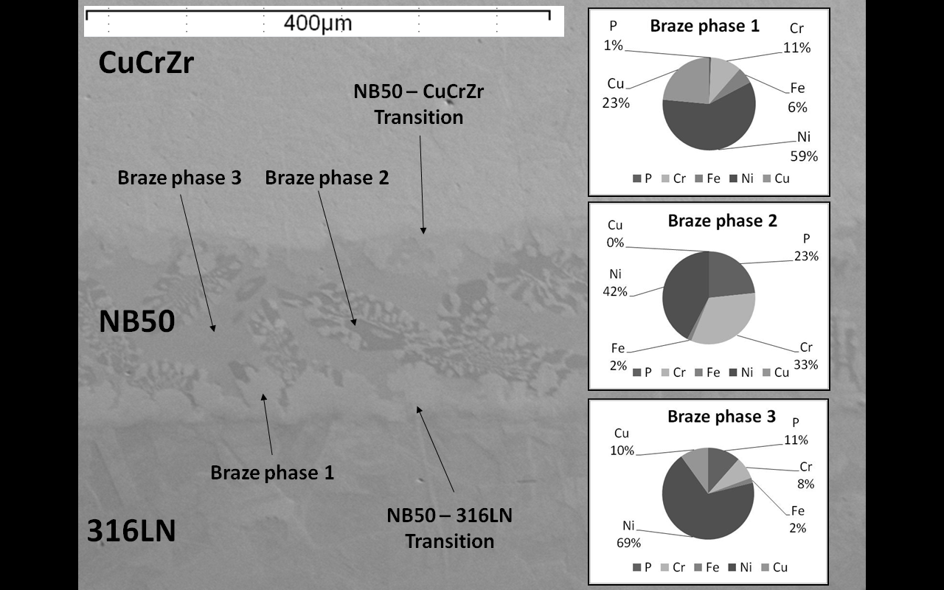
Figure 1: 316LN – NB50 – 316LN dissimilar material brazed joint cross section
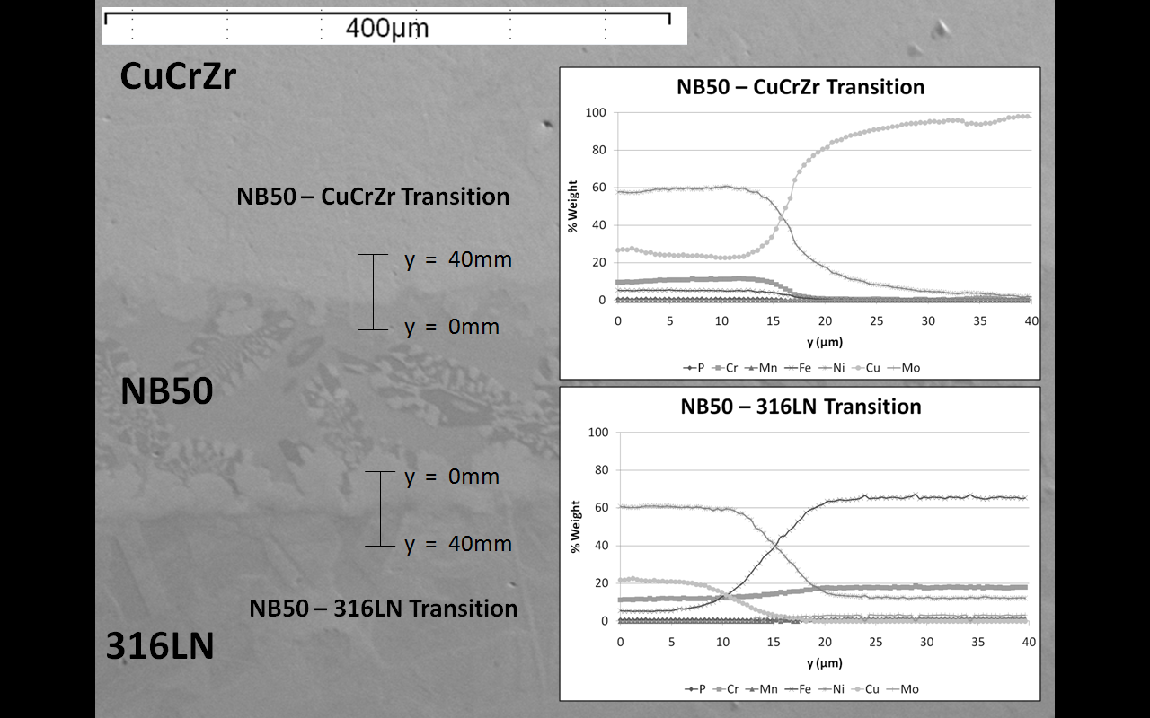
Figure 2: Elemental analysis of transitional regions
Figure 2 shows results from an elemental analysis across the braze – copper and braze - steel interfaces. The results clearly show a gradual variation in the composition between phase 1 in the braze and that of both parent materials highlighting the fact there is no step change in material properties. The width over which this transition happens can be estimated to be approximately 10-15µm based on these results shown in figure 2.
The presence of these features suggests that there will be a large variation in material properties over a relatively small scale which will provide considerable challenges when obtaining the relevant materials properties required to model such joints. Nanoindentation has been used to investigate the variation in hardness across the braze, the results are shown in the hardness map in figure 3.
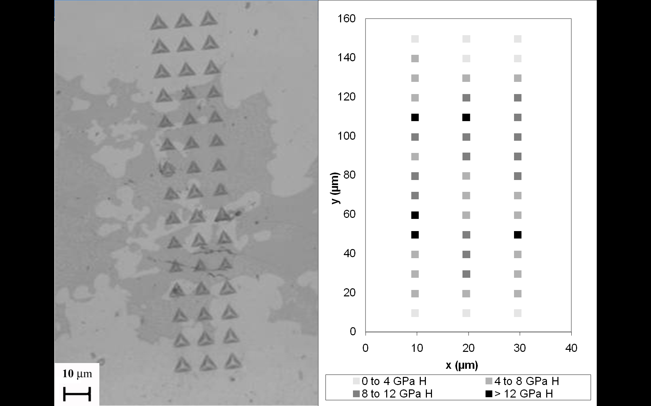
Figure 3: Variation in hardness across NB50 braze layer
This hardness map shows there is a large variation in hardness within the braze layer which also suggests large variations in other mechanical properties such as modulus, coefficient of thermal expansion, yield stress and fracture toughness [8] which are all relevant to accurate simulation of residual stresses and subsequent joint performance. The scale over which these variations occur is at the same order of magnitude as the thickness of the braze and given the microstructure of the braze such variations are to be expected.
The relatively small scale over which these variations in material properties occur presents significant challenges when modelling dissimilar material joints. One current approach to modelling dissimilar material brazed joints has been to model an abrupt change between both parent materials and to ignore the presence of the braze layer completely [9 - 11]. Another modelling approach has been to model the braze layer as a separate material [12 - 17]. This approach assumes an abrupt change in material properties at the interface between both parent materials and the braze filler. It is also invariably assumed that the material properties of the braze are the same in the as supplied condition as those after joining and that the brazed layer is a homogenous material through the thickness from the braze. The validity of these approaches is discussed in further sections of this paper.
3. The mechanics and stress state in a typical joint between dissimilar materials
3.1 Stress state in an elastic dissimilar material joint
Whilst to fully capture the stress state in a real dissimilar material joint the brazed layer and joining process must be accounted for [18], a simple joint approximation with an abrupt interface between two dissimilar materials can still be informative in terms of gaining an understanding of the features of the stress field in the region of a dissimilar material interface and the key relationships in material properties driving the mechanics and hence failure in the joint.
The stress state at the interface of an abrupt change in material properties using both a theoretical approach and finite element analysis (FEA) has been the topic of much previous research [19 - 21]; however it is pertinent to understand the key features of the stress state that will form of the basis of future discussion. As briefly outlined above, due to differences in thermal expansion coefficient, Young’s modulus and Poisson’s ratio, large stresses can develop in dissimilar material joints under thermal and mechanical loading particularly along any free edge in the region of the interface. It has also been shown that for simple butt joint geometry largest component of stress is perpendicular to the interface at the free edge [19] however other stress components are significant and could contribute to failure. To highlight the key features of the stresses perpendicular to the free edge results from a simple plane strain FEA model between two dissimilar materials under an applied bulk thermal load is shown in figure 4:
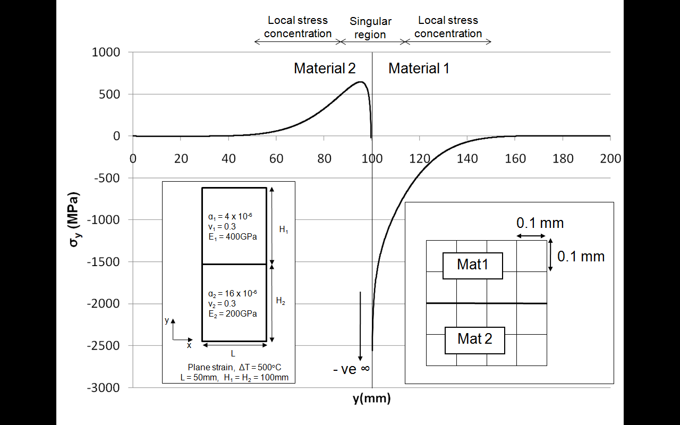
Figure 4: Free edge stress perpendicular to the interface in a simple dissimilar material joint under thermal loading
Firstly, due to this particular relationship of elastic properties (E₁, E₂, ν₁, ν₂) an analytical singularity exists at the interface hence as the interface is approached the stresses in both materials tend, in this instance, to negative infinity along the free edge [20 - 21]. It is known in an elastic analysis, converged results are never obtained on the nodes at the interface, and within one element adjacent to the interface. However, the singularity only has an effect in the proximity of the interface (the region of which can found by establishing the range across which the stress distribution obeys a power law fit) [19]. Outwith this region there is what can be a termed a local stress concentration, i.e the stress concentration due to the interface that is not influenced by the singularity. This can be illustrated in the context of the stress distribution in material 2 in figure 4. Remote from the interface there is a region of tensile stress along the free edge (c. y = 50mm to y = 90mm), however as the interface is approached this stress distribution begins to tend to negative infinity as the singularity at the interface begins to dominate the stress distribution. The concept of singular stresses and local stress concentration will now be discussed in more detail.

3.2 The nature of elastic stress singularities
Elastic stress singularities exist in a range of problems such as point loads, point constraints, internal re-entrant corners and abrupt changes in material properties. The singularity which exists at the abrupt change in materials properties has been investigated extensively theoretically [19 - 21] and the pertinent points in terms of this work are summarised in this section.
The stress state at an interface between an abrupt change in linear elastic materials can be described by equation 1 [19]:
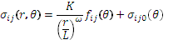
Equation 1
Where ω is defined as the stress singularity exponent, which is essentially a measure of how singular the relationship in material properties is (note at r = 0 (distance from interface), σ_{ij}(r,θ) = ∞). This stress singularity exponent can be either positive (i.e stress at the interface is infinite) or negative (no singularity and the stress state is bounded), however for the majority of real material combinations the stress singularity is positive and an analytical singularity exists [20]. In this case, even for very small changes in stiffness the theoretical elastic stress at the interface when an abrupt change in properties is assumed is infinite under a small mechanical or thermal load in both materials. As well as there being a metric for the strength of singularity that exists between two linear elastic dissimilar materials, it has also been shown [21] that the sign of the singular stress at interface can be either negative or positive.
3.3 Do elastic singularities exist in real dissimilar material joints?
The presence of these analytical singularities as predicted by linear elastic theory leads to the question of whether they actually exist in real dissimilar material joints. As mentioned in the previous section for the majority of real dissimilar material combinations, the relationship in material properties will result in a theoretical singularity at the interface. Therefore in such joints the stresses at the interface are theoretically infinite under an infinitesimally small mechanical or thermal load which should result in failure of such joints. This however, is obviously not the case as satisfactory dissimilar material joints with free edges (including ceramic – metal joints) can be found in a number of applications. Therefore in reality, the theoretical infinite stresses predicted by the elastic theory do not exist and the reasons for this are discussed in this section.
Firstly, the linear elastic theory described in the previous chapter assumes a step change in material properties. In reality, as shown above, this step change will never occur and there will be some form of grading across a transition region of finite width, albeit over an extremely small scale. In the case of dissimilar material brazed joints, this will occur due to a gradual transition region containing elements of the filler as highlighted in figure 2. Therefore there is never a true step change in material properties i.e. it is not simply a case of one molecular structure starting and the other finishing abruptly. Therefore the theoretical singular stresses predicted by the theory and linear elastic FEA will never exist in reality. However the length scale over which this transition happens is extremely small (shown to be c. 10µm for a copper to steel dissimilar material brazed joint – see figure 1) and even though the stresses will not be infinite due do this change, it is postulated that they will be extremely high compared to any material limit.
The second reason is analogous to the Linear Elastic Fracture Mechanics (LEFM) explanation which describes why sharp cracks in brittle materials do not fail under an infinitesimally small applied load but rather only if the applied load is raised to a critical value. In LEFM it is reasoned that inelastic deformations in real materials, even those that fail in a brittle manner, make the assumption of linear elastic behaviour in the region of the crack tip highly unrealistic [22]. This was verified by a series of studies performed by Orowan [23] who, using x-rays proved the presence of extensive plastic deformation on cracked surfaces of samples which failed in a brittle manner. Hence, in the analysis of dissimilar material joints, in a similar fashion to fracture mechanics, the major reason that the theoretical infinite stresses predicted by the elastic theory do not exist at the interface of dissimilar material joints is due to plasticity effects in real materials, even those that are known to fail in a brittle manner. The presence of dislocations due to plasticity at the interface of Si₃N₄ ceramic to Si₃N₄ ceramic joints brazed with copper based filler has been proven experimentally using a TEM by Singh [24] and a significant amount of theoretical work has been done to predict the size of the plastic zone theoretically [25]. In addition to plasticity effects blunting the theoretical singularity, inelastic behaviour due to creep will also have a similar effect.
3.4 The constraint mechanism at a dissimilar material joint interface
If the singularity is neglected and only the local stress concentration is considered, it is useful for engineers to understand the mechanism causing the high stresses in the first place, namely the constraint on free expansion of both materials in the region of the joint.
Consider the simple 90° dissimilar material joint as shown in figure 5, where E₁ = E₂, ν₁ = ν₂, but α₁ = 2 x α₂. Assuming both materials are initially of equal widths L, under a uniform thermal loading the thermal expansion in material 1 will be twice that of material 2. To maintain compatibility of displacements of both materials at the interface, equal and opposite constraining forces and moments are developed in both materials as shown in figure 5. It is these internal forces, developed due to the constraint on free expansion at the interface which results in high stresses in the region of the joint.
Figure 5 - Expansion and free body diagram of different materials at interface
Given the deformed shape, it is expected that material 1 would develop a compressive σ_{x} and material 2 a tensile σ_{x} given the relative deformed shape. In addition, the free edge of material 1 would develop a tensile σ_{y} and material 2 a compressive σ_{y} due to the compatibility constraint. In this case the greater the difference in CTE, the larger this constraining effect hence the larger the stress perpendicular to the interface. The magnitude of the stresses will also be dependent on the Young’s modulus of the materials. For a given differential expansion with stiffer materials, a greater constraint is required to maintain compatibility and hence more severe local stress state will arise.
A similar argument can be used to describe the stress field surrounding the interface under an isothermal uniaxial mechanical load when the materials have equal Poisson’s ratios but different Young’s modulus e.g E₁ = 2 x E₂, ν₁ = ν₂. For a given externally applied remote stress perpendicular to the interface σ∞, ε_{y} in material 1 will be half of ε_{y} in material 2 remote from the interface due to the difference in the Young’s modulus. In the case where the Poisson’s ratios are equal, ε_{x} in material 1 will be half ε_{x} in material 2. This case is now analogous to the case described above and the same argument for development of internal stresses holds. Hence, in this case minimising the difference in stiffness will reduce the constraint on expansion and reduce the geometrical stress concentration at the interface.
3.5 The effect of properties on singularity strength and local stress concentration
To investigate the effect of material properties on the strength of singularity and local stress concentration due to the interface a series of cases have been analysed using both linear elastic dissimilar material joint theory (as discussed in section 3.2) and FEA. The geometry used is identical to that in figure 4 and only a bulk thermal heating load of ΔT = 500°C from a stress free temperature of 20°C has been considered. The cases analysed are summarised in table 1:
Case No | E₁ (GPa) | E₂ (GPa) | ν₁ | ν₂ | α₁ (/°C) | α₂ (/°C) | ω
1 | 400 | 100 | 0.3 | 0.3 | 4 x 10⁻⁶ | 16 x 10⁻⁶ | 0.112
2 | 400 | 100 | 0.3 | 0.3 | 4 x 10⁻⁶ | 8 x 10⁻⁶ | 0.112
3 | 200 | 100 | 0.3 | 0.3 | 4 x 10⁻⁶ | 16 x 10⁻⁶ | 0.037
Table 1: Summary of cases analysed
3.5.1 Effect on singularity strength
The stress singularity exponent, ω, for each case is also shown in table 1. The strength of the stress singularity exponent is dependant solely on the geometry of the joint, the Young’s modulus and Poisson’s ratio of the joined materials. It is independent of the coefficients of thermal expansion of the joined materials. When the Poisson’s ratio of the materials joined are similar, the stress singularity exponent increases with increasing difference in effective moduli [19] as shown in table 1 and figure 6.
These relationships in material properties under bulk temperature heating should result in a negative singularity [21] in both materials. The free edge FEA stress distributions for cases 1 -3 in table 1 are shown in figure 6 and it is clear in each of these cases the singularity is causing the stress perpendicular to the interface to tend to negative infinity.
3.5.2 Effect on local stress concentration
In cases 1 and 2, the difference in Young’s modulus of both materials is constant (hence singularity strength is the same), however there is greater difference in coefficient of thermal expansion in case 1. This results in a larger constraint at the interface and hence larger local stress concentration away from the joint. This can be seen in figure 6 as the stress outwith the zone of influence of the singularity is greater in both materials for case 1 than case 2 (e.g at y = 80 and 120 mm).
In cases 1 and 3, the coefficients of thermal expansion are the same however material 1 has a lower stiffness case 3 than in case 1. In this case the singularity strengths are different as described in section 3.5.1, however the thermal strains due to heating will be the same. In material 2, outwith the zone of the singularity, the stress perpendicular to the interface due to the constraint mechanism is similar in both cases as material 2 has constant Young’s modulus (e.g at y = 80mm). However in material 1, the Young’s modulus is larger in case 1, hence the degree of constraint and hence local stress concentration is larger (e.g. at y = 120mm).
This simple example, as well as giving an insight into the elastic stress state, show’s that local stress concentration effects can be fully explained using the constraint mechanism described in section 3.4.
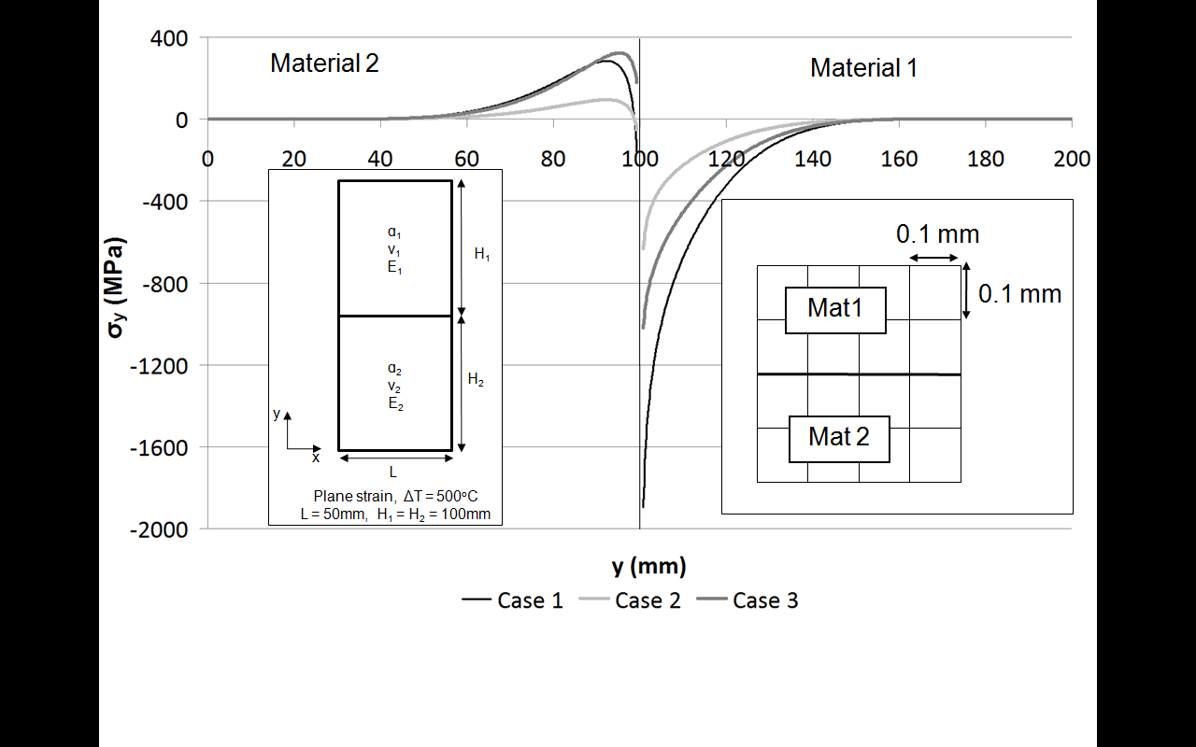
Figure 6: Free edge stress perpendicular to the interface for cases 1 – 3
It should be noted that despite this relationship in material properties resulting in negative singularity, there is a large converged tensile stress in material 2. In addition to these large tensile stresses perpendicular to the interface along the free edge there are other significant stress components however the largest stress component is perpendicular to the free edge.
3.6 Mechanical vs thermal induced stress fields
The stress state in dissimilar material joints under a mechanical only load has the same characteristics in terms of a local stress concentration and a singularity as under thermal loading and this is highlighted in figure 7. Figure 7 shows the free edge stress distribution for a uniaxially applied tensile stress of σ∞ = 200MPa:
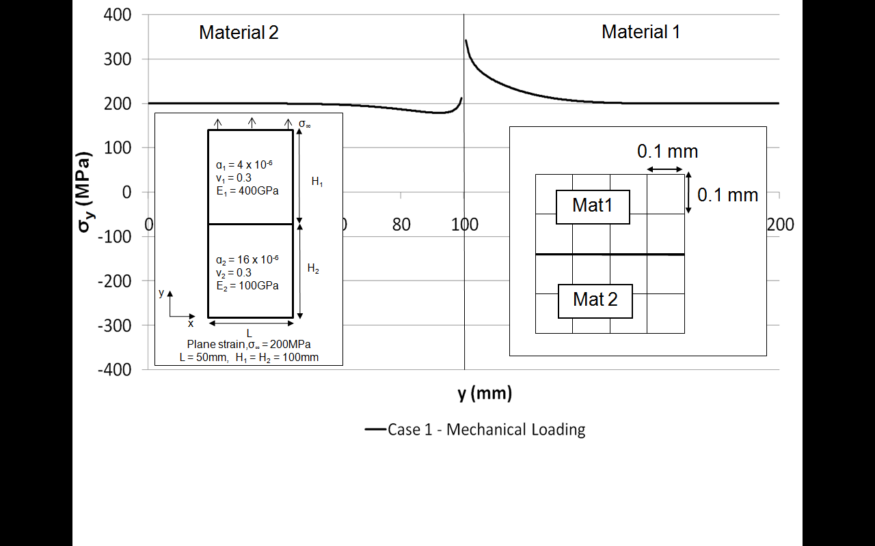
Figure 7: Free edge stress perpendicular to the interface for case 1 under mechanical loading
In the case of mechanical loading, away from the interface the stress is equal to the externally applied field stress, however as the interface is approached the presence of the local stress concentration and the analytical singularity is clearly visible. In this particular case the local stress concentration is caused by a similar mechanism to that in the thermal loading case, i.e it results from the constraint at the interface due to compatibility requirements and a difference in strain parallel to the interface. As material 2 is less stiff than material 1, under a uniaxial applied load σ∞ , ε_{y} will be greater in material 2 and hence ε_{x} will be greater in material 2 as the Poisson’s ratios of the materials are equal and it is this which induces the constraint. The effect of this on the local stress concentration causes a reduction about the uniaxially applied stress in material 2, and an increase in material 1. Adjacent to the interface the singularity is causing the stress to tend to positive infinity.

3.7 Effect of plasticity on dissimilar material joints behaviour
In section 3.3 it has been argued that the effect of plasticity, even in materials that are known to fail in a brittle manner, is one of the major reasons that the theoretical infinitely high stresses predicted by the elastic theory do not exist at a dissimilar material joint interface. This poses the question of how plasticity in a real material is likely to influence the mechanics of the joint. This section aims to illustrate what happens to the stress state in a brittle material when it is joined to a ductile elastic –plastic material.
For this, an additional set of cases have been analysed. These have been performed on an axisymmetric joint model with similar elastic properties to case 1 in section 3.5. For these cases the joint has been cooled from an assumed stress free temperature of 1000°C to represent a manufacturing process such as brazing or diffusion bonding. In each of these cases material 2 has a bilinear kinematic hardening plasticity law with a yield stress of 200MPa and a varying tangent modulus as per table 2. Figure 8 shows the free edge σ_{y} stress distributions for each of these cases.
Case No | E₁ (GPa) | E₂ (GPa) | ν₁ | ν₂ | α₁ (/°C) | α₂ (/°C) | σ_{yield2} (MPa) | E_{tan2} (GPa)
4a | 400 | 100 | 0.3 | 0.3 | 4 x 10⁻⁶ | 16 x 10⁻⁶ | ∞ | N/A
4b | 400 | 100 | 0.3 | 0.3 | 4 x 10⁻⁶ | 16 x 10⁻⁶ | 200 | 50
4c | 400 | 100 | 0.3 | 0.3 | 4 x 10⁻⁶ | 16 x 10⁻⁶ | 200 | 10
4d | 400 | 100 | 0.3 | 0.3 | 4 x 10⁻⁶ | 16 x 10⁻⁶ | 200 | 0.01
Table 2: Summary of cases analysed with plasticity

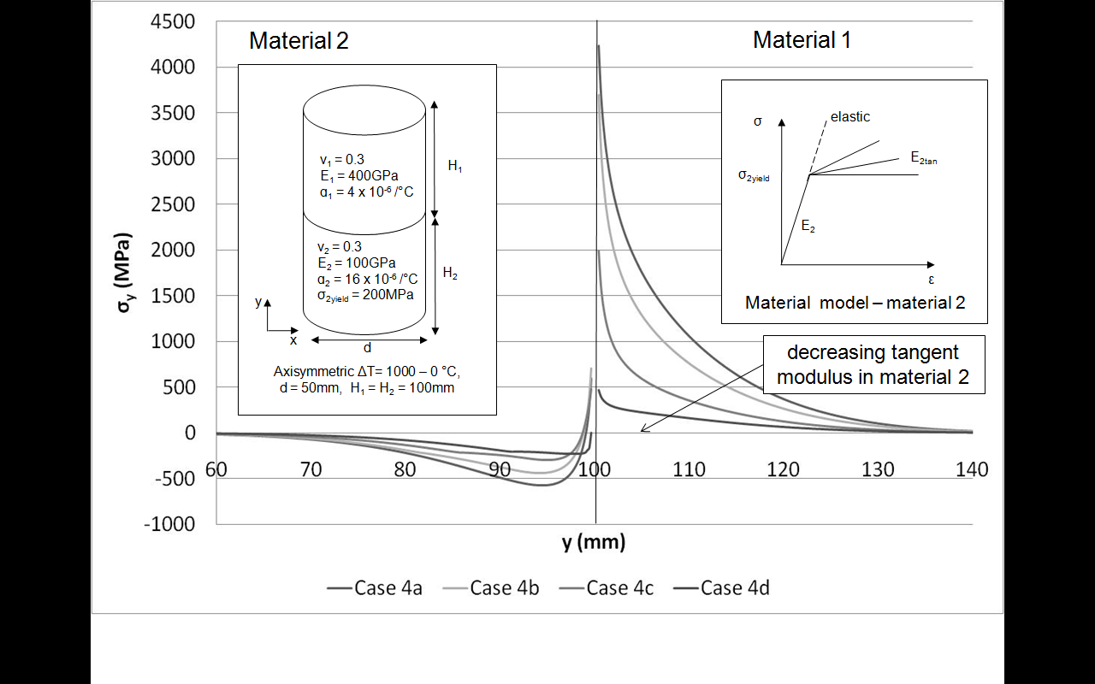
Figure 8: Free edge stress perpendicular to the interface for cases 4a – 4d under thermal cooling
Results from cases 4a-4d show that as the tangent modulus of elastic-plastic material 2 decreases, the stress in the brittle material in the region of the joint decreases. From a practical perspective this makes sense and can be explained by a reduction of the constraint at the interface as per the mechanism described in section 3.4.
Based on this finding it should be noted that when analysing dissimilar material joints, assuming an elastic – perfectly plastic material model is non-conservative. This is because it fails to account for the strain hardening of the material after yield and the additional constraint that this strain hardening induces. In a real material, the material will strain harden after yield and will never have a zero stiffness as assumed by an elastic-perfectly plastic material model.
To illustrate this plasticity protection further, the results from previous research on joining of ceramic to stainless steels can be explained in relation to these findings. The experimental results presented in [17] are based on a series of joints fabricated joints between a common ceramic and different grades of a stainless steel produced using a constant brazing process (filler and brazing process the same). One of the key findings was that in a steel with a lower yield stress but higher difference in coefficient of thermal expansion was easier to join than with a steel with the opposite trend in material properties. From an elastic perspective the higher difference in thermal expansion will increase the constraint on the ceramic at the interface and hence result in higher stresses in the region of the interface. However, the lower yield stress is obviously alleviating these higher elastic stresses and protecting the brittle ceramic by reducing the constraint at the interface.
3.8 Effect of joint geometry
In terms of dissimilar material joint design, the functional requirements of a structure dictate that certain material combinations are required to be joined therefore material selection is often a design variable which is outwith the control of the designer. In such instances joint geometry is a variable that can be used to improve the mechanics of the joint. Whilst a full investigation into how the geometry influences the mechanics of a dissimilar material joint is outwith the scope of this paper, the key findings from previous research in relation to this are summarised. In addition to joint geometry, ductile interlayers and functionally graded materials have been developed to reduce the effect of a step change in properties by gradually transitioning between the two parent materials [26 – 29].
From a theoretical perspective, Kelly [20] has shown that for material properties which give rise to singularities in 90° butt joints, analytical singularities can be removed through the use of a scarf joint. This has been investigated experimentally by Blackwell et al [30] who showed that for a series of dissimilar copper to molybdenum brazed joints the strength of the joint increased with an increasing degree of joint edge angle. This was however up to a certain angle where failure of the joint was in the copper away from the interface. After a certain angle the joint failed in the interface due to shearing effects because of the scarf joint geometry [30].
Xu et al [31] showed through both finite element analysis and an experimental investigation that free edge stress singularities could be removed in dissimilar material joints through the use of a convex interface geometry. The effect of removing the free edge singularity resulted in a 81% increase in ultimate tensile strength of the joint for a polycarbonate to aluminium joint. Baladi et al have also shown that the stress concentration at interface can be reduced using a convex joint design [32].
4. Thoughts on approaches to modelling and assessment of dissimilar material brazed joints
As mentioned in the introduction, dissimilar material brazed joints can be found in a range of current and emerging applications such as the first wall and divertor of present day and next step thermonuclear fusion reactors. In operation these components are subjected to cyclic high-heat flux loads in addition to intense fluxes of charged and neutral particles [3]. Under loading which is cyclic in nature, the high thermal stresses due to any mismatch in material properties have been known to cause failure.
Whilst recognising the challenges in obtaining the relevant material property data in both the unirradiated and irradiated state, this section focuses on addressing the issues faced with modelling and predicting failure in real dissimilar material brazed joints, the additional challenges still to be overcome in many cases and level of detail required in any brazed joint finite element model such that the correct stress concentrations are captured for any failure analysis.
4.1 Manufacturing residual stresses
When trying to predict the stress in real dissimilar material joint the residual stresses due to joint manufacture will have to be taken into account [18] [33]. The presence of these residual stresses has been the topic of previous research [12] [15] [33] and stress relief will be problematic due to the mechanical properties of the adjoined materials. The residual stresses will affect the various failure mechanisms, as discussed in the following sections, and must therefore be accounted for when trying to predict the stress distribution in dissimilar material joints.
4.2 Braze layer modelling
When two dissimilar materials are joined by brazing, a thin braze layer exists at the joint between the two materials as discussed in section 2. Given the constraint mechanism explained in section 3.4, it follows that the mechanical properties of this thin layer may play a key role in the mechanics of the joint. If for example the braze filler was extremely stiff relative to the parent materials, the degree of constraint at the free edge will be large. If however the stiffness of the material was relatively very low there would be very little constraint on the materials being joined. It is therefore important to model the brazed layer if the stress state in the joint is to be accurately captured. The practice of neglecting the braze layer is effectively assuming that the braze layer and diffusion regions have exactly the same properties (mechanical and thermal) as one of the materials being brazed.
The approach of modelling the braze layer as a separate material presents several non-trivial challenges. Firstly, due to the relatively small thickness of a brazed layer (c. 100µm - figure 1), extremely small mesh sizes are required if it is to be included in a model. There also exists the problem of obtaining temperature dependant material property data for the brazed layer. Such data is sparse and any material property characterisation is likely to be based on the as supplied brazed filler with the assumption that the material properties of the braze are the same in the as supplied condition as those after joining. This fails to account for the effect of the diffusion of elements from the parent material into the filler as well as different cooling rates which will affect grain size, microstructure and hence yield stress - which has been shown in section 3.6 to play an important role in the performance of the joint.
In addition, as highlighted in section 2, the microstructure of the brazed layer in a 316LN – CuCrZr brazed joint shows three very distinct phases with large variations in hardness, in addition to transitional regions at the interface between the parent materials. The current practice in modelling brazed layers assumes it to be a homogenous material across the thickness of the braze and fails to take into account the presence of these large variations in material properties that can occur within the braze. It also assumes an abrupt change in properties between the braze and both parent materials and fails to take into account any transition zones between as highlighted in figure 3. As a consequence of this abrupt change in properties, converged finite element results will never be obtained at the interface. An idealised brazed joint will therefore fail to model the correct material properties, including fracture toughness and fatigue strength and will also produce large discontinuity stresses at the interface (often a theoretical singularity in the elastic case).
Clearly, these all must be considered when modelling at such a small scale. In reality, due to these factors discussed, it is unlikely that accurate modelling of the stress state very close to, and across the brazed layer will be possible. Hence alternative techniques based on experimentally derived test results will be required to predict failure in close proximity to the interface and these are discussed in the next section.
It has however been shown that dissimilar material joints can fail away from the interface [17] [30] [34 - 35] in the parent materials and as such in some instances it may not be necessary to fully capture what is happening very close to and across the interface although the degree of constraint and local stress will have to be accurately modelled. In cases such as this, if a braze layer with representative properties is used which applies a representative constraint on the model, the reproducible representative converged stresses can be obtained away from the interface [12] [15], which will allow failure to be assessed using the methods discussed in 4.3.
In addition, using a simplified approach to model the brazed layer does not preclude its use in design. A simple joint approximation with an abrupt interface between a braze and two dissimilar materials can still be informative in terms of comparing the stress fields away from the interface and comparing different joint designs as long as the degree of constraint due to the braze is accurately represented.

4.3 Dissimilar material joint failure modelling approaches
The appropriate modelling strategy when assessing failure in a dissimilar material brazed joint is linked to the specific failure mechanism being considered as discussed in the following sections. In all cases capturing the constraint due to the interface will be important, however detailed stress distributions in the region of the joint may not always be necessary.
Many of the strategies suggested require experimentally derived failure criterion which account for the complex metallurgy of the braze as discussed in previous sections, albeit in a “smeared” manner. This experimental data will only be valid for the materials being joined, the braze filler adopted and the joining process used. As indicated previously, residual stresses due to joint manufacturing cannot be neglected when performing a failure analysis and in general must be accounted for.
This section reflects on the level of detail required in any brazed joint model such that the correct stress concentrations are captured for any failure analysis as described in previous sections. Creep, irradiation and environmental effects (such as erosion and corrosion) have not been accounted for, however in future, as fusion devices move towards less cyclic, steady state operational modes, there will be an increase in focus on creep as a failure mechanism. Additionally other aspects such as misalignment and quality of braze would have to be considered in any component design code of practice.
4.3.1 Brittle Failure
4.3.1.1 Away from the interface
Brittle failure is generally assessed by comparing a maximum principle stress with an allowable for the parent material. Hence in a dissimilar material brazed joint, this requires the constraint due to the brazed layer to be accurately represented through the use of a simplified braze layer model as described in section 4.2, in addition to the residual stresses developed during joint manufacture. The mesh refinement would need to be such that it fully captures the local stress concentration due to the interface as per figure 6.
4.3.1.2 Interface failure
When assessing failure at the interface, residual stresses due to joint manufacture must be accounted for in spite of the challenges in predicting the stress state at the interface. These residual stresses are not accurate at the level fracture will occur when a simplified braze layer is assumed.
Interfacial fracture mechanics methods have been developed to assess decohesion and cracks in dissimilar material interfaces and have been the topic of previous research [36 – 43] and such procedures could be developed for the brittle failure assessment of the interface of dissimilar material brazed joints.
Structural hot-spot stress techniques [44 - 47] are not commonly used to assess interfacial failure in brazed joints however they could also be adapted to predict failure at the interface of dissimilar material joints by obtaining a representative stress that is used to compare with an experimentally derived allowable stress.
At the heart of any procedure to assess brittle failure at the interface, experimentally derived failure criterion is required which inherently accounts for the complex metallurgy of braze discussed in previous sections.
4.3.2 Interface Fatigue
In a similar fashion to assessing brittle failure at the interface, when assessing interface fatigue the residual stresses due to joint manufacture must be accounted for.
Techniques such as the use of fatigue strength reduction factors or structural hot-spot stress techniques [44 - 47] could be adapted to assess interfacial fatigue in dissimilar material brazed joints. In addition cohesive zone modelling [48 - 52], which idealises complex fracture mechanisms with a macroscopic cohesive law which relates failure of the interface to its separation, could also be developed [53].
Again, at the heart of any procedure to assess fatigue at the interface, an experimentally derived failure criterion is required which accounts for the complex metallurgy of the braze layer discussed in previous sections.
4.3.3 Plastic collapse
Plastic collapse only occurs under a primary load and cannot occur due to secondary thermal loading alone. It can of course occur as a result of additional primary loads induced by buckling caused by secondary thermal loading. Methods for assessing gross plastic deformation of structures generally [54] do not require the modelling of small details such as welds [54]. In addition residual stress fields are invariably not accounted for as they are assumed to be self equilibrating and do not generally affect the limit state.
In the case of dissimilar material brazed joints, accurately capturing the local stress concentration effects due to the interface and stress distribution across the braze is not required. However the effect of the constraint due to the braze on any geometrical field stress or gross stress concentration must be accurately captured and hence a simplified braze layer should be included in any model.
4.3.4 Ratcheting
Modelling ratcheting behaviour generally requires the local stress concentrations to be modelled [54]. Hence in the case of performing a ratcheting analysis on a dissimilar material brazed joint, the local stress concentration due to the braze must be captured and hence a representation of the braze layer must be modelled. The initial ratcheting behaviour will also be influenced by the as-brazed residual stress field and must also be accounted for in such an analysis.
4.3.5 Buckling
The degree of stiffness provided by end fixity due to a brazed joint will generally be important for a buckling analysis concerning attached members or components, hence in these cases obtaining a value for the joint stiffness’s through experimentation would be advisable. However accurately capturing the local stress concentration at the interface and across the braze will not generally be required in a global buckling analysis. Modelling post buckling behaviour could involve other failure mechanisms and hence reference should be made to the above sections.
Buckling behaviour could also be influenced by the joining process, if for example the brazing process resulted in a global residual field stress being induced in an assembly and this would have to be accounted for in any buckling assessment.
5. Summary and conclusions
The metallurgical features of a CuCrZr – 316LN dissimilar material brazed joint have been presented. It has been shown that are various phases present within the braze which include elements diffused from the parent materials. These phases have large variations in hardness which suggests large variations in other material properties. There are also clear transitional regions at the interface between the braze and both parent materials.
By developing an understanding the of the stress state at the abrupt interface between two dissimilar materials it is has been shown that different relationships in material properties will affect the free edge stress distributions in the region of the joint based on the constraint due to the interface and, in most cases, the analytical singularity that exists in an elastic model. It has however been argued that such elastic singularities do not exist in practice due to the absence of an abrupt change in material properties which has been supported by the evidence presented in the metallurgical study. It has also been argued that, in a similar fashion to linear elastic fracture mechanics, the theoretical infinite stresses predicted by the elastic theory do not exist at the interface due to plasticity effects in real materials, even those that are known to fail in a brittle manner. Furthermore, it has also been shown that plasticity in one material provides a protection mechanism for the joint and limits the stresses induced in the joined material.
In terms of modelling real dissimilar material brazed joints; there are several barriers to accurately capturing the stress state in the region of the joint and across the brazed layer, as highlighted by the findings of the metallurgical investigation. At the heart of any procedure to assess failure at the interface, an experimentally derived failure criterion is required which inherently accounts for the complex metallurgy of braze. However this does not preclude using a simplified braze layer with representative material properties in design and assessing failure away from the interface. The modelling strategy required when assessing failure of dissimilar material brazed joints is dependent on the failure mechanism. In summary and in general:
- When assessing brittle failure away from or at the interface, the constraint due to the braze and residual stresses due to joining must be accounted for hence a representation of the braze layer must be modelled.
- When assessing plastic collapse accurately capturing the local stress concentration effects due to the interface and stress distribution across the braze is not required. However the effect of the constraint due to the braze on any geometrical field stress or gross stress concentration must be accurately captured and hence a representation of the braze layer must be modelled.
- When assessing ratcheting, the local stress concentration due to the braze must be captured and hence representation of the braze layer must be modelled. The initial ratcheting behaviour will also be influenced by the as-brazed residual stress field and hence must be accounted for in such an analysis.
- When assessing buckling, accurately capturing the local stress concentration at the interface and across the braze will not generally be required. However the degree of stiffness provided by end fixity due to a brazed joint will be important for a buckling analysis concerning attached members or components, hence in these cases obtaining a value for the joint stiffness’s through experimentation would be advisable.
The work presented throughout this paper is not only relevant to brazed joints but also dissimilar material joints manufactured by other processes.
Acknowledgements
The authors would like to thank Dr Wenzhong Zhu from the University of the West of Scotland for his help and expertise when performing experiments using nanoidentation, James Kelly (Metallurgist) from the University of Strathclyde for preparing metallurgical samples and helping with analysis of the braze layer, Gerry Johnston (Advanced Material Research Laboratory Lab Manager – University of Strathclyde) for his help performing the elemental analysis using the SEM, Rob Bamber and Dr Ioannis Katramados from CCFE for their continued support and advice and Prof Donald Mackenzie from the University of Strathclyde for his expert advice.
References
[1] ITER Materials Assessment Report (MAR), ITER Doc. G 74 MA 10 W 0.3
[2] ITER Materials Properties Handbook (MPH), ITER Doc. G 74 MA 10 W 0.3
[3] J. Linke, High heat flux performance of plasma facing materials and components under service conditions in future fusion reactors, Fusion Science and Technology 49 (2006) 455 – 464
[4] M.Rödig et al, Thermal fatigue tests with actively cooled divertor mock-ups for ITER, Fusion Engineering and Design 39-40 (1998) 551-557
[5] S Suzuki et al, Thermal fatigue damage of the divertor plate, Fusion Engineering and Design 49–50 (2000) 343–348
[6] P. Norajitra, Helium-cooled divertor for DEMO: Manufacture and high heat flux tests of tungsten-based mock-ups, Journal of Nuclear Materials 386-388 (2009) 813-816
[7] AWS Brazing Handbook, fourth ed. American Welding Society, Miami, 1991
[8] Y.W Bao, W. Wang, Y.C. Zhou, Investigation of the relationship between elastic modulus and hardness based on depth-sensing indentation measurements, Acta Materialia 52 (2004) 5397-5404
[9] J.H You, H. Bolt, Structural analysis of a plasma facing component reinforced with fibrous metal matrix composite laminate, J. Nucl. Mater. 329-333 (2004) 702-705
[10] R.L Williamson, B.H Rabin, G.E Byerly, FEM study of the effects of interlayers and creep in reducing residual stresses and strains in ceramic-metal joints, Comp. Engng. 5 (1995) 851 – 863
[11] C. Hamlyn-Harris, A. Borthwick, J. Fanthome, C. Waldon, M. Nightingale, N.Richardson, Engineering design of an RF vacuum window for the ITER ICRH antenna, Fusion Engineering and Design 84 (2009) 887-894
[12] P. Dadras, J.M. Ting, M.L Lake, Brazing residual stresses in Glidcop-Al12Si-Be, J. Nucl. Mater. 230 (1996) 164-172
[13] J.H You, G. Breitbach, Deformation of ductile braze layer in a joint element under cyclic thermal loads, Fusion Engineering and Design 38 (1998) 307-317
[14] T. Chehtov, J. Aktaa, O. Kraft, Mechanical characterization and modelling of brazed EUROFER-tungsten-joints, J. Nucl. Mater. 367-370 (2007) 1228-1232
[15] M. Galli, J. Botsis, J. Janczak-Rusch, G. Maier, U. Welzel, Characterization of the residual stresses and strength of ceramic-metal braze joints, Journal Of Engineering Materials And Technology, 131 (2009) 021004-1
[16] J. Gong, W. Jiang, Q. Fan, H. Chen, S. Tu, Finite element modelling of brazed residual stress and its influence factor analysis for stainless steel plate-fin structure, Journal of Materials Processing Technology 209 (2009) 1635-1643
[17] P. Bastid, P. Jackson, Predicting successful manufacture of ceramic/metal joints using Weibull modelling, TWI Technology Briefing 852 – 2006
[18] N. Hamilton, M. Robbie, J. Wood, A. Galloway, I. Katramados, J. Milnes, The challenges in predicting the fatigue life of dissimilar brazed joints and initial finite element results for a tungsten to EUROFER97 steel brazed joint, Fusion Engineering and Design 86 (2011) 1642-1645
[19] D. Munz, Y.Y. Yang, Stresses near the free edge of the interface in ceramic-to-metal joints, Journal of the European Ceramic Society 13 (1994) 453-460
[20] P.A. Kelly, D.A Hills, D. Nowell, The design of elastically dissimilar components (with special reference to ceramic/metal joints), Journal of Strain Analysis 27 (1992) 15-20
[21] J.H. You, H. Bolt, Analysis of singular interface stresses in dissimilar material joints for plasma facing components, J. Nucl. Mater. 299 (2001) 1-8
[22] F. Erdogan, Fracture Mechanics, International Journal of Solids and Structures 37 (2000) 171-183
[23] E. Orowan, Fracture and strength of solids. Reports on Progress in Physics XII (1948) 185-232.
[24] M. Singh, R. Asthana, F.M. Varela, J. Martinez-Fernandez, Microstructural and mechanical evaluation of a Cu-based active braze alloy to join silicon nitride ceramics, Journal of the European Ceramic Society 31 (2011) 1309-1316
[25] Y.Y Yang, D. Munz, M.A. Sckuhr, Evaluation of the plastic zone in an elastic-plastic dissimilar materials joint, Engineering Fracture Mechanics 56 (1997) 691-710
[26] I. Shiota, Y. Miyamoto, Functionally Graded Materials, Elsevier, Amsterdam, 1997.
[27] M.T Vieira, A.S Ramos, The influence of ductile interlayers on the mechanical performance of tungsten nitride coatings, Journal of Materials Processing Technology 92-93 (1999) 156-161
[28] L.Yun-Han et al, Fabrication and evaluation of SiC/Cu functionally graded material used for plasma facing components in a fusion reactor, Journal of Nuclear Materials 303 (2002) 188-195
[29] Z. Yan et al, Vacuum plasma sprayed FeAl/Al₂O₃ functionally graded coatings for fusion reactor applications, Fusion Engineering and Design 85 (2010) 1542-1545
[30] Blackwell, B E. A framework for determining the mechanical properties of dissimilar material joints. (1992) MIT PhD Thesis, pp 122.
[31] Xu, L.R, H. Kuai, S. Sengupta, Dissimilar Material Joints With and Without Free-edge Stress Singularities: Part I. A Biologically Inspired Design, Society for Experimental Mechanics 44 (2004) 608-615
[32] A. Baladi, A.F Arezoodar, Dissimilar Materials Joint and Effect of Angle Junction on Stress Distribution at Interface, World Academy of Science, Engineering and Technology 79 (2011) 47-50
[33] R.U Vaidya, P. Rangaswamy, M.A.M Bourke, D.P. Butt, Measurement of bulk residual stresses in molybdenum disilicide/stainless steel joints using neutron scattering, Acta Materialia 46 (1998) 2047-2061
[34] B.A Kalin, V.T. Fedotov, O.N Servrjukov, A Moeslang, M Rohde, Development of rapidly quenched brazing foils to join tungsten alloys with ferritic steel, J. Nucl. Mater. 329-333 (2004) 1544-1548
[35] F. Brossa et al, Experimental tests concerning the use of the tungsten-copper couple design concept on the divertor system, Proc. 12th Symp. on Fusion Technology, Jülich (FRG) (Sept. 1982), pp. 491–496
[36] H.C. Cao, A.G Evans, An experimental study of the fracture resistance of bimaterial interfaces, Mechanics of Materials 7 (1989) 295-304
[37] J.R. Rice, Elastic fracture mechanics concepts for interfacial cracks, Journal of Applied Mechanics 110 (1988) 98-103
[38] X.P Xu, A.Needleman, Numerical simulations of dynamic crack growth along an interface, International Journal of Fracture 74 (1996) 289-324
[39] P. Jousset, M Rachik, Cohesive Zone Model for the Finite Element Simulation of Structural Bonded Joints: Modelisation Parameters Identification and Validation, NAFEMS - FEM Idealisation of Joints (2010) 93-103
[40] Z. Suo, J.W Hutchinson, Interface crack between two elastic layers, International Journal of Fracture 43 (1990) 1-18
[41] J.W Hutchinson, Z.Suo, Mixed-mode cracking in layered materials, Advances in Applied Mechanics 29 (1992) 63-191
[42] P.G. Charalambides, J. Lund, A.G. Evans, and R.M. McMeeking. A test specimen for determining the fracture resistance of bimaterial interfaces. Journal of Applied Mechanics 56 (1989) 77-82
[43] R.H. Dauskardt, M. Lane, Q. Ma, N. Krishna., Adhesion and debonding of multi-layer thin film structures. Engineering Fracture mechanics 61 (1998) 141-162
[44] E. Niemi, W Fricke, S. Maddox, Fatigue analysis of welded components: designer's guide to the structural hot-spot stress approach, Woodhead Pub 2006
[45] S. Maddox, Fatigue strength of welded structures, Woodhead Pub 1991
[46] I. Poutiainen et a, Determination of the structural hot spot stress using finite element method – a comparison of current procedures, IIW Report XIII 1991-03
[47] W. Fricke et al, Determination of hot spot stress in structural members with in-plane notches using a coarse element mesh, IIW Report XIII 1870-01
[48] Simulia, Modelling Fracture and Failure with Abaqus, Coursenotes, 2010.
[49] A. Needleman, A continuum model for void nucleation by inclusion debonding, Journal of Applied Mechanics 54 (1987) 525-531
[50] Dugdale, D.S, Yielding of steel sheets containing slits, Journal of Mechanics and Physics of solids 8 (1960) 100-104
[51] A. Needleman, V. Tvergaard, J.W. Hutchinson, Void Growth in Plastic Solids, Topics in Fracture and Fatigue, Springer-Verlag, New York (1992), 145-178
[52] O.Nguyen, E.A Repetto, M. Ortiz, R.A Radovitzky, A cohesive model of fatigue crack growth, International Journal of Fracture 110 (2001) 351–369
[53] P. Jousset, M Rachik, Cohesive Zone Model for the Finite Element Simulation of Structural Bonded Joints: Modelisation Parameters Identification and Validation, NAFEMS - FEM Idealisation of Joints (2010) 93-103
[54] 2007 ASME Boiler & Pressure Vessel Code. 2007

