Design and Simulation of a Nonlinear, Discontinuous, Flight Control System using Rate Actuated Inverse Dynamics (RAID)
Joseph Brindley, John M. Counsell and Obadah S. Zaher
University of Strathclyde, Glasgow, Scotland, UK
John G. Pearce
ISIM International Simulation Limited, Salford, UK
This paper presents the novel nonlinear controller design method of Rate Actuated Inverse Dynamics (RAID). The RAID controller design uses a novel Variable Structure Control (VSC) based anti-windup method to ensure that the actuator does not become overdriven when rate or deflection limits are reached. This allows the actuator to remain on both rate and deflection limits without the system becoming unstable. This is demonstrated in a non-linear simulation of a missile body rate autopilot using a multivariable controller designed using RAID methods and, for comparison, a controller designed using Robust Inverse Dynamics Estimation (RIDE). The simulation is performed with an advanced solver which uses a discontinuity detection mechanism to ensure that errors do not occur during the simulation due to the presence of multiple discontinuities. The results show that using a smaller actuator, with reduced rate limits, is not possible with the RIDE design. Conversely, the RAID design demonstrates excellent performance, despite the actuator limiting in both deflection and rate of deflection. This illustrates the possibility of using smaller, less powerful actuators without sacrificing system stability.

Nomenclature
d = disturbance vector
dr = motor position control natural frequency
f = aerodynamic forces vector
h = missile diameter
m = missile mass
p = missile roll rate
q = missile pitch rate
r = missile yaw rate
s = Laplace operator
u = input vector
uc = control signal vector
u_{eq} = equivalent control vector
u* = transformed RAID input vector
v_{u} = missile forward velocity
v_{v} = missile side-slip velocity
v_{w} = missile vertical velocity
w = feedback vector
x = state vector
x* = transformed RAID state vector
y = output vector
y_{c} = commanded output
z = regulator vector
A = state matrix
A* = transformed RAID state matrix
B = input matrix
B* = transformed RAID input matrix
C = output matrix
F_{y} = horizontal aerodynamic force
F_{z} = vertical aerodynamic force
I = identity matrix
I_{xx} = missile moment of inertia about X axis
I_{yy} = missile moment of inertia about Y axis
I_{zz} = missile moment of inertia about Z axis
K_{I} = integral gain matrix
K_{d} = derivative gain matrix
K_{P} = proportional gain mtarix
L = rolling aerodynamic moment
LL = lower control signal limit
M = measurement matrix
M* = transformed RAID measurement matrix
Ma = Mach number
N = yawing aerodynamic moment
P_{a} = atmospheric pressure
P_{d} = dynamic pressure
Q = pitching aerodynamic moment
Ra = ideal gas constant
Sw = missile whetted surface area
T_{a} = air temperature
UL = upper control signal limit
V_{m} = total missile forward velocity
γ = heat capacity ratio
εl = lower switching surface
εu = upper switching surface
λ = missile angle of incidence
μ = derivative scalar gain
σ = proportional scalar gain
ρ = integral scalar gain
τ = motor speed control time constant
φ = missile roll angle
ω_{a} = motor position control natural frequency

Introduction
The feature of control systems which most often has the biggest effect on limiting performance of the system are the power limitation of the actuators [1]. For aerospace applications such as flight control of aircraft and missiles these power limitations are observed through the physical limits on deflection and rate of deflection of the control surfaces. The deflection limits are the result of space considerations as well as the fact that the airflow over the control surface will separate at a high enough deflection. In the case of a D.C. electric motor the limit on the rate of deflection of the control surface is caused by the amount of torque available which generally increases with the size of motor. When reached, these limitations often cause instability if the system has not been designed with forethought to safe operation on these limits [2][3]. This has resulted in many control systems being designed so that the actuator limits are never reached [4]. This conservative approach, whilst negating the problem of non-linear stability concerns, means that the performance potential of the system is never fully realized.
Inverse dynamics based controller designs have recently been used successfully for flight control applications [5]-[9]. Whilst the problem of input amplitude saturation has been investigated for inverse dynamics controllers the affect that the rate limit of the actuator has on the performance of the control system has not been fully addressed. Robust Inverse Dynamics Estimation (RIDE) [10] based flight control systems have demonstrated that safe operation on actuator deflection limits can be achieved by using a simple conditioning methodology [11][12]. However, this feature of the RIDE design is only applicable to deflection limits and so no provisions are made for input rate limits. As the control system is not constrained in rate the rate of change of the actuator can be overdriven, causing unstable behavior. This effect becomes more apparent the lower the rate limit is, as demonstrated in the case study later in this paper. Since the rate limit depends on either the valve size and supply pressure for a cold gas actuator or the maximum voltage and torque constant for a DC electric actuator, then generally the smaller the actuator the lower the rate limit. Therefore, the use of smaller actuators for control surfaces could be prohibited due to the stability concerns associated with operating the control surfaces at their maximum rate of deflection for relatively long periods of time. In applications such as missile control this is very important as space and weight in the fuselage is at such a premium.
The objective of this paper is to present a novel nonlinear controller design based on inverse dynamics and RIDE methods which uses an anti-windup scheme to ensure that actuator is not overdriven when either rate or amplitude limits are present. This enables smaller actuators to be used without compromising the system performance. The novel controller is known as Rate Actuated Inverse Dynamics (RAID). An general overview of recent anti-windup advances is found in [13]. Recent work in designing antiwindup controllers with rate saturation has used a derivative of the control signal and anti-windup compensators designed using Linear Matrix Inequalities (LMI), L₂ and Linear Quadratic Regulator (LQR) techniques [14]-[19]. Whilst the RAID controller shows some similarities with this work in its use of a derivative control signal, it differs by using a VSC antiwindup scheme and by using an inverse dynamics controller.
Although deflection limit compensation has recently been developed for general inverse dynamics based controllers⁵ there has been little research published on rate or rate and deflection limiting in inverse dynamics controller designs. Paper [20] addresses the problem of using neural networks with an actuator with rate and amplitude limits in an inverse dynamics design but the issue of antiwindup is not investigated.
Other recent methods for controller design with rate saturation involve phase compensation techniques to reduce the phase lag encountered when rate limits are reached [21].
In this paper the RAID controller design process will be described and the stability of the system will be analyzed. Conditions for the proper operation of the anti-windup scheme will be derived and conventional pole-zero stability analysis methods will also be investigated. Simulations of RAID and RIDE flight control systems will be performed with an advanced solver that ensures there are no errors when multiple limits and discontinuities occur.

Missile Model
The objective of the controller design presented in this paper is bodyrate control of a generalized non-linear missile model.The control surfaces are assumed to correspond to an elevator, aileron and rudder and so the deflection of the control surfaces will result in a pitch rate, roll rate and yaw rate respectively. The actuators for the control surfaces are modeled with characteristics typical of a high performance D.C. electric motors [22].

Aerodynamics
The non-linear aerodynamic equations of motion for the missile are shown below [22]. There are sixaerodynamic states (x); pitchrate (q),roll rate (p), yaw rate (r), vertical velocity (v_{w}), sideslip velocity (v_{v}) and forward velocity (v_{u}). The inputs are elevator deflection, η, rudder deflection, ζ, and aileron deflection, ξ .A number of assumptions were made in the development of the model; the aerodynamics are invariant with Mach number and hence the model is only valid for small changes in either altitude or missile velocity, the flexible body dynamics of the missile are not modeled and as such the missile is assumed to be completely rigid and the missile is assumed to have a constant mass, i.e. the effects of fuel being consumed are neglected.

r
v_{w}
v_{v}

p
q
X
Y
Z
v_{u}
Figure 1. Missile body axis

$\dot{p}\left(t\right)=$ $\frac{L(t)}{I_{xx}}$ (1)
$\dot{q}\left(t\right)=$ $\frac{Q\left(t\right)-\left(I_{xx}-I_{zz}\right)r\left(t\right)p(t)}{I_{yy}}$ (2)
$\dot{r}\left(t\right)=$ $\frac{N\left(t\right)-\left(I_{yy}-I_{xx}\right)p\left(t\right)q(t)}{I_{zz}}$ (3)
${\dot{v}}_{u}\left(t\right)=0$ (4)
${\dot{v}}_{v}\left(t\right)=\frac{F_{Y}\left(t\right)}{m}+p\left(t\right)v_{w}\left(t\right)-r\left(t\right)v_{u}(t)$ (5)
${\dot{v}}_{w}\left(t\right)=\frac{F_{z}\left(t\right)}{m}+p\left(t\right)v_{w}\left(t\right)-r\left(t\right)v_{u}(t)$ (6)
$L\left(t\right)=P_{d}Swh\left\{\begin{aligned}0.009{ϕ(t)}^{0.5}\left(sin\left(λ(t)\right)-sin\left(4λ(t)\right)\right) \\ -\left(0.035-0.000275ϕ\left(t\right)\right)\left(1-0.125cos\left(4λ\left(t\right)\right)\right)ξ(t) \\ +0.0004ϕ\left(t\right)\left(1+0.18cos\left(4λ\left(t\right)\right)\right)cos\left(λ\left(t\right)\right)ζ(t) \\ -0.0004ϕ\left(t\right)\left(1+0.18cos\left(4λ\left(t\right)\right)\right)sin\left(λ\left(t\right)\right)η(t)\end{aligned}\right\}$ (7)
$Q\left(t\right)=P_{d}Swh\left\{\begin{aligned}cos\left(λ(t)\right)\{-0.2ϕ(t)-\left(0.2+0.06ϕ(t)\right)cos\left(1.5λ(t)\right) \\ -X_{d}{ϕ(t)}^{2}\left(0.0005cos\left(λ(t)\right)-0.01\right)\} \\ +sin\left(λ(t)\right)\{-0.1333ϕ(t)sin\left(λ(t)\right) \\ +X_{d}\left(-0.02ϕ(t)\right)sin\left(λ(t)\right)\} \\ -\left(0.215+0.00425ϕ(t)-0.002875ϕ(t)cos\left(4λ\left(t\right)\right)\right)η(t)\end{aligned}\right\}$ (8)
$N\left(t\right)=P_{d}Swh\left\{\begin{aligned}-sin\left(λ(t)\right)\{-0.2ϕ(t)-\left(0.2+0.06ϕ(t)\right)cos\left(1.5λ(t)\right) \\ -X_{d}{ϕ(t)}^{2}\left(0.0005cos\left(λ(t)\right)-0.01\right)\} \\ +cos\left(λ(t)\right)\{-0.1333ϕ(t)sin\left(λ(t)\right) \\ +X_{d}\left(-0.02ϕ(t)\right)sin\left(λ(t)\right)\} \\ +{\{X}_{d}\left(0.032+0.0006ϕ(t)cos\left(4λ(t)\right)\right) \\ -0.2-0.004ϕ\left(t\right)cos\left(4λ\left(t\right)\right)ζ(t)\end{aligned}\right\}$ (9)
$F_{Y}\left(t\right)=P_{d}Sw\left\{\begin{aligned}-cos\left(λ\left(t\right)\right)0.02ϕ(t)sin\left(λ(t)\right) \\ +sin\left(λ(t)\right)\left(0.0005cos\left(λ(t)\right)-0.01\right){ϕ(t)}^{2} \\ +\left(0.032+0.0006ϕ(t)cos\left(4λ\left(t\right)\right)\right)ζ(t)\end{aligned}\right\}$ (10)
$F_{Z}\left(t\right)=P_{d}Sw\left\{\begin{aligned}{\left(sin\left(λ\left(t\right)\right)\right)}^{2}0.02ϕ(t) \\ +cos\left(λ(t)\right)\left(0.0005cos\left(λ(t)\right)-0.01\right){ϕ(t)}^{2} \\ +\left(0.00033ϕ(t)cos\left(4λ\left(t\right)\right)-0.001ϕ(t)-0.03\right)η(t)\end{aligned}\right\}$ (11)
$λ\left(t\right)=\sin^{-1}$ $\frac{v_{v}(t)}{{v_{v}(t)}^{2}+{v_{w}(t)}^{2}}$ (12)
$ϕ\left(t\right)=\frac{360}{2π}\sin^{-1}\left(\left({v_{v}(t)}^{2}+{v_{w}(t)}^{2}\right){V_{m}}^{2}\right)$ (13)
$V_{m}=Ma\sqrt{γR_{a}T_{a}}$ (14)
$Sw=$ $\frac{πh^{2}}{4}$ (15)
$P_{d}=$ $\frac{γ{Ma}^{2}P_{a}}{2}$ (16)

Control Surface Actuation
Whilst the aerodynamics contains continuous non-linearity, it is the discontinuous non-linearity present in the actuator model which is the focus of this paper. Specifically, the deflection and rate of deflection limit of the elevator which is caused by the limitations of the electric motor actuating the control surface. For simplicity the electric motor is not modeled directly. However, the elevator is modeled as having dynamics,deflection and rate limits which are typical of a controlled high performance D.C. electric motor. The RIDE controller design requests a deflection from the actuator whereas the RAID controller design requests a velocity, therefore, two different models are used. For RIDE, a second order dynamics are assigned to the input (Eqn. 18) which approximates an electric motor under position control and for RAID a first order model (Eqn. 17) is used that approximates an electric motor under speed control. For the purpose of the simulation studies, two rate limits were used: a higher limit and a lower limit which are representative of a larger and smaller motor respectively.
$u\left(t\right)=\left[\begin{matrix}(t) \\ (t) \\ (t)\end{matrix}\right]$
Motor under speed control: $\ddot{u}\left(t\right)=\frac{1}{τ}(uc\left(t\right)-\dot{u}\left(t\right))$ (17)
Motor under position control: $\ddot{u}\left(t\right)={ω_{a}}^{2}\left(uc(t)-u(t)\right)-2ω_{a}dr\dot{u}(t)$ (18)
Table 1. Actuator Properties

τ = 0.003 seconds
ω_{a} = 350 rad/s
dr = 0.7
Large motor deflection limit = 0.3 rad
Small motor deflection limit = 0.3 rad
Large motor rate limit = 17.5 rad/s
Small motor rate limit = 4.0 rad/s

Inverse Dynamics theory
Controllers designed using Inverse Dynamics methods have been used for flight control with highly non-linear systems⁸. A method of Inverse Dynamics controller design is Robust Inverse Dynamics Estimation (RIDE), which forms the basis of the rate limit conditioning controller design. Therefore, it is pertinent to include a brief section describing the basic theory and design process of RIDE.
The RIDE controller design method addresses some of the problems encountered when designing controllers using a direct inverse dynamics method. Namely, RIDE requires less knowledge of the system to invert the plant, there is improved robustness and the design procedure is simpler. This is achieved by combining a Pseudo Derivative Feedback (PDF) control structure [1] with an inner loop which contains an estimate of the inverted dynamics of the plant. The block diagram of the RIDE controller structure is shown in Figure 1.
The equations of motion of the missile (Eqs. 1 to 16) can be expressed in a generalized nonlinear state space form
$\dot{x}\left(t\right)=f\left(x\left(t\right)\right)+B\left(x\left(t\right)\right)u\left(t\right)+d(t)$ (19)
where $x\left(t\right)∈R^{n}$, $u(t)∈R^{m}$, $B(x\left(t\right))∈R^{n×m}$ and $d(t)∈R^{n}$ , with linear output and feedback relationships where $y(t)∈R^{m}$, $w(t)∈R^{m}$, $C∈R^{m×n}$ and $M∈R^{m×n}$.
$y\left(t\right)=Cx(t)$ (20)
$w\left(t\right)=Mx\left(t\right)$ (21)
The nonlinear state equation (Eqn. 19) can be linearized about and operating point and represented in a general linear state-space form, where $A∈R^{n×n}$and $B∈R^{n×m}$.
$\dot{x}\left(t\right)=Ax\left(t\right)+ Bu\left(t\right)+d(t)$ (22)
A dynamic inverse, formed by setting $\dot{w}=0$, is used to decouple the slow modes of the closed loop system [23]. This is known as the equivalent control, or u_{eq}. The use of u_{eq} to decouple the closed loop system is particularly important for missile control as there is very strong coupling between roll and yaw motions, especially at high angles of incidence.The complete inverse dynamics of the system would be difficult to obtain in practice as complete knowledge of the system would be required. A more practical solution is to replace certain knowledge of the system with extra feedback resulting in the following definition of u_{eq} [12]
$u_{eq}(t)=-{\left(MB\right)}^{-1}\dot{w}(t)+u(t)$ (23)
Since feedback is never perfect this equivalent control is an estimate that only requires knowledge of the fin effectiveness matrix, w and u as opposed to full state and disturbance feedback and f(x(t)).
The decoupled closed loop system can then be designed with a specified closed loop natural frequency and damping ratio determined by the values of the gain matrixes K_{P} and K_{I.} If the K_{P} and K_{I} matrixes are set as
$K_{P}=ρ{\left[MB\right]}^{-1}$ (24)
$K_{I}=σ{\left[MB\right]}^{-1}$ (25)
then the fast modes of the system will also be decoupled [23] which, along with the use of u_{eq}, results in a completely decoupled system.
For the RIDE design to be implementable there are two requirements which must be met: the actuator dynamics must be considered fast with respect to the closed loop bandwidth and the regulator transmission zeros with respect to the feedback vector must be stable. In the case of high performance aerospace application the actuator dynamics reach steady state quickly hence, it is a reasonable assumption to approximate the actuator transfer function as equal to unity.

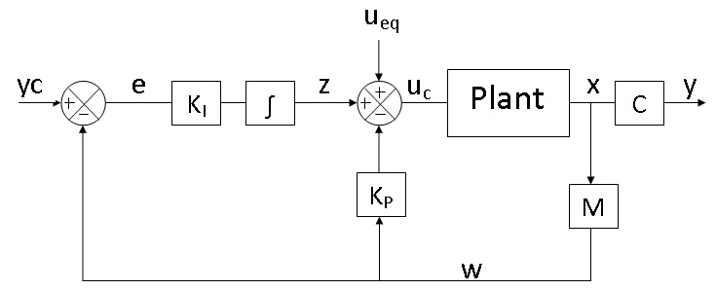
Figure 2. RIDE control structure

Rate Actuated Inverse Dynamics (RAID)
The RAID control system is a two-part design. When the actuator is not limited an inverse dynamics controller is used. When the actuator is limited a Variable Structure Control (VSC) law is implemented in order to limit the output of the control system so as to avoid overdriving the actuator. These are not two completely separate controllers as the VSC controller uses the inverse dynamics structure but with a switching logic implemented on the error signal. The implementation of a control law to be used with non-limited operation and a modification of that control law when the system is limited is known as an anti-windup design.

The first step in the design of the RAID control system is to change the controller output so that a rate of change request is sent to the actuator rather than amplitude, i.e.$u_{c}(t)≈\dot{u}(t)$. If this is the case then the limits on the amplitude limits on the control signal are equivalent to the rate limits of the actuator, therefore, amplitude limiting anti-windup techniques can be utilized to limit the rate of change of the actuator. Of course, a model for the plant could be derived that simply has a rate of change as its input, however, this is quite rare as most plant models (especially those in flight control) have an amplitude as an input. It should also be noted that during the transformations the transformed plant will be expressed in terms of the original plant so that no modifications to the original plant model need to be undertaken.
Firstly, a new state vector needs to be specified.
$x^{*}(t)=\left[\begin{matrix}x(t) \\ u(t)\end{matrix}\right]$ (26)
$u^{*}=\dot{u}(t)$ (27)
$A^{*}=\left[\begin{matrix}A & B \\ 0 & 0\end{matrix}\right]$ (28)
$B^{*}=\left[\begin{matrix}0 \\ I\end{matrix}\right]$ (29)
The transformed plant can now be expressed in state space form
$\left[\begin{matrix}\dot{x}(t) \\ \dot{u}(t)\end{matrix}\right]=\left[\begin{matrix}A & B \\ 0 & 0\end{matrix}\right]\left[\begin{matrix}x(t) \\ u(t)\end{matrix}\right]+\left[\begin{matrix}0 \\ I\end{matrix}\right]u^{*}\left(t\right)+\left[\begin{matrix}d(t) \\ 0\end{matrix}\right]$ (30)
It can be seen from Eqn.29 if feedback is taken in the form of $w=y$ then $M=[C 0]$ and $MB^{*}$ will be null. Therefore, extra measurements need to be taken in order to implement an inverse dynamics controller design. A new measurement vector is chosen, where K_{d} is a diagonal gain matrix.
$w(t)=y(t)+K_{d}\dot{y}$(t) (31)
$w(t)=\left[\begin{matrix}C+K_{d}CA & K_{d}CB\end{matrix}\right]\left[\begin{matrix}x(t) \\ u(t)\end{matrix}\right]$ (32)
$M=\left[\begin{matrix}C+K_{d}CA & K_{d}CB\end{matrix}\right]$ (33)
In order to decouple the slow modes of the closed loop system the equivalent control, u_{eq}, can now be designed based on Equation 23 and the transformed state space matrixes.
$MB^{*}=K_{d}CB$ (34)
$u_{eq}(t)=-{\left(MB^{*}\right)}^{-1}\dot{w}(t)+{\dot{u}}^{*}(t)$ (35)
This equivalent control is implemented within a RIDE control structure
$uc\left(t\right)=z-K_{p}w\left(t\right)+u_{eq}(t)$ (36)
where
$\dot{z}\left(t\right)=K_{I}\left(y_{c}\left(t\right)-w(t)\right)$ (37)
Gain matrixes can be designed based on Equations 24 and 25 and the transformed state space matrixes in order to decouple the fast modes of the closed loop system.
$K_{I}=σ{\left[MB^{*}\right]}^{-1}$ (38)
$K_{P}=ρ{\left[MB^{*}\right]}^{-1}$ (39)
The control signal must now be limited so that neither the rate or amplitude limits of the actuator are exceeded. A Variable Structure Control (VSC) design can be implemented to prevent the control signal from exceeding specified a specified rate of change or amplitude [24]. A control system with a VSC control law contains a discontinuous nonlinearity which has the effect of switching the structure of the closed loop system as one or more of its states pass through what is known as a sliding surface. If the state crosses and immediately re-crosses the sliding surface the controller is said to be in sliding mode. In sliding mode the state or states are constrained to lie on this sliding surface until the sliding mode is broken.
First consider a control system where the output of the controller is a requested rate of change for the actuator, such that $u_{c}(t)≈\dot{u}(t)$. The transformed system has the same closed loop feedback structure as the RIDE design and is depicted in Figure 3. The control system now outputs a rate of change request to the actuator, hence, the limits on the control signal are now the rate of change limits of the actuator and the control system designer can now treat the rate limiting problem as if it were an amplitude limiting problem, i.e.
${LL}_{i}≤{uc}_{i}(t)≤{UL}_{i}$ (40)
${UL}_{i}=i^{th} channel upper rate limit$
${LL}_{i}=i^{th} channel lower rate limit$

A VSC controller can be designed so that the control output is constrained as to not exceed these limits. In order to achieve this, two switching surfaces for each channel must be created; one corresponding to the upper limit and one corresponding to the lower limit.
${εu}_{i}={UL}_{i}-{uc}_{i}$ (41)
${εl}_{i}={LL}_{i}-{uc}_{i}$ (42)

When $uc$reaches either of these switching surfaces it has reached its limit and by entering a sliding mode it is constrained to not exceed this limit. In total there are $2m$ switching surfaces for a system with m inputs.
In order for a sliding mode to be achieved on each surface it is necessary to design maximum and minimum control inputs. These control inputs should be chosen so that the system states are always forced to ${εu}_{i}=0$ or ${εl}_{i}=0$.
${\dot{εu}}_{i}>0 when {εu}_{i}<0$ (43)
${\dot{εu}}_{i}<0 when {εu}_{i}>0$
${\dot{εl}}_{i}>0 when {εl}_{i}<0$
${\dot{εl}}_{i}<0 when {εl}_{i}<0$

Examining each of these conditions will provide insight into the conditions for maintaining sliding mode for chosen control actions.
When ${uc}_{i}$ is in the region of ${εu}_{i}$and ${εu}_{i}<0$(i.e. ${uc}_{i}>{UL}_{i}$) then
${\dot{εu}}_{i}>0$ (44)
${\dot{εu}}_{i}=-{\dot{uc}}_{i}$ (45)
${\dot{uc}}_{i}<0$ (46)

Therefore, it is necessary to choose a control action that will enforce this condition. A further consideration on selection of a control action is the presence of integrator windup when a system input (and thus the controller output) becomes limited. Ideally a control action would be chosen that enforces the condition in Eqn. 43 and prevents integrator windup. Previous work³ has used a form of regulator conditioning to achieve these goals. This conditioning can be formulated as a VSC commutation law.
${\dot{z}}_{i}=\left\{\begin{matrix} 0 if { ε}_{ui}<0 or ε_{li}>0 \\ {{KI}_{i}(yc}_{i}-w_{i}) if ε_{ui}>0 or ε_{li}<0\end{matrix}\right.$ (47)
Where ${KI}_{i}$ = $\left[{KI}_{i1 }{KI}_{i2}⋯{KI}_{im}\right]$, ${KP}_{i}$ = $\left[{KP}_{i1 }{KP}_{i2}⋯{KP}_{im}\right]$ and ${MB}_{i}^{*}$ = $\left[{MB}_{i}^{*} {MB}_{i}^{*}⋯{MB}_{im}^{*}\right]$
Since the rate of change of the regulator is set to zero when ${uc}_{i}$ exceeds its limits any integrator windup will be prevented. It is also only a modification of the original control law and so conforms to the proposed anti-windup strategy. The following analysis will define the conditions under which Eqn. 43 is satisfied.
When ${εu}_{i}<0$ then,
${\dot{uc}}_{i}=-{KP}_{i}{\dot{w}}_{i}+{\dot{ueq}}_{i}<0$ (48)

From Eqn. 35, ${\dot{w}}_{i}={MB}_{i}^{*}(u_{i}^{*}-{ueq}_{i})$ and from Eqn. 39, ${KP}_{i}=σ{\left[{MB}_{i}^{*}\right]}^{-1}$, therefore
${\dot{uc}}_{i}=-σ\left(u_{i}^{*}-{ueq}_{i}\right)+{\dot{ueq}}_{i}<0$ (49)

and since in these circumstances $u_{i}≈{UL}_{i}$
${\dot{uc}}_{i}=-σ\left({UL}_{i}-{ueq}_{i}\right)+{\dot{ueq}}_{i}<0$ (50)

and providing that σ> 0, rearranging gives
${ueq}_{i}<{UL}_{i}-\frac{{\dot{ueq}}_{i}}{}$ (51)

When ${εu}_{i}>0$(i.e. ${uc}_{i}<{UL}_{i}$) then ${\dot{εu}}_{i}<0$therefore ${\dot{uc}}_{i}>0$
${\dot{uc}}_{i}={\dot{z}}_{i}-{KP}_{i}{\dot{w}}_{i}+{\dot{ueq}}_{i}>0$ (52)

Noting that ${\dot{z}}_{i}={{KI}_{i}(yc}_{i}-w_{i})$ and ${KI}_{i}=ρ{\left[{MB}_{i}^{*}\right]}^{-1}$
${\dot{uc}}_{i}= ρ{\left[{MB}_{i}^{*}\right]}^{-1}\left({yc}_{i}-w_{i}\right)-σ\left(u_{i}^{*}-{ueq}_{i}\right)+{\dot{ueq}}_{i}>0$ (53)

and providing that σand ρ> 0 then rearranging
${ueq}_{i}>{UL}_{i}-\frac{{\dot{ueq}}_{i}}{σ}-\frac{ρ}{σ}{\left[{MB}_{i}^{*}\right]}^{-1}\left({yc}_{i}-w_{i}\right)$ (54)

Combining Eqns.51 and 54 yields a criterion which determines the conditions for a sliding mode to be maintained on the switching surface ${εu}_{i}=0$
${UL}_{i}-\frac{{\dot{ueq}}_{i}}{σ}-\frac{ρ}{σ}{\left[{MB}_{i}^{*}\right]}^{-1}\left({yc}_{i}-w_{i}\right)<{ueq}_{i}<{UL}_{i}-\frac{{\dot{ueq}}_{i}}{σ}$ (55)

Repeating the analysis when ${uc}_{i}$ is in the region of ${εl}_{i}$ yields the following condition for SM on the switching surface ${εl}_{i}=0$.
${LL}_{i}-\frac{{\dot{ueq}}_{i}}{σ}-\frac{ρ}{σ}{\left[{MB}_{i}^{*}\right]}^{-1}\left({yc}_{i}-w_{i}\right)>{ueq}_{i}>{LL}_{i}-\frac{{\dot{ueq}}_{i}}{σ}$ (56)
The two criteria given by Eqns. 55 and 56 results in two zones being created for each channel. If $ueq$ passes through either of these zones it will signify that the controller has entered a sliding mode on the switching surfaces ${εu}_{i}$or ${εl}_{i}$. More importantly, this also means that the control signal is being limited to ${UL}_{i}$ or ${LL}_{i}$ respectively.
There are two main scenarios that should be investigated by examining these criteria:
- The sliding mode is broken by ${uc}_{i}$ moving further into the limit – an undesirable situation. This will occur when ${ueq}_{i}$ exits the SM zone into the uncontrollable space.

- The sliding mode is broken by ${uc}_{i}$ moving away from the limit and hence the controller resuming its normal mode of operation. This will occur when ${ueq}_{i}$ exits the SM zone into the controllable space.

Before investigating scenario 1 it is necessary to explore the relationship between $ueq$ and input limits. $ueq$is the control required for the feedback to reach steady state at any given point in time. If $ueq$ is greater than either the upper or lower input limits then there is not enough power available in the system to reach steady state. If a steady state cannot be reached (i.e. the steady state is unreachable) then the system is uncontrollable. The limits on ${ueq}_{i}$ which define when a steady state is reachable can be expressed as
${LL}_{i}{<ueq}_{i}<{UL}_{i}$ (57)

A similar criterion that defines when scenario 1 will not occur can be expressed as

${-\frac{{\dot{ueq}}_{i}}{σ}+LL}_{i}{<ueq}_{i}<{UL}_{i}-\frac{{\dot{ueq}}_{i}}{σ}$ (58)

Firstly, comparing the two expressions it can be seen that if σ is sufficiently large then Eqn. 58 approaches Eqn. 57. Therefore, providing that the steady state is reachable the control signal will remain on the sliding mode and not exceed its limit. When scenario 1 occurs it is clear that a steady state is not reachable and the control signal will exit the sliding mode into an uncontrollable space. The control signal will return to the sliding mode when a steady state becomes reachable again and the system is controllable.Clearly the selection of σ is extremely important to maximizing the ability of the control signal to remain on the sliding mode. The expression $\frac{{\dot{ueq}}_{i}}{}$ will always make the limits on $ueq$ become reduced when $ueq$ is moving towards the limit. Therefore, decreasing σ will effectively reduce the available power from the actuators and hinder the ability of the controller to prevent $uc$ from exceeding its limit. If σ is large enough then the only limits on the ability of the control system to keep $uc$ below its limit are the limits LL and UL. Furthermore, if UL and LL are the actuator limits then only the system limits dictate whether uc will exceed UL or LL. This will only happen if the steady state is unreachable, which of course is a completely undesirable situation and controller operation (or a flight envelope) would be limited so this would not occur. Hence, during normal controller operation, the control signal $uc$will not exceed its upper or lower limits.
Scenario 2 is also important as it is vital the control signal does not become stuck on the limit. It is apparent that as ${yc}_{i}-w_{i}$ becomes smaller the likelihood of SM being maintained is diminished. This means that as the controlled output approaches the desired setpoint the SM will be broken and ${uc}_{i}$ will move away from the limit (providing that scenario 1 has not occurred). In fact, a condition for the existence of a SM is that $w_{i}<{yc}_{i}$. This proves that sliding mode is not possible if there is overshoot of the setpoint. Hence the control signal will not become stuck on a limit and will return to normal operation when the system trajectories determine that ${uc}_{i}$should reduce in magnitude.

Switching Surface Design

The first consideration in designing the switching surface are the values of the limits $UL$and $LL$ for each control channel. To ensure that the rate limits of the actuator are not exceeded the amplitude limits of the control signal must be set thus
$UL={\dot{u}}_{limit upper}$ (59)
$LL={\dot{u}}_{limit lower}$ (60)

The amplitude limits of the actuator of must also be considered for the RAID controller. When an actuator amplitude limit is reached the rate limits of the actuator will be modified.

$when u(t)=u_{limit} -{\dot{u}}_{limit}≤\dot{u}(t)≤0$ (61)
$when u(t)=-u_{limit} 0≤\dot{u}(t)≤{\dot{u}}_{limit}$ (62)

The control signal limits UL and LL will need to be changed accordingly when either the upper or lower actuator amplitude limits are reached. UL and LL now have two possible values each and can be defined by the following logic:
$if u<u_{limit upper} then UL={\dot{u}}_{limit upper}$ (63)
$if u≥u_{limit upper} then UL=0$
$if u>u_{limit lower} then LL={\dot{u}}_{limit lower}$
$if u≤u_{limit lower} then LL=0$

Implementation of switching logic

The implementation of this switching logic is quite straightforward for a SISO system. In order to switch the rate of change of the regulator the error signal is simply switched between its normal definition of $yc-w$ and zero in accordance with the logic in Eqn. 47. However, for a MIMO system with many input channels other considerations have to be taken in the controller design. As shown in Eqn. 47 the control signal variable ${\dot{z}}_{i}$ must be equal to zero when $ε_{ui}<0 orε_{li}>0$. Since ${\dot{z}}_{i}$ is a function of $e_{1…n}$ simply setting $e_{i}$ equal to zero for the corresponding input channel will not ensure that ${\dot{z}}_{i}$ is zero. Deconstructing the regulator vector illustrates this.
${\dot{z}}_{i}={KI}_{i1}e_{1}+K_{i2}e_{2}+K_{i3}e_{3}…K_{in}e_{n}$ (64)

One would assume that setting the entire $e$ vector to zero would ensure that ${\dot{z}}_{i}$ is zero and of course that would be the case. However, there is a major disadvantage to using this method. Since the error for every channel is now zero the switching logic defined in Eqn. 47 has not been followed as $ε_{ui}<0 orε_{li}>0$ will not necessarily be true for all channels. Furthermore, the integral action for all channels will be disabled and knowledge of the setpoint is lost. Meaning that if a change in setpoint occurs during this period it will not be tracked, even if it would normally be possible as all the inputs may not be at their limits. This is of course extremely undesirable. A solution would be to firstly separate the calculation of the regulator into individual channels.
$\begin{matrix}{\dot{z}}_{1}={KI}_{11}e_{1}+K_{12}e_{2}+K_{13}e_{3}…K_{1n}e_{n} \\ {\dot{z}}_{2}={KI}_{21}e_{1}+K_{22}e_{2}+K_{23}e_{3}…K_{2n}e_{n} \\ ⋮ \\ {\dot{z}}_{n}={KI}_{n1}e_{1}+K_{n2}e_{2}+K_{n3}e_{3}…K_{nn}e_{n}\end{matrix}$ (65)

The whole regulator function can then be switched for each channel in accordance with equation 47, ensuring that ${\dot{z}}_{i}$ is equal to zero. Note that there is no assignment for $ε_{ui}$ or $ε_{li}$ equal to zero as the function is switched only when the state passes through the sliding surface.

Pole Placement

Whilst it is the focus of this paper to investigate the non-linear effects of actuator limitations it is still pertinent to consider the linear stability of the system. Since the RIDE system has been transformed with a new measurement matrix and u_{eq} it is necessary to determine the new closed loop pole locations. The derivation of the pole locations are presented in the Appendix. If K_{d}= $\frac{1}{μ}I_{n-m}$, $K_{P}=ρ{\left(μCB\right)}^{-1}$ and $K_{I}=σ{\left(μCB\right)}^{-1}$then the locations of the regulator transmission zeros are given by Eqn. 66 and the closed loop poles for the total tracking system by Eqn. 67.
$sI_{n-m}+\frac{1}{μ}I_{n-m}=0$ (66)
$s^{3}I_{m}+s^{2}I_{m}\left(ρ+\frac{1}{μ}\right)+sI_{m}\left(\frac{ρ}{μ}-σ\right)+\frac{σ}{μ}=0$ (67)
Therefore, μ, ρ and σ can be designed so that all the closed loop poles lie within the left half plane.

Simulation

Control System Context
An assessment of the RIDE and RAID designs is provided by a simulation of a body-rate autopilot with the non-linear missile model. The main purpose of the simulations is to compare the performance of a controller with amplitude and rate limiting to the performance of a similar controller with purely amplitude limiting. The context of the body-rate controller within a complete autopilot design is shown in Figure 3.
It was required that a 5 rad/s yaw rate demand, a 0 rad/s roll rate demand and a 0 rad/s pitch rate demand be tracked with little or no overshoot, accurate tracking of the setpoint and minimised induced roll rate. The controllers were tested with two actuator models, firstly, one with a high rate of deflection limit which, simulates a large high performance electric motor and secondly, one with a smaller rate limit to simulate performance with a much smaller motor. The simulations were run with a Mach number of 3.0 and a trimmed angle of incidence of 10 degrees. The controllers were designed with a specified closed loop bandwidth of 40 rad/s and a damping ratio of 0.8. The results of the simulations are shown in Figures 6-17.

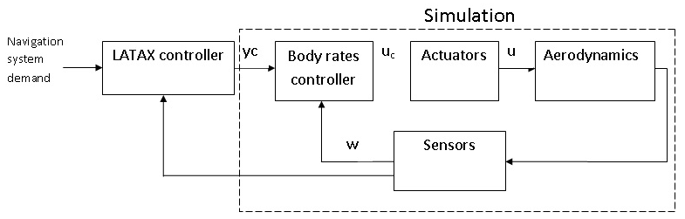
Figure 3. The body rate controller in the holistic autopilot structure

Numerical Integration Treatment of Discontinuities
The multiple discontinuities present in the RAID controller design merit special attention when the simulation of the missile flight control system is considered. Multiple discontinuities can occur simultaneously as both the missile’s actuators and the control system itself are nonlinear. This poses a significant simulation challenge. Specifically, a discontinuity occurring within an integration step will invalidate the Taylor series representation of the step and thus any integration algorithms used. Accurate simulation of these discontinuities is paramount as the RAID conditioning logic will not work effectively if the switching is not performed in the correct order and at the right time. The simulations presented in this paper were performed using a solver which addresses these problems.The solver uses a specified integration algorithm (e.g. 4th/5th order variable step) but when a discontinuity is detected an integration-discontinuity control mechanism is initiated that ensures the discontinuity does not occur within the step. It arranges it to occur after the end of one step and before the beginning of the next, that is, between steps. This would normally lead to a gross time error, however at the end of each step a check is made to see if a discontinuity should have occurred in the step. If this was the case the last step may be repeated with a shorter step-length based on an interpolation of the discontinuity function (the relational expression describing the discontinuity). The interpolation process is repeated until the step-end occurs just after the point of discontinuity, that is, within specified error bounds. The change to a modeling parameter may then be made, between steps, before proceeding with the simulation of the new state of the system. When multiple discontinuities occur within the same step the discontinuity treatment mechanism is used as before, however, a check is made to see if this has triggered any consequential discontinuities. The process is then repeated until all discontinuities occurring within the step have been processed in the correct sequence.

Simulation Results – Large Actuators

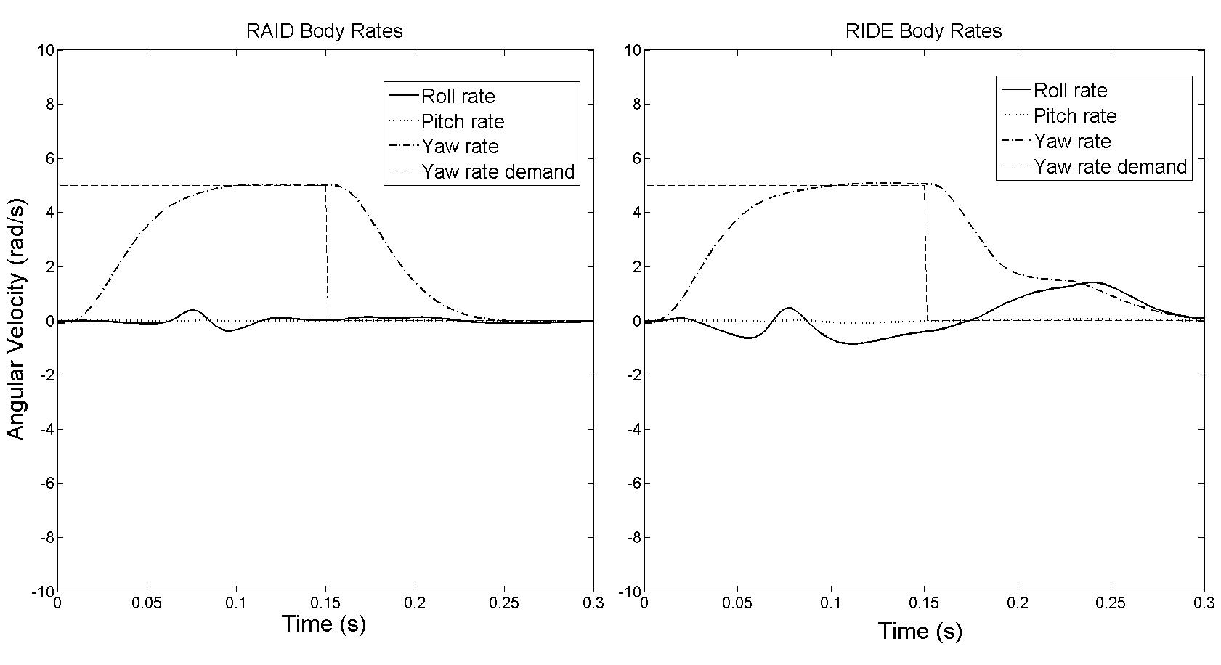
Figure 4. Body rate response, large actuator

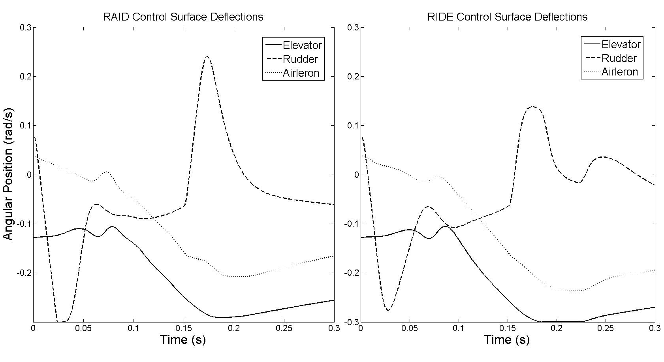
Figure 5. Control surface deflection, large actuator

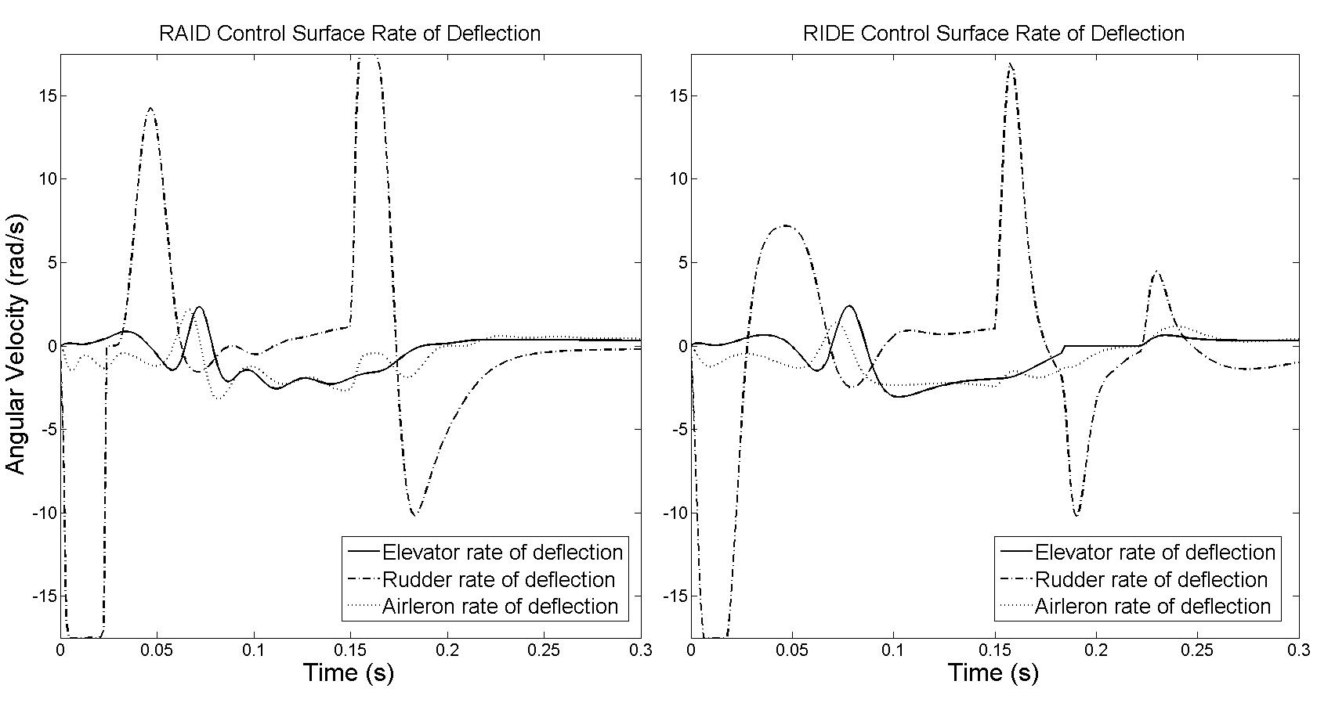
Figure 6. Control surface rate of deflection, large actuator

Simulation Results – Small Actuators

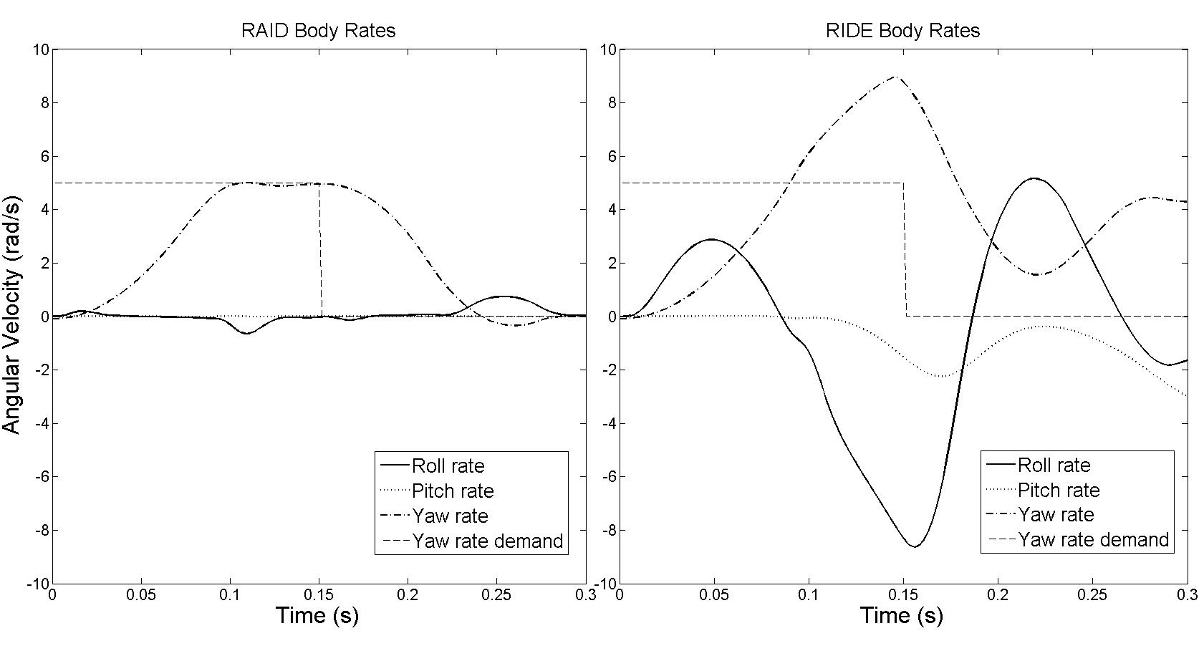
Figure 7. Body rate response, small actuator

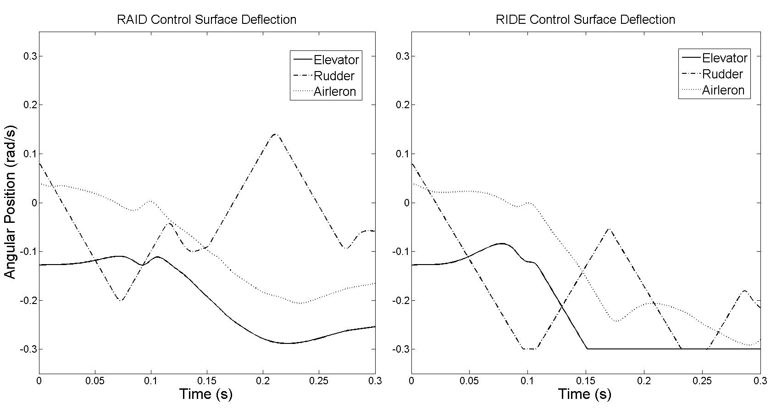

Figure 8. Control surface deflections, small actuator

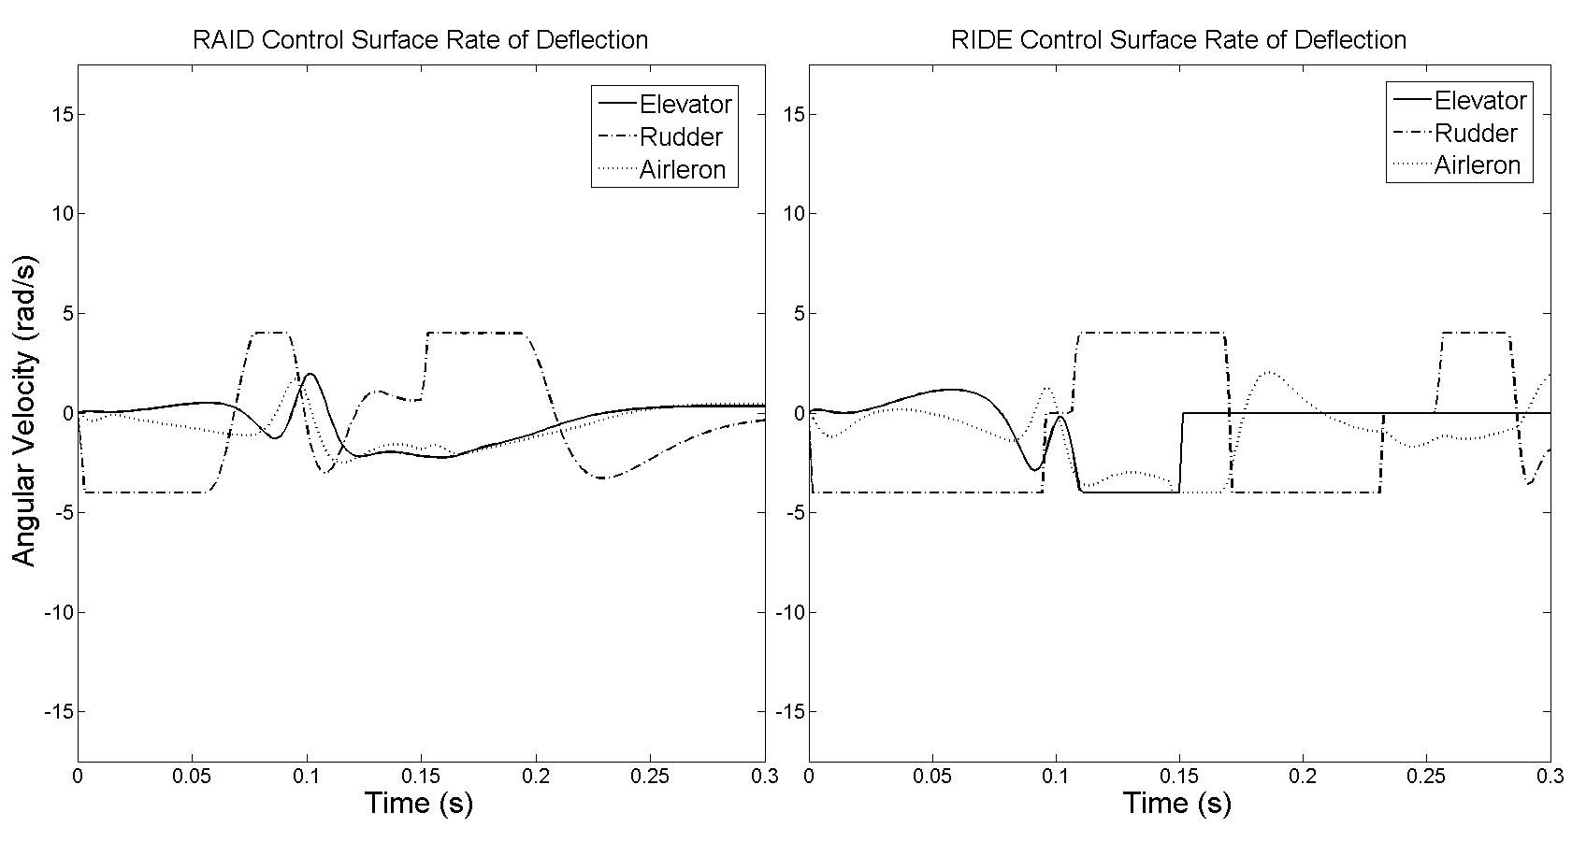
Figure 9. Control surface deflections, small actuator

Results Discussion
The simulation results in section 5.3 are those corresponding with the large, high performance actuator. Both controller designs demonstrate good performance in tracking the demanded yaw rate. However, the RAID controller is able to better de-couple the system. This is due to the fact that the RAID design uses a motor speed control system which can operate at a higher bandwidth compared to the position control system used by the RIDE design. Therefore the RAID actuator has faster dynamics and the design assumption that the actuator dynamics are fast compared to the closed loop dynamics is better realised. Overall the effect of the rate limit of the actuator on the pitchrate response is marginal, this is not surprising as the rate limit is relatively large and reached only for brief periods. Both designs reach the amplitude limit of the elevator, where the regulator conditioning ensures that the response remains stable.
The simulation results in section 5.4 were performed with an actuator model with a significantly reduced rate limit to approximate a smaller, less powerful motor. Here, there is a great disparity in performance between the RIDE and RAID designs. In the case of the RIDE design the reduced rate limits are reached for extended periods and multiple times. The absence of any conditioning to deal with this results in limit cycle occurring.The use of the smaller actuator is not possible with the RIDE controller design.
The performance of the RAID controller design with the smaller actuator is excellent; the stability of the system is not in any way compromised by the reduced rate limit. The rudder is still reaching its rate limit but is not overdriven resulting in a very stable output response. The elevator briefly reaches its deflection limit and, combined with the rudder saturating in rate, demonstrates that the system is operating close its maximum potential.

Conclusions and Future Work
It has been demonstrated that a new controller design, given the name of Rate Actuated Inverse Dynamics (RAID), is able to achieve stable control when the actuator is severely limited in rate through the application of regulator conditioning. The resulting controller design is relatively simple but allows for safe control when the actuator of a missile is saturated in both rate and deflection. It should be noted that the RAID controller is best suited to systems which are first order in nature (such as the body rates of a missile). This is because the transformation used in the RAID design process increases the order of the controlled system by one. If the original controlled system is first order then this is not a problem as second order systems are relatively easy to control. However, if the original system is second order then the use of RAID gives a third order system. This may become more difficult to control and will be investigated in future work.
The RAID controller design was simulated (along with RIDE as a benchmark) with a non-linear missile model for body rate flight control. The results demonstrated that RAID was able to achieve excellent control with an underpowered, heavily rate limited motor whilst the RIDE controller became critically unstable. Furthermore, the RAID design showed a performance improvement over RIDE when the actuator was not saturated. This was due to the RAID design being able to use speed control for the actuator motor (compared with position control for RIDE), resulting in faster actuator dynamics.
In summary, by employing the RAID controller design effectively to deal with actuator rate limits, high performance flight control with significantly smaller motors would be possible.

Acknowledgements
This work was supported by the Scottish Funding Council.

References
[1] Phelan R M.Automatic Control Systems.Cornell University, 1977.
[2] Fielding C, Flux, P K. Non-linearities in Flight Control Systems.Royal Aeronautical Society Journal 2003;107: 673- 686.
[3] Counsell J M,Brindley J, MacDonald M. Non-Linear Autopilot Design Using the Philosophy of Variable Transient Response. AIAA Guidance, Navigation, and Control Conference, 10th – 13th August 2009, Chicago.
[4] Magni J F, Bennani S, Terlouw J. Robust Flight Control: A Design Challenge.Springer-Verlag, 1997.
[5] Herrmann G, Menon P, Turner M, Bates D and Postlethwaite I. Anti-windup Synthesis for Non-linear Dynamic Inversion Control Schemes. Int. J. of Robust and Nonlinear Control 2010; 20: 1465-1482.
[6] Papageorgiu C and Glover K. Robustness Analysis of Nonlinear Flight Controllers. Journal of Guidance Control and Dynamics 2005; 26.
[7] Sieberling S, Chu Q and Mulder J. Robust Flight Control Using Incremental Nonlinear Inverse Dynamics and Angular Acceleration Prediction. Journal of Guidance Control and Dynamics 2010; 33.
[8] Qian W, Stengel RF. Robust nonlinear flight control of a high performance aircraft. IEEE Transactions of Control System Technology 2005; 13(1): 15-26.
[9] Fielding C, Varga A, Bennani S, Selier M. Advanced Techniques for Clearance of Flight Control Laws, Springer-Verlag, New York, 2002.
[10] Ding L, Bradshaw A, Taylor C J. Design of Discrete Time RIDE Control Systems. Proceedings of the UKACC International Conference on Control, August 2006, Glasgow, UK.
[11] Bennet D, Burge S E, Bradshaw A. Design of a Controller for a Highly Coupled V/STOL Aircraft. Transactions of the Institute of Measurement and Control 1999; 21: 63-75.
[12] Muir E and Bradshaw A. Control Law Design for a Thrust Vectoring Fighter Aircraft using Robust Inverse Dynamics Estimation. Proceedings of the IMechE, Part G: Journal of Aerospace Engineering 1996; 210:333 - 343.
[13] Tabouriech S, Turner M. Anti-windup design: an overview of some recent advances and open problems. Control Theory and Applications 2009; 3(1): 1-19.
[14] Galeani S, Onori S, Teel A R and Zaccarian L.A Magnitude and Rate Saturation Model and its Use in the Solution of a Static Anti-Windup Problem. Systems and Control Letters 2008; 57: 1 - 9.
[15] Brieger O, Kerr M, Leissling D, Postlethwaite I, Sofrony J and Turner M C. Flight Testing of a Rate Saturation Compensation Scheme on the ATTAS Aircraft. Aerospace Science and Technology 2009; 13: 92 - 104.
[16] Kahveci NE, Ioannou PA. Indirect adaptive control for systems with input rate saturation. American Control Conference 2008, Seattle WA; 3396-3401.
[17] Forni F, Galeani S, Zaccarian L. An almost anti-windup scheme for plants with magnitude, rate and curvature saturation. American Control Conference 2010, Baltimore MD; 6769-6774.
[18] Hu T, Teel AR, Zaccarian L. Antiwindup synthesis for linear control systems with input saturation achieving regional, nonlinear performance. Automatica 2008; 44(2): 512-519.
[19] Biannic JM, Tarbouriech S. Optimization and Implementation of a dynamic anti-windup compensator with multiple saturation s in flight control systems. Control Engineering Practice 2009; 17(6): 703-713.
[20] ShinY, Calise AJ, Johnson MD. Adaptive control of advanced fighter aircraft in nonlinear flight regimes. Journal of Guidance Control and Dynamics 2008; 31(5): 1464-1477.
[21] Yildiz Y, Kolmanovsky IV, Acosta D. A control allocation system for automatic detection and compensation of the phase shift due to actuator rate limiting. American Control Conference 2011, San Francisco CA; 444-449.
[22] Counsell J M. Optimum and Safe Control Algorithm (OSCA) for Modern Missile Autopilot Design.Ph.D. Thesis, Mechanical Engineering Department, University of Lancaster, 1992.
[23] Bradshaw A, Counsell JM. Design of autopilots for high performance missiles. Proceedings of the Institute of Mechanical Engineers 1992; 206: 75-84.
[24] Zinober ASI. Deterministic control of uncertain systems. Exeter: Short Run Press; 1990.

Appendix
In order to determine the closed loop pole locations of the RAID system it is first necessary to perform a state space transformation which will separate the slow and fast modes of the system. This is necessary as u_{eq} cancels plant dynamics and renders poles associated with equivalent control unobservable. Since the equivalent control only affects the slow modes of the system, a slow/fast decomposition will reveal all pole locations.
Initially the RAID state space equation (Eqn 53) is partitioned into the generalised form shown in Eqn. 54. The only condition on the partitioning is that $\overline{B_{2}}$ be invertible.
$\left[\begin{matrix}\dot{x}(t) \\ \dot{u}(t)\end{matrix}\right]=\left[\begin{matrix}A & B \\ 0 & 0\end{matrix}\right]\left[\begin{matrix}x(t) \\ u(t)\end{matrix}\right]+\left[\begin{matrix}0 \\ I\end{matrix}\right]u^{*}\left(t\right)+\left[\begin{matrix}d(t) \\ 0\end{matrix}\right]$ (68)
$\left[\begin{matrix}\dot{x_{1}}(t) \\ \dot{x_{2}}(t)\end{matrix}\right]=\left[\begin{matrix}{\overline{A}}_{11} & {\overline{A}}_{12} \\ {\overline{A}}_{21} & {\overline{A}}_{22}\end{matrix}\right]\left[\begin{matrix}x_{1}(t) \\ x_{2}(t)\end{matrix}\right]+\left[\begin{matrix}{\overline{B}}_{1} \\ {\overline{B}}_{2}\end{matrix}\right]u\left(t\right)+\left[\begin{matrix}{\overline{d}}_{1}(t) \\ {\overline{d}}_{2}(t)\end{matrix}\right]$ (69)
The partitioned system can be transformed into fast, feedback states (w) and slow states (z).
$\left[\begin{matrix}\dot{c}(t) \\ \dot{w}(t)\end{matrix}\right]=\left[\begin{matrix}A_{11} & A_{12} \\ A_{21} & A_{22}\end{matrix}\right]\left[\begin{matrix}c\left(t\right) \\ w(t)\end{matrix}\right]+\left[\begin{matrix}0 \\ B_{2}\end{matrix}\right]u^{*}+\left[\begin{matrix}d_{1}(t) \\ d_{2}(t)\end{matrix}\right]$ (70)
Where:
$w(t)=M_{1}x(t)+M_{2}u(t)$ (71)
$R={\overline{B}}_{1}{\overline{B}}_{2}^{-1}$ (72)
$S={\left(M_{2}-M_{1}R\right)}^{-1}$ (73)
$A_{11}=\left({\overline{A}}_{11}+R{\overline{A}}_{21}\right)\left(I+RSM_{1}\right)-\left({\overline{A}}_{12}+R{\overline{A}}_{22}\right)SM_{1}=A-BM_{1}M_{2}^{-1}$ (74)
$A_{12}=-\left({\overline{A}}_{11}+R{\overline{A}}_{21}\right)+\left({\overline{A}}_{12}+R{\overline{A}}_{22}\right)S=B{\left(M_{2}\right)}^{-1}$ (75)
$A_{21}=\left(M_{1}{\overline{A}}_{11}+M_{2}{\overline{A}}_{21}\right)\left(I+RSM_{1}\right)-\left(M_{1}{\overline{A}}_{12}+M_{2}{\overline{A}}_{22}\right)SM_{1}=M_{1}A-M_{1}^{2}M_{2}^{-1}B$ (76)
$A_{22}=-\left(M_{1}{\overline{A}}_{11}+M_{2}{\overline{A}}_{21}\right)RS+\left(M_{1}{\overline{A}}_{12}+M_{2}{\overline{A}}_{22}\right)S=M_{1}M_{2}^{-1}B$ (77)
$B_{2}=M_{1}{\overline{B}}_{1}+M_{2}{\overline{B}}_{2}=M_{2}$ (78)
$d_{1}\left(t\right)=d(t)$ (79)
$d_{2}\left(t\right)=M_{1}d(t)$ (80)
The RAID control algorithm is defined as:
$u^{*}(t)=r(t)-K_{p}w(t)+u_{eq}(t)$ (81)
$u_{eq}\left(t\right)=-B_{2}^{-1}A_{21}c\left(t\right)-B_{2}^{-1}A_{22}w\left(t\right)-B_{2}^{-1}d_{2}(t)$ (82)
Therefore the closed loop state equation becomes:
$\left[\begin{matrix}\dot{c}(t) \\ \dot{w}(t)\end{matrix}\right]=\left[\begin{matrix}A_{11} & A_{12} \\ 0 & -B_{2}K_{p}\end{matrix}\right]\left[\begin{matrix}c(t) \\ w(t)\end{matrix}\right]+\left[\begin{matrix}0 \\ B_{2}\end{matrix}\right]r\left(t\right)+\left[\begin{matrix}d_{1}(t) \\ 0\end{matrix}\right]$ (83)
The closed loop poles are given by the following relations, with ps₁ coinciding with the transmission zeros relating the control input to the measurement vector:
$p_{s1}=\left|sI-A_{11}\right|=0$ (84)
$p_{s2}=\left|sI+B_{2}K_{p}\right|=0$ (85)
For a measurement vector given by $w=y+K_{d}\dot{y}$
$M_{1}=C_{1}+K_{d}C_{1}A$ (86)
$M_{2}=K_{d}C_{1}B$ (87)
If $K_{d}=μI$, where μ is a scalar gain, then $A_{11}=\frac{1}{μ}I$, thus transmission zeros are located at $-\frac{1}{μ}I$ and are always stable.
By introducing integral action on the regulator so that $\dot{z}=K_{I}\left(y_{c}-w\right)$ a new closed loop state equation is formed.
$\left[\begin{matrix}\dot{c} \\ \dot{w} \\ \dot{z}\end{matrix}\right]=\left[\begin{matrix}A_{11} & A_{12} & 0 \\ 0 & -B_{2}K_{P} & B_{2} \\ 0 & -K_{I} & 0\end{matrix}\right]\left[\begin{matrix}c \\ w \\ z\end{matrix}\right]+\left[\begin{matrix}0 \\ 0 \\ K_{I}\end{matrix}\right]y_{c}+\left[\begin{matrix}d_{1}(t) \\ 0 \\ 0\end{matrix}\right]$ (88)
The closed loop poles are now given by:
$\left|\begin{matrix}s-A_{11} & -A_{12} & 0 \\ 0 & s+B_{2}K_{P} & {-B}_{2} \\ 0 & K_{I} & s\end{matrix}\right|=0$ (89)
If $K_{P}=ρ{\left(μCB\right)}^{-1}$ and $K_{I}=σ{\left(μCB\right)}^{-1}$ then the closed loop poles are defined by the set p₃.
${ps}_{3}=s^{3}+s^{2}\left(ρ+\frac{1}{μ}\right)+s\left(\frac{ρ}{μ}-σ\right)+\frac{σ}{μ}=0$ (90)

