Observations on the Modelling and Assessment of dissimilar material brazed joints
Niall Hamilton, James Wood
University of Strathclyde, Glasgow, United Kingdom

Summary
At the heart of any procedure for modelling and assessing the failure of dissimilar material brazed joints there must be a basic understanding of the metallurgy and mechanics of the joint. This paper is about developing this understanding and addressing the issues faced with modelling and predicting failure in real dissimilar material brazed joints. A metallurgical investigation has shown that due to a large variation in material properties and transitional zones between the braze and the parent materials, accurately predicting the stress state using FEA will be difficult. Consequently techniques based on experimentally derived test results will be required to predict failure in close proximity to, and at the interface. However, in some instances it may not be necessary to fully capture the stress state at the interface. In cases such as this, if a braze layer with representative properties is used which applies a representative constraint on the model, the converged stresses can be obtained away from the interface which will allow failure to be assessed.

1. The nature of brazed joints
To highlight the challenges involved in modelling dissimilar material brazed joints some of the key metallurgical features of such joints are highlighted below. Figure 1 shows a cross section of a dissimilar material brazed joint between CuCrZr copper alloy and 316LN stainless steel joined using a nickel based brazed filler NB50 (Ni bal – 14Cr – 10P – 0.05Si – 0.03C – 0.01B ). An elemental analysis has been performed using an SEM to determine the composition of each of the phases present within the brazed layer and the results have shown that there is a large variation in chemical composition (figure 1). The initial composition of the braze has neither copper nor iron present hence these elements are clearly being transported into the braze through diffusion during manufacturing. The variation in the chemical composition of these three phases suggests that the material properties will vary considerably across the braze and nanoindentation has shown this to be the case [1] in addition to damaging intermetallics being present within the braze. Figure 1 also shows results from an elemental analysis across the braze - copper and braze - steel interfaces. The results clearly show a gradual variation in the composition between phase 1 in the braze and that of both parent materials highlighting the fact there is no step change in material properties. The width over which this transition happens can be estimated to be approximately 10-15µm based on these results.
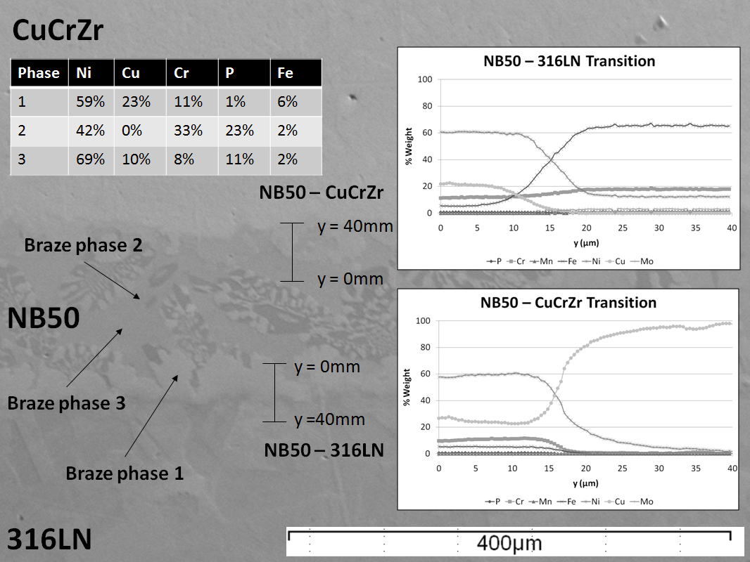
Figure 1: Elemental analysis of braze phases and transitional regions
2. The mechanics of dissimilar material joints
The large stresses that can exist in a dissimilar material joint are caused by the constraint on natural deformation of joined materials due to the compatibility requirements of both materials at the interface. This compatibility constraint results in discontinuity stresses in both materials at the interface. As this constraint is reduced so are the stresses in the joint. This mechanism has been validated through the use of a series of simple axisymmetric FEA models which have shown that reducing the difference in coefficients of thermal expansion, reducing the Young’s modulus of both materials and reducing the yield stress of both materials reduces the constraint due to the interface for both a simple thermal and mechanical loading case.
The theory describing the mechanics of dissimilar material joints [2] assumes a step change in material properties and this (in the case of an elastic analysis) often leads to an analytical singularity [2]. In reality, the theoretical infinite stresses predicted by the elastic theory do not exist. One reason for this is the assumed step change will never occur and there will be some form of grading across a transition region (figure 1), the second reason is due to inelastic deformations in real materials (even those that fail in a brittle manner) make the assumption of linear elastic behaviour in the region of the interface unrealistic.
The stress state at the interface of an abrupt change in material properties using finite element analysis has been the topic of much previous research; however it is pertinent to understand the key features of the stress state that are shown in figure 2. For this particular relationship of elastic properties an analytical singularity exists at the interface and the stresses in both materials tend to negative infinity along the free edge. Outwith this region there is what can be a termed a local stress concentration, i.e the stress concentration due to the interface that is not influenced by the singularity.
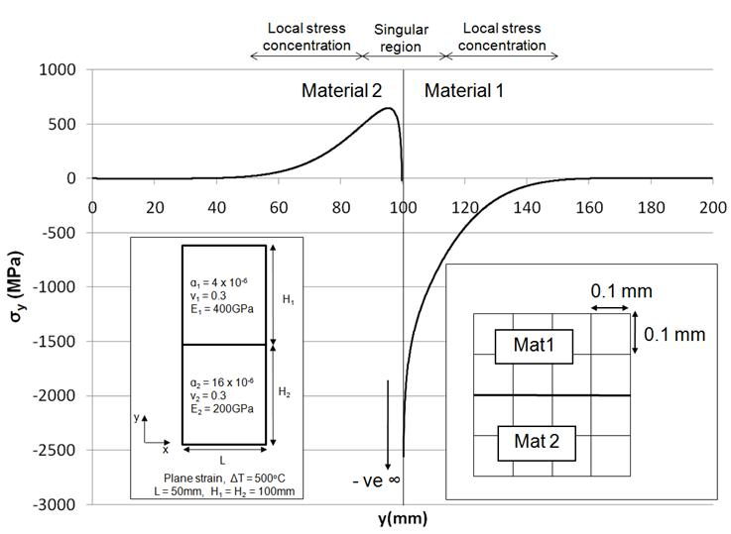
Figure 2: Free edge stress in a simple dissimilar material joint under thermal loading

3. Thoughts on approaches to modelling and assessment of dissimilar material brazed joints
When trying to predict the stress state in a real dissimilar material joint the residual stresses due to joint manufacture will have to be taken into account. The presence of these residual stresses has been the topic of previous research [3] and stress relief will be problematic due to the mechanical and thermal properties of the adjoined materials. The residual stresses will affect various failure mechanisms and must therefore be accounted for when trying to predict the stress distribution in dissimilar material joints.
Current approaches to modelling dissimilar material brazed joints has been to model an abrupt change between both parent materials, ignoring the presence of the braze layer completely [4], or to model the braze layer as a separate homogenous material [5]. These approaches assume an abrupt change in material properties at the interface between both parent materials and the braze filler. The former case effectively assumes that the property of the brazed layer is the same as one of the substrate materials being joined. In the latter case, it is also invariably assumed that the material properties of the braze are the same in the as supplied condition as those after joining and that the brazed layer is a homogenous material through the thickness of the braze. These approaches fail to take into account the presence of the large variations in material properties and the transitional zones that can occur as shown in figure 1. An idealised brazed joint will therefore fail to model the correct material properties, including fracture toughness and fatigue strength and will also produce large discontinuity stresses at the interface (often a theoretical singularity in the elastic case). In reality, due to these factors discussed, it is unlikely that accurate modelling of the stress state very close to, and across the brazed layer will be possible. Hence alternative techniques based on experimentally derived test results will be required to predict failure in close proximity to the interface. Techniques such as interfacial fracture mechanics, cohesive zone modelling, structural hot-spot stress or fatigue strength reduction factors could be modified to assess fracture and fatigue at the interface of dissimilar material brazed joints.
It has however been shown that dissimilar material joints can fail away from the interface [6] in the parent materials and as such in some instances it may not be necessary to fully capture what is happening very close to and across the interface. In cases such as this, if a braze layer with representative properties is used which applies a representative constraint on the model, the reproducible representative converged local stress concentrations can be obtained away from the interface which will allow failure to be assessed.
References
[1] Hamilton, N, Wood, J. 2012. The Metallurgy, Mechanics, Modelling and Assessment of Dissimilar Material Brazed Joints. Manuscript submitted for publication.
[2] Kelly, P.A, D.A. Hills, D. Nowell. 1992. The design of joints between elastically dissimilar materials. Journal of Strain Analysis, 27, pp. 15-20.
[3] Vaidya, R. Rangaswamy, P, Bourke, M, Butt, D. 1998. Measurement of bulk residual stresses in Molybdenum Disilicide/Stainless Steel joints using neutron scattering. Acta mater, 46, pp. 2047-2061.
[4] Williamson, R.L. Rabin, B, Byerly, G. 1995, FEM study of the effects of interlayers and creep in reducing residual stresses and strains in ceramic-metal joints. Composites Engineering. 5, pp. 851 – 863.
[5] Hamlyn-Harris, C, Borthwick, A, Waldon, C, Fanthome, J, Nightingale, M, Richardson, N. 2009. Engineering Design of an RF Vacuum Window for the ITER ICRH Antenna. Fusion Engineering and Design, 84, pp. 887-894.
[6] Blackwell, B E. 1992. A framework for determining the mechanical properties of dissimilar material joints. MIT PhD Thesis, pp 122.

