TOTAL WRIST ARTHROPLASTY: A FINITE ELEMENT STUDY¹ Magnús K. Gíslason and ¹David H. Nash¹University of Strathclyde, Department of Mechanical Engineering,
SUMMARY
Little is known about the mechanical effects that total wrist arthroplasty has on the arthritic wrist. Many clinical studies have presented poor long term functionality with high revision rates. This study presents a finite element model aimed to map the load transfer changes in the wrist after a total wrist arthroplasty.
INTRODUCTION
Computational models of the implanted hip and knee are well established in the literature and the knowledge obtained from them can be credited for the success rates of these operations. To date few finite element models of the implanted wrist exist and the ones available subjected to simplifications¹ or have carried out the analysis ex-vivo².

METHODS
The wrist of a healthy subject was imaged using an 3T clinical MRI scanner. The scans ranged from the distal end of the radius and ulna to the proximal third of the metacarpals. The total length of the scans was 64 mm and the resolution was 230 x 230 µm in plane and slice thickness was 0.7 mm. The scans were imported into Mimics (Materialise) where the edge detection of the bones was carried out. Three dimensional models of the bones were created
An STL file of the prosthesis was obtained and imported into Mimics where, using boolean operators, the proximal component of the prosthesis was implanted into the radius and the distal component placed on top, removing the lunate and the proximal aspects of the scaphoid and capitate. By using boolean operators on the three dimensional objects, it was possible to get a tight fit between the carpal bones and the prosthesis.
The two components and bones were meshed using a triangular surface mesh in Mimics and the meshes were exported into Abaqus (v.6.10EF) where the surface meshes were converted into volumetric mesh using tetrahedral C3D4 elements. In Abaqus the assembly was created and contact established between each articulation. It was assumed that between the carpal bones and the prosthesis no relative movement would occur and tie constraints were applied. Frictionless contact was assumed between the carpal bones. Loading was applied as compressive forces over the metacarpals. The force values were obtained through a biomechanical study where grip force was measured using five 6-degree-of-freedom force transducers in conjunction with an 8 camera Vicon system. Biomechanical model was used to convert the measured external forces into joint contact forces applied to the finite element model.

RESULTS AND DISCUSSION
The model was solved using the Explicit algorithm in Abaqus simulating a quasi static behaviour.
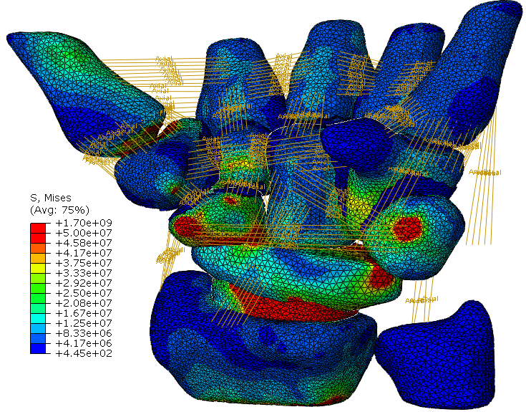
Figure 1: Stress plot of the implanted wrist with ligaments

CONCLUSIONS
In order to be considered for an award, you must check off the box for that award and all requirements must be fulfilled (these will be noted on the proceeding submission page). Please note, each proceeding can be nominated for one award only. In the event an incomplete submission is received, it will be withheld from acceptance until the authors supply all required components.
ACKNOWLEDGEMENTSAcknowledgments are optional and should specify research founding resources including organization and reference numbers
REFERENCES
- Lewis G. and Vannappagari SR.: Semin Arthroplasty. Jan;6(1):20-9, 1995
- Grosland N., et al., Clin Orthop Relat R, 421, pp. 134–142, 2004

