Kinetics of enzyme attack on substrates covalently attached to solid surfaces: influence of spacer chain length, immobilised substrate surface concentration and surface charge
Joseph Deere*, Rui F De Oliveira, Bartłomiej Tomaszewski, Sarah Millar, Antonia Lalaouni, Laura F Solares, Sabine L Flitsch,^{b} Peter J Halling*

Department of Pure and Applied Chemistry, Thomas Graham Building, 295 Cathedral Street, University of Strathclyde, Glasgow, G1 1XL, UK.
^{b}School of Chemistry and the MIB, The University of Manchester, 131 Princess Street, Manchester, M1 7ND, UK.
E-mail: Joseph.Deere@strath.ac.uk or P.J.Halling@strath.ac.uk

* To whom correspondence should be addressed. Fax: +44-141-5484822. Tel: +44-141-5482683.

Published in Langmuir 24(20): 11762–11769. DOI: 10.1021/la801932f
Abstract. The use of α-chymotrypsin to cleave covalently bound N-acetyl-L-tryptophan (Ac-Trp-OH) from the surfaces of aminopropylated controlled pore glass (CPG) and the polymer PEGA₁₉₀₀ was investigated. Oligoglycine spacer chains were used to present the covalently attached Ac-Trp-OH substrate to the aqueous enzyme. In the absence of the oligoglycine spacer chain, the rate of release was relatively slow, especially from the PEGA₁₉₀₀. These slow rates reflect the position of the amino group to which Ac-Trp-OH is covalently attached. On the glass there was a clear optimum with a chain of four glycine residues. For PEGA₁₉₀₀ there is no real apparent change beyond two glycine residues. The decline in rate beyond these optima are a possible result of changes in oligoglycine structure. Comparing different surface loadings of bound substrate, the rate of release of Ac-Trp-OH from CPG with a pore diameter of 1200 Å was optimal when using 83% of the maximum that can be coupled, then fell again at higher loading. The rate of Ac-Trp-OH release from CPG was the same for surface coverage’s of 0.4 and 1.0. The introduction of permanent surface charges on CPG₁₂₀₀ exhibits a distinct influence on enzymatic cleavage with an increase in the rate of biocatalysis at the surface. Optimal presentation of covalently immobilised substrate on different supports by use of appropriate linkers leads to favourable biocatalysis from the support.
Introduction
The catalytic activity of enzymes that naturally act on solid phase substrates, such as cellulases, lysozymes, and receptor tyrosine kinases have been widely studied.¹⁻³ Many of these enzymes have specific binding domains for solids. Enzymes that do not possess special adaptations for activity at solid surfaces but react with substrates covalently immobilised to solid supports have gained a wide appeal. The growing technological significance of such enzymatic systems is evident in areas such as protein chip technologies,⁴⁻¹⁰ DNA microarrays,¹¹⁻¹³ solid-phase assays/synthesis,¹⁴⁻²⁰ and also biosensor formats.²¹ There has been an increasing interest in the study of interfacial enzyme reactions in such systems at a range of different surfaces, such as planar surfaces, i.e. where the substrate is covalently attached to a slide surface^{4,6,7,22,23} or the external surfaces and internal pore surfaces of particles such as porous glass.²⁴⁻²⁷ Such immobilised substrate systems have been noted to have several significant differences in comparison with their homogenous reaction systems. Most notable are differences in substrate specificity,²⁸ cooperative interactions with the surface^{29,30} and rebinding and diffusion effects.^{27,31,32} Controlled pore glass (CPG)^{33,34} and other supports such as the polymers TentaGel (polyoxyethylene-polystyrene),³⁵⁻⁴⁰ PEGA (polyethylene glycol co-polymer cross-linked with polyacrylamide)^{20,41-43} and N-acetyl-D-glucosamine⁴⁴ have also been used for chemo-enzymatic synthesis in the solid-phase.⁴⁵ Indeed PEGA has been one of the most widely used polymer supports for enzymatic reactions since its introduction by Meldal et al.⁴² It has 2-aminopropyl groups at the end of polyethylene glycol chains, which are attached to a polyacrylamide core. It is favoured for its swelling properties, allowing access to large enzymes⁴⁶⁻⁴⁸ and its high loading of free amines for immobilising substrates. CPG has been widely used in the field of enzyme immobilisation since the 1970’s.^{49,50} More recently there have been reports of CPG studies using covalently supported substrates.^{24-27,51} The kinetics of collagenase activity (which naturally acts on solid substrates) on peptides covalently immobilised to CPG surfaces was studied by UV-vis spectrophotometry.^{26, 27} It was noted that the overall rate of reaction was dependent not only on the enzymatic catalysis rates but also on the diffusion of enzyme on the surface. The manner of presentation of the immobilised substrate to the enzyme is an important aspect of biocatalysis on the solid support and will dictate the ability of the enzyme to perform a reaction. It has been suggested that the use of ‘longer optimised linkers’ would increase the low enzymatic reaction yields often observed in hydrolytic reactions catalysed by enzymes both on polymer and CPG supports.^{35-37,39,40} Yamada and Nishimura have used glycol-polymers with a hexaglycyl phenylalanine spacer in oligosaccharide synthesis.⁴⁴ An ester linker bond was cleaved by addition of chymotrypsin to release the oligosaccharide product. There was an important recent study of cutinase enzyme reaction of immobilised 4-hydroxyphenol valerate at gold film self assembled monolayer interfaces.⁵² There have been previous reports of subtilisin cleavage of the peptide sAAPFpNA from both NH₂-(CH₂)₁₂-CPG and NH₂-(CH₂)₃-CPG. It was reported that there was an 8.3% increase in initial rate of p-nitroanilide cleavage from the (CH₂)₃ versus the (CH₂)₁₂ CPG.⁵¹ Beyond these individual examples there have been no systematic studies of the effects of spacer length during enzyme action particularly on the more widely used ‘solid-phase substrates’ such as CPG and PEGA. Spacers, have long been used in the related affinity systems (i.e. chromatography), where protein binding to the solid-phase groups is required, but not catalysis. There are studies of antibody recognition of carrier bound haptens where the use of a spacer longer than 20 Å has been reported for efficient display.⁵³ Recently a study on spacer arm length in affinity chromatography detailed that a 1,6-diaminohexane spacer gave an optimal distance to avoid steric hindrance of binding of the enzyme L-asparaginase.⁵⁴ We now report a systematic study into the use of oligoglycine chain spacers for the attachment of Ac-Trp-OH to two different (one solid the other a flexible polymer) supports which are widely used in solid phase synthesis, controlled pore glass (CPG₂₉₀₀) (2900 referring to the average pore diameter in Å) and PEGA₁₉₀₀ (1900 referring to the molecular weight of the polyethylene glycol chain). The rate of Ac-Trp-OH cleavage from the two solid supports on reaction with α-chymotrypsin is discussed in comparison with the homogenous reaction system. In addition to looking at spacer length we have also compared different substrate concentrations on CPG₁₂₀₀ surfaces for an optimised chain length system and discuss this in the context of enzyme accessibility. Finally we present data for enzyme catalysis at a modified CPG₁₂₀₀ surface, which contains permanent positive charges. Previous studies showed how such charges could be beneficial for action on PEGA supports (ref 71), but interpretation was complicated by changes in swelling characteristics of this flexile polymer.
Experimental Section
Reagents. Fmoc-Gly-OH (Fmoc-Gly), Fmoc-Cys(trt)-OH, N-hydroxybenzotriazole (HOBt) and N-acetyl-L-tryptophan (Ac-Trp-OH) were from NovaBiochem. Boc-Gly-OH, Fmoc-Gly-Gly-OH and Fmoc-Gly-Gly-Gly-OH were from Bachem. 1, 3-diisopropylcarbodiimide (DIC) (99%), N, N-diisopropylethylamine (99%) (DIPEA), 3-aminopropyltriethoxysilane (APS), controlled pore glass (i.e. CPG₂₉₀₀ where 2900 refers to the pore size in Å) (pore size 2878 Å, surface area 8.1 m² g⁻¹, pore volume 1.01 mL g⁻¹, mesh size 200-400, cat. number 27732), aminopropyl-CPG (i.e. CPG₁₂₀₀ pore size 1221 Å, surface area 31.2 m² g⁻¹, pore volume 1.73 mL g⁻¹, mesh size 200-400, 0.040 mmol NH₂ g⁻¹, cat. number 27798), α-chymotrypsin (type II bovine pancreas, EC 3.4.21.1), picrylsulfonic acid, Fmoc-chloride, Trizma® Base, Trizma® hydrochloride, Calcium chloride hexahydrate, toluene (reagent grade), trifluoroacetic acid (TFA) (99% spectroscopic grade), isopropylsilane, were from Sigma. 5, 5’-dithio-bis(2-nitrobenzoic acid) was from Uptima. Piperidine and dimethyl formamide (DMF), both peptide synthesis grade were from Rathburn Chemicals Ltd, Walkerburn, Scotland, EH43 6AU, UK. PEGA₁₉₀₀ resin (Acryloylated 0, 0’-bis(2-aminopropyl)polyethylene glycol resin, bead size ~300 μm) was supplied wet in ~10% methanol, with a free loading of 200 μmoles NH₂ g⁻¹ dry resin by Polymer Laboratories Ltd. (now part of Varian Inc.), Essex Road, Church Stretton, Shropshire, SY6 6AX, UK. (2-bromo-ethyl)trimethyl ammonium bromide 98% was from Acros Organics, Geel West Zone 2, Janssen Pharmaceuticalaan 3a, B-2440, Geel, Belgium.
Silanisation of CPG₂₉₀₀. CPG₂₉₀₀ was silanised by a method modified from Feng et al.⁵⁵ It is reported that the wetting and controlled dehydration process used in this procedure ensures a cleaner monolayer of aminopropyl groups on the glass surface. A commercially silanised CPG (i.e. CPG₁₂₀₀ was also used in this study with a free amine loading 40 μmoles g⁻¹ CPG but a pore size of 1221 Å).
4 g of CPG₂₉₀₀ was heated at 100ºC in 100 mL, milliQ H₂O (18.0 MΩ) for 1 h. Upon cooling the CPG₂₉₀₀ was filtered, air-dried and weighed. The CPG₂₉₀₀ was further dried by refluxing in 250 mL of dry toluene, using a Dean-Stark apparatus (130ºC, 400 rpm) until the appropriate amount of water was removed (i.e. this value is the weight of the wet CPG₂₉₀₀ minus weight of 4 monolayers of water on the CPG₂₉₀₀ surface with each monolayer having 5x10¹⁸ molecules m⁻²).⁵⁵ APS was added (0.28 mmoles g⁻¹ CPG₂₉₀₀, calculated on the basis of 75% coverage of the CPG surface area, i.e. 6.075 m² g⁻¹) to the CPG₂₉₀₀ suspension in toluene and reacted at 25ºC for 16 h. The suspension was refluxed at 120ºC for 4 h. The cooled CPG₂₉₀₀ was washed with 200 mL methanol and 200 mL acetone and dried under vacuum at 100ºC. The free NH₂ loading available for chemical reaction on the aminopropyl-CPG₂₉₀₀ was determined by chemically coupling Fmoc-Gly-OH, Fmoc removal with piperidine and subsequent analysis of the released Fmoc using HPLC (see below). The free NH₂ loading on the aminopropyl-CPG₂₉₀₀ was determined as 30 μmole g⁻¹ (standard deviation 6.5%). This loading compared favorably with other reported loadings of similar pore size CPG in the literature.⁵⁶
PEGA₁₉₀₀ resin pre-wash. 10 g of wet PEGA₁₉₀₀ was weighed into a solid phase extraction (SPE) tube. This was washed (10 mL portions) 3 times with each in the following order: DMF, DMF/methanol (50/50), THF, DCM, dry DMF.
Coupling of first Fmoc-Gly-OH. 1 g of the dry aminopropyl-CPG₂₉₀₀ or wet PEGA₁₉₀₀ was weighed into a solid phase extraction (SPE) tube and was washed three times with 10 mL dry DMF. Fmoc-Gly-OH (5 eq. relative to the amount of free NH₂ on the resin) and HOBt (2.5 eq.) were dissolved in 20 mL dry DMF. This was added to the washed resin. Then DIC (2.5 eq.) was added to initiate the coupling reaction. The suspension was mixed by inversion at 20 rpm for 2 h at room temperature (25˚C). The suspension was then filtered, and 40 μL acetic anhydride in 10 mL dry DMF was added to acetylate excess NH₂ on the resin. The suspension was mixed by inversion at 20 rpm for 1 h at room temperature (25˚C). The resin was then filtered and washed three times with 10 mL dry DMF.
Fmoc removal. Fmoc was removed from resins by incubating with 16 mL of piperidine/DMF (20% piperidine) per 1 g of resin with mixing by inversion at 20 rpm for 1 h at room temperature (25˚C). The suspension was subsequently filtered and the supernatant was analysed by HPLC for released Fmoc.
Stepwise assembly of oligoglycines on CPG₂₉₀₀ and PEGA₁₉₀₀. The resin was further coupled with Fmoc-Gly-OH and Fmoc was removed from 100 mg of this resin. The remaining resin was stored at 4˚C. The above process was repeated to synthesise 100 mg of resin with various glycine chain lengths from 0-8. Finally each portion of the resin was filtered and washed three times with 10 mL dry DMF.
Coupling of Ac-Trp-OH. Ac-Trp-OH was coupled to all of these resins with various glycine chains and also directly to 100 mg of both resins with no glycines attached. Ac-Trp-OH (3 eq. relative to the concentration of free amino groups on resin support) and HOBt (1.5 eq.) were dissolved in 4 mL dry DMF and were added to the washed 100 mg of resin whose Fmoc has been removed. DIC (1.5 eq.) was added to initiate the reaction. The resin suspension was mixed by inversion at 20 rpm for 2 h at room temperature (25˚C). After this cycle the resin was filtered and washed three times with 3 mL dry DMF. Another Ac-Trp-OH coupling cycle was repeated. Finally the resin was filtered and washed three times with 3 mL dry DMF.
The loading was estimated from HPLC analysis of the Fmoc released in the final glycine coupling. On CPG the values were similar for all chain lengths at 28 μmoles g⁻¹ (standard deviation 6.5%), while on PEGA it declined from 156 to 67 μmoles g⁻¹ for chain lengths 0 to 8 (yields, 34-78%).
Synthesis of CPG₁₂₀₀ with different surface loadings of Ac-Trp-Gly-Gly-Gly-OH. A modification of the method described for the coupling of the first Fmoc-Gly-OH was used.⁴⁰ Different molar ratios of Boc-Gly-OH and Fmoc-Gly-OH were simultaneously coupled and following selective removal of the Fmoc groups the surface concentration of free amines on the CPG₁₂₀₀ surface was varied. After subsequent coupling with Fmoc-Gly-Gly-OH via HOBt/DIC and removal of Fmoc, the resins were coupled with Ac-Trp-OH.
Determination of CPG₁₂₀₀ loading of Ac-Trp-OH. Dry resin (50 mg) was added to 1 mL of 1 M NaOH. The suspension was heated to 70C until the resin dissolved (~24 h). The dissolved material was diluted 20 times with 2% TFA in dH₂O and samples were analysed for free Ac-Trp-OH and also for Ac-Trp-Gly compounds on a C₁₈ RP-HPLC column. HPLC peaks of Ac-Trp-OH and Ac-Trp-Gly-OH were confirmed by MS. Note that this method was also applied to CPG₂₉₀₀ but it was not possible to totally dissolve the silica material.
Synthesis of permanently charged resin. 150 mg of the above CPG₁₂₀₀ resin with terminal Ac-Trp-Gly-Gly-Gly- (18.7 moles g⁻¹ CPG₁₂₀₀) and Boc-Gly- both attached to the silica surfaces was weighed. The Boc group was removed by addition of 1.5 ml of 50% TFA in DCM (v:v) for 2 h at room temperature. On removal of the TFA/DCM the resin was washed with each DCM (3 x 25 mL) and dry DMF (3 x 25 mL). The resin was then coupled with Fmoc-Cys(trt)-OH via HOBt/DIC as per Ac-Trp-OH. The trityl group was removed by adding 1.5 ml of 95% TFA, 5% isopropylsilane for 2 h at 50C. The released trityl cation was determined by UV-spectrophotometry at 495 nm. Permanent positive charges were added via reaction of –SH with (2-bromo-ethyl)trimethyl ammonium bromide (BETMA).^{57,58} The resin was suspended in 5 ml 100 mM Tris-HCl at pH 8.5 and 2 M BETMA was added to a final concentration of 100 mM. The reaction mixture was covered under nitrogen gas and reacted overnight at room temperature. The presence of free –SH groups on the resin was determined via DTNB test (i.e. reaction with 5,5’-dithio-bis(2-nitrobenzoic acid) and detection at 412 nm using UV-spectrophotometry.^{59,60} The free loading of –SH before (7.2 moles thiol g⁻¹ CPG₁₂₀₀) and after (0 moles thiol g⁻¹ CPG₁₂₀₀) BETMA reaction on the CPG₁₂₀₀ overnight, revealed a loading of 7.2 moles BETMA g⁻¹ CPG₁₂₀₀.
The terminal Fmoc was subsequently removed from the resin and the free NH₂ were acetylated with acetic anhydride (i.e. 100 l in 4 mL of dry DMF) with reaction at room temperature for 3 h. Resins were washed each with dry DMF (3 x 25 mL) and acetone (3 x 25 mL).
Enzymatic reactions. Both CPG₂₉₀₀ and PEGA₁₉₀₀ resins were suspended in 10 mL of 20 mM Tris—100 mM CaCl₂ buffer at pH 8.0 in the presence of α-chymotrypsin (0.0662 mg enzyme mL⁻¹ buffer). The enzyme reactions for both CPG₂₉₀₀ and PEGA₁₉₀₀ resin (2 mg mL⁻¹) were incubated at 25˚C for a maximum of 24 h with stirring by inversion at 20 rpm for the PEGA₁₉₀₀ suspension and by magnetic stirring at 300 rpm for the CPG₂₉₀₀ suspension. For the reactions on the CPG₁₂₀₀, 0.9 ml of CPG suspension (11.11 mg mL⁻¹) was transferred to individual Eppendorf tubes and 0.1 mL of α-chymotrypsin (0.66 mg enzyme mL⁻¹ in 20 mM Tris—100 mM CaCl₂ buffer at pH 8.0) and incubated at 25˚C with stirring by inversion at 20 rpm for a maximum of 24 h. Samples were taken at different times with centrifuging in a micro-centrifuge (9,000 rpm for 2 min). The supernatant from the samples were then analysed by HPLC for released Ac-Trp-OH.
HPLC analysis. All HPLC analysis was carried out on a Waters 2695 alliance separations module and a Waters 2996 photo diode array detector. A Vydac C₁₈ (Cat. No. 218TP54) column was used. A gradient method was used to detect both released Fmoc-piperidine cleavage product and Ac-Trp-OH for all analysis. The gradient was generated with water containing 0.1% (v/v) TFA and acetonitrile containing 0.1% TFA, rising from 10 to 90% of the latter over 30 min (flow rate 1 mL min⁻¹) with detection at both 280 and 254 nm (200-400 nm scan range for photo diode array).
Results and Discussion
The influence of spacer chain length on enzyme catalysis. When a substrate is covalently immobilised onto a solid support the conditions of catalysis are fundamentally changed in comparison to the homogeneous reaction system. Many factors will now be important which largely relate to the microenvironment of the immobilised substrate. Such factors include the inherent nature of the solid support and its surface chemistry, the surface concentration of the immobilised substrate, how the substrate is anchored to the solid support, how accessible the substrate sites are to the enzyme active site and also the inherent heterogeneity of surface sites on the solid phase support will influence the nature of the surface catalysis reaction.
It seems plausible that a ‘spacer’ is preferable to allow the substrate to enter the enzyme active site, compared with direct attachment of the substrate to the solid surface. It has been stated for example that the choice of both spacer⁶¹ and support³⁶ ‘could be crucial’ to enzymatic solid phase synthesis in such systems.
In this study we chose as a model the α-chymotrypsin cleavage of Ac-Trp-OH from peptides attached to solid phase supports. -Chymotrypsin is a 23 kDa molecular weight protease which recognises aromatic amino acid residues and cleaves the amide bond on their carboxyl side. The homogenous reaction system of this enzyme has been widely studied in the literature.^{62,63} The protein is approximately 35 Å in diameter (estimate based on crystal data).⁶⁴
Two supports were investigated, CPG of 2900 Å pore size and also the hydrophilic polymer PEGA₁₉₀₀. It should be noted that one of the CPGs used in this study has larger pores than the previously reported studies using CPG (~500 Å)^{26,27,33,34,36,51}
The rate of release of substrate by the enzyme was investigated over a period of 3 h (CPG₂₉₀₀) or 24 h (PEGA₁₉₀₀). Substrates varied by the length of the oligoglycine spacers between support and substrate, which contained 0-8 glycine residues (see Scheme 1).
Scheme 1. Structures of PEGA₁₉₀₀ (n~43) and aminopropyl-CPG surfaces the showing bonding sites of the Ac-Trp-oligoglycine (n₁=0-8) substrates.

Some typical Ac-Trp-OH release results are presented in Figures 1 and 2 for the two supports. Release from CPG₂₉₀₀ was best described by quadratic curves and the PEGA results were fitted to straight lines. Progress curves were not forced through the origin, as we cannot exclude the possibility that traces of Ac-Trp-OH were present at time zero. Replicate HPLC analyses were made for all samples, leading to error bars smaller than the size of the points. However, it is clear from scatter in the points that errors other than in sample analysis are substantial. This is typical for these immobilised substrate reactions, and one contributing factor may be possible heterogeneity of the substrate beads in different incubations. Reactions were also run in replicate and average rates and yields are reported in Table 1.
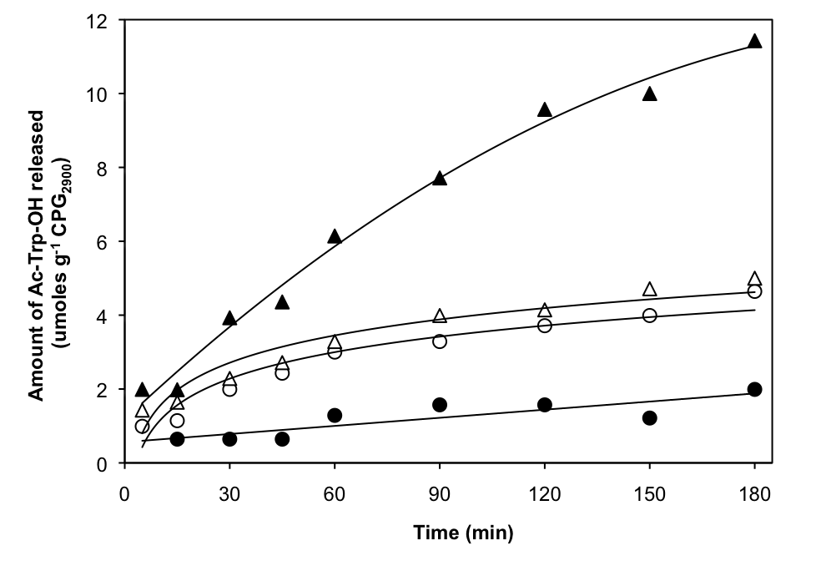
Figure 1. -Chymotrypsin catalysed (25C, pH 8.0) release of Ac-Trp-OH from oligoglycine-CPG₂₉₀₀ surfaces versus time. (•) CPG (i.e. no glycines), (◻) Gly-Gly-Gly-CPG, () Gly-Gly-Gly-Gly-Gly-Gly-Gly-Gly-CPG, () Gly-Gly-Gly-Gly-Gly-Gly-CPG. Error bars for replicate analyses are smaller than the size points. Replicate reactions gave rate values with a standard deviation of about 10%.

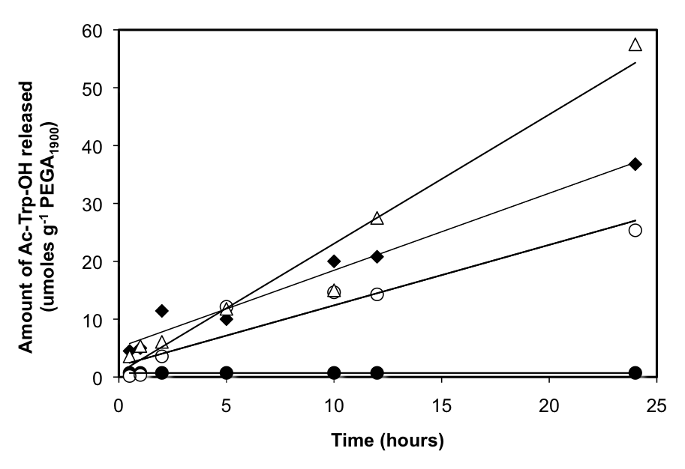
Figure 2. -Chymotrypsin catalysed (25C, pH 8.0) release of Ac-Trp-OH from oligoglycine-PEGA₁₉₀₀ surfaces versus time. (•) PEGA₁₉₀₀ (i.e. no glycines), () Gly-PEGA₁₉₀₀, (◻) Gly-Gly-Gly-PEGA₁₉₀₀, () Gly-Gly-Gly-Gly-Gly-Gly-PEGA₁₉₀₀. Error bars for replicate analyses are smaller than the size of the points. Replicate reactions gave rate values with a standard deviation of about 20%.

Table 1 presents a summary of the data. The rates for hydrolysis from CPG₂₉₀₀ without a glycine linker are comparable to other studies where substrates were cleaved from aminopropyl glass.^{24,26,27,51} For instance Esker et. al. reported the release of 373 +/- 15 molecules of p-nitroanilide min⁻¹ m⁻² CPG₅₀₀ from a succinylated peptide which was covalently linked to an aminopropyl–CPG₅₀₀ surface.⁵¹ This value is 31 nmoles p-nitroanilide released min-1 g-1 CPG (i.e. surface area 50 m2 g-1).51 Indeed this value is very similar to the rates from the PEGA material and also from the CPG2900 as noted in Table 1.

Table 1. Summary of kinetic results for -chymotrypsin catalysed (25C, pH 8.0) release of Ac-Trp-OH from oligoglycine-CPG2900, oligoglycine-PEGA1900 solid supports. Rates on the CPG support were determined from the linear coefficient of the quadratic fit.

Number of Gly | Rate  nmoles Ac-Trp-OH released by enzyme  g-1 Support min-1 | R² | Substrate released   moles Ac-Trp-OH  g⁻¹ Support)

CPG support (3 h reaction)
0 | 11 | 0.91 | 2.14
1 | 54 | 0.98 | 6.58
2 | 42 | 0.94 | 6.08
3 | 107 | 0.99 | 11.50
4 | 113 | 0.99 | 10.30
5 | 93 | 0.98 | 8.41
6 | 45 | 0.99 | 5.36
7 | 55 | 0.99 | 5.34
8 | 45 | 0.97 | 4.83

PEGA support (24 h reaction)
0 | 0.9 | N/A | 0.63
1 | 16.5 | 0.93 | 25.39
2 | 27.0 | 0.97 | 43.21
3 | 22.6 | 0.95 | 36.40
4 | 24.1 | 0.92 | 35.30
5 | 22.2 | 0.99 | 35.70
6 | 37.4 | 0.99 | 57.13
7 | 30.2 | 0.99 | 45.70
8 | 14.8 | 0.97 | 21.70

It can be noted from Table 1 that for enzyme catalysis from both supports the rate of release is relatively slow when no spacer is used. The relative rate is slower in the case of PEGA₁₉₀₀ (see Figure 2 and Table 1). The amine leaving group here carries an alpha-methyl substitution (in a 2-amino-propyl group), in contrast, with the CPG₂₉₀₀ where the leaving group is a 1-amino-propyl chain (see Scheme 1) which is attached to the glass surface (it should be noted that the Ac-Trp-OH directly attached to the supports are not peptides). As has already been mentioned, it is surprising that the enzyme shows this level of activity when the Ac-Trp-OH is bound close to the rigid glass surface of CPG, with only the propyl chains giving a degree of flexibility. The level of rigidity of the CPG and its influence on biocatalysis can be noted by the longer chain dependency of the CPG (i.e. optimal rate with four glycines) as opposed to the PEGA system (i.e. optimal rate at 6 glycines). It can also be noted from Figure 1 and 2 that the amount of Ac-Trp-OH released from Gly-Gly-Gly- in the first 3 h of reaction is similar (i.e. 11 µmoles g-1 PEGA and 11.5 µmoles g-1 CPG).
On both the CPG₂₉₀₀ and PEGA₁₉₀₀, the rate of release decreases for the longest chain lengths. Such optima in spacer length have also been found in affinity chromatography. For binding of L-asparaginase to a Sepharose polymer a 1,6-diaminohexane spacer was found to be optimal, while an increase to 7 or 8 carbons led to structural changes and a decrease in the specific binding of enzyme.⁵⁴ With the oligoglycine chains used in our study, there are reasons to expect structural changes as the length increases. There have been several reports,⁶⁵⁻⁶⁷ that oligoglycine chains with two to five residues have a type I structure in solution, which has been reported to be an extended β-sheet structure.⁶⁵ Oligoglycine chains of more than five residues have been reported to have an increasing proportion of type II helical structure, which is fully reached with 12 residues.⁶⁵⁻⁶⁷ This suggests that an extended β-structure allows for a more favourable access of chymotrypsin to Ac-Trp-OH, with the structural changes that occur on further glycine additions leading to a less accessible Ac-Trp-OH. The slower rates are also noticed on the SAMs materials reported recently. This study showed the first system whereby enzymatic kinetic constants could be measured online using an electrochemical approach. It was noted that the rates of interfacial enzyme reactions at the C6 and C8 systems were very similar to one another. On increasing the chain length further to C11 there was a 4-fold decrease in the rate of enzyme reaction and increasing the chain length further to C16 resulted in rates which were too slow to monitor.⁵² A similar effect of ‘optimal’ chain length is noted here for the model -chymotrypsin system.
The influence of immobilised substrate surface concentration on catalysis. The surface concentration of bound substrate will undoubtedly have effects on the rate of biocatalysis at the surface of the immobilised support. These effects will be a result of the nature of the packing and orientation of the substrate and will affect the accessibility of the enzyme to the surface substrate sites. It is important to investigate this parameter for solid phase supports for such biocatalytic systems and to define the levels of accessibility for an enzyme system. Here we use a CPG support, due to the rigid nature of this material the positions of the substrate groups on the surface will be relatively fixed.
A commercially silanised CPG (note this CPG is different to the linker study, this CPG was chosen on the basis of its higher surface area and loading of free NH₂) with an average pore size of 1200 Å and a 40 moles g⁻¹ loading of free surface aminopropyl groups was investigated in our model system. The surface of the CPG₁₂₀₀ was modified by a simultaneous coupling of both Fmoc-Gly-OH and Boc-Gly-OH in different relative ratios to the free aminopropyl groups . The different relative ratios of Fmoc-Gly-OH to Boc-Gly-OH used were 1.00, 0.50, 0.36, 0.19, 0.01. These Fmoc-Gly-OH / Boc-Gly-OH mixtures were coupled to five different batches of CPG₁₂₀₀. The final Fmoc removal results prior to Ac-Trp-OH coupling are presented in Table 2 and show that five resins with different free surface loadings of NH₂ were achieved. The other NH₂ groups on the CPG remaining coupled with Boc-Gly-OH groups, see reaction Scheme 2.
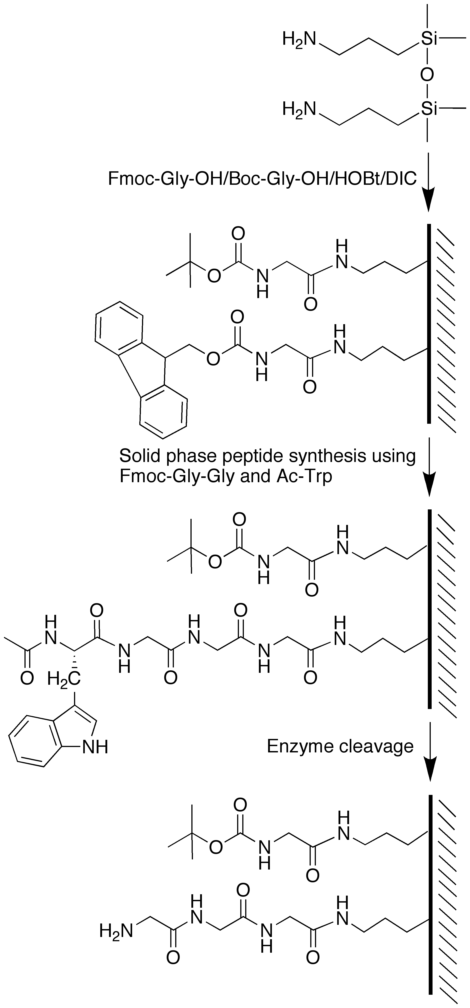
Scheme 2. Stepwise reactions to achieve varying surface concentrations of Ac-Trp-Gly-Gly-Gly on aminopropyl-CPG1200 surfaces.

To test the distribution of free NH₂ groups produced after Fmoc removal, we also coupled samples with dansyl chloride, and imaged by two photon fluorescence microscopy as previously reported⁴⁸ Images of optical sections throughout the bead showed uniform intensity, implying that the NH₂ groups were distributed homogenously throughout the bead. We would therefore expect that the same is true of the Ac-Trp groups subsequently coupled to them.
Ac-Trp-Gly-Gly-OH was subsequently synthesised on each resin. This gave five resins with different surface mixtures of Boc-Gly-OH and Ac-Trp-Gly-Gly-Gly-OH attached to the aminopropylated glass. Table 2 shows data for the terminal loading of Ac-Trp-OH on each resin. It can be clearly noted that we have five resins with different surface concentrations of Ac-Trp-OH.
Table 2. Summary data of aminopropyl-CPG₁₂₀₀ after stepwise coupling of Fmoc-Gly/Boc-Gly and Fmoc-Gly-Gly detailing the terminal Fmoc removal yields for different ratios of coupled Fmoc-Gly/Boc-Gly. Following removal of Fmoc from Fmoc-Gly-Gly, Ac-Trp-OH was coupled to the resin. The terminal loadings of Ac-Trp-OH determined by NaOH digestion and HPLC are also detailed.
 | Final Fmoc removal | Final Ac-Trp-OH loading
% Fmoc-Gly- in initial coupling | (moles NH₂ g⁻¹ CPG₁₂₀₀) | (moles Ac-Trp-OH g⁻¹ CPG₁₂₀₀)
100.0 | 24.9 | 22.6
50.0 | 19.2 | 18.7
36.3 | 11.1 | 12.6
19.4 | 6.3 | 9.7
10.0 | 3.6 | 4.5

The experimental percentage loading is the actual loading of Ac-Trp-OH, which was measured on the CPG surface upon NaOH digestion of the CPG resin. Figure 3 details initial rate measurements for chymotrypsin cleavage of Ac-Trp-OH from the five different CPG₁₂₀₀ resins. There is a steep increase in the rate of Ac-Trp-OH release as the relative surface concentration is increased to 0.83 (a surface coverage of 1.00 is defined as the maximum amount of Ac-Trp-Gly-Gly-Gly-OH which could be chemically coupled to the aminopropyl-CPG₁₂₀₀, from Table 2 this is 22.6 moles Ac-Trp-OH g⁻¹ CPG). The rate of Ac-Trp-OH release then decreases rapidly. This ‘optimum’ level of peptide surface concentration is around 0.83. This surface coverage presumably presents the covalently immobilised Ac-Trp-OH in an ‘optimised’ microenvironment where the chymotrypsin can access the immobilised Ac-Trp-OH. The rapid decrease in rates after this surface concentration is probably due to crowding effects within the pore surfaces.
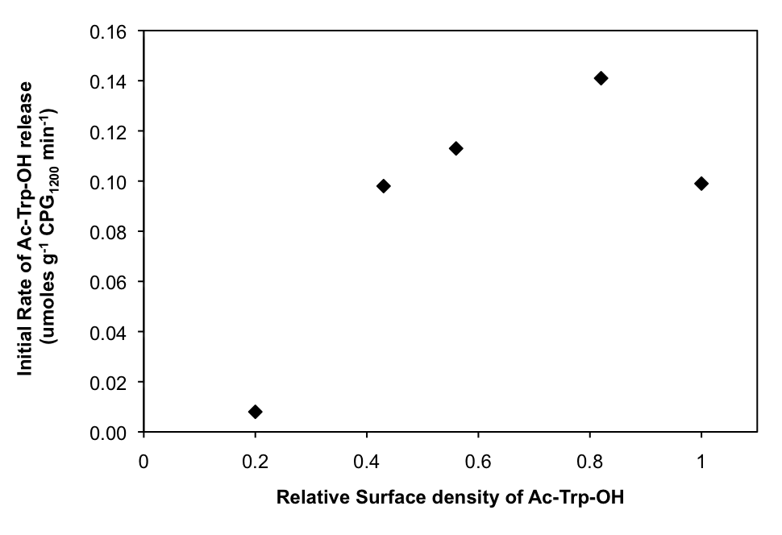
Figure 3. Rate of -chymotrypsin catalysed (25C, pH 8.0) release of Ac-Trp-OH (molecules m⁻² CPG₁₂₀₀) versus the initial Ac-Trp-OH relative surface concentration. Error bars are smaller than the size of the points.

Indeed there are several studies which show enzymatic accessibility/activity at highly homogeneous self assembled monolayer surfaces (SAMS).⁶⁸⁻⁷⁰ These systems allow for the interfacial chemistry to be engineered and finely controlled. For instance the degree of surface coverage has been investigated for the enzymatic glucosylation of N-acetylglucosamine immobilised to a mixed SAMs on a gold surface.⁷⁰ The use of a high loading density (above 0.7) on these SAMs resulted in a dramatically reduced accessibility of enzyme for the immobilised carbohydrate.⁷⁰ In another study the surface initiated polymerisation of d(A-T) by Taq DNA polymerase was found to be unsuccessful when high loadings of single SAMs were used this was due to steric crowding effects.⁶⁸ These studies clearly show that biological activity at an interface can be very different at high surface loadings compared to lower surface loadings. Figure 3 clearly indicates that these findings can also be transferred to other surfaces (i.e. porous SiO₂) and this is the first time that such data have been reported for porous particles.
Substrates immobilised on CPG surfaces also have the added complexity of confinement in a porous network. This will present quite different curved surface topographies, compared with SAMs materials that can also effect enzyme accessibility. Table 3 presents data showing the effect of CPG average pore diameter versus the amount of molecules accessible for enzyme reaction (defined as the maximum number of molecules cleaved from the surface). The benefit of having an open porous network is clearly seen. The number of enzyme accessible surface molecules per nm² increases by a factor of 16 on increasing the average pore diameter from 500 to 2900 Å. Thus the concentration of surface immobilised substrate and also the pore size dimensions of the CPG material both need to be considered to allow optimal enzyme access for surface biocatalysis to occur.
Table 3. Summary of substrate loading data of aminopropyl-CPG. CPG materials with three different average pore diameters and their reactions with enzymes. CPG data for pore size 500 was taken from Esker et. al. 2000. The other two substrates are Ac-Trp-Gly-Gly-Gly-CPG.
CPG  Average Pore Size (Å) | Measured loadings  (moles g⁻¹) | Amount substrate cleaved (moles g⁻¹) | Surface area  (m² g⁻¹) | Substrate surface density  (molecules nm⁻²) | Substrate cleaved (molecules nm⁻²)
500⁵¹ | 4.9⁵¹ | 4.9⁵¹ (subtilisin reaction) | 50.0⁵¹ | 0.06⁵¹ | 0.06⁵¹
1200 | 18.7 | 17.7(-chymotrypsin reaction) | 31.2 | 0.36 | 0.34
2900 | 21.2 | 13.2(-chymotrypsin reaction) | 8.1 | 1.58 | 0.98

The influence of permanent positive surface charges on CPG₁₂₀₀. To understand more clearly the role of the interactions of chymotrypsin with the surface immobilised substrate permanent positive charges were introduced to the surface of the CPG₁₂₀₀. This was achieved by adding trimethyl ammonium groups (see reaction Scheme 3). A CPG₁₂₀₀ with a mixture of 2.6 molecules of Ac-Trp-Gly-Gly-Gly for every 1 molecule of trimethyl ammonium-S-Cys-Gly attached to the surface was created. A typical rate curve for the chymotrypsin cleavage of Ac-Trp-OH is shown in Figure 4 and compared to the identical material without surface charges (The identity of cleaved Ac-Trp-OH was confirmed by both UV spectrum and mass spectrometry). The permanent charges clearly exhibit an influence on the rate of biocatalysis. Indeed the initial rate, which was taken from the linear parts of these graphs indicate that the rate is double on introduction of the positive charges to the CPG₁₂₀₀ surface.
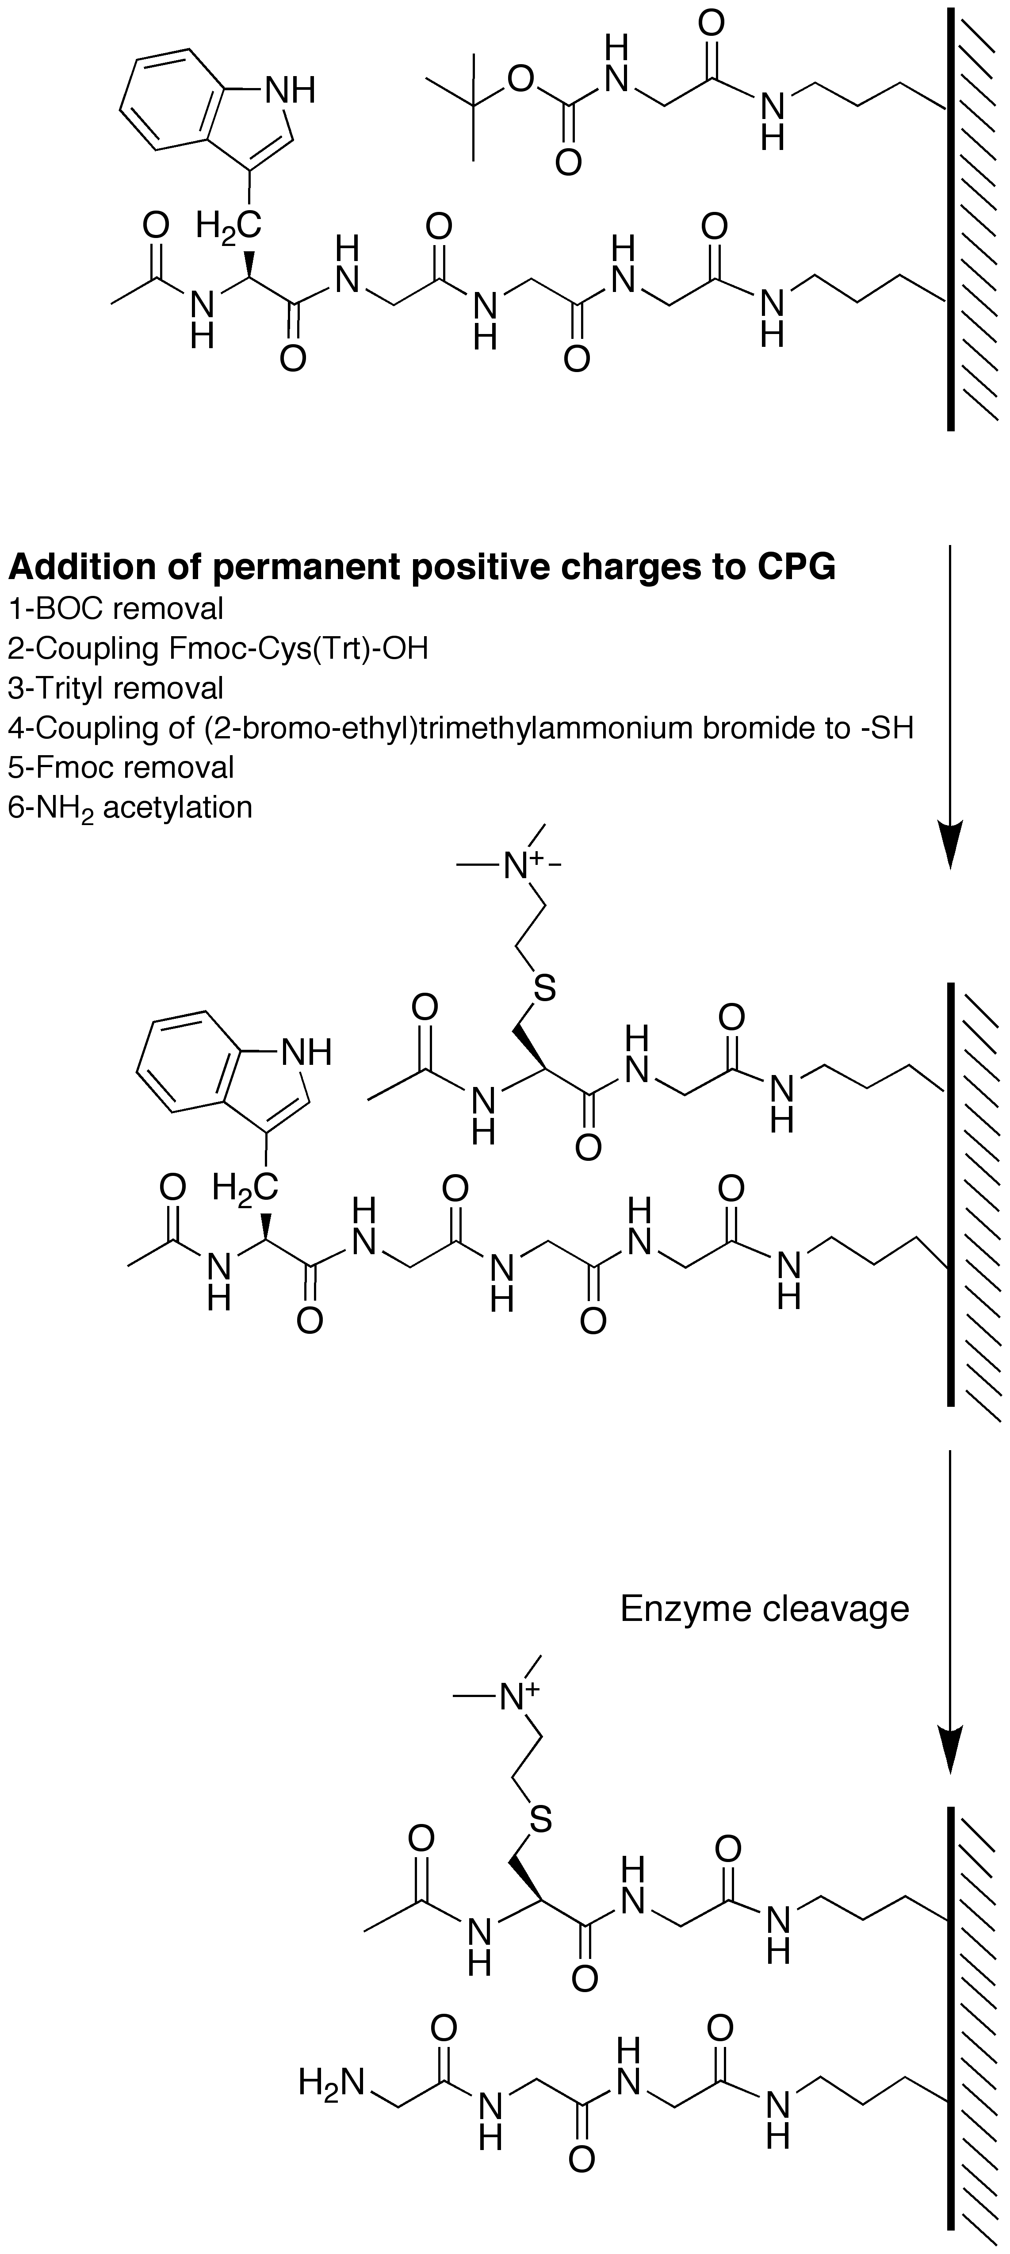
Scheme 3. Stepwise reactions to introduce permanent positive charges on aminopropyl-CPG1200 surfaces with Ac-Trp-Gly-Gly-Gly substrate.

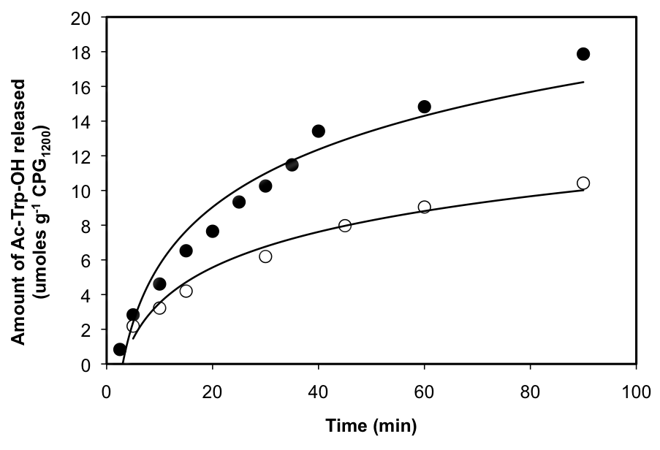
Figure 4. Rate of -chymotrypsin catalysed (25C, pH 8.0) release of Ac-Trp-OH from (•) Gly-Gly-Gly-CPG₁₂₀₀ with N⁺(CH₃)₃-(CH₂)₂-S-Cys-Gly-CPG₁₂₀₀ permanent positive charges and from () Gly-Gly-Gly-CPG₁₂₀₀ with the same initial surface concentration of Ac-Trp-OH but no surface charges. Error bars for three different reaction runs are smaller than the size of the points.

A similar enhancement was previously reported for a PEGA₁₉₀₀ resin with permanent charges: a positively charged resin led to higher yields of biocatalysis with the large enzyme penicillin G amidase.⁷² With PEGA the positive charges were noted to substantially increase the swelling of the resin beads, and it was suggested that this made an important contribution by aiding accessibility of the enzyme to the bead interior. In the present case of rigid CPG particles, this effect is not present, so other explanations must be sought.
One important effect will be that the permanent positive charges will generate an effective pH of the microenvironment inside the pores that is significantly higher than the bulk outside. This effect, which can be seen as a repulsion of H⁺ ions by the fixed charges, has been well studied in the context of charged supports for immobilised enzymes. Chymotrypsin has an isoelectric point at pH 8.6,⁷¹ so will be slightly positively charged in the bulk medium at pH 8.0. However, the effective micro-environmental pH will be above 8.6, so that attraction between net negative enzyme and the support charges would contribute to its action at the surface. The increased pH may also directly increase the catalytic activity above that at pH 8.0. For instance for a positively charged poly(ornithyl) modified chymotrypsin the aqueous non-immobilised enzyme exhibited a shift towards lower pH values by 1.4 (at low ionic strengths).⁷³ The positive charges may thus be allowing for optimal presentation of the immobilised substrate and increased interaction of active enzyme at the glass interface.
Conclusions
Oligoglycine spacers increase the rate of catalytic hydrolysis by chymotrypsin of acetyl-tryptophan derivatives attached covalently to the surface of CPG₂₉₀₀ or PEGA particles. A Gly-Gly linker is sufficient to give near maximal rates with PEGA, while there is a clear optimum for Gly-Gly-Gly-Gly on CPG₂₉₀₀. When the surface concentration of immobilised substrate on CPG₁₂₀₀ was varied, a clear optimum at about 80% of maximal loading was observed, this is similar to what has been observed for other enzymes on planar solid surfaces.⁶⁸⁻⁷⁰ Both at lower (40%) and higher (100%) loading reactivity levels are significantly lower. This is attributed to steric effects of immobilised substrate in the CPG pore network. The pore diameter of CPG also has an effect on the levels of enzyme accessibility, with the number of enzyme accessible surface molecules per nm² increasing by a factor of 16 when the average pore diameter of CPG is increased from 500 to 2900 Å. The introduction of permanent positive charges at the CPG surface increases the rate of biocatalysis, probably by a co-operative effect of presenting the immobilised Ac-Trp-OH in a more accessible microenvironment. This leads to increased rates of biocatalysis at CPG surfaces, which we are currently investigating in more detail.
ACKNOWLEDGMENT We wish to acknowledge the BBSRC, the Wellcome Trust and the Royal Society for financial support for this work.

1. Bayer, E. A.; Belaich, J. P.; Shoham, Y.; Lamed, R. Annu. Rev. Microbiol. 2004, 58, 521-554.
2. Boraston, A. B.; Bolam, D. N.; Gilbert, H. J.; Davies, G. J. Biochem. J. 2004, 382, 769-781.
3. Ingram, J. L.; Bonner, J. C. Curr. Mol. Med. 2006, 6, 409-421.
4. Arenkov, P.; Kukhtin, A.; Gemmell, A.; Voloshchuk, S.; Chupeeva, V.; Mirzabekov, A. Anal. Biochem. 2000, 278, 123-131.
5. Caiazzo, R. J.; Tassinari, O. W.; Ehrlich, J. R.; Liu, B. C. S. Expert Rev. Proteomics 2007, 4, 261-272.
6. Houseman, B. T.; Huh, J. H.; Kron, S. J.; Mrksich, M. Nat. Biotechnol. 2002, 20, 270-274.
7. Houseman, B. T.; Mrksich, M. Trends Biotechnol. 2002, 20, 279-281.
8. Kwon, Y.; Han, Z. Z.; Karatan, E.; Mrksich, M.; Kay, B. K. Anal. Chem. 2004, 76, 5713-5720.
9. Templin, M. F.; Stoll, D.; Schrenk, M.; Traub, P. C.; Vohringer, C. F.; Joos, T. O. Trends Biotechnol. 2002, 20, 160-166.
10. Zhu, H.; Bilgin, M.; Bangham, R.; Hall, D.; Casamayor, A.; Bertone, P.; Lan, N.; Jansen, R.; Bidlingmaier, S.; Houfek, T.; Mitchell, T.; Miller, P.; Dean, R. A.; Gerstein, M.; Snyder, M. Science 2001, 293, 2101-2105.
11. DeRisi, J. L.; Iyer, V. R.; Brown, P. O. Science 1997, 278, 680-686.
12. Ducray, F.; Honnorat, J.; Lachuer, J. Rev. Neurologique 2007, 163, 409-420.
13. Ramsay, G., Nat. Biotechnol. 1998, 16, 40-44.
14. Altreuter, D. H.; Dordick, J. S.; Clark, D. S. Biotechnol. Bioeng. 2003, 81, 809-817.
15. Borchardt, A.; Still, W. C. J. Am. Chem. Soc. 1994, 116, 373-374.
16. Bosma, A. Y.; Ulijn, R. V.; McConnell, G.; Girkin, J.; Halling, P. J.; Flitsch, S. L. Chem. Commun. 2003, 22, 2790-2791.
17. Houseman, B. T.; Mrksich, M. J. Org. Chem. 1998, 63, 7552-7555.
18. Humphrey, C. E.; Turner, N. J.; Easson, M. A. M.; Flitsch, S. L.; Ulijn, R. V. J. Am. Chem. Soc. 2003, 125, 13952-13953.
19. Tolborg, J. F.; Petersen, L.; Jensen, K. J.; Mayer, C.; Jakeman, D. L.; Warren, R. A. J.; Withers, S. G. J. Org. Chem. 2002, 67, 4143-4149.
20. Ulijn, R. V.; Baragana, B.; Halling, P. J.; Flitsch, S. L. J. Amer. Chem. Soc. 2002, 124, 10988-10989.
21. Jena, B. K.; Raj, C. R. Chem. Eur. J. 2006, 12, 2702-2708.
22. Salisbury, C. M.; Maly, D. J.; Ellman, J. A. J. Amer. Chem. Soc. 2002, 124, 14868-14870.
23. Zourob, M.; Gough, J. E.; Ulijn, R. V. Adv. Mater. 2006, 18, 655-670.
24. Brode, P. F.; Erwin, C. R.; Rauch, D. S.; Barnett, B. L.; Armpriester, J. M.; Wang, E. S. F.; Rubingh, D. N. Biochemistry 1996, 35, 3162-3169.
25. Brode, P. F.; Rauch, D. S. Langmuir 1992, 8, 1325-1329.
26. Gaspers, P. B.; Gast, A. P.; Robertson, C. R. J. Colloid Interface Sci. 1995, 172, 518-529.
27. Gaspers, P. B.; Robertson, C. R.; Gast, A. P. Langmuir 1994, 10, 2699-2704.
28. Horan, N.; Yan, L.; Isobe, H.; Whitesides, G. M.; Kahne, D. Proc. Nat. Acad. Sci U.S.A. 1999, 96, 11782-11786.
29. Cooper, M. A.; Fiorini, M. T.; Abell, C.; Williams, D. H. Bioorg. Med. Chem. 2000, 8, 2609-2616.
30. Rao, J. H.; Yan, L.; Xu, B.; Whitesides, G. M. J. Amer. Chem. Soc. 1999, 121, 2629-2630.
31. Lagerholm, B. C.; Thompson, N. L. J. Phys. Chem. B 2000, 104, 863-868.
32. Lieto, A. M.; Lagerholm, B. C.; Thompson, N. L. Langmuir 2003, 19, 1782-1787.
33. Schuster, M.; Wang, P.; Paulson, J. C.; Wong, C. H. J. Amer. Chem. Soc. 1994, 116, 1135-1136.
34. Waldmann, H.; Reidel, A., Angew. Chem. Int. Ed. 1997, 36, 647-649.
35. Cheung, Y. W.; Abell, C.; Balasubramanian, S. J. Amer. Chem. Soc. 1997, 119, 9568-9569.
36. Grether, U.; Waldmann, H. Chem. Eur. J. 2001, 7, 959-971.
37. Rademann, J.; Grotli, M.; Meldal, M.; Bock, K. J. Amer. Chem. Soc. 1999, 121, 5459-5466.
38. Reents, R.; Jeyaraj, D. A.; Waldmann, H. Drug Discovery Today 2002, 7, 71-76.
39. Sauerbrei, B.; Jungmann, V.; Waldmann, H. Angew. Chem. Int. Ed. 1998, 37, 1143-1146.
40. Vagner, J.; Barany, G.; Lam, K. S.; Krchnak, V.; Sepetov, N. F.; Ostrem, J. A.; Strop, P.; Lebl, M. Proc. Nat. Acad. Sci. U.S.A. 1996, 93, 8194-8199.
41. Babiak, P.; Reymond, J. L. Anal. Chem. 2005, 77, 373-377.
42. Meldal, M.; Auzanneau, F. I.; Hindsgaul, O.; Palcic, M. M. J. Chem. Soc., Chem. Commun. 1994, 1849-1850.
43. Meldal, M.; Svendsen, I.; Breddam, K.; Auzanneau, F. I. Proc. Nat. Acad. Sci. U.S.A. 1994, 91, 3314-3318.
44. Yamada, K.; Nishimura, S. I. Tetrahedron Lett. 1995, 36, 9493-9496.
45. Kadereit, D.; Waldmann, H. Chem. Rev. 2001, 101, 3367-3396.
46. Kress, J.; Zanaletti, R.; Amour, A.; Ladlow, M.; Frey, J. G.; Bradley, M. Chem. Eur. J. 2002, 8, 3769-3772.
47. Thornton, P. D.; McConnell, G.; Ulijn, R. V. Chem. Commun. 2005, 47, 5913-5915.
48. Ulijn, R. V.; Brazendale, I.; Margetts, G.; Flitsch, S. L.; McConnell, G.; Girkin, J.; Halling, P. J. J. Comb. Chem. 2003, 5, 215-217.
49. Weetall, H. H. Chimia 1976, 30, 429-430.
50. Weetall, H. H.; Lee, M. J. Appl. Biochem. Biotechnol. 1989, 22, 311-330.
51. Esker, A. R.; Brode, P. F.; Rubingh, D. N.; Rauch, D. S.; Yu, H.; Gast, A. P.; Robertson, C. R.; Trigiante, G. Langmuir 2000, 16, 2198-2206.
52. Nayak, S.; Yeo, W. S.; Mrksich, M. Langmuir 2007, 23, 5578-5583.
53. Kimura, K.; Arata, Y.; Yasuda, T.; Kinosita, K.; Nakanishi, M. Biochim. Biophys. Acta 1992, 1104, 9-14.
54. Martin del Valle, E. M. G., M.A. Ind. Eng. Chem. Res. 2002, 41, 2296-2304.
55. Feng, X.; Fryxell, G. E.; Wang, L. Q.; Kim, A. Y.; Liu, J.; Kemner, K. M. Science 1997, 276, 923-926.
56. Gupta, K. C.; Sharma, P.; Kumar, P.; Sathyanarayana, S. Nucleic Acids Res. 1991, 19, 3019-3025.
57. Paetzel, M.; Strynadka, N. C. J.; Tschantz, W. R.; Casareno, R.; Bullinger, P. R.; Dalbey, R. E. J. Biol. Chem. 1997, 272, 9994-10003.
58. Smith, H. B.; Hartman, F. C. J. Biol. Chem. 1988, 263, 4921-4925.
59. Bulaj, G.; Kortemme, T.; Goldenberg, D. P. Biochemistry 1998, 37, 8965-8972.
60. Ellman, G. L. Arch. Biochem. Biophys. 1959, 82, 70-77.
61. Schmitz, C.; Reetz, M. T. Org. Lett. 1999, 1, 1729-1731.
62. Bender, M. L.; Clement, G. E.; Kezdy, F. J.; Heck, H. D. A. J. Amer. Chem. Soc. 1964, 86, 3680-3690.
63. Obara, M.; Karasaki, Y.; Ohno, M. J. Biochem. 1979, 86, 461-468.
64. Fujinaga, M.; Sielecki, A. R.; Read, R. J.; Ardelt, W.; Laskowski, M.; James, M. N. G. J. Mol. Biol. 1987, 195, 397-418.
65. Gupta, V. D.; Gupta, M. K.; Nath, K. Biopolymers 1975, 14, 1987-1990.
66. Sek, S.; Sepiol, A.; Tolak, A.; Misicka, A.; Bilewicz, R. J. Phys. Chem. B 2004, 108, 8102-8105.
67. Shin, Y. G. K.; Newton, M. D.; Isied, S. S. J. Amer. Chem. Soc. 2003, 125, 3722-3732.
68. Chi, Y. S.; Jung, Y. H.; Choi, I. S.; Kim, Y. G. Langmuir 2005, 21, 4669-4673.
69. Chi, Y. S.; Lee, J. K.; Lee, K. B.; Kim, D. J.; Choi, I. S. Bull. Korean Chem. Soc. 2005, 26, 361-370.
70. Houseman, B. T.; Mrksich, M. Angew. Chem. Int. Ed. 1999, 38, 782-785.
71. Basso, A.; De Martin, L.; Gardossi, L.; Margetts, G.; Brazendale, I.; Bosma, A. Y.; Ulijn, R. V.; Flitsch, S. L. Chem. Commun. 2003, 1296-1297.
72. Goldstein, L. L., Y; Katchalski, E Biochemistry 1964, 3, 1913-1919.
73. Mclaren, A. D.; Estermann, E. F. Arch. Biochem. Biophys. 1957, 68, 157-160.
74. Goldstein L. Biochemistry 1972, 11, 4072-4084.

SYNOPSIS TOC.

