Star-shaped π-Conjugated Oligomers

and Their Applications in Organic Electronics and Photonics

Alexander L. Kanibolotsky,ª Igor F. Perepichka^{b,c,†} and Peter J. Skabaraª

ª WestCHEM, Department of Pure and Applied Chemistry, University of Strathclyde, Glasgow G1 1XL, UK. E-mail: peter.skabara@strath.ac.uk; Fax +44 141 548 4822; Tel: +44 141 548 4648

^{b} Department of Chemistry, Bangor University, Bangor, Gwynedd LL57 2UW, UK. E-mail: i_perepichka@yahoo.com; Fax: +44 1248 370528; Tel: +44 1248 382375.

^{c} Centre of Materials Science, University of Central Lancashire, Preston PR1 2HE, UK.
E-mail: iperepichka@uclan.ac.uk; Fax: +44 1772 894981; Tel: +44 1772 893758.

† Current address: Bangor University

 | Alexander Kanibolotsky graduated from Donetsk State University in 1992. After completing his PhD in 1996 under the supervision of Dr. V.A. Mikhailov and Professor V.A. Savelova at the Institute of Physical Organic and Coal Chemistry of the National Academy of Sciences of Ukraine (NASU), he was appointed as a Research Scientist at this institute, working on the interaction of halogens with O- and N-nucleophiles. He worked as postdoctoral researcher in the groups of Professor Peter Skabara in Manchester University, UK (2001-2002) and Professor Alan Gorgues in Angers University, France (2002-2003). Currently on leave from NASU, he is a Research Fellow in the group of Professor Peter Skabara at the University of Strathclyde. His current research activities are in the synthesis and characterisation of molecular and macromolecular systems for electronic and optoelectronic applications.
 | Igor Perepichka obtained his Diploma in Chemical Engineering in 1981 from Donetsk Polytechnic Institute and his PhD in Organic Chemistry in 1987 from the Institute of Physical Organic and Coal Chemistry of the National Academy of Sciences of Ukraine (IPOCC NASU), working with Professor A. F. Popov on mechanisms of nucleophilic reactions. He started his career at IPOCC NASU as an engineer in 1981 and was promoted to Senior Research Scientist in 1989. He had several visiting positions: Alexander von Humboldt Fellow at Würzburg University, Germany working in the group of Professor S. Hünig (1995–1997), Visiting Scientist in CEA Saclay, France with Professor J.-M. Nunzi (1999) and in CNRS, Angers with Dr. J. Roncali (2000-2001), Invited Professor at Angers University, with Prof. J.-M. Nunzi (2001-2002), Senior Research Associate at Durham University, UK, with Professor M. R. Bryce (2003-2007). In 2007 he moved to the University of Central Lancashire, UK as Reader in Chemistry. In 2010 he was appointed as LCRI Chair (Low Carbon Research Institute) and Professor of Chemistry at Bangor University. His current research interests are focused on the synthesis and studies of organic molecular and polymeric materials for electronics and optoelectronics. He has contributed over 100 peer-reviewed scientific papers and book chapters, a similar number of conference presentations and filed over 20 patents.
 | Peter Skabara was born in Edinburgh, Scotland, in 1968. He obtained his first degree (BSc Hons in Chemistry) from Queen Mary and Westfield College, University of London in 1991. After completing his doctoral studies under the supervision of Professor Martin Bryce at the University of Durham (1994), he then went on to work in the group of Professor Klaus Müllen at the Max-Planck Institute for Polymer Research in Mainz, Germany. In 1995, he was appointed as Lecturer in Organic Chemistry at Sheffield Hallam University and moved to the University of Manchester in 2000 as Lecturer in Inorganic Materials Chemistry. In 2005, he moved to Glasgow as the first WestCHEM Professor and Burmah Chair of Physical Chemistry. He is currently Head of Department of Pure and Applied Chemistry at the University of Strathclyde. His research activities involve the synthesis of electroactive molecules and macromolecules and their application in organic semiconductor devices.

Abstract:

Strategies for the design and construction of non-linear, 2D and 3D conjugated macromolecules are presented in this critical review. The materials, termed here as star-shaped structures, feature a core unit which may or may not provide conjugated links between arms that radiate like spokes from a central axle. The arms of the macromolecules consist of linear oligomers or irregular conjugated chains lacking a formal repeat unit. The cores range from simple atoms to single or fused aromatic units and can provide a high level of symmetry to the overall structure. The physical properties of the star-shaped materials can be markedly different to their simple, linear conjugated analogues. These differences are highlighted and we report on anomalies in absorption/emission characteristics, electronic energy levels, thermal properties and morphology of thin films. We provide numerous examples for the application of star-shaped conjugated macromolecules in organic semiconductor devices; a comparison of their device performance with those comprising analogous linear systems provides clear evidence that the star-shaped compounds are an important class of material in organic electronics. Moreover, these structures are monodisperse, well-defined, discrete molecules with 100% synthetic reproducibility, and possess high purity and excellent solubility in common organic solvents. They feature many of the attributes of plastic materials (good film-forming properties, thermal stability, flexibility) and are therefore extremely attractive alternatives to conjugated polymers.
1. Introduction

The level of interest in conjugated materials has escalated substantially in the last twenty years with the development of various types of devices, some of which have now been established in the marketplace. Historically, conjugated polymers have represented the main type of material used in organic semiconductor applications, such as solar cells,,,,,,, light emitting diodes,,,, field effect transistors,, sensors,, lasers and electrochromics.,, However, small molecules are alternatives to polymers that, in many cases, provide significant improvement in device efficiencies and performance. The pros and cons to both types of materials are manifold. Polymers can be prepared with good solubility so that cheap deposition methods can be used to manufacture devices (e.g. by spin-casting, screen printing, doctor-blading, ink-jet printing and roll-to-roll processing). In contrast, films of small molecules tend to be processed by vacuum deposition which is an expensive alternative to solution-based techniques. Depending on the application and the physical characteristics of the small molecule, this economic off-set could be tolerable. Organic field effect transistors represent a good example of high performance at a cost. The best small molecules (e.g. rubrene, pentacene and its derivatives) can give hole mobilities in the range of 1–20 cm² V^{–1} s^{–1}, whereas the best polymer materials exhibit mobilities at least an order of magnitude less. Pentacenes and their analogues are expensive to make or buy, but their performance is clearly superior to polymers. One critical parameter for this particular application is the crystallinity and hence morphology of the organic semiconductor and the high level of ordering observed in small molecules is the dominating factor for attaining higher mobilities. In OLED applications, small molecules are versatile and commonly used as hole or electron injection layers and singlet or triplet emitters. One redeeming feature of these materials is their precise HOMO and LUMO energy levels and, being single well-defined molecules, these physical properties are completely reproducible between product batches. Also worth noting, for the same reasons given above, is that small molecules are being studied as organic donor and acceptor materials in organic solar cells.,
Well-defined and monodisperse oligomers can be considered to be intermediate of conjugated small molecules and polymers, and can feature the best of both sets of attributes. Precise HOMO/LUMO energy levels, high thermal stability, good solubility and excellent film-forming properties are common features that can be achieved in such materials. Moreover, the precise structure of the material is known (compared with polydisperse systems) and this makes our understanding of structure-property relationships much easier to establish. No single generic material is perfect and the main drawback of well defined oligomers is in their synthesis. The synthetic procedures are normally more complex than for small molecules and polymers requiring, in some cases, several iterative steps.
Most π-conjugated polymers and oligomers are one-dimensional (1D) chains with large intrinsic anisotropy. π-Orbital delocalisation occurs along the chain, facilitating efficient movement of charge carriers and excitons through the backbone, but the migration of these species in the two other directions are slowed down. The latter limits the total electronic characteristics of 1D conjugated polymeric and oligomeric materials in the bulk, when they are disordered, and provides a large anisotropy for aligned 1D conjugated systems. Therefore, there is good reason to increase the dimensionality of conjugated systems into a second dimension. , The pioneering research of Geim and Novoselov on graphene, an isolated form of carbon with truly two dimensional conjugation, demonstrated exceptional electronic properties., A current boom is experienced in this field of science and many wonders are expected from this material.,,
Star-shaped or dendritic conjugated macromolecules are ones that share a common central unit with three or more conjugated arms radiating from the core. The electronic properties and other characteristics (supramolecular organisation, morphology of the materials in bulk and nanoscale levels) of these complex structures often differ significantly from those of the ’arms’ as isolated and independent molecules. In particular, the close proximity of the arms within a single molecule can give rise to intramolecular interactions between non-conjugated as well as conjugated links through the core. Their different shapes can be extended to second and third (2D and 3D) dimensions and the degree of intermolecular interactions can be changed substantially. By preventing aggregation, it is possible to achieve an amorphous morphology, but in other systems the bulk solid can self-assemble to form highly ordered liquid crystalline phases and long-range ordered nanostructures. With this point in mind, star-shaped structures are quite exceptional and provide a fascinating (and often complex) subject of study. In this critical review, we focus on several types of conjugated star-shaped molecules and discuss their synthesis, properties and applications in semiconductor devices. The review is partitioned into sections in which the composition and nature of the arms take the focus. We present the development of these generic, linear conjugated oligomers into star-shaped structures with various cores, that result in 2D propeller-like and 3D tetrahedral architectures.

2. From 1D to 2D and 3D π-Conjugated Oligomers

Star-shaped oligomers are macromolecules that comprise several linear oligomers or arms joined together through a central structure (the core). Depending on the arrangement of the bonds between the arms and the core they can possess one of several different shapes. A flat, inflexible core usually provides an overall 2D geometry if the arms are rigid-rod structures, whereas non-planar centres provide a 3D architecture. Various fixed orientations of the conjugated spokes allow additional control over the supramolecular organisation of the materials at macroscopic and nanoscopic levels. The assemblies range from isotropic amorphous phases (avoiding undesirable aggregations, e.g. in light-emitting applications), to straightforward and precisely controlled long-range nanoscale assemblies, consisting of π-π stacks of flat 2D conjugates.
The core not only controls the shape of the molecules but it defines the symmetry of the star-shaped system, with the whole molecule’s point group being the subgroup of the core’s symmetry. Some of the core structures used in the design of star-shaped π-conjugates are represented in Figure 1, along with their symmetry point groups.

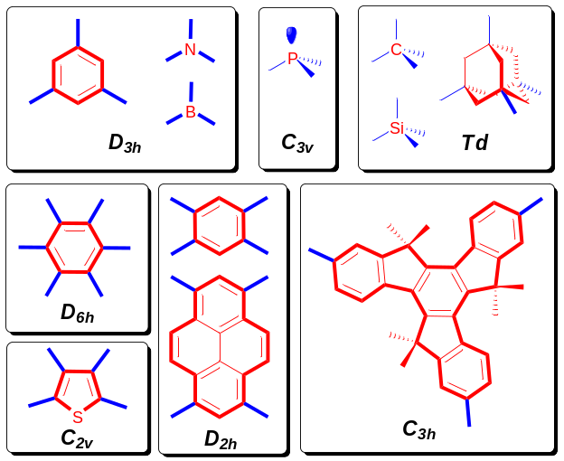

Figure 1. Symmetry of the commonly used core structures.

Some consideration of the symmetry of a single repeat unit within an oligomer might be useful in establishing a generic connection between symmetric star-shaped structures and their linear counterparts. If the symmetry point group of the oligomer repeat unit comprises any rotational symmetry operations with an order greater than two, then applying the latter to the whole linear molecule is the most natural way to switch from a linear conjugated oligomer to a star-shaped system. Applying C₃ or C₆ symmetry (magenta symbols on Figure 2a), which are subgroups of the benzene point group (D_{6h}), to a benzene unit in an oligo-p-phenylene chain creates a star-shaped system with three (Figure 2a, left) or six arms (Figure 2a, right), respectively. If only part of the monomer structure possesses rotational symmetry, not only does the above transformation create a star-shaped oligomeric system, it also generates a new core structure. Thus, applying C₃ symmetry operations to oligofluorene (at the benzene ring with the magenta symbol, Figure 2b) provides two possibilities for creating trigonal oligomers – with benzene (Figure 2b, left) and truxene cores (Figure 2b, right) – depending on which part of the oligomer is subjected to the symmetry operation (red or blue fragments of oligofluorene in Figure 2b). Such generic speciation of 2D systems through simple symmetry operations within linear structures makes benzene and truxene cores the most attractive targets for the synthesis of star-shaped oligofluorenes. Any axial symmetry of the molecule with an order greater than two can impart some electronic structural features, such as degeneracy of the HOMO and LUMO levels which can be exploited in electronic materials applications.

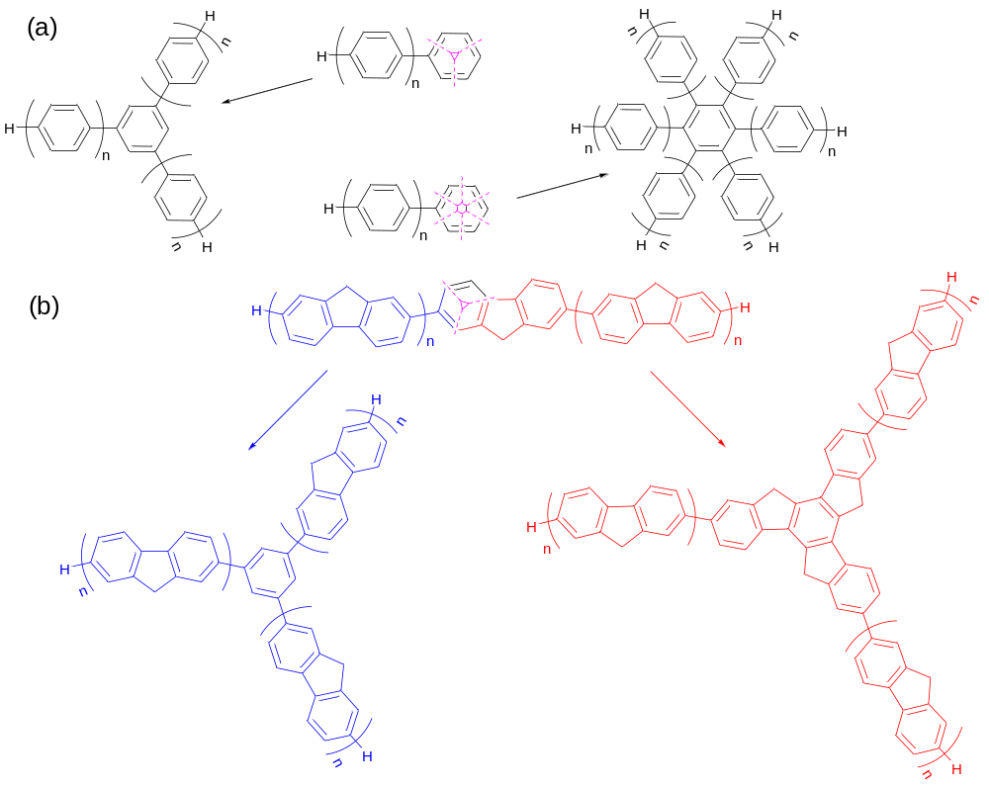

Figure 2. Generating star-shaped architectures by applying axial symmetry operations to linear systems.

Star-shaped systems with four arms and a core symmetry of D_{2h} (depicted in the Figure 1), on the other hand, provide cross-conjugation of the spokes by various pathways through the core that facilitates electronic communication between the arms. Such type of cross-conjugation provides an additional way of tuning the band gap of the materials or increasing the dimensionality of the donor-acceptor interactions.,,
The two basic synthetic strategies towards the design of well-defined, star-shaped systems follow divergent and convergent approaches. Both include synthetic methodologies commonly used in the synthesis of linear π-conjugated oligomers and polymers (i.e. variations of commonly used Pd(0) catalysed coupling reactions) (Figure 3).
The divergent approach (Figure 3, top), uses repetitive procedures, such as the following sequence: (i) coupling the ‘arm’ monomer units to the core ; (ii) terminal functionalisation of the arms; (iii) extension of the arms on the star-shaped core by further aryl-aryl coupling; (iv) terminal functionalisation of the arms; (v) extension of the arms on the star-shaped core by further aryl-aryl coupling; etc, etc. This strategy has an advantage of using a simple monomer building block at every coupling stage. However, for the synthesis of higher oligomers there is an increase in the difficulty of separating the target star-shaped oligomers from partially reacted, “under-derivatised” by-products at each of the reactions steps. This becomes more of a problem as the higher oligomers develop, since the properties of fully and partly substituted products converge with increasing molecular weight.
The convergent strategy (Figure 3, bottom), affords a star-shaped system in one synthetic step by attaching pre-prepared oligomeric arms to the core unit. Synthetically, the protocols for the preparation of derivatised arms of different lengths are the same as those widely used in the synthesis of linear oligomers. The redeeming features of the strategy are: (i) the possibility to create the target star-shaped molecules in one step, by coupling easily accessible linear functionalised oligomers with a suitably functionalised core; and (ii) to use the procedure for core structures that are not stable towards halogenation. For these reasons, the convergent strategy has proved to be the most popular method adopted for the synthesis of star-shaped conjugated architectures.

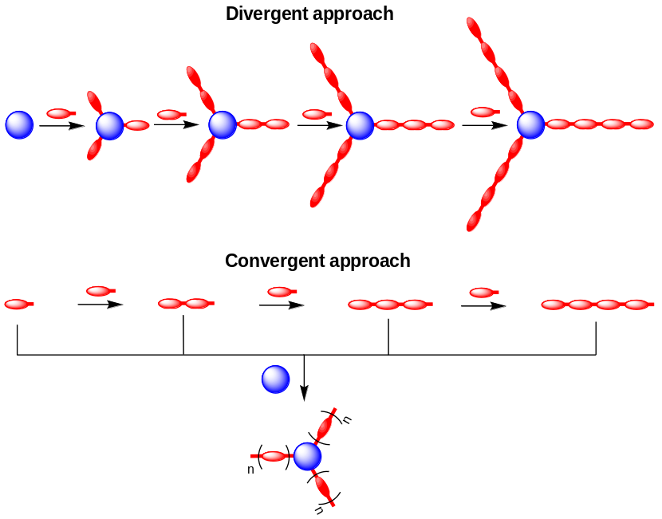

Figure 3. Divergent and convergent approaches for the synthesis of star-shaped oligomers.

Another variant of the convergent strategy involves the creation of the core as a final step, using an appropriately functionalised arm precursor. Figure 4 illustrates some examples of this approach. Within the scheme, (a) reflects numerous examples for constructing a benzene core by using, for example, SiCl₄- or TiCl₄-mediated trimerisation of oligomers with a terminal acetyl functionality to afford star-shaped structures with three arms. The synthesis of star-shaped systems with a benzene core and six arms can be achieved by two methods (b,c). In the first case, scheme (b) depicts the trimerisation of symmetrically substituted acetylenes, catalysed by transition metal complexes (e.g. Co₂(CO)₈). Scheme (c) depicts the synthesis of hexagonal star-shaped systems with a benzene core by Diels-Alder reaction of tetrasubstituted cyclopentadienones with disubstituted acetylenes., It should be noted that this scheme allows the synthesis of six-fold symmetrical structures (D₆) with identical arms, as well as two-fold structures (C₂) using different arms for the acetylene and cyclopentadienone counterparts. This convergent core-creating approach can be used for the design of four-armed and eight-armed star-shaped systems, through the construction of symmetrically substituted porphyrins and phthalocyanines (schemes (d) and (e)).

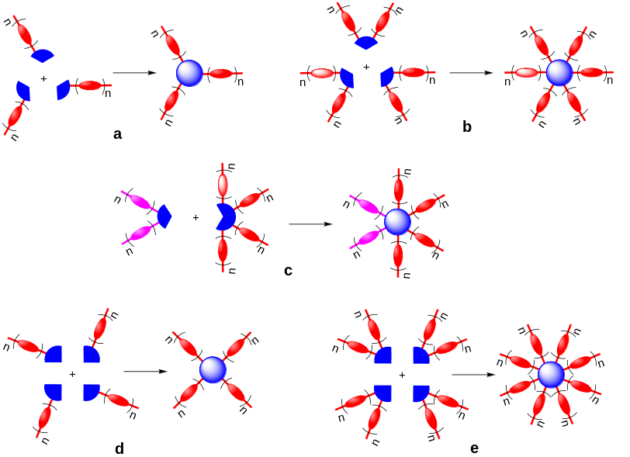

Figure 4. Convergent syntheses of star-shaped architectures with simultaneous formation of the core structure.

3. Oligophenylenes

Using a divergent synthetic approach, Pei and co-workers have synthesised a series of well-defined 2D disk-like star-shaped oligophenylenes (1(n=1-4)) with a truxene core. These nanosized oligomers (d ~ 4.6 nm for 1(n=4)) are amorphous materials and exhibited efficient blue emission in the region of ~350–450 nm (Φ_{PL} = 0.91–0.98, in THF), typical for oligo/polyphenylenes. With an increase in the lengths of the arms, both absorption and emission spectra are red-shifted, showing linear correlations of energies with an inverse number of benzene rings. Due to the long-chain substituents in the core, oligomers are highly soluble in common solvents and (except for the shorter compound 1(n=1)), are amorphous materials showing an increase of T_{g} from 39 to 192 ºC.

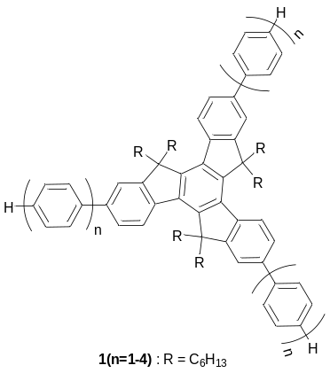

A series of star-shaped oligophenylenes 2a-c have been developed as a new class of efficient hole-blocking amorphous molecular materials for use in OLEDs, as demonstrated for multilayer devices with a molecular or polymer emitting layer and Alq₃ as the electron transporting layer., Possessing a high band gap and low-lying HOMOs they efficiently prevented exciplex formation, often observed between the hole and electron transporting layers. The best performance was achieved for the fluoro-derivative 2b, allowing efficient blue-violet emission from an OLED with different amorphous molecular emitters (λ_{EL} ~ 404 – 422 nm, turn-on voltage 3–4.5 V; external EL efficiency, Φ_{EL}^{ext} = 1.10–1.95%; maximum luminance, L_{max} = 1600–3960 cd m^{–2}).Error: Reference source not found

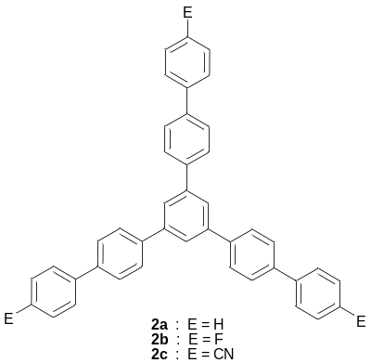

A general synthetic methodology towards perfluorinated star-shaped oligophenylenes 3(n=1,3), 4 has been developed by Suzuki et al. When tested in OLEDs 3(n=3) and 4 gave stable amorphous films and showed good electron-transport properties.

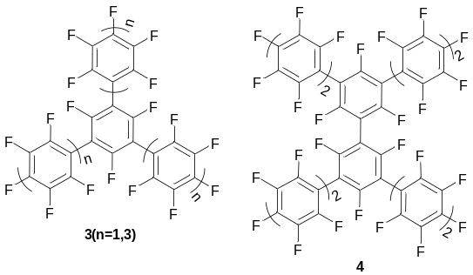

Two amorphous blue-light-emitting 2D cruciforms with end-capped oligophenylenes 5a-b have been reported. While large twisting is observed between the arms and the 1,2,4,5-tetrasubstituted benzene core, these X-shaped structures provide slight improvement in π-electron delocalisation leading to slightly red-shifted emission spectra and a lowering of the oxidation potentials compared to their linear analogues (1,4-phenylene core). The electronic properties can also be altered by the use of end-capping groups [λ_{PL} = 404 nm (5a), 433 nm (5b)].

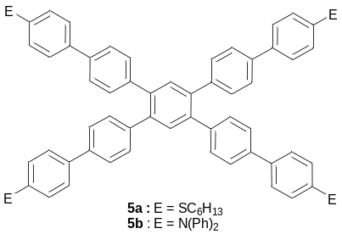

Carbon, nitrogen, silicon and boron atoms have been used as cores to construct star-shaped oligophenylenes. The trigonal arrangement of boranes provides D₃ and C₃ symmetries for the 2D conjugated geometries of 6(n=1) and 6(n=2), respectively. The two propeller-like oligophenylenes 6(n=1-2), possessing electron deficient boron cores, are capable of binding to metal ions such as Zn(II) via the 2,2’-dipyridylamino chelating end-cap sites. The structures have been designed as three-coordinate, blue-emissive materials for application as fluorescent sensors for metal ions, or metal-modified nonlinear optical materials. Whilst the absorption spectra of these molecules are solvent independent, the photoluminescence spectra demonstrate red shifts with increasing solvent polarity (by ~30–40 and ~70–80 nm, for 6(n=1) and 6(n=2), respectively), indicating intramolecular charge transfer character in the excited state.,
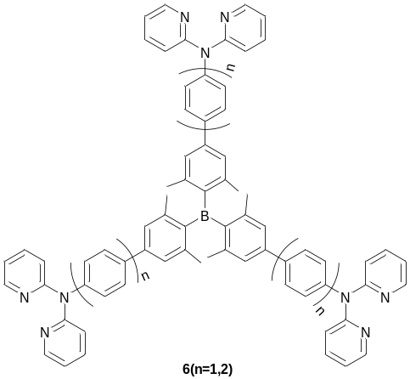

The situation is somewhat different when a nitrogen atom is used as a core, resulting in an intermediate geometry of conjugation between 2D and 3D states. Although the nitrogen atom in triarylamines is formally in an sp³ hybrid state, they have a near-planar configuration, as confirmed by X-ray single crystal diffraction and gas-phase electron diffraction data, with the N atom being out of plane from the three adjacent carbons by only 0.08 Å., The geometry is due to a combination of steric repulsion between the phenyl groups adjacent to the nitrogen core and a degree of conjugation between the nitrogen lone pair and the π-electrons of the phenyl arms. A Suzuki coupling protocol was used for building up star-shaped oligophenylenes with a central nitrogen atom 7(n=2-3). Similar to other triarylamines (which are strong electron donors), compounds 7(n=2-3) are easily oxidised, as can be seen in cyclic voltammetry (CV) experiments, generating radical cations in the first step at low potentials (~0.25–0.30 V vs Fc/Fc⁺). Further oxidation results in electropolymerisation through the diphenylamino end-caps to form 3D cross-linked films of the polymers with star-shaped conjugated fragments in their structures. These polymers have been studied as electrochromic materials and hole-injection layers in OLEDs. Non-end-capped tris(p-terphenyl-4-yl)amine has also been used as an amorphous, thermally stable blue-emitter in OLEDs (λ_{EL} = 435 nm), demonstrating a device efficiency Φ_{EL}^{ext} = 0.4% and maximum luminance L_{max} = 350 cd cm^{–2} (at 14 V).

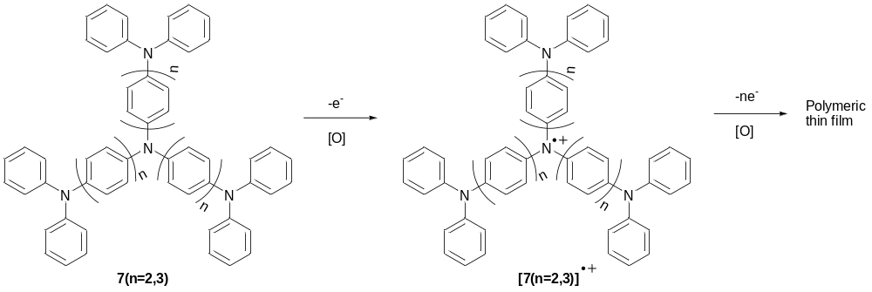

The tetrahedral configuration of sp³ hybridized carbon or silicon atoms allows their use as cores for the design of star-shaped, rigid-rod conjugated oligomers with increased 3D dimensionality. 3D oligomers 8a(n=1-2), 8b(n=1) end-capped with solubilising dihexylfluorenyl groups are amorphous, high band gap materials (E_{g} ≈ 3.5 eV), which emit relatively pure blue light with small FWHM (~55–75 nm). They are less prone to self-aggregation in the solid state, which is often observed in linear oligomers and polymers, and Φ_{PL} for 8a(n=1-2) is extremely high in solution and solid state samples (100% and 96–98%, respectively), with no signature of excimer-like emission.

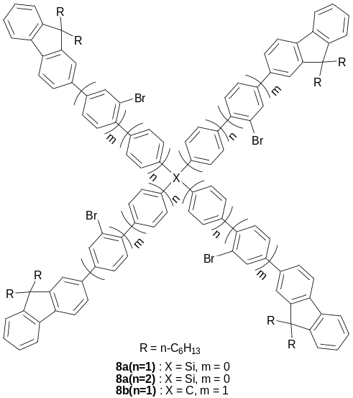

The tetrahedral configuration of the core in such oligomers and the rigid structure of the arms provide nanosized molecules of precisely controlled shape and size in 3D. Cai and co-workers described the convergent synthesis of unsymmetrical tripod-shaped oligophenylenes 9a-c end-capped with three functional groups for covalently anchoring onto an hydrogen-terminated silicon surface via hydrosilylation (Figure 5). The approach is based on the earlier concept of Tour and Shea, who proposed to use such types of tetrahedral conjugated systems for the modification of scanning probe microscope (SPM) tips through the relatively weak S-metal bonds, and designed adsorbates 9a-c to allow stronger covalent anchoring onto hydrogen-terminated silicon surfaces.

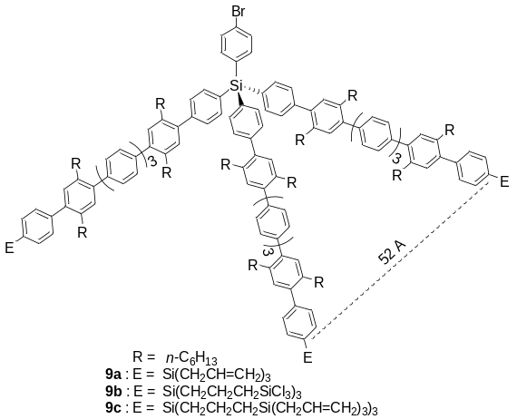

Figure 5. Mode of anchoring of 3D star-shaped oligophenylenes terminated with surface active groups on the surface. Reproduced with permission from Ref. [61]

Amorphous films of blue-emitting spiro-like oligophenylenes 10a(n=1,2) demonstrated lasing properties: narrowing of their PL emission spectra with an increase of pump power (picosecond pulses at 337 nm), and a dramatic collapse of the emission linewidth down to 2.2–2.9 nm was observed and attributed to amplified spontaneous emission (ASE)., The spectral narrowing is associated with more intense vibronic bands in their PL spectra, i.e. a 0-0 transition for 10a(n=1) and a 0-1 transition for 10a(n=2) (Fig. 6).

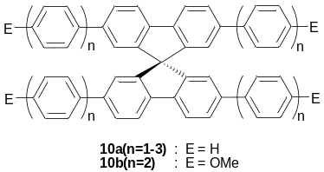

(a)
(b)

Figure 6 Comparison of the photoluminescence spectra of (a) 10a(n=1) and (b) 10a(n=2) in films at different excitation intensities, normalized to the maximum of each spectrum. Reproduced with permission from Ref. [Error: Reference source not found].

2,2’:6’,2’’-Terpyridines attached to π-conjugated systems through the 4’ position are known to present interesting photophysical and electrochemical properties, and remarkably high binding affinity toward most transition metals. These features make terpyridine conjugates attractive building blocks for the construction of supramolecular assemblies.,, Very recently Sakamoto and co-workers reported the synthesis of three star-shaped oligophenylenes of different molecular symmetry derived from various substitution patterns at the core: D_{3h} (11a), D_{6h} (11b) and T_{d} (11c). The compounds were end-capped with terpyridine units for the construction of 2D and 3D co-ordinating polymer networks through complexation with metals.

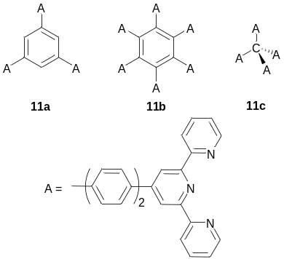

4. Oligophenylenevinylenes

Star-shaped oligophenylenevinylenes (OPV) 12 contain a methylium ion (i.e. a sp² hybridised carbon atom) as the common attachment, which represents the simplest star-shaped 2D core possible. These tri(OPV)methylium cations 12 have been generated in strong acid media from the parent tri(OPV)methyl carbinol 13. Wittig –Horner methodology has been applied for creating both OPV carbaldehyde arm precursors 14(n=0-3) and attaching them to the core – triphenylmethane triphosphonate 15 (Scheme 1). During this latter step, the triphenylmethane’s C–H bond was spontaneously oxidised in air to the carbinol C–OH functionality. Further treatment with trifluoromethansulfonic acid generated carbocations 12 quantitatively and the tetrafluoroborate salts have been precipitated and isolated after adding HBF₄ acid in acetic anhydride.
Whilst carbinols 13 absorbed light in the UV-Vis region (λ_{abs} = 333 → 403 nm for n = 1 → 4), strong ICT from the arms to the core in 12 was observed, leading to bathochromic shifts in absorption spectra down to the NIR region of the spectrum (λ_{abs} = 746 → 864 nm for n = 1 → 4). Using an empirical exponential for the λ(n) values, Meier et al. estimated the convergence limits, λ_{max}^{n=∞}, at 415 and 879 nm, for 13 and 12 respectively. This gave the conjugation length for both series at ~8, which is smaller than that for linear OPV (10–11).Error: Reference source not found

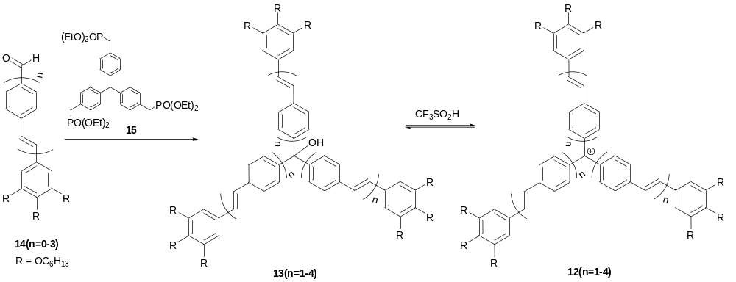

Scheme 1. Synthesis of oligophenylenes with a carbocation core.

The same strategy was recently used in the synthesis of star-shaped OPV 16 with triphenylcarbinol as a core and bis(2-hexyloctyl)amino end-caps. Depending on the length of the arms, protonation of 16(n=1-3) yielded different products and intermediates. The shorter compound 16(n=1) gave an intermediate carbocation 17(n=1) with characteristic absorption in the NIR region at λ_{max}=1100 nm, preceding successive three-fold protonation of the dialkylamino groups and the formation of 17(n=1)·3[H⁺]. Protonation of 16(n=2,3) primarily occurs first on the terminal dialkylaminogroups to form the corresponding trication 16(n=2,3)·3[H⁺] before the formation of 17(n=2,3)·3[H⁺]. The absorption maxima of carbocations protonated at the amino group end-caps 17(n=1-3)·3[H⁺] lie in the Vis-NIR region with λ_{max} =622, 740 and 790 nm, respectively (calculated convergence limit for n= ∞ is λ_{max}^{n=∞} = 827 nm).

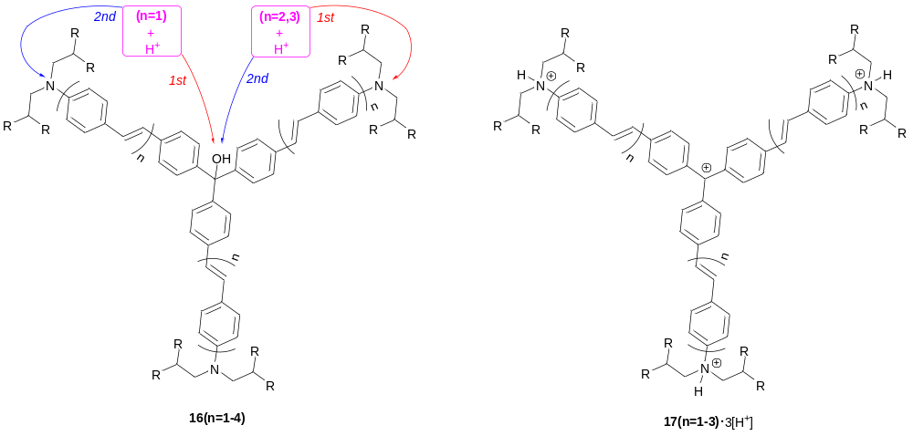

Meier et al. synthesised star shaped OPVs with an electron-deficient triazine core 18a,b. Oligomers 18a(n=1-4) showed systematic bathochromic shifts with an increase in the number of repeating phenylenevinylene units in the arms, giving an extrapolated effective conjugation length of ~7,Error: Reference source not found which is close to that determined for star-shaped OPV 12 and 13 (~8).Error: Reference source not found

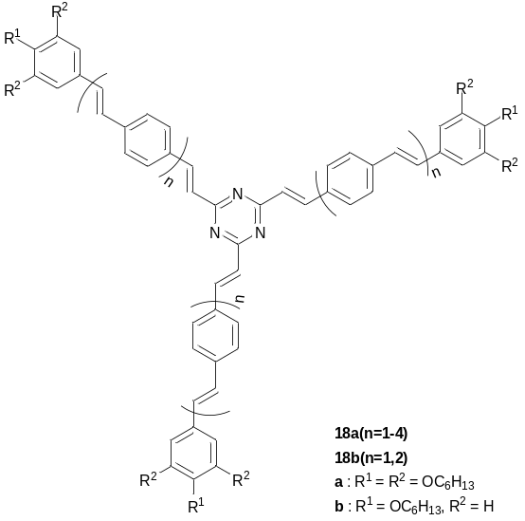

There is much interest in the development of organic materials for non-linear optics (NLO), particularly materials exhibiting large two-photon absorption (TPA) cross sections (δ_{TPA}), for a wide range of applications, e.g. fluorescence imaging of biological samples, optical power limiting, photodynamic therapy, 3D optical data storage and microfabrication. One of the most extensively investigated structural motifs in these studies is the donor–π–acceptor (D–π–A) dipole.,, Octupolar molecules combining a star-shaped, three-branched structure with dipolar donor-acceptor (D–A) branches attract much recent attention as materials with high NLO responses and possible applications in optical and optoelectronic devices.,, The donor-acceptor conjugate can exist between the arm and the core or between an end-capping functionality and the core with the arm acting as a π-bridge. An advantage of such structrures over conventional linear D–A systems is that the second order harmonic response of octupoles does not depend on the polarisation of the incident light. Triphenylamine, as a strong donor, is widely exploited as a core unit in the design of 1D linear D–π–A dipolar and 2D octupolar NLO-phores. Below, we present several examples of 2D star-shaped oligomers based on a triphenylamine core and phenylenevinylene arms. This family of materials has substantial octupolar character and possesses NLO activity (particularly two-photon absorption, TPA) when the arms have an acceptor character, due to the incorporation of electron-withdrawing groups within the chain or functionalisation with electron-deficient end-caps.
The polar star-shaped conjugate 19(n=2) bearing electron-deficient rings in the caps showed a significant solvatochromic effect in emission spectra (λ_{PL} = 528 nm (CHCl₃), 582 nm (DMF)), resulting in an increase in the Stokes shift with increasing polarity of the solvent. This behaviour indicates a higher polarity of the excited state compared to the ground state. The compound has been found to be an effective two-photon initiator for photopolymerisation. Both 19(n=1) and 19(n=2) are good TPA chromophores: the TPA cross-section is increased with an increase in the length of the conjugated arms; this correlation was determined from two-photon excited fluorescence (TPEF) (δ_{TPA} = 370 and 1037 GM, for n = 1 and 2, respectively) and non-degenerate TPA experiments (δ_{TPA} = 187 and 812 GM) providing values much higher than those obtained from theoretical calculations (δ_{TPA} = 42.4 GM for 19(n=2).Error: Reference source not found

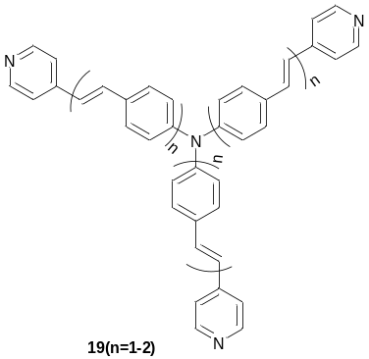

A number of acceptor fragments have been introduced into the arms of the star-shaped OPVs 20, 21, and 22 using Knoevenagel condensation, Wittig – Horner reaction or Heck coupling. Similar to the compounds above, the values for the TPA cross-section increase with extension of the conjugation length (cf. 20a(n=0) and 21a(n=1)), and are affected by the nature of the substituent X and the end-capping groups, reaching the highest maximum value of δ_{TPA} = 1360 GM for conjugate 22d(n=1).

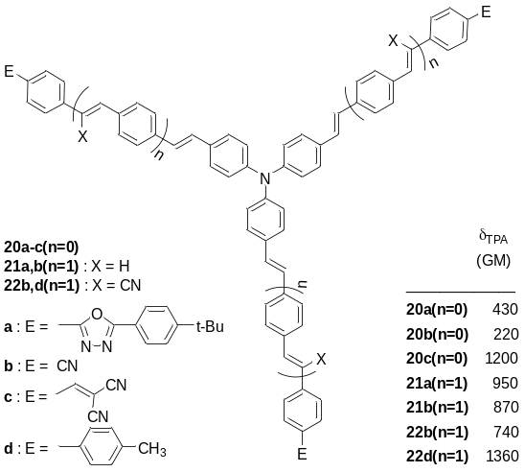

An interesting example of an octupolar donor-acceptor system is 23a, which was designed and compared with its analogues possessing only one or two arms (23b, 23c). The two-photon cross-section was measured by TPEF, showing a much higher δ_{TPA} value for the trigonal star-shaped structure 23a than those for the less-substituted conjugates 23b and 23c (5030, 3130 and 1370 GM, respectively). Similar regularities of substitution pattern on δ_{TPA} values have also been observed for other triphenylamine-based NLO-phores.Error: Reference source not found

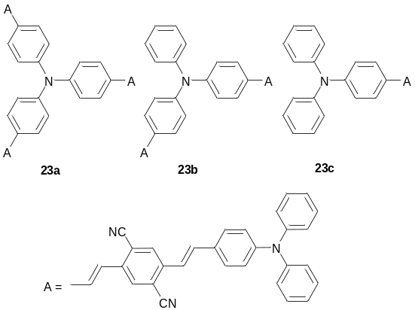

A series of star shaped OPVs with a benzene core (24), functionalised at the terminal positions of the arms with donor or acceptor groups has been prepared by Wittig – Horner reaction. The materials showed significant solvatochromic behaviour in absorption and, even more so, in emission spectra. This indicates that multidimensional ICT takes place between the centre and the periphery of the molecules. Enhancing ICT by the application of strong acceptor (or donor) end-groups and increasing the distance between the core and the periphery lead to an increase of molecular nonlinearities. This strategy achieved high hyperpolarizability for 24e(n=2), whilst maintaining wide transparency in the visible region, thus presenting superior transparency-nonlinearity tradeoff (||β|| = 810×10–30 esu for λ_{max} = 377 nm).

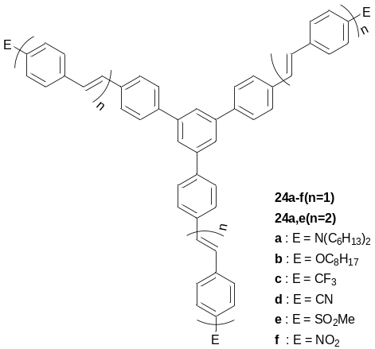

A large TPA cross-section was observed for a star-shaped OPV terminated with electron-donating groups attached to a benzene core containing three electron-withdrawing cyano groups, 25a-d (δ_{TPA} = 143 – 2620 GM). The best values have been achieved for compounds containing oligomers end-capped with a diphenylamino group, with very close TPA responses for shorter and longer oligomers (have been (δ_{TPA} = 2480 and 2620 GM, for 25i(n=1) and 25i(n=2), respectively).

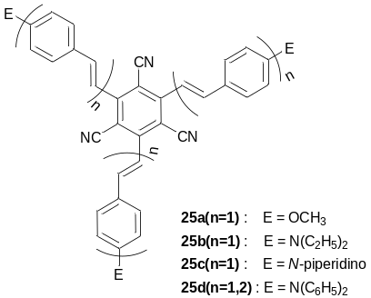

Using a convergent strategy, a series of cross-conjugated, X-shaped OPVs with a benzene core has been designed, affording conjugates of different symmetry. Within this series, two compounds have four identical arms (26a, 26b), and there are three variations of substitution patterns using two different arms (26c, 26d, 26e). The oligomer 26a with four OPV arms showed no indication of strong π–π stacking, while the oxadiazole and cyano-containing molecules 26b-d all have some degree of π–π interactions. Oligomers 26b-d show nearly identical photophysical properties and HOMO-LUMO energy levels, suggesting a similar charge delocalisation mechanism. However, their different substitution patterns greatly affect their morphology (Figure 7). OLEDs fabricated from these oligomers showed the best performance for 26c (Φ_{EL}^{ext} = 0.46% versus 0.28% and 0.10% for 26d and 26e), films of which seems to be more ordered, resembling chevron-type textures commonly seen in smectic liquid crystals (Figure 7). Charge-transport calculations for these systems indicate that high charge carrier mobilities can be achieved for transport along π–π stacks of oligomers at small mutual twist angles.

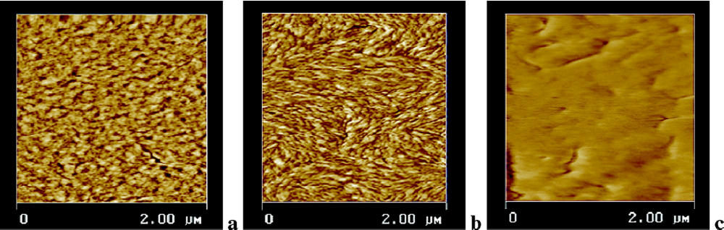

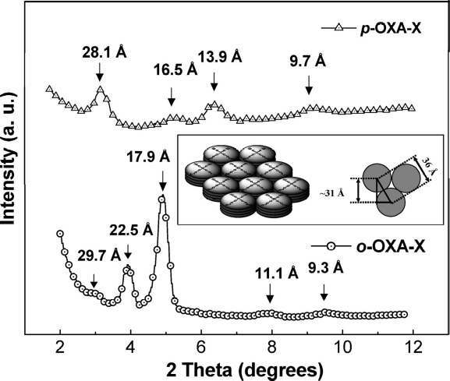d e
Figure 7. Atomic force microscopy (AFM) phase images of (a) 26d, (b) 26c, and (c) 26e. (d) Small-angle X-ray scattering (SAXS) pattern for 26c and 26d powder samples (intensities shown are on a log scale. Inset shows a simplified diagram of intercolumnar packing of 26c). (e) Wide-angle X-ray diffraction (WAXD) pattern for 26c and 26d powder samples. o-OXA-X = 26c, p-OXA-X 26d. Reproduced with permission from Ref. [Error: Reference source not found].

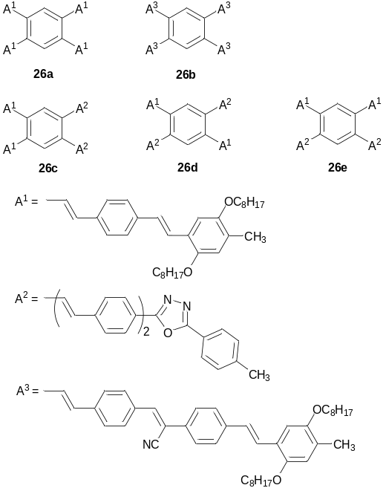

Meijer’s group synthesised six-armed star-shaped oligophenylenevinylenes bearing chiral alkyl groups (27) with a benzene core. The compounds were prepared by cyclotrimerisation of the corresponding disubstituted acetylenes in the presence of Co₂(CO)₈ as a catalyst. The products exhibited a pronounced tendency to form intermolecular columnar assemblies upon cooling of the melt, showing under polarised optical microscopy fan-shape domains, the size of which increased with decreasing cooling rates. Studying solutions in low-polarity solvents by CD spectroscopy revealed a bisignated Cotton effect. The spectrum featured a positive sign at long wavelengths and a negative sign at short wavelengths with a zero-crossing at 421 nm, indicating self assembly of the molecules into right-handed helical aggregates. AFM in tapping mode showed long fibrils (a few µm) with a constant diameter of 6 nm (Figure 8a). Remarkably, at places where the fibrils are densely packed, they leave the surface and form a supercoiled organisation with a right-handed helix (Figure 8b). On HOPG, fibrils are shorter and tend to orient along the 3-fold symmetry of HOPG (Figure 8d). An STM image of oligomer 27 shows six-armed stars, which assemble into a hexagonal lattice with identical unit cell vectors a and b of 5.56 nm (Figure 8b). Combining these data with wide-angle X-ray scattering experiments, a helical columnar packing has been proposed as shown in Figure 9 (for a recent review on helical self-assembled nanofibers of conjugated oligomers see Ref. []).

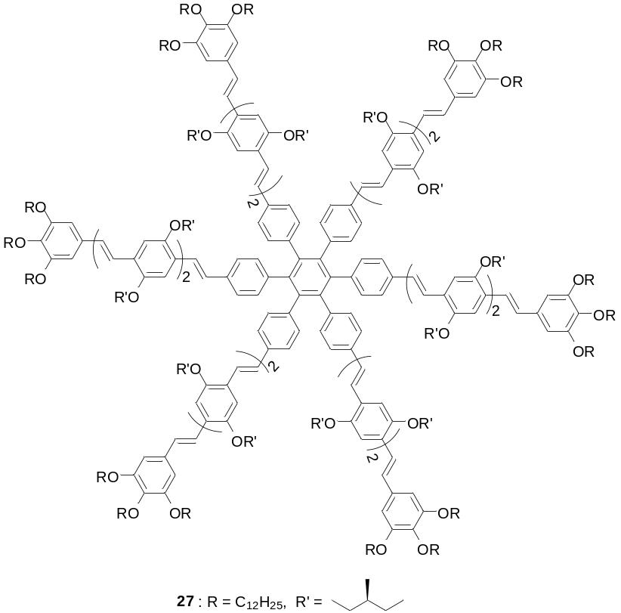

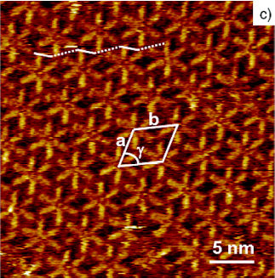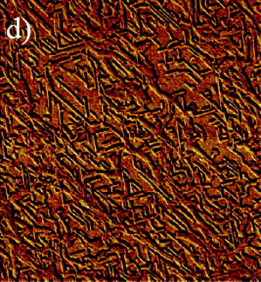
Figure8. AFM tapping mode phase images of 27 deposited from heptane solutions (1.1 × 10^{–5} M ) on silicon wafer: (a) scan size = 500 nm), (b) scan size = 200 nm and (d) on HOPG (scan size = 1 µm). (c) STM image of 27 at the 1-phenyloctane-HOPG interface. The unit cell is indicated. The longer dashed and shorter solid white lines connect the terminal phenyl groups of similarly oriented OPV units along unit cell vector b. Reproduced with permission from Ref. [Error: Reference source not found].

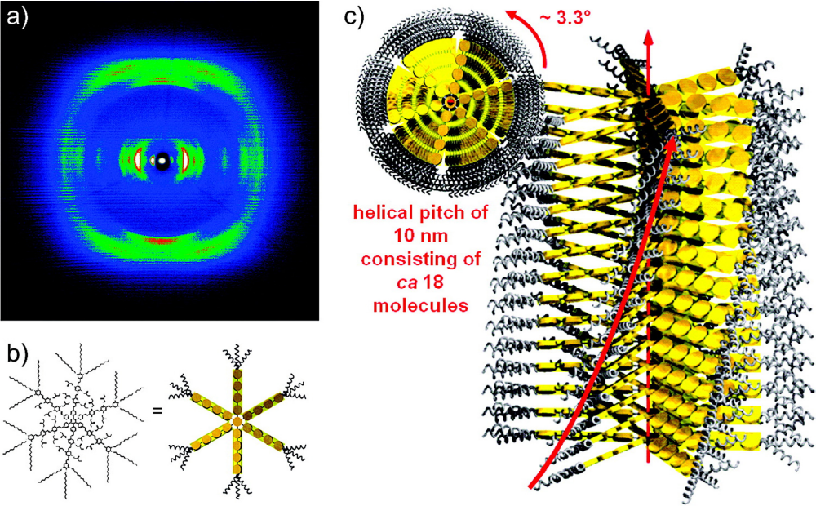
Figure 9. 2D-WAXS pattern recorded at 30 °C of 27 prepared as an extruded filament, (b) schematic representation of 27, and (c) schematic illustration of the helical columnar packing based on X-ray, CD and AFM data. Reproduced with permission from Ref. [Error: Reference source not found].

Self-assembly of star-shaped systems 28a-c, in which the OPV arms are attached to the central benzene core by means of a flexible amide linkage, have been studied in both methylcyclohexane (MCH) solution and on a solid-state surface. In the case of the star-shaped oligomer 28c, with a diamidobipyridine linkage between the core and the arms, aggregates formed in solution exhibit little chirality and remain present over a wide temperature interval. However, in the solid, completely disordered structures exist probably due to different types of π-π stacking interactions. Oligomer 28a (the only system with core–NH-CO–arm links), in MCH solution formed the most ordered system in the series and a chiral structure that was stable below 50ºC. In this case, a clear bisignated Cotton effect was observed with a positive sign at high wavelengths and a negative sign at low wavelengths.

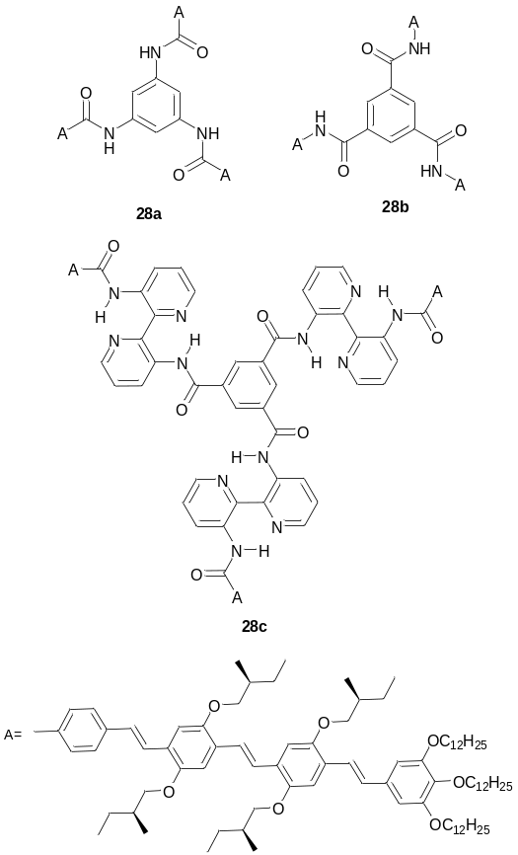

Another strong aggregation in star-shaped OPVs was demonstrated for oligomers 29a,b bearing a porphyrin core. Compound 29a drop-cast from water formed extended nanofibres of chiral aggregates with a height of 3.5 nm (Figure 10a), which at elevated temperature were converted to achiral aggregates as evidenced by changes in CD spectra. Mixed face-to-face aggregates 29a – 29b resulted in the formation of chiral face-to-face co-aggregates, which showed efficient energy transfer from the OPV arm, via the Zn porphyrin, to the free-base porphyrin. This was observed as a decrease of emission intensity (623 nm) for 29b and an increase in emission intensity (666 nm) of 29a. The PL of 29a and 29b were effectively quenched on their mixtures with C₆₀ in water, proving that a new type of aggregation was achieved; an alternate stacked structure (Figure 10b) has been proposed.

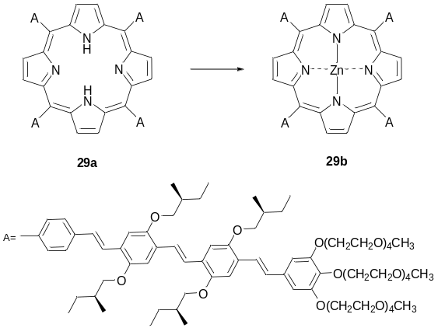

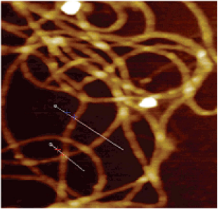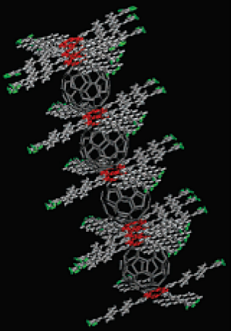

(a) (b)
Figure 10. (a) Tapping mode AFM image showing fibres of 29a, drop-cast from water (10^{–5} M) onto a MICA surface (420 nm × 420 nm). (b) Proposed mode of co-aggregation of 29a with C₆₀. Reproduced with permission from Ref. [Error: Reference source not found].

A series of Zn-phthalocyanines with eight OPV arms (30a-d) has been reported by Kimura et al. The introduction of an OPV arm at the β-positions of the Zn-phthalocyanines induced red shifts of the Q-band (e.g. λ_{abs} = 762 nm for 30c versus 678 nm for 30a) and for emission maxima (λ_{PL} = 773 nm for 30c versus 747 nm for 30b). The oligomer with longer (hexyl) chains in the terminal positions of the arms (30d) formed a discotic liquid crystalline phase. The material self-organises spontaneously into one-dimensional columnar assemblies (Figure 11), with a d-spacing of 0.35 nm and in a hexagonal arrangement, through intermolecular π-π stacking and van der Waals interactions, as evidenced by temperature-controlled XRD. The formation of columnar aggregates in films is also accompanied by spectral changes of both Q-band and π–π* transitions, and it is assumed that the interactions exist not only between the phthalocyanine cores but also between the OPV arms within the stacks (see also).

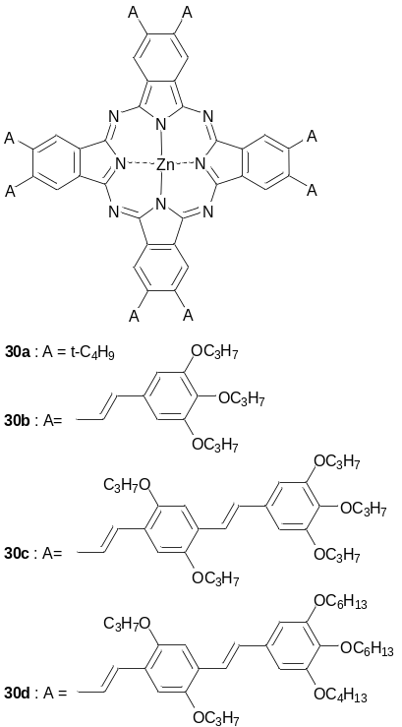

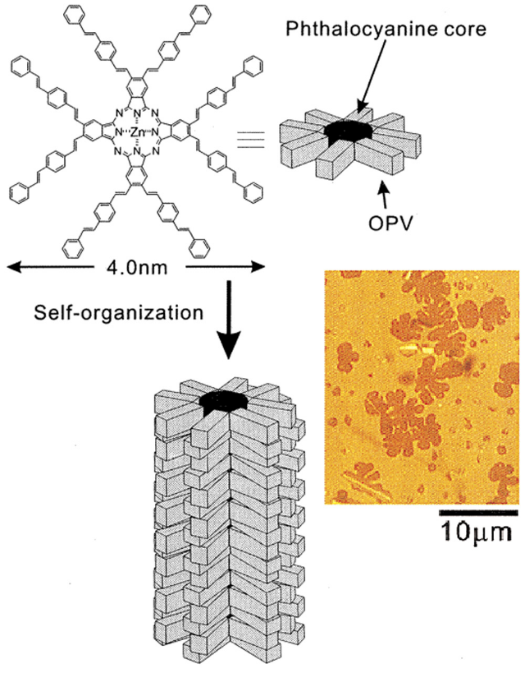
Figure 11. Digitated stars under an uncrossed polarised microscope when the isotropic liquid of 30d is cooled slowly and the schematic representation of the columnar aggregate of 30d in the liquid-crystalline state. Reproduced with permission from Ref. [Error: Reference source not found].

A series of star OPVs with a central sp³-carbon atom (31a-f),, silicon (32) and adamantane (33) tetrahedral coresError: Reference source not found has been reported. DSC measurements reveal some crystallinity for 31a and 32. In contrast to their linear arm analogues, all other star-shaped systems show amorphous behaviour (after the first heating cycle), with T_{g} in the range 142–230 ºC. In spite of their amorphous nature, all of the tetrahedral star-shaped OPVs exhibit a bathochromic shift of emission maxima in films compared to solution-state spectra. After annealing, the spectra shift even more to the red and this indicates possible interdigitation of the arms in the solid, leading to excimer formation. The only compounds with almost identical emission spectra in solution and in the solid-state are 31e and 31f. The extra phenyl ring clearly hinders interdigitation and prevents excimer formation.

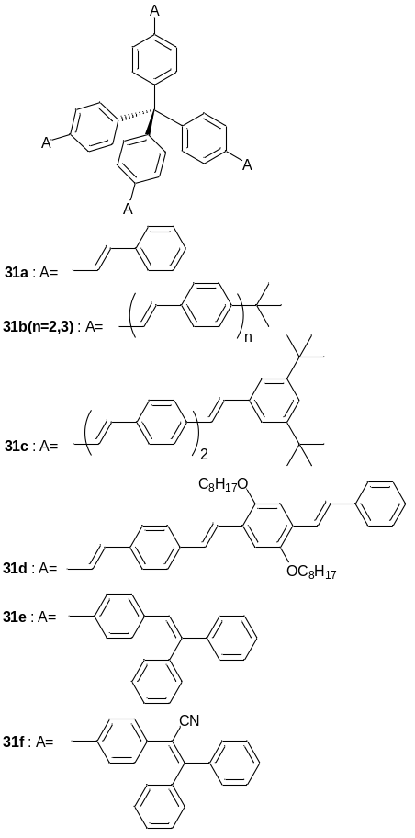

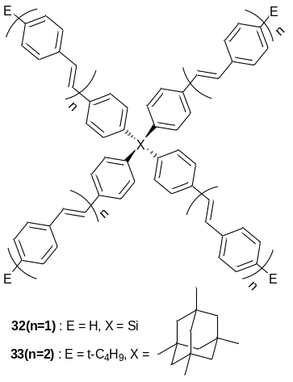

The pyramidal star-shaped OPV system with a phosphorus core 34b was obtained by the reduction of the corresponding phosphorus oxide 34a. The properties of this compound have been compared with analogous structures consisting of a tetrahedral carbon (sp³) core (35) and a trigonal nitrogen core (36). The difference in fluorescence anisotropy decays between 34b and 35, 36 in time-resolved experiments indicated a breaking in symmetry and an appearance of the dipole moment which is consistent with a pyramidal structure of the phosphorus-based OPV.

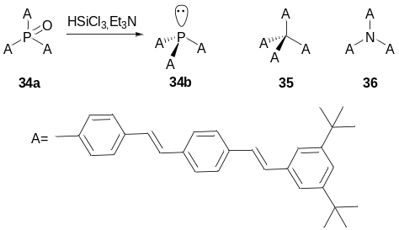

5. Oligophenyleneethynylenes.

In a series of multipolar star-shaped conjugates, based on a trigonal boron atom as an electron-deficient core and phenyleneethynylene arms, 37, strong electron-donating end-capping groups result in pronounced positive solvatochromism in emission (e.g. for 37b: λ_{PL} = 457 nm (benzene), 530 nm (DMF)) with a decrease of Φ_{PL} values. Interestingly, an increase in the length of the arm has no effect on the emission wavelength (λ_{PL} (THF) = 415 nm for both 37a and 37e)

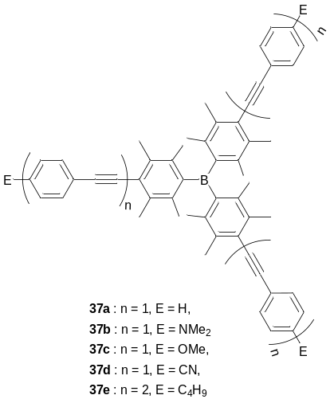

Compounds 38(n=1,2) represent an alternative type of D–A octupolar conjugate, having an electron-donating core and electron-deficient terminal groups on the arms.Error: Reference source not found Several examples of comparable architectures with OPV arms have been considered in section 4. Similar to their analogues, 19, conjugates 38 showed nonlinear optical properties, but the TPA cross-sections (δ_{TPA} = 91 and 280 GM, for 38(n=1) and 38(n=2)) were ca. 4 times lower than those for the corresponding OPV conjugates 19.

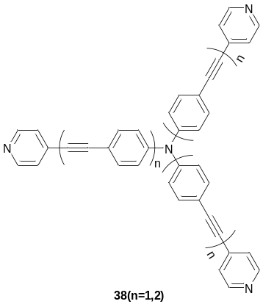

Star-shaped oligomers with a nitrogen core and phenyleneethynylene or hybrid phenyleneethynylene / phenylenevinylene arms have been prepared with different substituents at the terminal position of the arms (39a-c, 40a,b). Similar to other octupolar propeller-shaped fluorophores, they possessed positive solvatochromism and molecular nonlinearity. In both sets of compounds, the highest TPA value was obtained from the compound with the longest arm and the strongest electron-withdrawing terminal group, 40b (λ_{PL} = 473 nm (toluene), 542 nm (CHCl₃); δ_{TPA} = 1080 GM at 740 nm, – cf. 30 GM for 39c).

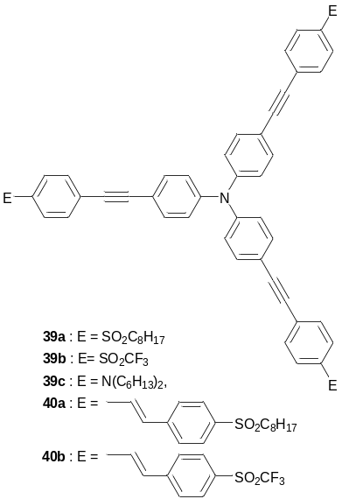

Compound 41 is another type of hybrid phenyleneethynylene / phenylenevinylene star-shaped oligomer, but in this case the terminal groups consist of terpyridine units. The material is attractive for its high fluorescence quantum yield (0.59), and for studying its complexation with metals and subsequent design of supramolecular assemblies. Several other terpyridine end-capped oligophenylenes (11a-c) of different shape have already been discussed.

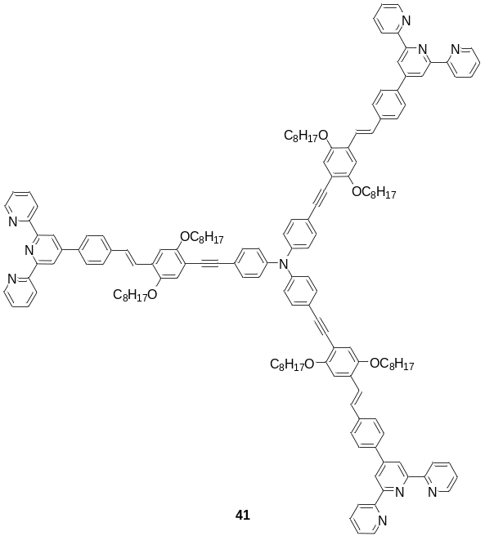

Rodríguez and Tejedor described the synthesis of a series of dimethylaminonaphthyl end-capped star-shaped oligophenyleneethynylenes (OPE) 42 and their 1,5-naphthylene analogues 43. The preparation of these compounds followed a convergent Sonogoshira coupling protocol. It has been shown that the emission wavelength of oligomers 42(n=1,2) and 43(n=1,2) is almost unaffected by the structure and the length of the arms, remaining at 527–531 nm (in CH₂Cl₂), but showed anomalously large Stokes shifts of 160–178 nm (1.01–1.18 eV).

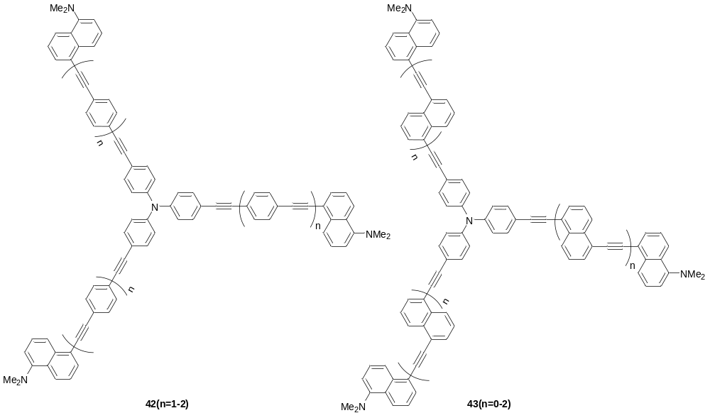

In contrast, star-shaped OPEs 44(n=0-2) showed more typical trends in photophysical properties with increasing lengths of the arms, i.e. an increase in Φ_{PL} = (0.16, 0.48, 0.80), and bathochromic shifts in both absorption maxima (λ_{abs} = 308, 351, 366 nm) and emission maxima (λ_{PL} = 353, 356, 377 nm) for n = 0 →1 → 2, respectively, with moderate Stokes shifts.

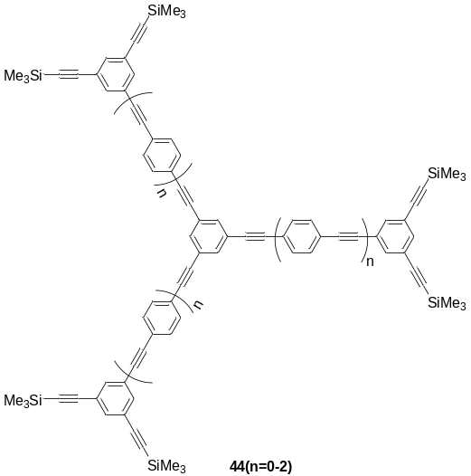

The “snowflake-like dendrimer” 45a.b, a trigonal star-shaped OPE with lateral bulky aryl substituents at phenylene junctions within the arms, was designed for creating a specific microenvironment to provide encapsulation of the π-conjugated arms which function as electron-transporting channels. Such an encapsulation provides an isolation of the arms from intramolecular interactions. The authors mentioned that it is difficult to synthesise such dendrimers by means of the simple application of divergent and/or convergent procedures. Instead, they applied site-selective synthesis of the dendrons, where an attachment of the encapsulating dendritic branches and an extension of phenylethynyl units were alternatively manipulated on the structure of 4-(Et₂N₃)-2,6-Br₂-substituted diphenylacetylene using a combination of Suzuki and Sonogashira cross-coupling reactions. The UV absorption in THF features three maxima for 45b (292, 342 and 362 nm) and for 45a (287, 370 and 392 nm), with the shortest band being mainly attributed to the dendritic cone structure. The dendrimers emitted blue light (around 410 nm) with high Φ_{PL} (0.5 for 45b and 0.7–0.8 for 45a).

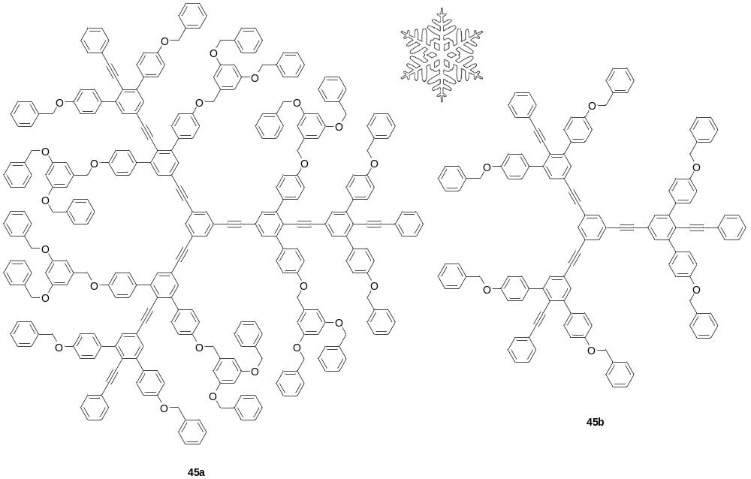
The hybrid multichromophore structures 46a,b, comprising aryleneethynylene light harvesting antennas surrounding a central hexaphenylbenzene core also feature a porphyrin-fullerene donor-acceptor unit. The material has been designed as a functional mimic of photosynthetic antenna-reaction-centre complexes. They demonstrate efficient light-harvesting by five aryleneethynylene antenna arms (at 430–480 nm), followed by surprisingly rapid (a few picoseconds) and efficient (with a quantum yield close to unity) singlet Förster energy transfer to the porphyrin. Once the excitation energy reaches the porphyrin unit of 46a,b, it forms the charge-separated state P^{•+}–C₆₀• through photoinduced electron transfer (the process of charge separation is slower and 46b gives higher quantum yields compared to 46a, 96% and 80%, respectively). The measured rates of charge recombination were 8.9 ns for 46a and 15.3 ns for 46b.

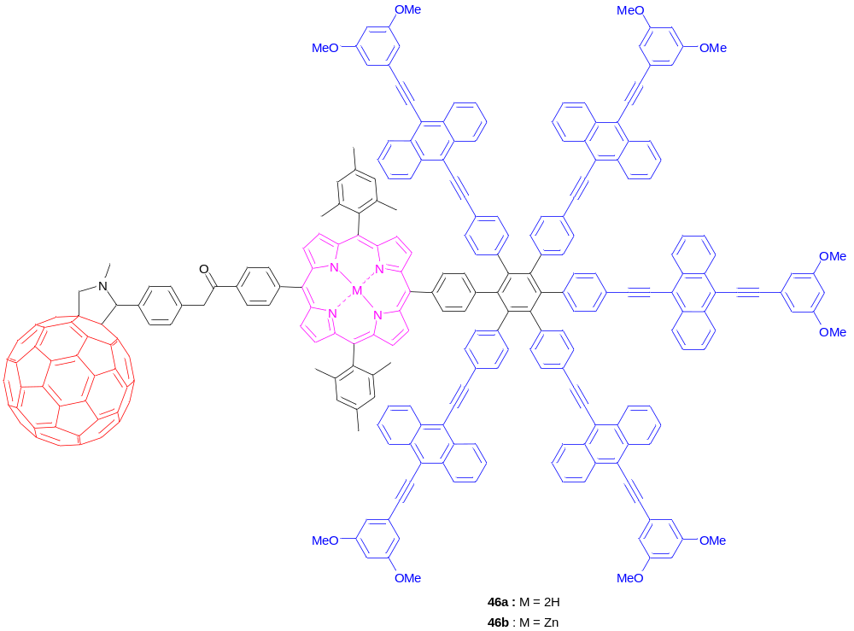

In the section on oligophenylenes, we described some examples of tripod-shaped conjugated structures (9a-c). The compounds were based on tetrahedral carbon or silicon cores, end-capped with functional groups, and have been designed for anchoring to surfaces, e.g. for modification of SPM tips. Tetrahedral conjugates with a central sp³ carbon atom (47) or adamantane (48) and phenyleneethynylene fragments in the arms represent another example of such types of anchoring molecules, which can be used in AFM applications., Among four [1,2,5]-diazepane terminal groups, three termini are intended for eventual binding to a gold-coated conventional AFM tip, whilst the fourth terminus scans the sample.

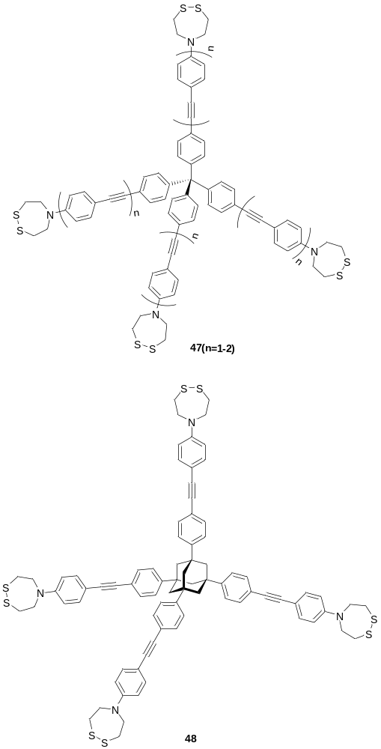

6. Oligofluorenes

Over the past decade or so, linear polyfluorenes have emerged as leading electroluminescent materials with bright blue emission, high charge carrier mobilities, reasonably good electrochemical, photo and environmental stability, and interesting morphological properties.,,,, Possessing high quantum yields for both photo- and electroluminescence, fluorene building blocks are widely used in the design of conjugated copolymers with tunable optical and redox properties. Many linear oligofluorenes have been synthesised and studied as model compounds to gain a deeper insight into the photophysics and electronic processes in fluorene polymers.,,,,, Therefore, it is not surprising that linear oligofluorene sub-units have attracted much attention as conjugated arms in the construction of star-shaped oligomers for electronic and photonic applications. Several series of star-shaped oligofluorenes with 1 to 4 fluorene units in the arms and various cores have been synthesised, e.g. 2D architectures with three, four, and six arms, spiro-type oligofluorenes, and 3D architectures with a tetrahedral core.

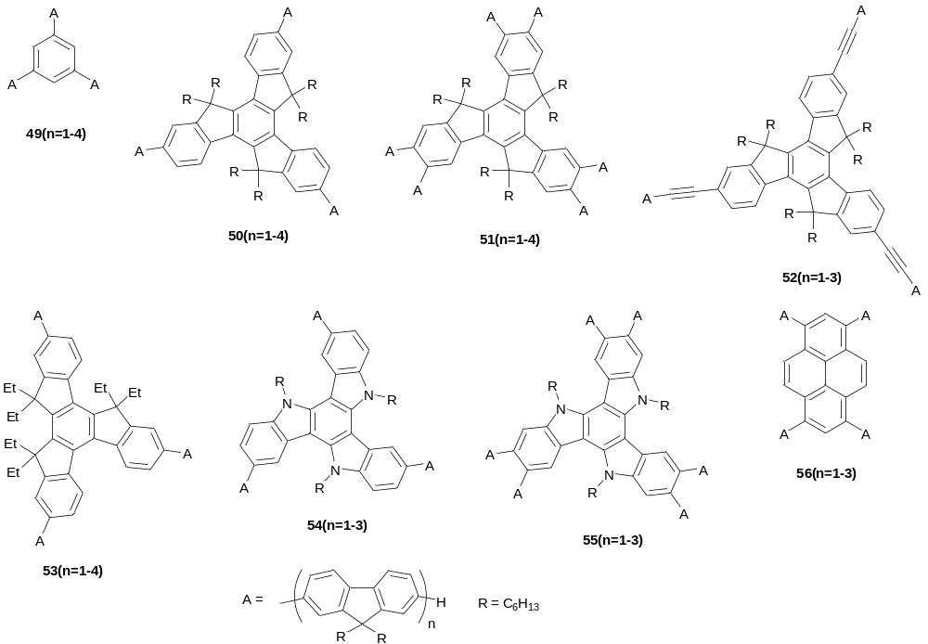

Both divergent and convergent synthetic approaches have been used to construct star-shaped oligofluorenes 49 with a benzene core. The materials are amorphous (T_{g} = 47–91ºC fron n=1 to n=4) and show high thermal stability (T_{d} > 400ºC). Similar to linear oligofluorenes, they emit light in the deep blue/blue region (~350–450 nm) with high quantum yields in both solution and solid state (Φ_{PL} = 0.41–0.82 and 0.43–0.58, respectively). The photoluminescence spectra feature fine vibronic structure, which is characteristic of rigid-rod conjugated systems. Progressive red shifts are observed for both absorption and emission spectra with an increase in the length of the arms. CV experiments demonstrated reversible or quasi-reversible electrochemical oxidation and reduction, generating stable radical cations and radical anions, respectively. The redox processes take place on each of the arms, which behave as independent electroactive units with no electronic communication through the meta-connections of the core.Error: Reference source not found Cation radicals of 49(n=2-4) show two distinct Vis/NIR absorption waves in spectroelectrochemistry experiments (~500–600 nm and ~1400–2000 nm),Error: Reference source not found similar to that observed for linear oligofluorenes in pulse radiolysis (solutions, r.t.) and γ-irradiation (solid matrix, 100 K) experiments.
Truxenes can be considered as three overlapped fluorene units sharing a central benzene ring, such that the unit has virtually “no core” structure. Replacing the small benzene core in oligomers 49 with the larger truxene core (oligomers 50), results in small bathochromic shifts in both absorption and emission spectra (decrease with an increase of n) and an increase in T_{g} (63–116 ºC). Compared to 49 the truxenes retain high quantum efficiency of photoluminescence, high thermal stability and reversible/quasi-reversible redox processes.Error: Reference source not found Molecular and electronic structures of oligomers 50 have been studied experimentally by Raman spectroscopy and theoretically by DFT method. Both series of oligomers demonstrated blue electrogenerated luminescence (ECL) by ion annihilation, with ECL emissions observed at the same positions as fluorescence emissions.Error: Reference source not found, Nanosized oligofluorene-truxenes 50(n=3,4) (d = 6.4 and 8.0 nm) have been recently used in various photonics applications. Photocurable composites based on the UV-transparent negative photoresist 1,4-cyclohexanedimethanol divinyl ether (CHDV) blended with oligomer 50(n=4) have been recently used to produce fluorescent microstructures of crosslinked polymer by direct laser writing (Figure 12a,b) and solventless inkjet printing (Figure 12c).,

(a) 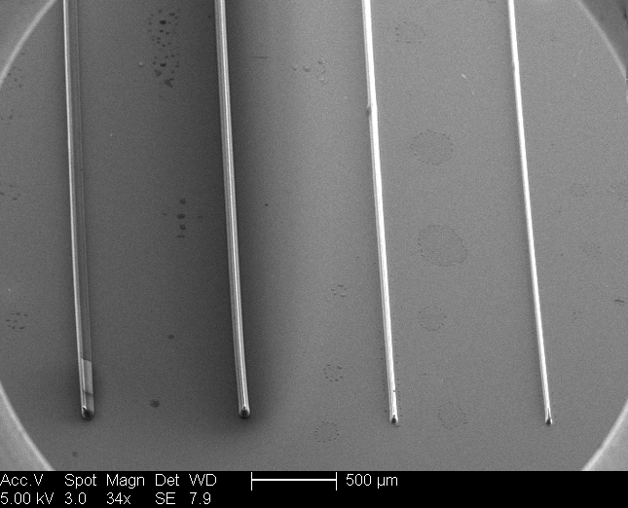 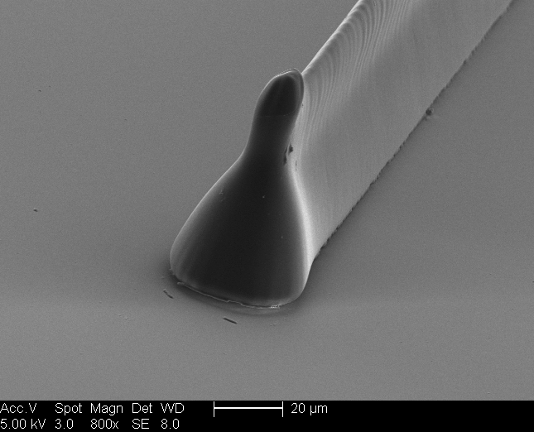

(b) 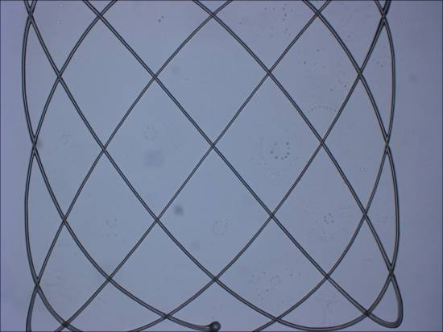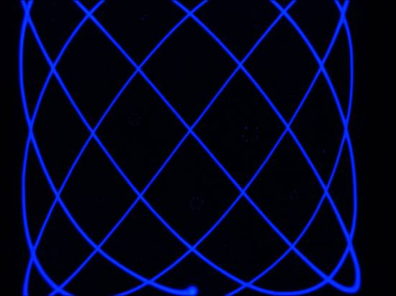
60 µm
60 µm

(c) 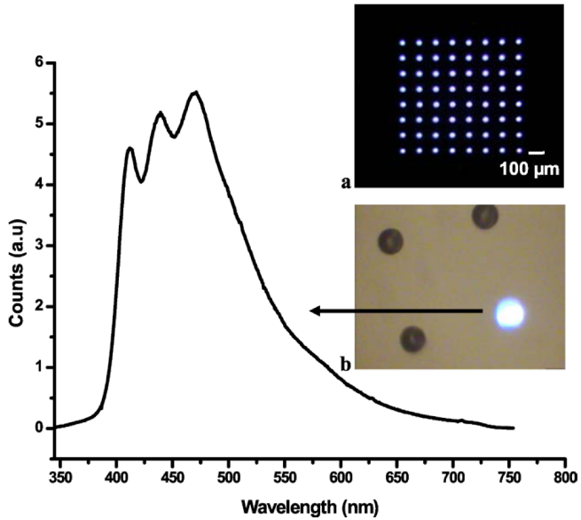
Figure 12. (a) SEM images of direct laser written lines of microstructures into CHDV:0.5wt% 50(n=4) blend (left) and close up image (right). (b) Optical microscopy images of 4:5 Lissajous structure written in CHDV:1wt% 50(n=4) resulting in a line width of 2.5mm, observed under white-light (left) and 368 nm (right) illumination. (c) Photoluminescence spectrum of a single photoexcited micro-dot, together with (inset) optical micrographs of the full photoexcited array [a] and a single-photoexcited micro-dot [b]. Reproduced with permission from Ref. [Error: Reference source not found, Error: Reference source not found].

Light amplification studies of 50(n=4) revealed a low lasing threshold of 270 W cm^{–2}, attributed to low amplified spontaneous emission (ASE) threshold and a very low waveguide loss coefficient of 2.3cm^{–1}, with distributed feedback (DFB) laser wavelength tuning range of ~25 nm. An even broader tuning range of emission of 51 nm (from 422 to 473 nm, with a minimum threshold density of 515 W cm^{–2}) was very recently demonstrated for a DFB laser based on oligomer 50(n=3) (Fig. 13).

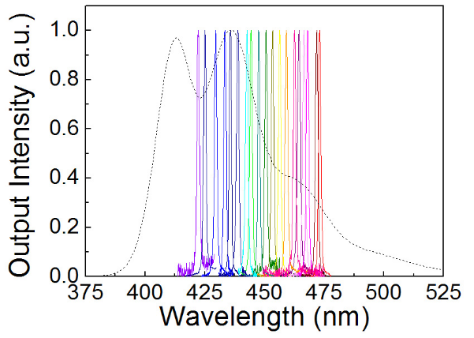
Figure 13. Laser emission spectra of 50(n=3) in the tuning range of 422–473 nm for different combinations of grating period and film thickness. Reproduced with permission from Ref. [Error: Reference source not found].

Truxene-based oligomers with six oligofluorenes arms (51) demonstrated bright blue emission with high Φ_{PL} (0.64–1.00 in solution, 0.50–0.90 in films), while due to steric hindrance between the core and arms (and consequently lower degree of conjugation) they also showed some blue shifts of their absorption and emission maxima compared to the tri-substituted analogues 50. Again, low threshold DFB lasers (109 W cm^{–2}), tunable from 421 to 443 nm, have been demonstrated for star-shaped oligomers 51(n=3).
Convergent synthesis exploiting Sonogashira coupling of tri(ethynyl)truxene with 2-bromo-oligofluorenes was used to synthesise star-shaped oligofluorenes 52. While solution and solid state absorptions, and solution photoluminescence maxima of oligomers 52(n=1-3) show only minor bathochromic shifts of 4–11 nm compared to their analogues 50(n=1-3) without ethynylene linkers between the truxene and oligofluorene arms, solid state emission spectra demonstrate a pronounced red shift by 45–67 nm, possibly due to some ordering in the condensed phase (aggregation and/or formation of excimers). Similar behaviour, i.e. large red shifts in the solid state emission spectra compared to solutions (and small difference between absorption maxima in solution and solid state), was also observed for star-shaped truxene-core oligomers with oligo(ethynylenefluorenylidene) arms 57(n=1-4). Moreover, both series of oligomers, 52 and 57, demonstrate unusual length dependence of solid state emission: the expected red shift is observed from the monomer (n = 1) to the dimer (n=2), whereas further increase of the number of fluorene units in the arms results in hypsochromic shifts of λ_{PL} and a change in the shape of the photoluminescence spectra {λ_{PL} = 447 → 470 → 462 nm [52(n=1→3)],Error: Reference source not found 442 → 468 → 467 → 451 nm [57(n=1→4)]Error: Reference source not found} (Fig. 14).
Oligomers 57(n=2-4) demonstrated bluish electroluminescence in a double layer OLED [in configuration ITO/PEDOT:PSS/polyTPD and PVK/57(n=2-4)/Ca/Al] with turn-on voltages of 3.7–5.1 V, maximum luminous efficiency in the range 0.41–0.60 cd A^{–1} and maximum luminance of 2861–5176 cd m^{–2} (the best parameters have been achieved for oligomers 57(n=3)).Error: Reference source not found Similar to solid state PL, the EL for the longest oligomers, n = 4, is blue shifted compared to shorter homologues (n = 2,3) (Fig. 14). The nature of this phenomenon is not well understood at the moment, although we can suppose that longer arms in star-shaped architectures with flexible ethynylene linkers between the core and the arms results in decreased ordering, thereby reverting to emissions at shorter wavelength which are typical for other oligomers 49, 50 with direct linkage between oligofluorene arms and the cores.

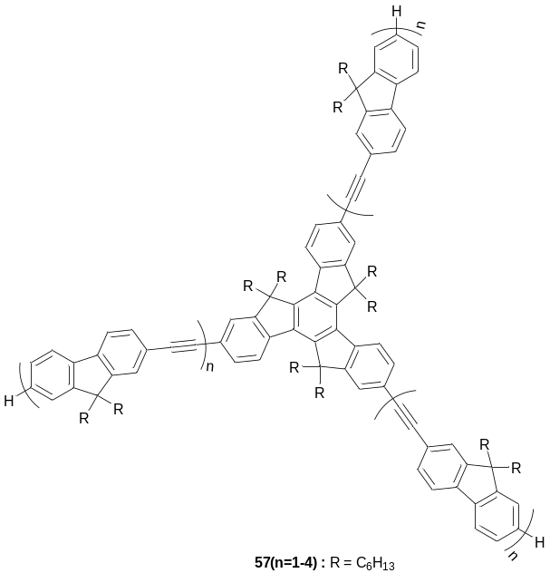

(a) 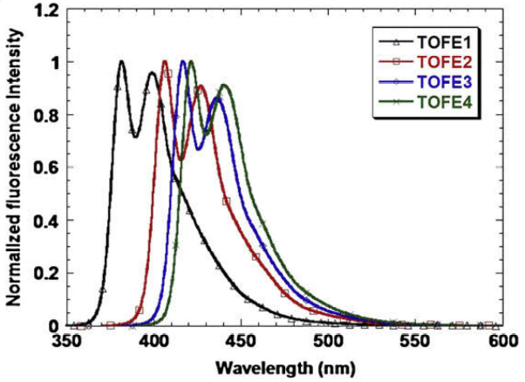

(b) 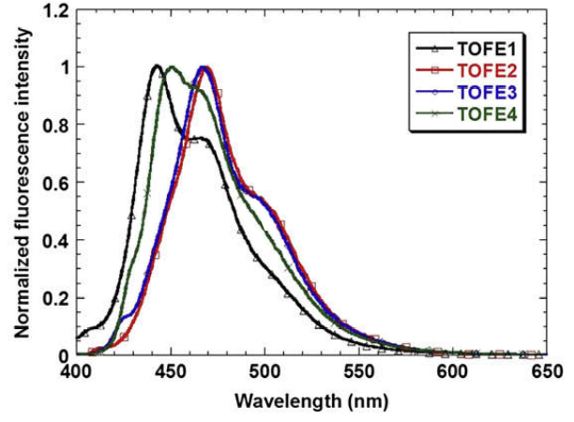

(c) 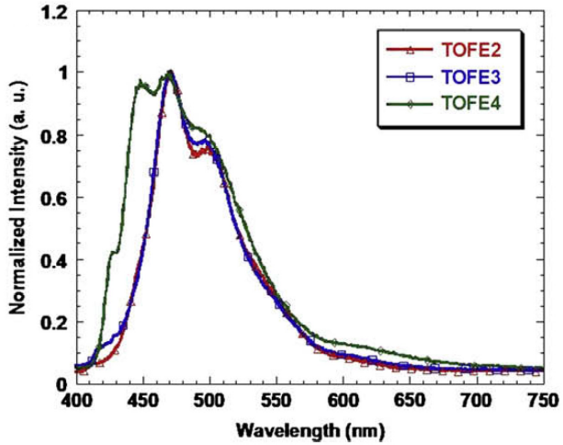

Figue 14. Photoluminescence spectra of 57(n=1-4) in THF solution (a) and in films (b), and EL spectra of OLED devices in ITO/PEDOT:PSS/polyTPD and PVK/57(n=2-4)/Ca/Al configuration (c); n = 1 (TOEF1), 2 (TOEF2), 3 (TOEF3), 4 (TOEF4). Reproduced with permission from Ref. [Error: Reference source not found].

Yang et al. have reported star-shaped oligofluorenes 53, in which the truxene core is replaced with isotruxene, breaking the C₃ symmetry of the system., The para-/ortho-branched isotruxene scaffold results in stronger coupling between the oligofluorenes arms, compared to the links in isomers 49 in which the truxene core has meta-linkages. Similar to their analogues 49, oligomers 53 are well-soluble amorphous materials with excellent thermal (T_{d} = 390–403 ºC) and electrochemical stability (reversible or quasi-reversible electron transfer in both oxidation and reduction) and emit blue light with high quantum yields (Φ_{PL} = 0.77–0.79). However, in contrast to oligomers 49 they showed very little chain-length dependence of their oxidation and reduction potentials as well as their emission spectra (E_{ox}^{1/2} = 0.61–0.60 V, E_{red}^{1/2} = –2.74–2.71 V, λ_{PL} = 430–438 nm for n = 1–4), which is explained by the integration of the isotruxene core into conjugated pathways between the arms. This elongated conjugation leads to saturation for short oligomers with n = 2–3.
This group has also synthesised an interesting star-shaped ladder-type oligo(p-phenylenes) based on an isotruxene core with up to four benzene rings in the arms (58) and compared them with linear ladder-type oligomers 59. Synthetically, the authors exploited methodology previously used for the synthesis of ladder-type oligo(p-phenylenes),, which is based on the original approach of Scherf and Müllen for the construction of ladder-type poly(p-phenylenes)., The procedure uses intramolecular cyclisation of biphenyl fragments with R¹R²CH(OH)– alcohol substituents at ortho positions by the action of a Lewis acid (BF₃∙(Et₂O)) to form a five-membered carbon ring. Oligomers 58(n=1-4) emitted blue light with high quantum yields (λ_{PL} = 428–470 nm, Φ_{PL} = 0.79–0.89). Their emission peaks are bathochromically shifted compared to linear oligomers 59 which indicates effective exciton delocalisation over the 2D conjugated backbones in the star-shaped structures 58, due to para-/ortho-branching at the isotruxene core. An increase in the lengths of the arms in 58(n=1-4) results in a decrease of the Stokes shift, although the shifts remain larger than those for the linear oligomers 59(n=0-3) (Δν_{st} = 907 → 557 and 736 → 439 cm^{–1}, respectively). These results have been discussed considering the non-planarity of the central isotruxene core (the torsion angles between the two ortho-branched arms in isotruxene are 9.8º and 18.6º for 58(n=0) and 58(n=1), respectively), and its effect on relaxation processes in the excited state.

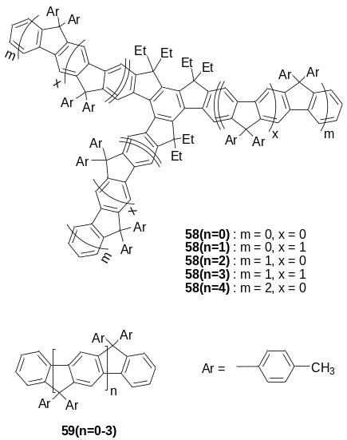

Huang et al. have synthesised tri- and hexa(oligofluorene)-substituted triazatruxenes 54 and 55 via the Suzuki-Miyara coupling protocol, exploiting a convergent approach., These hetero-analogues of oligomers 50 and 51, show bright blue emission (slightly red-shifted by ~30–50 nm compared to oligomers 50 and 51) with high quantum efficiencies characteristic of other star-shaped and linear oligofluorenes (up to 1.0 in solutions and 0.9 in films). The electron-donating triazatruxene core elevates the HOMO level of the oligomers leading to better hole-injection/transporting properties. Single-layer solution-processed OLEDs have been fabricated using oligomers 54 as the emitting layer (ITO/PEDOT:PSS/54/Ba/Al). The best device performance had been achieved with compound 54(n=3), showing a rather low turn-on voltage (3.3 V), high EL efficiency (2.16%), high brightness (7714 cd m^{–2} at 10 V) and maximum luminance of 1.56 cd A^{–1}, with CIE coordinates of EL (0.16, 0.15).Error: Reference source not found The same configuration of devices with hexasubstituted oligomer 55(n=3) also showed deep blue EL (CIE 0.15, 0.09) with high EL efficiency (2.0%) and maximum luminous efficiency (2.07 cd A^{–1}) and somewhat lower brightness (1343 cd m^{–2} at 16 V),Error: Reference source not found although higher brightness (5545 cd m^{–2}) was achieved in devices with 55(n=2). Moreover, blending 55(n=2) with uncapped polyfluorene gave highly efficient devices (Φ_{EL} = 2.95% and maximum luminous efficiency of 2.33 cd A^{–1}) with stabilised blue emission (no green band appeared during device operation, which is often observed in PF-based devices due to oxidation and formation of fluorenone defects).,,, Several other efficient OLEDs of different configurations were demonstrated with these oligomers 55(n=2,3), as well as amplified spontaneous emission.
A convergent synthetic approach, which is more common in the construction of star-shaped oligofluorenes, was also used in the synthesis of efficient (Φ_{PL} up to 95% in films) blue-emitting cross-conjugated cruciform oligomers 56 possessing a pyrene core., They have been tested as emitters in single layer OLEDs (ITO/PEDOT:PSS/56/CsF/Al) showing sky-blue EL (CIE 0.20, 0.32), achieving a brightness of 2716 cd m^{–2} and maximum luminous efficiency of 1.75 cd A^{–1} (for 56(n=3).Error: Reference source not found These materials possess encouragingly low laser thresholds and relatively high thermal and environmental stability.Error: Reference source not found The ASE threshold was found to remain unaffected by heating at temperatures up to 130 ºC, i.e. 40 to 50 ºC above the glass transition temperatures of the oligomers. 1D DFB lasers with 75% fill factor and 320 nm period showed optical pumping down to 38–65 W cm^{–2} and wavelength tuning range of ~40 nm around 471–512 nm. As discussed above, the excellent lasing properties of different series of oligofluorenes 50, 51, 55, 56 indicate the great potential of 2D star-shaped conjugated architectures for laser applications.
Bo and co-workers combined blue-emitting oligofluorenes as arms with a red-emitting porphyrin core in the design of star-shaped oligomers 60.The materials showed blue absorption, but emitted in the red due to efficient energy transfer. The side octyl chains on the fluorene units efficiently suppressed the aggregation of the porphyrin rings, and an energy transfer was intensified with increasing conjugation length of the oligofluorenes arms (Φ_{PL} = 0.11→0.22 from n = 1 to n = 4). Suzuki polycondensation was used to afford polymer 61a; GPC (M_{n} = 7000, PDI = 1.40) and MALDI-TOF data (dominant MS peak at 5379 Dalton) corresponded to arm lengths of ~3–6. Similar triphenylamine end-capped polymers 61b have also been prepared. Their spectral characteristics were similar to monodisperse oligomers 60 and both polymers displayed pure saturated red electroluminescence (λ_{EL} = 662, 726sh nm) when used as emitters in single-layer devices (ITO/PEDOT:PSS/61/Al).

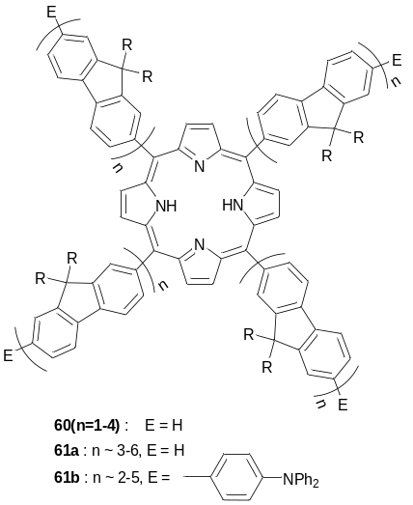

For donor-bridge-acceptor systems, in cases of donor > bridge > acceptor energy alignment, the energy transfer is weakly dependent on the bridge length, which behaves as a coherent wire.,,, Triads 62 with an Alq₃ core, oligofluorene arms and platinum porphyrin end-caps have been designed to study energy level/distance-dependenence in energy transfer processes (Figure 15). The materials showed effective singlet and triplet energy transfer from the Alq₃ core onto the porphyrin site through the oligofluorene bridge, which behaves as a molecular wire. The materials emitted red light with high colour purity. They have been studied as active layers in OLEDs, demonstrating improved device performance for longer oligofluorene bridges (by more than one order of magnitude) where better triplet energy level alignment was observed.

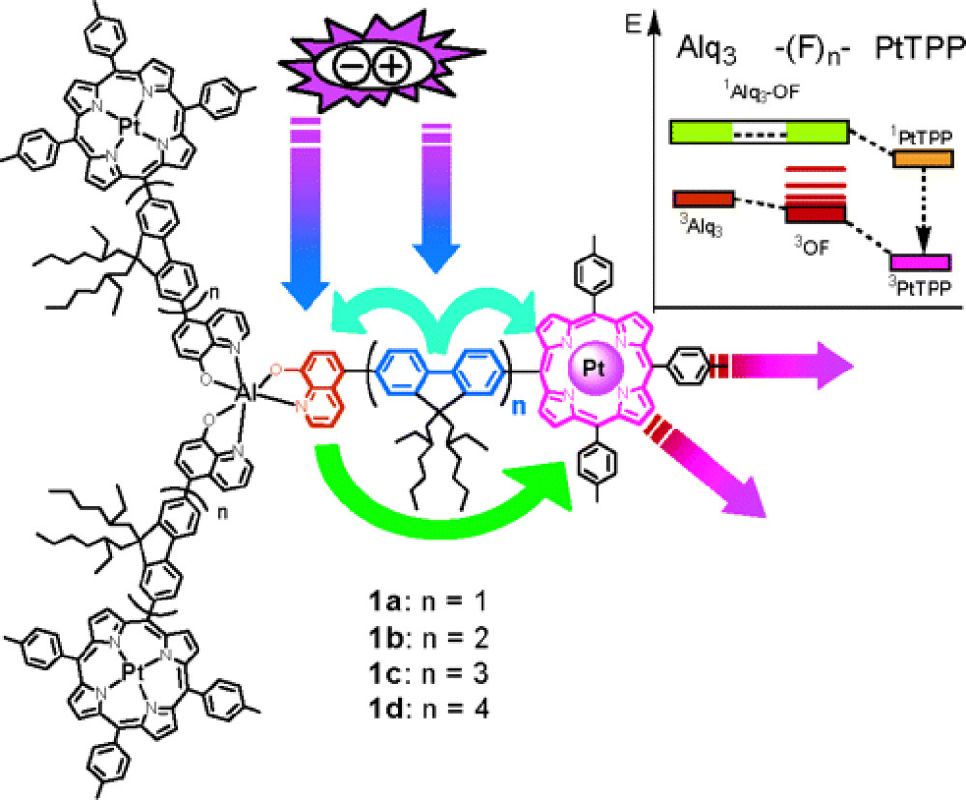
Figure 15. Structure and energy alignments in triads 62(n=1-4) (shown as 1a-1d in the Figure). Reproduced with permission from Ref. [Error: Reference source not found]

Spiro-type oligofluorenes with a 90º orientation between the two central spiro-linked fluorene units have been synthesised by Chen et al. using a convergent approach and a Suzuki-Miyara protocol. The amorphous character of spin-coated films was found to persist upon prolonged heating and longer oligomers (n = 2,3) were found to resist thermally activated crystallisation. Spiro(oligofluorene)s 63 emit blue light with almost identical spectroscopic characteristics in both solution and solid state and have Φ_{PL} close to 0.5.

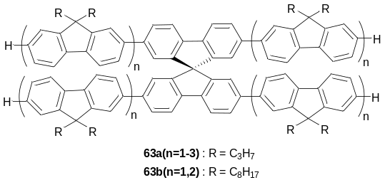

In contrast to other classes of conjugated oligomers, the number of 3D star-shaped oligofluorene structures is limited. Jeeva and Moratti synthesised oligofluorenes 64 with an adamantane core of tetrahedral architecture, which emitted in the UV region at ~350 nm, but no further details on their photophysical properties have been reported.

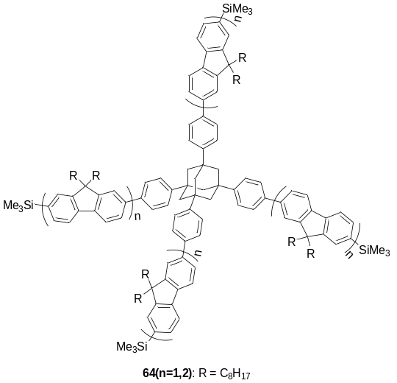

Two series of oligomers consisting of electron-deficient 1,3,5-triazine (65) and electron-rich N,N,N’N’-tetraphenylbenzidine cores (66) linked to oligofluorene arms through flexible aliphatic spacers have been synthesised by Chen et al. They are able to form glassy-isotropic films and glassy-liquid-crystalline structures by solution processing (evidenced by polarised absorption and emission spectroscopies), and emit blue light at wavelengths typical of analogous linear oligofluorenes.

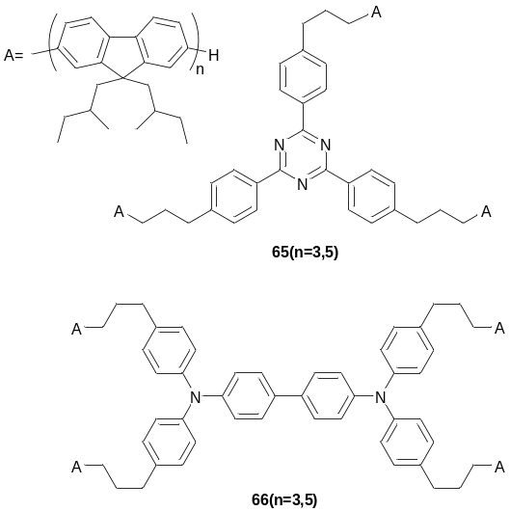

Water-soluble conjugated polyelectrolytes have been recognised in the last few years as emerging materials for organic electronics and bio-applications.,,,,, A star-shaped system with a polyhedral oligomeric silsesquioxane (POSS) core and cationic bifluorene arms (67) has been synthesised by Liu and coworkers by Heck coupling of 2-bromobifluorenyl, having quarternary ammonium groups as side chains (68), with octavinyl POSS. The compound formed water-soluble unimolecular nanoparticles with an average particle size of 3.6 ± 0.3 nm (from transmission electron microscopy (TEM) data), which are highly fluorescent (Φ_{PL} = 0.85→0.80, slightly decreasing with an increase of ionic strength of the solution). For comparison, Φ_{PL} of most water-soluble cationic polyfluorenes is known to be less then 0.60 and often significantly decreases in high ionic strength buffers down to less then 0.20, due to aggregation. When added to a mixture of double-stranded DNA (dsDNA) with an intercalating dye ethidium bromide (EB) in buffer solution, compound 67 provided 52-fold amplification of EB emission at 610 nm (an excitation at 67 absorption, 390 nm) through Förster resonance energy transfer (FRET), allowing discrimination of dsDNA from ssDNA (single-stranded DNA) with the naked eye (Figure 16). The authors demonstrated the signal amplification in breast cancer cells MFC-7 (Figure 17). Due to the small nanoparticle size of 67 (3.6 nm), not only can it be effectively internalised by MFC-7 and distributed in the entire cell, but it can also be permeated into cellular nuclei, providing light-harvesting for efficient FRET in a harsh biological environment.

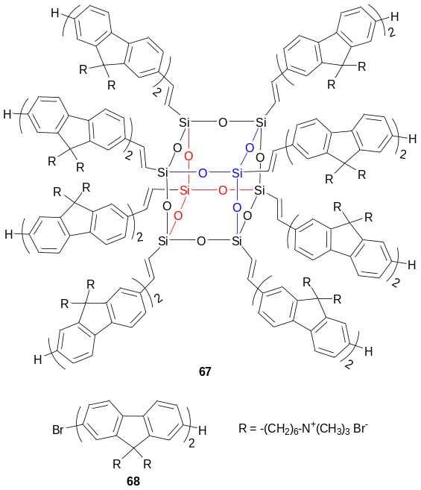

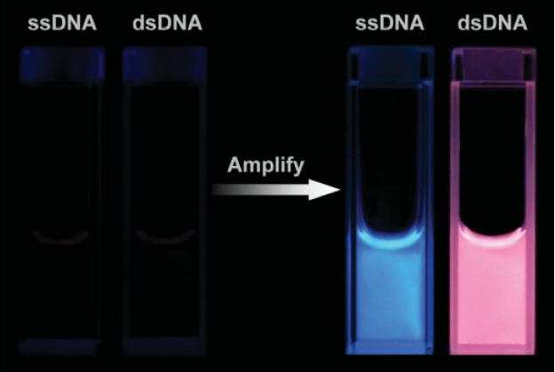
Figure 16. Photographs of the fluorescent solutions of EB/ssDNA and EB/dsDNA in the absence (left) and presence (right) of 2µm 67 under 365nm UV radiation. [ssDNA or dsDNA] = 0.020 µm and [EB] = 2µm. Reproduced with permission from Ref. [Error: Reference source not found].

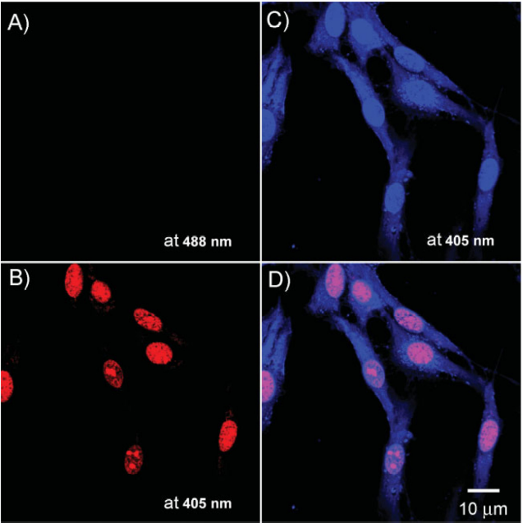
Figure 17. Confocal laser scanning (CLSM) fluorescence images of breast cancer cells (MCF-7) co-stained by 67 and EB: A) upon excitation at 488nm (an absorption wavelength of EB) and collection of fluorescence above 650 nm, B) upon excitation at 405nm and collection of fluorescence above 650 nm, and C) upon excitation at 405nm and collection of fluorescence from 430 to 470 nm. D) Overlapped images of B and C visualising the cytoplasm and the nucleus by blue and pink colours, respectively. Reproduced with permission from Ref. [Error: Reference source not found].

7. Oligothiophenes

Among all classes of π-conjugated polymers, polythiophenes possess the most unique combination of efficient conjugation length, chemical stability and synthetical versatility for tuning their optical and electronic properties, making them among the most frequently used π-conjugated materials for organic electronic devices.Error: Reference source not found,, The versatility of thiophene chemistry defines the huge number of oligothiophenes synthesised, not only traditional linear oligomers but also oligomers of higher dimensionalities and novel topologies (star-shaped oligothiophenes, macrocycles, helix structures of linear oligothiophenes, dendrimers).,, They not only play an important role as models for understanding the electronic processes in polymers but also occupy their own niche for electronic applications and as nanomaterials. Below we review 2D and 3D star-shaped oligothiophenes of various cores, shapes and substitution patterns and their application as active components in organic electronic devices.
Tetrachlorosilane-mediated cyclotrimerisation of 2-acetyloligothiophenes 69a,b(n=1,2) has been used in the synthesis of star-shaped oligothiophenes with a benzene core (70a,b(n=1,2)) (Scheme 2). Among the compounds bearing an unblocked α-position 70a(n=1,2) only 70a(n=2) has been successfully electropolymerised (itself or in a mixture with 2,2'-bithiophene) to form a cross-linked polymer.

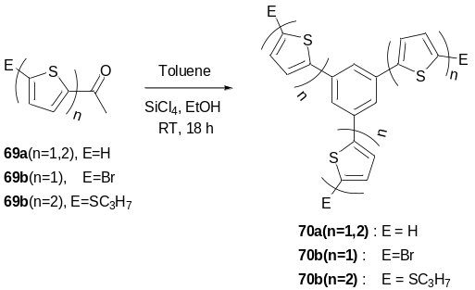
Scheme 2. Synthesis of star-shaped oligothiophenes by SiCl₄-mediated formation of a benzene core from acetylthiophenes

Kumada cross-coupling of 1,3,5-tribromobenzene or 1,3,5-tris(4-bromophenyl)benzene with oligothienyl magnesium bromide has been used in the convergent synthesis of star-shaped compounds with a benzene core (71a,b) (Scheme 3). They have been used for the fabrication of OFETs, but the materials showed very low mobilities.The best mobility was achieved for oligomer 71a(n=3) (2 × 10^{–4} cm² V^{–1}s^{–1}), which had a low on/off ratio of 10².

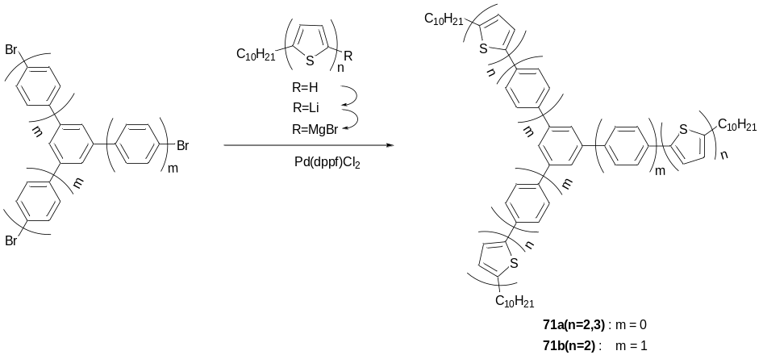
Scheme 3. Synthesis of star-shaped oligothiophenes by convergent methodology using Kumada cross-coupling reaction.

Another convergent strategy for constructing hexa-substituted star-shaped architectures with a benzene core (72), is based on the use of Co₂(CO)₈ as a reagent for the cyclotrimerisation of disubstituted acetylenes. The liquid crystalline behaviour of 72 has been studied by differential scanning calorimetry (DSC) and polarised optical microscopy (POM). Whereas 72b formed a more stable mesophase compared to 72a, the mesophase of 72c was less ordered due to distortion of the conventional packing motif, caused by the exchange of the inner core from a hexabenzene to a hexathiophene system.

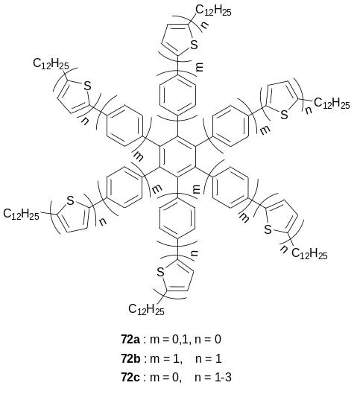

Compounds featuring linear ethynylene spacer units 73 - 76 have been synthesised as a means to diminish the steric hindrance between the core and arms. The properties of these materials have been compared with the simple linear analogues 77.. An increase in the number of the arms results in sequential lowering of oxidation potentials, absorption and emission energies of the compounds (77 > 73 > 74 ~ 76 > 75). Star-shaped structures also showed higher Φ_{PL} values compared to the single arm 77 (Φ_{PL} = 0.086), with the highest Φ_{PL} of 0.34 observed for the cross-conjugated cruciform 74. The combination of the electrochemical data, Raman spectroscopy of the oxidised states and theoretical calculations showed that the hole-transporting and light-absorbing units are located at the periphery of the molecules and are weakly coupled electronically to the central core

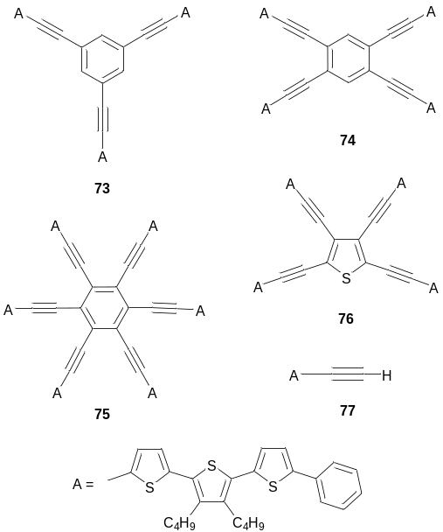

A divergent strategy has been employed for the synthesis of star-shaped oligothiophenes 78(n=1-4) with a truxene core, using iterative Suzuki coupling and bromination procedures. A similar approach has been applied in the preparation of compounds 79(n=1,2) with ethylenedioxythiophene (EDOT) units in the arms, exploiting the Negishi coupling protocol.. Six hexyl chains on the truxene core provided good solubility for the target compounds even without additional solubilising groups in the arms. Oligomers 78(n=1-4) have been used for the fabrication of OFETs, exhibiting a maximum hole mobility of 1.03 × 10⁻³ cm² V⁻¹ s⁻¹ and on/off ratio of ~10³ for the smallest conjugate 78(n=1).
FeCl₃ mediated oxidative polymerisation of oligomer 78(n=1) resulted in a soluble (in THF) hyperbranched dendritic polymer.Error: Reference source not found The absorption and emission spectra of the polymer were red-shifted compared to monomer 78(n=1) indicating an increase in the conjugation length of the polymer product.

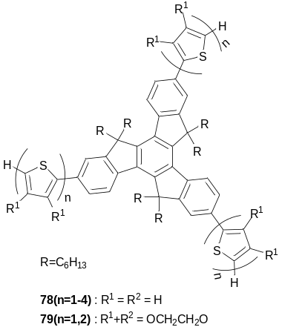

Using Prato's protocol, compounds 78(n=1-4) and 79(n=1,2) have been decorated at the terminal positions of the arms by C₆₀ units to afford donor-acceptor systems 80(n=1-4) and 81(n=1,2).Error: Reference source not found The emission peaks of oligomers 80(n=1-4) shifted bathochromically and their intensities decreased with an increase of the length of the arms from n = 1 to 4, indicating more efficient quenching of photoluminescence for longer oligomers (oligomer 80(n=4) also contained a small emission peak in the region of 780 nm, not explained by the authors, but which might be due to residual emission of the fullerene). Prato's methodology has also been used in the design of similar D-A triads with a benzene core and thienylenevinylene units as the arms (82(n=1,2).

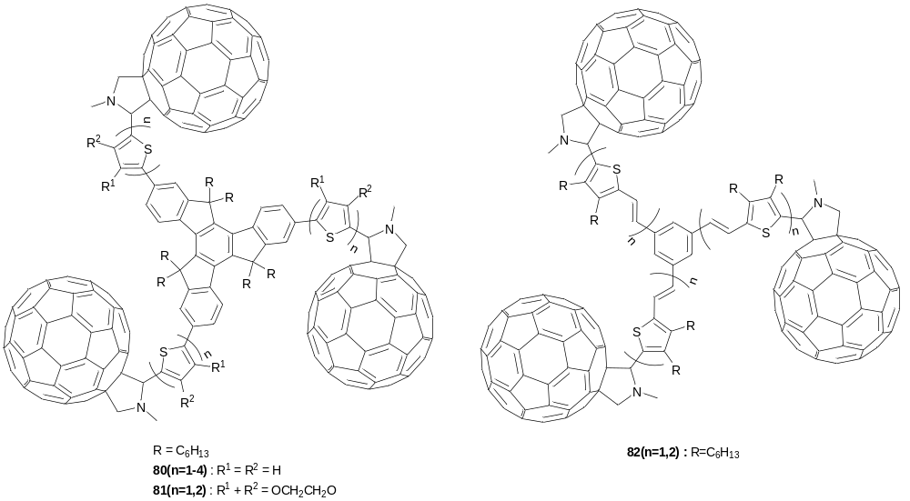

Pei et al. have functionalised oligomers 78(n=1,2) with chiral amine end-caps (83b,c). Their CD absorption spectra showed opposite behaviour of the Cotton effect compared to the reference compound 83a.

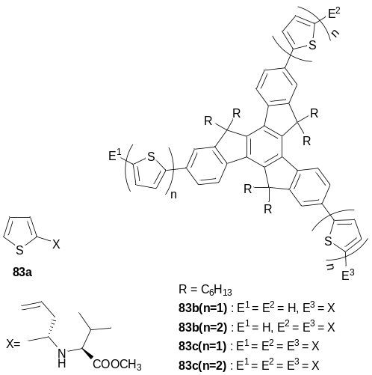

The same group used the structural fragment of compound 78(n=1) for expansion to dendritic structures 84a,b with the truxene core as a branching point and thienyleneethynylene arms as linkers. The compounds emitted blue light in THF solutions (444 and 468 nm for 84a and 84b, respectively) and solid state emissions showed 23–33 nm red shifts and a change in the shapes of the photoluminescence spectra (broad features in the solid state spectra, compared to well-defined vibronic structures for solution state samples).

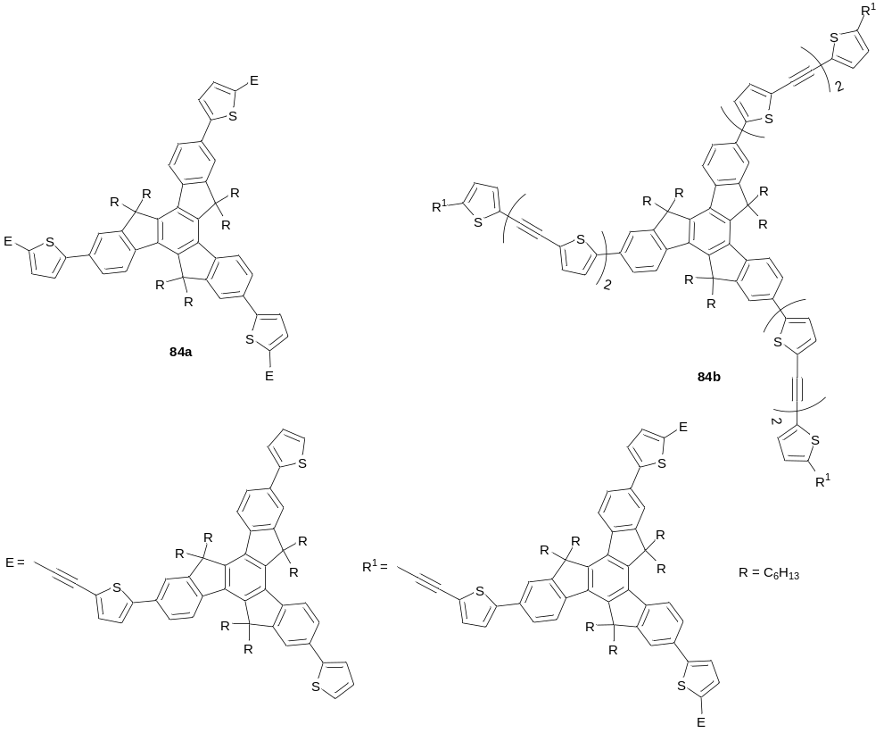

Trigonal star-shaped oligothiophenes with a trithienobenzene core 85 have been synthesised along with linear analogues (86) using Stille and Suzuki coupling protocols. Star-shaped oligomers 85(n=1,2) have been found to possess lower oxidation potentials and bathochromically shifted absorption peaks compared to the linear compounds, due to enhanced π-electron delocalisation. They also showed improved thermal stability with T_{d} above 400 ºC, which is more than 200 ºC higher than that of the linear analogues. Compounds 85(n=2) and 86(n=2) have been used for the fabrication of bulk heterojunction photovoltaic cells, using N,N’-bis(tridecyl)perylenedicarboxyimide as the acceptor component. An enhanced conjugation in 2D star-shaped systems, as well as preferential horizontal orientation of the molecules in films, favoured efficient absorption of the incident light. This provided a significant improvement in device performance with increases in the open circuit voltage, V_{oc}, from 0.74 V to 0.85–0.89 V, short circuit current, J_{sc}, from 94.2 to 969–1350 µA cm^{–2} and power conversion efficiency, η, from 0.04 to 0.57–0.78% (for 86(n=2) and 85(n=2), respectively).

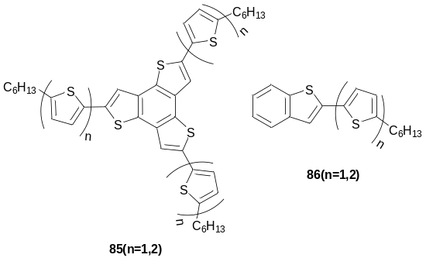

Thiophene and 3,3’-bithiophene units have been used as cores to yield X-shaped (87a,b) and swivel-cruciform (88a,b) oligothiophenes, exploiting divergent and convergent synthetic approaches, respectively.
The absorption spectra of 87a(n=1), 87b(n=1) and 87a(n=2) were very similar for THF solutions and films, and the bands were quite broad due to the existence of different conjugation pathways. The optical HOMO-LUMO gaps decreased in the order 87a(n=1) > 87b(n=1) > 87a(n=2) (2.96, 2.89 and 2.47 eV, respectively). Compounds 87a(n=1), 87b(n=1) and 87a(n=2) showed emission maxima in THF at 491, 494, 547 nm, respectively. The fluorescence spectra of films were significantly blue-shifted for 87a(n=1) (464 nm) and 87b(n=1) (473 nm), but slightly red-shifted for oligomer 87a(n=2) (556 nm). Electropolymerisation of compounds 87a(n=1,2) resulted in polymers with very broad absorption bands around 400–500 nm and emissions around 610 nm. Comparative studies of compounds 87a(n=1), 87b(n=1) and 87a(n=2) in bulk heterojunction photovoltaic cells with PCBM as an acceptor demonstrated increases in power conversion efficiency (η) from 0.04 to 0.8%, short circuit current (J_{sc}) from 0.29 to 3.65 mA cm⁻² and the maximum of incident photon to current efficiency (IPCE) from 4.2 to 31.6%, with increasing length of the arms .
Compared to linear unsubstituted oligothiophenes, swivel-cruciform oligomers 88a(1-3) showed improved solubility, sufficient to allow solution processing. In OFET studies, among oligomers 88a(1-3), compound 88a(n=2) provided the best performance with a field-effect mobility µ_{FET} = 3.7 × 10^{–5} cm² V^{–1} s^{–1} and a current on/off ratio I_{on/off} = 2.5 × 10³. Much higher mobility was achieved for its analogue with hexyl end-groups 88b(n=2) (µ_{FET} = 0.012 cm² V⁻¹ s⁻¹, I_{on/off} > 10⁵).

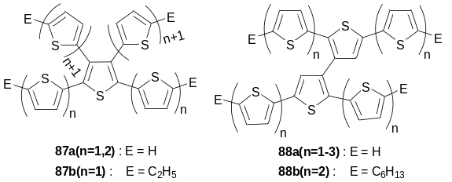

Bäuerle and co-workers have reported the synthesis of a series of dendritic-type oligothiophenes (up to 90-mer, 89a-b) as a novel class of monodisperse 3D hyperbranched oligothiophenes. The materials are highly soluble and do not require functionalisation with long chain alkyl groups, which are generally required for solubilising linear oligothiophenes. The longest conjugation pathway in dendrimer 89b involves 16 thiophene units, yet the dendrimer exhibited an hypsochromic shift in its absorption spectrum (λ_{max} = 387 nm), compared to its linear 16T oligothiophene (464 nm) due to steric hindrance between the branches, which causes inter-ring distortions and a decrease in the effective conjugation length. The multiple chromophores in dendrimer 89b provide a large Stokes shift of 167 nm. Synthesis of dendrimer 89b involved a final step of CuCl₂ oxidative coupling of the lithiated dendron 90 (Scheme 4). Bulk heterojunction solar cells constructed from dendron 90 and PCBM had the following characteristics: V_{oc} = 1.0 V, J_{sc} = 3.29 mA cm^{–2} and η = 1.12% under standard AM1.5G.

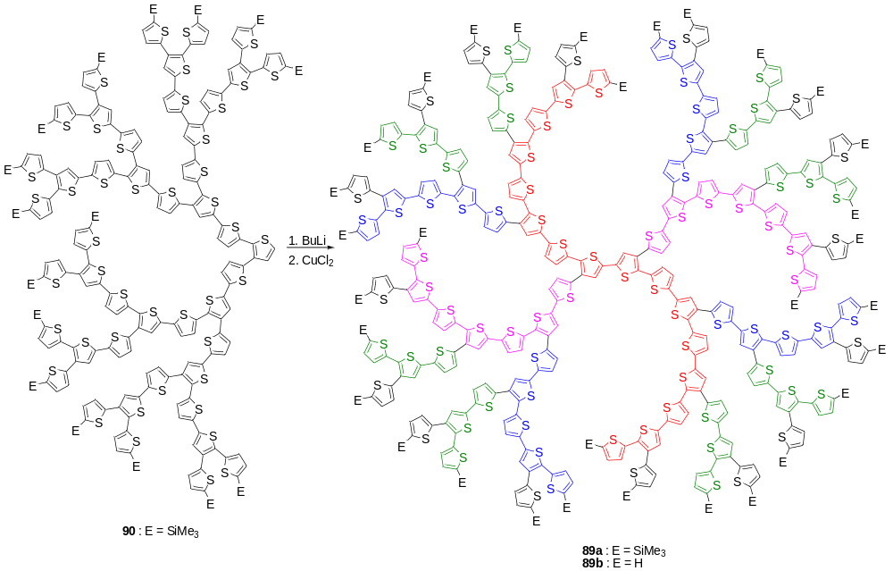
Scheme 4. Synthesis of dendrimer 89 from dendron 90. Colours show chromophore fragments of different conjugation lengths.

An appearance of long wavelength absorption bands in π-extended thiophene/terthiophene–sumanene conjugates 91(n=1,3) (λ_{abs} = 373, 482 nm and λ_{abs} = 434, 545 nm for n = 1 and 3, respectively), compared to sumanene itself (λ_{abs} = 278 nm), was rationalised by DFT calculations. The compounds exhibited pronouncedly red-shifted emissions with values of λ_{PL} = 376, 564 and 650 nm for sumanene, 91(n=1) and 91(n=3), respectively.

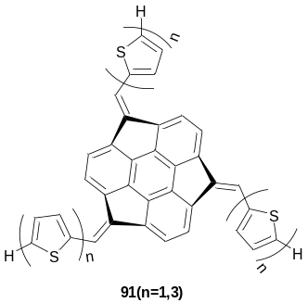

A series of star-shaped thiophene conjugates with an electron deficient triazine core has been prepared using Stille coupling of cyanuric chloride and the corresponding stannylated derivatives. Their spectroscopic and electrochemical properties have been studied, which show a decrease in absorption energies and oxidation potentials with an increase in the length of the arms and stronger electron donating properties of the thiophene units (i.e. EDOT vs thiophene). The EDOT-terminated compounds 92b(n=2) and 92c were successfully electropolymerised to produce electroactive polymer films.

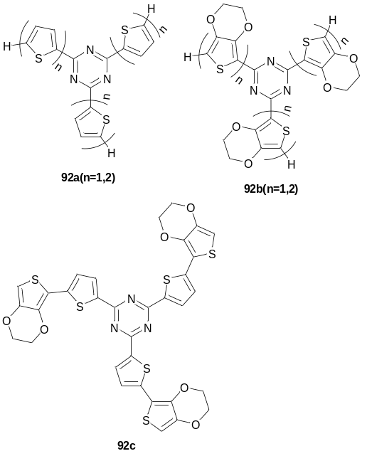

Conjugates 93a,b(n=1,2) with another type of acceptor core, benzothiadiazole, and triphenylamine -oligothiophene arms have been synthesised using the Suzuki coupling protocol, along with the linear analogues 94a,b(n=1,2). Star-shaped systems 93a,b(n=1,2) possess wider energy gaps and lower HOMO levels compared to their linear analogues 94a,b(n=1,2). When studied in photovoltaic devices (with PCBM), star-conjugates with bithiophene arms 93a,b(n=2) demonstrated higher V_{oc} = 0.84 V, 0.89 V and somewhat better power conversion efficiency of η = 1.4, 1.6% compared to the linear analogues (V_{oc} = 0.73 V, η = 1.4, 1.1 %).

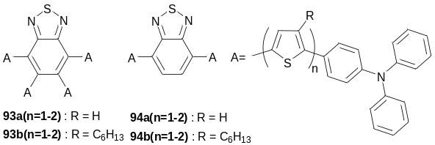

The synthesis of star-shaped oligothiophenes with an electron-rich triphenylamine core 95a,b and 95c has been performed using Stille and Suzuki coupling protocols, respectively. Bilayer photovoltaic cells of compounds 95a,b with C₆₀ as an acceptor gave power conversion efficiencies of η = 0.14 – 0.32%, which was substantially limited by a low fill factor of FF ~ 0.3. OFETs prepared with oligomers 95a by vacuum deposition showed reasonably high hole mobilities of µ_{FET} = 1.1 × 10^{–2} cm² V^{–1} s^{–1} (I_{on/off} ~170–200), which was substantially higher than in OFETs with the same materials, but spin-coated from solution (µ_{FET} = 10^{–5} cm² V^{–1} s^{–1}).

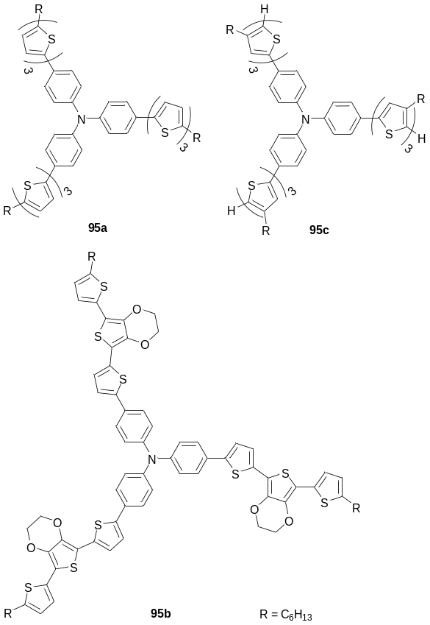

Bäuerle et al. decorated triphenylamine-core oligothiophenes with acceptor N-(2,4-diisopropylphenyl)peryleneimide (PMI) caps [96(n=2,4,6)]., They showed pronounced quenching of emission in solutions [e.g. in THF: Φ_{PL} = 0.003 and 0.004 for 96(n=2) and 96(n=4); cf.: Φ_{PL} = 0.80 (PMI), 0.28 (sexithiophene)] due to an efficient intramolecular charge transfer process. Femtosecond transition spectroscopy experiments, together with analysis of the process using Marcus theory, indicates that in the electron transfer (ET) process the thiophene arms are the first and only electron donors, whereas the triphenylamine core only serves to improve the electron-donating properties of the oligothiophene units.Error: Reference source not found A bulk heterojunction photovoltaic device with the structure ITO/PEDOT:PSS/96(n=2) : PCBM(1:4)/Al gave the following device characteristics: V_{oc} = 0.6 V, J_{sc} = 1.4 mA cm^{–2}, FF = 0.29 and η = 0.25% under standard AM 1.5 G source (100 mW cm^{–2}).198

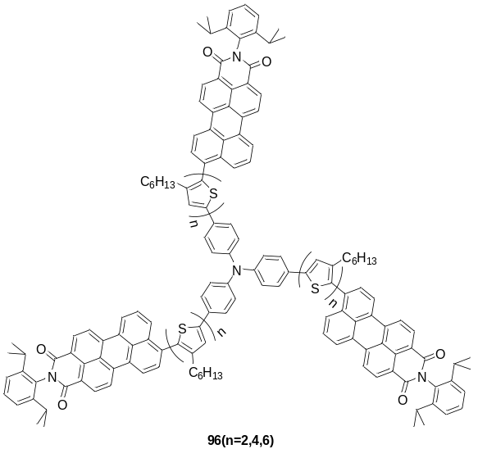

A four-fold star-shaped oligothiophene with a porphyrin core and end-capped with anthracene units 97 represents another example of a donor-acceptor conjugate; the compound was used to study transfer excitation energy in a given direction. Steady-state and picosecond time-resolved fluorescence measurements revealed that selective excitation of the anthracene donor moieties at 254 nm leads to an efficient unidirectional intramolecular energy transfer to the emitting porphyrin core via the oligothiophene bridges (two typical emission bands at ~650–800 nm). The efficiency of energy transfer and the fluorescence properties are both independent of the length of the oligothiophene chain.

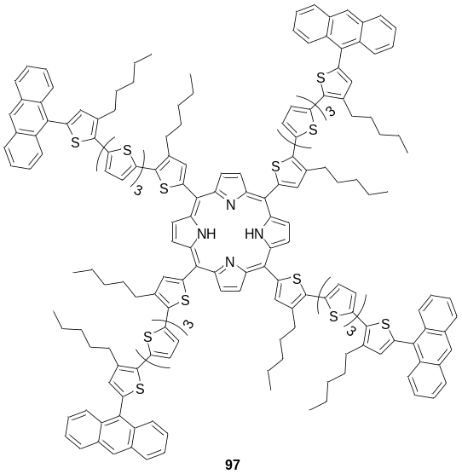

Structures 98 with six oligothiophene arms, α-linked to a central benzene core through sulfur atoms, have been synthesised using a nucleophilic substitution reaction under MacNicol conditions. For the shorter molecules 98(n=1,2), DSC only revealed a transition from a crystalline to an isotropic liquid phase, but for the longer oligomer 98(n=3) three liquid crystalline phases with different textures were observed: a smectic C phase (192 – 232 ºC), a smectic A phase (232 – 236 ºC) and a nematic phase (236 – 250 ºC). XRD analyses at 210 and 233 ºC demonstrated diffraction patterns characteristic of the two smectic phases with interlayer spacing of 35.7 and 36.4 Å, respectively. This suggests that compound 98(n=3) adopts a cylinder-type arrangement, in which the six terthiophene fragments are folded upwards and downwards alternatively. Notably, the material does not adopt the more expected disc-like conformation.

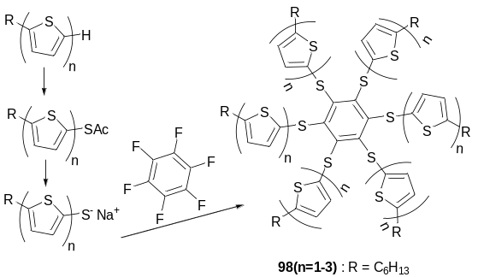

More recently, similar liquid crystalline behaviour (i.e. the formation of a highly ordered smectic phase), has been observed for a star-shaped structure consisting of quaterthiophenes linked through flexible aliphatic spacers to a carbosilane branching core 99. A series of OFETs has been fabricated using both drop-casting and spin-coating deposition techniques. The highest performance has been achieved for a spin-coated sample, annealed at 70 ºC in vacuo, with mobility µ_{FET} = 1 × 10^{–2} cm² V^{–1} s^{–1} and I_{on/off} = 10⁶.

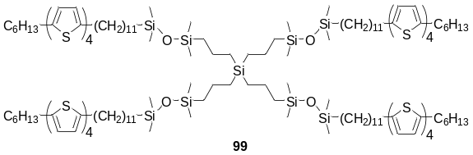

Another example of star-shaped systems with oligothiophene arms attached to a tetrahedral silicon core via flexible linkers are compounds 100, which have been synthesised via hydrosilylation of tetravinylsilane by 2,2'-bithiophen-5-yldimethylsilane in the presence of Speier’s catalyst, followed by stannylation and Stille coupling with the corresponding bromothiophene.

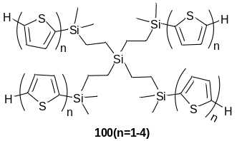

Shorter and more sterically crowded –(Me₂Si)– linkers have been used in the construction of 3D oligothiophenes 101. Evidence of intramolecular excimer formation between terthiophene arms in shorter oligomers 101(n=3) was obtained by both steady-state fluorescence spectroscopy and time-resolved PL measurements. The possibility of intramolecular excimer formation has been postulated to be caused by the rotation of the arms around the Si-Si bond, which places the terthiophene segments in close proximity to each other. In contrast, the longer oligomer 101(n=5) did not form excimers since the rotation is slowed down by the larger quinquethiophene arms.

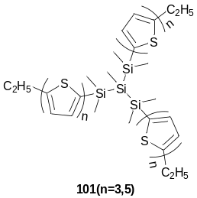

Direct linkage of the oligothiophene arms to a tetrahedral silicon core to form 3D rigid-rod structures has been realised in oligomers 102a,b, prepared by the condensation of oligothienyllithium with tetrachlorosilane. Small changes in solubilising end-capping substituents change the degree of solid-state ordering of the oligomers: whilst the absorption spectra of oligomer 102b in solution and in vacuum-deposited films are near identical, films of 102a (compared to solutions) showed a bathochromic shift and an appearance of vibronic structure (384 → 406, 427 nm). Non-optimised photovoltaic devices fabricated with these 3D oligomers showed better efficiency compared to linear 2,5’’-dihexylterthienyl (η = 0.17–0.20 % vs 0.04 %).
A star-shaped terthiophene with an sp³ carbon atom core and a pendant hexylthiol chain 103 has been prepared and used for deposition onto the surface of Au nanoparticles, which are in turn attached to an ITO surface with 3-mercaptopropyl-trimethoxysilane. Subsequent electrooxidation resulted in the coupling of adjacent oligomer arms, which was confirmed by spectral changes from the band at 375 nm representing the terthiophenes to that of the π-π* band of substituted sexithiophene (450 nm).

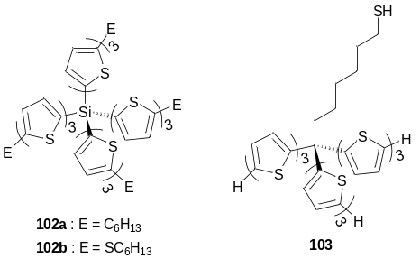

Tetraphenylmethane was used as a core to construct 3D tetrahedral oligothiophenes 104a(n=1-3). Suzuki coupling was found to be more efficient for the synthesis of these oligomers than the Kumada route. Two extended compounds 104a(n=2,3) have been converted into the corresponding carboxylic acids 104b(n=2,3), and esterified with polyethyleneglycol (PEG) to afford esters 104c(n=2,3). In organic solvents (THF, CHCl₃, EtOH) esters 104c(n=2,3) emitted bluish light (455 – 479 nm) with an high efficiency of Φ_{PL} = 14–16% and 31–34% (for n = 2 and 3, respectively). However, in aqueous solutions they showed red shifts in photoluminescence maxima (514–531 nm) and a marked reduction in emission efficiency down to Φ_{PL} = 3.2–3.5%.

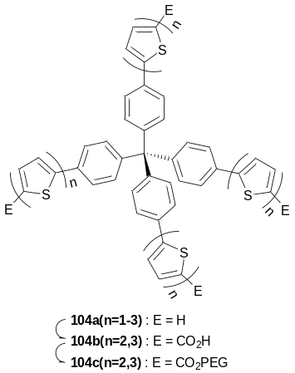

Negishi, Suzuki and Stille coupling protocols have been used for the synthesis of a series of star-shaped oligothiophenes 105, 106 and 107 with a spiro-9,9’-bifluorene core. The materials show good thermal stability (T_{d} ≈ 330–397 ºC) and their energy gaps range from 2.82–2.89 eV (for n = 0) to 2.20–2.3 eV (for n = 2). Analogous oligothienyleneethynylene and oligothiophene compounds 108 and 109 are also based on a spiro-core, but with a central silicon atom.Error: Reference source not found

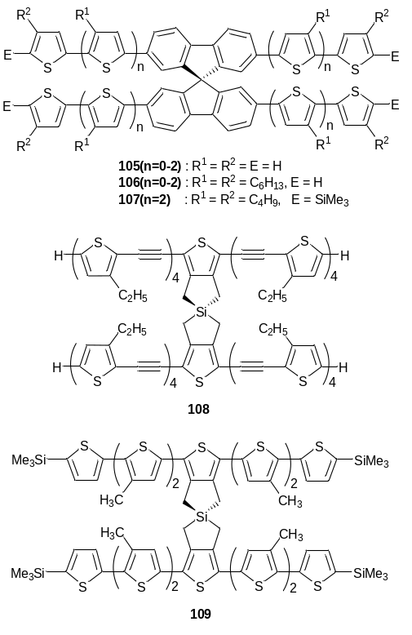

9. Summary and Outlook

From a synthetic chemist’s perspective, it is extremely pleasing and encouraging to see that the development of new materials for organic electronics stands well alongside progress in other areas of this field, such as materials processing, solid-state physics, photonics and device engineering. It has been said by some that materials design has reached its limit and that the major advances in device performance and efficiencies will be derived from innovations in processing and device architecture only. The counter-argument is that new materials and molecular architectures continue to provide surprises in form and function, beyond the predictable outcome of simple substituent effects and modifications to conventional, linear conjugated structures. This work presents one family of compounds, star-shaped conjugated structures, that provides convincing evidence that the application of new, unusual architectures in organic devices can provide improvements in performance and specific advantages over simple molecular and polymeric species. Conformational effects, intramolecular charge transfer and energy transfer, self-assembly (or lack of) and thermal behaviour are features that behave differently with respect to one-dimensional analogues of star-shaped structures. Compared to polymeric materials, the higher-dimensional monodisperse materials featured herein provide an indomitable degree of synthetic reproducibility and precise electronic characteristics. Moreover, star-shaped conjugated structures often feature the best attributes of conjugated polymers such as excellent film-forming properties, solution processability, compatibility in polymer blends and thermal stability. This promising family of compounds will remain at the forefront of organic semiconductor research, alongside other types of materials, and will undoubtedly provide further landmarks in physical properties and device performance.

Acknowledgements

PJS and ALK thank the EPSRC for funding under the HYPIX programme.

References

FIGURES CAPTIONS

Figure 1. Symmetry of the commonly used core structures.

Figure 2. Generating star-shaped architectures by applying axial symmetry operations to linear systems.

Figure 3. Divergent and convergent approaches for the synthesis of star-shaped oligomers.

Figure 4. Convergent syntheses of star-shaped architectures with simultaneous formation of the core structure.

Figure 5. Mode of anchoring of 3D star-shaped oligophenylenes terminated with surface active groups on the surface. Reproduced with permission from Ref. [61]

Figure 6 Comparison of the photoluminescence spectra of (a) 10a(n=1) and (b) 10a(n=2) in films at different excitation intensities, normalized to the maximum of each spectrum. Reproduced with permission from Ref. [Error: Reference source not found].

Figure 7. Atomic force microscopy (AFM) phase images of (a) 26d, (b) 26c, and (c) 26e. (d) Small-angle X-ray scattering (SAXS) pattern for 26c and 26d powder samples (intensities shown are on a log scale. Inset shows a simplified diagram of intercolumnar packing of 26c). (e) Wide-angle X-ray diffraction (WAXD) pattern for 26c and 26d powder samples. o-OXA-X = 26c, p-OXA-X 26d. Reproduced with permission from Ref. [Error: Reference source not found].

Figure8. AFM tapping mode phase images of 27 deposited from heptane solutions (1.1 × 10^{–5} M ) on silicon wafer: (a) scan size = 500 nm), (b) scan size = 200 nm and (d) on HOPG (scan size = 1 µm). (c) STM image of 27 at the 1-phenyloctane-HOPG interface. The unit cell is indicated. The longer dashed and shorter solid white lines connect the terminal phenyl groups of similarly oriented OPV units along unit cell vector b. Reproduced with permission from Ref. [Error: Reference source not found].

Figure 9. 2D-WAXS pattern recorded at 30 °C of 27 prepared as an extruded filament, (b) schematic representation of 27, and (c) schematic illustration of the helical columnar packing based on X-ray, CD and AFM data. Reproduced with permission from Ref. [Error: Reference source not found].

Figure 10. (a) Tapping mode AFM image showing fibres of 29a, drop-cast from water (10^{–5} M) onto a MICA surface (420 nm × 420 nm). (b) Proposed mode of co-aggregation of 29a with C₆₀. Reproduced with permission from Ref. [Error: Reference source not found].

Figure 11. Digitated stars under an uncrossed polarised microscope when the isotropic liquid of 30d is cooled slowly and the schematic representation of the columnar aggregate of 30d in the liquid-crystalline state. Reproduced with permission from Ref. [Error: Reference source not found].

Figure 12. (a) SEM images of direct laser written lines of microstructures into CHDV:0.5wt% 50(n=4) blend (left) and close up image (right). (b) Optical microscopy images of 4:5 Lissajous structure written in CHDV:1wt% 50(n=4) resulting in a line width of 2.5mm, observed under white-light (left) and 368 nm (right) illumination. (c) Photoluminescence spectrum of a single photoexcited micro-dot, together with (inset) optical micrographs of the full photoexcited array [a] and a single-photoexcited micro-dot [b]. Reproduced with permission from Ref. [Error: Reference source not found, Error: Reference source not found].

Figure 13. Laser emission spectra of 50(n=3) in the tuning range of 422-473 nm for different combinations of grating period and film thickness. Reproduced with permission from Ref. [Error: Reference source not found].

Figue 14. Photoluminescence spectra of 57(n=1-4) in THF solution (a) and in films (b), and EL spectra of OLED devices in ITO/PEDOT:PSS/polyTPD and PVK/57(n=2-4)/Ca/Al configuration (c); n = 1 (TOEF1), 2 (TOEF2), 3 (TOEF3), 4 (TOEF4). Reproduced with permission from Ref. [Error: Reference source not found].

Figure 15. Structure and energy alignments in triads 62(n=1-4) (shown as 1a-1d in the Figure). Reproduced with permission from Ref. [Error: Reference source not found].

Figure 16. Photographs of the fluorescent solutions of EB/ssDNA and EB/dsDNA in the absence (left) and presence (right) of 2µm 67 under 365nm UV radiation. [ssDNA or dsDNA] = 0.020 µm and [EB] = 2µm. Reproduced with permission from Ref. [Error: Reference source not found].

Figure 17. Confocal laser scanning (CLSM) fluorescence images of breast cancer cells (MCF-7) co-stained by 67 and EB: A) upon excitation at 488nm (an absorption wavelength of EB) and collection of fluorescence above 650 nm, B) upon excitation at 405nm and collection of fluorescence above 650 nm, and C) upon excitation at 405nm and collection of fluorescence from 430 to 470 nm. D) Overlapped images of B and C visualising the cytoplasm and the nucleus by blue and pink colours, respectively. Reproduced with permission from Ref. [Error: Reference source not found].

SCHEMES CAPTIONS

Scheme 1. Synthesis of oligophenylenes with a carbocation core.

Scheme 2. Synthesis of star-shaped oligothiophenes by SiCl₄-mediated formation of a benzene core from acetylthiophenes

Scheme 3. Synthesis of star-shaped oligothiophenes by convergent methodology using Kumada cross-coupling reaction.

Scheme 4. Synthesis of dendrimer 89 from dendron 90. Colours show chromophore fragments of different conjugation lengths.

GRAPHICAL ABSTRACT

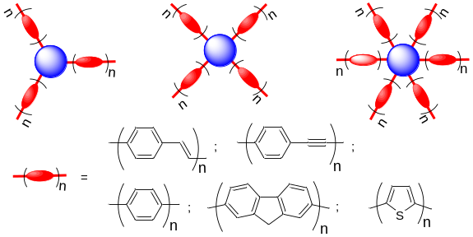

Star light, star bright – an overview of monodisperse macromolecules consisting of discrete cores and well-defined, radiating conjugated arms. Synthesis, properties and applications are discussed.

Part of the Conducting Polymers for Carbon Electronics themed issue.
J. W. Chen and Y. Cao, Acc. Chem. Res., 2009, 42, 1709–1718.
S. Gunes, H. Neugebauer and N. S. Sariciftci, Chem. Rev., 2007, 107, 1324–1338.
Y. J. Cheng, S. H. Yang and C. S. Hsu, Chem. Rev., 2009, 109, 5868–5923.
M. Helgesen, R. Sondergaard and F. C. Krebs, J. Mater. Chem., 2010, 20, 36–60.
G. Dennler, M. C. Scharber and C. J. Brabec, Adv. Mater., 2009, 21, 1323–1338.
K. M. Coakley and M. D. McGehee, Chem. Mater., 2004, 16, 4533-4542.
E. Bundgaard and F. C. Krebs, Solar Energy Materials & Solar Cells, 2007, 91, 954–985.
K. T. Kamtekar, A. P. Monkman and M. R. Bryce, Adv. Mater., 2010, 22, 572–582.
A. C. Grimsdale, K. L. Chan, R. E. Martin, P. G. Jokisz and A. B. Holmes, Chem. Rev., 2009, 109, 897–1091.
I. F. Perepichka, D. F. Perepichka, H. Meng and F. Wudl, Adv. Mater., 2005, 17, 2281–2305.
D. F. Perepichka, I. F. Perepichka, H. Meng, F. Wudl, in: Organic Light-Emitting Materials and Devices, ed. Z. R. Li and H. Meng, CRC Press, Boca Raton, FL, 2006, Chapter 2, pp. 45–293.
A. Facchetti, Mater. Today, 2007, 10, 28–37.
S. Allard, M. Forster, B. Souharce, H. Thiem and U. Scherf, Angew. Chem. Int. Ed., 2008, 47, 4070–4098.
D. T. McQuade, A. E. Pullen and T. M. Swager, Chem. Rev., 2000, 100, 2537–2574.
J. Bobacka, A. Ivaska, A. Lewenstam, Electroanalysis, 2003, 15, 366–374.
I. D. W. Samuel and G. A. Turnbull, Chem. Rev., 2007, 107, 1272–1295.
P. M. Beaujuge and J. R. Reynolds, Chem. Rev., 2010, 110, 268–320.
R. J. Mortimer, A. L. Dyer and J. R. Reynolds, Displays, 2006, 27, 2–18.
G. Sonmez, Chem. Commun., 2005, 5251–5259.
H. Hoppe and N. S. Sariciftci, J. Mater. Chem., 2006, 16, 45–61.
D. A. Pardo, G. E. Jabbour and N. Peyghambarian, Adv. Mater., 2000, 12, 1249–1252.
F. Padinger, C. J. Brabec, T. Fromherz, J. C. Hummelen and N. S. Sariciftci, Opto-Electronics Rev., 2000, 8, 280–283.
M. Singh, H. M. Haverinen, P. Dhagat and G. E. Jabbour, Adv. Mater., 2010, 22, 673–685.
F. C. Krebs, Org. Electronics, 2009, 10, 761–768.
D. Braga and G. Horowitz, Adv. Mater., 2009, 21, 1473–1486.
A. C. Arias, J. D. MacKenzie, I. McCulloch, J. Rivnay and A. Salleo, Chem. Rev., 2010, 110, 3–24.
M. Riede, T. Mueller, W. Tress, R. Schueppel and K. Leo, Nanotechnology, 2008, 19, 424001.
M. T. Lloyd, J. E. Anthony and G. G. Malliaras, Mater. Today, 2007, 10, 34–41.
Electronic Materials: The Oligomer Approach, ed. K. Müllen and G. Wegner,Wiley-VCH, Weinheim, 1998.
D. F. Perepichka and F. Rosei, Science, 2009, 323, 216–217.
J. Roncali, P. Leriche and A. Cravino, Adv. Mater. 2007, 19, 2045–2060.
K. S. Novoselov, A. K. Geim, S. V. Morozov, D. Jiang, Y. Zhang, S. V. Dubonos, I. V. Grigorieva, A. A. Firsov, Science, 2004, 306, 666–669.
K. S. Novoselov, A. K. Geim, S. V. Morozov, D. Jiang, M. I. Katsnelson, I. V. Grigorieva, S. V. Dubonos, A. A. Firsov, Nature, 2005, 438, 197–200.
A. K. Geim, K. S. Novoselov, Nature. Mater., 2007, 6, 183–191.
A. H. Castro Neto, F. Guinea, N. M. R. Peres, K. S. Novoselov, A. K. Geim, Rev. Modern Phys., 2009, 81, 109–162.
A. K. Geim, Science, 2009, 324, 1530–1534.
S. Sengupta, SynLett, 2004, 1191–1194.
S. Samori, S. Tojo, M. Fujitsuka, E. L. Splitler, M. M. Haley and Tetsuro Majima, J. Org. Chem., 2007, 72, 2785–2793.
A. L. Kanibolotsky, J.C. Forgie, G.J. McEntee, M. M. A.Talpur, P.J. Skabara, T. D. J. Westgate, J. J. W. McDouall, M. Auinger, S. J. Coles and M. B. Hursthouse, Chem. Eur. J., 2009, 15, 11581–11593.
X.-Y. Cao, W.-B. Zhang, J.-L. Wang, X.-H. Zhou, H. Lu and J. Pei, J. Am. Chem. Soc. 2003, 125, 12430–12431.
Modern Acetylene Chemistry; ed. P. J. Stang and F. Diederich, VCH, Weinheim, 1995.
C. D. Simpson, J. Wu, M. D. Watson and K. Müllen, J. Mater. Chem., 2004, 14, 494–504.
A. C. Grimsdale and K. Müllen, Chem. Record, 2001, 1, 243–257.
The Porphyrin Handbook, Volume 1: Synthesis and Organic Chemistry, ed. K. M. Kadish, K. M. Smith, R. Guillard, Academic Press, San Diego, 1999.
The Porphyrin Handbook, Volume 15: Phthalocyanine Synthesis, ed. K. M. Kadish, K. M. Smith, R. Guillard, Academic Press, Amsterdam, 2003.
W.-B. Zhang, W.-H. Jin, X.-H. Zhou and J. Pei, Tetrahedron, 2007, 63, 2907–2914.
K. Okumoto and Y. Shirota, Chem. Mater., 2003, 15, 699–707.
J. Lu, Y. Tao, M. D’iorio, Y. Li, J. Ding and M. Day, Macromolecules, 2004, 37, 2442–2449.
Y. Sakamoto, T. Suzuki, A. Miura, H. Fujikawa, S. Tokito and Y. Taga, J. Am. Chem. Soc., 2000, 122, 1832–1833.
Z. H. Li, M. S. Wong and Y. Tao, Tetrahedron, 2005, 61, 5277–5285.
W.-L. Jia, D. Song and S. Wang, J. Org. Chem., 2003, 68, 701–705.
S. Yamaguchi, T. Shirasaka and K. Tamao, Org. Lett., 2000, 2, 4129–4132.
F. B. Dias, S. Pollock, G. Hedley, L.-O. Pålsson, A. Monkman, I. I. Perepichka, I. F. Perepichka, M. Tavasli and M. R. Bryce, J. Phys. Chem. B, 2006, 110, 19329–19339.
A. N. Sobolev, V. K. Belsky, I. P. Romm, N. Yu. Chernikova and E. N. Guryanova, Acta. Cryst. C, 1985, 41, 967–971.
V. A. Naumov, S. Samdal, A. V. Naumov, S. Gundersen and H. V. Volden, Zh. Obshch. Khim., 2005, 75, 2046–2051 (in Russian), Russ. J. General Chem., 2005, 75, 1956–1961.
M.-Y. Chou, M.-k. Leung, Y. O. Su, C. L. Chiang, C.-C. Lin, J.-H. Liu, C.-K. Kuo and C.-Y. Mou, Chem. Mater. 2004, 16, 654–661.
For review, see Y. Shirota, J. Mater. Chem., 2000, 10, 1–25.
K. T. Kamtekar, C. Wang, S. Bettington, A. S. Batsanov, I. F. Perepichka, M. R. Bryce, J. H. Ahn, M. Rabinal and M. C. Petty, J. Mater. Chem., 2006, 16, 3823–3835.
H. Ogawa, K. Ohnishi and Y. Shirota, Synth. Metals, 1997, 91, 243–245.
X.-M. Liu, C. He, J. Huang and J. Xu, Chem. Mater. 2005, 17, 434–441.
X. Deng, A. Mayeux and C. Cai, J. Org. Chem. 2002, 67, 5279–5283.
Y. X. Yao and J. M. Tour, J. Org. Chem. 1999, 64, 1968–1971.
A. V. Rukavishnikov, A. Phadke, M. D. Lee, D. H. LaMunyon, P. A. Petukhov and J. F. W. Keana, Tetrahedron Lett., 1999, 40, 6353–6356.
N. Johansson, J. Salbeck, J. Bauer, F. Weissörtel, P. Bröms, A. Andersson and W. R. Salaneck, Adv. Mater., 1998, 10, 1136–1141.
T. Spehr, R. Pudzich, T. Fuhrmann and J. Salbeck, Org. Electronics, 2003, 4, 61–69.
U. S. Schubert, H. Hofmeier and G. R. Newkome, Modern Terpyridine Chemistry, Wiley-VCH: Weinheim, 2006.
H. Hofmeier and U. S. Schubert, Chem. Soc. Rev., 2004, 33, 373–399.
P. R. Andres and U. S. Schubert, Adv. Mater., 2004, 16, 1043–1068.
T. Bauer, A. D. Schlüter and J. Sakamoto, SynLett, 2010, 877–880.
H. Meier and S. Kim, Eur. J. Org. Chem., 2001, 1163–1167.
H. Meier, U. Stalmach and H. Kolshorn, Acta Polym., 1997, 48, 379–384.
S. Kim, H. Kalbitz, S. Hillmann and H. Meier, Eur. J. Org. Chem., 2009, 1976–1983.
H. Meier, H. C. Holst and A. Oehlhof, Eur. J. Org. Chem., 2003, 4173–4180.
L. Ventelon, S. Charier, L. Moreaux, J. Mertz and M. Blanchard-Desce, Angew. Chem., Int. Ed., 2001, 40, 2098–2101.
M. Rumi, J. E. Ehrlich, A. A. Heikal, J. W. Perry, S. Barlow, Z.-Y. Hu, D. McCord-Maughon, T. C. Parker, H. Röckel, S. Thayumanavan, S. R. Marder, D. Beljonne and J.-L. Brédas, J. Am. Chem. Soc., 2000, 122, 9500–9510;
S. K. Lee, W. J. Yang, J. J. Choi, C. H. Kim, S.-J. Jeon and B. R. Cho, Org. Lett., 2005, 7, 323–326.
C. Katan, F. Terenziani, O. Mongin, M. H. V. Werts, L. Porrés, T. Pons, J. Mertz, S. Tretiak and M. Blanchard-Desce, J. Phys. Chem. A, 2005, 109, 3024–3037.
P. C. Ray and J. Leszczynski, J. Phys. Chem. A, 2005, 109, 6689–6696.
C. Le Droumaguet, O. Mongin, M. H. V. Werts and M. Blanchard-Desce, Chem. Commun., 2005, 2802–2804.
Y.-X. Yan, X.-T. Tao, Y.-H. Sun, C.-K. Wang, G.-B. Xu, J.-X. Yang, Y. Ren, X. Zhao, Y.-Z. Wu, X.-Q. Yu and M.-H. Jiang, J. Mater. Chem., 2004, 14, 2995–3000.
A. Bhaskar, G. Ramakrishna, Z. Lu, R. Twieg, J. M. Hales, D. J. Hagan, E. V. Stryland and T. Goodson III, J. Am. Chem. Soc., 2006, 128, 11840–11849.
W. J. Yang, D. Y. Kim, C. H. Kim, M.-Y. Jeong, S. K. Lee, S.-J. Jeonand and B. R. Cho, Org. Lett., 2004, 6, 1389–1392.
J. Yoo, S. K. Yang, M.-Y. Jeong, H. C. Ahn, S.-J. Jeon and B. R. Cho, Org. Lett., 2003, 5, 645–648.
J. Brunel, O. Mongin, A. Jutand, I. Ledoux, J. Zyss and M. Blanchard-Desce. Chem. Mater. 2003, 15, 4139–4148.
R. Cho,K. H. Son, H. L. Sang,Y.-S. Song,Y.-K. Lee, S.-J. Jeon, J. H. Choi, H. Lee and M. Cho, J. Am. Chem. Soc., 2001, 123, 10039–10045.
Z. I. Niazimbetova, H. Y. Christian, Y. J. Bhandari, F. L. Beyer and M E. Galvin, J. Phys. Chem. B, 2004, 108, 8673–8681.
H. K. Christian-Pandya, Z. I. Niazimbetova, F. L. Beyer and, M. E. Galvin, Chem. Mater. 2007, 19, 993–1001.
S. Fratiloiu, K. Senthilkumar, F. C. Grozema, H. Christian-Pandya, Z. I. Niazimbetova, Y. J. Bhandari, M. E. Galvin and L. D. A. Siebbeles, Chem. Mater. 2006, 18, 2118–2129.
Z. Tomovic, J. van Dongen, S. J. George, H. Xu, W. Pisula, P. Leclere, M. M. J. Smulders, S. De Feyter, E. W. Meijer and A. P. H. J. Schenning, J. Am. Chem. Soc., 2007, 129, 16190–16196.
C. C. Lee, C. Grenier, E. W. Meijer and A. P. H. J. Schenning, Chem. Soc. Rev., 2009, 38, 671–683.
J. van Herrikhuyzen, P. Jonkheijm, A. P. H. J. Schenning and E. W. Meijer, Org. Biomol. Chem., 2006, 4, 1539–1545.
M. Wolffs, F. J. M. Hoeben, E. H. A. Beckers, A. P. H. J. Schenning and E. W. Meijer, J. Am. Chem. Soc., 2005, 127, 13484–13485.
M. Kimura, H. Narikawa, K. Ohta, K. Hanabusa, H. Shirai and N. Kobayashi, Chem. Mater., 2002, 14, 2711–2717.
A. P. H. J. Schenning, P. Jonkheijm, E. Peeters and E. W. Meijer, J. Am. Chem. Soc., 2001, 123, 409–416.
W. J. Oldham Jr., R. J. Lachicotte and G. C. Bazan, J. Am. Chem. Soc., 1998, 120, 2987–2988.
S. Wang, W. J. Oldham Jr., R. A. Hudack Jr. and G. C. Bazan, J. Am. Chem. Soc., 2000, 122, 5695–5709.
Y. Wang, M. I. Ranasinghe and T. Goodson III, J. Am. Chem. Soc., 2003, 125, 9562–9563.
S. Yamaguchi, T. Shirasaka and K. Tamao, Org. Lett., 2000, 2, 4129–4132.
L. Porres, O. Mongin, C. Katan, M. Charlot, T. Pons, J. Mertz and M. Blanchard-Desce, Org. Lett., 2004, 6, 47–50.
A. Winter, D. A. M. Egbe and U. S. Schubert, Org. Lett., 2007, 9, 2345–2348.
J. Gonzalo Rodrıguez and J. L. Tejedor, Tetrahedron, 2005, 61, 2047–2054.
J. Gonzalo Rodrı´guez, J. Esquivias, Antonio Lafuente and C. Dıaz, J. Org. Chem., 2003, 68, 8120–8128.
M. Kozaki and K, Okada, Org. Lett., 2004, 6, 485–488.
G. Kodis, Y. Terazono, P. A. Liddell, J. Andreasson, V. Garg, M. Hambourger, T. A. Moore, A. L. Moore and D. Gust, J. Am. Chem. Soc., 2006, 128, 1818–1827.
Q. Li, A. V. Rukavishnikov, P. A. Petukhov, T. O. Zaikova and J. F. W. Keana, Org. Lett., 2002, 4, 3631–3634.
Q. Li, A. V. Rukavishnikov, P. A. Petukhov, T. O. Zaikova, C. Jin and J. F. W. Keana, J. Org. Chem., 2003, 68, 4862–4869.
Polyfluorenes, ed. U. Scherf, D. Neher, Advances in Polymer Science, Vol. 212, Springer Verlag, Berlin, 2008.
M. Leclerc, J. Polym. Sci. A, Polym. Chem., 2001, 39, 2867–2873.
U. Scherf and E. J. W. List, Adv. Mater., 2002, 7, 477–487.
D. Neher, Macromol. Rapid Commun., 2001, 22, 1365–1385.
M. Knaapila, R. Stepanyan, B. P. Lyons, M. Torkkeli and A. P. Monkman, Adv. Funct. Mater., 2006, 16, 599–609.
R. Anémian, J.-C. Mulatier, C. Andraud, O. Stéphan and J.-C. Vial, Chem Commun., 2002, 1608–1609.
Y. Geng, A. Trajkovska, S. W. Culligan, J. J. Ou, H. M. P. Chen, D. Katsis and S. H. Chen, J. Am. Chem. Soc., 2003, 125, 14032–14038.
S. W. Culligan, Y. Geng, S. H. Chen, K. Klubek, K. M. Vaeth and C. W. Tang, Adv. Mater., 2003, 15, 1176–1180.
R. Güntner, T. Farrell, U. Scherf, T. Miteva, A. Yasuda and G. Nelles, J. Mater. Chem., 2004, 14, 2622–2626
J. Jo, C. Chi, S. Höger, G. Wegner and D. Y. Yoon, Chem. Eur. J,. 2004, 10, 2681–2688
C. Chi, C. Im, V. Enkelmann, A. Ziegler, G. Lieser and G. Wegner, Chem. Eur. J., 2005, 11, 6833–6845.
X. H. Zhou, J. C. Yan and J. Pei, Org. Lett., 2003, 5, 3543–3546.
K. M. Omer, A. L. Kanibolotsky, P. J. Skabara, I. F. Perepichka, D. D. C. Bradley, M. Koeberg and A. J. Bard, submitted.
S. Fratiloiu, F. C. Grozema, Y. Koizumi, S. Seki, A. Saeki, S. Tagawa, S. P. Dudek and L. D. A. Siebbeles, J. Phys. Chem. B, 2006, 110, 5984–5993.
A. L. Kanibolotsky, R. Berridge, P. J. Skabara, I. F. Perepichka, D. D. C. Bradley and M. Koeberg, J. Am. Chem. Soc., 2004, 126, 13695–13702.
M. M. Oliva, J. Casado, J. T. López Navarrete, R. Berridge, P. J. Skabara, A. L. Kanibolotsky and I. F. Perepichka, J. Phys. Chem. B, 2007, 111, 4026–4035.
K. M. Omer, A. L. Kanibolotsky, P. J. Skabara, I. F. Perepichka and A. J. Bard, J. Phys. Chem. B, 2007, 111, 6612–6619.
A. J. C. Kuehne, D. Elfstrom, A. R. Mackintosh, A. L. Kanibolotsky, B. Guilhabert, E. Gu, I. F. Perepichka, P. J. Skabara, M. D. Dawson and R. A. Pethrick, Adv. Mater., 2009, 21, 781–785.
M. Wu, E. Gu, A. Zarowna, A. L. Kanibolotsky, A. J. C. Kuehne, A. R. Mackintosh and P. R. Edwards, O. J. Rolinski, I. F. Perepichka, P. J. Skabara, R. W. Martin, R.A. Pethrick,, D. J. S. Birch and M. D. Dawson, Appl. Phys. A, 2009, 97, 119–123.
M. Wu, Z. Gong, A. J. C. Kuehne, A. L. Kanibolotsky, Y. J. Chen, I. F. Perepichka, A. R. Mackintosh, E. Gu, P. J. Skabara, R. A. Pethrick and M.D. Dawson, Opt. Express, 2009, 17, 16436–16443.
G. Tsiminis, Y. Wang, P. E. Shaw, A. L. Kanibolotsky, I. F. Perepichka, M. D. Dawson, P. J. Skabara, G. A. Turnbull and I. D. W. Samuel, Appl. Phys. Lett., 2009, 94, 243304.
Y. Wang, G. Tsiminis, A. L. Kanibolotsky, I. F. Perepichka, P. J. Skabara, G. A. Turnbull and I. D. W. Samuel, Synth. Metals, 2010, submitted.
W.-Y. Lai, R. Xia, Q.-Y. He, P. A. Levermore, W. Huang and D. D. C. Bradley, Adv. Mater., 2009, 21, 355–360.
Q.-Q. Chen, F. Liu, Z. Ma, B. Peng, W. Wei and W. Huang, Synlett., 2007, 3145–3148.
S.-C. Yuan, Q. Sun, T. Lei, B. Du, Y.-F. Li and J. Pei, Tetrahedron, 2009, 65, 4165–4172.
J. S. Yang, H. H. Huang and J. H. Ho, J. Phys. Chem. B, 2008, 112, 8871–8878.
J.-S. Yang, Y.-R. Lee, J.-L. Yan and M.-C. Lu, Org. Lett., 2006, 8, 5813–5816.
J.-S. Yang, H.-H. Huang, Y.-H. Liu and S.-M. Peng, Organic Letters, 2009, 11, 4942–4945.
F. Schindler, J. Jacob, A. C. Grimsdale, U. Scherf, K. Müllen, J. M. Lupton and J. Feldmann, Angew. Chem., Int. Ed., 2005, 44, 1520–1525.
K.-T. Wong, L.-C. Chi, S.-C. Huang, Y.-L. Liao, Y.-H. Liu and Wang, Org. Lett., 2006, 8, 5029–5032.
U. Scherf and K. Müllen, Makromol. Chem. Rapid Commun., 1991, 12, 489–497.
U. Scherf, J. Mater. Chem., 1999, 9, 1853–1864.
W.-Y. Lai, Q.-Y. He, R. Zhu, Q.-Q. Chen and W. Huang, Adv. Funct. Mater., 2008, 18, 265–276.
W.-Y. Lai, R. Zhu, Q.-L. Fan, L.-T. Hou, Y. Cao and W. Huang, Macromolecules, 2006, 39, 3707–3709.
R. Zhu, W.-Y. Lai, H.-Y. Wang, N. Yu, W. Wei, B. Peng, W. Huang, L.-T. Hou, J.-B. Peng and, Y. Cao, Appl. Phys. Lett., 2007, 90, 141909.
E. J. W. List, R. Guentner, P. S. de Freitas and U. Scherf, Adv. Mater., 2002, 14, 374–378.
X. Gong, P. K. Iyer, D. Moses, G. C. Bazan, A. J. Heeger and S. S. Xiao, Adv. Funct. Mater., 2003, 13, 325–329.
L. Romaner, A. Pogantsch, P. S. de Freitas, U. Scherf, M. Gaal, E. Zojer and E. J. W. List, Adv. Funct. Mater., 2003, 13, 597–601.
M. Sims, D. D. C. Bradley, M. Ariu, M. Koeberg, A. Asimakis, M. Grell and D. G. Lidzey, Adv. Funct. Mater., 2004, 14, 765–781.
P. A. Levermore, R. Xia, W. Lai, X. H. Wang, W. Huang and D. D. C. Bradley, J. Phys. D: Appl. Phys., 2007, 40, 1896–1901.
F. Liu, W.-Y. Lai, C. Tang, H.-B. Wu, Q.-Q. Chen, B. Peng, W. Wei, W. Huang and Y. Cao, Macromol. Rapid Commun., 2008, 29, 659-664.
R. Xia, W.-Y. Lai, P. A. Levermore, W. Huang and D. D. C. Bradley, Adv. Funct. Mater., 2009, 19, 2844–2850.
B. Li, J. Li, Y. Fu and Z. Bo, J. Am. Chem. Soc., 2004, 126, 3430–3431.
B. Li, X. Xu, M. Sun, Y. Fu, G. Yu, Y. Liu and Z. Bo, Macromolecules, 2006, 39, 456–461.
S. Speiser, Chem. Rev., 1996, 96, 1953–1976.
M. R. Wasielewski, J. Org. Chem., 2006, 71, 5051–5066
E. A. Weiss, M. J. Tauber, R. F. Kelley, M. J. Ahrens, M. A. Ratner and M. R. Wasielewski, J. Am. Chem. Soc., 2005, 127, 11842–11850
C. Atienza-Castellanos, M. Wielopolski, D. M. Guldi, C. van der Pol, M. R. Bryce, S. Filippone and N. Martín, Chem. Commun., 2007, 5164–5166.
V. A. Montes, C. Pérez-Bolívar, N. Agarwal, J. Shinar and P. Anzenbacher, Jr., J. Am. Chem. Soc., 2006, 128, 12436–12438.
D. Katsis, Y. H. Geng, J. J. Ou, S. W. Culligan, A. Trajkovska, Shaw H. Chen and L. J. Rothberg, Chem. Mater., 2002, 14, 1332–1339.
S. Jeeva and S. C. Moratti, Synthesis, 2007, 3323–3328.
A. C.-A. Chen, J. U. Wallace, S. K.-H. Wei, L. Zeng, S. H. Chen and T. N. Blanton, Chem. Mater., 2006, 18, 204–213.
C. V. Hoven, A. Garcia, G. C. Bazan and T.-Q. Nguyen, Adv. Mater., 2008, 20, 3793–3810.
B. S. Gaylord, A. J. Heeger and G. C. Bazan, J. Am. Chem. Soc., 2003, 125, 896–900.
S. Wang, B. S. Gaylord and G. C. Bazan, J. Am. Chem. Soc., 2004, 126, 5446–5451.
F. He, Y. Tang, S. Wang, Y. Li and D. Zhu, J. Am. Chem. Soc., 2005, 127, 12343–12346.
C. J. Yang, M. Pinto, K. Schanze and W. Tan, Angew. Chem. Int. Ed., 2005, 44, 2572–2576.
M. B. Abérem, A. Najari, H.-A. Ho, J.-F. Gravel, P. Nobert, D. Boudreau and M. Leclerc, Adv. Mater., 2006, 18, 2703–2707.
O. R. Miranda, C.-C. You, R. Phillips, I.-B. Kim, P. S. Ghosh, U. H. F. Bunz and V. M. Rotello, J. Am. Chem. Soc., 2007, 129, 9856–9857.
K.-Y. Pu, K. Li and B. Liu, Adv. Mater., 2010, 22, 643–646.
B. Liu, S. Wang, G. C. Bazan and A. Mikhailovsky, J. Am. Chem. Soc., 2003, 125, 13306–13307.
H. D. Burrows, V. M. M. Lobo, J. Pina, M. L. Ramos, J. Seixas de Melo, A. J. M. Valente, M. J. Tapia, S. Pradhan and U. Scherf, Macromolecules, 2004, 37, 7425-7427.
Handbook of Thiophene-Based Materials: Applications in Organic Electronics and Photonics, ed. I. F. Perepichka, D. F. Perepichka, Two-Volumes Set (Vol. 1: Synthesis and Theory, Vol. 2: Properties and Applications), Wiley, Chichester, 2009, 910 pp.
Handbook of Oligo- and Polythiophenes; ed. D. Fichou, Wiley-VCH: Weinheim, 1999.
Thiophenes, ed. S. Gronowitz and A.-B. Hörnfeldt, Elsevier Academic Press, San Diego, CA, 2004.
A. Mishra, C.-Q. Ma and P. Bäuerle, Chem. Rev., 2009, 109, 1141–1276.
A. Mishra, C.-Q. Ma, J. L. Segure and P. Bäuerle, in: Handbook of Thiophene-Based Materials: Applications in Organic Electronics and Photonics, ed. I. F. Perepichka, D. F. Perepichka, Wiley, Chichester, 2009, Vol. 1, Chapter 1, pp. 1–155.
P. J. Skabara, in: Handbook of Thiophene-Based Materials: Applications in Organic Electronics and Photonics, ed. I. F. Perepichka, D. F. Perepichka, Wiley, Chichester, 2009, Vol. 1, Chapter 3, pp. 219–254.
F. Cherioux and L. Guyard, Adv. Funct. Mater., 2001, 11, 305–309.
S. A. Ponomarenko, S. Kirchmeyer, A. Elschner, B. H. Huisman, A. Karbach and D. Drechsler, Adv. Funct. Mater., 2003, 13, 591–596.
Y. Geng, A. Fechtenkötter and K. Müllen, J. Mater. Chem., 2001, 11, 1634–1641.
T. M. Pappenfus and K.R. Mann, Org. Lett., 2002, 4, 3043–3046.
J. Casado, T. M. Pappenfus, V. Hernandez and J. L. Navarrete. J Chem. Phys., 2004, 120, 11874–11881.
J. Pei, J. L. Wang, X. Y. Cao, X. H. Zhou and W. B. Zhang, J. Amer. Chem. Soc., 2003, 125, 9944-9945.
J.-L. Wang, X.-F. Duan, B. Jiang, L.-B. Gan, J. Pei, C. He and Y.-F. Li, J. Org. Chem., 2006, 71, 4400-4410.
Y. M. Sun, K. Xiao, Y. Q. Liu, J. L. Wang, J. Pei, G. Yu and D. B. Zhu Adv. Funct. Mater., 2005, 15, 818–822.
C. Martineau, P. Blanchard, D. Rondeau, J. Delaunay and J. Roncali, Adv. Mater., 2002, 14, 283–287.
H. Wang, J.-L. Wang, S.-C. Yuan, J. Pei and W.-W. Pei, Tetrahedron, 2005, 61, 8465–8474.
J.-L. Wang, J. Luo, L.-H. Liu, Q.-F. Zhou, Y. Ma and J. Pei, Org. Lett., 2006, 8, 2281–2284.
Y. Nicolas, P. Blanchard, E. Levillain, M. Allain, N Mercier and J. Roncali, Org. Lett., 2004, 6, 273–276.
R. de Bettignies, Y. Nicolas, P. Blanchard, E. Levillain, J.-M. Nunzi and J. Roncali, Adv. Mater., 2003, 15, 1939–1943.
X. Sun, Y. Liu, S. Chen, W. Qiu, G. Yu, Y. Ma, T. Qi, H. Zhang, X. Xu and D. Zhu, Adv. Funct. Mater., 2006, 16, 917–925.
A. Bilge, A. Zen, M. Forster, H. Li, F. Galbrecht, B. S. Nehls, T. Farrell, D. Neher and U. Scherf, J. Mater. Chem., 2006, 16, 3177–3182.
X. Sun, Y. Zhou, W. Wu, Y. Liu, W. Tian, G. Yu, W. Qiu, S. Chen and D. Zhu, J. Phys. Chem. B 2006, 110, 7702–7707.
A. Zen, A. Bilge, F. Galbrecht, R. Alle, K. Meerholz, J. Grenzer, D. Neher, U. Scherf and T. Farrell, J. Am. Chem. Soc., 2006, 128, 3914–3915.
C.-Q. Ma, E. Mena-Osteritz, T. Debaerdemaeker, M. M. Wienk, R. A. J. Janssen and P. Bäuerle, Angew. Chem., Int. Ed., 2007, 46, 1679–1683.
T. Amaya, K. Mori, H.-L. Wu, S. Ishida, J. Nakamura, K. Murata and T. Hirao, Chem. Commun., 2007, 1902–1904.
P. Leriche, F. Piron, E. Ripaud, P. Frère, M. Allain and J. Roncali, Tetrahedron Letters, 2009, 50, 5673–5676.
W. Li, C. Du, F. Li, Y. Zhou, M. Fahlman, Z. Bo and F. Zhang, Chem. Mater., 2009, 21, 5327–5334.
A. Cravino, S. Roquet, O. Aleveque, P. Leriche, P. Frere and J. Roncali, Chem.Mater., 2006, 18, 2584–2590.
J.-C. Li, S.-H. Lee, Y.-B. Hahn, K.-J. Kim, K. Zong and Y.-S. Lee, Synth. Met., 2008, 158, 150–156.
A. Petrella, J. Cremer, L. De Cola, P. Bäuerle and R. M. Williams. J. Phys. Chem. A., 2005, 109, 11687-11695.
J. Cremer and P. Bäuerle. J. Mater. Chem., 2006, 16, 874–884.
M. S. Vollmer, F. Würthner, F. Effenberger, P. Emele, D. U. Meyer,T. Stümpfig, H. Port and H. C. Wolf, Chem. Eur. J., 1998, 4, 260–269.
S. Inoue, S. Nishiguchi, S. Murakami, Y. Aso, T. Otsubo, V. Vill, A. Mori and S. Ujiie, J. Chem. Research (S), 1999, 596–597.
S. A. Ponomarenko, E. A. Tatarinova, A. M. Muzafarov, S. Kirchmeyer, L. Brassat, A. Mourran, M. Moeller, S. Setayesh and D. de Leeuw, Chem. Mater. 2006, 18, 4101–4108.
P. Arsenyan, O. Pudova, J. Popelis and E. Lukevics, Tetrahedron Letters, 2004, 45, 3109–3111.
M. Fujitsuka, D. W. Cho, J. Ohshita, A. Kunai and T. Majima, J. Phys. Chem. C, 2007, 111, 1993–1998.
S. Roquet, R. de Bettignies, P. Leriche, A. Cravino and J. Roncali, J. Mater. Chem., 2006, 16, 3040–3045.
B. Vercelli, G. Zotti and A. Berlin Chem. Mater., 2007, 19, 443–452.
X.-M. Liu, C. He and J.-W. Xu, Tetrahedron Letters, 2004, 45, 1593–1597.
J. Pei, J. Ni, X.-H. Zhou, X.-Y. Cao, Y.-H. Lai, J. Org. Chem., 2002, 67, 4924–4936.
R. Wu, J. S. Schumm, D. L. Pearson and J. M. Tour, J. Org. Chem., 1996, 61, 6906–6921.
J. Pei, J. Ni, X.-H. Zhou, X.-Y. Cao and Y.-H. Lai, J. Org. Chem., 2002, 67, 8104–8113.

