Dependence of interfacial strength on the anisotropic fiber properties of jute reinforced composites
J. L. Thomason
University of Strathclyde, Department of Mechanical Engineering, 75 Montrose Street, Glasgow G1 1XJ, United Kingdom.

Abstract
The upsurge in research on natural fiber composites over the past decade has not yet delivered any major progress in large scale replacement of glass fiber in volume engineering applications. This paper presents data on injection molded jute reinforced polypropylene and gives a balanced comparison with equivalent glass reinforced materials. The poor performance of natural fibers as reinforcements is discussed and both chemical modification of the matrix and mercerization and silane treatment of the fibers are shown to have little significant effect on their level of reinforcement of polypropylene in comparison to glass fibers. A hypothesis is proposed to explain the poor performance of natural fibers relating their low level of interfacial strength to the anisotropic internal fiber structure.
Introduction
Glass fibers currently still represent more than 95% of the reinforcement fibers used globally in the composites industry. However, the increasing pressure on natural resources and the large amounts of energy required in glass fiber production has led to an upsurge in interest in the reinforcement potential of natural fibers, either as derived directly from various plant sources, or as regenerated cellulose fibers manufactured from naturally sustainable sources [1-14]. Part of the justification often used for the current intense level of research of natural fibers is their apparent potential to replace high carbon footprint glass fibers with a more environmentally friendly reinforcement [1-4]. However, commercial considerations require a certain level of reinforcement performance from such fibers and many researchers refer to the respectable and sometimes equivalent level of axial modulus exhibited by some natural fibers, which can be made to look even more attractive by comparing modulus/density ratios [1-11]. Typical examples of these data are shown in Table 1. It is clear from these data that, if one severely limits the range of performance requirements on a reinforcement fiber, it may be possible to make a case for direct replacement of glass fiber with some forms of natural fibers. However, material choice in any engineering application depends on the balance of price-processibility-performance, and one should carefully evaluate this balance for any material system. Further points to note in Table 1 are the large range of variability in the properties of natural fibers and the lower strength and higher diameter of natural fibers. It should further be noted that, for natural fibers, the range of diameters shown in Table 1 may actually all be present, whereas for glass fibers the range of diameters shows the range of different average diameters available in glass fiber products. In fact most natural “fibers” are non-circular and are actually composites in their own right. This is illustrated in Figure 1 which shows a microscopic view of a jute fiber in cross section. It can be observed that the fiber shown in this figure is actually a composite construction of many smaller units adhered together. This is typical of many natural fibers and is of great consequence when it comes to the discussion of fiber-matrix stress transfer and adhesion. A further important point which is often passed over when presenting the case for glass fiber replacement by natural fibers is the anisotropic nature of natural fibers which means that their transverse and shear modulus are orders of magnitude lower than the axial modulus values [12-14]. Nevertheless, it is a relatively simple exercise to use these axial data in typical rule-of-mixtures models for predicting composite performance to make a case for the possibility that some natural fibers have the potential to replace glass fibers. There has been an upsurge in research activity on natural fiber reinforced composites over the past decade based to some degree on these arguments. However, many researchers have reported disappointing levels of performance from their natural fiber composites which are significantly less than the level implied from such fiber property comparisons [1-13].

This disappointing level of reinforcement performance exhibited by many natural fibers is often discussed in terms of the challenges of obtaining good compatibility and adhesion between such fibers and polymer matrices. Optimization of the stress transfer capability of the fiber-matrix interphase region is critical to achieving the required performance level from composite materials. The ability to transfer stress across the fiber-matrix interphase in these composites is often reduced to a discussion of ‘adhesion’ which is a simple term to describe a combination of complex phenomena on which there is still significant debate as to what it means and how to measure it. Certainly, one of the generally accepted manifestations of ‘adhesion’ is in the mechanically measured value of interfacial shear strength (IFSS). The frequent inability of natural fibers to deliver an acceptable level of composite reinforcement is often explained by a poor level of IFSS. In particular, with thermoplastic matrix composites, reference is often made to the poor level of chemical compatibility between apolar polyolefin matrices and the polar materials found in natural fibers [1-12]. The early history of the research and development of composite materials is dominated by the use of chemically reactive thermosetting polymers. A natural consequence of this fact is that much of the published work relating to adhesion and stress transfer at the fiber-matrix interface has been grounded in the assumption that chemical bonds play a key role. Consequently there are many ongoing research activities investigating chemical modification of either natural fiber surfaces or the polymer matrix or both. In the field of natural fiber reinforced polyolefins the chemical modification approach has typically followed the routes already identified as successful in improving the performance of glass fiber reinforced composites. Thus silane modification of fiber surfaces and the use of maleic anhydride modified polyolefins (MAP) as matrix additives have been investigated by many groups [1-12]. This work can also be summarized by saying that silane modification of the interface has been significantly less successful with natural fibers in comparison with glass fibers. The use of MAPs has had some better results but in general these additives must be used in much greater concentrations than is typical in glass fiber reinforced systems and also show significantly less effect. Moreover, many researchers in this area do not fully take into account the cost of such large scale chemical modifications on the overall financial picture for these composite materials. The apparent relative cost advantage of natural fiber can be rapidly diminished by the necessity of using expensive chemical methods to improve composite performance.

To date the influence of the anisotropic physical structure of natural fibers, although often commented on, has received little attention. Characterization of fiber mechanical performance is an exacting task with many potential pitfalls; however it is intuitively obvious that most fiber testing will be least challenging experimentally when characterizing axial properties. The characterization of the transverse properties of a reinforcement fiber [12-14] is a much greater challenge. Cichocki and Thomason have published [14] one of the very few papers on jute reinforced composites where a full thermo-mechanical characterization of the fiber was carried out and they quantified very high levels of anisotropy in these fibers. This paper will present data on the performance of injection molded jute reinforced polypropylene and give a balanced comparison with equivalent glass reinforced polypropylene materials. The analysis of this data will be shown to be in support of the above comments on the disappointing performance of natural fibers in comparison to some of the expectations initiated from the fiber tensile properties. Secondly, data will be presented on the effects of chemical modification of the interface in the jute-polypropylene composites. Both chemical modification of the PP matrix and mercerization and silane treatment of the fibers will also be shown to have limited effect on the level of natural fiber reinforcement of polypropylene in comparison to glass fibers. Finally the thermo-elastic anisotropy of natural fiber will be discussed. This is an area which is often acknowledged by researchers in the field but is mostly ignored in any further prediction of composite performance or analysis of experimental data. A hypothesis based on the fiber anisotropy will be proposed which may explain the poor performance, in comparison to expectation and to glass fiber performance, of natural fibers in many composite systems. If proved correct, this hypothesis could also have significant implications for the nature of the research required to successfully develop improved performance natural fiber reinforced thermoplastic composites.

Experimental
The long natural fiber polypropylene (LNFPP) compounds used in this investigation have been produced using a crosshead extrusion wire coating process in combination with a proprietary sizing technology as previously described [15,16]. This process ensured excellent dispersion of the jute fibers at low injection molding temperatures used to minimize the level of fiber thermal degradation [15,16]. A three ply jute yarn, linear density 2.9 g/m, three ply twist average of 108 S twists per meter and a single ply twist average of 84 Z twists per meter (Lehigh Company) was used, as received or after surface treatment, with polypropylene P4C6Z-059 polypropylene, MFI=35 g/10min, (Huntsman Corporation) to produce LNFPP composites. The yarn was pulled through the crosshead coating device which was fed with PP melt at 225°C from the attached single screw extruder. When required, the level of fiber-matrix interaction in some systems was changed by the addition of the desired amount of Polybond 3200 MAP coupling agent dry blended with the PP pellets fed to the extruder. On exit from the die the coated yarn was cooled in a water bath and chopped into pellets of 12.5 mm length. The fiber to polymer ratio of the pellets was controlled by adjusting the extruder throughput in accordance with the linear density of the fiber yarn, the pulling speed of 30 m/min, and the desired fiber content. The fiber content was measured from the linear density of meter lengths of the coated fibers isolated prior to chopping. When required sizing was applied to the jute yarn via an inline continuous applicator positioned before the entry to the crosshead coating die [15].

The compounds were dried at 90°C for 6 hours prior to injection molding using a 200-ton Cincinnati Milacron molding machine with a 225 g barrel capacity. The temperature profile from the hopper to the mould varied as follows: rear 143°C, centre 199°C, front 188°C, nozzle 188°C, mould 54°C. Boost injection pressures typically ranged between 3.10 and 3.45 MPa and were followed by hold pressures of ~2.20-2.35 MPa. A back pressure of 1.21 MPa led to a screw recovery time of ~20s. The mould was designed to produce a number of standard test specimens in one shot, all test bars and disks were single end gated. Unless otherwise stated, all mechanical property testing was performed at 23°C and at a relative humidity of 50%. Tensile properties were measured in accordance with the procedures in ASTM D-638, using five ASTM Type I specimens at a crosshead rate of 5 mm/min (0.2 in./min) and an extensometer gauge length of 50 mm (2 in.). Flexural properties were measured on five specimens in accordance with the procedures in ASTM D-790, at a crosshead rate of 2.5 mm/min (0.1 in. /min) and a span width of 50 mm (2 in.). The preparation of the glass fiber PP composites referenced in this work has been described previously [17,18]. These glass fiber PP materials were, in general, prepared using the same equipment and conditions as described above.

The tensile strengths of single jute fibers were determined according to the ASTM D3322-01 Standard Test Method for Tensile Properties of Single Fibers. The measurements were conducted on 100 single fibers using an Instron Corporation Series IX Automated Materials Testing System with a 50N load cell at a gauge length of 70 mm and a strain rate of 0.1/min. Another well known characteristic of natural fibers is their non-circular cross section which complicates the calculation of fiber failure stress and also introduces some uncertainty into the application of standard methods developed for analysis of circular cross section fibers. In common with other groups an equivalent diameter method was applied. Short lengths of the tested fiber, taken far from the fracture zone, were mounted in epoxy and prepared for microscopic analysis after fiber strength testing. The mounted fibers were sectioned orthogonal to their lengths and examined with an optical microscope (example shown in Figure 1). The cross-sectional areas (A) of each fiber at three locations along its length were measured (using Leica Q500 stereological software) and averaged to arrive at an estimate for fiber cross-sectional area. The equivalent diameter (D) of a circular cross section of equal area was also calculated using D=( 4A/π)^{½}. In order to quantify fiber length, the jute fibers were isolated from injection molded composite samples by dissolving off the polypropylene matrix in hot toluene. Fibers were collected and distributed in a thin layer over a microscope slide. Image analysis software was then used to measure the fiber lengths and compile fiber length distribution data.

Jute yarn was dried at 80°C until constant weight before treatment; an average weight loss (water content) of 9.0% was recorded. Mercerization was carried out on as received (900 g) rolls of jute yarn by total immersion in a 5% NaOH solution for 90 minutes at room temperature. The samples were then drained and rinsed frequently in distilled water, with a final rinse in 0.1% citric acid solution, followed by drying at 80°C for approximately 3 days until constant weight was achieved. An average weight loss of 7.7% was recorded on dried NaOH treated samples, control samples which were only treated with distilled water exhibited only 0.4% weight loss. For silane treatment the predried jute was soaked in a 1% silane solution for 15 minutes and then allowed to drain naturally for a further 15 minutes at which time the weight of the silane soaked jute was recorded. These samples were dried at 80ºC for 3 days until constant weight was achieved. The silane content of the jute was calculated from the known concentration of the silane solution and the weight of solution taken up by the jute prior to drying. Silane contents were in the range 1.5-1.7% by weight of jute for all samples. Silane coupling agents APTES (aminopropyltriethoxysilane), MTMS (Methyltrimethoxysilane), MPTMS (methacryloxypropyltriethoxysilane) , OTES(n-octyltriethoxysilane) GPTMS (Gamma-glycidoxypropyltrimethoxysilane) (Crompton OSi Specialities) were used as received.

Results and Discussion
Figure 2 presents results for the modulus of LNFPP as a function of fiber content and the level of MAP added to the system. This figure also includes values of modulus calculated using the modified rule-of-mixtures [17] shown in equation 1.
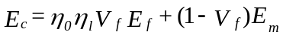 (1)
Input values used were E_{f}=40 GPa, E_{m}=1.3 GPa, η_{o}=0.65 [17], η_{l} calculated using a fiber length of 3.5 mm, and V_{f} calculated using densities ρ_{nf}=1400 kg/m³ and ρ_{gf}=2600 kg/m³. It can be seen that the modulus of the system increases significantly with increasing natural fiber content. At 30% weight NF level there is an approximate 200% increase in tensile modulus above that of unreinforced PP. However, it is also clear that the measured value of modulus of the LNFPP system is significantly lower that the levels predicted by using the longitudinal fiber modulus (40 GPa) in equation 1. Furthermore, at the 30% weight reinforcement level the LNFPP modulus is only approximately 60% of the 6-7 GPa modulus typical of an injection molded 30% GF-PP material [17, 18]. The addition of MAP does not appear to have any significant effect on the modulus of LNFPP. Similarly Figure 3 presents results for the strength of LNFPP as a function of fiber content and the level of MAP added to the system. It can be seen that addition of natural fiber to PP actually reduced the tensile strength of the system, with a greater reduction in strength with increasing fiber content. The tensile strength is increased with increasing fiber content when 2% MAP is present in the PP matrix. It can also be seen that the flexural strength of the system is higher than the tensile strength on average by a factor of approximately 1.6. This ratio of flexural to tensile strength has been observed in a number of composite systems [19,20]. In general it can be seen that the flexural strength is little improved by addition of natural fiber unless MAP is present in the PP matrix. It can be commented that the addition of NF to PP does increase the strength performance by up to 30% when MAP is used as a coupling agent. However, the data in Figure 4 puts this statement into some perspective and shows similar data for the strength of injection molded short glass fiber reinforced PP. It can be seen that the addition of short glass fiber to PP leads to significant improvements in strength performance even in the absence of MAP coupling agent. When 2% MAP is added to the PP matrix, increases in strength greater than 200% can be achieved over the base PP matrix. Both Figures 3 and 4 are based on weight fraction of fiber, however composite properties are known to scale with fiber volume fraction. Figure 5 compares the reinforcement effect of LNFPP versus SGFPP as a function of fiber volume fraction in a 2% MAP PP matrix. This Figure makes clear the difference in the reinforcement performance levels of glass and natural fiber and emphasizes the challenge to natural fiber materials developers to fulfill the idea of glass fiber replacement.

Figure 6 compares the influence of the MAP matrix concentration of the strength performance in LNFPP and SGFPP. The data in this Figure again confirms the large difference in reinforcement performance level of glass fibers versus natural fibers in PP. Without MAP added to the matrix there is already a significant difference between the strength levels in these materials. The LNFPP system responds very weakly to the addition of MAP and appears to reach a maximum at around 4% added MAP. The SGFPP system responds much more quickly to the addition of MAP and reaches a plateau level already at 0.5% addition. At this low concentration of MAP the SGFPP system shows a 50% increase in strength compared to the LNFPP increase of only 25% which requires an eight times higher concentration. As previously mentioned this requirement for high MAP levels has significant negative implications for the cost of the LNFPP system. Figure 7 shows the effect of NaOH treatment of jute fibers in combination with 2% added MAP in the PP matrix on the tensile and flexural performance of 20% LNFPP composites. It can be observed that addition of 20% water treated jute fibers has no significant effect on the tensile strength of PP whether or not MAP is present. NaOH pretreatment of the fibers also has no significant effect on composite tensile strength. Only the combination of NaOH fiber pretreatment and added MAP resulted in a small, but significant, increase in tensile strength. In the case of the composite flexural strength the addition of 20% jute fibers either the control water treated or NaOH treated led to only a minor increase over the PP resin alone. Once again the combination of NaOH fiber treatment and added MAP lead to the greatest effect on flexural strength.

As previously discussed it has often been suggested that the use of silane coupling agents may also improve the interface in natural fiber composites. These multifunctional molecules have been extremely important to the growth in the use of glass fibers for composite reinforcement. It is thought that hydrolyzed silane molecules have the ability to react by condensation reaction with the many hydroxyl groups which are present in the chemical components of natural fibers. In Figure 8 results of a screening experiment on a number of common silanes are presented, in this case only the more positive results for the MAP modified matrix are presented. Once again it can be seen that the surface treatment of jute fiber with either silane alone or silane treatment after NaOH treatment has little significant effect on the tensile strength of 20% LNFPP composites and also brings little improvement in comparison with the PP alone. Furthermore, an increase in flexural strength of a similar level as that observed in Figures 3 and 7 can be seen in Figure 8. However, the results on composite strength obtained in these experiments, cannot be said to likely be a cost effective route to improving natural fiber composite performance. Figures 9 and 10 present some results from another investigation of the application of silane coupling agents to the modification of the interface in LNFPP. In this case, a more cost effective route of inline silane application during the compounding process was used [15]. The results shown in these two figures reconfirm the conclusion from previous figures that the addition of 20% jute to PP does lead to a significant increase in modulus (although not as great as the increase predicted by simple rule-of-mixtures calculations) but brings very little improvement in the tensile strength of the material. Furthermore it can be seen once again that the addition of silane coupling agents to the system has little significant effect. Finally, to put these results into perspective, Figures 9 and 10 also contain data on short glass fiber reinforcement of the same PP matrices. Data for SGFPP are presented at both equal fiber weight fraction (20%) and equal fiber volume fraction (≈0.135) as the LNFPP samples. The results in these two figures emphasize the extent of the challenge still facing natural fibers if they are to be used as a direct replacement for glass fibers. Indeed, considering that the NF composites shown in these figures were manufactured using long fiber technology a more realistic comparison would require the use of long glass fiber PP data which would have significantly higher strength performance than the 80-90 MPa shown for SGFPP in Figure 10. As a final point it is relevant to observe that, although the results for reinforcement performance of NF versus GF are not that impressive for composite modulus and quite poor for composite strength, it is well known that the results for impact performance of natural fiber composites are an even greater challenge.

It would appear from the above results and discussion that, in general, natural fibers do not deliver the level of reinforcement of polypropylene that might be anticipated from the initial analysis of their longitudinal modulus combined with their low density. This is apparent from low values of composite modulus and a neutral to negative effect on composite strength. Furthermore the use of chemical methods to improve fiber-matrix interaction does not appear to deliver significant improvements in the performance of natural fiber reinforced PP in comparison to glass fiber reinforcement. It can be suggested that one of the principal reasons for this poor performance is the internal anisotropic structure of these natural fibers. The level of thermo-mechanical orthotropicity of jute fibers has recently been quantified [14] and it is of interest to note that the transverse and shear moduli of these fibers are an order of magnitude lower than the longitudinal modulus. This significantly lower level of transverse and shear modulus explains the lower than expected moduli of natural fiber composite where a large fraction of the fibers are loaded off-axis, as is the case with most injection and compression molded thermoplastics. Moreover, it seems likely that the orthotropic physical nature of natural fibers may also have an important influence on the stress transfer capability of the fiber-matrix interface.

Despite the high level of focus on the chemical nature of interfacial ‘adhesion’ and interface modification, a number of authors have also commented on the role of shrinkage stresses contributing to the stress transfer capability at the fiber-matrix interface [18-27]. Thermoplastic composite materials are generally shaped at elevated temperature and then cooled. Since in most cases the thermal expansion coefficients of polymers are much greater than reinforcement fibers this cooling process results in compressive radial stress σ_{r} at the interface [23]. Assuming that the coefficient of static friction (β) at the interface is non-zero these compressive stresses will contribute a frictional component τ_{f}= β. σ_{r} to the apparent shear strength of the interface. In a series of recent publications [17,18,24-27] Thomason has examined the level of apparent IFSS in a number of glass fiber reinforced thermoplastic systems and shown clearly how the results obtained can in fact be well modeled by assuming that the main component of the IFSS is actually due to a static friction at the fiber-polymer interface calculated using Nairn’s model [23]. Thomason has furthermore shown how the addition of 2% MAP to SGFPP leads to an increase of the apparent IFSS of approximately 6.5 MPa across a glass fiber content of 10-40%wt. However, it was also shown that, using the calculated residual interfacial compressive stress for the various fiber contents, the increase in IFSS could equally well be explained by an increase in the fiber-matrix static coefficient of friction (β) from 0.4 to 0.7. It was proposed that such an increase in β could be explained by an increased level of fiber-polymer interfacial contact area on a nanoscale due to an improved wetting of the fiber surface by the higher polarity MAP matrix [17,27]. Schoolenberg [28] has reported a value of similar order of magnitude β=0.65 for GF-PP.

It would appear from the foregoing results and discussion that we can make a case for residual thermal stresses contributing a significant amount to the apparent IFSS in thermoplastic composites. Moreover, the relative proportion of this contribution is higher in polyolefin based composites where the levels of other fiber-matrix physical and chemical interaction are low. The magnitude of these residual stresses can be adequately estimated using models such as that of Nairn [23]. The main missing requirement in converting these residual stresses into IFSS is an accurate estimation of the coefficient of static friction for any particular system. A better understating of the role of wetting and interfacial interaction on this coefficient of friction is also required. It may be that many of the chemical modifications applied to thermoplastic composites which are assumed to improve adhesion through increased chemical bonding across the interface may actually be changing the level of matrix-fiber wetting and consequently the static coefficient of friction. Notwithstanding these points it is interesting to compare the relative levels of residual compressive stress in polypropylene composites where different reinforcements are used. Unlike glass, many of the other typical reinforcement fibers available are highly orthotropic in their mechanical and thermal properties and this may have significant influence on the residual stress state in any composite.

This point is illustrated in Figure 11 which shows results of calculations of the residual radial compressive stress present at the fiber-matrix interface in polypropylene containing glass, carbon, aramid and natural (jute) reinforcing fibers. The relevant input parameters for the calculation are given in Table 2 [14,22-24]. As indicated above it can be seen from Table 2 that carbon, aramid and jute are highly orthotropic in comparison with glass. These fibers all have small but negative LCTE’s in the fiber direction and much larger positive LCTE’s (in some cases approaching polymer matrix values) in the transverse direction. The effect of this anisotropy is clearly illustrated in Figure 11. All these systems exhibit compressive residual radial stress at the interface at room temperature and all show a mild dependence on the fiber content. However, the magnitude of these residual stresses is strongly dependent on the fiber properties. Glass fibers exhibit the highest levels of residual stress with carbon fibers lower but at a similar level. Aramid fibers show significantly lower levels and the natural fibers have a very low level of residual radial compressive stress at all fiber contents. These results are well in line with the generally accepted view on interfacial adhesion in thermoplastic composites that glass and carbon are often well bonded, aramid fibers present some challenges to obtained good adhesion, and that there are very low levels of IFSS in natural fiber composites. Although the explanations and remedies for these issues are often sought in the chemistry of the system, these results suggest that, for improved reinforcement of polyolefins, we also need to better understand the role of fiber structure, the levels of residual stress, and the interfacial friction, on the apparent interfacial strength in thermoplastic composites.

This analysis can be carried further by noting the average level of calculated residual compressive stress at the interface in the jute-PP system in Figure 11 is approximately 3MPa. In the absence of values for β in this system we can approximate the potential IFSS contribution in jute-PP using the GF-PP values [27] of β=0.4 for unmodified PP matrix and β=0.7 for a 2% MAP modified matrix. By this means we obtain a value for the IFSS in the jute-PP system with or without the use of MAP. This is one of the input values required in the Kelly-Tyson model [29] for the prediction of composite strength which has been well validated for the GF-PP system [17,18,24,26]. Further required input parameters for this system were obtained from the fiber characterization. Results from the measurement of fiber strength are presented in Figure 12 as a Weibull plot, which is a standard form of presentation of fiber strength data at a single gage length. The data can be well fit by a single straight line in this plot indicating that the simple two parameter Weibull analysis can be used to describe the strength-gage length relationship where the probability of failure P of any fiber at stress σ and gage length L is given by
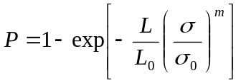 (2)
Where m is the Weibull modulus, σ₀ is the characteristic strength and L₀ is a reference length. From the slope of the line in Figure 12 we obtain a value of the Weibull modulus of 3.1 which falls well in the range of values 2.5-3.5 reported fro the Weibull modulus of single jute fibers [30,31]. Moreover, the average fiber strength of 420 MPa (95% confidence limit ±28MPa) at this gage length correlates well with the other reported values [31]. The distribution of equivalent diameter for the jute fibers in this study is presented in Figure 13. This figure illustrates one of the characteristics of natural fibers in that the distribution of diameters is extremely wide in comparison to typical man-made reinforcement fibers, an average diameter of 42 μm (95% confidence limit ±0.9 μm) was obtained. Fiber length distributions for six analyzed injection molded composites in this study are presented in Figure 14. There was little significant difference found between the distributions shown in Figure 14 and so a weight average fiber length for all six composite was calculated as 3.5 mm (95% confidence limit ±0.5 mm). Using these input values, the predicted tensile strength for the composites shown in Figure 3 have been calculated using the Kelly-Tyson equation [26,29] and the results are present in Figure 15. In both cases it can be seen that, the strengths predicted by the model for the jute-PP system with and without MAP match well with the measured tensile strengths.

Consequently, it appears that it is possible to predict a value of the stress transfer capability of a natural fiber – polypropylene interface (the IFSS) purely from the thermo-mechanical characteristics of the fiber and polymer and the level of static friction at the interface. Using this value of IFSS as input for the Kelly-Tyson equation it is further possible to predict a failure stress of these natural fiber composites close to the experimentally observed values. Moreover, this analysis is also able to match the experimentally observed trends for the effects of fiber content and matrix modification using MAP of the composite strength. It would appear from the above analysis that it is possible to fully explain the low levels of tensile strength exhibited by injection molded LNFPP using existing strength prediction models and the assumption that an apparent IFSS for the system can be calculated directly from the residual compressive interfacial stress and appropriate values for the static coefficient system of the system. Moreover, this analysis relates the poor level of performance in this LNFPP system directly to the anisotropic nature of the fiber morphology.
Conclusions
One of the most commonly used justifications for research and development activity of natural fibers is that the properties of some of these fibers, usually the modulus or specific modulus, can match that of glass fibers which still currently account for >95% of the reinforcement fibers used in the composite industry. This fact is then further compounded with simple micromechanical models to imply that it should also be possible to match the performance of glass reinforced polymers with similarly manufactured natural fiber materials. However, an overwhelming number of the published results based on such justifications have failed to fulfill these expectations and the natural fibers show only moderate reinforcement in modulus and very little significant positive effect on composite strength in comparison to glass fibers. Such results are often explained in terms of the poor interfacial compatibility between many natural fibers and polymers. However, it is also becoming clear that many research programmes based on this hypothesis and subsequently on surface and interfacial modification of natural fibers are also failing to show substantial (and economically acceptable) improvements in composite performance. The data on injection molded long fiber jute reinforced polypropylene presented here support the above conclusion. Addition of jute fiber to polypropylene led to some increase in modulus, although much less than expected from a rule-of-mixtures analysis. The strength of polypropylene was significantly reduced by the addition of untreated natural fibers. Furthermore, in comparison to the magnitude of the effects in glass fiber reinforced polypropylene, chemical modification of the matrix using MAP, and surface modification of the natural fibers using mercerization and silane treatments resulted in little significant improvement in strength.

It is concluded that one of the principal reasons for this poor reinforcement performance is the internal anisotropic structure of these natural fibers. The level of thermo-mechanical orthotropicity of most natural fibers results in transverse and shear moduli of these fibers an order of magnitude lower than the longitudinal modulus which consequently delivers significantly lower than expected moduli for natural fiber composites. Furthermore, the orthotropic physical nature of natural fibers also has an important influence on the stress transfer capability of the fiber-matrix interface. It is shown possible to predict a value of the stress transfer capability of a natural fiber – polypropylene interface purely from the level of static friction at the interface and the residual compressive interfacial stress as determined by the orthotropic thermo-mechanical characteristics of the natural fibers. Using this value of IFSS as input for the Kelly-Tyson equation it is further possible to predict the strength of these natural fiber composites close to the experimentally observed values. Moreover, this analysis is also able to match the experimentally observed trends for the effects of fiber content and matrix modification using MAP of the composite strength. It is suggested that only by fully understanding the internal structure-performance relationships of these complex composite like fibers can we hope to significantly improve the performance levels of natural fiber reinforced composites.

Acknowledgement

The author gratefully acknowledges OCV Reinforcements, a division of Owens Corning, for their permission to publish the data on LNFPP composites.

 | Modulus  (GPa) | Strength  (GPa) | Density (10⁻³kg/m³) | Diameter  (μm)
Flax | 27-80 | 0.35-1.5 | 1.4-1.5 | 45-60
Hemp | 60-80 | 0.55-0.9 | 1.4-1.5 | 20-200
Sisal | 9-38 | 0.4-0.7 | 1.33-1.5 | 50-300
Jute | 10-42 | 0.4-0.8 | 1.3-1.46 | 25-50
Glass | 70-75 | 1.5-3.5 | 2.5-2.62 | 8-25
Table 1 Typical range of properties of natural and glass fibers

 | Glass | Carbon | Aramid | Jute | PP
Longitudinal Modulus (GPa) | 72 | 220 | 130 | 39.4 | 1.5
Transverse Modulus (GPa) | 72 | 14 | 10 | 5.5 | 1.5
Longitudinal Poisson Ratio | 0.22 | 0.08 | 0.3 | 0.11 | 0.35
Transverse Poisson Ratio | 0.22 | 0.01 | 0.1 | 0.01 | 0.35
Longitudinal LCTE (μm/m.ºC) | 5 | -0.36 | -3.6 | -0.6 | 120
Transverse LCTE (μm/m.ºC) | 5 | 18 | 50 | 77 | 120
Table 2 Input data used for modeling interfacial residual stress
References

- S.J. Eichhorn, C.A. Baillie, N. Zafeiropoulos, L.Y. Mwaikambo, M.P. Ansell, A. Dufresne, K.M. Entwistle, P.J. Herrera-Franco, G.C. Escamilla, L. Groom, M. Hughes, C. Hill, T.G. Rials, and P.M.Wild, Journal of Materials Science 36, 2107 (2001).
- Y. Li, Y.W. Mai, and L. Ye, Composites Science and Technology 60, 2037 (2000).
- X. Li, L.G. Tabil, and S. Panigrahi, J.Polym.Environ, 15, 25 (2007).
- D.N. Saheb, and J.P Jog, Adv.Polym.Tech., 18, 351 (1999).
- A.K. Bledzki, and J. Gassan, Prog.Polym.Sci., 24, 221 (1999).
- A.G. Facca, and N. Yan, Composites:Part A, 37, 1660 (2006).
- P.J. Herrera-Franco, and A. Valadez, Composites:Part A, 35, 339 (2004).
- E. Rodríguez, R. Petrucci, D. Puglia, J.M. Kenny, and A. Vázquez, Journal of Composite Materials, 39, 265 (2005).
- A. Valadez, J.M. Cervantes, R. Olayob, and P.J. Herrera-Francoa, Composites:Part B, 30, 309 (1999).
- L. Peponi, J. Biagiotti, L. Torre, J.M. Kenny, and I. Mondragon, Polym. Compos., 29, 321 (2008).
- W. Qiu, F. Zhang, T. Endo, and T. Hirotsu, Polym.Compos., 26, 448 (2005).
- R. Ntenda, A. Beakou, J.A. Ateba, and L.A. Ohandja, J.Mater.Sci., 43, 6206 (2008).
- C. Baley, Y. Perrot, F. Busnel, H. Guezenoc, and P. Davies, Materials Letters, 60, 2984 (2006).
- F.R. Cichocki, and J.L. Thomason, Compos.Sci.Tech., 62, 669 (2002).
- J.L. Thomason, and T.L. Cheney, Patent WO/2001/083598 (2001).
- F.R. Cichocki, J.L. Thomason, and T.L. Cheney, US Patent 7,052,640 (2006)
- J.L. Thomason, Composites: Part A, 33, 1641 (2002).
- J.L. Thomason, Compos.Sci.Tech., 62, 1455 (2002).
- M.R. Wisnom, J.Composite Materials, 26, 1173 (1992).
- J.L. Thomason, Composites Part A, 39, 1618 (2008).
- L. Di Landro, and M. Pegoraro, Composites, 27A, 47 (1996).
- H.D. Wagner, and J.A. Nairn, Compos.Sci.Tech., 57, 1289 (1997).
- J.A. Nairn, Polym.Compos., 6, 123 (1985).
- J.L. Thomason, Composites Part A, 33, 1283 (2002).
- J.L. Thomason, Polym.Compos., 27, 552 (2006).
- J.L. Thomason, Composites Part A, 38, 210 (2007).
- J.L. Thomason, Interfaces and Interfacial effects in glass reinforced thermoplastics. Proceedings of the 28th Risø International Symposium on Materials Science’, (Risø National Laboratory, Roskilde, Denmark, 2007)
- G.E. Schoolenberg, Chapter 3.6 in "Polypropylene: Structure, blends and composites" Edited by J.Karger-Kocsis, Chapmann and Hall, London 1995
- A. Kelly, and W.R. Tyson, J.Mech.Phys.Solids, 13, 329 (1965).
- J.M. Park, S.T. Quang, B.S. Hwang, K.L. DeVries, Compos.Sci.Tech, 66, 2686 (2006).
- T.T.L. Doan, S.L. Gao, E. Maeder, Compos.Sci.Tech, 66, 952 (2006).

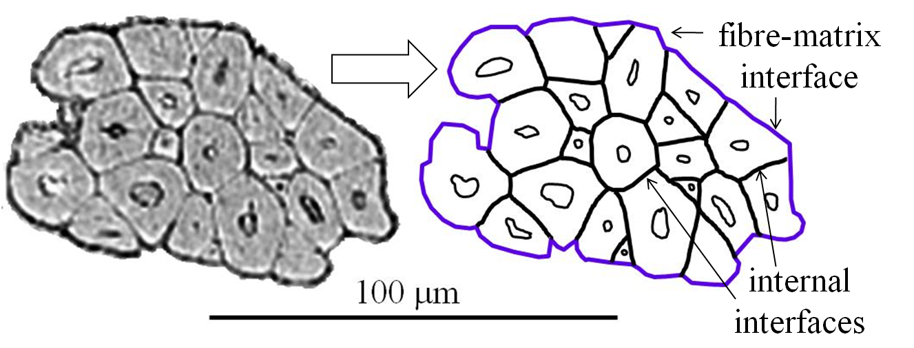
Figure 1 Micrograph of jute fibre cross section illustrating the composite nature of natural fibres

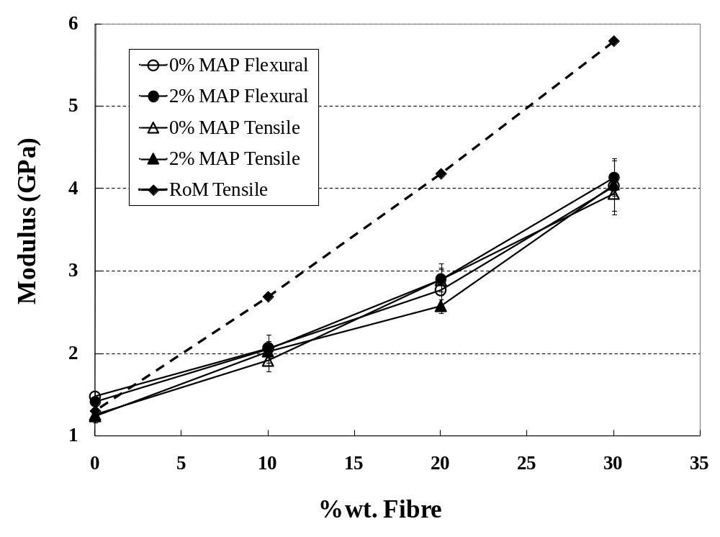
Figure 2 Influence of fibre and MAP content on the modulus of LNFPP

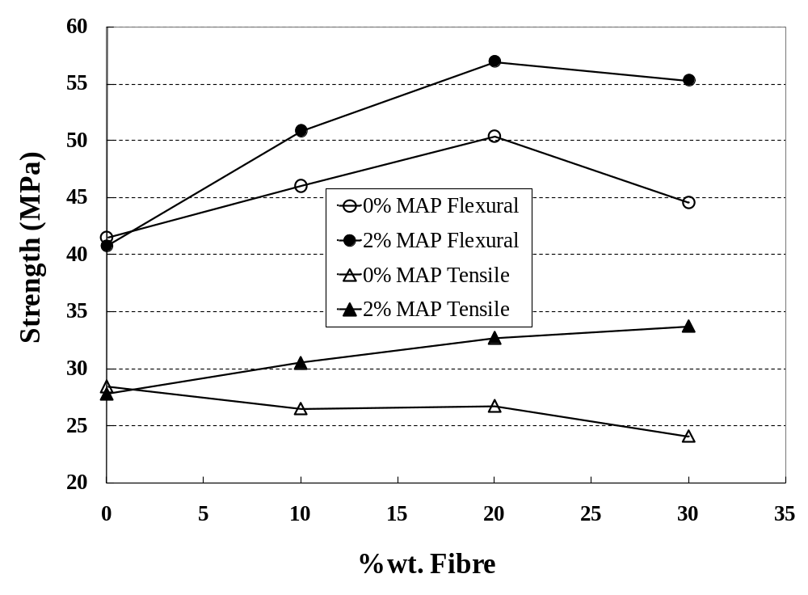
Figure 3 Influence of fibre and MAP content on the strength of LNFPP

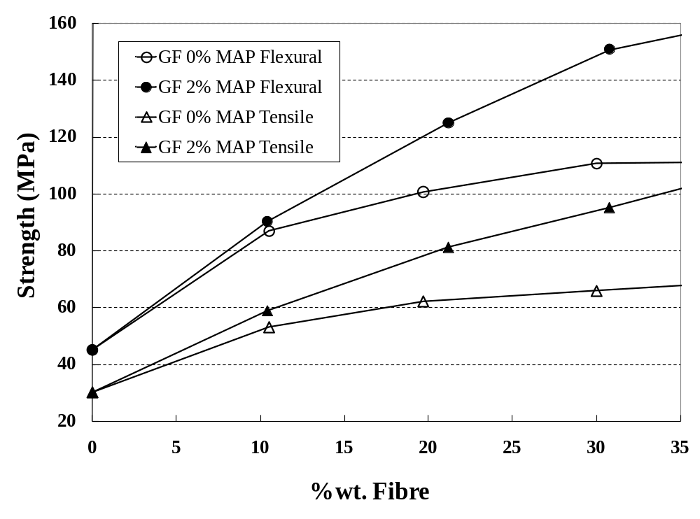
Figure 4 Influence of fibre and MAP content on the strength of GFPP

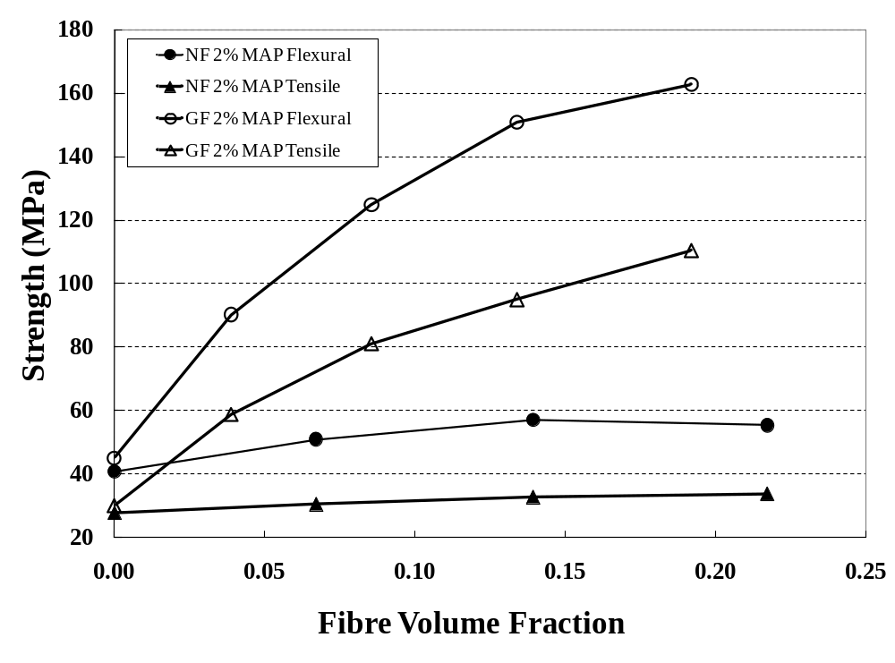
Figure 5 Comparison of GF and NF reinforcement of PP

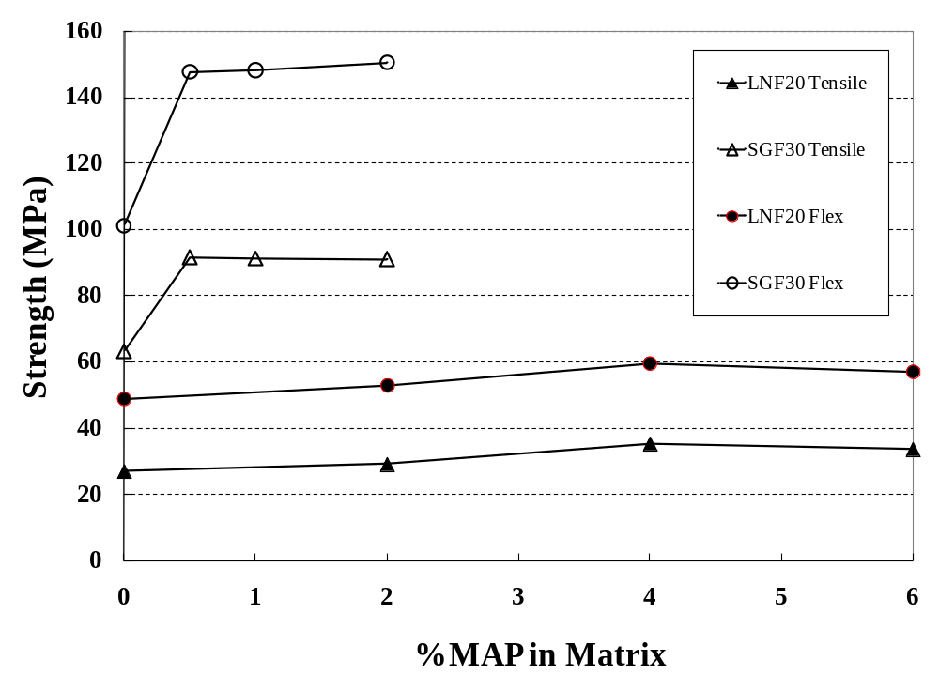
Figure 6 Influence matrix MAP content on the composite strength with 30%GF and 20%NF (approximately equal volume fractions of 0.135)
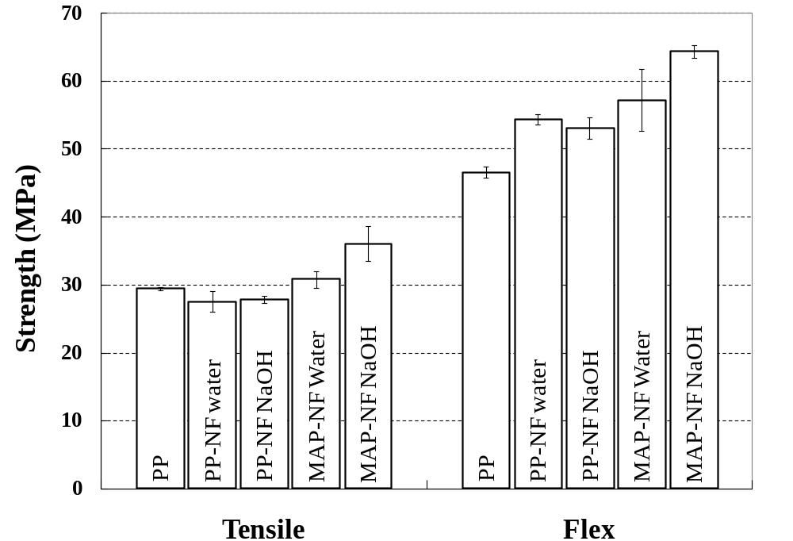
Figure 7 Influence of fibre mercerisation and MAP content on the strength of 20% LNFPP

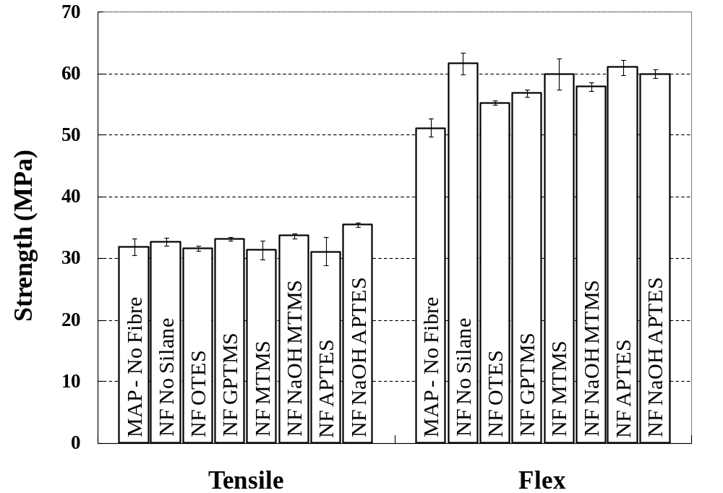
Figure 8 Influence of silane pretreatment of fibre on the strength of 20% LNFPP
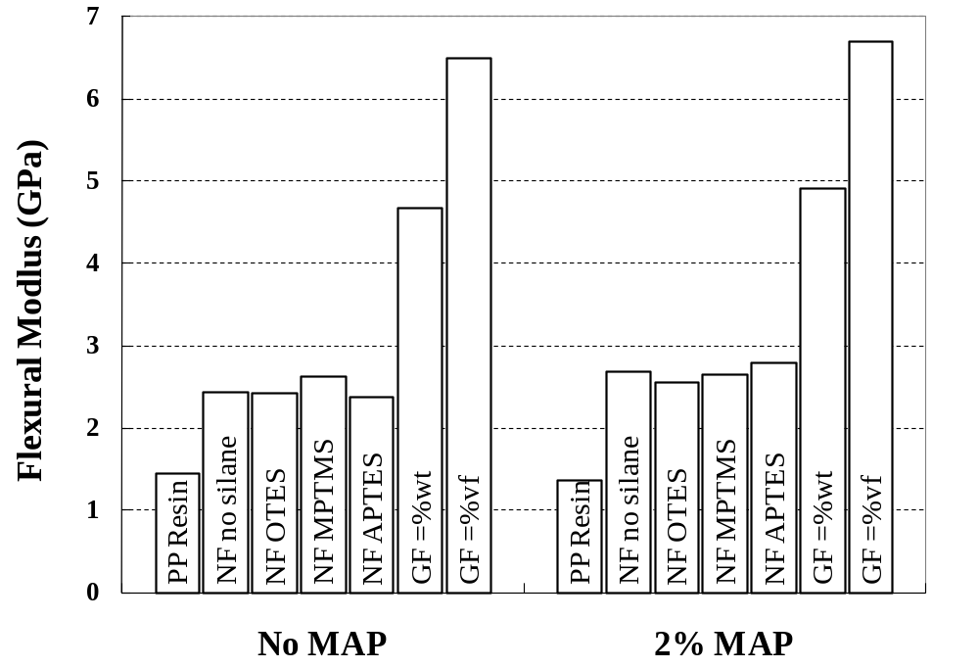
Figure 9 Influence of inline silane treatment of fibre on the modulus of 20% LNFPP

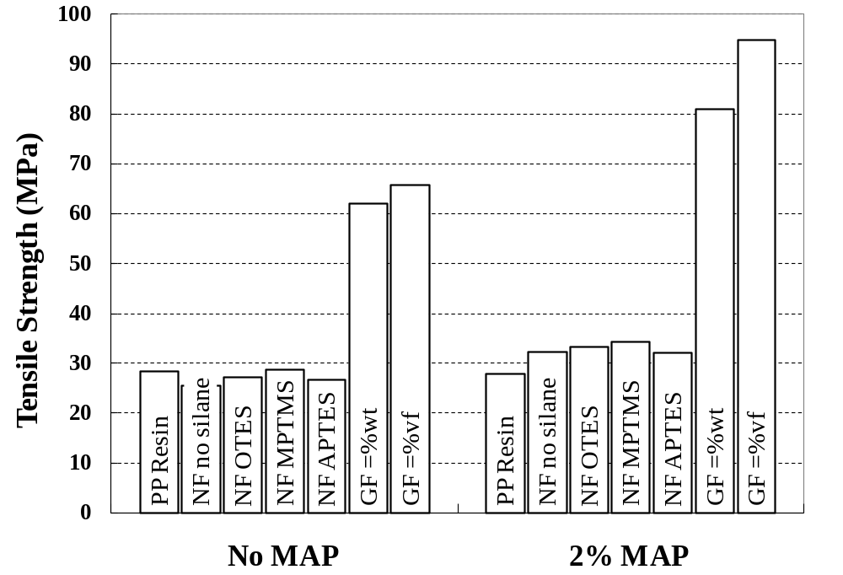
Figure 10 Influence of inline silane treatment of fibre on the strength of 20% LNFPP

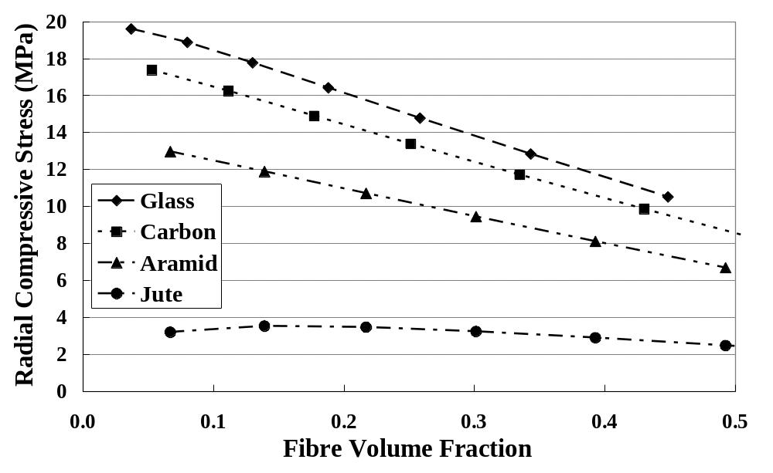
Figure 11 Modelling of interfacial residual radial compressive stress in reinforced PP

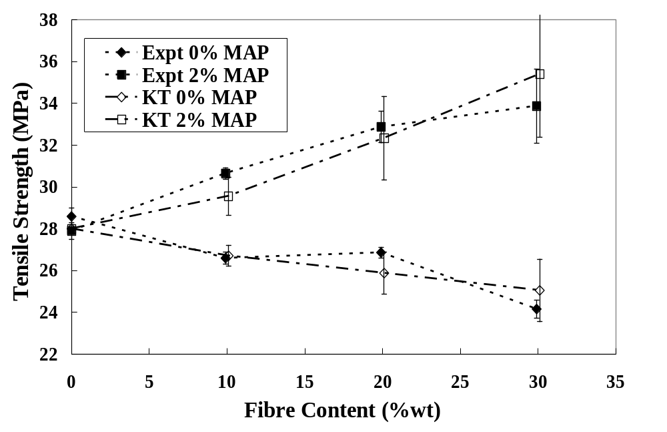
Figure 12 Comparison of experimental strength of LNFPP with Kelly-Tyson modelling using IFSS calculated from interfacial residual radial compressive stress

