Analytical Control Laws for Planet-Centred Solar Sailing
Malcolm Macdonald
University of Glasgow, Glasgow, Scotland, E.U.
Colin R M^{c}Innes
University of Strathclyde, Glasgow, Scotland, E.U.

Abstract
With increased interest in solar sailing from both ESA and NASA for future science missions comes the requirement to assess potential planet-centred orbits and generate algorithms for effective orbit manoeuvring and control. Prior planet-centred solar sail trajectory work has been limited mostly to Earth escape or Lunar fly-by trajectories due to the difficulties of fully-optimising multi-revolution orbits. A new method of blending locally optimal control laws is introduced, where each control law is prioritised by consideration of how efficiently it will use the solar sail and how far each orbital element is from its target value. The blended, locally optimal sail thrust vector is thus defined to use the sail as efficiently as possible, allowing the rapid generation of near-optimal trajectories. The blending method introduced is demonstrated for a complex orbit transfer and for two station-keeping applications. Furthermore, the algorithms developed are explicitly independent of time and as such the control system is demonstrated suitable as a potential future on-board sail controller.

Nomenclature
a Semi-major axis
a_{s} Sail acceleration
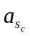 Sail characteristic acceleration
E Eccentric anomaly
e Eccentricity
F Disturbing acceleration within variational equations of motion
f Modified equinoctial element
f_{s} Orbit perturbation vector due to sail = [F_{R} F_{T} F_{N}]
f_{k} Sail normal vector for element k
g Modified equinoctial element
h Modified equinoctial element
i Orbit inclination
k Modified equinoctial element
L Modified equinoctial element
M Denotes Mercury as a sunscript
p Semi-latus rectum
r Orbit radius
r Radius vector
r_{p} Radius of pericentre
sat Denotes spacecraft as a subscript
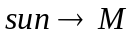 Denotes sun with respect to Mercury as a subscript
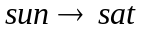 Denotes sun with respect to spacecraft as a subscript
t Time
W Weight of control law
Sail pitch angle
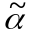 Pitch angle of ideal force vector
δ Sail clock angle
ς Spacecraft shadow parameter
ς_{p} Penumbra critical shadow parameter
λ_{k} Function of orbit elements = [λ_{x} λ_{y} λ_{z}]^{T} for element k
λ_{b} Blended locally optimal force vector [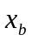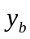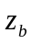]^{T}
μ Gravitational parameter
τ Auxiliary positive variable
ν True anomaly
Ω Right ascension angle of ascending node
ω Argument of pericentre

Introduction
Solar sailing is increasingly being considered by both ESA and NASA for future science missions. With the absence of reaction mass from the primary propulsion system arises the potential for new high-energy mission concepts, such as a Solar Polar orbiter, an Interstellar Heliopause Probe and planetary sample return missions., Planet-centred solar sail trajectory analysis has been limited in range, such as simple Earth escape strategies that provide crude estimates of escape time and often physically impossible orbits due to negative altitude passes at perigee. , , , Other planet-centred applications that have been studied in detail include lunar fly-by , or potential simple orbit manoeuvring capabilities.

In the late 1970’s Sackett produced optimal solar sail transfers and Earth escape trajectories, which although they did not include orbit perturbations did note a tendency for optimal and near-optimal solar sail orbits to require very low, often negative, altitude passes of Earth. , This problem was suitably addressed by inclusion of a penalty function. Subsequent work has failed to redress this problem, neglecting and dismissing the inclusion of minimum altitudes on Earth escape trajectories as trivial while also repeatedly re-generating simplistic escape scenarios. A recent, comprehensive study by Leipold considered the effects of orbit perturbations, Earth shadow and a non-ideal sail force model for operations in Earth orbit, yet this model also neglected the inclusion of a negative altitude constraint when considering Earth escape trajectories. A potential solution to the problem of maintaining a minimum altitude during Earth escape has recently been demonstrated, which mathematically guarantees against a collision with the central body while continuing to provide near-optimal solutions in the presence of orbit perturbations, shadow and a non-idealised sail surface. This paper follows on from Ref. Error: Reference source not found, which concentrated on producing realistic Earth escape solutions. We will consider the use of a solar sail for planet-centred transfers and station keeping. The use of locally optimal control laws for solar sailing is developed from prior work and a new control method introduced which blends these individual control laws to provide near-optimal results.

Previously, locally optimal control laws have been used widely for low-thrust trajectory generation where no constraint is placed on the orientation of the thrust vector, such as solar electric propulsion, SEP., Commonly, locally optimal control laws are blended by the use of optimisation techniques to set the weight functions for each control law. Therefore, the weightings are given as a function of time from the start epoch. However, the method previously outlined for solar sailing suggested that a more prudent approach would be to use the osculating orbit elements to set the weight functions of each control law. Error: Reference source not found, Error: Reference source not found Thus, the solution is adaptive to previously un-modelled orbit perturbations and as such provides a more robust solution to the orbit control problem while also being suitable as a potential on-board autonomous controller. A similar approach has recently been proposed by Petropoulos for SEP orbit transfers following a similar hypothesis. Petropoulos uses the control laws for SEP orbit transfers and blends them to generate relatively simple transfer trajectories, this work uses a number of separate criteria to judge the importance of each control law prior to defining the blended optimal thrust vector.

The locally optimal control laws previously outlined for SEP type transfers differ slightly from the solar sail locally optimal control laws previously outlined. The control laws required in this paper will be derived and defined, following Ref. Error: Reference source not found and Error: Reference source not found where appropriate. We will then discuss the control method developed in order to set the weighted importance of each of the orbit elements, prior to blending the control laws. The paper will discuss the new control method for station keeping in previously proposed planetary solar sail missions and investigate how such a method could enhance the science return of such missions. A complex orbit transfer at Mercury will also be presented where the main constraints are thermal and not transfer duration, which can be considered secondary in many solar sail applications at Mercury as will be discussed later.Error: Reference source not found

Locally Optimal Control Laws
The rate of change of any orbital element can be calculated and hence a locally optimal control law generated. These control laws maximise the instantaneous rate of change of the element and provide the required sail orientation in closed analytical form. It is important to note such a method provides only a locally optimal solution, which does not guarantee global optimality. In Ref. Error: Reference source not found the blended use of a semi-major axis control law, also known as the locally optimal energy gain control law and a radius of pericentre control law was introduced to facilitate the generation of realistic Earth escape trajectories. Within this paper we will evolve the work in Ref. Error: Reference source not found, such as to incorporate control laws for the five classical orbit elements plus radius of pericentre and apocentre. The derivation of selected additional control laws is presented, which will allow derivation of all other control laws.

The variational equation of the element to be optimally altered is written in the form of Eq. 1,
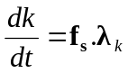 (1)
where k represents the element under consideration. The required relative perturbing force on each of the Radial, Transverse and Normal (RTN) axes to maximise the rate of change of k is found as a unit vector of λ_{k}. Maximising the thrust vector, f_{s}, along λ_{k} maximises the right-hand side of Eq. (1), thus the instantaneous rate of change of element k will be maximised. The sail control angles are defined in the standard form with respect to a Sun-sail line reference frameError: Reference source not found and are shown in Figure 1. Within the Sun-sail line reference frame the Sun is fixed along the –X axis, while the Y-axis corresponds with the heliocentric velocity vector of the planet the sail is orbiting. The Z-axis completes the right-hand Cartesian coordinate system.
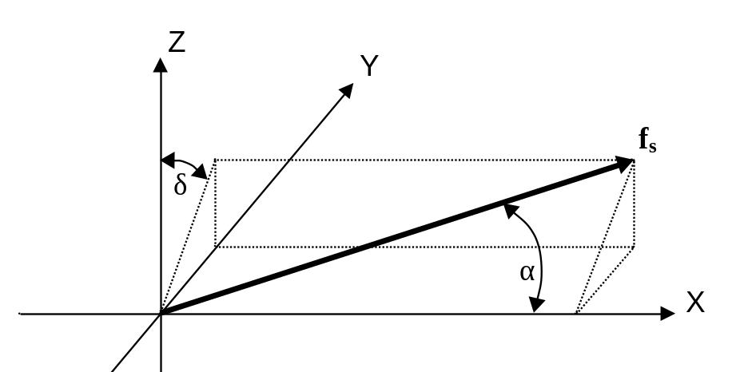
Figure 1 Sail control angles in Sun-sail line reference frame.

It is required that we transpose the unit vector of λ_{k} from the satellite RTN reference frame into the Sun-sail line reference frame within which the sail control angles are defined. With conversion of the unit vector of λ_{k} into the Sun-sail line coordinate system we can define 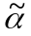 using Eq. (2). The sail clock angle is derived in Eq. (3) as,
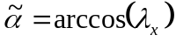 (2)
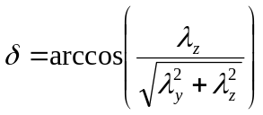 (3)
With the derivation of the ideal force angles in the Sun-sail line reference frame, a standard optimisation derivative is used, Eq. (4), to find the sail orientation which will maximise the sail thrust vector along the ideal force vector. The pitch angle of the ideal force vector is defined as the angle between the Sun-sail line and the ideal force vector. The locally optimal sail pitch angle is thus found directly from the Eq. 4 and .
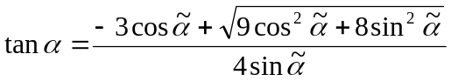 (4)
The locally optimal sail clock angle is found directly from the ideal force vector using Eq. (3) and does not require optimisation since the sail acceleration magnitude does not depend on the sail clock angle. If a negative rate of change is desired the ideal force vector direction should be reversed, hence flipping the vector orientation prior to application of Eq. (4) and giving a negative rate of change.

The derivation of the semi-major axis control law is presented in Ref . Error: Reference source not found along with the radius of pericentre control law. The derivation of the eccentricity and radius of apocentre control laws can be derived as a simple extension of Ref . Error: Reference source not found and are hence not presented within this paper.

Inclination Control Law
Contrasting the semi-major axis and pericentre control laws, the rate of change of inclination depends on only the one perturbing force, the out-of-plane perturbation. Thus, the method used for locally optimal variation is somewhat different. For the locally optimal rate of change of inclination consider Eq. (5), the variational equation of inclination,
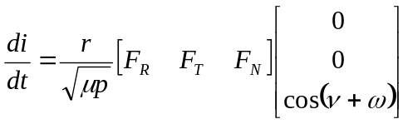 (5)
From Eq. (5) we see that a switching relationship is required in order to maintain the desired sense of rate of change, positive or negative. For example if cos(ν + ω) is negative we require a negative out-of-plane sail force, hence generating a positive rate of change. Conversion into modified equinoctial elements gives the switching term as 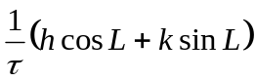, we can thus define λ_{i} in Eq. (6).
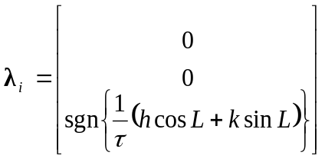 (6)
The sail pitch and clock angles are thus derived through conversion of λ_{i} into the Sun-sail line reference frame discussed above and application of Eqs. (2) – (4).

Argument of Pericentre Control Law
The variational equation of the argument of pericentre, Eq. (7), is one of the few which depends on the perturbing acceleration along all three RTN axis. However, despite this the locally optimal control law is derived in a similar manner to other orbit elements.
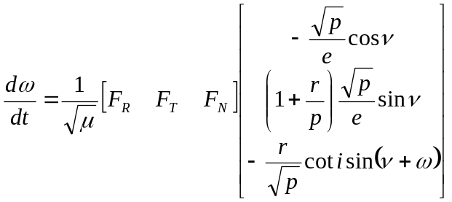 (7)
From Eq. (7) we can find λ_{ω}, which is given by Eq. (8) in modified equinoctial elements as,
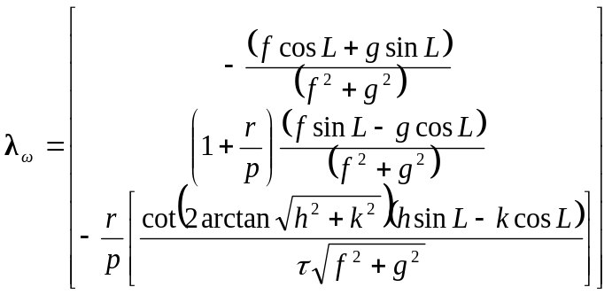 (8)
Thus, the locally optimal sail pitch and clock angles are derived in a similar manner to prior control laws, with the use of Eqs. (2) – (4).

Blending Locally Optimal Control Laws
The rudimentary technique of blending control laws for geocentric solar sail orbit transfers has previously been introduced.Error: Reference source not found The blending of control laws was further refined in Ref. Error: Reference source not found, for the generation of realistic Earth escape trajectories. For clarity we will very briefly review the mechanics of the actual blending process presented in Ref. Error: Reference source not found.

The blending of control laws is accomplished by initially calculating the unit vector, in the Sun-sail line reference frame, along which the force should be maximised in order to maximise the rate of change of each individual element being blended, obtaining a separate unit vector for each control law. We then compute the blended vector by applying Eq. (9).
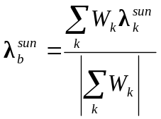 (9)
where subscript k once again represents each individual control law being blended and superscript sun denotes the vector is in the Sun-sail line reference frame. From 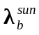 we can directly define using Eq. (2), thus application of Eq. (4) gives the blended locally optimal sail pitch angle. The sail clock angle is derived directly from , using Eq. (3).

As already stated the blending procedure previously outlined for solar sail applications uses the orbital elements to define the weight of each control law, rather than defining each weight as a function of time from the start epoch. Defining the weight functions by the orbital elements has additional benefits. The sail pitch and clock angles are defined as a closed loop, thus the control system can adjust for small unforeseen orbit perturbations or perturbations which cannot currently be modelled due to lack of real-world knowledge such as sail wrinkles or sail degradation due to radiation. As such the system would potentially be suitable as an on-board autonomous controller for future sail mission. An autonomous controller is attractive as it reduces the amount of data in the uplink telecom budget by removing the need for sail control commands, which would typically be a large data set of several hundreds of points. The sail control commands could thus be replaced with the spacecraft state vectors at a given epoch.

The optimality of the blended system depends heavily on the weight functions applied in gaining the blended locally optimal thrust vector. In Ref Error: Reference source not found the weight functions were defined by a series of simple exponential relationships. However, in attempting to create a more complex and robust control system for orbit transfers and station keeping applications we require an evolution of the derivation and calculation of the weight functions.

Accessibility and Deficit Blending
The Accessibility and Deficit (A^{n}D) blending method seeks to give each individual control law a relative importance prior to defining the final weight functions and thus the blended control vector. The deficit of each element from the final target value is considered. Additionally, the efficiency or accessibility of any attempt to alter an orbital element is considered, thus avoiding inefficient use of the sail such as in prolonged periods of high pitch.

The Deficit is found not by consideration of each element’s value, but instead by estimation of the time required to attain the target value using the locally optimal control law. We compute 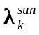, thus allowing the locally optimal pitch and clock angle for control law k to be found. With the locally optimal pitch and clock angles calculated, we can thus calculate the sail perturbation vector in Sun-centred coordinates, using Eq. (10) as,
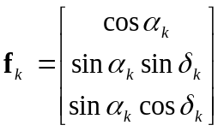 (10)
Eq. 10 is then converted back into satellite RTN axis in order to calculate ^{dk}/_{dt}, the rate of change of element k. We note that to find ^{dk}/_{dt} we must find the magnitude of the sail perturbation vector using Eq. (11) to correct sail acceleration due to the locally optimal sail pitch angle.
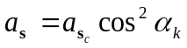 (11)
With knowledge of the locally optimal rate of change of element k, the current value of k and the target value of k, it becomes a simple matter to estimate the time required to attain the target value assuming a constant rate of change. Repeating this process for each control law being blended allows us to normalise the time required with respect to the greatest time. Thus, each control law gains a score between zero and one for the corresponding deficit, with zero meaning the element has attained its target value and one that it is the furthest, or has the greatest deficit, from its target value.

The deficit of an element can appear excessively high if the corresponding locally optimal pitch angle is high, which results in a low rate of change and thus gives a high deficit score to an element which will poorly utilise the sail. We thus consider the accessibility of control law k by consideration of the corresponding optimal pitch angle. From Eq. (11) we see that as the pitch angle is increased the corresponding sail acceleration drops off as the cosine squared. The accessibility score is found by calculating the cosine squared of the optimal pitch angle for each control law and normalising with respect to the largest. Hence, the control law which best utilises the sail acceleration gains a score of one, while the most inefficient gains a low score. Using the A^{n}D blending method we can select the weight functions based not only on need, but also on an opportunistic level. The deficit score gives the highest score to the element furthest from its target value, while the accessibility score gives priority to the element which most efficiently uses the sail. Combination of the two scores provides the weighted relevance of each control law, however the method of combining the two scores must itself be carefully considered and rationalised. Multiplying the Accessibility and Deficit scores results in a low total score should either score be low. However, it has been found that if an element has low accessibility for a given direction of change, say negative, this is because the orbit alignment about the planet and with respect to the Sun is typically close to optimal for the opposite direction of change. As a result of this if an element has low accessibility and high deficit then multiplication of the two scores results in an increase in the deficit. It is thus found that even though the accessibility is low we cannot ignore the element. Addition of the two scores results in a low accessibility and high deficit scenario receiving a middle of the range score and was thus found to offer a better solution. The final A^{n}D score is thus found by addition of the two individual scores.

The final weight functions are found by multiplying an individual element A^{n}D score by a constant. For example, as will be seen later, the GeoSail mission primary requirement is to rotate the orbit argument of pericentre. Thus an additional importance is placed on this element and it is multiplied by a larger constant. Elements which are not being blended are multiplied by zero to remove them from consideration and elements of less importance are multiplied by smaller weights. The use of weights allows the control system to be fine tuned to increase optimality. The selection of appropriate constants is intuitive and typically follows the mission goals, such as seen for the GeoSail mission. However, an initial guess can be gained by utilising the A^{n}D scores only, prior to then introducing the constants in order to improve optimality if it is unclear which orbital elements should be focused on.

Orbit Transfer’s Using A^{n}D Blending
The generation of solar sail planet-centred orbit transfers are perhaps of limited purpose. For instance, lengthy Earth escape spirals at the beginning of a heliocentric mission should be eliminated by the launch vehicle whenever possible. If however the sail is the primary form of propulsion then during a reconnaissance or sample and return mission the sail must be utilised to correctly deliver the science payload to the target orbit about the destination body. Much prior work that has claimed to generate capture trajectories has simply been escape trajectories integrated over a negative time-span. However, such an approach does provide a suitable approximation to obtain the required timescale of any capture trajectory and is thus suitable for early mission analysis studies.

Only a few solar sail planet-centred orbit transfer have been previously published due primarily to the significant difficulty of generating trajectories which are optimised over numerous revolutions. A rudimentary transfer from Geostationary Transfer Orbit, GTO, to the original GeoSail mission orbit of 10 x 30 Earth radii was generated using locally optimal control laws.Error: Reference source not found A recent doctoral thesis used extremal steering strategies for simulation and optimisation of Earth – Moon transfer trajectories using solar sailing. This work resulted in the solution of a weak stability boundary problem and generated realistic transfer trajectories from GTO to bound lunar orbit. One of the few other published planet-centred solar sail transfer trajectories; other than lunar flybys which are not actual orbit-to-orbit transfers, was in a 1977 study., This study developed a computer program to calculate optimal planet-centred trajectories, however only one orbit–to–orbit transfer was generated as it was found that the coding required a very good initial guess before a solution was found and that eccentricity convergence was difficult when the target eccentricity was low. Transfer to sub-escape points presented no convergence difficulties; however orbit transfers were much more difficult and the authors were unable to generate more than one complete trajectory within the timeframe of the study.

It is the experience of the authors that while planet-centred orbit transfers are of only limited purpose, when they are required the primary cost function is seldom time. For example, the primary cost function for sail operations at Mercury is typically thermal and avoidance of passage near the sub-solar point. During a recent Mercury Sample and Return mission studyError: Reference source not found it was found that the surface thermal conditions were such that a lander could only survive at key specific times of the Hermian year. It was also found that the optimal Earth – Mercury transfer and subsequent capture spiral result in arrival of the lander at an inappropriate time for landing. Thus, we require the lander to wait in Mercury orbit until the surface thermal conditions are suitable. The optimal orbit for the sail to enter while waiting for the surface conditions to become suitable was found to be the Mercury-forced sun-synchronous orbit,Error: Reference source not found, , , hence minimising thermal loads on the sail and its systems. Thermal requirements thus necessitate an orbit-to-orbit transfer from the sun-synchronous orbit to the low-circular near-polar orbit for deployment of the lander. The primary cost function of this transfer is not time as the arrival time is fixed and the transfer is necessitated by a need to wait for the correct surface conditions.

Mercury-Forced Sun-Synchronous Orbits
A Mercury solar sail trajectory model including solar gravity effects and Mercury J₂ was created. The solar sail force model utilises a standard optical modelError: Reference source not found, while the Sun is modelled as a uniformly bright finite disk. The eccentric nature of Mercury’s orbit also makes it important that we accurately model the true sail – Sun distance, hence modelling the true variation of sail acceleration through the Hermian year. Furthermore, the trajectory model also considers and distinguishes between umbra and penumbra shadow on the sail surface. Modified equinoctial elements are utilised in the equations of motion, which are propagated using an explicit, variable step size Runge-Kutta formula, the Dormand-Price pair, with relative and absolute error tolerances of 10⁻⁹ ensuring minimal truncation error.

The close proximity of Mercury to the Sun means that even a relatively modest level of sail performance can provide a significant thrust vector. Mercury has a reciprocal of flattening over eighteen times that of Earth, with a J₂ value of only 60e-6, although the reciprocal of flattening is often mistakenly quoted as being infinite. Thus, once in orbit about Mercury it is not possible to create a natural sun-synchronous orbit; a supplemental thrust vector is required to replace the oblateness utilised at Earth. Leipold, et al showed that this supplemental thrust could be provided by a modest solar sail in a highly elliptical polar orbit, Error: Reference source not found consequently allowing the spacecraft to maintain station at or near to the solar terminator of Mercury. As such the thermal loading due to reflection and re-radiation from Mercury’s surface is significantly reduced, while the severe thermal cycling encountered by numerous passes through the shadow cone is also eliminated. It is considered that the optimal remote sensing orbit places the spacecraft at a small offset from the solar terminator, rather than directly overhead as the low Sun angles near the terminator on the dayside of the planet allow high topographic discrimination in near-constant illumination conditions. Finally, due to Mercury’s rotational period : orbital period, 3:2 resonance, the Sun-synchronous polar orbit allows complete surface coverage in only 88 days. However, due to the optimal orbit offset from the solar terminator it is necessary to remain in orbit for 176 days to acquire full surface visual coverage and dual coverage in other spectrums. It is thus clear that such a reconnaissance orbit is of great potential scientific use and worthy of study.

Recreating the trajectories published by Leipold, et al it is found that the orbit is an unstable equilibrium point. It has been shown previously that the ascending node angle cannot be varied without also altering the argument of pericentre angle. It was similarly noted by Leipold, et al that the argument of pericentre experienced a long period oscillation due to the sail thrust vector. Over short timescales the small variation in argument of pericentre results in only small variations in semi-major axis and eccentricity. However as the argument of pericentre reaches the peaks and troughs of its long period oscillation the nominal pericentre altitude of 200 km varies as low as 70 km and rises as high as 400 km, prior to collision with the Hermian surface. Collision typically occurs around day 100 – 140 from the initial start epoch, depending on initial conditions. It thus becomes clear that while the optimal science orbit has a very low pericentre we require either an active sail to achieve this, as will be discussed later or an initially greater altitude.

We determine the allowed sun-synchronous orbits for a given sail characteristic acceleration, defined as the acceleration experience by an idealised, 100 % reflective sail at 1 AU, through analysis of the variational equation of motion of the ascending node angle, Eq. (12),
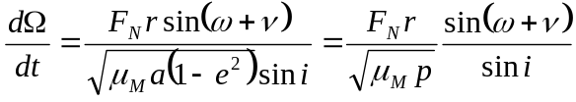 (12)
Following Leipold et alError: Reference source not found we can integrate Eq. (12) over one orbit period, assuming inclination, semi-latus rectum and argument of pericentre are constant over the orbit period and the sail orientation is constant over one orbit revolution and directed normal to the orbit plane. That is to say, α = 0 º for orbits along the terminator and α = 10º for orbits offset from the terminator by 10º. Changing the integration variable from time to true anomaly allows the derivation of Eq. (13),
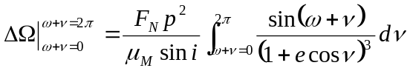 (13)
The precession of the node can thus be determined using the orbit period as given in Eq. (14) as,
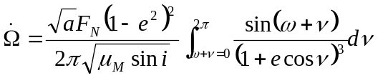 (14)
Extending the analysis performed by Leipold et alError: Reference source not found we can generate contours of the potential Sun-synchronous orbits for a given sail acceleration or offset angle from the solar terminator, thus enabling rapid assessment of different potential scenarios. Analysis of Eq. (14), with ω=or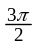 and setting i=, such that sin i =1, allows derivation of Eq. (15).
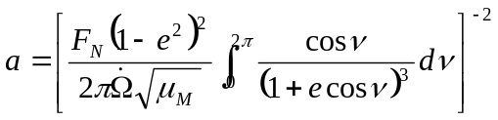 (15)
The required rate of change of ascending node angle for a Sun-synchronous orbit is found to be the specific angular momentum of Mercury with respect to the Sun divided by the square of the Mercury – Sun distance. Thus, the required rate of change of ascending node angle varies between 1.28x10⁻⁶ rad s⁻¹ and 5.57x10⁻⁷ rad s⁻¹ depending on Mercury’s position. We note however that as Mercury orbits the Sun the sail acceleration varies as the inverse square of the solar distance, thus the induced rate of change of ascending node will vary similarly, as required. Thus, no alteration in the orbit is required during the Hermian year as was also found by Leipold, et al.

Solving Eq. (15) for a given eccentricity allows the corresponding semi-major axis for any given sail acceleration level to be determined. For example, the orbit defined previously by Leipold, et al for utilisation within a future science mission was for a sail with characteristic acceleration 0.25 mm s⁻² at zero offset from the solar terminator. Pericentre altitude was defined as 200 km and apocentre altitude was quoted as approximately 6350 km. We find that the actual idealised value is
6293.63 km for such a scenario. Extending the analysis for a sail characteristic acceleration 0.25 mm s⁻² we see in Figure 2 a plot of pericentre altitudes versus apocentre altitudes for a range of solar terminator offset angles. Above a 50º offset angle from the solar terminator the orbit begins to intersect the shadow cone; we recall that for an orbit offset from the solar terminator we require to maintain the sail force vector normal to the orbit plane and as such the fixed sail pitch angle equals the nominal offset angle. Figure 3 shows a plot of pericentre altitudes versus apocentre altitudes for a range of sail accelerations and orbits with solar terminator offset angles of 0º and 10º; we note that the 0.25mm s⁻² contours correspond to the 0º and 10º contours shown in Figure 2. We see in Figure 3 that the increased sail accelerations allow for the apocentre to be lowered for a given pericentre value, while the increase in solar terminator offset angle requires an increase in apocentre altitude for a given pericentre value. We note that the orbits defined in Figure 2 and Figure 3 correspond to the required actual thrust vector and have not been corrected for an imperfect sail surface.

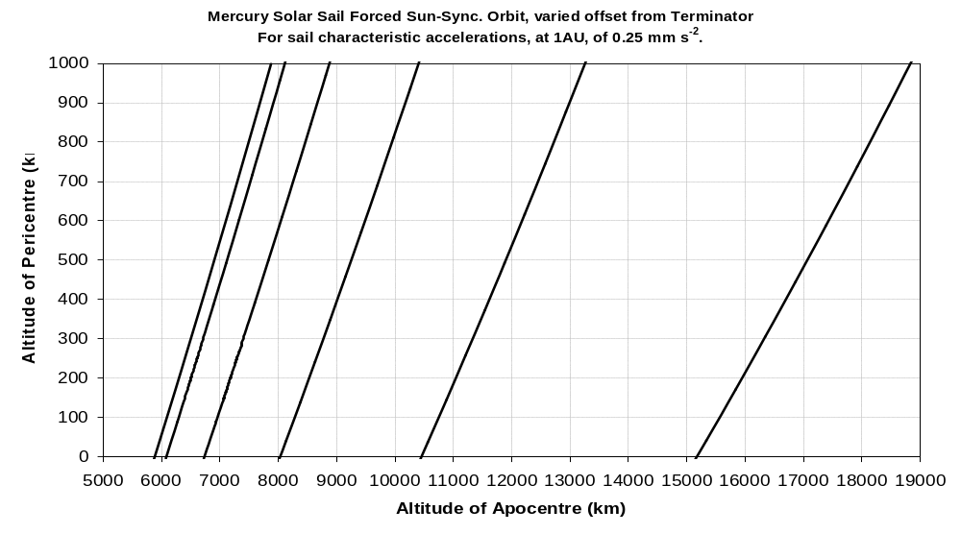
Figure 2 Pericentre versus apocentre contours for = 0.25 mm s⁻² forced Sun-synchronous orbits, at a range of offset angles from the solar terminator.
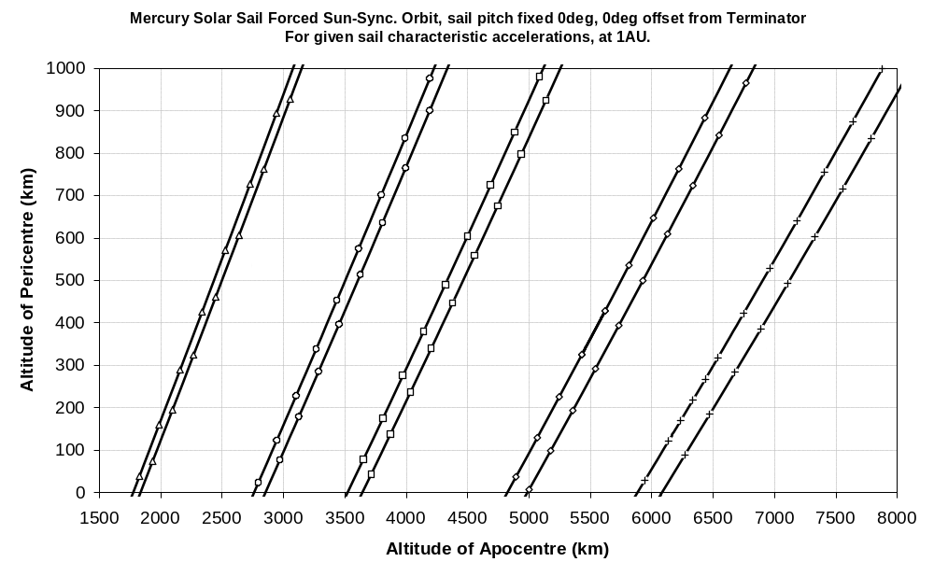
Figure 3 Pericentre versus apocentre contours for orbit planes at 0º and 10º offset from solar terminator at a range of sail accelerations.

For a fixed sail orientation we select an increased pericentre altitude of 500 km; noting that Leipold, et al first suggested a pericentre altitude of 600 km before later reducing this to 200 km.Error: Reference source not found The sail orbit is displaced from the terminator by 10º. We see from Eq. (15) and Figure 2/Figure 3 that the apocentre altitude is thus 7109.9 km, for a sail characteristic acceleration of 0.25 mm s⁻². Note, sail characteristic acceleration is fixed at 0.25 mm s⁻² for the remainder of this paper when discussing sail operations at Mercury . Utilising the trajectory model discussed above we can propagate a 180 day simulation for a forced Sun-synchronous orbiter with pericentre over the northern geographical pole. Start epoch at 05 July 2010 gives an initial ascending node angle of 54.5º. The ascending node angle varies from this initial value to 360º and back up to approximately 54.5º after one Hermian year. The rate of change of ascending node varies throughout the Hermian year, as expected, thus maintaining a separation angle from the solar terminator of approximately 10º. The orbit inclination remains within +0.45⁰ and –0.27º of 90º, similarly the argument of pericentre varies minimally. It is found that both the pericentre and apocentre altitudes vary considerably from the initial values quoted. Large variations could potentially impact the science goals of the mission and as such active sail control could potentially be used to minimise pericentre altitude variation, while also lowering the pericentre altitude. Such an active sail control system will be discussed later within this paper.

The 180 day propagation terminates on 01 January 2011 with the corresponding orbiter position elements defined in Table 1. We note that the final pericentre altitude is 361 km above its nominal value. Inclination and argument of pericentre are both close to their nominal values, while the ascending node angle places the orbiter ground track approximately 10.3º ahead of the solar terminator.

Table 1 Orbit elements after 180 day forced Sun-synchronous orbit
Orbit Element | Value | Unit
Semi-Major Axis | 6258.2 | km
Eccentricity | 0.47 | –
Altitude of Pericentre | 861.2 | km
Altitude of Apocentre | 6775.8 | km
Inclination | 90.26 | deg
Argument of Pericentre | 89.84 | deg.
Right Ascension of Ascending Node | 75.11 | deg.
True Anomaly | 228.44 | deg.

We can use the elements defined in Table 1 as starting conditions for an orbit transfer to a south-pole pericentre orbit. Such a transfer would potentially enable high-resolution mapping of the entire surface of Mercury with a single spacecraft. We note that Leipold, et al proposed using two spacecraft for such 100 % coverage.Error: Reference source not found

Transfer between Sun-Synchronous Orbits Using A^{n}D Blending
A direct transfer from a north-pole pericentre to south-pole pericentre forced sun-synchronous orbit is relatively simple. The argument of pericentre and ascending node angles must be rotated through 180º, while the nominal value of all the other elements remains unaltered. However, a direct and simple transfer would require the orbiter to pass directly over the sub-solar point and through the planetary shadow cone. We thus optimise the transfer orbit such that the orbiter does not pass through the planetary shadow cone at any point of the transfer. The primary optimisation cost function hence becomes spacecraft thermal constraints rather than a minimum time transfer.
Using the orbit elements in Table 1 as the initial conditions for the orbit transfer we define the target elements in Table 2. Several potential strategies can be adopted to eliminate planetary shadow from this transfer. The ascending node angle could be rotated very rapidly or the orbit velocity could be reduced to approximately zero and then the direction reversed on a parabolic orbit at a large orbit radius. However this second option would require the orbit energy to approach zero and would require a very high level of navigation accuracy. Alternatively, the adopted strategy was to raise the orbit energy and circularise the orbit, allowing the planet to rotate rapidly beneath the orbiter. The use of a circular orbit also much simplifies the transfer, as the argument of pericentre can be selected as eccentricity rises again, rather than actually rotating the orbit through 180º. The targeting of a continually varying ascending node adds an additional complication to the optimisation, but we find that the A^{n}D blending method handles such a condition well.

The transfer trajectory is split into eight phases and propagated using the trajectory model previously discussed within this paper. The first phase of the trajectory raises the orbit energy using the semi-major axis control law exclusively for approximately 27 days. Subsequent phases have similar intermediate aims, which all contribute towards the final complete trajectory. For example, the purpose of the second phase is the reduction of eccentricity to zero, while also targeting an ascending node value which aligns the orbit correctly for passage of the ascending node / Solar terminator offset angle through the 90º mark, when avoidance of the shadow cone is critical. The weight by which the A^{n}D score is multiplied is determined by the relative importance of each element during that particular phase of the trajectory, hence in phase 2 the eccentricity and right ascension angle have high weights and the semi-major axis weight is low. Additionally, at certain times the target eccentricity is set to zero, rather than that given in Table 2, this was found to reduce transfer time which while not the primary cost function of the transfer remains of critical importance. Furthermore, at certain times the control laws are not allowed to automatically determine which direction they should be driving the orbit; instead they are forced to always increase a certain element irrespective of current and target values. For example, the ascending node angle is always increased and never decreased, this has a slightly different effect from altering the target value, as the A^{n}D score is affected in a different way but is done for similar reasons. Selection of such strategies is through engineering judgement.

Table 2 Target orbit elements for forced Sun-synchronous orbit with south pole pericentre
Orbit Element | Value | Unit
Semi-Major Axis | 6244.65 | km
Eccentricity | 0.53 | –
Altitude of Pericentre | 500.0 | km
Altitude of Apocentre | 7109.9 | km
Inclination | 90.00 | deg
Argument of Pericentre | 270.0 | deg.
Right Ascension of Ascending Node | (Ω_{sun} + 10º)  + 180º from N-pole value | deg.
True Anomaly | 228.44 | deg.

Analytical analysis of Mercury, Sun and spacecraft position vectors can be used to confirm the entire transfer trajectory is shadow free. We define the spacecraft shadow parameter in Eq. (16) as,
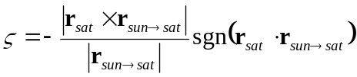 (16)
The critical shadow parameter for penumbra conditions is defined in Eqs. (17) as,
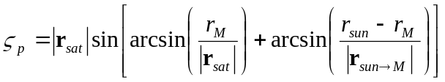 (17)
We note that the umbra critical shadow parameter is found by replacement of the negative Mercury radius term in the second arcsine expression with a positive Mercury radius. We concentrate on penumbra shadow however as this ensures the sail remains within full sunlight at all times. If the magnitude of the spacecraft shadow parameter is greater than the magnitude of the penumbra critical shadow parameter then the spacecraft is in complete Sun-light on the night-side of the planet and if the shadow parameter is less than zero then the spacecraft is on the dayside of Mercury and thus in complete Sun-light. Post-processing the spacecraft shadow parameter output vector from the trajectory analysis we can remove the terms which correspond to the spacecraft being on the day-side of the planet. Figure 4 shows the penumbra critical shadow parameter throughout the transfer trajectory and it is seen that at all times when the spacecraft is on the night-side of the planet the spacecraft shadow parameter is greater than the penumbra critical shadow parameter, thus we can confirm the trajectory is entirely shadow free.

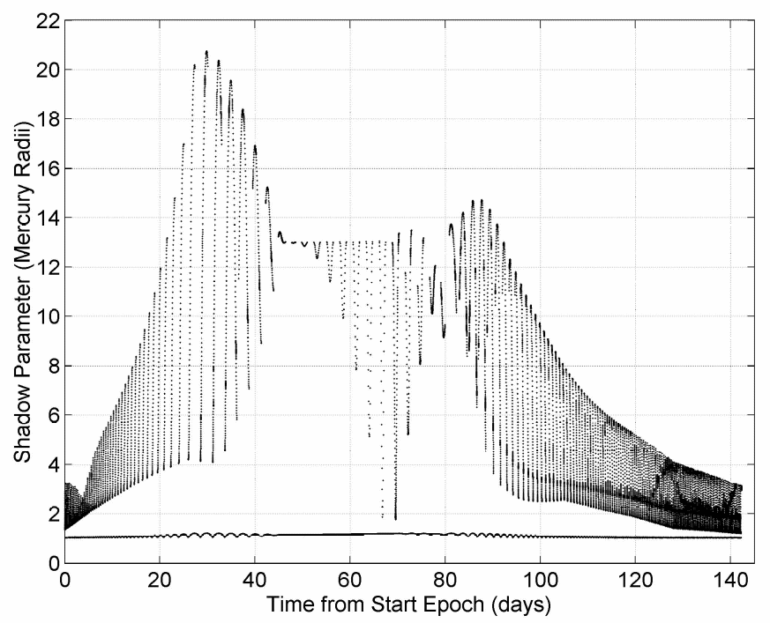
Figure 4 Spacecraft shadow parameter (night-side of planet only) and penumbra critical shadow parameter

Figure 5 shows the orbit argument of pericentre and inclination angles, which are shown to converge with their target values, while the right ascension angle is seen to terminate 10º ahead of the solar terminator. Finally, Figure 6 shows the altitude of pericentre and apocentre throughout the 142.3 day trajectory. We see that the orbit eccentricity peaks at day 30, prior to an extended period where eccentricity is very low, which corresponds with the rapid variations in argument of pericentre angle in Figure 5. Figure 6 shows that both pericentre and apocentre converge well with the target values; with all the orbit elements reaching convergence with Table 2 values on day 142 of the simulation.

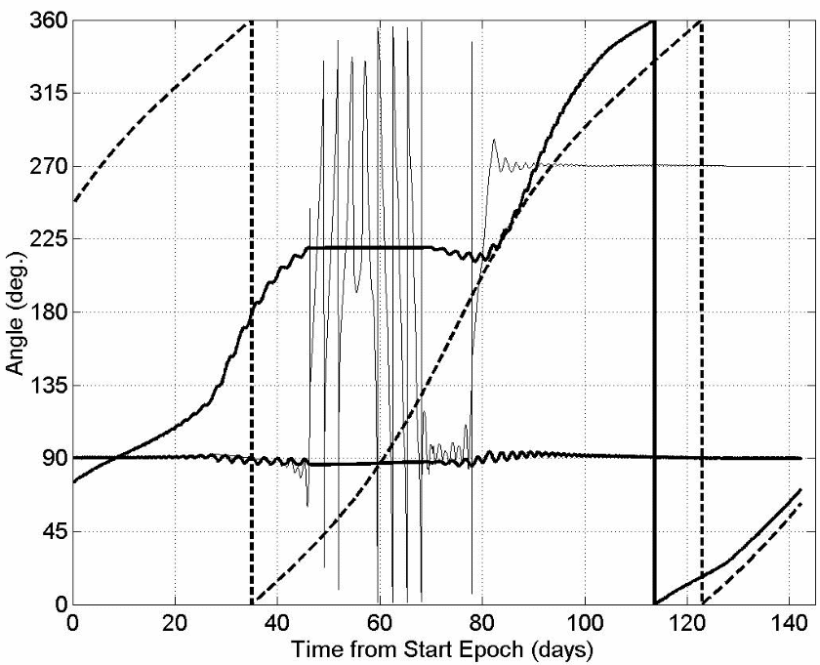
Figure 5 Right ascension of orbiter (heavy solid line starting at ~54º), right ascension of target solar terminator ground track (dotted), argument of pericentre (light solid line) and inclination (heavy solid line, starting at 90 º and ending at 90 º).
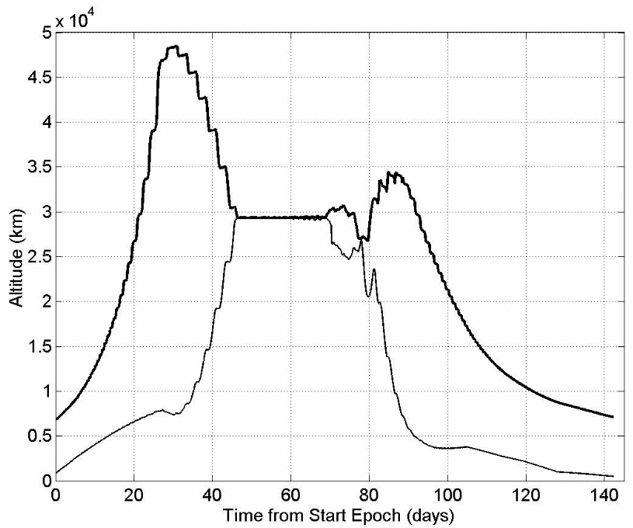
Figure 6 Instantaneous altitude of pericentre and apocentre during transfer trajectory.

The transfer trajectory created using A^{n}D blending requires numerous rapid sail slew manoeuvres. Furthermore, the time optimality of the transfer at approximately 142 days is difficult to evaluate, however we recall that this was not the primary cost function of the transfer. The transfer trajectory is constrained by spacecraft thermal considerations and is verified as being shadow free. Hence, we can state that it is possible to generate a shadow free transfer trajectory between a north-pole pericentre forced Sun-synchronous orbit and a south-pole pericentre orbit. Moreover, we can state that the use of A^{n}D blending has enabled such a transfer to be generated much easier than would be possible with conventional optimisation tools.

Forced Sun-Synchronous Orbit with Active Sail Control Using A^{n}D Blending
One of the significant attractions of using a solar sail to generate a forced Sun-synchronous orbit is the lack of sail control requirements. The sail pitch angle is constant at all times through the orbit and as such sail attitude control could be maintained by mostly passive methods. If the sail were used to deliver the payload into Mercury orbit then an active sail control system would be required for the Earth – Mercury transit and the capture spiral. However, if the sail is delivered to Mercury by a chemical, electric or combination of systems then it could be deployed in Mercury orbit, allowing a relatively small, simple and low cost solar sail to be utilised. Such an approach would appear to be the best approach for a near-term, low risk mission, as sail capture manoeuvres typically require a high sail slew rate capability and increase mission risk meaning that such a mission requires more advanced sail technology. We note however that the polar nature of the target orbit in this Sun-synchronous scenario actually allows a fixed sail pitch of 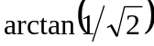 to be utilised while spinning the sail clock angle through 360º each orbit. Such a fixed pitch capture trajectory can actually be accomplished in a marginally shorter time than the locally optimal steering strategy requires. Both fixed pitch and locally optimal trajectories are shadow free.

The primary requirement of an active sail control system for a forced sun-synchronous orbit is clearly that the ascending node angle is rapidly rotated. It is logical therefore to investigate the use of the ascending node angle control law exclusively. The control law autonomously selects whether to increase or decrease the ascending node angle based on the current and target values. We find however that the variation of pericentre and apocentre altitude through a single Hermian year is considerably more than a fixed sail pitch over two Hermian years. This is a direct result of an increase in the amplitude of the long period oscillation of the argument of pericentre, as discussed earlier. We also find that the right of ascension angle follows the solar terminator much more poorly as a direct result in the substantial variations in orbit size and shape. It is also noted that the inclination angle varies by as much as +5º and -6 º from the nominal value of 90 º. It is thus evident that an active sail control system must consider more than just the right ascension control law due to the unstable nature of the orbit.

It is found that in the fixed sail pitch scenario the orbit offset from the solar terminator is not a constant, instead varying from plus ten degrees, the nominal value, to as low as +3 º and as high as +14 º from the terminator. With such wide variations in the offset angle the surface illumination conditions would not be constant. We thus require the active sail control system to provide a much more constant solar terminator offset angle and hence a much more constant surface illumination angle. It was also mentioned earlier than an active sail control system could potentially allow a reduction in pericentre altitude. Such a reduction increases surface resolution imaging for science data. Accordingly, an active sail control system for a forced sun-synchronous orbit is beneficial if it provides an improvement in surface illumination consistency and an increase in surface image resolutions, without any adverse effects on other orbit elements and parameters.

When we consider the fixed sail pitch scenario the offset angle from the solar terminator, the orbit eccentricity and semi-major axis each vary considerably. It is thus logical that when first attempting to generate an active sail control scenario we would attempt to control only these orbit elements. It was found however that when we control only these elements that the orbit inclination and argument of pericentre now vary significantly more than in the fixed sail pitch scenario, primarily due to the coupling in the out-of-plane perturbation terms. As a result of these initial findings it is apparent that an active sail control system must control orbit size and shape, while also considering the exact orbit plane location rather than just its ascending node angle.

When propagating station-keeping trajectories using the A^{n}D blending method we set the sail pitch angle at given discrete time-steps; typically these time steps are equal to or less than a quarter of the nominal orbit period. The pitch and clock angle are set by the current orbital elements without any forward-looking considerations through the duration of the time-step. The use of discrete time-steps has two objectives; primarily in the forced Sun-synchronous scenario it is implemented in order to reduce computation costs, as the variable step-size integrator has a tendency to take very small step sizes when the current and target elements are close together. By fixing sail pitch for a given period of time the integrator can propagate the orbit, while maintaining calculation accuracy without readjusting the sail at very small time-steps. Note that although the sail pitch is set in discrete time-steps the integrator is still variable step-size and typically takes many steps during each discrete pitch angle setting. The use of discrete sail pitch angle settings also has the effect of removing the potential requirement for multiple large angle slews in a very short period of time. Furthermore, if the discrete settings are significantly far apart the time required to slew the sail between settings can become significantly shorter than each discrete pitch time step; hence sail slew rate effects are minimised within the trajectory simulation. Such a scenario is investigated later within this paper, when we analyse A^{n}D blending applications within the GeoSail mission framework.

The use of active sail control to generate a forced sun-synchronous orbit at Mercury allows the pericentre altitude to be significantly lowered. It was found that pericentre could be taken below 100 km and easily maintained within a narrow range of altitudes. It was felt however that altitudes below 100 km were undesirable, partly for science data acquisition and that in order to maintain very low pericentre values within safe bounds we were required to relax control of other orbit elements. As such we define the nominal forced sun-synchronous orbit as 100 km pericentre altitude and 7500 km apocentre altitude, with ground track displaced 10º ahead of the solar terminator. Using the constants detailed in Table 3 we obtain the final weight functions utilised to gain a forced sun-synchronous orbit at Mercury with A^{n}D blending setting sail pitch and clock angle once per hour. It was found that the control method had a tendency to bring the ascending node angle 10º ahead of the terminator and then allow it to drift backwards before then acting to drive it back towards its nominal value. As a result the average offset angle from the solar terminator tended to be less than 10º; we therefore set the target offset angle at 10.25º, forcing the ascending node ahead of its nominal value and then allowing it to drift backwards through the nominal value, hence gaining an average offset angle much closer to the nominal, as seen in Figure 7. We also see in Figure 7 that the offset angle is maintained within very tight bounds at certain times of the Hermian year, for example in days 0 – 20 and 80 – 100 the offset angle is maintained with ± 0.2º. Yet at other times the offset angle spikes at values as much as 0.5º away from the nominal; such events are found to correspond with Mercury’s perihelion passage and the significantly increased levels of solar radiation pressure acting on the sail. The ability of the A^{n}D blending method to maintain orbit control during such large fluctuations in orbit perturbations illustrates the self-adaptive nature of the control system. We recall that solar radiation flux varies from four times Earth values at Mercury aphelion to just over ten times at Mercury perihelion, a variation of 250 % in orbit perturbation magnitude during each Hermian year. We note that the maximum recorded sail pitch angle during the active sail control trajectory show was 70º, thus while the active sail provides excellent orbit control it would require an agile sail.

Figure 7 shows the offset angle from the solar terminator for a fixed sail pitch angle of 10º and for an active sail control. As stated earlier, it is seen that the fixed pitch sail has a much larger variation in offset angle than an actively controlled sail, which thus provides a much more consistent level of surface illumination for science data acquisition. We see in Figure 8 the displacement in pericentre and apocentre from their nominal values for fixed sail pitch and an active sail control. The active sail significantly reduces variation in orbit size and shape, with pericentre varying by 40 km and apocentre by less than 100 km. Hence the active sail control would provide a much more constant surface resolution during science data acquisition. A final consideration with the use of an active sail control system is that it should not adversely affect the orbit elements that previously were noted to vary little with a fixed sail control system. We find that both the fixed sail pitch and active sail control system result in only very small variations in inclination and argument of pericentre.

Table 3 Constant weights by which A^{n}D score is multiplied to gain final weight functions
Control law weight | Constant factor  on A^{n}D score
W_{e} = | 8
W_{a} = | 6
W_{i} = | 20
W_{ω} = | 4
W_{Ω} = | 35
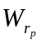= 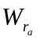= | 0

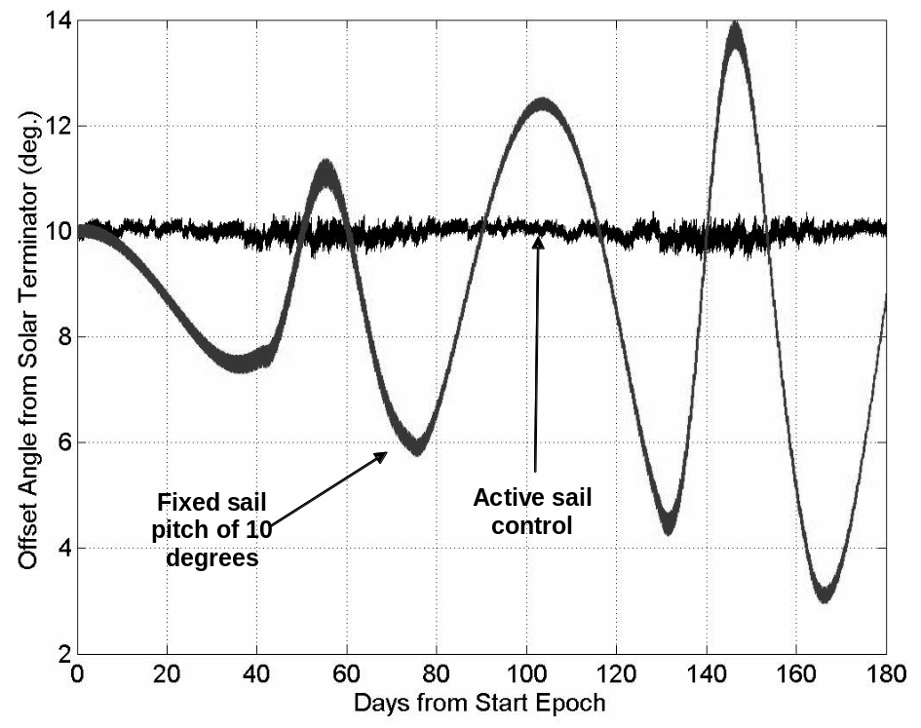
Figure 7 Orbiter/solar terminator offset angle, fixed and active sail control
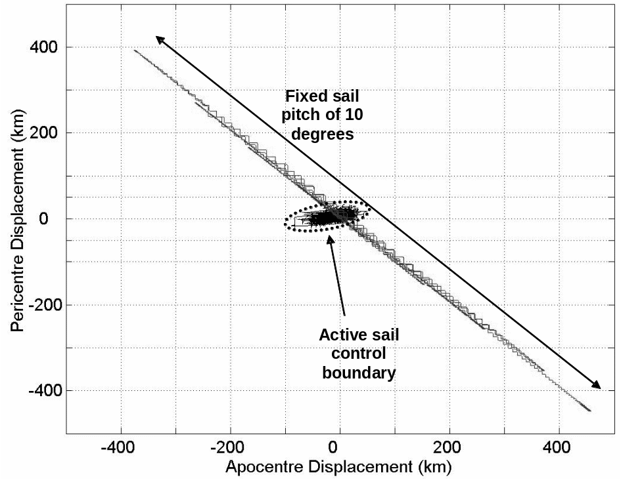
Figure 8 Displacement of pericentre & apocentre from nominal values, fixed and active sail control

GeoSail Orbit Control Using A^{n}D Blending
The use of an active sail control for forced Sun-synchronous orbits at Mercury has been shown to significantly improve orbit uniformity. However, the short orbit period necessitates many rapid sail slew manoeuvres. The GeoSail mission utilises a much larger orbit at Earth, with a nominal period of just over four days. The GeoSail mission utilises an orbit with a Sun-pointing perigee at 11 Earth radii and apogee at 23 Earth radii. The orbit is positioned within the Ecliptic plane and the sail pitch angle is fixed at zero-degrees, thus the natural inversions of the radial and tangential thrust vectors about the orbit, due to the orbit plane location, result in a secular variation of the argument of perigee while all other orbit elements experience zero secular variation. By correctly selecting the sail acceleration we can match the rate of change of argument of perigee to that of the Earth/Sun-line, hence maintain an orbit with apogee inside the Earth’s magnetotail. An inertially fixed orbit on this scale has apogee within the magnetotail once per year; rotation of the argument of perigee allows continuous, year round observations of the magnetotail with a single spacecraft.Error: Reference source not found

The A^{n}D blending method for active sail control is considered within the GeoSail mission for a similar purpose to that for which it was considered within the Mercury forced Sun-synchronous orbiter mission. That is to say that while the GeoSail orbit is a more naturally stable scenario we consider the use of an active sail control system to maintain a more precise orbit than would otherwise be attained by a fixed sail pitch scenario, with the corresponding oscillations in orbit elements. However, we additionally consider the application of a fixed upper limit to the allowed sail pitch angle. The imposition of an upper pitch angle means that we can expect much smaller sail slew angles between discrete sail pitch settings. It also simplifies spacecraft design if the solar aspect angle is more constant. We set the duration of each discrete sail pitch angle as one day, just under a quarter of the nominal orbit period. It was found that using a single set of weights on the A^{n}D scores we could maintain good orbit control down to an upper pitch angle of 15º. Reduction of maximum pitch to 10º was found to be overly restrictive and the control system required an increase in sail acceleration. The required sail acceleration is determined by consideration of the orbit size and shape as defined in Ref. Error: Reference source not found; the required sail characteristic acceleration is 0.0999 mm s⁻².

The Earth centred trajectory model utilises modified equinoctial elements in the equations of motion; the perturbational equations of motion are propagated using an explicit, variable step size Runge-Kutta formula, the Dormand-Price pair with relative and absolute error tolerances of 10⁻⁹ ensuring minimal truncation error.Error: Reference source not found The solar sail force model utilises a standard optical modelError: Reference source not found, while the Sun is modelled as a uniformly bright finite disk. The true sail – Sun distance is determined, correcting for the eccentricity of Earth’s orbit in order to correctly quantify the sail acceleration. The trajectory model includes 3rd body gravity effects due to both the Moon and the Sun, while modelling the Earth as a non-spherical body up to and including the 18th order harmonics. Umbra and penumbra shadow from the Earth and the Moon are also included within the trajectory model.

Using the constant weights detailed in Table 4 we obtain the final weight functions utilised to generate a GeoSail orbit with active sail control, setting sail pitch and clock angle once per day. We note that the factor by which the argument of perigee is multiplied by is much larger than the other control laws. The value of each factor reflects the importance of the orbit element. Similar to the Mercury forced Sun-synchronous orbit we find it is beneficial to target the primary orbital element, the argument of perigee is this case, ahead of the nominal value. Thus, the argument of perigee is targeted 0.2º ahead of the Earth-Sun line.

Table 4 Constant weights by which A^{n}D score is multiplied to gain final weight functions
Control law weight | Constant factor  on A^{n}D score
= | 35
= | 25
W_{a} = | 2
W_{ω} = | 170
W_{e} = W_{i} = W_{Ω =} | 0

The maximum sail pitch angle allowed is 15º; thus if the blended locally optimal pitch angle is greater than 15º the pitch angle is set as 15º, with the clock angle allowed to take any value between 0º and 360º degrees. Similar to the Mercury forced Sun-synchronous scenario the sail control angles are set by consideration of only the current orbit elements and no forward-looking considerations are taken. We see in Figure 9 the displacement of perigee and apogee from the nominal values of eleven and twenty-three Earth radii respectively, for the fixed sail pitch and active sail control scenarios. It is found that the active sail control scenario using A^{n}D blending to select the sail control angles reduces the variation in orbit perigee and apogee, thus providing a much more consistent orbit shape and size. The radius of perigee is seen in Figure 9 to be centred on a value of approximately 10.8 Earth radii, rather than the nominal value of 11 Earth radii. If desired the target perigee could be raised to 11.2 Earth radii, thus the orbit would shift towards the nominal GeoSail orbit in a similar manner to that used for accurate targeting of the argument of perigee. We note however that this is a magnetotail science mission and as such the primary science requirement is for accurate control of apogee and the argument of perigee thus no such adjustment was adopted.

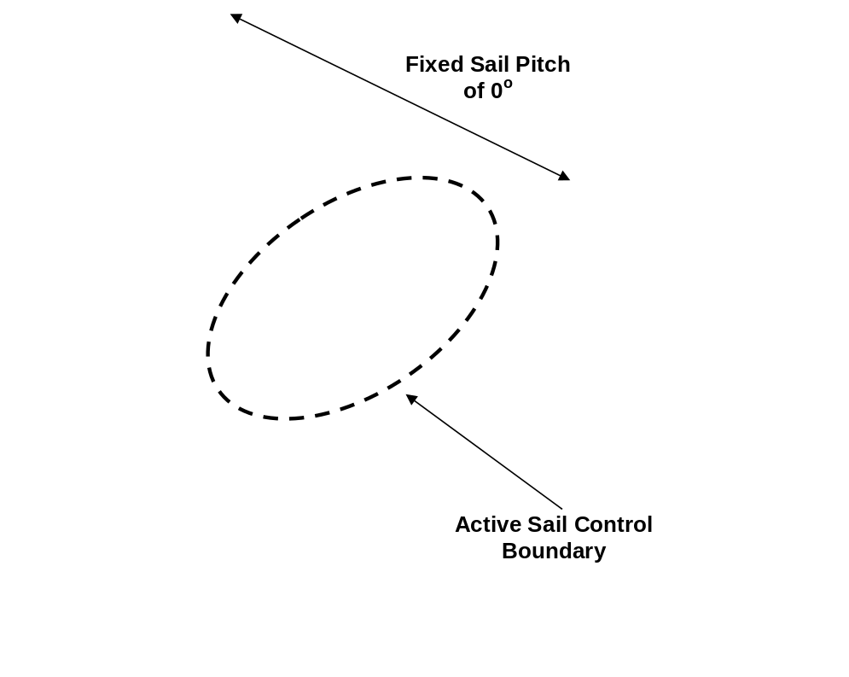
Figure 9 Displacement of perigee & apogee from nominal values, fixed and active sail control.

Figure 10 shows the variation in the angle between the Earth-Sun line and the orbit major axis for a fixed and active sail. We note that the orbit major axis and Earth-Sun line vary by as much as 3º for a fixed sail pitch, while the A^{n}D blending method reduces this variation to less than 1º. Finally, we see in Figure 11 the sail control angles generated by the A^{n}D blending method for the GeoSail scenario with active sail control. We define sail pitch angle as the angle from the sail-Sun line to the sail normal, while the sail cone angle is the angle from the sail-Sun line to the sail thrust vector. The sail cone angle equals the sail pitch angle for an ideal sail only and is less than the pitch angle for a non-ideal sail. We note that typically the sail pitch angle is 15º with the clock angle flipping the sail thrust vector either left or right of the orbit major-axis. As such the maximum required sail slew angle between discrete sail pitch settings is 30º; however we also note that at other times the sail does not move for as much as three to five days. We can thus define the technology requirement for sail slew capabilities in an active sail mission scenario as 30º in 1.25 – 2.5 hrs, 5 – 10 % of the duration of each discrete sail setting. Thus, the time for each slew manoeuvre is significantly less than the duration of each discrete set of control angles. GeoSail is a demonstration class mission thus as part of an extended mission active sail control using A^{n}D blending could be demonstrated over and above the basic solar sail demonstration capabilities of the GeoSail mission.

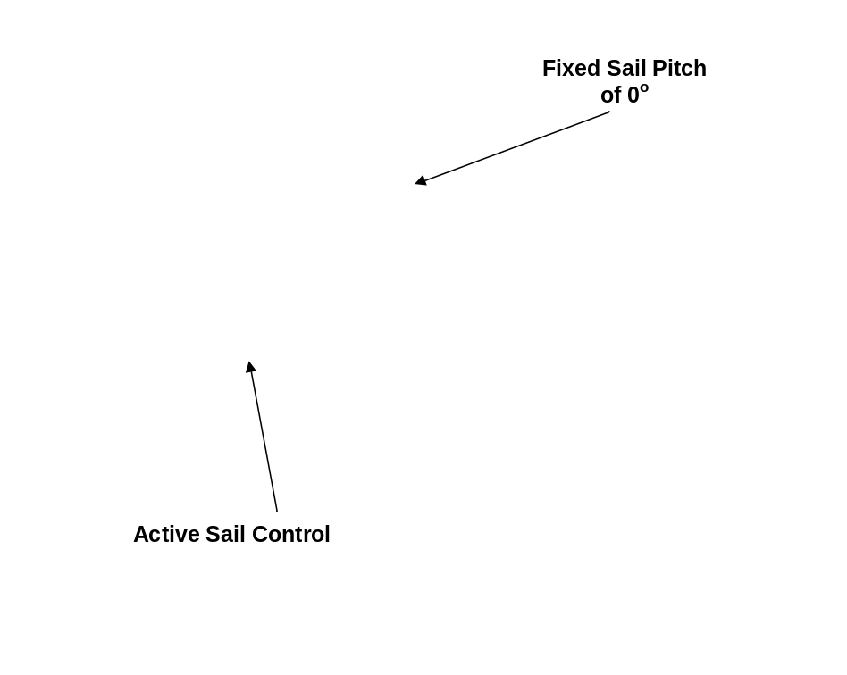
Figure 10 Variation in angle between Earth-Sun line and orbit major axis, fixed and active sail control.

Figure 11 Active sail control angles selected using A^{n}D blending.

Conclusions
A new method of assessing the relative importance of orbit elements during solar sail transfer and station-keeping manoeuvres has been introduced, allowing rapid generation of trajectories by blending locally optimal control laws. The Accessibility and Deficit, A^{n}D, blending method considers both an orbital element’s variance from its target value and how well that orbital element will use the sail prior to calculating a score for the element. A^{n}D blending directs the blended locally optimal force vector such that it avoids prolonged periods of high sail pitch settings, which are an inefficient use of the sail, thus increasing sail efficiency.

The A^{n}D blending method has been demonstrated for generation of a complex orbit transfer at Mercury, where the primary cost function of the transfer was thermal rather than time. The transfer trajectory rotates argument of pericentre by 180º, while continually re-targeting towards a new ascending node final value, which is initially rotated 180º from the trajectory’s starting ascending node value. The trajectory is verified shadow free and all orbit elements converge well with the target values. The use of A^{n}D blending allows the generation of such a transfer trajectory in a much more rapid fashion than would be possible with conventional optimisation techniques.

Furthermore, A^{n}D blending has been demonstrated to act as an excellent solar sail station-keeping algorithm; capable of adjusting to significant variations in orbit perturbation magnitude. The control method demonstrated is capable of providing the sail control angles in real-time, based solely on the current spacecraft state-vectors. Thus, these two factors combined make A^{n}D blending suitable as a potential autonomous on-board sail control system.

References

Research Assistant/Lecturer, Department of Aerospace Engineering m.macdonald@aero.gla.ac.uk
Professor, Department of Mechanical Engineering colin.mcinnes@strath.ac.uk
McInnes, C.R., “Solar Sailing: Technology, Dynamics and Mission Applications”, Springer-Verlag, London, 1999.
Hughes G., Macdonald M., M^{c}Innes C. R., Atzei, A., ‘Terrestrial Planet Sample Return Using Solar Sail Propulsion’, Proceedings of Fifth IAA International Conference on Low-Cost Planetary Missions, ESA Special Publication SP-542, pp. 377-384, September 2003.
Sands, N., “Escape from Planetary Gravitational Fields by Using Solar Sails” American Rocket Society Journal, Vol. 31, 1961, pp. 527-531.
Fimple, W.R., “Generalized Three-Dimensional Trajectory Analysis of Planetary Escape by Solar Sail”, American Rocket Society Journal, Vol. 32, 1962, pp. 883-887.
Coverstone-Carroll, V. and Prussing, J.E., “A Technique for Earth Escape Using a Solar Sail”, AAS 99-333, Astrodynamics Specialist Conference, Westin Prince Alyeska Resort, Girdwood, Alaska, August 16-19 1999.
Coverstone, V. L. & Prussing, J.E., “Technique for Earth Escape from Geosynchronous Transfer Orbit Using a Solar Sail”, Journal of Guidance, Control and Dynamics, Vol. 26, No. 4, July-August 2003.
Fekete, T.A., Sackett, L. L., von Flotow, A.H., “Trajectory Design for Solar Sailing from Low-Earth Orbit to the Moon”, AAS 92-184, Advances in Astronautical Sciences, Vol. 79, Pt. 3, pp. 1083-1094, 1992.
Eguchi, S., Ishii, N., Matsuo, H., “Guidance Strategies for Solar Sail to the Moon”, AAS 93-653, Advances in Astronautical Sciences, Vol. 85, Pt. 2, pp. 1419-1433, 1993.
Morgan, T.O., “The Inclination Change for Solar Sails and Low Earth Orbit”, AAS 79-104, Advances in Astronautical Sciences, 1979.
Sackett, L.L., “Optimal Solar Sail Planetocentric Trajectories”, R-1113, The Charles Stark Draper Laboratory, Inc., JPL-NASA Contract NAS 7-100 Final Report, September 1977.
Sackett, L.L. & Edelbaum, T.N., “Optimal Solar Sail Spiral to Escape”, Advances in Astronautical Sciences, AAS/AIAA Astrodynamics Conference, A78 31-901, 1978.
Leipold, M., “Solar Sail Mission Design”, Doctoral Thesis, Technische Universität München, DLR-Forschungsbericht 2000-22.
Macdonald, M., M^{c}Innes, C.R., “Realistic Earth Escape Strategies for Solar Sailing”, Submitted to Journal Guidance, Control and Dynamics, 12 September 2003, Accepted 14 May 2004.
Macdonald, M., M^{c}Innes, C.R., ‘Analytic Control Laws for Near-Optimal Geocentric Solar Sail Transfers (AAS 01-473)’, Advances in the Astronautical Sciences, Vol. 109, No. 3, pp. 2393-2413, 2001.
Kluever, C. A., “Simple Guidance Scheme for Low-Thrust Orbit Transfers”, Journal Guidance, Control and Dynamics, Vol. 21, No. 6, pp. 1015-1017, 1998.
Schoenmaekers, J., Pulido, J., Jehn, R., “SMART-1 Mission Analysis: Moon Option”, ESOC report S1-ESC-RP-5001, Issue 1, 22 September 1998.
Petropoulos, A. E., “Simple Control Laws for Low-Thrust Orbit Transfers”, AAS 03-630, AAS/AIAA Astrodynamics Specialists Conference, Big Sky, Montana, 3-7 August 2003.
Green, A.J., “Optimal Escape Trajectories From a High Earth Orbit by Use of Solar Radiation Pressure”, T-652, Master of Science Thesis, Massachusetts Institute of Technology, 1977.
Pagel, G., “Extremale Steuerstrategien für Sonnensegler am Beispiel von Bahntransferproblemen zum Erdmond“, Doctoral Thesis, Technischen Universität Berlin, May 2002. (In German)
Sackett, L.L., “Optimal Solar Sail Planetocentric Trajectories”, R-1113, The Charles Stark Draper Laboratory, Inc., JPL-NASA Contract NAS 7-100 Final Report, September 1977.
Sackett, L.L. & Edelbaum, T.N., “Optimal Solar Sail Spiral to Escape”, Advances in Astronautical Sciences, AAS/AIAA Astrodynamics Conference, A78 31-901, 1978.
Leipold M., Borg, E., Lingner, S., Pabsch, A., Sachs, R., Seboldt, W., “Mercury Orbiter with a Solar Sail Spacecraft,” Acta Astronautica, Vol. 35, Suppl., pp. 635-644, 1995.
Leipold M., Borg, E., Lingner, S., Pabsch, A., Sachs, R., Seboldt, W., “Mercury Sun-Synchronous Polar Orbiter with a Solar Sail,” Acta Astronautica, Vol. 39, No. 1-4, pp. 143-151, 1996.
Leipold, M.E., Wagner, O., “Mercury Sun-Synchronous Polar Orbits Using Solar Sail Propulsion”, J. Guidance, Control and Dynamics, Vol. 19, No. 6, pp 1337-1341, 1996.
Dormand, J.R., Price, P.J., “A Family of Embedded Runge-Kutta Formulae”, Journal of Computing and Applied Mathematics, Vol. 6, pp 19 – 26, 1980.
Burt, E.G.C., “On Space Manoeuvres With Continuous Thrust”, Planet Space Science, Vol. 15, pp 103-122, 1967.
Roy, A.E., “Orbital Motion”, Institute of Physics Publishing, London, 1998.
M^{c}Innes, C., Macdonald, M., Angelopous, V., Alexander, V. GEOSAIL: Exploring the Geomagnetic Tail Using a Small Solar Sail, Journal of Spacecraft and Rockets, Vol. 38, No. 4, July-August 2001.

