Strathclyde University Flight Test Course

This year the 500th Student from the Department of Mechanical and Aerospace Engineering at the University of Strathclyde took part in the flight test/experience course (FTC) at the Scottish Gliding Centre at Portmoak.

The genesis of the course dates back to 2001 when I was in the process of implementing a new course, Aero-Mechanical Engineering, At the University of Strathclyde. The course was to be accredited as an Aeronautical Engineering degree by the Royal Aeronautical Society and therefore required some form of flight test/experience as part of the course. I had started to learn to fly at the same time and, as my flying abilities improved and I found that I could fly and talk at the same time, I had a number of conversations with George Ross in the back about how our students might benefit from flight experience in a K21 at Portmoak.

I discussed my ideas with George Ross and Kevin Hook and, as they were both very supportive, I approached the board to see if the SGU would help. The board agreed to let me run a trial course so I buckled down to write the syllabus.

The Syllabus is loosely based around the types of flights undertaken by other universities in the National Flying Laboratory Jetstream aircraft from Cranfield University. I was concerned that the limited flight instrumentation available in the K21s might restrict the test possibilities but, even with these limitations, a comprehensive course was developed with the emphasis being on giving the students an understanding of how an aircraft is flown and behaves rather than on just taking data.. The trial course was run at the beginning of September 2002, over three days, with four of our fourth year Mechanical Engineering with Aeronautics students acting as guinea pigs. The trial course found a number of slight issues with the organisation and syllabus but, with slight modification, the first actual flight test course ran in 2003. Since that first course ran about 50 students have taken part in the course each year over the summer at the end of the second year of their studies.

During their second year the students use the ASK21 as the basis for a number of calculations. They calculate the stall speed at 1g and 2g, the parasite drag coefficient, C_{Do}, and induced drag factor, k, maximum L/D, the rate of descent with full airbrakes, the never exceed speed, V_{ne}, the neutral point stick fixed and free and the range of static margins for the aircraft. The flight tests attempt to verify the results of these calculations.

Because of the large number of students that need to take part; two courses are run each week with five students per course. The courses are residential and last two and a half days changing over Wednesday lunch time. After completing the requisite paperwork for their three month temporary club membership the students are given a thorough safety brief and once this is complete the flying begins. There are four flights planned for each student which, depending on the weather conditions, are planned to be aero towed, typically, to between three and four thousand feet depending on cloud base.

The syllabus for the four flights is;

Flight 1: Demonstration of aircraft controls,

The first flight demonstrates the aircraft controls and instruments to the student. The effects of adverse yaw and how to coordinate turns are demonstrated.

Flight 2: The stall

The second flight is to investigate the stall and stall recovery. The indications of an approaching stall and the change in the effects of the controls are demonstrated in a gradual straight and level 1g stall. To show that the aircraft can stall at any speed the aircraft is stalled 2g. During the flight the students record, on a kneeboard data sheet, figure 2, the indicated air speed (IAS) at which the aircraft stalls at 1g and 2g.

Flight 3: Performance

During flight 3 the aircraft is flown at constant speed while the students record the time to descend 100’, the indicated airspeed and the stick position for two different airspeeds. On the approach the time to descend 100’ with full airbrakes is measured. These measurements allow the parasite drag coefficient, induced drag factor and neutral point of the aircraft to be determined.

Flight 4: Dynamic Stability,

To demonstrate the dynamic stability in pitch, speed stability, of the K21 the aircraft is flown through phugoid oscillations at 60kts and 45 kts, figure 3. To initiate these oscillations the pilot trims the aircraft to 60kts and notes the stick position and then initiates a 30º climb. For the stick fixed phugoid the stick is returned to the 60kts position and held rigidly in place. For stick free the stick is released and the elevator allowed to float free. Usually the 60kts phugoids are stable but the 45kts phugoids, which are below the minimum drag speed, are unstable and lead to a divergence in the oscillation. During each phugoid the student records the maximum and minimum IAS and makes a subjective assessment of whether or not the oscillation is stable, neutral or unstable.

Dynamic stability in roll and yaw are demonstrated by initiating a spiral divergence and by deflecting and then releasing full rudder.

During all flights the students are encouraged to take control and fly the aircraft as much as possible.

Analysis of results.

At the start of the third year of their course the students take the data recorded during their flight tests and compare the results with their theoretical calculations. Depending on the meteorological conditions during each flight and the age/condition of the aircraft the results may, or may not, agree with their calculations. Differences in the results forces the students to consider the uncertainties that may have existed during the recording of their data.

The results of the dynamic stability flight are used in the third year of the course where the students are introduced to the equations of motion of an aircraft and flight simulation. The ASK21 is simulated and the results of simulations of pitching, rolling and yawing motions compared to the results of the dynamic stability flights.

Summary

The Strathclyde FTC run in collaboration with the SGU has surpassed all expectations. As a learning experience it cannot be beaten as it gives students first-hand experience of flying and comparing experimental data with the results of numerical simulations. There is also the experience of being in an aviation environment where the students learn about meteorology, NOTAMS, airworthiness, aircraft maintenance etc.

Strathclyde FTC from the Scottish Gliding Union’s perspective

The SGU and its instructors have enjoyed the experience of working with the University and its students over the years, providing an opportunity to do something more than the usual instructing drills.

The course instructor must be sure that flights are repeated accurately over the week for all students so that results can stand reasonable comparison. Additionally, the students may have never flown in an unpowered craft and the instructor must be sensitive to some fears and anxieties making sure that the students are well briefed to be able to record their information, whilst understanding what the aircraft is doing at the same time.

Time is also made to give them practical hands on time as well to supplement the course work, which helps to make it even more interesting for them.
The students are always welcome on the field and are interested in the practical side of flying and they are encouraged to take part fully in launching and retrieving aircraft.

At Portmoak, these courses have become as standard a part of the year as the other welcome visitors from England, Wales, Ireland or even further afield, who visit us every year. We look forward to continuing this into the future.

Strathclyde FTC from a student’s perspective.

FTC: Alasdair Mackenzie, BEng Aeromechanical engineering 2014.

The flight test course (FTC) I did as part of second year ‘Aerodynamic Performance’ was the best part of any class I did in my undergraduate degree. One thing that made the FTC unique is that it showed the practical application of the university lectures, something that no other class did to anywhere near the same level. We learnt in depth about the aerodynamic aspects of the K-21 glider during the university year, through lectures and coursework, and having the FTC at the end was something to look forward to. Learning to fly is something I’ve always wanted to do, and to do it part of my university degree was excellent! Groups of 5 students had 3 days’ flying, learning the basics: the controls, the stall, turns, and eventually trying to gain lift. It was great to feel first-hand what the glider was like to control, by changing the aerodynamic aspects of the aircraft; something university lectures cannot come close to.

The instructors were very experienced glider pilots who showed us what the gliders could do, doing loops and other acrobatic manoeuvres. Having 4 fellow student friends to share these experiences with was great, as we could discuss what happened in the previous flight. We had to carry out some basic calculations on a few flights, to verify the work we had carried out in university before the course started. These included sink rates, and stall speeds. Again, this was very interesting comparing experimental and theoretical results first hand.

When teaching us the pilots were very patient and encouraging, and by the end of day three I was managing to keep inside a thermal, gaining altitude. This was a very exciting experience, and a great end to the course. Going on the course has encouraged me to continue gliding, and has rekindled my passion for flying. In conclusion, the course was one of the best experiences in my degree and very worthwhile, as I think there is a lack of practical engineering aspects to our course.

The course meets, if not surpasses, all expectations we had for the course when it was initially developed. The students find the course to be an educational experience as well as a lot of fun. The flying and theoretical work complement each other and reinforce the students knowledge of flight mechanics and aerodynamics. We are dependent on the SGU supporting this course and the willingness of instructors and tug pilots to give up their valuable time to help us. However, talking to the instructors they also find taking part an educational and rewarding experience.

For further information and a more technical discussion the reader is directed to “A novel method for the provision of flight experience and flight testing for undergraduate aeronautical engineers at the University of Strathclyde” Stickland M.T., Scanlon T.J., Aeronautical Journal Vol 108, No. 1084, pp. 315-318 (2004)

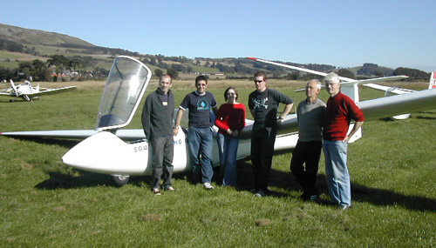

Figure 1: Trial flight test course students in 2002 with Ian Dandie and George Ross.

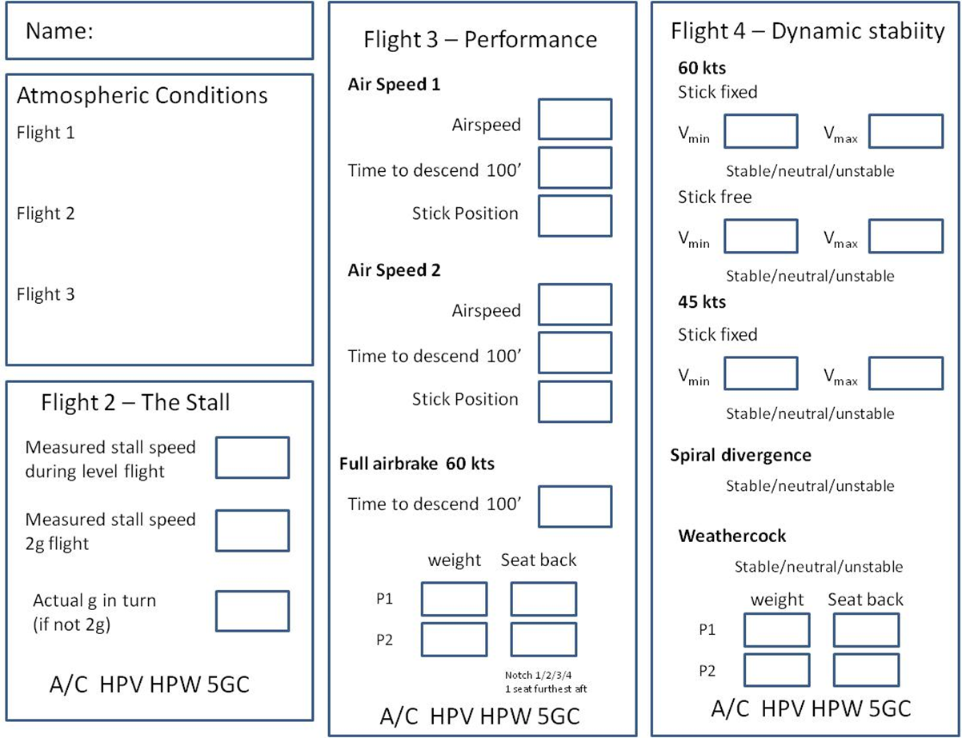
Figure 2: data record sheet. Copies of sections of this sheet are completed in the air and the data transcribed to the master sheet at the end of each flight.

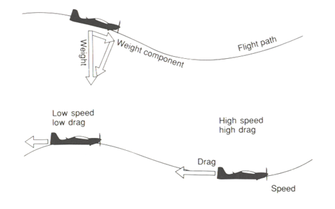
Figure 3: phugoid oscillation, Barnard and Philpott (2000)

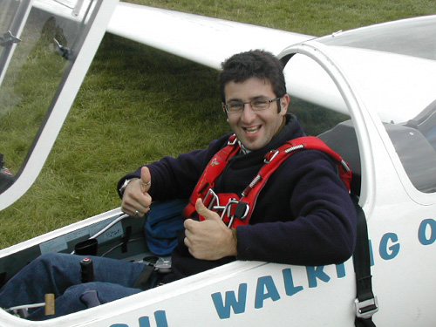

Figure 4. Another successful flight

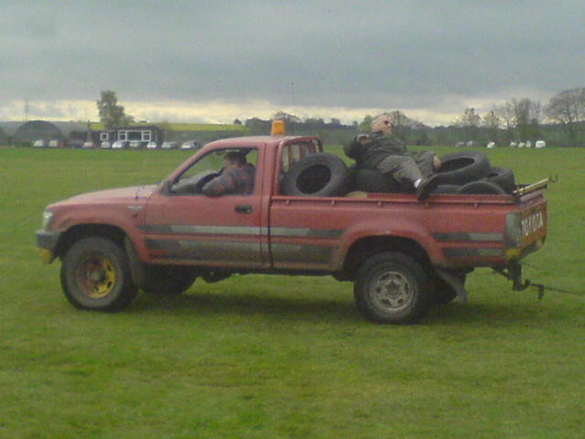

Figure 5. It is never clear which the students enjoy the most; flying or driving the variety of retrieve vehicles to be found at the SGC.

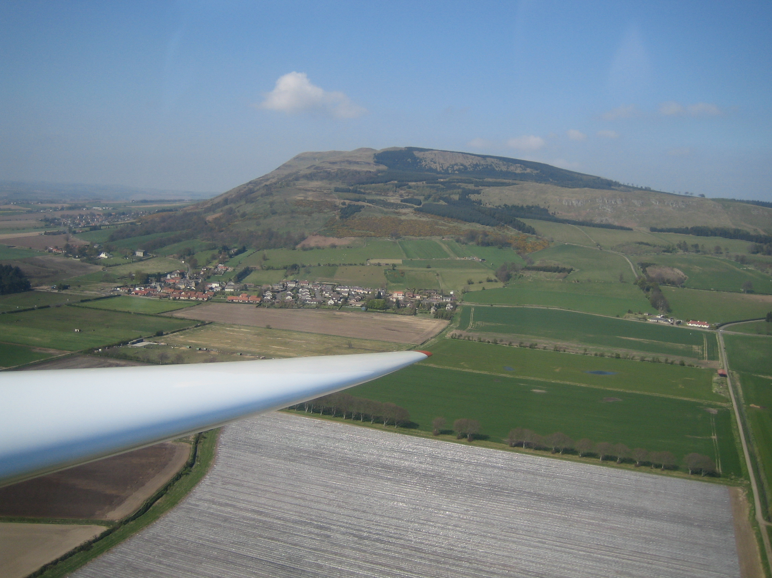

Figure 6. Students have to be restrained from taking too many videos and photos when armed with their mobile phones and now can be found strapping Gopro cameras to various different parts of their bodies to record their experience.

