SEPARATION OF MECHANICAL AND THERMAL DEGRADATION OF THERMALLY CONDITIONED SIZED GLASS FIBRE

P. Jenkins^{1*}, J. Thomason¹, R. Meier¹

¹Department of Mechanical and Aerospace Engineering, University of Strathclyde, The University Centre, 347 Cathedral Street, Glasgow, G1 2TB
*peter.jenkins@strath.ac.uk

Keywords: Glass fibre, thermal conditioning, strength loss

Abstract
The loss of strength of glass fibres following exposure to elevated temperatures for even short times is a well-documented phenomenon, and is a major factor in restricting the recyclability of this material for structural applications. Boron-free E-glass with aminopropyltriethoxysilane (APS) coating was thermally conditioned at 450°C for 25 minutes. The effect of damage due to manual handling was investigated by separating single fibres from the bundle at different stages of the process and performing tensile tests on them. Fibres separated after thermal conditioning were found to have lost around 65% of their original tensile strength, while those separated before the thermal conditioning procedure exhibited only a 35% decrease.

1 Introduction
The loss of strength of E-glass fibre following exposure to elevated temperatures has been studied for many years and well-documented during this time. Early research by Thomas [1] attempted to systematically measure strength loss, and reported approximately a 60% decreases in strength at 450°C, for treatment durations of less than 30 minutes. Other researchers, such as Cameron [2], obtained similar results while using more rigorous statistical analytical methods.

In more recent times the performance loss exhibited by heat treated glass fibre has become a critical issue affecting the recyclability of fibre reinforced composites. Due to their excellent mechanical properties and relative low cost glass fibres have become more widely used in structural composites in the wind industry and semi-structural components in the automotive industry. Consequently the end-of-life recyclability of glass fibre reinforced composites is becoming a more particular industrial concern. Pickering et al. [3] used a fluidized bed to recover fibre samples from sheet molded compound a temperatures of 450°C and 650°C. Their results showed that elevated temperatures cause greater tensile strength degradation for glass fibres and the temperature and residence time should be minimised to achieve improved retention of mechanical properties.

Despite the effect being well established, no research has yet fully clarified the mechanism for the loss of strength of glass fibre after heat treatment. Early work [4] suggested that bonding of contaminant particles caused stress-raising features on the fibre surface. Alternatively, Aslanova [5] suggested heating within the range 400-600°C caused crystallization within some glass fibres resulting in strength reduction. More recently Feih et al. [6] reported structural relaxation during thermal annealing, as well as secondary attack of surface-adsorbed water, to be the likely causes of tensile strength loss.

While numerous thermal causes for glass fibre strength loss have been proposed, purely mechanical sources of damage have not been fully investigated. According to the classic brittle fracture theory of Griffith [7] a glass fibre will fail when the applied tensile load causes catastrophic growth of a critical crack on its surface. Therefore any process which creates new surface damage is liable to change the strength of a brittle fibre. To investigate this effect a novel test was developed by the authors, by which glass fibre was thermally conditioned in two different arrangements: bundled and as separated single fibres.

2 Materials and Experimental Methods
2.1 Materials and Equipment
All experimental work was carried out using a boron-free formulation of E-glass provided by Owens-Corning. Average fibre diameter was measured as 17 µm with standard deviation of 1.6. Both unsized and sized fibre was used: the sizing was the commonly industrially used AminoPropyltriethoxySilane (APS) type. Tensile tests were carried out by affixing fibres to 250 g/m² card using Loctite® superglue as the adhesive.

Thermal conditioning, as described below, was carried out using a CSF1200 Carbolite electric furnace. Tensile tests, at a crosshead speed of 0.3 mm/min, were conducted using an Instron 3342 uniaxial tensile testing machine with a 10N capacity load cell.

2.2 Experimental Procedures
2.2.1 Fibre Bundle Thermal Conditioning (TC)
Newly cut bundles of fibre (shown as ‘B’) were attached to a specially designed steel rig (Figure 1) using a nut, bolt and washer (indicated by ‘A’) to prevent fibre breakage. Care was taken to ensure that the bundle was not subjected to tensile stresses and that unwanted contact between the fibre and any surface was prevented. After preheating the oven to 450°C for around 1 hour, the rig was inserted into the furnace for 25 minutes. It was then removed and allowed to cool under room temperature conditions. Single fibres were then extracted for the purpose of tensile testing.

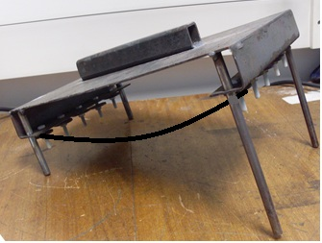
A
B
Figure 1. Image of the steel rig used for bundled TC.

2.2.2 Single Fibre Thermal Conditioning
Single fibres were extracted one-by-one from a bundle and attached to steel wire frames (Figure 2) using a slow drying cement. After allowing the cement to set for a minimum of 24 hours these frames were arranged on an aluminium tray and inserted into the furnace, which had been preheated to 450°C for around 1 hour. After 25 minutes the samples were removed and air cooled at room temperature.

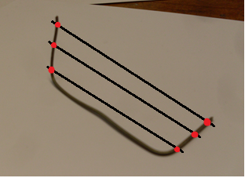
Figure 2. Image of a wire frame used for single fibre TC – altered to show position of attached single fibres and cement used to hold them in place

2.2.3 Tensile Testing
Single fibres were placed on the centre line of 20mm gauge length card templates using double-sided tape to position them accurately and superglue to fix them at the correct length. Care was taken during this process not to stress them excessively. After production samples were kept in closed containers. Following drying of the glue, a Nikon Epiphot inverted optical microscope and ImageJ software was used to measure the diameter of each fibre (with accuracy of approximately ± 1 µm). Finally uniaxial tensile testing was carried out using the equipment detailed in Section 2.1. The card template was gripped at the base with a vice clamp; load was applied at the top via a punched hole which was hung from a hook attached to the load cell. The error bars given for all average tensile strength data presented represent the 95% confidence limits.

Cut fibre bundle from roving
Thermal conditioning
Fibre separation
Mount single fibre tensile test samples
Measure diameter
Tensile test
Thermal conditioning
Fibre separation
Bundle procedure ‘b’
Single fibre procedure ‘sf’
Figure 3. Simplified flowchart showing the difference between the single fibre and bundle TC procedures

3 Results and Discussion
3.1 Characterisation of Thermal Degradation
An initial investigation into the strength loss of thermally conditioned glass fibre was conducted on sized and unsized fibres as part of undergraduate research work. The result is summarised in Figure 4, in which the loss of tensile strength for both sized and unsized glass fibre is presented through a range of TC temperatures. Each datum point in the figure represents the average of at least 75 tests.

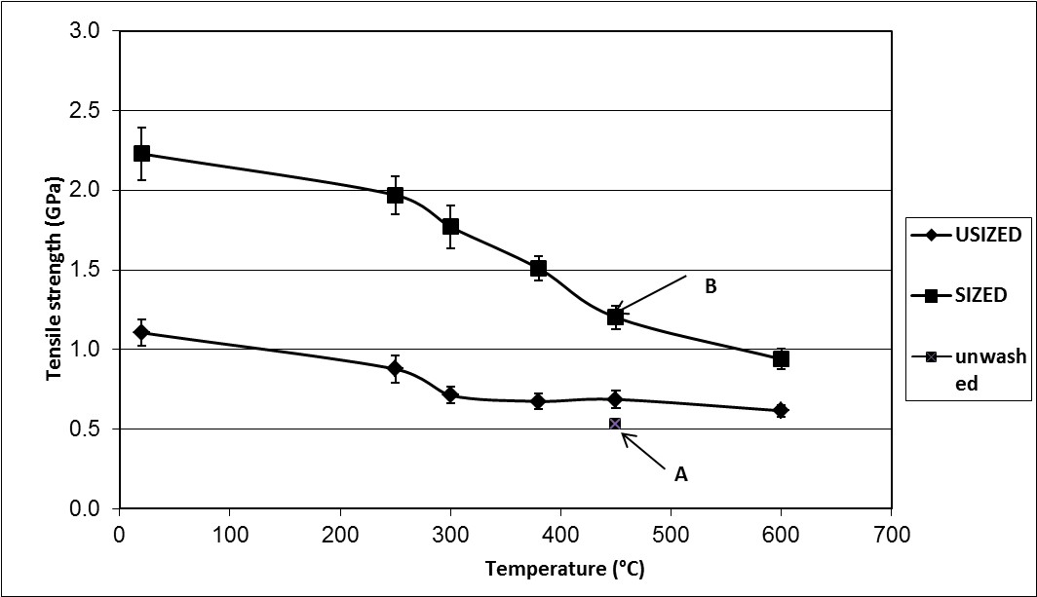
Figure 4. Tensile strengths for sized and unsized glass fibre treated at various temperatures (tested at 20mm gauge length)

These results are in general agreement with findings of other researchers ([1], [8]). Significantly for recyclability concerns the results for sized fibre demonstrate a loss of tensile strength of almost 60% at 600°C, with significant deterioration occurring at 300°C – well below the temperature required to remove composite matrix materials. Both sized and unsized fibres exhibited the tensile strength property drop, although it was more severe for sized fibre. The authors suggest that two different mechanisms occurred: one a fundamental change in the unsized fibre, the other surface damage which affects the sized fibre only.

A further interesting outcome of this work was noted in the data for sized fibre conditioned at 450°C. Datum point B was obtained using a bundle that was washed and dried prior to execution of the procedures outlined in Sections 2.2.1 and 2.2.3. This involved washing the bundle in deionized water at 70°C for 4 hours followed by drying overnight at 110°C. Without this process, a lower tensile strength of approximately 0.5 GPa was obtained, as shown by datum point A. A precise explanation for this effect has not been formulated since too many variables were present. However it is postulated that fibres taken from the unwashed bundle become more strongly bonded together (than those that have been washed) during TC and hence suffer greater damage while being separated, resulting in a lower measured strength. In order to further investigate this phenomenon, the experiment detailed in section 3.2 was performed.

3.2 Single Fibre vs. Bundle Thermal Conditioning
A more rigorous experiment was designed specifically to investigate the effect of mechanical damage during handling. The details of the two thermal conditioning procedures are given in 2.2.1 and 2.2.2; the flowchart in Figure 3 summarises the two procedures. The only variable in the procedure is the point at which single fibres are separated from the bundle: in the single fibre case (designated ‘sf’) this is before thermal conditioning, in the bundle case (designated ‘b’) it is after. Figure 5 shows the results of the experiment using unwashed sized fibre at a conditioning temperature of 450°C.

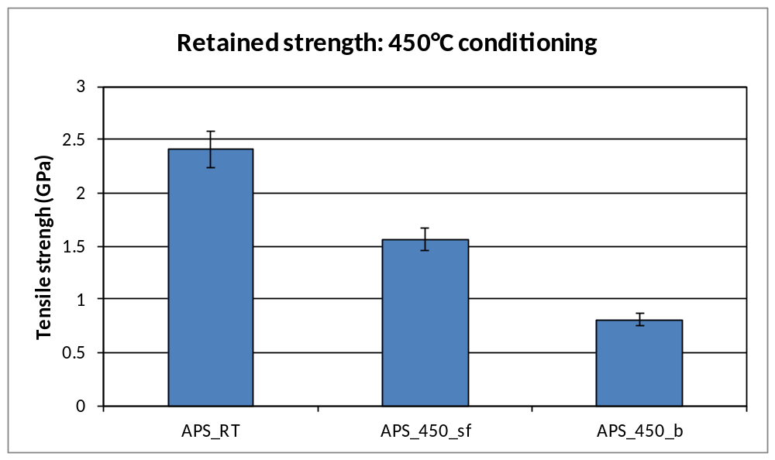
Figure 5. Retained strength for sized fibre following bundle and single fibre TC procedures

The column APS_RT in the figure represents the strength of virgin fibre measured at room temperature which was found to be in the region of 2.4 GPa. After thermal conditioning, an average strength loss of around 65% was observed for the fibre bundle (APS_450_b). On the other hand the average strength loss measured for fibre conditioned by the single fibre method (APS_450_sf) was in the region of 35%. This amounts to a difference in retained strength between the two processes of 0.75 GPa.

The authors suggest that these results imply the presence of two distinct processes which contribute significantly to the observed loss of tensile strength of glass fibres thermally conditioned in close proximity to other fibres in a bundle. It also seems likely that these two processes apply to fibres in a composite during the thermal recycling process. The first process involves some fundamental change in the properties of the glass, the result of which was the 35% strength loss from the room temperature value to that indicated by APS_450_sf. The second process is an increase in the level of fibre damage caused by fibre-to-fibre interaction during the bundle thermal conditioning process. This explains the significant further strength loss of 0.75 GPa.

4 Conclusions
It has been demonstrated that significant strength loss occurs in glass fibres following exposure to elevated temperatures for a short duration of 25 minutes. The observation was made using both sized and unzised fibres. However, the reduction in strength was more significant in sized fibre rather than unsized which may be due to the occurence of sizing degradation in the thermal process. Mechanical testing of fibres treated using the two different thermal procedures showed that single fibres thermally conditioned following extraction from the bundle exhibit greater mechanical performance than those extracted from a bundle after an identical heat treatment. It is proposed that this is due to a decrease in the amount of mechanical damage experienced by the fibres before testing. It should therefore be considered that strength loss of glass fibres is the result of a combination of thermal and mechanical effects.

5 Acknowledgements
This research work has been financially supported by the EPSRC as part of Towards Affordable, Closed-Loop Recyclable Future Low Carbon Vehicle Structures (TARF-LCV). The authors would like to acknowledge the University of Strathclyde, for the provision of funding and laboratory equipment and Dr Liu Yang for support and guidance throughout the execution of this work.

References
[1] W. F. Thomas, “An investigation of the factors likely to affect the strength and properties of glass fibres,” Physics and Chemistry of Glasses, vol. 1, no. 1, pp. 4-18, 1960.
[2] N. M. Cameron, “The effect of environment and temperature on the strength of E-glass fibres. Part 2. Heating and ageing,” Glass Technology, vol. 9, no. 5, pp. 212-130, 1968.
[3] J. R. Kennerley, N. J. Fenwick, S. J. Pickering, and C. D. Rudd, “The properties of glass fibers recycled from the thermal processing of scrap thermoset composites,” Journal of Vinyl and Additive Technology, vol. 3, no. 1, pp. 58-63, Mar. 1997.
[4] W. Brearley and D. G. Holloway, “The effect of heat-treatment on the breaking strength of glass,” Physics and Chemistry of Glasses, vol. 4, no. 3, pp. 69-75, 1963.
[5] M. S. Aslanova, “THE EFFECT OF DIFFERENT FACTORS ON THE MECHANICAL PROPERTIES OF GLASS FIBERS,” Steklo i Keramika (translated), vol. 17, no. 11, pp. 10-15, 1960.
[6] S. Feih, E. Boiocchi, G. Mathys, Z. Mathys, A. G. Gibson, and A. P. Mouritz, “Mechanical properties of thermally-treated and recycled glass fibres,” Composites Part B: Engineering, vol. 42, no. 3, pp. 350-358, Apr. 2011.
[7] a. a. Griffith, “The Phenomena of Rupture and Flow in Solids,” Philosophical Transactions of the Royal Society A: Mathematical, Physical and Engineering Sciences, vol. 221, no. 582–593, pp. 163-198, Jan. 1921.
[8] D. B. Dorzhiev, V. E. Khazanov, and V. V. Gorbachev, “Some features of the structure and strength of a magnesium aluminosilicate fiber,” The Soviet journal of glass physics and chemistry, vol. 15, no. 2, pp. 99-102, 1990.

