CHARACTERISATION OF THE MECHANICAL PERFORMANCE OF NATURAL FIBRES FOR LIGHTWEIGHT AUTOMOTIVE APPLICATIONS.

José Luis Rudeiros-Fernández^{1*} and James L. Thomason¹

¹Advanced Composite group, Department of Mechanical and Aerospace Engineering, University of Strathclyde, Montrose Street, Glasgow G1 1XJ, United Kingdom
*Jose.Rudeiros-Fernandez@strath.ac.uk

Keywords: Natural Fibres, Mechanical Properties, Automotive.

Abstract

It is well recognized that light weighting of automotive parts leads to reduced carbon emissions over vehicle lifetime. Mineral fibres and fillers have a relatively high weight and can require very high levels of energy in their production, resulting in a large carbon footprint. Natural fibres could be a potential candidate to substitute mineral fillers in automotive application of thermoplastic matrix composites. Results will be presented from single fibre testing for characterization of fibre modulus and strength. One of the unique aspects of natural fibres is their variable, non-circular cross-section which usually has larger dimensions than mineral fibres and fillers. This paper will further discuss the need for accurate determination of fibre cross-section in order to properly characterize the mechanical performance.

1 Introduction

Over the last decade, the automotive industry has come under increasing pressure regarding its sustainability and environmental performance in terms of production, vehicle lifetime and end of life disposal-recycling. Policy regulators have been developing policies encouraging better sustainability practices and dictating strict regulations in terms of energy efficiency, emissions and materials recycling. On the other hand, the increasing societal sensitivity to environmental issues could also make customers change their purchasing criteria, making the vehicle’s sustainability parameters a key factor in their decision making. The need to fulfil all these regulations and customer needs, combined with increasing pressure on the supply of natural resources is making the automotive industry change their target material specifications. In this context, natural fibres could be a potential candidate to substitute mineral fillers in automotive application of thermoplastic matrix composites. A significant body of evidence is being amassed that natural fibres may have potential to compete with mineral fibres and fillers as a more environmentally friendly reinforcement [1][2]. This adoption could lead to smaller energy consumption during the overall vehicle’s life due to reduced production energy, light-weight products and increased use of renewable resources. Nevertheless, commercial reality requires a certain minimum level of cost-performance-processability balance from such fibres. This paper focuses on the characterisation of palm leaf fibre as part of an evaluation of its potential for the substitution of high density mineral fillers with more environmentally friendly low weight natural fibre reinforcements.

One of the assumptions used in micromechanical analysis of fibres is that the fibres have a constant cross section area (CSA) along the fibre length and that the fibres are circular in cross section. These two assumptions can lead to significant errors in the measurement of the mechanical characteristics of natural fibres due to the non-circular CSA and its variability along their length of natural fibres. Thomason et al [3] reported evidence on how an accurate measurement of the CSA is necessary for the determination of modulus and strength. In this study, mechanical characterisation of palm fibre was determined through single fibre testing and accurate measurement of the CSA.

2 Experimental

2.1 Tensile test

Palm fibres were individually separated until no fraying could be seen with the naked eye. The fibres were then mounted for testing on card frames made from 250 g/m² card. The gauge lengths used for testing were 5, 10 and 20 mm. LoctiteTM Gel Superglue was used to fix the fibres to the card. All fibres were photographed at the middle point of the gauge length under transverse observation using a Leica microscope at 10x magnification. The three most representative diameters in each picture were measured using the software ImageJ. The fibre diameter was estimated as the average of these three measurements. Tensile testing was carried out using an Instron 3342 tensile testing machine with a 100 N load cell at 5% strain per minute. For the tensile test, card and fibre were clamped up to the gauge length as it is showed in Figure 1 in order to avoid any slippage.

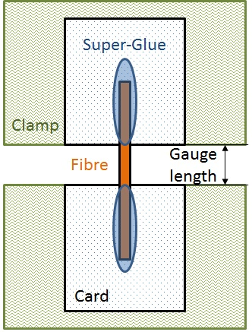

Figure 1. Schematic drawing of tensile test
2.2 CSA measurements

Once the fibres were tested the bottom and top ends were cut off from the remaining card. The two parts were then fixed to 250 gr/m² card in vertical position for later manipulation. The cards with the fibres fixed were then inserted into a mould for embedding them in resin as it is showed in Figure 2. These samples were then grounded and polished for CSA analysis. The fibres’ cross sections were photographed using an Olympus GX51 microscope at different magnifications depending on the size of the fibre. In every picture the cross-section was traced and exported for post-treatment. The resulting images were converted to binary and then measured using the “analyse particles” feature of ImageJ. The CSA was estimated as the average of the two measurements on each fibre. These measured CSA values were used to correct the modulus and strength data from tensile test calculated using the CSA obtained by the “diameter”.

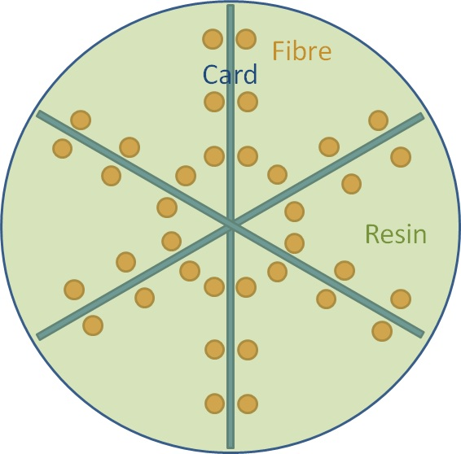

Figure 2. Schematic drawing of CSA measurement

3 Results and discussion

Figure 3 shows some examples of palm fibres’s cross section obtained through optical microscopy. This figure clearly illustrates the very large range in fibre diameters coming from the same plant. The range of diameter for palm fibre goes from 100 μm to 1000 μm fibres approximately. Each fibre it is made up from certain number of individual cells. At the same time each of these cells it is made up from three different parts: lumen, cellular walls and middle lamella [4]. The lumen is the void in the middle of the cell and that was actually where the protoplast of the cell is located. The walls of the cell basically establish the size of the protoplast. The structure and composition of the walls could vary depending on their age, position and function. The main component of the cell walls is cellulose in the shape of nano-fibrils winded around the longitudinal axis of the fibre. Along with them, a “matrix” of hemicellulose, pectin and other non-cellulosic substances hold the cellulose nano-fibrils together.
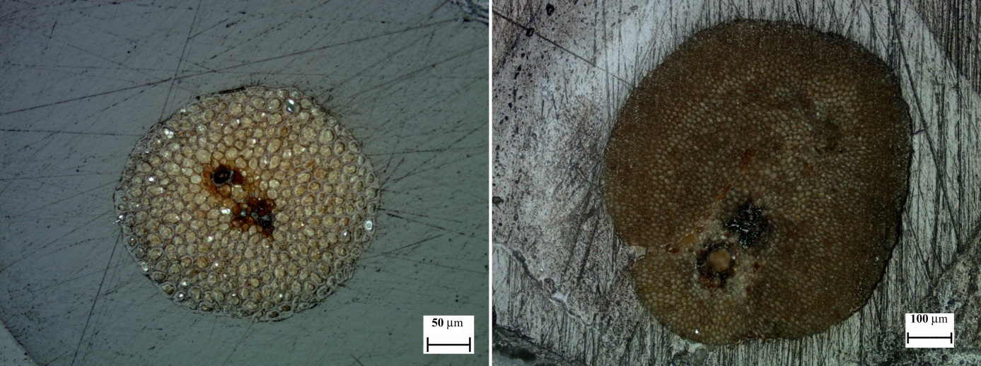

Figure 3. Palm fibre cross section

Figure 4 compares the real CSA and the CSA obtained from the diameter measurements. The first value is obtained as the average of the two direct measurements of the cross section after testing. The fibres are embedded and polished for the measurements. The second value is obtained assuming a circular cross section. The average of the three most representative diameters is used as diameter for the calculation. As Thomason et al [3] pointed out, the second method is the most extended procedure and normally lead to underestimation of the real mechanical properties. When a straight line is plotted as trend-line, it shows that palm fibres’ CSA are approximately an 80% of the CSA based on the diameter measurements. This could lead to an underestimation of approximately 20 % in Young’s modulus and tensile strength.

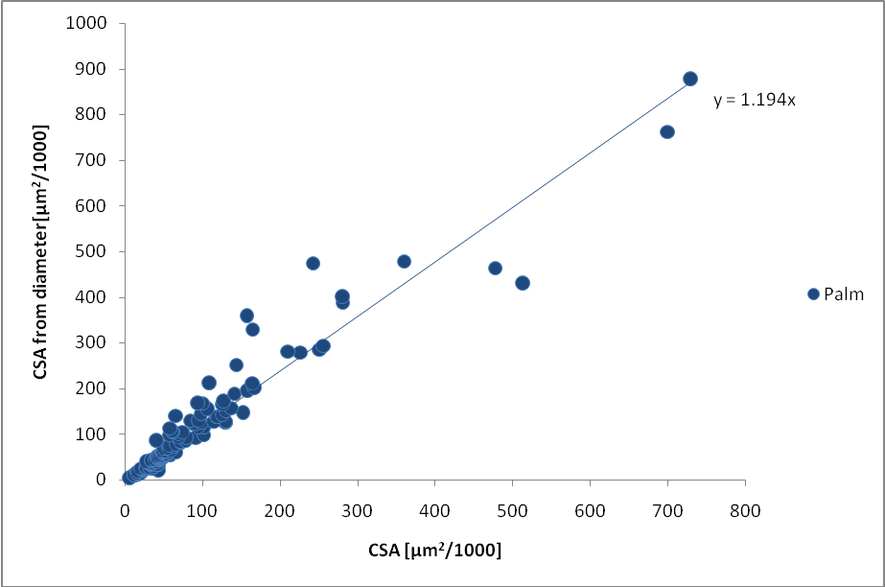

Figure 4. CSA directly measured vs CSA calculated from diameter
Figure 5 shows the average modulus for all gauge lengths. It shows initial data and corrected through the measured CSA where the error bars represent the 95 % confidence limits on the average values. It can be observed how the initial data represents an underestimation of approximately a 10 % in the modulus as it was previously discussed. This value for Young’s modulus is far from other fibre’s modulus as flax or sisal with approximate modulus of 70 and 30 Gpa [3][5]. These differences are based among others on the different composition of fibres, cell wall thickness and different orientation of cellulose fibres in the cell walls among others.

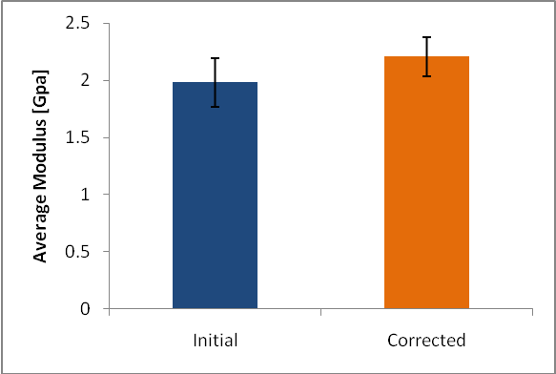

Figure 5. Average Young's modulus

It is well recognised that the values obtained during single fibre testing can be affected by the gauge length of the fibre. During testing, the contribution of the strain of some parts of the system is not taken into account. To obtain a corrected fibre modulus the following assumptions need to be made [6]. The fibre stress-strain curve has to be linear. Being E* the experimental Young’s modulus, the measured stress is given by 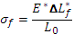. is the initial gauge length and is the apparent system measured fibre elongation. If is the actual fibre elongation then , where it is assumed that K is proportional to the applied force where is the CSA of the fibre and C is proportional to the compliance of the system. Arranging the previous equations the actual modulus and the experimental modulus are related by (1)

(1)

The fibre modulus can be estimated using this equation, that matches the generic equation for a straight line . Being the variables 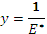 and 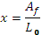, the interception point of the straight line with will equals 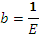. The data obtained through tensile testing were plotted as described and the least squares fitted lines were traced as well. The data were plotted in two sets, one of them as it was measured and the other where modulus and CSA were corrected based on real CSA measurements. Figure 6 shows the two sets, where the orange set is the corrected through CSA, showing again that with diameter measurements the modulus is underestimated. The slope of the lines gives an estimation of the compliance of the system and can be used to obtain a corrected strain to failure.

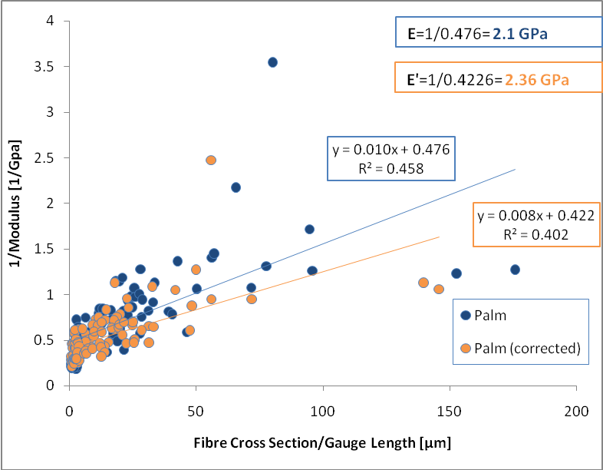

Figure 6. Estimation of actual fibre modulus from gauge length experiments

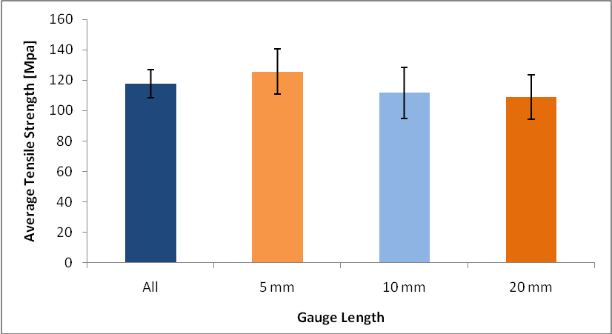

Figure 7. Average fibre strength for the different gauge lengths

Figure 7 shows the average fibre strength for the different gauge length tested where the error bars indicate the 95% confidence limits on the average values. It seems there is no significant difference between average values considering the confidence limit. Again these values are far lower than the tensile strength for flax or sisal.
Conclusions

Accurate CSA measurements are necessary in order to accurately calculate the Young’s modulus and strength of natural fibres. The estimation of the CSA through transverse diameter measurements and the assumption of circular cross section lead to underestimation of the mechanical properties. The difference between real CSA and estimated through diameter are around 20% for palm fibre. The overall results indicate that mechanical properties are far behind from other natural fibres with a Young’s modulus of 2.4 GPa and a tensile strength of 118 MPa.

References
[1] Bledzki A. K., Gassan J. Composites reinforced with cellulose based fibres. Progress in Polymer Science, Volume 24, pp. 221-274 (1999).
[2] Goda K. , Cao Y. Research and Development of Fully Green Composites Reinforced with Natural Fibers. Journal of Solid Mechanics and Materials Engineering, Volume 1, pp. 1073-1084 (2007).
[3] Thomason J. L., Carruthers J., Kelly J., Johnson G. Fibre cross-section determination and variability in sisal and flax and its effects on fibre performance characterisation. Composites Science and Technology, Volume 71, pp. 1008-1015 (2011).
[4] Raven P. H., Evert R. F., Eichhorn S. E. Biology of plants,W.H. Freeman/Worth Publishers, New York (1999).
[5] Baley C. Analysis of the flax fibres tensile behaviour and analysis of the tensile stiffness increase Composites Part A: Applied Science and Manufacturing, Volume 33, pp. 939-948 (2002)
[6] A. Bunsell, Fibre Reinforcements for Composite Materials, Elsevier, Amsterdam (1988)

