NATURAL FIBRE CROSS SECTIONAL AREA EFFECTS ON THE DETERMINATION OF FIBRE MECHANICAL PROPERTIES

J. L. Thomason*, F. Gentles, A. Brennan

*University of Strathclyde, Department of Mechanical Engineering, Glasgow G1 1XJ, United Kingdom*

*\* james.thomason@strath.ac.uk*

Keywords: natural fibre, diameter, cross section, properties.

Abstract

*The cross section values obtained from fibre “diameter” measurements on a range of natural fibres were much greater than those obtained from actual observation of cross sections of the same individual fibres. This overestimation was found to be as much as 400% in some extreme cases. The overall conclusion is that fibre “diameter” measurement is not an attractive method for accurate estimation of cross sectional area of these natural fibres. This conclusion is significant for researchers engaged in micromechanical investigation of natural fibre composites since differences in fibre cross section translate directly into differences of the same magnitude in the values obtained for the fibre modulus and strength. The error in fibre cross section introduced by the “diameter” method scales with the average fibre “diameter” which may also result in erroneous observations of fibre modulus and strength scaling inversely with natural fibre “diameter”. A simple mathematical model based on an elliptical fibre cross section is shown to explain the observed trends and the magnitude of the fibre cross section area overestimation from the “diameter” method is shown to scale with the average eccentricity of the observed natural fibre cross sections.*

1 Introduction

In recent years there has been a growing renewal of interest in the research of fibres derived from natural sustainable sources as potential reinforcements for high performance composites. It has been claimed that natural fibres show potential as alternatives to conventional reinforcements such as glass fibres [1-3] although these claims often ignore the well documented low levels of shear and transverse properties of natural fibres [4-6]. Nevertheless, one of the basic underlying assumptions in virtually all micromechanical analysis and modelling of fibre reinforced composites is that the fibres are circular in cross section and that the fibre diameter is constant along the fibre length. Accurate determination of engineering parameters such as fibre modulus and stress depends heavily on these assumptions. Furthermore, many researchers have identified the fibre-matrix interface in natural fibre composites as an area of potential weakness and consequently there has been a significant focus on the investigation of methods to tailor the level of natural fibre-polymer interactions [1-8]. This has resulted in the application of many characterisation tools, developed using man-made fibres, to natural fibre technology. These include single fibre methods for interface characterisation [7,8] and determination of single fibre strength distributions [8-12]. These methods present researchers with significant technical and resource challenges, however up to now measurement of fibre cross section and its uniformity has not received much attention [9]. Unfortunately most natural fibres suffer from the variability inherent in materials sourced directly from nature. Hence the documentation of their structural properties usually does not quote specific values but often presents wide ranges [1-3]. This presents engineers, used to the availability of consistent and accurate mechanical property data of manmade fibres, with a significant challenge in designing reliable structures based on natural fibre composites. The measurement of the longitudinal mechanical properties of traditional reinforcement fibres depends on their cross-section being circular and uniform along their length. This allows a simple measurement of fibre diameter to be used to calculate the fibre cross-section area (CSA) required to obtain modulus and strength from an experimental load-displacement curve. Most natural fibres are neither circular in cross section nor uniform along their length. Consequently, a simple “diameter” measurement of a transversely viewed fibre image may not be sufficient to accurately assess CSA at any point and may certainly not be representative of the fibre at any other point. In this paper we present the results of an investigation of the CSA of single fibres of flax, sisal, hemp, jute, kenaf, abaca and coir.

2 Materials and testing methods

Single technical fibres [9] were separated from one another until no fraying could be seen with the naked eye. These fibres were mounted to card windows typical of those used in single fibre tensile testing. The mounted fibres were photographed at ten positions at 2 mm intervals while under transverse observation using a Nikon Epiphot inverted microscope. The average fibre “diameter” at each position was obtained from four measurements on each micrograph. The CSA was then calculated using the average “diameter” under the assumption of uniformly circular cross section fibres. To directly examine the CSA along the fibre length, these same individual fibres were glued to card and then embedded vertically in resin blocks. These embedded samples were prepared for microscopy by grinding using progressively finer grinding papers. The fibre cross sections were then photographed under the microscope at 50-200x magnification depending on the fibre dimensions. The true value of fibre CSA was obtained from these micrographs using imageJ image analysis software. Samples were repeatedly ground, polished and photographed, in 2 mm steps to give ten CSA measurement along a 20 mm length of fibre. The measurements of “diameter” and actual CSA were estimated to be at the same points on the fibre ±0.2 mm.

3 Results and discussion

Figure 1 shows some typical cross section images obtained on sisal and flax fibres. The non-circular cross section of these natural fibres is clearly illustrated in these micrographs. The fibre outline has been highlighted and it is this outline which was used to evaluate fibre CSA.

**Figure 1.** Cross section view of single Sisal and Flax fibre

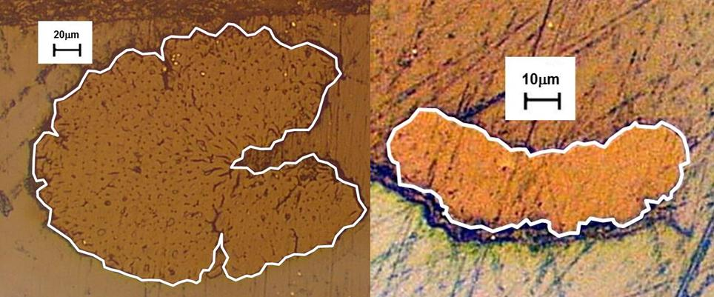

**Figure 2.** Cross section variations along Sisal and Flax fibres



Figure 2 shows the results of the measurement CSA of twelve individual sisal fibres at ten positions along the length of each fibre. It can be observed that there is quite some variation in CSA along the length of some fibres whereas other fibres appear relatively uniform. What is also clear from the results in Figure 2 is that the difference in CSA observed from fibre to fibre is significantly greater than the variation along the length of each individual fibre. Similar trends in the variability of flax fibre CSA can be seen in Figure 2. The flax fibres exhibit a significantly lower average CSA compared to the sisal fibres. Nevertheless, it is clear from Figure 2 that the inter-fibre CSA variability for flax is also greater than the intra-fibre variability. A further analysis of the data presented in Figure 2 is shown in Table 1 along with similar results for the five other types of natural fibre investigated. The data presented in this Table show the 95% confidence limits of the various fibres CSA averages calculated as a percentage of the relevant average. The values in Table 1 confirm the observations stated above that the inter-fibre CSA variability is significantly greater than the intra-fibre CSA variability for all types of natural fibres studied. Furthermore, the fibre to fibre variability appears to be much greater than the variability along these relatively short lengths of individual fibres. It can also be concluded from this data that the use of an average CSA obtained from a number of measurements on a single fibre could lead to significant errors in the calculation of fibre mechanical performance from load-displacement data and that the use of (even single) measurements of the CSA of each individual fibre will probably result in a more accurate estimation of the properties of natural fibres.

|  |  |  |  |
| --- | --- | --- | --- |
| Fibre | Average CSA (mm2) | 95% Confidence Limit of the average CSA | |
|  |  | Intra-fibre | Inter-fibre |
| Sisal | 0.0326 | 5.0 % | 24.3 % |
| Coir | 0.0283 | 11.3 % | 24.0 % |
| Abaca | 0.0213 | 6.5 % | 42.5 % |
| Flax | 0.0125 | 7.5 % | 24.1 % |
| Kenaf | 0.0061 | 12.9 % | 15.6 % |
| Hemp | 0.0058 | 10.8 % | 27.6 % |
| Jute | 0.0032 | 11.0 % | 18.3 % |

Table 1. Analysis of various natural fibre cross sectional area variations

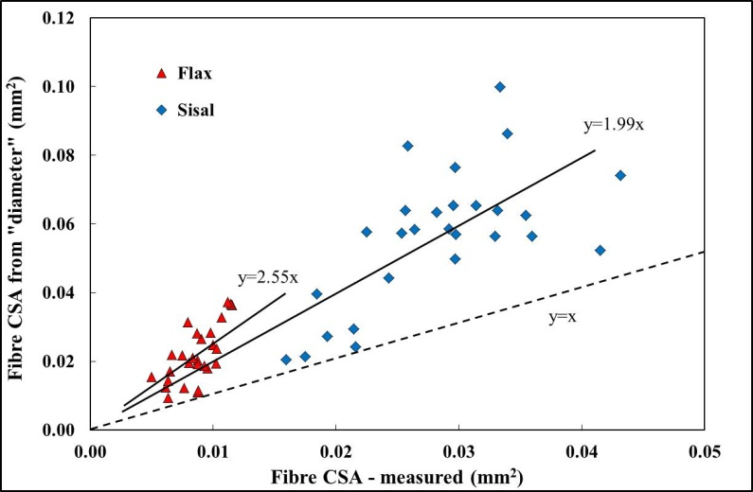

**Figure 3.** Fibre cross sectional area – diameter calculated versus directly measured

Figure 3 compares the values obtained for fibre CSA obtained by two different methods where both measurements were obtained at approximately the same position on the same individual fibres. As is common with natural fibres there is considerable scatter observed in the data. However, notwithstanding the degree of scatter it is striking that the CSA values obtained from fibre “diameter” measurements are on average double or more the values obtained from actual observation of the fibre cross sections. Despite the scatter observed in Figure 3, analysis of the data indicates that the averages for the two fibres fall outside the 95% confidence limits of the other fibre. Consequently, we can state that flax fibres show a statistically significant greater potential error in using fibre “diameter” calculated CSA. However, the overall conclusion is that fibre “diameter” measurement is not an attractive method for accurate estimation of CSA of either of these natural fibres. This observation has important consequences for those researchers engaged in the determination of the properties of natural fibres. The above results indicate that use of a “diameter” determined fibre CSA may lead to the underestimation of properties such as modulus and strength by up to 60%. This is in good agreement with recent results from a study of jute fibre diameter by Virk [12] who suggested the use of a “fibre area correction factor” of 1.42 in the measurement of fibre modulus and strength to account for the overestimation of the fibre CSA by the diameter method. Figure 4 shows the results for the ratio of the “diameter” calculated CSA to

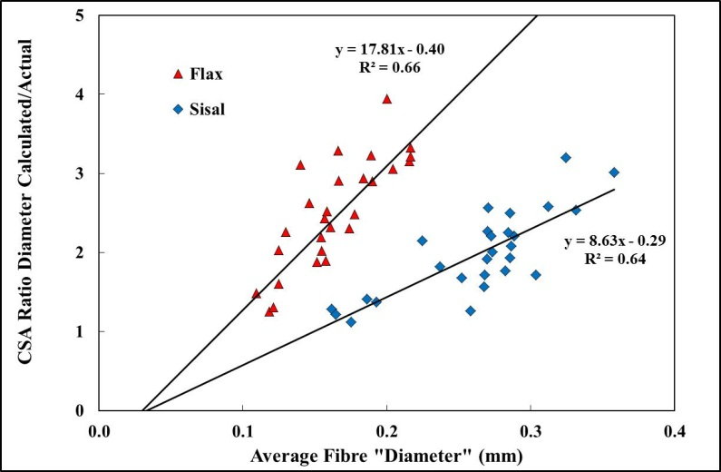

**Figure 4.** Diameter dependence of ratio of diameter calculated to measured fibre CSA

measured fibre CSA plotted against the fibre “diameter”. It can be seen for most of these flax and sisal fibres a much greater correction factor would be necessary in order to obtain a reasonably accurate estimation of the fibre mechanical properties from single fibre testing. Moreover, it is clear from Figure 4 that there is a strong correlation between the required “correction” and the apparent fibre diameter. It also appears that the error from using a “diameter” calculated fibre CSA is greater for flax fibres compared to sisal fibres. The higher slope of the flax data may be indicative of a higher aspect ratio of the flax fibre cross section.

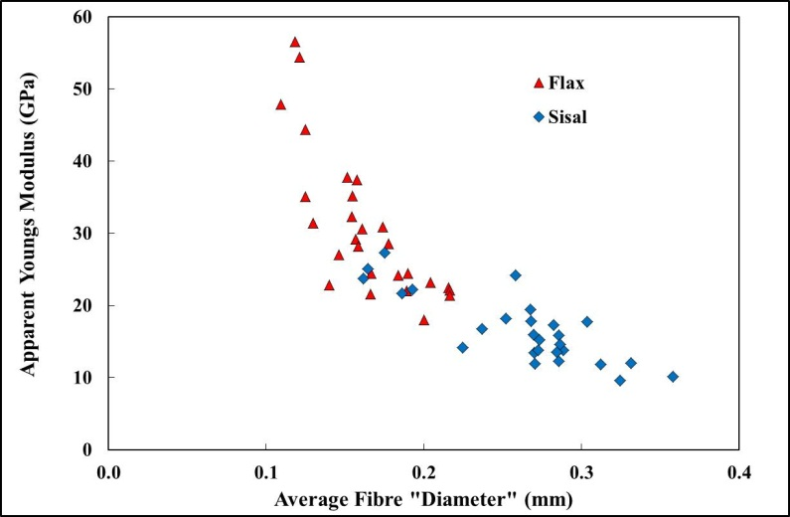

**Figure 5.** Dependence of apparent fibre modulus on diameter caused by CSA “diameter” method error

The “diameter” method is currently almost universally employed in papers reporting investigations on natural fibres and their composites [7-12]. Clearly the results presented above may go some way to explaining the large range of mechanical properties reported for individual types of natural fibre. Furthermore, another potentially significant consequence of the error in CSA obtained using the “diameter” method is shown in Figure 5. These data show the apparent dependence of the Young’s modulus of these fibres [9] which would be obtained assuming a diameter independent value (flax = 71 GPa, sisal = 30 GPa) but including the diameter dependent error in CSA observed in Figure 4. It can be seen that the “diameter” effect on the error in estimating the fibre CSA can lead to a situation where the fibre modulus appears to be inversely correlated with “diameter”. A number of papers have presented results indicating such an effect [10,12]. Of course it is possible that the modulus of natural fibres is indeed inversely dependent on the apparent fibre “diameter”. However, Figure 5 indicates that there is also significant room for an artificial dependence to be observed if the “diameter” method is employed to estimate single fibre CSA.

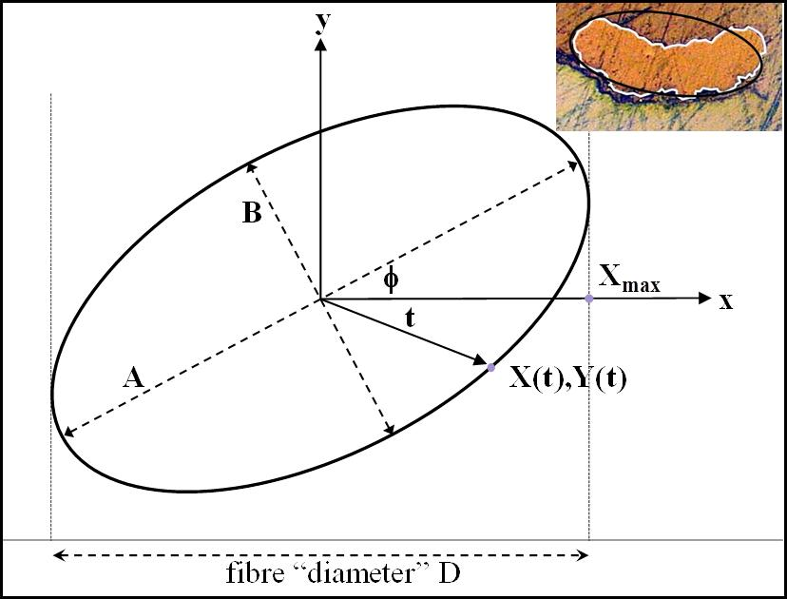

**Figure 6.** Observation of the “diameter” of an elliptical cross section fibre

It is relatively easy to qualitatively understand this effect when considering the transverse observation of a non-circular cross section cylinder to obtain a “diameter” measurement. It is clear from the fibre cross sections in Figures 1 and 6 that an ellipse is a much better model of a natural fibre cross section than a circle. It is also well known that natural fibres exhibit a level of twist along their length which means that the apparent diameter of a fibre with a constant elliptical cross section fibre will vary along its length. As illustrated in Figure 6 an ellipse centred on the origin can be expressed as the path of point X(t),Y(t) where

X(t) = ½ACos(t)Cos() - ½BSin(t)Sin() (1)

as the parameter t varies from 0 to 2π. Here A and B are the ellipse's major and minor axes respectively and  is the angle between the X-axis and the major axis of the ellipse. The experimental measurement of a natural fibre “diameter” (D) is the equivalent of measuring the width of the projection of the ellipse in Figure 6 on the x-axis which is equal to 2Xmax, where Xmax is the maximum value of X for any angle . The value of Xmax can be obtained as shown by setting the differential of equation 1 equal to zero and solving for tmax and then substituting tmax into equation 1 to obtain Xmax at any angle . Finally an average value for Xmax, which is equivalent to the average value of fibre “diameter” measured at many points along the fibre length, can be obtained over the range 0<<90. This average value (D) of apparent ellipse diameter should approach the average value of the equivalent natural fibre diameter if sufficient fibre diameter measurements are made along a length of fibre covering one natural twist in the fibre. Figure 7 presents the results from this simple analysis comparing the ratio of D2/AB over the range 0<<90 for ellipses with aspect ratios between 1 (a circle) and 5. The D2/AB ratio is the equivalent to the y-axis of Figure 4 the ratio of fibre CSA obtained by the “diameter” method to the actual fibre CSA. It can be seen in Figure 7 that this ratio depends strongly on both observation angle and on the aspect ratio of the elliptical cross section. Although the ratio is slightly less than unity at high angles it is significantly greater than unity for over the majority of the Figure. Consequently the average value of the D2/AB ratio over the full range of angles is always greater than unity and increases strongly with increasing ellipse aspect ratio (maintaining constant area) as shown by the averaged values in Figure 7.

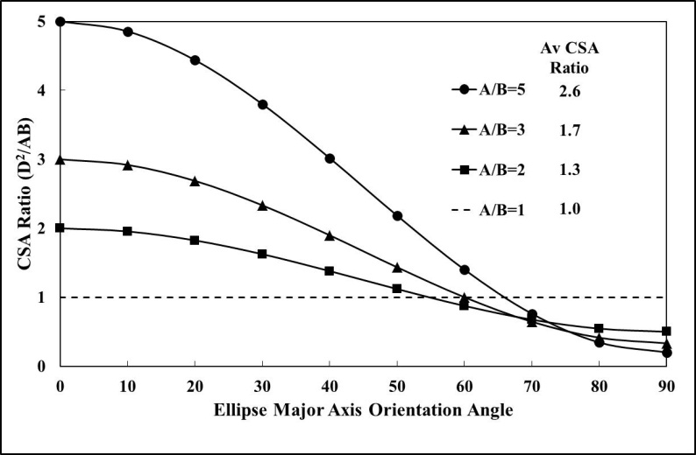

**Figure 7.** CSA ratio versus orientation and aspect ratio of ellipse

Figure 8 shows the experimental data from Figure 4 for the “diameter”/actual CSA ratio of flax and sisal compared with the results from the simple model presented above. The lines show data calculated for the average D2/AB ratio for ellipses with varying aspect ratio and constant values of CSA. The six lines represent minimum, maximum, and average values of CSA for the two fibre types. It can be seen that the model lines form envelopes which contain all the experimental data and the lines for the average fibre CSA form a reasonable representation of the trends of the experimental data. Clearly the spread in the data could well be explained by the fibre to fibre variability of the CSA and the fact that the fibres do not have an exactly elliptical cross section. A large number of fibre cross section micrographs were generated in the above study and so it was possible to generate a value for the average A/B ratio of an ellipse fitted to each fibre cross section micrograph while also generating the values for the “diameter”/true CSA ratio. These two ratios are plotted together in Figure 9 for the seven fibre types in this study along with a line indicating the theoretical relationship derived from the mathematical model presented above. It can be seen that there is a strong correlation between the overestimation of CSA by the “diameter” method and the eccentricity of an ellipse fitted to the fibre cross section micrographs.

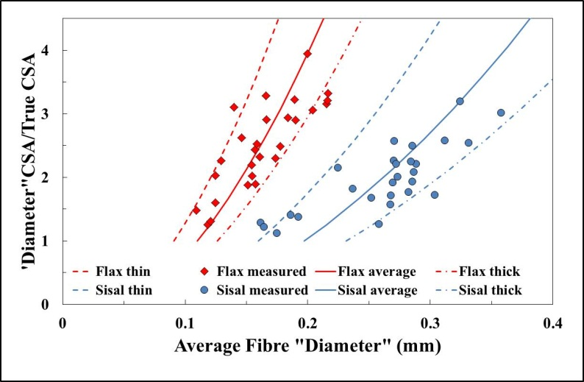

**Figure 8.** Comparison of CSA ratio from experiment and from ellipse model

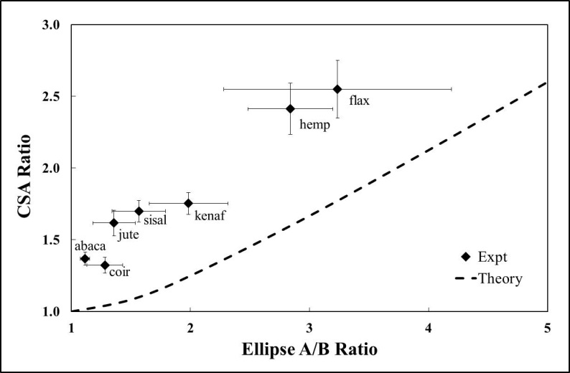

**Figure 9.** CSA ratio versus ellipse aspect ratio for various natural fibres

These results would appear to strongly indicate that natural fibre CSA cannot be well estimated by the use of simple “diameter” measurements combined with an assumption of a circular fibre cross section. The above results indicate some of the challenges of characterising natural fibres where many of the micro-structural parameters required for dependable design of fibre reinforced composite exhibit high levels of variability. Single fibre analysis of traditional man-made reinforcements is already highly resource intensive. Nevertheless, it appears from the results presented here that the time saving strategy of assuming natural fibres have a constant circular cross section and using a “diameter” measurement to characterise cross sectional area can introduce high levels of error into the determination of fibre modulus and strength.

4 Conclusions

The ability to efficiently and accurately characterise the cross sectional area of reinforcement fibres is critical to the development of a database of engineering performance of reinforcement fibres. A commonly employed shortcut in this area is the assumption that fibre cross section is uniform and circular, which reduces CSA determination to a simple measurement of fibre diameter. The results of this study on the measurement of the CSA of a range of natural fibres revealed significant variation in fibre CSA along the length of many fibres whereas other fibres appear relatively uniform. However, the difference in average CSA observed from fibre to fibre was significantly greater than the variation along the length of each individual fibre. Furthermore, CSA values obtained from fibre “diameter” measurements on these natural fibres were found to be significantly greater (up to 400%) than the values obtained from direct observation of the fibre cross sections. Such differences in CSA translate directly into differences of the same order of magnitude in the determined values of fibre modulus and strength. Consequently, the overall conclusion is that fibre “diameter” measurement is not a particularly attractive method for accurate estimation of CSA for these natural fibres. The level of error in the fibre CSA introduced by the “diameter” method appears to scale with the average fibre “diameter” which may go some way to explaining published observations of fibre modulus and strength scaling inversely with natural fibre “diameter”. The magnitude of the fibre CSA overestimation from the “diameter” method appears to scale directly with the average eccentricity of the natural fibre cross sections.

References

1. Bledzki A.K., Gassan J. Composites Reinforced with Cellulose Based Fibres. *Prog Polym Sci*., **24**, pp. 221-274 (1999).
2. Goda K., Cao Y. Research and development of fully green composites reinforced with natural fibers. *J Sol Mech Mater Eng***,** **1**, pp. 1073-1084 (2007).
3. Hughes M., Carpenter J., Hill C. Deformation and fracture behaviour of flax fibre reinforced polymer composites. *J Mater Sci*, **42**, pp. 2499–2511 (2007).
4. Thomason J.L. Dependence of interfacial strength on the anisotropic fiber properties of jute reinforced composites. *Polymer Composites*, **31**, pp. 1525–1534 (2010).
5. Thomason J.L. *Why are Natural Fibres failing to deliver on Composite Performance?* in proceedings *17th Int Conf Composite Materials*, Edinburgh, UK (2009).
6. Cichocki F.R., Thomason J.L. Thermoelastic anisotropy of a natural fiber. *Compos Sci Technol*, **62**, pp. 669-678 (2002).
7. Li Y., Pickering K.L., Farrell R.L. Determination of interfacial strength of hemp reinforced polypropylene. *Compos Sci Tech*, **69**, pp. 1165–1171 (2009).
8. Park J.M., Quang S.T., Hwang B.S., DeVries K.L. Interfacial evaluation of modified Jute and Hemp/polypropylene composites using micromechanical technique and acoustic emission. *Compos Sci Technol*, **66**, pp. 2686-2699 (2006).
9. Thomason J.L., Carruthers J., Kelly J., Johnson G. Fibre cross section determination and variability in sisal and flax and its effects on fibre performance characterisation. *Compos Sci Technol*, **71** pp. 1008-1015 (2011).
10. Baley C. Analysis of the flax fibres tensile behaviour and analysis of the tensile stiffness increase. *Compos Part A*, **33**, pp. 939-948, (2002).
11. Symington M.C., Banks W.M., West O.D., Pethrick, R.A. Tensile Testing of Natural Fibers. *J Compos Mater*, **43**, pp. 1083-1108 (2009).
12. Virk, A.S., *Numerical models for natural fibre composites with stochastic properties*, PhD thesis, University of Plymouth 2010.