Linear Matching Method for ratchet limit prediction in comparison to Rolls-Royce's Hierarchical Finite Element Framework

Michael Lytwynª*, Haofeng Chenª, Michael Martin^{b}
ªDepartment of Mechanical & Aerospace Engineering, University of Strathclyde, Glasgow, G1 1XJ, UK
^{b}Rolls-Royce Power Engineering plc., PO Box 2000, Derby, DE21 7XX, UK

Abstract
This paper provides a direct comparison between the Linear Matching Method (LMM) and the procedures currently being employed within Rolls-Royce Power Engineering plc Hierarchical Finite Element Framework (HFEF) for the assessment of shakedown and ratcheting behaviour. These methods include the application of Direct Cyclic Analysis (DCA), utilised in an automated search procedure for load-interaction plot generation and the recently developed Hybrid procedure. The Hybrid procedure is based on a similar premise to the LMM in that the load history can be decomposed into cyclic and constant components. The LMM allows for the direct evaluation of shakedown and ratchet limits to be obtained in a traditional Bree load-interaction format, along with the subsequent maximum plastic strain range for low-cycle fatigue considerations. Three problems have been used for comparison in this paper; the classic Bree cylinder, a nozzle-in-sphere with a cold media injection transient typical of nuclear power plant loading and a pressurised two-bar structure for multi-axial failure analysis. The accuracy of each method has been verified using Abaqus step-by-step inelastic analysis. The variations in the implementation strategies associated with each method have also been discussed along with computational efficiency and effectiveness.

Keywords: ratchet limit; shakedown; linear matching method; direct cyclic analysis.

- Introduction
In the nuclear industry, structural integrity assessments are undertaken to the requirements of recognised international standards such as ASME III to provide through-life assurance against the occurrence of potential structural failure modes, including ductile burst, ratchetting and fatigue. This paper is concerned with the prediction of shakedown and prevention of the ratchetting failure mode. Ratchetting is associated with structures operating at temperature and pressure, whereby under certain cyclic load conditions the structure accrues a net increment of plastic strain with each application of the load cycle, thus eventually leading to failure. Under certain circumstances, the load history may be such that the accumulated plastic strains cease to develop after a few initial load cycles, known as elastic shakedown. Rolls-Royce Power Engineering plc. is currently developing the use of ‘modern’ finite element methods for the assessment of pressure vessel structures to the strength, shakedown and fatigue requirements of ASME III Code, Subsection NB. This is encapsulated in the Hierarchical Finite Element Framework, or HFEF. HFEF is based on the application of Limit Load Analysis (LLA), direct shakedown prediction and nodal strain-based fatigue post-processing in lieu of the SCL and linearisation techniques traditionally used to demonstrate acceptance to the primary and secondary stress limits of ASME III Subsection NB. LLA provides assessment of the burst failure mode whilst direct shakedown prediction and strain-based fatigue analysis respectively assess the incremental collapse and fatigue failure modes. The HFEF methods do not require the application of stress classification lines (SCLs) or their associated classification and linearization procedures. If the stable cyclic strain range includes a fluctuating plastic component without a net accumulation after each cycle, then reversed or alternating plasticity is observed. Recent shakedown analysis methods have been developed by applying plasticity bounding theorems [1, 2] in tandem with modern FEA packages and mathematical optimization theory. Such methods are known as direct shakedown analysis methods and offer the advantage that the exact load history is not required for implementation purposes, only the most significant loads acting on the structure need to be specified and the shakedown theorems applied to determine a safe operational envelope in load space. The recent advances in direct shakedown approaches has led to a significant reduction in analysis times for the assessment of progressive plastic deformation in components subjected to high temperature operating conditions without sacrificing accuracy, compared to the traditional step-by-step FE methods commonly used for verification purposes. Such step-by-step methods require significant computation time for ratchet boundary prediction and cannot predict a ratchet limit directly, thus only being capable of indicating if elastic shakedown, plastic shakedown or ratchetting occur at a certain point in the load domain. Direct methods can be seen to offer a supporting alternative or complete replacement altogether to traditional methods, until modern computer facilities advance enough to allow step-by-step methods to become considerably more efficient. Examples of such direct methods include the Linear Matching Method [3, 4, 5], the Nonlinear Superposition Method [6], Mathematical Programming Methods [7] and Repeated Elastic Analysis methods; including Seshadri’s GLOSS r-node method [8]. The LMM is distinguished from other direct methods by ensuring that equilibrium and compatibility are satisfied at each stage of analysis as well as the ability to incorporate high temperature material behaviour [4]. The LMM has recently been developed to incorporate multi-load extremes in the thermo-mechanical load domain [5] and as such offers a robust and accurate method for obtaining the ratchet boundary in a direct manner. The LMM process involves calculating the load carrying capacity of a structure subjected to a predefined cyclic load component ensued by the addition of an extra constant load in order to determine the proximity of the ratchet limit. This methodology allows the stable cyclic response, i.e. the cyclic stress, residual stress and plastic strain ranges for the low-cycle fatigue assessment to be computed [5]. The entire LMM numerical procedure for both shakedown and ratcheting assessment has been incorporated into the commercial finite element code ABAQUS [9]. As a result, the LMM can be readily used for the ratchet limit assessment of structures involving load histories with complex multi-load extremes, as are commonly prevalent in the nuclear industry. A significant advantage of the LMM includes offering pressure vessel designers the ability to assess 3D structures under complex loading and allow for rapid specification of the ratchet load without requiring unrealistic computing facilities as well as ease of user implementation. Within HFEF, two methods currently being developed for ratchet boundary prediction include the use of Direct Cyclic Analysis [10] and the Hybrid procedure [11], more in-depth details of the HFEF are available in [12]. DCA is a Fourier based approach which was initially implemented in Abaqus to detect if a stabilised cyclic response existed and therefore indicate if ratchetting or elastic/plastic shakedown occurred, without determining a ratchet boundary directly [13, 14]. This method however has been automated in [10] such that a ratchet boundary can be obtained via an optimisation procedure generated using Python [15], whereby varying load levels and the application of several load cycles are used to establish the ratchet boundary. This method may prove to be time consuming and impractical in an industrial context for problems involving complex thermo-mechanical load histories, especially for acute thermal transients. The Hybrid methodology stems from recent work undertaken by Reinhardt [16] and Adibi-Asl et al [17]. The fundamental concept of the Hybrid method is to ascertain the magnitude of yield capacity utilised solely by the cyclic component initially, before establishing the capability of the remaining yield capacity (termed modified yield strength in [11]) to support the time-invariant load component. As a result the Hybrid method operates by decomposing the load history into cyclic and constant components, similar to the LMM ratchet assessment procedure. The Hybrid method uses DCA for the evaluation of the modified yield strength (but may be implemented using any cyclic analysis procedure for this segment of the process), followed by a limit load calculation to obtain the ratchet boundary. Both the application of pure DCA and the Hybrid methodology demonstrated in [10] and [11] require the entire cyclic load history to be analysed, which accounts for larger analysis times compared to the LMM, as insignificant loads in the cycle are taken into taken into consideration even though they may not contribute to the overall global ratchetting failure mechanism. It is noted that some form of cycle simplification could probably be employed to the DCA and Hybrid methods to filter insignificant cycles. This paper aims to compare the LMM with the application of pure Direct Cyclic Analysis (DCA) [10], as well as the recently developed Hybrid procedure [11]. The three example problems that will be used for comparison in this paper include; the classic Bree cylinder first postulated in [18], a nozzle-in-sphere with a cold-media injection transient and a pressurised two-bar structure for multi-axial failure considerations, which has been modified from Abdalla’s original problem [19] via the inclusion of internal pressure. The comparison results used in this paper for the pure DCA and Hybrid methods have been obtained from [11], in order to form the benchmark data for the models analysed.
*Corresponding author - Email: michael.lytwyn@strath.ac.uk

Nomenclature
$ρ_{\text{ij}}(t_{n})$ The accumulated residual stress at instance t_{n}
$σ_{y}$ Uniaxial yield stress of material
$P(x_{i},t)$ Cyclic component of load history (mechanical load)
Cyclic component of load history (thermal)
λ Load parameter
n Number of load instances
N The total number of time points
$σ_{\text{ij}}(x,t)$ Linear elastic stress history
$ρ_{\text{ij}}^{r}(x,t)$ The varying residual stress field during the cycle t
${\tilde{σ}}_{\text{ij}}^{\overline{F}}$ Elastic stress associated with constant component
${\tilde{σ}}_{\text{ij}}^{Δ}(x,t)$ Varying elastic stress associated with cyclic component
${\tilde{σ}}_{\text{ij}}$ Stress tensor
$σ_{p}$ Mechanical load component
${\bar{ρ}}_{\text{ij}}$ The constant component of the changing residual stress
t_{n} Series of time points within the cyclic load history
${Δε}_{\text{ij}}^{n}$ The increment of plastic strain at load instance n
$\bar{ε}$ Von Mises effective strain
2.0 The Linear Matching Method
The LMM [3, 4, 5] is based upon Koiter's upper bound (UB) kinematic theorem [1] and Melan’s lower bound shakedown theorem [2]. From a continuum mechanics viewpoint, we can consider a body with volume V and surface S, where the material is isotropic, elastic-plastic and satisfies the von Mises yield condition. A cyclic history of temperature $\text{λθ}(x,t)$occurs within the volume V. A cyclic load history $λP(x,t)$ is applied over part of the surface S, namely S_{T}. Here$λ$denotes a scalar load parameter. On the remainder of S, namely S_{u}, zero displacements are maintained. Both load and temperature histories act over a cycle of $0≤t≤Δt$. The cyclic history may be expressed in terms of three components, the elastic solution, a transient solution accumulated up to the beginning of the cycle and a residual solution that represents the remaining changes within the cycle. The linear elastic stress solution is denoted by$λ{\hat{σ}}_{\text{ij}}$. The general form of the stress solution is given by:
$σ_{\text{ij}}(x,t)=λ{\hat{σ}}_{\text{ij}}(x,t)+{\bar{ρ}}_{\text{ij}}(x)+ρ_{\text{ij}}^{r}(x,t)$ (1)
where${\bar{ρ}}_{\text{ij}}$denotes a constant residual stress field in equilibrium with zero surface traction on $S_{T}$ and corresponds to the residual state of stress at the beginning and end of the cycle. The history$ρ_{\text{ij}}^{r}$ is the change in the residual stress during the cycle and remains constant, i.e.;
$ρ_{\text{ij}}^{r}(x,0)=ρ_{\text{ij}}^{r}(x,Δt)$ (2)

2.1 Dual minimisation for ratchet limit analysis

The fundamental basis of the LMM UB ratchet analysis consists of being able to decompose the entire cyclic load history into cyclic and constant components separately, i.e.
${\hat{σ}}_{\text{ij}}(x,t)={\hat{σ}}_{\text{ij}}^{Δ}(x,t)+λ{\hat{σ}}_{\text{ij}}^{\overline{F}}(x)$ (3)
The calculation of the ratchet limit includes dual minimisation processes, stage one is an incremental minimisation process for the evaluation of a cyclic history of residual stresses and plastic strain range in a stable cycle which in this paper will constitute cyclic thermal loading. Stage 2 involves global minimization for the ratchet limit due to an extra constant load which is superimposed onto the cyclic solution in order to assess the proximity to the ratchet limit. By decoupling the evaluation of the changing residual stress and the constant residual stress in (1), the entire numerical procedure of ratchet analysis includes two steps [5]:
- The first stage is to calculate the cyclic history of residual stresses associated with the applied cyclic load ${\hat{σ}}_{\text{ij}}^{Δ}(x,t)$and the corresponding plastic strain range in a stable cycle for the low cycle fatigue assessment.
- The second stage is to locate the ratchet limit due to the extra constant load$λ{\hat{σ}}_{\text{ij}}^{\overline{F}}(x)$as a conventional shakedown analysis where a constant residual stress is evaluated by global minimization and the elastic stress history is augmented by the changes in residual stress calculated in the first step.
Stages 1 & 2 of the LMM have been implemented in ABAQUS via user-defined subroutines (UMAT & URDFIL), which can accommodate multi-load extremes and temperature-dependent yield stress data [5].

2.2 Evaluation of the upper bound ratchet limit

The upper bound formulation is based upon Koiter’s kinematic theorem [1], which states that if any kinematically admissible strain rate can be located such that the strain field is compatible with the applied displacements and that the subsequent plastic dissipation within the problem domain is less than or equal to the applied work, then shakedown does not occur. As described in [5], once the history of the residual stress field$ρ_{\text{ij}}(t_{n})$associated with the cyclic component of the load history has been calculated by an incremental minimisation process as described, the numerical technique for the ratchet limit can be accommodated within the existing methods of shakedown analysis where the linear elastic solution is augmented by the changing residual stress field, such that:
${\hat{σ}}_{\text{ij}}=λ{\hat{σ}}_{\text{ij}}^{\bar{F}}+{\hat{σ}}_{\text{ij}}^{Δ}(x,t)+ρ_{\text{ij}}\left(x,t\right)$ (4)
For the von Mises yield condition and the associated flow rule, an upper bound on the ratchet limit multiplier can be obtained by:
$λ_{\text{UB}}^{R}=\frac{\int_{V}{\sum_{n=1}^{N}{σ_{y}\bar{ε}\left({Δε}_{\text{ij}}^{n}\right)}}\text{dV}−\int_{V}{\sum_{n=1}^{N}{\left({\hat{σ}}_{\text{ij}}^{Δ}(t_{n})+ρ_{\text{ij}}(t_{n})\right){Δε}_{\text{ij}}^{n}}\text{dV}}}{\int_{V}{{\hat{σ}}_{\text{ij}}^{\bar{F}}\left(\sum_{n=1}^{N}{{Δε}_{\text{ij}}^{n}}\right)}\text{dV}}$ (5)
which gives the capacity of the body subjected to a predefined cyclic load history${\hat{σ}}_{\text{ij}}^{Δ}(t_{n})$ to withstand an additional constant load${\hat{σ}}_{\text{ij}}^{\bar{F}}$ before ratchetting takes place. Eq. (5) produces a sequence of monotonically reducing upper bounds$λ_{\text{UB}}^{R}$, which converge to the least upper bound ratchet limit for the chosen class of displacement fields. All LMM results and method descriptions in this paper are discussed with respect to the upper bound LMM framework only.
3.0 Bree Cylinder Analysis
In order to generate the load-interaction plot for the Bree cylinder problem, a finite element model was generated. A cyclic thermal load was applied to the inner surface of the cylinder alongside a constant internal pressure. The FE mesh is shown in Fig. 1 and the thermal and pressure loading is shown in Fig. 2. Subsequently the problem can be characterised by the two load extremes, $σ_{p}$and ∆θ + θ, resulting from the pressure and thermal loading respectively. The geometry of the problem consists of a thin closed-end cylinder, with an internal radius of 365mm and an external radius of 385mm, as illustrated in Fig. 1. The FE mesh for the Bree cylinder consisted of 10 elements in the thickness direction. The cyclic thermal load depicted in Fig. 2 was analysed using quadratic DCAX8 heat transfer elements, with the resulting temperature distributions used as an input to the static analyses, which were performed using quadratic CAX8R reduced integration structural elements. The model cylinder was constrained vertically at one end and allowed to expand in-plane at the other, with a thrust applied to the free end to simulate the closed-end condition. The following temperature independent material properties were used in the analysis: thermal conductivity = 0.035W/mm°C, Young’s Modulus = 184GPa, Poisson’s ratio = 0.3, coefficient of thermal expansion = 1.335e⁻⁵°C⁻¹ and $σ_{y}$= 402.7 MPa. The resulting pressure versus cyclic temperature interaction diagram found using the LMM, Hybrid and pure DCA methods can be seen in Fig. 3, taken directly from [10] and [11]. In order to generate such a plot using the DCA method solely, the method in [10] implemented an automated bisection algorithm in Python, such that the ratchet boundary could be located with a tolerance of around ± 0.05MPa.
σ_{P}
R = 365mm
20 mm
∆θ + θ
θ


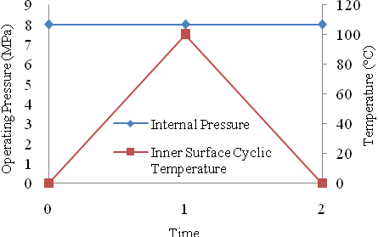

Fig. 2 - Bree cylinder loading.
Fig. 1 - Model geometry and axisymmetric FE mesh with boundary conditions.

Fig. 3 illustrates that the hybrid method marginally under predicts the ratchet boundary with respect to the pure DCA method, particularly so as the temperature increases. This can be attributed to the to the increase in plastic zone size with respect to increasing cyclic temperature, which highlights the limitations within the vector addition approach adopted in the Hybrid method [11]. The reverse plasticity limit has been located at a maximum cyclic temperature of around 500°C, which has been verified by a full 50 cycle elastic-plastic analysis, with further inspection of the resulting magnitudes of plastic strain (Fig. 4).

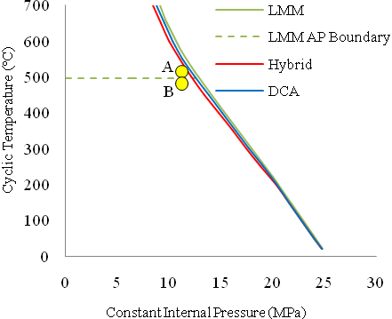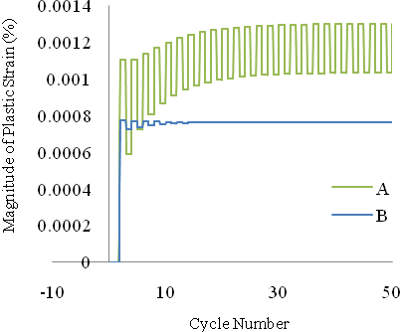
Fig. 3 - Load interaction plot for the Bree problem.
Fig. 4 – Step-by-step plastic strain results from points
A and B respectively.

The discrepancies between the LMM derived ratchet boundary and the pure DCA results may be considered small enough to disregard with respect to further step-by-step analysis verification along this boundary, as such studies have previously been completed for the same exact problem [10]. Also shown in Fig. 3, as a dashed line, is the alternating plasticity (AP) limit obtained via the LMM. The plastic strain results in Fig. 4 illustrate the stabilised reverse plasticity mechanism at point A:(p=11.2MPa, T=515°C) after 50 cycles, i.e. exhibiting non-incremental plastic strains, as well as the state of elastic shakedown achieved at point B:(p=11.2MPa, T=480°C).
4.0 Nozzle-in-sphere with cold shock
This problem provides a more complex analysis case of the methods presented, by simulating the pressurised cold-shock example of the nozzle-in-sphere model and the resulting high transient thermal gradients. The FE mesh consisted of 5717 elements, with linear heat transfer elements (DCAX4) being used for the thermal analysis and quadratic reduced integration elements (CAX8R) with midside node interpolation for the structural analyses. The vessel includes a 45° section which is fixed locally in the direction normal to the cut surface, in order to allow radial movement only. An in-plane constraint was applied to the pipe attachment as well as a thrust due to the internal pressure force being exerted on the vessel, as shown in Fig. 5. The operational history over one cycle can be seen in Fig. 6, which shows the constant pressure load and cyclic thermal transients with a 20°C cold-fluid injection. The thermal response of the model is driven entirely by thermal loading through the application of film coefficients, as detailed in Fig. 7.
1 - Vessel shell
3 – Pipe attachment
2 – Nozzle reinforcement
Sphere htc application zone
Nozzle htc application zone
T_{N}
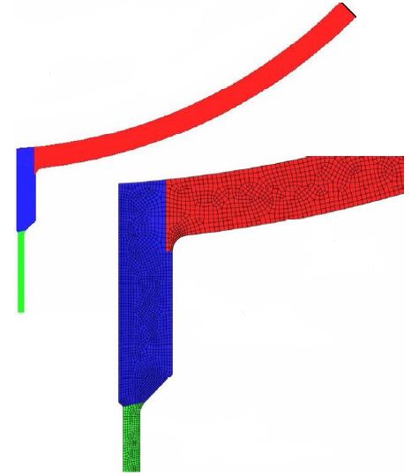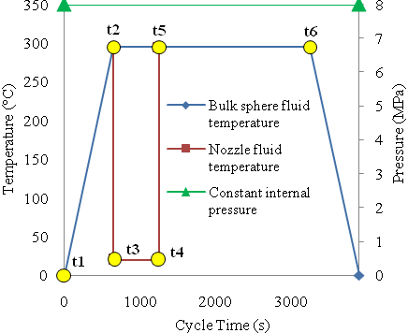
Fig. 6 - The thermo-mechanical operational load cycle.

Fig. 5 - FE mesh, htc application zones and boundary conditions.

The model consists of three varying materials, with the relative material parameters shown Tables A1 & A2 in Appendix A. In order to generate comparison data with the results available for the Hybrid [11] and pure DCA [10] methods, the most severe cold-injection case of T_{c} = 20°C is used to for the LMM ratchet boundary calculations. The load points used to obtain the thermal stress extremes are shown in Fig. 6 (labelled t₁- t₆). The thermal stresses are each calculated by an elastic thermal analysis a priori, are subsequently used as inputs to the LMM ratchet boundary calculation.

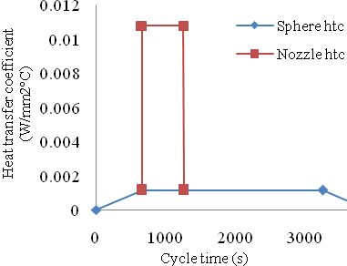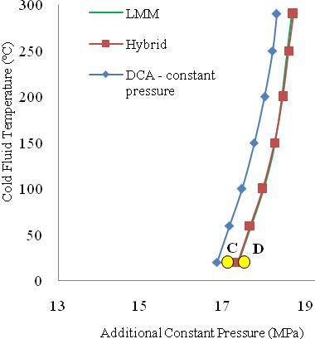
Fig. 7 - The htc application cycle.
Fig. 8 – Comparison data obtained from the LMM, Hybrid and pure DCA methods [2].

Figs. 9 (i-iii) indicate the locations where the most significant stress magnitudes for the problem are situated (for T_{c} = 20°C), with i) T_{c} + 10s, ii) T_{c} + 600s and iii) the additional constant load component.

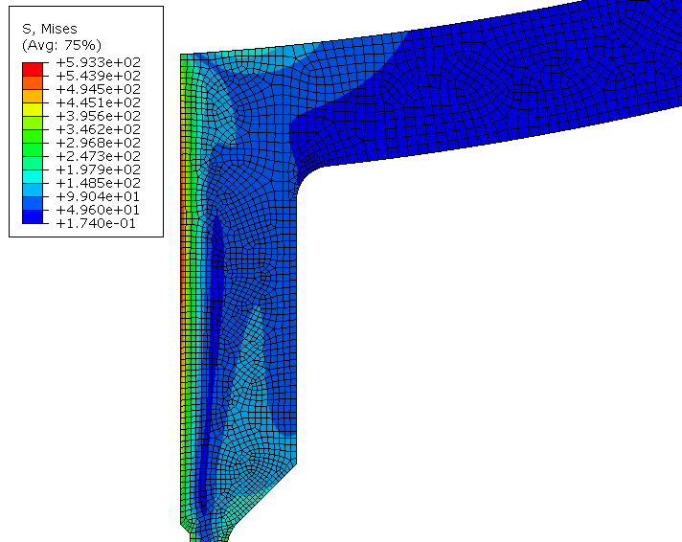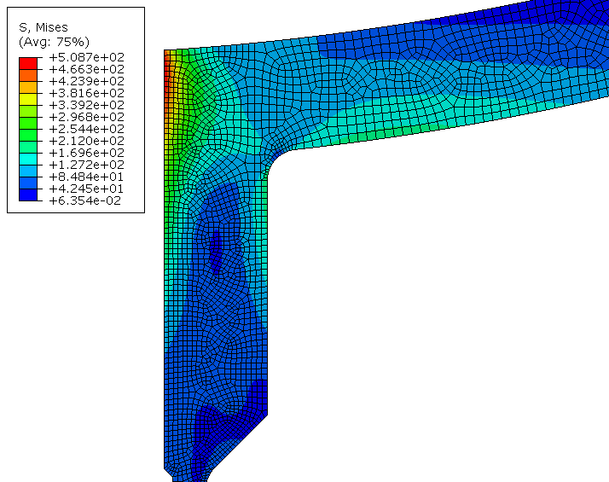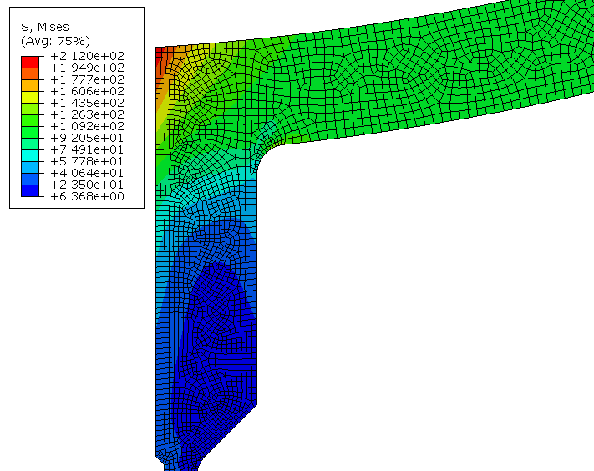
location 1
location 2
location 3
i)

ii)

iii)

Figs. 9 i) The effective von Mises stress at T_{c}+10s, with the peak value found at 'location 1', ii) The effective von Mises stress 600s after a cold-media injection (i.e. at steady-state), with the peak value found at 'location 2' and iii) The effective von Mises stress due to the mechanical load component only, with the peak value found at 'location 3'.

The cyclic thermal time-points can be seen to be representative of:
- t₁ – Ambient conditions.
- t₂ – Steady-state operating conditions at 295°C uniform temperature.
- t₃ – 10 seconds after a cold-media injection of T_{c} = 20°C.
- t₄ – 600 seconds after a cold-media injection of T_{c} = 20°C, i.e. steady-state injection.
- t₅ – 10 seconds after the removal of the cold-media and return to steady-state (295°C) conditions.
- t₆ – 2000 seconds after the removal of the cold-media.

These salient points t₁ – t₆ have been identified in order to encapsulate the most significant thermal stress ranges evident in a 20°C cold-injection phase and as such are deemed fully representative of the entire cycle in terms of accurately identifying the ratchet boundary directly via the LMM. The cyclic thermal load history must be represented accurately in terms of the relevant peak stresses involved, such that the most onerous stress ranges dominating the failure response of the structure can be identified successfully. Subsequently, the ratchet limit multiplier can subsequently be obtained by analysing the capacity of the vessel to withstand the elastic stress ranges from t₁ – t₆ in conjunction with an additional constant pressure load, before ratcheting occurs. Fig. 8 also depicts the ratcheting boundaries obtained via Hybrid and pure DCA methods respectively for comparison purposes. The ratchet boundary derived from the LMM assessment can be seen to almost exactly follow the data obtained using the Hybrid method. In order to verify the data obtained, step-by-step calculations were conducted for T_{c} = 20°C at two locations; C = 17.1 MPa and D = 17.5 MPa, with 100 cycles adopted as shown in Fig. 10. The results from the elastic-plastic verification analyses are taken from 'location 4' (Fig. 11), using a perfectly-plastic material model. As is evident from Fig. 10, point C shows alternating plasticity and point D outside the ratchet boundary (obtained via the LMM and Hybrid methods) displays incremental plastic strain accumulation.

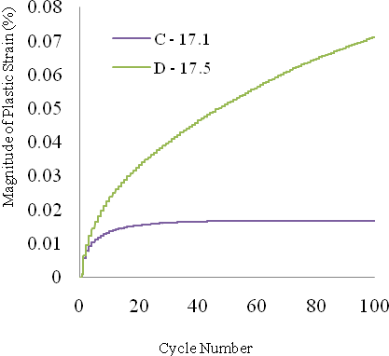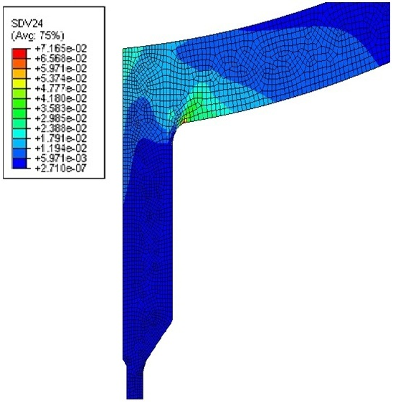
,
location 4
Fig. 10 – Step-by-step plastic strain results from points C and D respectively.

Fig. 11
The effective plastic strain at ∆θ = 275°C and P = 17.4 MPa.

The LMM and Hybrid methods both show that for more complex scenarios involving non-proportional loading (where the thermal actions vary with time and are not in phase with the pressure loading), that the application of pure DCA leads to a conservative ratchet boundary prediction. The implementation strategy adopted in the application of pure DCA for ratchet analyses requires considerable computational expense, as the accuracy of the method accuracy relies upon suitable parameter selection, in terms of Fourier coefficients. Increasing the number of Fourier coefficients directly influences the analysis time. DCA must incorporate the entire load history as an input to the problem, before determining whether or not convergence is achieved based on a user-defined iteration limit. Convergence before the iteration limit is reached is therefore deemed to represent shakedown and failure to convergence represents ratcheting, or plastic collapse. As discussed previously, the benefits of using the LMM stem from the requirement that only the stress locations in the cycle which contribute to the most severe stress ranges dominating the failure mechanism need to be included in the ratchet boundary calculations, therefore the entire load history does not need to be incorporated into the analysis. The main factor related to the reduction in computation time arises from the LMM producing the ratchet boundary directly, as opposed to searching for this limit by means of a search algorithm in the case of DCA [10].

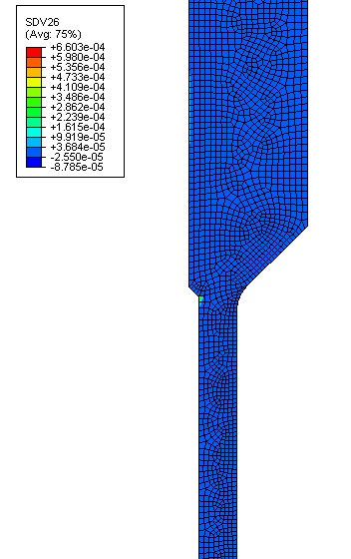
,
location 5

Fig. 12 – The maximum plastic strain range attributed to the cyclic thermal loading can be seen at 'location 5'.
The maximum effective plastic strain range generated by the cyclic thermal transient of T_{c} = 20°C can be seen in Fig. 12 at ‘location 5’. This location was noted by Rauscher et al [20] but deemed insignificant in terms of the overall global shakedown response of the structure due to the limited cross sectional extent, however this would be the low-cycle fatigue crack initiation site, attributed solely to the cyclic thermal loading.

5.0 Pressurised two-bar structure
The final example considered consists of a pressurised two-bar structure which is analysed in order to investigate multi-axial failure effects, as both the Bree cylinder and nozzle-in-sphere problems predominantly exhibit failure mechanisms in the hoop direction only. This problem was initially presented by Abdalla et al [19] and subsequently modified by Martin et al [11] with the addition of internal pressure. A three-dimensional model was constructed of two hollow cylinders with a total of 4700 continuum elements in the FE mesh. The 3D quadratic heat transfer element DC3D20 was used for the thermal analysis, with the element type then switched to a 3D quadratic reduced-integration element, C3D20R, for the structural analyses. Dimensional and material data for this problem can be found in Appendix B Table B1. The cyclic load history is created by cycling only the outer temperature of the 200mm bar from 0°C to 100°C, with the smaller 100 mm bar remaining at a constant 0°C. The boundary conditions consisted of fixing the bottom ends of each bar in the axial direction, with an in-plane constraint being used to apply a constant axial force to each of the free ends as depicted in Fig. 13, in order to allow for tandem movement of the free ends. An internal pressure was also added to the 200 mm bar so that various ratios of axial force (F) to internal pressure (p) could be generated in order to explore multi-axial failure in the problem. In order to implement the LMM for this particular problem, the cyclic load extremes derived from the thermal stresses associated with 0°C and 100°C temperature magnitudes are cycled in Stage 1 of the LMM ratchet calculation before proceeding to add the mechanical load component in order to obtain the proximity to the ratchet limit, which in this case consisted of the applied axial force and internal pressure. Therefore in order to generate the load-interaction plot for this particular problem, ∆θ = 100°C was scaled according to the temperature of interest in the LMM ratchet calculations.
F
θ = 0
∆θ +θ
P
P = 0
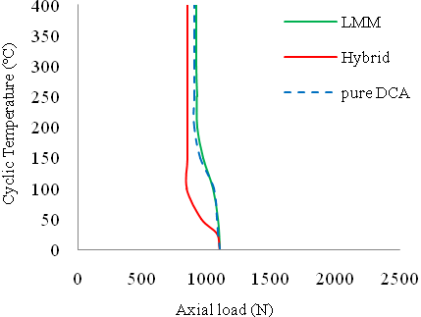
Fig. 14 - F/p = 10.

Fig. 13 – Loading and boundary conditions for the pressurised two-bar problem [11].

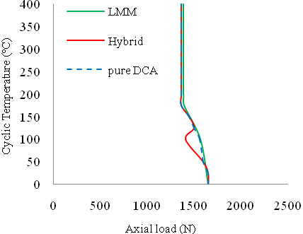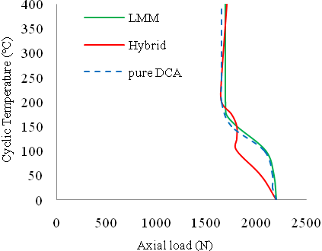
Fig. 15 - F/p = 15.

Fig. 16 - F/p = 20.

Figs. 14-16 show the results obtained for each LMM analysis relative to the pure DCA and Hybrid solutions, whereby the ratio of axial force F to internal pressure p was altered from 10, 15 and 20 respectively. As is evident from the results, the most severe case arrives at F/p = 10, where the hoop failure mechanism causes the lowest limit load of all F/p ratios and a reduction in the overall ratchet limit, due to the geometry of the problem. As the ratio of F/p is increased, the severity of the hoop stresses are reduced such that a transition to an axially induced failure mechanism occurs, which is less detrimental in terms of ratcheting behaviour and thus an increase in the ratchet limit and limit load is observed. The LMM calculations closely follow the ratchet boundaries obtained from the application of pure DCA, which is deemed to be more representative of the actual response of the structure compared to the Hybrid method results [11], however the LMM can achieve these results with less computational expense as mentioned previously. The inaccuracy of Hybrid method for this problem may be attributable to errors in the vector addition approach as the extent of plasticity develops [11].

6.0 Conclusions
In the present study, the LMM has been used to directly to evaluate the ratchet limit for three example problems in order to compare results with those obtained via an automated DCA based optimisation procedure and a modified yield strength based approach. The computational efficiency of the LMM over both alternative methods stems from not having to consider the entire cyclic load history of the component in question and avoiding the need to search for the ratchet boundary, as this is obtained directly. Both of the comparative methods used in this paper rely upon the DCA method and are therefore influenced by the selection of Fourier coefficients. More Fourier coefficients are required to resolve severe gradients in load and structural response to ensure sufficient accuracy, at the expense of solution time [10]. A benefit of the LMM can be seen in the ability to immediately identify the maximum plastic strain range attributed to the cyclic load history, which can readily be verified by means of elastic-plastic step-by-step FEA. When the results obtained from each method are similar in terms of accuracy, then the merits of each procedure may be analysed further in terms of user implementation and computational efficiency aspects. The work has shown that LMM provides an alternative approach to the use of pure DCA and the Hybrid method for the prediction of ratchetting and ratchet boundary location for pressure vessels subject to complex thermo-mechanical loading. As such, LMM provides a promising alternative approach for the analysis of ratcheting within the Rolls-Royce Power Engineering plc. HFEF methodology for the ASME III assessment of pressure vessel strength, shakedown and fatigue. Further application of LMM to pressure vessel structures is required to build experience in the use of the method.
7.0 Acknowledgements
The authors gratefully acknowledge the Engineering and Physical Sciences Research Council (EPSRC) of the United Kingdom, Rolls-Royce Power Engineering plc. and the University of Strathclyde for their support during this work.
8.0 References
- Koiter WT, General theorems for elastic plastic solids. Progress in solid mechanics J.N. Sneddon and R. Hill, eds. North Holland, Amsterdam, 1, 1960;167-221.
- Melan E, Theorie Statisch Unbestimmter Systeme aus Ideal-Plastischem Bastoff. Sitzungsberichte der Akademie der Wissenschaft. Wien, Abtiia, 1936;145, 195–218.
- Chen HF, Lower and Upper Bound Shakedown Analysis of structures With Temperature-Dependent Yield Stress. Journal of Pressure Vessel Technology, 2010; 132, 1-8
- Chen HF, Ponter A.R.S. Linear Matching Method on the evaluation of plastic and creep behaviours for bodies subjected to cyclic thermal and mechanical loading. International Journal for Numerical Methods in Engineering 2006; 68: 13-32
- Chen HF, A Direct Method on the Evaluation of Ratchet Limit. Journal of Pressure Vessel Technology, 2010; 132, 041202
- Muscat M, Mackenzie D and Hamilton R. Evaluating shakedown by non-linear static analysis. Computers and Structures 2003; 81: 1727-1737.
- Staat M, Heitzer M, LISA a European Project for FEM-based Limit and Shakedown Analysis. Nuclear Engineering and Design 2001; 206: 151–166.
- Seshadri R, The generalised local stress strain (GLOSS) analysis – theory and application. Trans ASME, Journal Pressure Vessel Technology 1991;113: 219-227.
- Abaqus 6.10, SIMULIA, 2010
- Martin, M. Application of direct cyclic analysis to the prediction of plastic shakedown of nuclear power plant components. Pressure Vessels and Piping, Chicago, Illinois, 2008.
- Martin M, Rice D. A hybrid procedure for ratchet boundary prediction. Pressure Vessels and Piping, Prague, Czech Republic, 2009.
- Martin M, Rawson L, Rice D, A hierarchical finite element framework for the assessment of pressure vessels to the ASME III code. Pressure Vessels and Piping, Bellevue, Washington, 2010.
- Nguyen-Tajan et al, Determination of the stabilized response of a structure undergoing cyclic thermal-mechanical loads by a direct cyclic method. Abaqus Users' Conference Proceedings, 2003.
- Abaqus, User’s Manual, Version 6.10, 2010.
- Python 2.5, www.python.org
- Reinhardt W, Elastic-Plastic Shakedown Assessment of Piping using a Non-Cyclic Method, PVP2007-26703, San Antonio, Texas, July 22-26 2007.
- Adibi-Asl R and Reinhardt W, Elastic Modulus Adjustment Procedure (EMAP) for Shakedown, PVP2008-61641, Chicago, Illinois, July 27-31 2008.
- Bree J, Elasto-plastic behaviour of thin tubes subjected to internal pressure and intermittent heat fluxes with application to fast reactor fuel elements. Journal Strain Analysis, 1967l 2, 226-238.
[19] Abdalla HF, Megahed M.M, Younan MYA, A Simplified Technique for Shakedown Limit Load Determination, Nuclear Engineering and Design, 237(2007) 1231-1240.
[20] Rauscher F, Design By Analysis Direct Route for Cases With Pressure and Thermal Action, PVP2006-ICPVT-11, July 23-27 2006, Vancouver, BC, Canada.

9.0 Appendix A: Nozzle-in-sphere dimensional and material data
45°
R1061.5
45.5
174.0
Ø167.3
Ø134.1
Property | Material | Temperature (°C)
Property | Material | 20 | 100 | 150 | 200 | 250 | 300
Yield Strength (MPa) | 1 | 290 | 249 | 238 | 232 | 227 | 221
Yield Strength (MPa) | 2 | 355 | 323 | 312 | 304 | 296 | 289
Yield Strength (MPa) | 3 | 265 | 226 | 213 | 192 | 171 | 154
Table. A1 - Temperature dependent yield strength data.

167.0
45°
45°
R13
R13
42.5
13.5
174.0

Property | Material
Conductivity (W/mm°C) | 1+2 | 0.0349
Conductivity (W/mm°C) | 3 | 0.051
Young’s Modulus (GPa) | 1+2+3 | 212
Poisson’s ratio | 1+2+3 | 0.3
Expansion (°C⁻¹) | 1+2 | 1.15e-5
Expansion (°C⁻¹) | 3 | 1.19e-5
Specific heat (J/kg°C) | 1+2+3 | 461

Table. A2 - Temperature independent material data.

Fig. A1 - Dimensional data for the DBA problem.

10.0 Appendix B: Pressurised two-bar material data

Property | Bar 1 | Bar 2
Length | 100 | 200
Conductivity (W/mm°C) | 0.035 | 0.035
Outside radius (mm) | 2.68 | 3.22
Inside radius (mm) | 2.00 | 2.00
Young's Modulus (GPa) | 210 | 210
Poisson's ratio | 0.3 | 0.3
Expansion (°C⁻¹) | 11.7e-6 | 11.7e-6
Yield Strength (MPa) | 200 | 200

Table. B1 - Pressurised Two-Bar problem material properties.

