Early Women Engineering Graduates from Scottish Universities
Nina Baker, Ph.D.
Although women were admitted to Scottish Universities at the end of the 19th Century, they did not start to take engineering courses until the early 20th Century. Data was sought from the older Scottish Universities (Edinburgh, Glasgow, Strathclyde, Dundee and Aberdeen) for women graduating in engineering subjects. None of the universities’ or engineering faculties’ published histories mention women in engineering, whereas women medical and science students are generally better documented, so this synthesis of statistical data and case studies will be completely new. Pioneering women were taking engineering classes at the beginning of the 20th Century and the first woman to graduate from the University of Glasgow in an engineering subject did so in the very male-dominated field of Naval Architecture in 1926. The careers of some of the graduates are considered in terms of barriers and opportunities for women entering non-traditional work. All engineering faculties are experiencing falling student recruitment and claim to seek a more diverse entry. These data and case studies could be helpful in normalising the position of women in engineering.

Introduction and Background
Published histories of women’s admission to UK universities mainly consider the Oxbridge colleges and women’s fight to obtain medical qualifications. As Moore points out, there are few published sources about women at the Scottish universities and a similarly rare example of an account of the process towards higher education for women in Ireland is provided by Harford. It is thought that the world’s first female engineering graduate was Alice Perry, with first class honours in civil engineering from University College, Galway, Ireland, in 1906. The purpose of this paper is to uncover the histories of women who chose engineering at the older Scottish universities. Although all the universities have publications celebrating their histories, only one makes any mention of women taking engineering courses. In marked contrast to the celebration of early women medical pioneers, the apparent silence about women in engineering led to the following questions, which this paper aims to address:

- When and who were the first women to study and graduate in engineering from the Scottish Universities?
- What career paths did these pioneers take?

All engineering faculties are experiencing falling student recruitment and claim to seek a more diverse entry. It is hoped that this survey of women’s historical participation in engineering at Scottish universities will be of intrinsic interest to historians, gender studies specialists and engineers. It could be said to be a feminist history, in that it aims to make women’s experiences visible and looks at how the sexual division of labour in engineering affected, and was affected by, those experiences. It will also provide material of use to faculties wishing to normalise the position of women in engineering by demonstrating the considerable background that exists.

Cronin & Roger theorise the progressive under-representation of women in engineering in higher education (HE) as an inverted 3-stage pyramid: Access (taking maths and science at school), Participation (taking engineering courses at university) and Progression (following careers in engineering). They point to the persistence of women’s under-representation, with a slow rise to about 14% during the 1970s-80s, leveling or decreasing thereafter. The many schemes to encourage more women into science engineering and technology (SET) seem only to have maintained the status quo. The reasons for this are wide-ranging and deeply embedded in SET and HE cultures, requiring substantial effort to alter. Dragulescu and Yakovenko’s theory of “econophysics” suggests that a closed physical system (e.g. energy) can be analogous with aspects of sociology, such as economics (e.g. wealth distribution) or gender (e.g. equality of opportunity). These theories suggest that a few can benefit, sometimes excessively, but systemic change to benefit a whole disadvantaged group, requires enormous energy input (i.e. political will). Siann & Callaghan agree that little is changing and that women are pragmatic consumers of the university “product”, choosing low-risk courses that lead straightforwardly to rewarding careers.

This paper follows Cronin & Roger’s pyramid, chronologically. The early history is of access to appropriate preparation and entry to university, followed by a long process of women slowly choosing to participate in engineering at university, and culminating in the possibility of progression to an engineering career for more than the occasional individual.

Women’s desire to be better educated was initially supported only so far as it equipped them to be better mothers or servants. Although women of the lower classes had always had to work (36% women working in 1841 falling to 28% in 1911), it became increasingly clear that they were ill-equipped for the new work introduced by the industrial revolution and that their ignorance did not even allow them to carry out traditional domestic tasks adequately. The church established Scotland’s first public school system, to teach boys and girls basic literacy and, increasingly, to give practical training for the roles that gender expectations of the time required.
The advent of serious academic schooling for girls encouraged more middle class families to consider that their daughters might be as academically able as their sons. War and migration resulted in a gender imbalance, such that many women of all classes could have no expectation of marrying and must be prepared to support themselves in adult life. In 1911 about 500,000 women were not reliant on a male provider. Middle class women were particularly vulnerable if there was no man to provide for them, as “appropriate” paid employment was limited to posts as governesses, companions or (by lowering their sights) ladies’ maids. These limited and badly-paid options revealed how ill-prepared girls were and training for governesses launched the first efforts to provide further education for women.
Oberlin College, Ohio, USA, opened its doors to women in 1833, but it would be another half a century before Scotland took such radical steps. The Enabling Act 1876 allowed universities to grant degrees to women and the University of London soon did so, but the Scottish universities were deeply conservative and resisted for a long time. The University of Edinburgh’s “Local examinations” (university entrance exams in several required subjects) were opened to girls in 1865, providing a structured goal in a range of subjects for their secondary education for the first time. Between 1867 and 1877 associations to promote the education of ladies were set up in the Scottish university cities. They were supported by reformist male professors from the universities and delivered rigorous, certificated lecture series. Science subjects were popular and Professor Kelland, President of the Royal Society of Edinburgh and professor of applied mathematics (heat, fluids etc) strove for reform so that his lectures to the Edinburgh Ladies’ Educational Association could be replaced by full university courses for women.
However, many people in Scotland continued to believe women to be too biologically weak to withstand the demands of university study, despite the earlier English examples. It would require the Universities (Scotland) Act 1889 to force the issue but even so, the Scottish universities did not admit women until 1892. The cost of a university education would need to be balanced against the opportunities for the student to less of a drain on the family budget thereafter. For women, the most likely paying career was infant school teaching, and the majority of the first women to study at the Scottish Universities took the general arts degree to equip them for this.
The four “ancient” universities are very old indeed and for centuries taught mainly the classics and theology. All degrees were general, with science included as a part of the general arts degree. In the 1890s, the reforms that admitted women also changed the degree structure and specialized Honours degrees became available, with matching specialist faculties, (Table 1). Science Faculties taught both pure and applied sciences, including engineering, until the establishment of separate Faculties of Engineering.

Table 1 Chronology of Science and Engineering at the “Old” Scottish Universities

From 1867-1892 the women’s education associations’ delivered rigorous lecture courses, taught by reformist university professors, with non-university certification based on the same exams as male undergraduates. Science subjects were popular and Professor Kelland, President of the Royal Society of Edinburgh, lectured on applied mathematics, heat, and fluids, to the Edinburgh Ladies’ Educational Association. John Anderson, whose Institution became the University of Strathclyde, encouraged women to attend his demonstrations of natural philosophy in Glasgow. Professor Hope gave extramural chemistry courses in Edinburgh, regularly attracting audiences of 300 women. Although English had consistently high numbers (Table 2), there was a substantial female audience for engineering subjects, as taught to male undergraduates.

Table 2 Attendances at the Edinburgh Ladies Educational Association Classes 1867-1877

When the universities first admitted women, none officially excluded women from engineering degrees but it seems that scientifically-inclined women mostly chose medicine, chemistry or natural philosophy. Hence, although women were studying subjects related to engineering from the start, this paper will show that very few of the first women to attend Scottish universities took the further step to stand out from the norms of the time and actually take an engineering degree.

Method

The literature, relating to the history of women’s access to secondary and higher education in Scotland and the UK, and the development of engineering in universities, was searched, to clarify the chronology of the provision of engineering degrees and the entry of women to the Scottish universities. Until the late 1960s, university calendars published lists of graduates and class prizewinners, which were searched for names of women graduating in engineering. The engineering faculties and Archives departments of each university were asked for information, but in no case had any data been collected about women engineers, although most had information about women medical students. In all cases, the Data Protection Act was invoked to prevent access to any information about women not proven to be dead. A general request for information was also put out on the networks for women in science and engineering.
Where names were obtained, biographies of individual women were researched as far as possible, via newspapers, university obituaries and other historical sources. In the case study of Dorothy Rowntree, her grandson provided much of the biographical information, and permission to use her graduation photo. Former colleagues of Dorothy Buchanan were asked for memories of her working life.
Statistical data on overall numbers of women taking engineering courses, nowadays, were sought via the Higher Education Statistics Agency (HESA), the Scottish Executive and the UK Resource Centre for Women in Science Engineering and Technology.

Records from the Universities

Percentages of women taking engineering courses were very variable from the end of the First World War up to 1965 (Figure 1), when the new “redbrick” universities, such as Strathclyde, Heriot Watt etc, were established. Aberdeen, Edinburgh, St Andrew’s/Dundee and Glasgow all had tiny numbers of female students during this period, with only Edinburgh’s increasing in the 1960s. Neither Aberdeen nor St Andrew’s/Dundee were major centres for science and engineering when women were first admitted. Engineering intakes at all the universities were small at that time (Moore 1991).

Figure 1 Women students as % of total undergraduate students attending engineering, applied chemistry, mining, metallurgy, architecture etc 1919-1965

Although there are infrequent records of individual women graduating in the 1940-70 period, it is not until the 1970s that there is a regular female intake. Data protection rules mean that we know little of recent detailed statistics, let alone the individuals. Equal opportunities legislation of the 1970s, and an increasing societal awareness of feminism, opened up the options girls were willing to consider on leaving school. Some employers were willing to give women a chance perhaps because it portrayed the organisation as progressive. For the first time, the effort of obtaining an engineering degree could bring the possibility of a job for a woman, and enterprising girls took up this still challenging opportunity. From a base of <2%, most faculties were taking in about 10% female students in most years, now up to about 14% (Figure 2), with Scotland broadly following the UK trend.

Figure 2 Full-time Undergraduate Level Engineering/ Technology Students: women as % of total 1966-2001, comparing Scotland and Britain

Each of the four ancient universities will be considered in detail, with some information about their relationships with the neighbouring technical colleges and the chronology of women’s attendance.

University of Glasgow
The University of Glasgow was established in 1451 and provided general degrees, until the reforms of the late 19th Century. A BSc degree was introduced in 1872 and a Faculty of Science opened in 1893, offering BSc Engineering degrees shortly afterwards. Engineering degrees awarded by the University of Glasgow were partly taught at the Royal Technical College (RTC, now University of Strathclyde). The latter also taught short technical courses, such as telegraphy, and sanitary engineering, which attracted some female students and may be the reason for the higher % of female RTC students between the wars (Figure 1).

Women were admitted to the university from 1892 and the first woman to gain a BSc was Miss Ruth Pirret in 1895. The first woman to graduate in an engineering subject did so in the very male-dominated field of Naval Architecture in 1926 (Rowntree, see below). Although other women had studied engineering subjects at earlier dates, the course and faculty regulations at the University of Glasgow meant that engineering degrees were included in the science lists (BSc) until the Faculty of Engineering was established (1925). Hence, early graduation records do not always reveal who had studied engineering. The Faculty of Engineering celebrated its Jubilee in 1973 by publishing its history, but with no mention of any female engineering students.

By 1977, at the time of the “second wave” of feminism and introduction of concepts of equality of opportunity, about 2% of the engineering intake was female (20 of 920). This level had, therefore, barely increased on the continuously low level evident from 1919 onwards for Glasgow (Figure 1), whereas by this point, Edinburgh had substantially higher percentages. Unfortunately, comparable figures for female intake after RTC became the University of Strathclyde are not available.

Table 3 Some early women engineering students from the University of Glasgow University of Aberdeen

Aberdeen’s first women started in 1894, graduating in 1898. Numbers of women enrolling at Aberdeen were low in the early years but the % was comparable with the other Scottish Universities by 1908. As elsewhere, most of the first women students took arts subjects. The first woman to gain a science degree was Miss Bain in 1901, (BSc chemistry). From 1892-1908 there were few women in the science courses but 25% of the total by 1913. Initially, Natural Philosophy was popular with women science students but was later displaced by zoology. In 1907 the university appointed the first woman science examiner, but women were not promoted to tenured posts until WW2 and no women professors in any faculty until 1964.

Christina Geddes seems to have been the first woman to graduate in engineering (1947), and other women studied engineering courses in the 1950s, but did not graduate.

Table 4 Early women engineering students, University of Aberdeen
The Robert Gordon’s Institute of Technology (RGIT, now Robert Gordon’s University RGU) delivered engineering courses for Aberdeen University. Women were studying engineering subjects at RGIT from 1898. It became a higher education institute in 1965 and a university in 1992. The first woman engineering graduate from Robert Gordon’s was probably Cathy Bulmer in about 1969. The intake of female engineering undergraduates in 2003 was 6%, and 12% postgraduates.

University of Edinburgh
The University of Edinburgh is the only Scottish university to celebrate its earliest women engineering students in a publication. This mentions Miss Georgeson (first female engineering graduate, 1919) and Miss Smith but does not record any women engineering academics. Many women graduated with degrees in natural philosophy (see figure 3) but very few did engineering in the early years.

Figure 3 Comparison of numbers of Female Engineering and Natural Philosophy graduates, 1919-43, University of Edinburgh

The first woman to graduate in electrical engineering is thought to have been Margaret Fraser (BSc 1973), who also became Edinburgh’s first female PhD in electrical engineering (1983).

Table 5 Early women engineering students, University of Edinburgh

The School of Arts of Edinburgh was established in 1821, to provide knowledge and skills for ordinary working people. Women were admitted from 1869, many years ahead of other Scottish institutions. It ultimately became Heriot-Watt University in 1966, and continues to focus on vocational courses, particularly engineering. Heriot-Watt delivered engineering courses for degrees awarded by the University of Edinburgh.

Universities of St Andrew’s and Dundee
The University of St Andrew’s is the oldest university in Scotland (established 1413). The University of Dundee was originally a college of the University of St Andrew’s, from 1881 until 1967. In Dundee, the Dundee Institute of Technology (DIT)) delivered some of practical aspects of the applied sciences and engineering courses.

The first women students were admitted to DIT in 1914 (60 out of 932 students). The first woman to obtain an engineering degree was Sheila McLeod Weir, who gained a BSc Engineering in 1951, and Sally Davis was the first woman to get an honours degree in engineering (1964). Numbers of women taking engineering courses remained at a very low level until 1980 (Figure 4).

Figure 4 Women as percentage of all students of engineering and applied science, University of Dundee, 1954-86

Table 6 Early female engineering graduates, University of Dundee

Some Case Histories

Pioneering women were taking engineering classes at the Scottish universities and colleges from the beginning of the 20th Century, although the date of first graduation varies. For completeness, it should be noted that Elizabeth Smith seems to have been the earliest female engineering student at the University of Edinburgh. She passed most of the engineering courses during 1911-13, but did not graduate. From 1916-21, she ran her British Resorcin Manufacturing Co. Ltd., with two male and one female directors, none of whom had technical expertise, later becoming an officer in the WRAF.
The following are some selected case histories, chosen to demonstrate the barriers facing women in engineering and their achievements.

Elizabeth Helen MacLeod Georgeson (b. 1895)
Elizabeth Georgeson started studying engineering at the University of Edinburgh in 1916. Interestingly, she was 21 when she started her studies, i.e. the age of majority when she could make her own decisions about her future. It may also be significant that she did this at the height of World War 1, when many women of all social classes were taking on new roles, often in engineering fields previously barred to them.
Elizabeth studied chemistry, maths, introductory engineering and natural philosophy (1st year); technical maths II, junior engineering labs and junior engineering drawing (2nd year); and heat engineering, junior engineering fieldwork, applied maths, senior engineering labs, senior engineering fieldwork, geology and senior engineering drawing (final year). She graduated with BSc in engineering in July 1919 and also gained a 1st class certificate of merit in mechanical engineering and 2nd class certificates in junior engineering labs and engineering fieldwork.
It has not been possible to find a record of what Elizabeth did after graduation. She seems to have been the first female engineering graduate from any Scottish university.

Dorothy Donaldson Buchanan (Fleming), 1899-1985

Figure 5 Dorothy Buchanan

Dorothy was raised in Dumfriesshire, where the many works of the great engineer Thomas Telford inspired her to become a civil engineer, even though all her male relatives were doctors or clergy. She gained a BSc in Engineering from the University of Edinburgh in 1923. Professor Beare, recommended her to contractors, S. Pearson & Sons, but they would not take her until she had some experience. Dorothy worked in the design office of Sir Ralph Freeman’s engineering consultancy, at £4 a week - the same as the “boys” – on “running out weights of members, panels, girders etc” for the Sydney Harbour Bridge.
With this experience, Dorothy was taken on by Pearsons in 1926 and worked on site at the Belfast Waterworks Scheme in the Mourne Valley. Site work was apparently not a problem, with workers accepting her as an engineer. She worked for Dorman Long’s drawing office, on the George V Bridge (Newcastle) and London’s Lambeth Bridge.
Dorothy became the Institution of Civil Engineers’ first female corporate member (1927), which she regarded as a highlight of her life. In 1930 she left to get married, feeling that she could not combine family and professional roles well.
Buchanan was probably the first female engineering graduate from a Scottish university to follow a career directly related to her degree. Even though her career was curtailed by her own choice, she nevertheless attained professional recognition. Given the prevailing automatic marriage bar for women in almost all paid employment, and the employment difficulties of the Depression, it is likely that she would have found it difficult to continue. Victoria Drummond, the Scottish marine engineer, was Buchanan’s near contemporary and experienced enormous difficulties in obtaining work at this time, because most employers preferred to take any man rather than the best qualified of women.
In later years Buchanan took up rock climbing and painting and she died in 1985.

Dorothy Rowntree (Joly) 1903-1988

Figure 6 Dorothy Rowntree, at her graduation

Dorothy was the first engineering graduate from the University of Glasgow and almost certainly the first woman to qualify as a Naval Architect. Her father was a marine surveyor for Lloyds Register of Shipping. Dorothy studied at the University of Glasgow and the Royal Technical College (Now the University of Strathclyde), Glasgow 1922-26. She took maths, chemistry, natural philosophy and physics lab in 1st year; maths, naval architecture, maths for engineers class IV 2nd course, and practical drawing in 2nd year; senior engineering lab, natural philosophy higher B, naval architecture and engineering IV in 3rd year; and naval architecture junior and senior classes and drawing in 4th year. She gained her BSc Engineering in Naval Architecture in 1926. She may have taken the degree to work with her father, but in fact there is no record of her having one so, or even having been a student member of the Royal Institute of Naval Architects.
In 1928 she became the personal assistant to President Professor Bayard Dodge at the American University in Beirut. There, Dorothy met and married Norman Joly, who ran a banking/insurance/shipping company in Haifa. They raised their family in both Palestine/Israel and the Lebanon until after the Second World War, returning to the UK in old age. Although she seemingly made little use of her qualification, perhaps her time as a student naval architect taught her how to get along in hostile environments. It cannot have been easy to be the only and first woman in one of the most male-dominated of departments. After Dorothy’s achievement, it would be the 1960s before the department had another female undergraduate, and has never had a female member of the lecturing staff.

Mary Isolen Fergusson OBE (1914-1997)
Mary Fergusson’s interest in engineering was encouraged at school and by her father. She graduated BSc Hons in Civil Engineering from the University of Edinburgh in 1936, and remained living in Edinburgh for the rest of her working life.
In 1936 she started as an unpaid indentured trainee, with the Scottish firm of civil engineers, Blyth and Blyth. She showed exceptional promise and after her first year she was paid thirty shillings a week (£1.50). She worked with the senior partner on important infrastructure projects, such as bridges in the Highlands and Islands.
In 1948 Mary became the first female senior partner in a UK civil engineering firm. Known for her relentless energy, she worked on projects such as the Markinch paper mills and River Leven water purification scheme. She became the first female Fellow of the Institution of Civil Engineering (1957). On retiring in 1978, she continued with some consultancy work, using the income to endow a university bursary fund for young engineers. Mary was active in the Women’s Engineering Society and the Edinburgh Soroptimists, was given an OBE in 1979 and was awarded an honorary doctorate of science at Heriot-Watt University in 1985 for her work in encouraging women to take up engineering careers. She never married but was active in the Scout movement for 35 years. Fergusson was probably the first woman in Scotland to make a full career as an engineer.

Discussion
Although it is apparent that women wanted to study all the sciences, including engineering, at the time of the various campaigns for women’s entry into higher education, this appears not to have translated into women choosing those subjects when the universities’ doors opened to them. The evidence suggests the following reasons for this:
- Economic necessity - Medical or arts degrees were straightforward routes to respectable paid employment.
- Social pressures - The drive to return women to the home, after both world wars, made it less likely that even a highly qualified woman would get a professional engineering post.

Scotland is rightly proud that women were successful pioneers in gaining medical qualifications at its universities. Why have the efforts of early women engineering graduates apparently drained away into the sands and not resulted in equal numbers? It is worth considering what happens in other countries and whether government interventions make a difference to women’s choices. There are countries where affirmative action (USA) has enabled step changes, and others where assumptions of high status for engineering (Germany) encourage women to strive for it. Yet others have such strong social expectations of academic high achievers that women automatically go into engineering if they have done well at school (Syria, Malaysia), resulting in at least 50% female intakes in engineering.
Are faculties themselves unwelcoming to women students in any way? Currently there are very few female academics in engineering faculties. Heriot Watt is the only Scottish University to have edged into double figures for women academic staff, with 12. Many departments have none and have never had any.
Published histories of the universities and their engineering departments do not mention women, even when this research demonstrates they were there. If departments do not have pictures of former female graduates on their walls and if faculties do not employ many or even any women academics, what impression does this create for students? That women in engineering are still to be considered special, unusual, pioneering rarities, daring tomboys etc, rather than just another choice of career, normal, perhaps a casual choice even, as it would be for many male entrants.

Conclusions
Women have been, and continue to be, in a severe minority in engineering. To claim that the opportunity exists and is merely not being taken up is to ignore questions of institutional bias across the whole sphere of educational and societal expectations and in the various sectors of the engineering industry. Faculties should examine their student intakes and academic staffing and question why there is such an unequal gender balance.
Not every young woman who has done well in maths and science at school is necessarily willing to be yet another pioneer or to be labeled as unusual in choosing engineering at university. Why should they have to? By now, 110 years after women gained the right to enter the Scottish universities, 86 years after the first woman engineering graduate and a whole generation after the women’s rights movement of the 1970s, such a choice should be normal in every sense. By now, girls’ excellent school results in maths and science should be translating into equality across all the pure and applied sciences. By now, engineering should be taking in approaching equal numbers of women and men students.
Demonstrably, able women engineers have always managed to find a way to an engineering education, but it has often been a battle to go on to a rewarding career. Rowntree abandoned the battle. Buchanan and Fergusson had to struggle to show that they could do the job, even though they were as qualified as the male graduates who obtained positions easily. Smith took a route being followed by few today, by setting up her own company. The apparent invisibility of the career of Georgeson may even be read as a story of the failure of all concerned to record her career, in comparison with the lavish coverage of the early women medical graduates in the same era.
The data and case studies presented in this paper could be publicised by faculties and hence helpful in normalising the position of women in engineering. We could choose to celebrate the early pioneering women, so that their sisters today do not feel they must always be pioneers.

Table 1 Chronology of Science and Engineering at the “Old” Scottish Universities

 | Separate Science faculty | Separate Engineering Faculty | First female engineering graduate
St Andrew’s/ Dundee | 1897 |  | 1951
Edinburgh/Heriot Watt | 1893 | 1979 | 1919
Aberdeen/RGU | 1892 |  | 1947
Glasgow/RTC | 1893 | 1923 | 1926

Table 2 Attendances at the Edinburgh Ladies Educational Association Classes 1867-1877

 | Experimental Physics | Logic | Maths | Chemistry | Geology | English Literature
1867 |  |  |  |  |  | 265
1868 | 141 | 65 |  |  |  | 129
1869 | 72 | 44 | 35 |  |  | 141
1870 | 70 | 49 | 17 |  |  | 84
1871 | 43 | 52 |  |  |  | 64
1872 |  | 35 | 17 |  | 64 | 55
1873 |  |  |  | 35 | 43 | 78
1874 |  | 25 | 17 |  |  | 67
1875 |  | 20 |  |  |  | 93
1876 |  |  | 10 |  |  | 71
1877 | 76 |  | 7 |  |  | 97

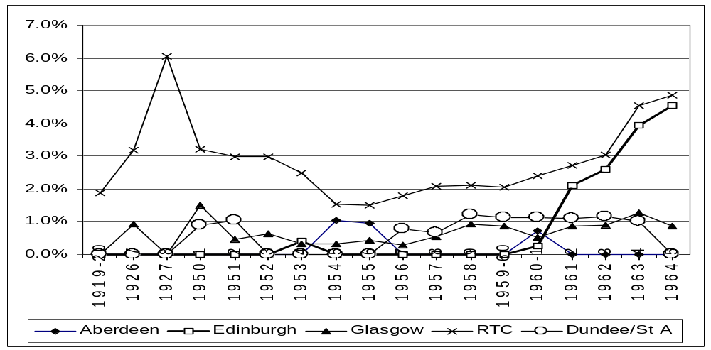
Figure 1 Women students as % of total undergraduate students attending engineering, applied chemistry, mining, metallurgy, architecture etc 1919-1965
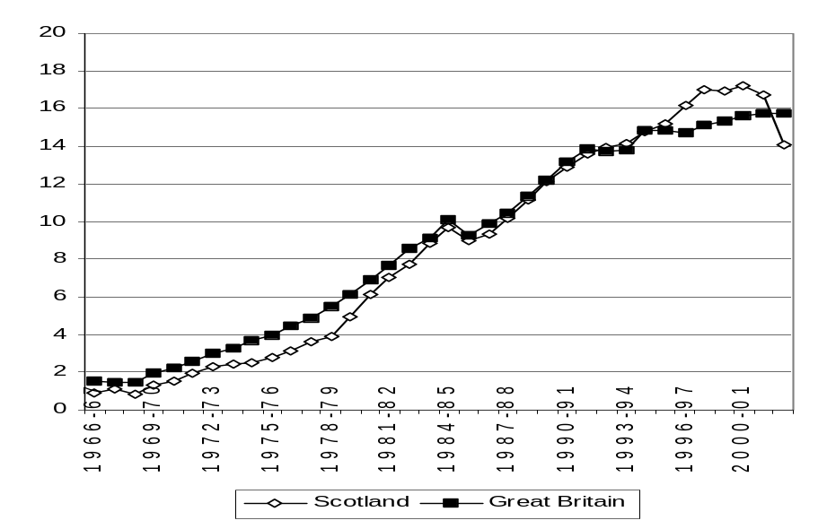
Figure 2 Full-time Undergraduate Level Engineering/ Technology Students: women as % of total 1966-2001, comparing Scotland and Britain

Table 3 Some early women engineering students from the University of Glasgow

Ruth Pirret | 1898 BSc | First female BSc having attended University of Glasgow courses taught at Queen Margaret College.
Dorothy Galbraith | BSc 1922*
Williamina Hood | BSc 1923*
Janet F Armour | BSc 1923*
Elsie M Hutton | BSc 1924*
Margaret F Mursell | BSc 1924*
Anna M L Alcock | BSc 1924*
Mary Smith | BSc 1924*
Jean Allan | BSc 1924*
Dorothy Rowntree | BSc Naval Architecture 1926 | First woman engineering graduate
Hilda C Higgins | BSc 1926*
Margaret Parker | BSc applied chemistry 1927*
Isobel D Arthur | BSc Agriculture 1928*
Isobel Charlotte Campbell | BSc Applied chemistry 1928*
Hanna Grais | BSc Electrical engineering 1937
Lesley Scott Souter | BSc Hons 1, Electrical Engineering1940 | First woman honours graduate in engineering. Patent holder
Maureen Richardson | BSc Engineering 1964
Sarah Charlotte Cameron | BSc aero engineering Hons 1964 | First woman aero graduate
Winifred Gladys Ewen Scott | BSc Engineering Hons 2, Aeronautics 1964 | Class prize: aeronautics 4
* They graduated BSc, but these women had taken engineering classes, such as: Engineering drawing, engineering 1, Engineering fieldwork, Natural philosophy for engineers, Electrical engineering, or heat engineering. It is not known if any became working engineers.

Table 4 Early women engineering students, University of Aberdeen

Flora Weir Black | BSc 1940 | Scientific civil servant, Building Research Station, 1951
Julia Grant Wilson Conchie (or Dorrell) | BSc 1940 | Scientific administrator, Gas Industry 1941-44, Coal Industry, 1950.
Myra Frances Copland | BSc  1941 | Computer programmer, DH Propellers/Hawker Siddely Dynamics, 1952-64, Computing manager, CI Data Centre 1964, FBCS 1968,
Kathleen Johnston | BSc  1941 | BBC technical staff 1941-44
Annie Somerville Scrimgeour | BSc 1943
Catherine Mary Macpherson (or Maclean) | BSc 1944 | Electronics R&D assistant, Hayes 1945-6, technical sub-editor, London 1946-7
Christina Carnegie Geddes (or MacTaggart) | BSc Engineering 1947 | First female engineering graduate.
Sheila Munro Griffith (or Wardell) | BSc 1954 | Research engineer at Marconi Wireless Telegraphy Company, 1973
Margaret Black (or Neville) | BSc 1954 | Laboratory assistant, Natural Rubber Products Association 1970-73

Table 5 Early women engineering students, University of Aberdeen

Flora Weir Black | BSc 1940 | Scientific civil servant, Building Research Station, 1951
Julia Grant Wilson Conchie (or Dorrell) | BSc 1940 | Scientific administrator, Gas Industry 1941-44, Coal Industry, 1950.
Myra Frances Copland | BSc  1941 | Computer programmer, DH Propellers/Hawker Siddely Dynamics, 1952-64, Computing manager, CI Data Centre 1964, FBCS 1968,
Kathleen Johnston | BSc  1941 | BBC technical staff 1941-44
Annie Somerville Scrimgeour | BSc 1943
Catherine Mary Macpherson (or Maclean) | BSc 1944 | Electronics R&D assistant, Hayes 1945-6, technical sub-editor, London 1946-7
Christina Carnegie Geddes (or MacTaggart) | BSc Engineering 1947 | First female engineering graduate.
Sheila Munro Griffith (or Wardell) | BSc 1954 | Research engineer at Marconi Wireless Telegraphy Company, 1973
Margaret Black (or Neville) | BSc 1954 | Laboratory assistant, Natural Rubber Products Association 1970-73

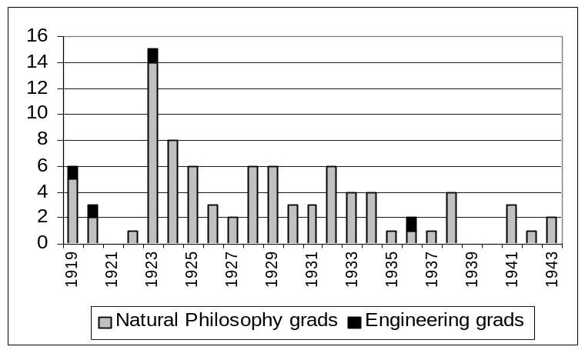
Figure 3 Comparison of numbers of Female Engineering and Natural Philosophy graduates, 1919-43, University of Edinburgh

Table 6 Early women engineering students, University of Edinburgh

Elizabeth Jane Smith | - | Studied 1911-13 but did not graduate, see case history below
Elizabeth Georgeson | BSc engineering 1919 | First engineering graduate. See case history below.
Isabella Lumsden | - | Studied Introductory engineering in 1919-20
Elibet Barclay Lindsay Minnie | BSc mechanical engineering  & MA 1921 | 2nd class certificate of merit in mechanical engineering. Probably 2nd engineering graduate
Dorothy Donaldson Buchanan Fleming | BSc Civil engineering 1923 | See case history below
Mary Isolen Fergusson | BSc Civil engineering | See case history below
Maria Watkins | BSc Electrical engineering 1941 | 1941 BSc Electrical Eng. Assistant technical adviser, Johnson & Phillips Ltd., 1947 Lecturer SE London Tech Coll., 1959 Senior Lecturer Northampton Coll. of advanced Tech, now City Univ. WES President.

Figure 4 Women as percentage of all students of engineering and applied science, University of Dundee, 1954-86
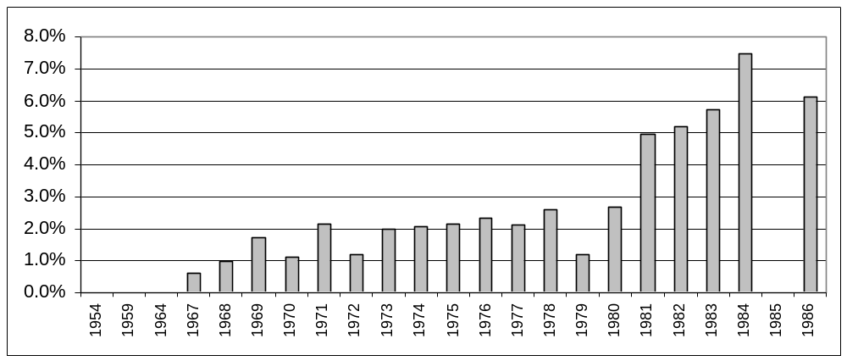
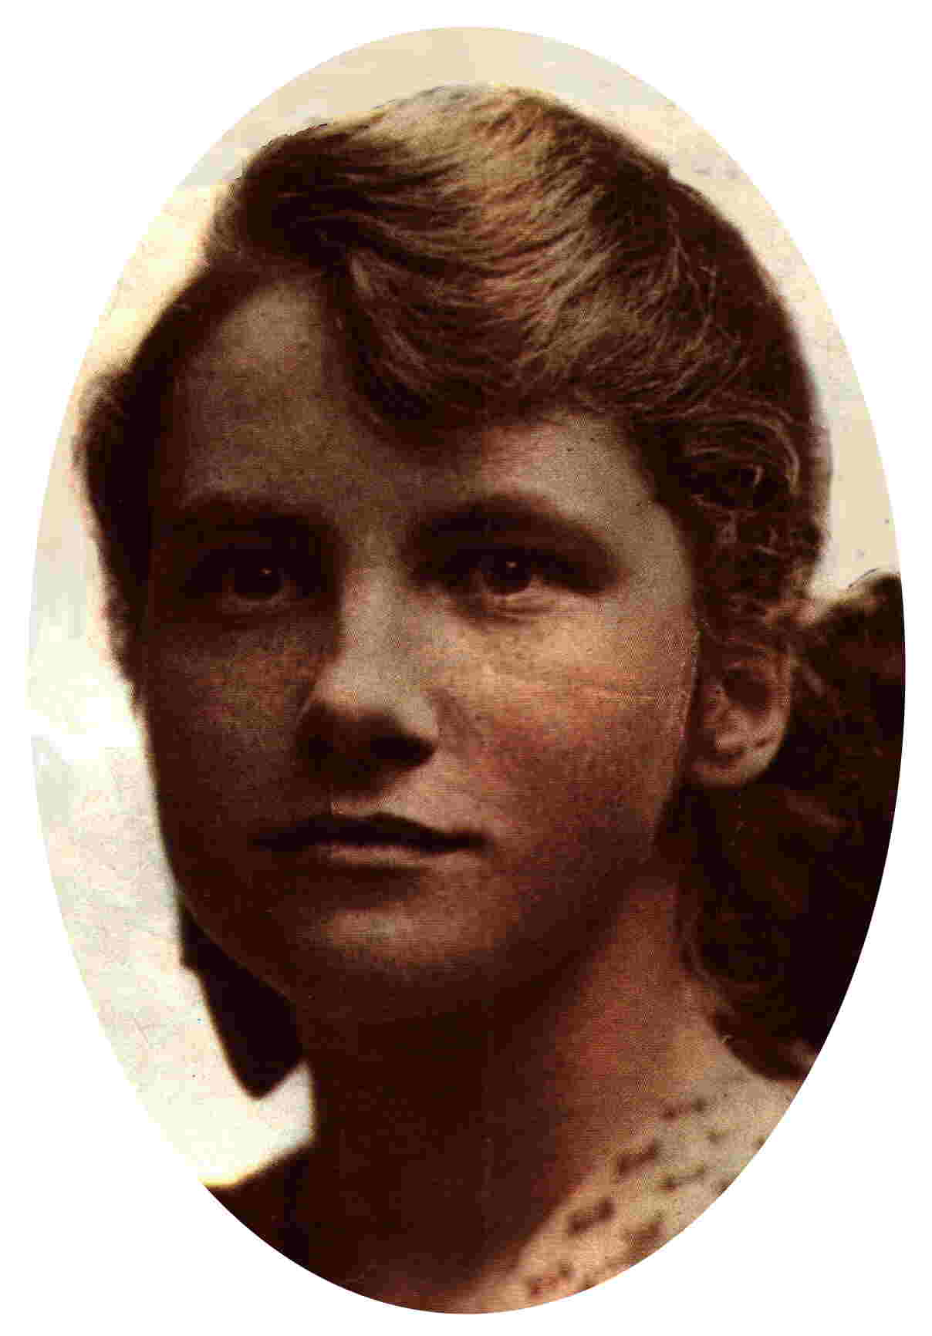

Figure 5 Dorothy Buchanan

Figure 6 Dorothy Rowntree

Bionotes

Nina Baker was born in London and started her career in 1972, as the UK’s first female merchant navy deck cadet, with BP Tankers. After 7 years at sea, and gaining her first mate’s certificate, she lived abroad for some years and resumed her education with some OU foundation courses. These led her to take an engineering degree, BSc Engineering design with appropriate technology, as a mature student at the University of Warwick (1987) and then a PhD in concrete durability at the University of Liverpool (1991). At this point, family responsibilities took her to Glasgow and a variety of part time work, teaching in FE and administrating and researching in the HE sector. Her research work has been mainly on equalities issues, including an EU-funded disability issues project. Baker is now a project assistant at the University of Strathclyde’s Department of Architecture and is researching the history of women in engineering in Scotland, currently focussing on tradeswomen in the building industry in Victorian Scotland. She is a join coordinator of the West of Scotland Local Academic Women’s Network and a trades union activist. She is a member of the Women’s Engineering Society, Construction History Society, Women’s History Scotland and the British Society for the History of Science.
Address: Department of Architecture, Faculty of Engineering, University of Strathclyde, Glasgow G4 0NG
Tel: 0141 954 4602
Email: nina.baker@strath.ac.uk

Blake, C. The Charge of the Parasols: women’s entry to the medical profession. The Women’s Press Ltd., 1990, ISBN 0704342391
Moore, L. Bajanellas and Semilinas, Aberdeen University and the education of Women 1860-1920. Aberdeen University Press, 1991. ISBN 0080412025.
Harford, J. The movement for the higher education of women in Ireland: gender equality or denominational rivalry?, History of Education, 34, 5 (2005): 497-516
Alice Perry. Institution of Engineers in Ireland. Retrieved October 2005 from: http://www.realizedvision.com/ap.htm
Husband, T. Engineering provision in Scottish Higher Education Institutions. COSHEP, 1998. ISBN 0952169177
Purvis, J., ed. The education of girls and women, History of Education conference papers – December 1984, (1985), Introduction, 5. Quoted in R. Watts, Gendering the story: change in the history of education, History of Education, May 2005, vol34, no3, p228.
Cronin, C. & Roger, A. Theorizing progress: women in science, engineering and technology in higher education. Journal of Research in Science Teaching, 1999, 36(6), 637-661.
Dragulescu, A. A. & Yakovenko V. M., Statistical mechanics of money. The European Physical Journal, 2000, 17, 723-729.
Hogan, J., There’s one rule for the rich… New Scientist, 12 March 2005, p 6.
Siann, G. & Callaghan, M., Choices and barriers: factors influencing women’s choice of higher education in science, engineering and technology. Journal Of Further And Higher Education, 2001, 25 (1), 85-95.
1841 Decennial Census
1911 Decennial census
Geyer-Kordesch, G. & Ferguson, R., Blue stockings, black gowns, white coats, University of Glasgow, 1994. ISBN 0951176595
Corr, H., An exploration into Scottish education, in: People in Scotland Vol. 2, 1830-1914, eds. Fraser & Morris. John Donald Publishing Ltd., 1990, ISBN 0859762114. P.303: by 1911 70% of schoolteachers in Scotland were women.
Craik, A.D.D., Philip Kelland. Retrieved June 2005, from: http://www-groups.dcs.st-and.ac.uk/~history/Mathematicians/Kelland.html
University Grants Committee returns from Universities and University Colleges in receipt of treasury grant. HMSO 1919-1965
Higher Education Statistics Agency (HESA) statistics. Note the following discontinuities: 1966 to 1980: Undergraduates from 'old' universities (predominantly first degrees), Department of Education and Science 'Statistics of Education'. 1980-85: Undergraduates from 'old' universities (predominantly first degrees), Universities Statistical Record 'Students and Staff'. 1985 to 1994: Undergraduates from 'old' universities (predominantly first degrees), Universities Statistical Record 'Students and Staff', new classification. 1994 to 2002
Coutts, J., A history of the University of Glasgow 1451-1909, James Maclehose & Sons, 1909.
Oakley, C.A., A history of a faculty, engineering at Glasgow University, University of Glasgow, 1973.
University of Glasgow annual calendars to 1965.
Personal communication from K. Kirkwood who graduated in engineering from the University of Aberdeen in 1959.
Watt, T., Roll of Graduates of the University of Aberdeen 1901-1925 with supplement 1860-1900, Aberdeen University Press, 1935.
Donald, L. & MacDonald, W. S., Roll of Graduates of the University of Aberdeen 1956-70 with supplement 1860-1955. Aberdeen University Press, 1982.
Robert Gordon's University statistics 2003: Retrieved 26/May/2005, from: http://www.rgu.ac.uk/governance/who/page.cfm?pge=11287
Birse, R.M., Engineering at Edinburgh University, a short history 1673-1983, University of Edinburgh Press, 1983.
University of Edinburgh calendars
Private communication with Margaret Fraser.
University of Edinburgh calendars
University of St Andrews and University College Dundee Calendars
University of Dundee calendars.
University of Dundee minutes of senatus academicus
University of Dundee calendars.
Birse, R.M., Engineering at Edinburgh University, a short history 1673-1983, University of Edinburgh Press, 1983.
Records of the British Resorcin Manufacturing Company Ltd., 1917, National Archives ref: BT 31 / 23654 / 147055 # 121492.
Birse, R.M., Engineering at Edinburgh University, a short history 1673-1983, University of Edinburgh Press, 1983.
University of Edinburgh matriculation and graduation records.
The Silent Valley, a short history for schools, Water Service Northern Ireland, Retrieved April 2005, from: http://www.waterni.gov.uk/pdfs/SVALLEY.pdf
Private communications from Dorman Long
Drummond, C., The remarkable life of Victoria Drummond - marine engineer. Thomas Telford Publ, 1999, ISBN 1-902536-25-8
Lucas, S., New Civil Engineer, 6 July 1978
University of Glasgow matriculation records
University of Glasgow Calendars to 1965.
Private communications from the Joly family.
University of Edinburgh calendars.
Personal communications from S. Macartney, Blyth and Blyth, Edinburgh
Obituary, The Scotsman, 9 January 1998
Heriot-Watt University Citation for honorary degree of Doctor of Science 1985

