Modelling of a Finite Element Mesh for the Tibia of a Spinal Cord Injured Patient
K. Sasagawa^{1,2}, S. Coupaud¹, M. Gislason³, Q. Hatem¹, K.E. Tanner¹, D.B. Allan⁴ and Y. Tanabe²
1 University of Glasgow, Glasgow, UK, ksasagawa@eng.niigata-u.ac.jp
2 Niigata University, Niigata, JAPAN,
3 University of Strathclyde, Glasgow, UK,
4 Queen Elizabeth National Spinal Injuries Unit, Southern General Hospital, Glasgow, UK,

Introduction
Spinal Cord Injury (SCI) provides a natural model of the effects of unloading of the bones through paralysis. In paraplegia, bone loss can occur rapidly and extensively in the paralysed lower limbs whilst the upper limbs remain unaffected. Coupaud et al. (2011) report that some patients develop osteoporosis in the tibia and femur even within the first year of injury. Weakening of the bones after SCI is accompanied by a substantially increased risk of fracture. Lower-limb fractures often result from everyday activities, such as a transfer between the wheelchair and the bed. There is a clinical need to understand the macro-structural behaviour of the long bones in the body in order to develop potential physical treatments to tackle this musculoskeletal disorder in SCI patients.

Peripheral Quantitative CT (pQCT) imaging enables measurements of bone mineral density (BMD). The extensive bone loss after SCI results in altered BMD distribution throughout the long bones. By comparing this with able-bodied reference data, changes to the susceptibility of the bone to fracture can be identified. This enables predictions of the most likely locations of fracture at regions of weakness along the bone in SCI.

The aim of this ongoing study is to develop a modelling tool to help clinicians to quantify changes in bone structure and fracture susceptibility resulting from bone loss in the paralysed limbs after SCI.

Materials and Methods
Persons with SCI and able-bodied control subjects are being recruited through the Queen Elizabeth National Spinal Injuries Unit (Glasgow). Ethical approval was granted by the Greater Glasgow & Clyde NHS Research Ethics Committee. The tibia was scanned using a pQCT scanner (XCT3000, Stratec, Germany). Slice thickness was 2mm. Slice interval differed at diaphyseal and epiphyseal regions. Defining the total length of the tibia as 100%, a slice interval of 1% was used in epiphyseal regions. In diaphyseal regions slice intervals of 4-5% were used. The in-plane resolution of pQCT was set at a voxel size of 0.5 mm.

The segmentation of bone and the generation of the FE models from the pQCT dataset were performed using commercial software (ScanIP+ScanFE v. 4.2, Simpleware Ltd, Exeter, UK). A FE mesh with tetrahedral element was automatically generated. Heterogeneous material properties obtained from pQCT data were mapped onto the FE models and the FE mesh with heterogeneous material properties was created (Bessho et al, 2007). Poisson’s ratio of 0.3 was assumed. FE analyses were performed using Abaqus (v. 6.9, Simulia, US). A load of 800 N was distributed on the proximal surface of the tibia on the FE models. The distal end of the tibia was fixed in all directions.

Results and Discussion
Data from the first two subjects are presented here, one able-bodied person (AB1, male, 34 years old), and one person with SCI (SC1, male, 32 years old). The stacks of slice scanned were 43 slices and 24 slices for AB1 and SC1, respectively. A number of slices from the SCI subject were discarded due to excessive motion artefact. Only ¾ of total tibia length could be scanned for SC1 due to the long scanning time, and movement artefacts caused by spasms. The distributions of von Mises stress of the compression load for AB1 and SC1 are illustrated in Fig 1. For AB1, high von-Mises stress occured at a single site. Two high von-Mises locations were identified for SC1.

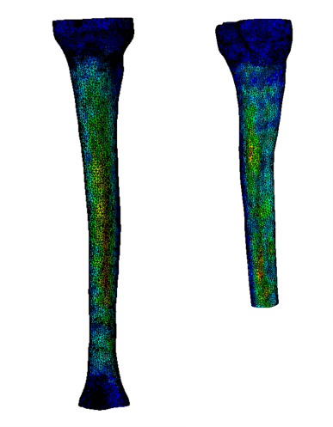
Figure 1: Distribution map of maximal von Mises stress for an able-bodied person, AB1 (left), and a person with SCI, SCI1(right)

In the long-term, such models of the long bones for SCI patients could inform the development of physical intervention strategies to slow down or reverse the natural development of osteoporosis following SCI.

References
[1] Coupaud S. et al. (2011). Disabil Rehabil (in press)
[2] Bessho M. et. al. (2007).Journal of Biomechanics. 40:1745-1753.

