Temperature dependence of the interfacial shear strength in glass-fibre polypropylene composites.
J. L. Thomason and L. Yang
University of Strathclyde, Department of Mechanical Engineering, 75 Montrose Street, Glasgow G1 1XJ, United Kingdom.
Abstract
The present work focuses on further investigation of the hypothesis that a significant fraction of the level of apparent IFSS in glass fibre-reinforced thermoplastic composites can be attributed to a combination of thermal residual stress and static friction at the fibre-polymer interface. In order to obtain information on the temperature dependence of glass fibre – polypropylene IFSS a thermo-mechanical analyser has been adapted to enable interfacial microbond testing to be carried out in a well controlled temperature environment. Test results obtained by TMA-microbond testing showed excellent comparability with those obtained by normal microbond testing. The temperature dependence of IFSS of glass fibre – polypropylene was measured in the range from -40°C up to 100°C. The IFSS showed a highly significant inverse dependence on testing temperature with a major increase in the glass transition region of the PP matrix. It is shown that approximately 70% of the apparent room temperature IFSS in this system can be attributed to residual radial compressive stress at the fibre-matrix interface.

Keywords: A Glass fibres, B Fibre/matrix bond, B Interfacial strength, C Residual stress
Author Nominated – Thermoplastic Composites

1. Introduction
There has been a rapid growth in the development and application of fibre-reinforced thermoplastic polymer composites in recent years. Parallel to this growth has been the increasing recognition of the need to better understand and measure the micro-mechanical parameters which control the structure–property relationships in such composites. The properties of thermoplastic composites result from a combination of the fibre and matrix properties and the ability to transfer stresses across the fibre–matrix interface. Optimization of the stress transfer capability of the fibre-matrix interface region is critical to achieving the required composite performance level. The ability to transfer stress across this interface is often reduced to a discussion of ‘adhesion’ which is a simple term to describe a combination of complex phenomena on which there is still significant debate as to their relative significance and their characterisation. Certainly, one of the generally accepted manifestations of ‘adhesion’ is in the mechanically measured value of interfacial shear strength (IFSS). Despite the high level of attention commonly focussed on the chemical influences such as the application of silane and polymeric coupling agents on the level of composite IFSS, a number of authors have also commented on the role of shrinkage stresses contributing to the stress transfer capability at the fibre-matrix interface [1-6]. Most thermoplastic composite materials are shaped at elevated temperature and then cooled. Since in most cases, the thermal expansion coefficients of matrix polymers are much greater than that of the reinforcement fibres, this cooling process results in a build-up of compressive radial stress (σ_{R}) at the interface. Assuming that the coefficient of static friction (μ_{s}) at the interface is non-zero these compressive stresses will contribute a frictional component τ_{fs} =μ_{s}.σ_{R} to the apparent shear strength of the interface. In the case of thermoplastic polymer matrices where there may often be little or no chemical bonding across the interface these static frictional stresses can make up a large fraction of the apparent IFSS.

Although it is unlikely that these residual stresses provide a full explanation of the apparent IFSS in all composite systems, the above discussion does underline the need to better understand the role of fibre structure, the levels of residual stress, and the interfacial friction, on the apparent IFSS in thermoplastic composites. Most of the available models [1-6] of these phenomena indicate that the level of residual compressive stress at the composite interface should be directly proportional to (ΔT) the difference between matrix solidification temperature and the composite operating or test temperature. Consequently, this would imply that the apparent IFSS in thermoplastic composites should also be dependent on the test temperature. In order to explore this concept an ability to accurately measure IFSS at different temperatures is required. IFSS is commonly measured using micromechanical test methods such as the fibre fragmentation test, the single fibre pullout test and the single fibre microbond test [7]. In this paper we present data on the IFSS in a glass fibre – polypropylene system, in the temperature range -40°C to 100°C, obtained using the microbond test. Although these micromechanical test methods are commonly employed there is little, if any, standardisation of the testing apparatus. Furthermore, it is certainly the case that accurate control of the temperature of the test sample presents considerable challenges in the building of such micromechanical testing equipment. However, thermal analysis equipment for polymers and composite samples has been developed to a high degree of sophistication. Consequently, we have investigated and report in this paper the possibility of combining a microbond test setup with a thermomechanical analyser in order to generate data on the temperature dependence of IFSS for glass-polypropylene composites.

2. Experimental

2.1 Materials
In order to minimise the complexity of the interface to be investigated the choice of the materials was limited to uncoated glass fibre and homopolymer polypropylene. Boron free uncoated E-glass fibres (average diameter = 17.5µm) were supplied by Owens Corning - Vetrotex and commercial isotactic homopolymer polypropylene PP 579S with melt flow index = 47 g/10 min at 230°C was supplied by SABIC-Europe. IFSS was measured using a laboratory-developed microbond test technique.

2.2 Room temperature microbond testing
In this work, the room temperature interfacial shear strength (IFSS) was measured by a laboratory-developed microbond test technique. The specific procedure to form a PP microdroplet on a glass fibre and details for the room temperature (“normal”) microbond test has been reported [8]. In the present work, the formation of PP microdroplets for the microbond test was initially carried out in air. However, after the discovery that this led to significant oxidative-thermal degradation of the PP which significantly affects the value obtained for IFSS, subsequent sample preparation was carried out under the nitrogen [9]. The free fibre length above the polymer droplet matrix was set at a constant value of 5 mm and the rate of fibre displacement was 0.1 mm/min. The load-displacement curve from each test was recorded (typical example is shown in Figure 1) to obtain the maximum force (F_{max}). This was used with the corresponding fibre diameter (D) and embedded length (L_{e}) to calculate the IFSS according to Equation (1).
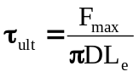 (1)
The tested samples were then examined under the Nikon Epiphot Inverted optical microscope to see if pure debonding process had occurred. Approximately 30 tests were carried out to obtain the IFSS for each sample using Equation.1 and the average IFSS for the entire data set using a least-squares regression procedure.

2.3 TMA-Microbond testing
The temperature dependence of glass fibre–polypropylene IFSS was investigated by adapting the “normal” microbond test configuration to fit into the well controlled temperature environment of a Thermomechanical Analyzer (TMA Q800EM from TA Instruments) using the TMA film/fibre clamping mode. This system consists of two concentrically installed probes (see Figure 2). The outer one is fixed on a flat stage, while the inner probe is driven up and down by a shaft. Both of them have a 1.2 mm slot on the top for supporting two clamps normally used at each end of the specimen when measuring the sample expansion coefficients. Such a fixture provides the potential of conducting the microbond test in TMA, where the resin droplet could sit on the outer stationary probe and the fibre could thread through both slots and end up with some attachment that can just fit under the slot of the inner movable probe.

There were three main challenges to overcome in carrying out the microbond test in a TMA.
- Sample mounting - how to connect the fibre to the inner movable quartz probe.
- Droplet restraint - the width of the upper slot in the stationary quartz probe is approximately 1.2 mm which is much too large to engage the microbond polymer droplets with a normal diameter range of 40-400 µm.
- Development of an appropriate TMA testing protocol for an instrument not initially designed for quasi-static tensile testing.

The TMA Q800 fibre/film accessory is supplied with a pair of stainless steel clamps for gripping thin film samples and cleaved aluminium balls for gripping fibre samples. Such clamping mechanisms work quite well with tough materials such as polymer films and natural fibres. However, brittle 17μm diameter glass fibres do not survive such severe clamping. In addition, heavy clamps would lead to underestimation of the maximum load for interfacial failure or even premature sample failure, since the weight of the clamps could excessively pre-strain the sample. Thus, we used two small paper tabs to sandwich the fibre end. Approximately 0.5 mN is applied on the fibre by the weight of the paper tab which is negligible in comparison to the normal measured debonding forces. To support the resin droplet in the TMA and to provide the droplet shearing force, a small shearing plate (Figure 2) which could be positioned on the top (Figure 3) of the stationery quartz probe was manufactured. The shearing plate was machined from high carbon content stainless steel and consisted of three separate parts, as shown in Figure 2. Two plates had been polished so that there was a sharp edge formed along one of the surfaces. A small angle of approximately 1.2° was deliberately designed between these knife plates to facilitate sliding of the fibre (i.e. the sample) into the gap. Moreover, this ensured the required experimental condition that there was no gap between the fibre and the shearing knives for each fibre, despite the individual variations of fibre diameter from sample to sample. Compared to perfect parallel shearing plates, this angle leads to the difference of 0.33% in the fibre perimeter in loading points around the fibre on each side. For the maximum fibre diameter in this investigation, about 22 µm, the arc length between the loading point applied by the parallel plate and that by the angled plate is only 0.23 µm. Consequently, this slight non-parallel alignment of the shearing plate knives was not expected to have any significant effect on the loading pattern of the resin droplet in comparison with the conventional parallel slot. The third upper plate was used to hold the other two knife plates together.

The TMA configuration proved to be a challenging part in the process of achieving TMA-Microbond since this instrument was not originally developed to carry out the microbond test. In a normal TMA test with the film/fibre probe in use, a static pre-load on the sample is required to remove the slack of the fibre or film and put them under slight tension. The choice of this parameter mainly depends on mechanical properties of materials to be tested. Given that we were attempting to investigate the IFSS of the system, then the interface strength was considered as the criterion for choosing the static pre-load. Hence, the pre-load should be significantly smaller than the maximum load required to cause interfacial failure (found to be in the range 40-230 mN for room temperature testing of IFSS). It was found that a minimum preload of 1 mN was required for the instrument to register the presence of a sample.

The “normal” microbond test is carried out by measuring the load generated during the displacement of the droplet at a constant rate, however the TMA was unable to operate in this mode. The TMA was consequently configured to measure sample displacement during a linear force ramp. It can be seen that the rate of force increase in the “normal” microbond test force displacement plot shown in Figure 1 is approximately linear during most of the strain ramp up to the debonding force. The average value of the slope of the force-displacement curve for all of the individual microbond measurements was found to be 0.15 N/min (with a 95% confidence limit = 0.007 N). In order to keep the TMA-Microbond test as comparable as possible to the “normal” test we therefore adopted 0.15 N/min as the applied force ramp rate in the TMA.

The measurement protocol then proceeded as follows. The probe displacement was electronically zeroed and the single fibre microdroplet sample was loaded into the shearing plate with the lower paper tab hanging freely below the movable quartz probe. With the movable probe immobilised above the paper tab the furnace was closed. The initial sample length and probe position was recorded and then the furnace was equilibrated at the desired test temperature (in the -40ºC to 100ºC range) with an addition 3-5 minutes isothermal segment to ensure a constant equilibrium temperature was attained. The movable quartz probe was then lowered very gently to contact the paper tab and the force ramp was initiated at 0.15 N/min. The increasing probe displacement was then recorded until debonding occurred. A typical result obtained from a TMA-microbond test is plotted as a Force-Displacement curve in Figure 4. The general form of the curve is clearly different than that obtained in a “normal” force-displacement experiment (Figure 1). However, the maximum value of force required to obtain a debonding event is still obtained. The major difference is what occurs after debonding. Since the TMA continues to attempt to increase the applied force above F_{max} after debonding there is a rapid downward displacement of the debonded fibre. Consequently, in this test configuration, there can be no further information obtained on post-debond dynamic friction in a similar manner to the “normal” microbond test.

2.4 Thermomechanical response of fibre and matrix
Characterisation of thermo-mechanical properties of PP with dimensions 60x12.6x3.2 mm was carried in a DMA Q800 out by a three-point bending test with support span length of 50 mm and a heating rate 3°C/min from -60°C to 130°C, frequency 1 Hz, oscillating amplitude 100 µm, static pre-load 0.1 N, and force track: 150%. The coefficient of linear thermal expansion (CLTE) of PP discs with dimensions of 6x1.6 mm was measured using a TMA Q400 with heating rate 3°C/min from -60°C to 130°C with a 0.1 N static force. Axial CLTE of 20 mm lengths of single unsized glass fibre was also determined using a Q400 TMA heated at 3°C/min from -60°C to 500°C under 50ml/min nitrogen [10]. Crystallisation behaviour of PP films of diameter 5.5mm and thickness 0.22 mm weighing approximately 5–6 mg was measured by using a differential scanning calorimeter Q1000 cooling from 250°C to room temperature at 10°C/min.

3. Results and Discussion

Results of the microbond test of peak load versus embedded area of samples prepared in air and under nitrogen are presented in Figure 5. The IFSS for each system is obtained from the slope of the fitted straight lines in the Figure. It can be clearly seen in Figure 5 that measured IFSS for GF-PP is significantly affected by the thermal load (temperature and time) and the atmosphere (air or nitrogen) in terms of thermal-oxidative degradation in PP matrix [10]. Samples prepared under nitrogen with minimal PP degradation exhibit a measured average IFSS (7.9 MPa) over twice the magnitude obtained from degraded PP samples prepared in air (3.6 and 2.1 MPa). The fact that the linear fitting lines of the data from non-degraded samples goes through the origin indicates that thermal degradation of PP may be the reason why some regression lines of microbond data do not pass through the origin as would be expected from equation 1. Results of F_{max} versus embedded area obtained for GF-PP samples, prepared under nitrogen, using the “normal” and the TMA microbond test at room temperature are shown in Figure 6. It can be seen that the comparison of the two test configurations indicate an excellent level of reproducibility of the apparent IFSS of PP with bare glass fibre. The TMA-microbond results for F_{max} versus embedded area obtained for this system at five different test temperatures in the range -40°C to 100°C are shown in Figure 7. Once again the data for each test temperature exhibit a strong linear relationship with a low level of scatter, high values of R², and all extrapolated lines pass through the origin as predicted from equation 1. The results for IFSS obtained for this system at five different test temperatures in the range -40°C to 100°C are summarised in Figure 8 which shows the average values with 95% confidence limits (between 25-45 individual measurements per temperature) of apparent IFSS plotted versus the testing temperature. It is clear from this Figure that the IFSS of GF-PP is significantly dependent on testing temperature. It is worth noting that the rate of change of IFSS with temperature is highest around room temperature (approximately 0.2 MPa/°C at 20°C) which is in the region of the glass transition temperature (Tg) of the PP matrix (-10 < Tg < 10°C from Figure 9 depending on the preferred method for defining Tg). It is well known that the scatter in the measurement of IFSS using the microbond test can often be quite high. The results in Figure 8 indicate that variations of the sample test temperature, for instance over the length of a day or more extremely summer to winter comparisons, could contribute significantly to observed scatter in the results for IFSS measured in polypropylene matrices.

As previously discussed an increase in IFSS with decreasing temperature is a phenomenon which would be expected if compressive residual stresses and interfacial static friction play a significant role in the interfacial stress transfer capability in this system. If the temperature dependence of the fibre and matrix modulus and expansion coefficients is known then the residual compressive stress (σ_{R}) at the GF-PP interface can be calculated from available models [1-5]. Raghava proposed that the radial stresses due to thermal shrinkage can be calculated from
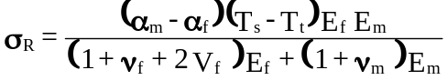 (2)
where α is the thermal expansion coefficient, Ts is the stress free temperature where matrix solidification begins, T_{t} is the testing temperature, ν is the Poisson ratio, V_{f} is the fibre volume fraction, E is the modulus and f and m are subscripts for the fibre and matrix respectively [3]. For many composite systems Ef>>Em, in which case equation 2 approximates that σ_{R} scales with the magnitude of Δα.ΔT.E_{m}. This could already be a good explanation of the general form of the temperature dependence of IFSS in Figure 8 appearing remarkably similar to the temperature dependence of E_{m} seen in Figure 9.

Nairn developed a more complex model [2] which accounted for the effects of differences in the axial and transverse fibre properties and Wagner and Nairn later expanded that model to allow for the presence of an intermediate interphase in the system [4]. The reader is referred to the original manuscripts for the details of these models, however they basically require similar input parameters as equation 2 and the results for residual stress are of similar magnitude when isotropic fibres such as glass are being considered. These models also predict a volume fraction dependence of the residual stress, however it was found that this only began to show any significant effects when V_{f} exceeded 10%. The average V_{f} for the microbond samples used to generate the data in Figure 8 was found to be 3%. DSC analysis showed the matrix solidification process of PP begins when the temperature drops below 120°C. Figure 9 show the results for the thermo-mechanical characterisation of the PP matrix obtained by TMA and DMA. The data shows that the both the modulus and expansion coefficient of the PP matrix are strongly dependent on the temperature and this must be incorporated into the calculations. Glass fibre properties are also temperature dependent but on a much less significant scale and can be considered constant in this temperature range, a value of α_{f} = 4.8x10⁻⁶ m/m was measured for the fibres used in this study [10]. The build up of residual compressive radial stress at the GF-PP interface was calculated in step of 10°C using equation 2 and the above input data. As previously discussed, if the magnitude of the coefficient of static friction for glass-polypropylene is known then contribution of σ_{R} to the apparent IFSS can be calculated. There is very little information available on μ_{s} in the literature, however Schoolenberg reported a value for μ_{s}=0.65 in a sized glass fibre-polypropylene system [11]. The glass fibre used in this study was unsized and consequently there is some uncertainty as to the accuracy of using this value, however it does give the appropriate order of magnitude for μ_{s} in glass fibre-polypropylene. The potential contribution to apparent IFSS of the residual interfacial compressive stress was calculated using various values of coefficient of static friction and added to the IFSS value (τ₀) extrapolated at the stress free temperature of 120ºC in Figure 8. The combination of components based on residual stress (σ_{R}) and physiochemical molecular interactions (τ₀) at the interface may then fully account for the measured IFSS on a basis of the coulomb friction law. For the sake of simplicity, we first assume that τ₀ is independent of temperature and σ_{R} enabling the measured IFSS value (τ_{ult}) to be modelled by
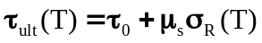 (3)
The experimental values for GF-PP IFSS at different temperatures are compared with values of (τ_{ult}) calculated using equation 3 and various values of μ_{s} in Figure 10.

It can be seen that the residual interfacial stress builds up significantly as the temperature is lowered. Furthermore, the experimental IFSS data fall well within the range of values of interfacial shear strength contribution for coefficients of static friction between 0.35-0.75 which notably covers the value of 0.65 quoted above. One explanation for this range of values may be that μ_{s} in this system is temperature dependent. The coefficient of static friction may be expressed by a combination of a molecular (adhesion) component of the frictional force and a deformation component caused by the introduction of microroughnesses into the softer of the two working bodies and their deformation of the surface layer [12]. Both these components are thought to be temperature dependent and the overall correlation between μ_{s} and temperature will depend on the result of superimposition of these two components and in turn the materials that come into contact, surface state and processing conditions. It has been shown that the μ_{s} for low density polyethylene can vary significantly in temperature range of 25°C to 60°C [13]. Clearly, further investigation of the temperature dependence of μ_{s} between the glass and the polypropylene is required. Furthermore, the detailed dependence of the IFSS on temperature also requires further investigation; however it is clear that there is a strong dependence of the apparent IFSS in GF-PP on the test temperature. The above analysis indicates that approximately 70% of the values of the IFSS in this GF-PP system measured at room temperature can be attributed to residual radial compressive stresses at the interface. This would seem to be supportive of the hypothesis that the interface in this system is dominated by residual thermal stresses.

4. Conclusions
In order to investigate the temperature dependence of the interfacial properties of glass fibre-polypropylene the microbond test has been successfully adapted to be carried out in the temperature controlled environment of a thermo-mechanical analyser. Excellent comparability was obtained for the room temperature apparent interfacial shear strength of glass fibre – polypropylene measured by the TMA-microbond and the “normal” microbond test configurations. The temperature dependence of apparent interfacial shear strength of GF-PP in the range -40°C up to 100°C showed a highly significant inverse dependence on testing temperature with a major increase in the glass transition region of the PP matrix. This temperature dependence of the GF-PP IFSS was interpreted as being due to the increase in residual radial compressive stresses at the interface as the test temperature is lowered. The analysis indicated that approximately 70% of the value of the IFSS in this GF-PP system measured at room temperature could be attributed to residual radial compressive stresses at the interface. This would seem to be supportive of the hypothesis that the interface in this system is dominated by residual thermal stresses.

Acknowledgements
The authors gratefully acknowledge the financial support from the Glasgow Research Partnership in Engineering (GRPE) and would also like to thank Owens Corning Vetrotex and SABIC-Europe for providing the materials used in this study.

References
1. Di Landro L, Pegoraro M., Evaluation of residual stresses and adhesion in polymer composites. Composites Part A 1996;27:847-53.
2. Nairn JA. Thermoelastic analysis of residual stresses in unidirectional, high-performance composites. Polym Compos 1985;6:123-30.
3. Raghava RS, Thermal expansion of organic and inorganic composites. Polym Compos 1988;9:1-11.
4. Wagner HD, Nairn JA. Residual thermal stresses in three concentric transversely isotropic cylinders. Compos Sci Technol 1997;57:1289-1302.
5. Thomason JL. Interfacial strength in thermoplastic composites – at last an industry friendly measurement method? Compos Part A 2002;33:1283-8.
6. Thomason JL, Dependence of interfacial strength on the anisotropic fiber properties of jute reinforced composites. Polym Compos 2010;31:1525–34.
7. Pitkethly MJ et al. A round-robin programme on interfacial test methods.
Compos Sci Technol 1993;48:205–14.
8. Yang L, Thomason JL. Interface strength in glass fibre-polypropylene measured using the fibre pull-out and microbond methods. Compos Part A 2010;41:1077-83.
9. Yang L, Thomason JL, Zhu W Z. The Influence of Thermo-oxidative Degradation on the Interface Strength of Glass-Polypropylene. Accepted Compos Part A (2011).
10. Yang L, Thomason JL. The thermal expansion behaviour of single E-glass fibres. Submitted Polymer Testing, 2011.
11. Schoolenberg GE. In: Karger-Kocsis J. editor. Polypropylene: Structure, Blends and Composites, Chapter 3.6. Chapmann and Hall; 1995.
12. Mikhin NM, Amosov NI. Investigation of the dependence of the coefficient of external static friction on temperature. Soviet Physics Journal, 1974;17(6):873-5.
13. Wróbel G, Szymiczek M. Influence of temperature on friction coefficient of low density polyethylene. Journal of Achievements in Materials and Manufacturing Engineering 2008;28(1):31-34.
Figure Captions

Figure 1. Sample configuration and typical load-displacement curve for the “normal” microbond test
Figure 2. TMA film/fibre probe and TMA-Microbond shearing plate
Figure 3. Schematic and close up photograph of the TMA-Microbond test configuration
Figure 4. Load-Displacement curve from a typical TMA-Microbond test
Figure 5. Room temperature microbond test results for samples prepared in air at 220°C for 4 and 6 minutes and under nitrogen at 220°C for 4 minutes.
Figure 6. Comparison of results for GF-PP obtained from TMA-microbond and standard microbond testing.
Figure 7. TMA-microbond peak load versus embedded area for GF-PP at various test temperatures (▲-40°C,  0°C,  20°C,  40°C,  100°C).
Figure 8.Comparison of average IFSS of glass fibre - polypropylene versus test temperature.
Figure 9. PP matrix storage modulus and coefficient of linear thermal expansion versus temperature.
Figure 10. Comparison of average IFSS with residual frictional stress contribution calculated from equation 3 with different values of static friction coefficient μ.

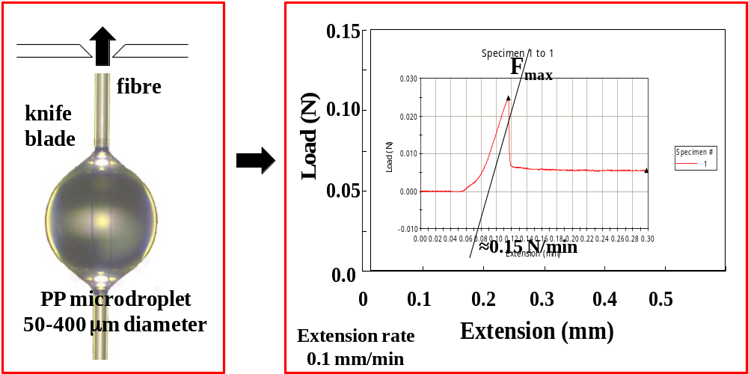
Figure 1. Sample configuration and typical load-displacement curve for the “normal” microbond test

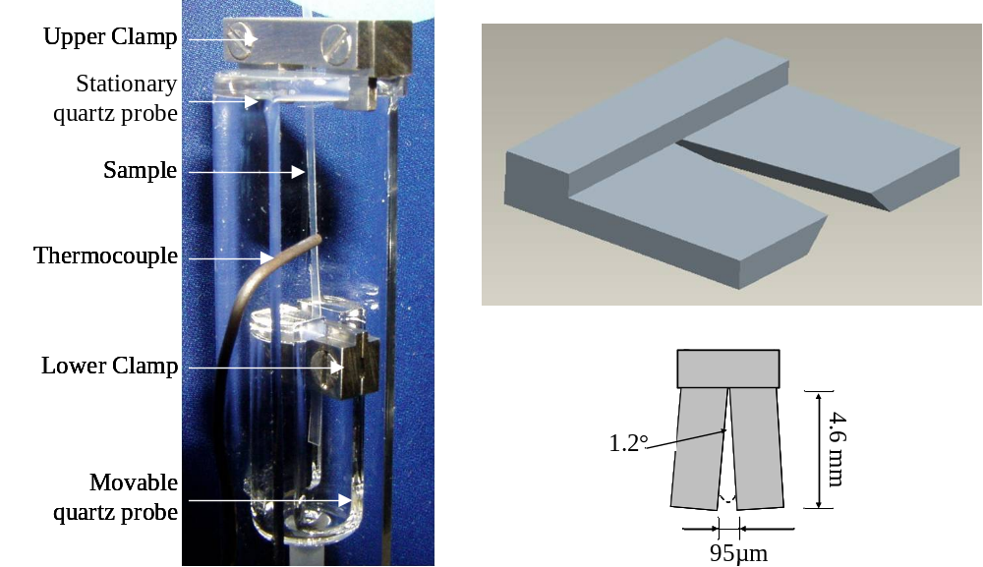
Figure 2. TMA film/fibre probe and TMA-Microbond shearing plate

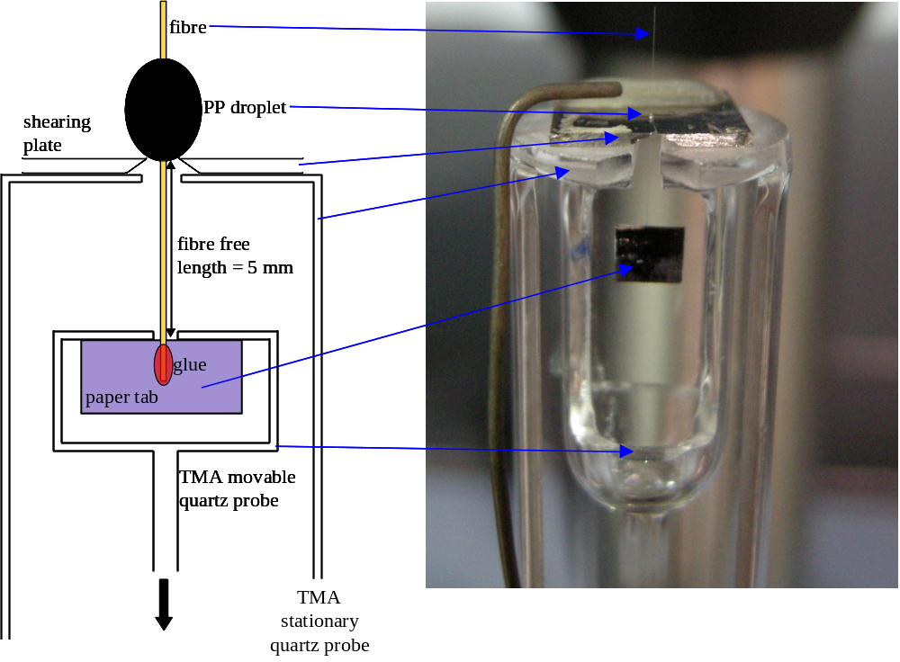
Figure 3. Schematic and close up photograph of the TMA-Microbond test configuration
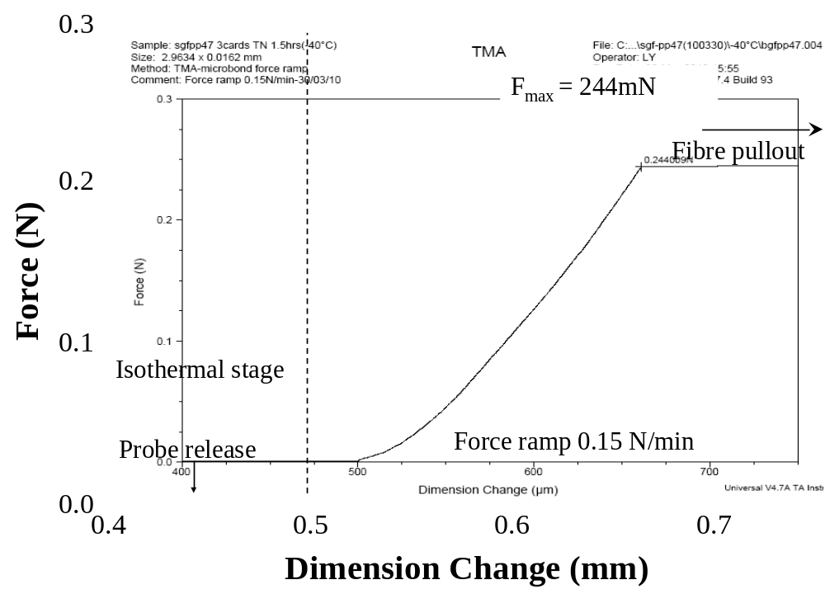
Figure 4. Load-Displacement curve from a typical TMA-Microbond test
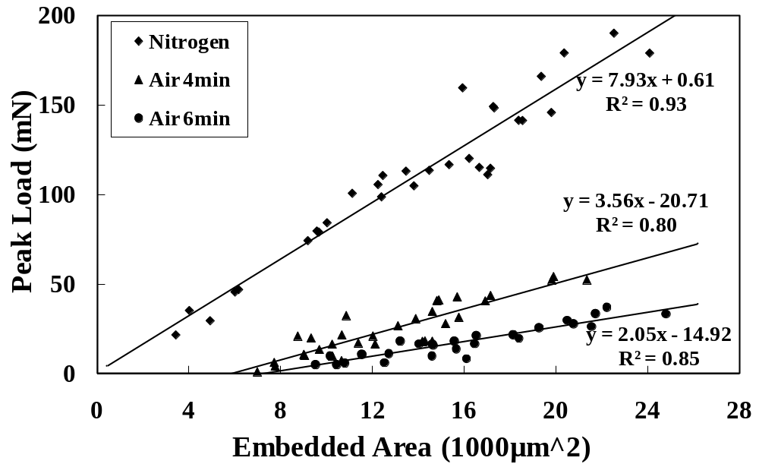 Figure 5. Room temperature microbond test results for samples prepared in air at 220°C for 4 and 6 minutes and under nitrogen at 220°C for 4 minutes.

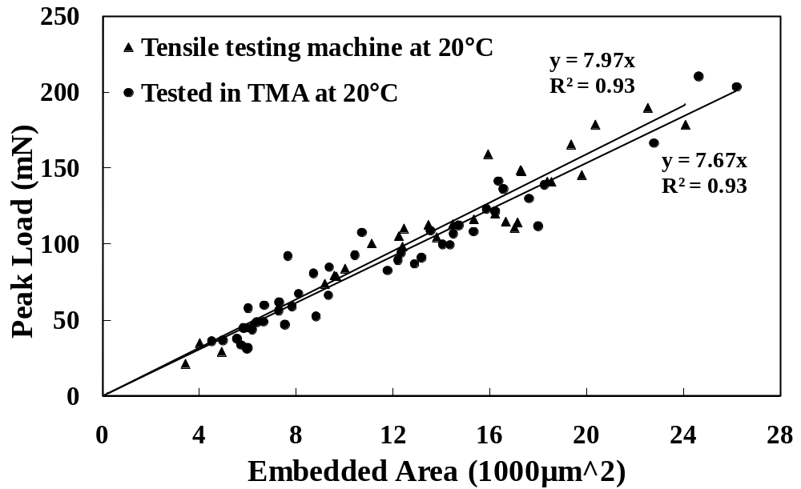
Figure 6. Comparison of results for GF-PP obtained from TMA-microbond and standard microbond testing.

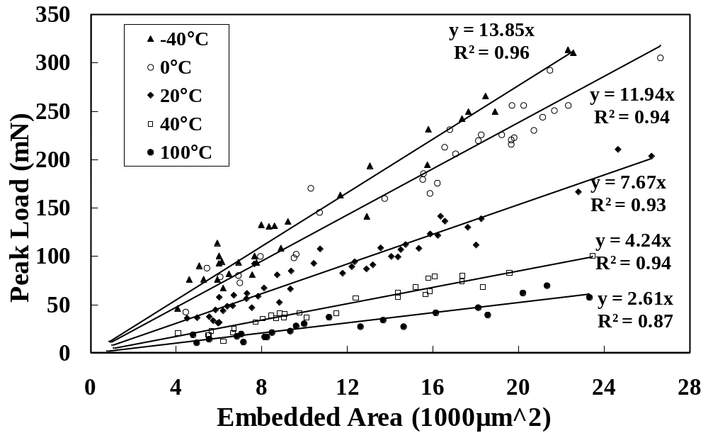
Figure 7. TMA-microbond peak load versus embedded area for GF-PP at various test temperatures (▲-40°C,  0°C,  20°C,  40°C,  100°C).

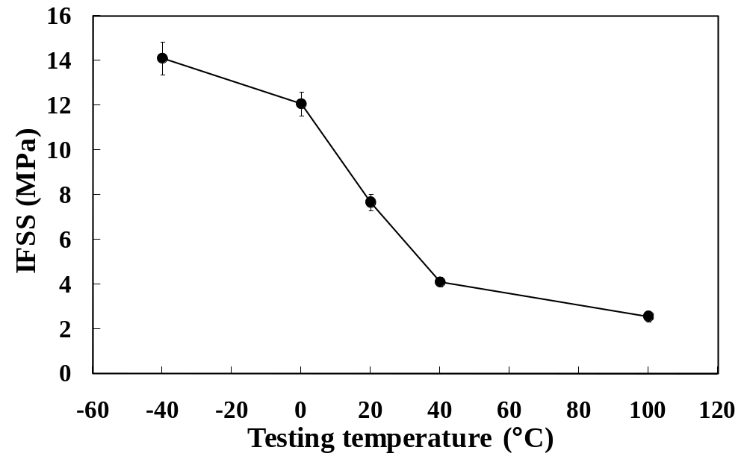
Figure 8. Comparison of average IFSS of glass fibre - polypropylene versus test temperature.

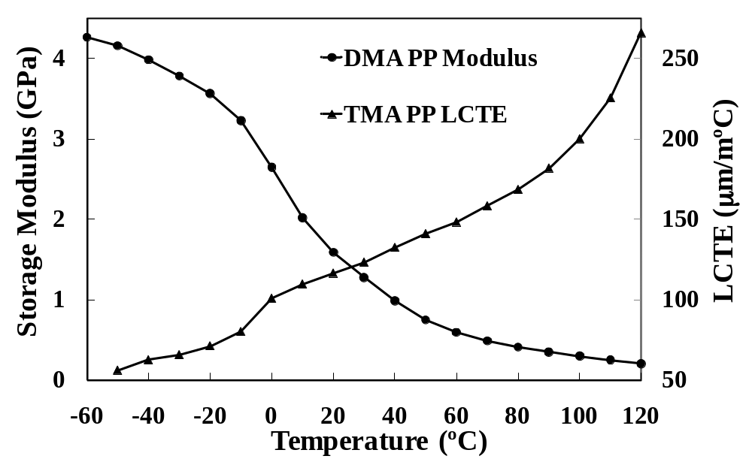
Figure 9. PP matrix storage modulus and coefficient of linear thermal expansion versus temperature.

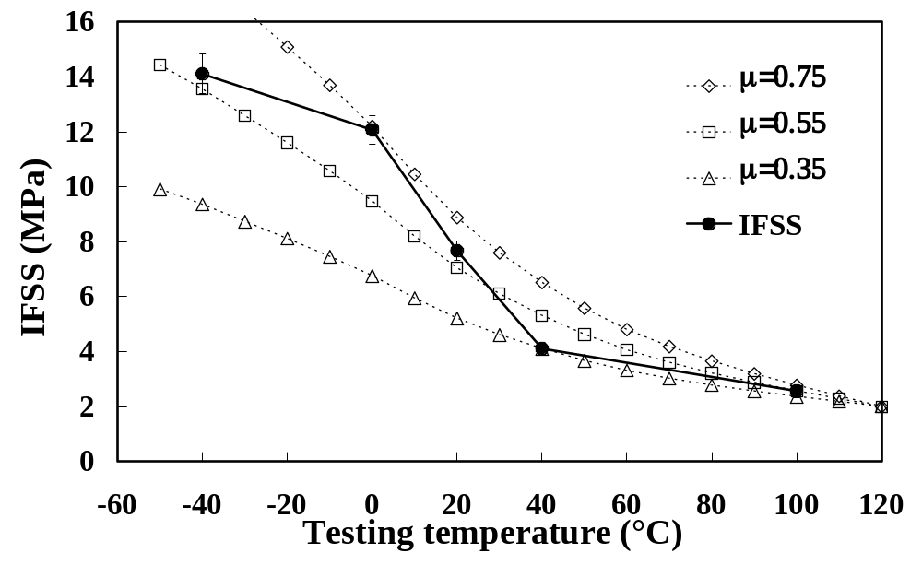
Figure 10. Comparison of average IFSS with residual frictional stress contribution calculated from equation 3 with different values of static friction coefficient μ.

