CONTROLLABILITY OF BUILDINGS, A multi-input multi-output stability assessment method for buildings with slow acting heating systems

John M Counsell¹, Yousaf A Khalid², Joseph Brindley³

¹Professor of Energy Utilisation and Director of the BRE Centre, Department of Mechanical Engineering, University of Strathclyde, Glasgow, UK; email: john.counsell@strath.ac.uk
²BRE Trust PhD Student, Department of Mechanical Engineering, University of Strathclyde, Glasgow, UK email: yousaf.khalid@strath.ac.uk
³BRE Trust PhD Student, Department of Mechanical Engineering, University of Strathclyde, Glasgow, UK email: joseph.brindley@strath.ac.uk

Abstract

The paper describes a methodology to assess the controllability of a building and its servicing systems, such as heating, lighting and ventilation. The knowledge for these methods has been transferred from design processes and methods used in the design of aircraft flight control systems to establish a modelling and design process for assessing the controllability of buildings. The paper describes a holistic approach to the modelling of the nonlinear and linear dynamics of the integrated building and its systems. This model is used to analyse the controllability of the building using Nonlinear Inverse Dynamics controller design methods used in the aerospace and robotics industry. The results show that this design approach can help the architects in their decisions on which building design and services to use. Furthermore, the results demonstrate how the same method can assist the control systems designer in developing complex control systems especially for buildings designed with a Climate Adaptive Building (CAB) philosophy.

Keywords: Buildings, Systems, Modelling, Controllability, MIMO

1. Nomenclature

CAB = Climate Adaptive Building, SISO = single input single output
RIDE = Robust Inverse Dynamics Estimation
MIMO = multiple inputs and multiple outputs
MV = Mechanical Ventilation, NV = Natural ventilation, PSV = Passive stack ventilation
A - Surface Area (m²) with subscripts: w1, w2 & w3 = walls, s = screed, c = concrete, win = window, r = roof, in = insulation, i = inlet & o = outlet openings and n = air infiltration openings.
C - CO₂ concentration level (kg/m³) with subscripts: a = internal air, o = external air, d = coefficient of discharge of opening and p = coefficient of pressure.
c_{p} - Specific heat capacity of (J/kg K) with subscripts: w1, w2 & w3 = walls, a = internal air, s = screed and c = concrete.
F_{r} - Radiation exchange factor (dimensionless).
G - Gravitational acceleration m/s².
g – Global gain of the control system
H - Height between the two openings in zone.
I - Identity matrix
k_{s} - Watts/m² per unit Lux.
k_{f} - Fraction of fan power converted to heat.
k_{e} - Proportion of light power converted to heat.
k_{L} - Lux/W Ratio for internal lighting.
L – Lux sources with subscripts: i = internal lights, s = solar lux in the zone and o = external lux level.
n - Air changes per second (s⁻¹)
P_{L} – Electrical power into lights (W)
P_{f} - Fan power per volume air flow rate (W/m³/s)
q_{m} - Mechanical Air flow rate (m³/s)
- Internal Heat gain (W) with subscripts: oc = Occupancy and ap =Appliances.
S - Internal CO₂ gain (kg/s)
t - Time (s)
T - Temperature (K) with subscripts: a = internal air; 2, 4 & 6 = other zones; w1, w2 & w3 = walls, s = screed, c = concrete, r = roof and o = external air.
u_{L} - Control input for power into internal lights
U - Overall heat transfer coefficient (W/m²K) with subscripts: w1, w2 & w3 = walls, s = screed, c = concrete, r = roof
v - Air flow speed (m/s) with subscripts: n = natural ventilation and o = external air
V - Volume (m³), with subscripts: w1, w2 & w3 = walls, a = internal air, s = screed and c = concrete.
α - Transmissivity (Daylight Factor)
ρ - Density of (kg/m³), with subscripts: w1, w2 & w3 = walls, a = internal air, s = screed and c = concrete.
σ_{b} - Stefan-Boltzmann constant W/ (m².K⁴)
σ – Is a diagonal matrix of scalar gains of the ideal closed-loop control system.
∆ – denotes difference between two different values of the same parameter.
Note: Any symbol with an over bar denotes the value of an input or state at the chosen operating point for linearising the model.

2. Introduction

In recent times commercial buildings have utilised many different systems simultaneously, such as solar blinds, perimeter heating, mechanical ventilation, chilled-beams and under floor heating. This has presented control systems designers the challenge to design advanced building management systems to successfully control them all simultaneously [1-2]. In reality, building services engineers face huge problems in commissioning these complex building management systems to work reliably all year round . Often control systems of lighting, heating and ventilation become unstable as one system fights against another resulting in poor comfort and high energy consumption [2-3].

Interest in low energy building design continues to increase demand for design tools, which can assist building design engineers in evaluating building designs [4]. In the industry computer programs for architectural design and building simulation have developed to become very sophisticated and precise, but in the process the tools have a very steep learning curve and require large amounts of data and time to produce useful results. Also detailed building simulation packages (Energy Plus, ESP-r) require a description of the building and its system that is often unavailable at early design stage [5]. Furthermore, simplified modelling methods have also been developed for building-plant simulations [6]. However, these programs and methods are for evaluating energy consumption rather than assessing the controllability of building and its systems.

A simplified viewpoint of the building design process is illustrated in Figure 1. The conceptual phase of any design project of the building is potentially the most vibrant, dynamic and creative stage of the overall design process. Controllability assessment at the conceptual design stage will help to prevent current problems of poor control which arise later in the detailed design phase or at post construction stage. The cost of removing poor control performance in the later stages of design is normally excessive and must be avoided if possible [5, 7].

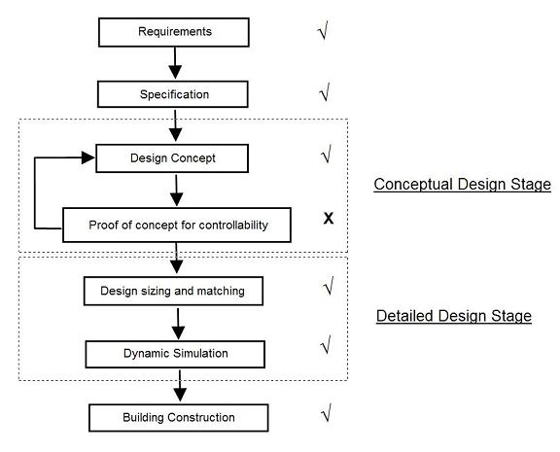

Figure 1. Current building design process (√ = included x = not included).

The industry currently uses dynamic modelling and simulation in the design process to test the detail design of the building where the cost of error removed can be significantly high. At this stage traditional control algorithms (i.e. PID) are also applied. If the building proves not to be controllable, then it is very difficult to identify the factors affecting the controllability as there are too many effects and parameters to be identified. Thus, it is crucial to address the fundamental scientific issues of controllability of the building and its systems at the conceptual design stage through the use of simple nonlinear and linear dynamic models.

After conducting consultation and research [Building Research Establishment (BRE), Archial Group] in industry it is found that there is a need for mathematical models that architects can use in the early phases of the design process for testing their designs for controllability. This type of model should require minimum data input, give reliable indication of trends and sensitivities, and be user friendly. With little effort the architect can then evaluate the controllability of a number of options, make comparisons of different systems and generate positive inputs to his/her design. For this case, a dynamic model is needed to study the controllability of the overall building-plant system.

The contention against this method [8] is that the accuracy of building control system modelling in the transient domain can only be increased and optimised if all relevant aspects, features and characteristics of real systems are taken into account during the modelling process. This premise requires tools that adopt a fully integrated approach, which considers all energy flow paths and the interaction of control systems with fabric, flow, plant and power systems. However, control methods based on simple dynamic models are commonly used in the design of large, complex systems. For many years this method has been a widely used design tool in the robotics [9], aerospace [10] and process control [11] industries for assessing controllability and designing advanced control systems. In these methods, a mathematical model of the system is constructed, utilizing, for example, first principles analysis and experimental data, which is then used for subsequent control system design and analysis. The Control Theory was developed to design feedback controllers that remove uncertainty to poor prediction where as modelling was developed to improve prediction. For the purposes of feedback control highly accurate models are desired. However, such accuracy often requires that complicated high order models be used, which in turn lead to more difficult control design problems from both an engineering and a computational perspective. In these high technology disciplines, emphasis is on the development of methods for reducing the size and complexity of the model while retaining the essential features of the system description. Their aim is to find a simplified system model which describes the physical system accurately enough so that controllers designed based on this simplified model perform well when implemented on the real system. [12]

Mathematical modelling has been used for decades to help building scientists design, construct and operate buildings [13]. Lumped capacitance models of building envelopes with HVAC plant and control have been developed by Underwood et al as a test bed for analyzing control strategies [8, 14-15]. Others have also developed these models for thermal performance assessments using model reduction methods [16]. However these models have not been used to assess controllability of buildings as in the case of aerospace industry [10]. Also, Climate adaptive buildings are MIMO systems and holistic simplified models representing many different processes of the building together, such as natural ventilation, heat, moisture, CO2, internal thermal mass, lux transfers and their plant systems are required. Such models are very difficult to find and majority of the models are of two states mainly temperature and humidity or CO₂ [17].

In order to apply this concept of controllability in building design, a simplified mathematical model is required with enough detail to know which factors are affecting the controllability. After conducting extensive research and consultation, the conclusion is that the building industry also requires a method for assessing the controllability of buildings which may require advanced controllers using nonlinear control and MIMO control systems. This paper describes the science and methods to be used in step 1 of the proposed modelling and controller design process consisting of 3 design stages illustrated in figure 2:

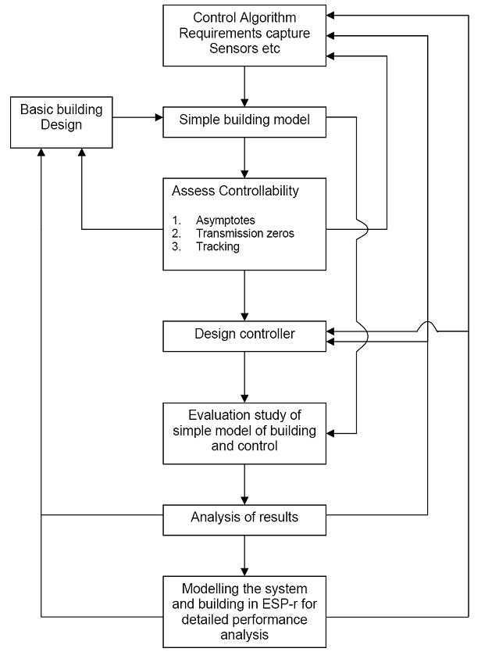

Figure 2. Proposed design process flow diagram for controllability assessment and controller design.

Step 1 consists of two separate stages as follows:

a) Simple Building Model: A simplified [18] dynamic model that provides answers to fundamental questions of controllability and also accurately predicts the dynamic and cross-coupling behaviour of the total energy system.

b) Assess Controllability: A scientific method originally developed in the aerospace industry is utilised consisting of linear state-space models to investigate the potential for the system to be stabilised when using near perfect MIMO controller designs [10, 19]. It also utilises nonlinear models to investigate the ability of the system to track at all times a desired set point for all the buildings properties to be controlled.

3. Case Study

The paper presents a case study of a school being designed in Scotland using the CAB design philosophy and is illustrated in figure 3. The school will have a building management system that will utilise the latest technology to control and monitor the school’s environmental conditions to aid learning and maximise energy efficiency. Some of the technologies proposed for achieving thermal comfort through a sustainable, low-energy approach incorporate under floor heating system rather than the conventional radiator system that will be of the “self-regulating” type. The temperature of the floor and air in the zone will be controlled by means of floor embedded and air sensors connected to the BMS software to monitor and regulate the space temperature. The ventilation strategy employs natural means by manually operated windows and ventilation “stacks”. The “stacks” will also incorporate axial fans which will be automatically operated via a combined temperature and CO₂ room sensor ensuring a fresh teaching environment and that the temperature is kept within the stated criteria. The school will have an intelligent lighting control system that dims down the lighting depending on the natural daylight available externally, thus reducing the energy consumption. In this case study a single class room is modelled for controllability analysis (Fig. 10 Appendix 2).

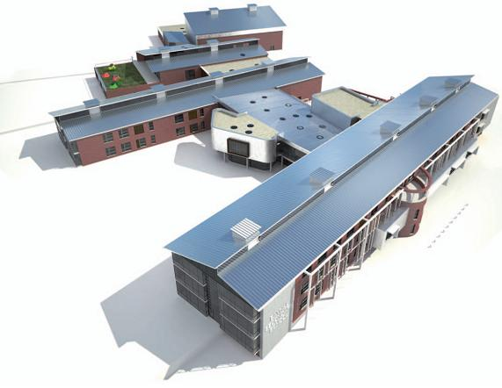

Figure 3. Case study School Design Concept

As stated above, the mechanical ventilation (axial fans) will be used to control both temperature and CO₂ to ensure fresh teaching environment and comfort temperature are achieved. In this paper, only the heating mode (Fig.4) is considered for controllability analysis where mechanical ventilation is not required for cooling and thus mechanical ventilation is only used for controlling CO₂ concentration levels.

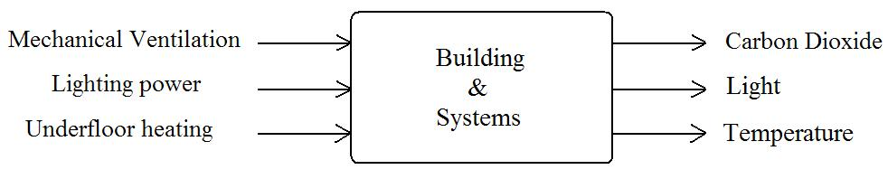

Figure 4. Heating mode, showing inputs of the whole system, where MV = Mechanical ventilation, PL = lighting power and UFH = Under-floor heating

4. Mathematical model

The proposed model is specifically developed to test the controllability of a nonlinear multivariable system. The dynamic model describes the energy and mass balance of air in the building zone having heating, ventilation and lighting (Fig. 5). The assumptions inherent in constructing this model are numerous. However, the purpose of the model is not to emulate future reality and base design decisions around it, as advanced integrated software packages, such as ESP-r [4] already exist.

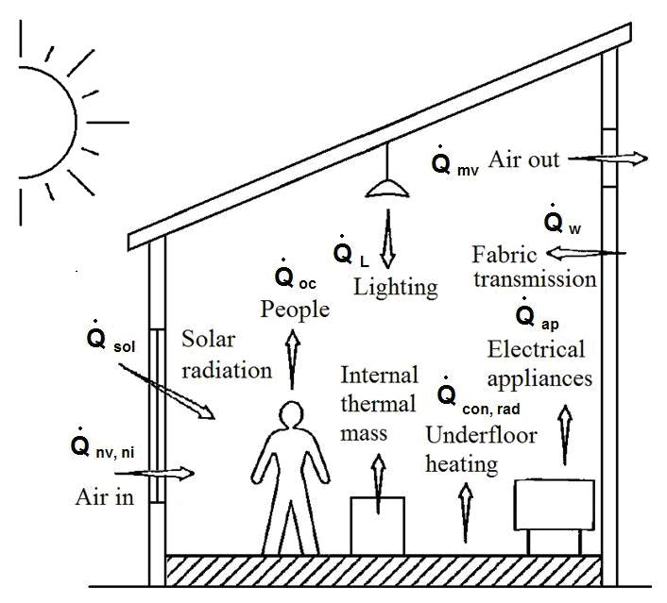

Figure 5. Schematic of the building’s energy flows, CO₂ and Lux balance showing the factors affecting the internal environment of the zone.

The differential equations that govern temperature, Lux and CO₂ levels are as follows:

4.1 Rate of change of indoor air temperature:

The simplified model assumes that the indoor zone air is fully mixed at constant pressure and the stack is stratified for natural ventilation. The roof and windows are considered to be in steady state. This leads to far less complex dynamic equations, but are still detailed enough to analyse controllability. The internal structures e.g. furniture, internal walls etc are considered to be at the same temperature as the indoor air [20]. The Equation describes the indoor temperature T_{a} as follows:

(1)

Where,
Mechanical Vent heat gain: 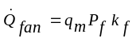,
Solar heat gain: 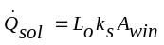,
Lighting heat gain: 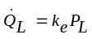,
Convection: 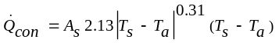,
Radiation: 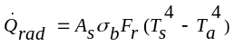,
Wall 1 heat transfer: 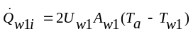,
Wall 2 heat transfer: 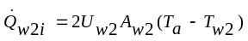,
Wall 3 heat transfer: 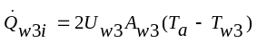,
Window heat transfer: 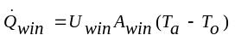,
Roof heat transfer: 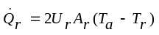,
Natural ventilation: 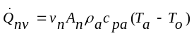,
Infiltration: 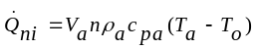,
Mechanical ventilation: 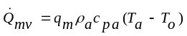
and the area of the fresh air infiltration openings A_{n} is given by:
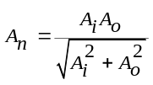 (2)

The air speed in inlet and outlet openings of the zone v_{n}, (m/s) due to stack and wind pressure is given by [21]:

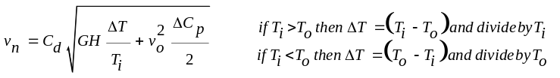 (3)

4.2 Rate of change of wall temperatures:

Thermal corner effects are neglected so that internal and external wall areas can be assumed to be the same. U-Values (overall thermal transmittance coefficient) are used to model the heat transfer through the building fabric. While the thermal resistances and thermal capacities can be calculated, a weighted average of these resistances and capacities was used for a single capacity equivalent of a multi-layer wall construction to simplify the model for controllability analysis. The wall temperatures T_{w1}, T_{w2} and T_{w3} are given by the following:

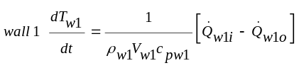 (4)

Where, heat leaving is: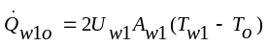.

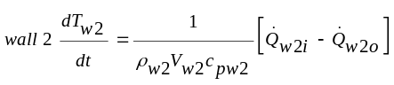 (5)

Where, heat leaving is: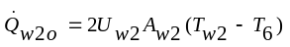.
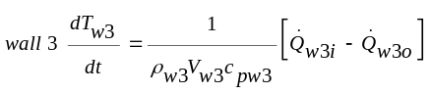 (6)

Where, heat leaving is: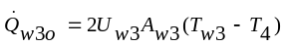.

Note:

a) When the wall and roof temperatures have reached a steady state value, these as expected will be given by:
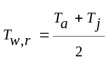 . Where, T_{j} is the external zone temperature connected to the wall or roof.

b) The U value is taken as the reciprocal of the overall resistance to heat transfer, which is the sums of the individual resistances given as:
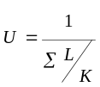, where, L is the thickness of the layer and K is the thermal conductivity.

c) A weighted average of densities and specific heat capacities was calculated using the following formulae:
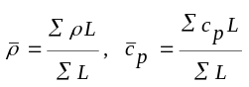, where, L is the thickness of the layer.

4.3 Rate of change of floor temperatures:

The floor has three sections: screed, insulation and concrete. Since the floor is heated, each section of the floor is modelled separately for heat transfer. The radiant interchange is assumed to be between the floor and the air. Thus, the temperature of the screed is given by,

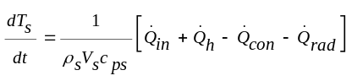 (7)
Where, the heat transfer through the insulation is: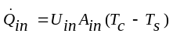.

The temperature of the floor’s concrete is given by:

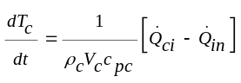 (8)

Where, heat entering is: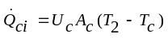.

Note: the floor’s insulation layer is assumed to be in a steady state condition.

4.4 Rate of change of CO₂ concentration:

The air is assumed to be of constant pressure and volume inside the zone, consequently the CO₂ concentration is given by [22]:

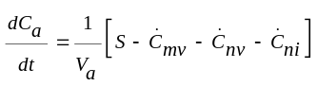 (9)

Where, S is internal CO₂ gain,
CO₂ transferred via mechanical ventilation (MV) is: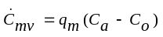,
CO₂ transferred via natural-ventilation (NV) is: 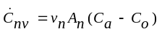 and
CO₂ transferred via infiltration is: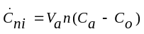.

4.5 Rate of change of lighting power:

Lighting systems are constrained to limiting the frequency at which their lux levels can power on and off [23]. Consequently, it is sensible to control the rate-of-change of power delivered to the lighting system such that,

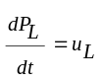 (10)

This enables simple limits to the rate-of-change of lighting lux to be easily set and controlled.

4.6 Sensors for the Controller

A feedback control system can only control (i.e. track) what it feeds back as measured system outputs. Thus, to analyse the controllability of these measurements, they must be defined and are as follows:

Measured Comfort CO₂ is given by: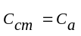, (11)
Measured Comfort lux level is given by: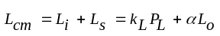, (12)
Measured Comfort Temperature level is given by: 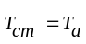 (13)

In order to apply the aerospace controllability science [10, 19], the nonlinear dynamic equations 1-13 must be linearised about a steady state operating point. The results of this linearisation enable the total system to be represented in the state-space form [24]:

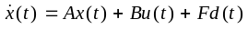 (14)
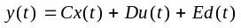 (15)

This linear model describes the dynamic behaviour of the building and its systems for a small amplitude perturbation δ about a steady state equilibrium condition. Where y (t) is the measured output vector, x (t) is a vector of state variables, u (t) is a vector of system inputs (i.e. controller outputs) and d (t) is a vector of disturbances. A, B, C, D, E and F are time invariant matrices consisting of constants which can be readily derived using symbolic mathematical software tools. The vectors associated with these matrices are given as follows:

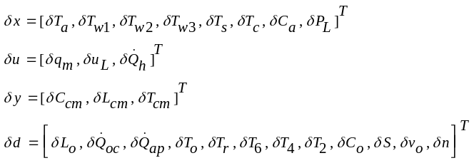 (16)

5. Controllability

Control problems in the buildings industry are not trivial. However, the consequences of failure of plant through bad control are rarely catastrophic. The industry has been able to treat many problems through regular maintenance and commissioning schedules. This has sometimes led to surprisingly good results, but frequently fails to satisfy all the essential occupants and owner’s comfort, energy use, operating cost and capital cost requirements. The research community has been active in proposing new controller algorithms for buildings [1-2]. However, the building industry has been generally reluctant to adopt them due to difficulty in practical implementations and uncertainty in guaranteeing performance. Past research in building design has concentrated on controller design rather than controllability. Controllability is a property of the total system and hence depends on how the building has been designed and what conditions in the building are to be controlled using feedback sensors, e.g. temperature, light intensity and CO₂ levels.

The engineering science presented in this paper is based on ‘A Perfect Control Philosophy’. This philosophy aims to establish for a given design, if perfect control is feasible whilst maintaining stability for the closed loop control system. The value of this feasibility strictly is in allowing the designer to assess the ease in which perfect control could be achieved. The assumption is that the easier it is to achieve perfect control then in reality the easier the real system will be to control. The authors believe that is a sound and thorough philosophy to adopt to establish the controllability of a building. In this paper using state space format, the controllability of the building model is assessed by using Nonlinear Inverse Dynamics and the RIDE Methodology [10, 19], which in a modelling exercise provides a perfect control solution.

5.1 Inverse Dynamics

First order systems behave well and are easier to control. Many Climate adaptive buildings are not predominately first order and are difficult to control. The RIDE theory [10, 19] has successfully utilised inverse dynamics to control highly nonlinear missile systems, and many other aircraft [19] and power plants [25]. The theory uses the inverse dynamics to provide an algorithm that operates a higher order nonlinear MIMO system to behave like an ideal first order non-interacting MIMO system. The RIDE methodology can be viewed as a form of realisable inverse dynamics due to the use of equivalent control input [10] U_{trim} (t) which inverts the model with respect to the controlled outputs (fig. 6).

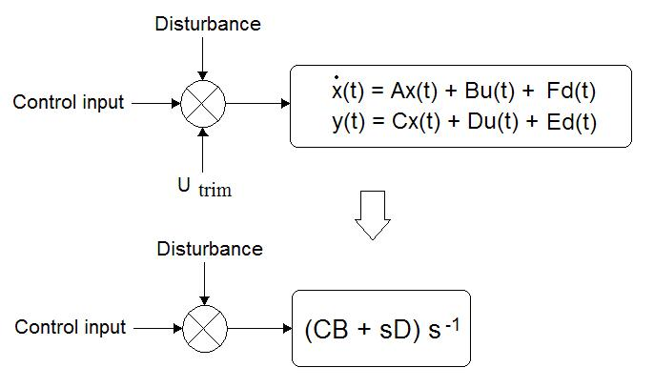

Figure 6. U_{trim} feedback makes a MIMO system behave like an ideal integrator (i.e. First Order, in case D ≡ 0)

In this paper, the RIDE theory is further developed to be used to study the impact on control performance of disturbances for highly nonlinear climate adaptive buildings. It is shown that a good estimate of the U_{trim}(t) enables the control system to accurately track the reference input. For a feedback control system steady state tracking [10] of a constant reference input v (0) can be expressed as,
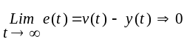 (17)

If this condition is satisfied then the tracking condition will be satisfied even in the presence of a disturbance vector d (t). It is clear that the above condition depends on what is being measured? Therefore it is important that what is measured in approaches the desired output y (t) in steady state.

The input U_{trim}(t) uses inverse dynamics to determine the actuator inputs that are required to ensure zero rate of change of the outputs. It does this by taking into account the disturbances and system dynamics that would otherwise prevent the system from operating like an ideal integrating system. This U_{trim}(t) term however, necessitates the measurement of all state variables and disturbances, as well as plant parameters which are typically unknown. Thus, in reality, the implementation of the equivalent control term is often ignored as it is viewed impractical. However rapid estimation of U_{trim}(t) has been shown to be achievable through the implementation of the RIDE controller design methodology. [10, 19]

5.2 RIDE Methodology

RIDE methodology has applied this inverse dynamics technique to a class of system represented in [10]. However climate adaptive buildings are found to be more complex and are represented by an extended version of the system [10] in which the rate of change of state vector and output vector are also functions of the disturbances in the system (equations (14-15). The estimate of the U_{trim} (t) can be obtained straightforwardly for a system represented in state-space form Eq. (14-15). Consider a basic control system which has a controller matrix K (t) and an extra input U_{trim} (t).

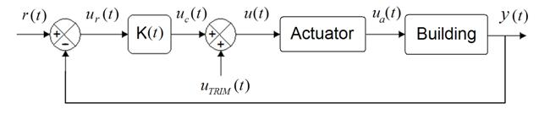

Figure 7. Block diagram of the control system with controller matrix K (t) and dynamic inverse input U_{trim} (t) where: u_{r} (t) = reference input to the controller, u_{c} (t) = controller output, u (t) = control signal to the actuator, u_{a} (t) = actuator output, y (t) = actual output of the system and r (t) = desired output.

Note: It is, of course, essential that all relevant actuator dynamics are represented in the state equation (14). However, it is also important not to include high frequency dynamical modes which would serve only to obscure the important features at the initial design stage. For this reason, the dynamical modes associated with the actuators and sensors are not included. Of course, these dynamics will be incorporated later in the fine tuning of the control system. Here the dynamics of the actuator are assumed to be fast, thus the transfer function of actuator is equal to 1. Hence 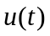becomes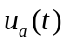.

From Fig. 7, 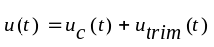. This is substituted into Eq. (14-15) to give:

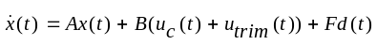 (18)
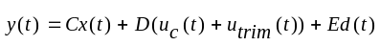 (19)
The output Eq. (19) is differentiated (rate of change of output) and the state equation (18) is substituted into it. Then a Laplace transform is taken to give a transfer function from input to output and from disturbance to output:

(20)

In RIDE methodology [10, 19] the U_{trim}(s) and the controller gain K is chosen such that it reduces the system to a first order system. For the system under consideration the U_{trim}(s) is given by:

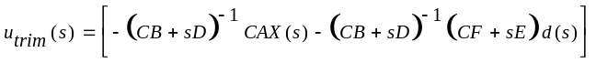 (21)

If 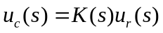 [fig. 7] and the transfer function matrix K(s) is given by 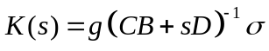, then by substituting these and equation (21) into Eq. (20), the system’s transfer function is reduced to a first order system and each channel of the multivariable system behaves like a perfect integrator for each control variable, i.e. just like a Single Input Single Output (SISO) system given by,

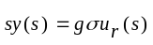 (22)

In closed loop error actuated control with K(s) given above the system is represented as follows:

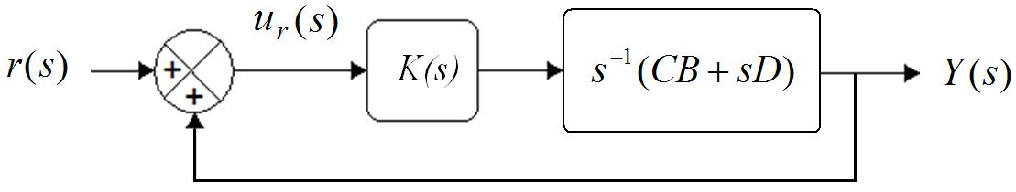

Figure 8: Block diagram of a simple feedback control system with controller matrix K(s)

Then the closed-loop transfer function is given by an ideal non-interacting and perfect first order response as follows:

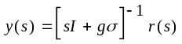 (23)

Thus, overall it has been shown that by having a good estimate of the U_{trim}(s) and controller matrix K(s), the system can be made to behave like a first order system and the tracking condition will be satisfied even in the presence of a disturbance vector d(s).

5.3 (CB+sD) Matrix

As the feedback gain of a control system is varied from zero to infinity the closed-loop poles can be traced out on a root-locus [24] and a number of these poles equal to the number of inputs/outputs approach the asymptotes. On the root-locus, the structure of the (CB+sD) matrix determines the direction of asymptotes which fundamentally effect the ability for the system to be stable when using high performance control. If the matrix is found to be invertible and diagonal, then it means that any asymptotes can be aligned with the negative real axis of the complex plane, thus greatly assisting high gain and high performance controls to be successfully deployed. It also means that classical single input single output (SISO) controllers such as Proportional plus Integral control (PI), could be sufficient. In general, in order to align these asymptotes a MIMO controller is required using a pre-filter matrix given by (CB+sD)⁻¹to re-align the asymptotes along the negative real axis and allow high gain control to be implemented in this more complex situation [10, 19]. It was noted that when air temperature T_{a} was controlled for achieving the required comfort temperature i.e.T_{cm} = T_{a}, the matrix (CB+sD) is not of full rank (i.e. not invertible) as shown in (24). This indicates that perfect control of temperature is not feasible and thus extra measurements from the sensors are needed for perfect control. In this case of rate of measured output feedback sensors which have been successfully deployed in the aerospace industry [10, 19] and the electric motor based systems [9], can be used.

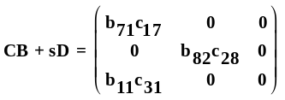 (24)

To make the (CB+sD) matrix invertible, rate of change of measured temperature was fed back and tracked i.e. 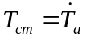. With this new output variable, the following (CB+sD) matrix is produced:

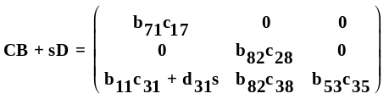 (25)

The constants shown in the matrixes above are functions of building parameters and operating conditions as follows (Appendix 1):

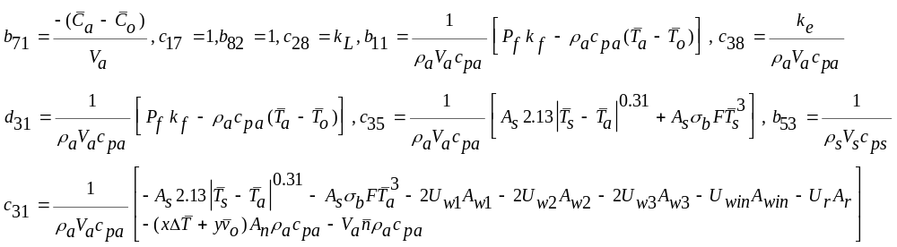,

The cross coupling between the inputs and outputs in the CB+sD matrix is indicated as follows:

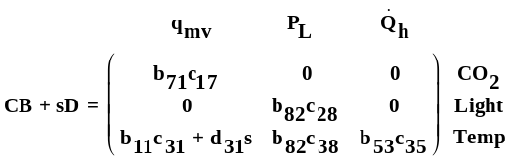 (26)

The (CB+sD) matrix (26) is not diagonal and in some cases, but not this one, this could means that some of the asymptotes are pointing at angles to the negative real axis of the root-locus. In this case when high gain is used, which is desirable to reject disturbances such as changes in solar gains and outside temperature, the system is more likely to become oscillatory in its response.

It is clear that there is cross coupling between temperature and CO₂ controls via the MV. Also there is coupling between lighting and temperature modes through the heat emitted by the lighting power. However, as can be seen, the coupling between the temperature and CO₂ controls is only one way, i.e. rate of change of temperature control has no effect on CO₂ control. The d₃₁s term shows that the coupling is due to the rate of change of ventilation which has a significant effect on the temperature control. The coupling is very strong because the ventilation system has a faster time constant then the heating system. Thus, the heating system cannot respond faster to the change in ventilation. This is the reason for the non-diagonal terms in (CB+sD) matrix.

The (CB+sD) matrix gives an indication of which properties of the building such as U values, wall area etc. embedded in the constants could be changed to give as near a diagonal matrix as physically possible and thus allowing simple PI controllers to be successfully utilised. As can be seen from the (CB+sD) matrix (Eq. 26) that asymptote directions are affected by coupling of constants (b₁₁c₃₁+d₃₁s) and (b₈₂c₃₈). These constants correspond to the building parameters as well as operating points. This shows that the stability is dependent on the operating internal and external temperatures, CO₂ levels, floor temperature, wind speed and air outside to inside exchange rate. The direction of asymptotes is also a function of the temperature difference between the internal and external operating temperatures ΔT. This indicates that as ΔT changes with the seasons, the stability of the system will be affected.

In winter lighting power will be at its greatest and will have a greater impact on temperature control stability than in the summer season. Higher occupancy levels will have a greater impact on the temperature control stability due to the coupling with rate of change of ventilation. It is also interesting to note that the thermal mass of the construction has NO impact on the asymptote direction, and thus no impact on cross coupling that could prevent the high performance control of the system.

The RIDE theory [10, 19] states that the asymptotes for a multivariable design are given by Eigen-values: 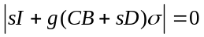 where, g is the global gain from zero to infinity and σ is a scalar gain. Therefore the asymptotes are the solutions for s of the following determinant:

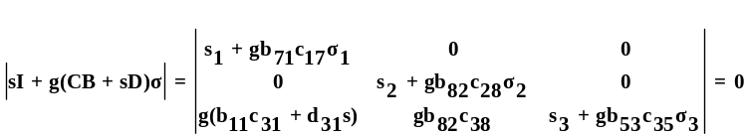 (27)

Note: in the above matrix (Eq. 27) the ‘s’ multiplying the constant d₃₁ is a differential operator, where as the other ‘s’ multiplying the identity matrix I represents the Eigen values i.e. solution to the determinant of the matrix.

The determinant of Eq. (27) is found to be:

(28)

The Eq. (28) is solved symbolically to obtain expressions for s which are the three asymptotes of the states going to infinity. They are as follows:

(29)

Hence, the asymptotes are defined by the following building parameters:

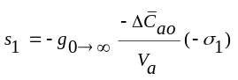, 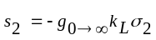,
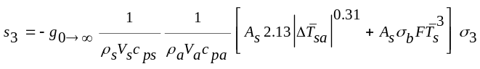

The first asymptote s₁ for CO₂ level the asymptote is pointing towards the positive real axis as the negative signs cancel to make the asymptote positive. This asymptote can be aligned to the negative real axis by making the scalar gain negative (– σ₁). The other two asymptotes for lighting and temperature are already negatively aligned. From the symbolic analysis it can be shown in Fig. 9 that the asymptotes will be displayed on the root loci as follows as g tends to infinity:

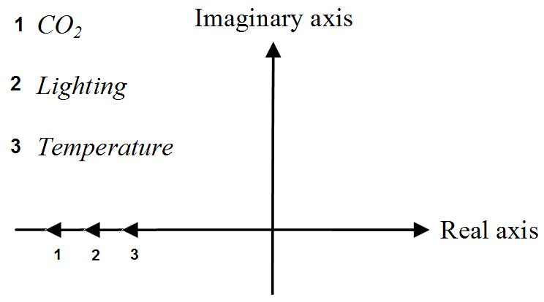

Figure 9. Asymptote directions on a root locus for a closed-loop system shown in Figure 8.
Note: It is difficult to perform asymptote direction analysis for all the possible operating points, thus the asymptotes are analysed symbolically in terms of differences between parameters rather than each individual operating point parameters i.e. 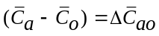 and 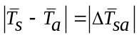.

Asymptotes are a function of the operating points such as temperature difference between internal & external CO₂ levels and also between the floor & air temperatures. It is also interesting to note that the asymptotes are not at an angle and thus variation in the operating points will not affect the controllability as the asymptotes will always be horizontal and negatively aligned. Two fundamental conclusions can be drawn from this analysis as follows:

1. Easier to deploy high gain and high performance controls
2. Classical single input single output (SISO) controllers such as Proportional plus Integral control (PI) could be sufficient, but could be difficult to achieve fast and accurate control since asymptote are a function of operating points.

5.4 Transmission Zeros (TZ)

The transmission zeros determine how well the system can be stabilised when using high gain feedback control [10] and inverse dynamics. The linear time-invariant state-space model equations (18-19) were used for the calculation of transmission zeros and their stability analysis over the operating range. The transmission zero locations are determined by the determinant (30) [26] and can be readily solved using control system analysis software.

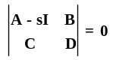 (30)

When the matrices are substituted the determinant is given as follows:

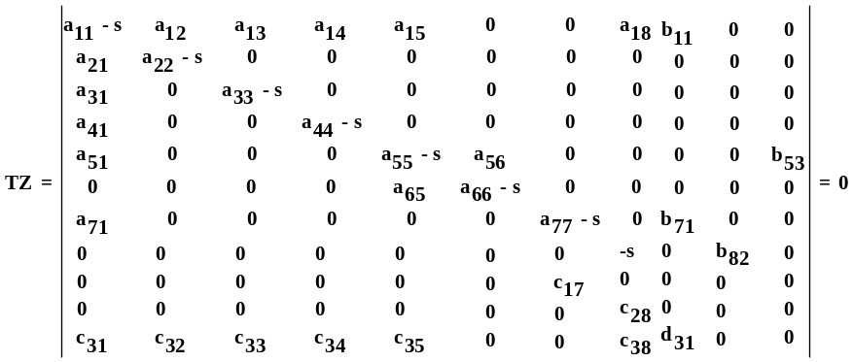 (31)

The different constants in the matrix (Eq. 31) are the constant coefficients of the state space model and they are a function of building properties, environmental parameters and plant parameters (Appendix 3, Table 1-2). The determinant is then symbolically solved for expressions of s which are the roots of the determinant and are called transmission zeros of the control system. The variables in the output equation for comfort temperature are the same as the state equation for rate of change of air temperature, due to state feedback for air temperature control i.e. feedback 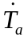. Hence, variables a₁₁ = c₃₁, a₁₂ = c₃₂, a₁₃ = c₃₃, a₁₄ = c₃₄, a₁₅ = c₃₅, a₁₈ = c₃₈ and b₁₁ = d₃₁ (Appendix 1). Therefore the determinant can be further simplified and is as follows;
(32)

The equation is solved to find the values of s which are the transmission zeros. In this case study, there are five transmission zeros, which if assumed that the zone has one internal wall, two partition walls and an external wall (see Appendix 2 for zone geometry) are given by:
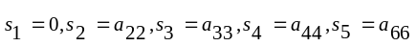. Where,
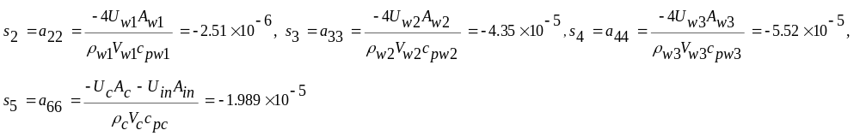
The transmission zeros are stable as they are always negative i.e. on the left half plane of the root-locus. In this case they are not a function of operating conditions such as outside temperature, but are a function of thermal properties; area, mass and thermal capacitance of the walls, concrete and insulation. This shows that the transmission zeros will always remain negative and therefore stable since the building parameters will never have negative values. There is a transmission zero at the origin i.e. s =0. This is due to rate of change of temperature being a function of temperature and thus we can only track temperature and not rate of change of temperature. To eliminate the effect of this undesirable transmission zero, a cascade control solution is required where temperature feedback is utilised to produce a rate of change of temperature command for the rate of change of temperature control system previously analysed. This control strategy is widely used with great effect in electric motor based systems [9].

In section 5.3, it is mentioned that system’s poles (equal to the number of inputs/outputs) approach their asymptotes. In this system there are eight state variables and therefore eight poles. Three poles approach the asymptotes i.e. infinite zeros and the remaining five approach the finite zeros i.e. transmission zeros. These five poles are the slow modes of the system representing the three walls, screed and concrete due to their high thermal mass. As mentioned in [26] that if the zero coincides with the slow pole (pole-zero cancellation) or is very close to it, its sluggish influence on the response is reduced. Thus the effect of the high thermal mass has less influence on the output response of the system i.e. air temperature.

6. Conclusions & further work

The controllability analysis method described in this paper is sufficiently described for alternative zone formats to be easily analysed. If the requirements outlined in this paper are met at the conceptual stage of the design process then it will be easier to design control solutions with confidence that they will perform well at dynamic simulation, build, installation and commissioning stages of the design process.

The (CB+sD) matrix of the zone takes into account all the inputs and feedbacks of the control system. Now with this analysis the matrix was proved rank defective due to temperature feedback and the thermal mass of the under-floor heating system. With the rate of change of temperature feedback the (CB+sD) matrix has been proved to be full rank. The (CB+sD) matrix is not aligned diagonally which will make fast and accurate control very difficult with independent SISO controllers for temperature, light and CO₂. This undesirable coupling changes seasonally and throughout the day as the root-locus asymptote directions are a function of the operating conditions. By assessing the state-space model (CB+sD) matrix, the suitability of the system for high performance control has been proven to be seasonal (i.e. function of temperature difference) and not a function of the thermal mass of the construction or its U value.

Transmission zeros in the case study presented are all negative, thus stable except the zero at the origin. Its effect can be eliminated through a cascade control feedback loop to ensure stability, good tracking and robustness. The transmission zero locations will allow a high performance high gain control to be successfully utilised when simultaneously controlling, CO₂, lux and rate of change of room temperature with a MIMO controller.

Further work is also aimed at assessing the impact on control performance of disturbances such as changes in outside temperature and also changes in thermal characteristics such as U values can be minimised through the use of equivalent control input (U_{trim}) (equation 21). This will also be useful in sizing the system actuators, such as lighting power, mechanical ventilation rate, heater power etc, by assessing the conditions of U_{trim} for safe system operation and guaranteeing tracking. Currently work is also being done to improve the model to include the effect of internal thermal mass (furniture), long-wave radiation, model of the 4th wall & roof and wind impact on air change rate of the zone.

7. Acknowledgements

This research has been funded by the BRE Trust as part of Strathclyde's BRE Centre of Excellence in Energy Utilisation in partnership with the University of Strathclyde's EPSRC funded CTA Programme. The case study was provided by Archial Sustainable Futures part of Archial Group.

8. Reference

[1] A.I.Dounis, c.Caraiscos,; Advanced control systems engineering for energy and comfort management in a building environment - A review; Renewable and sustainable energy reviews 2008
[2] Salsbury, T. I. 2005. “A Survey of Control Technologies in the Building Automation
Industry”. Proceedings of the International Federation of Automatic Control World Congress,
Prague, Czech Republic.
[3] Timothy I.Salsbury,; Control performance assessment for building automation systems; Energy saving control in plants and buildings, October, 2-5, 2006 Bansko, Bulgaria
[4] Drury B. Crawley, Jon W. Hand, Michael kummert and Brent T. Griffith, Contrasting the capabilities of building energy performance simulation programs, Building and environment volume 43, issue 4, april 2008, pages 661-673
[5] Chunhai Xia, Yingxin Zhu, Borong Lin, “building simulation as assistance in the conceptual design” Building simul (2008) 1: 46-52
[6] Anton Sodja, Borut Zupancic,;"Modelling Thermal processes in buildings using an object orientated approach and modelica",; Simulation modelling practice and theory 17 (2009) 1143-1159
[7] D. Bownass, Building services Design Methodology A Practical Guide, ISBN:978-0-419-25280-1
[8] John MacQueen; P.hD Thesis: “The modelling and simulation of energy management control systems” August 1997, Mechanical Engineering, University of Strathclyde.
[9] A. P. Roskilly, et al; Non-linear modelling of robust controllers for robotic manipulators; ImechE 1990.
[10] Bradshaw, A., Counsell, J.M., Design of autopilots for high performance missiles, IMechE J. Systems & Control 1992. pp. 75-84
[11] R. Laknera, , , K.M. Hangosb, a,; and I.T. Cameronc,; "On minimal models of process systems",Chemical Engineering Science Volume 60, Issue 4, February 2005, Pages 1127-1142
[12] John C. Doyle,; Final report "Nonlinear Robust Control Theory and Applications" California Institute of Technology
[13] Xiaoshu Lu1,2*, Derek Clements-Croome3, Martti Viljanen2,; Past,present and future mathematical models for buildings: focus on intelligent buildings (Part 1 & 2), Intelligent Buildings International, Part 1, Volume 1 Number 1 2009, 23-38, Part 2, volume 1, number 1, 131-141
[14] Bourhan Tashtoush*, M. Molhim, M. Al-Rousan, “Dynamic model of an HVAC system for control analysis” Energy 30 (2005) 1729–1745
[15] G. Hudson, C.P. Underwood,; ”A simple building modelling procedure for matlab/simulink”, Building simulation Conference 1999
[16] Underwood C.P, et al, Building thermal model reduction using nonlinear constrained optimization, Building and Environment 37 (2002) (12), pp. 1255–1265.
[17] P.I. Daskalov;, K.G. Arvenitis; “Nonlinear adaptive temperature and humidity control in animal buildings” Biosystems Engineering (2006) 93 (1), 1-24
[18] Magni, J. et al, Robust Flight Control: A Design Challenge, Springer-Verlag 1997, Lecture Notes in Control and Information Sciences, 224.
[19] E Muir, A Bradshaw; Control law design for thrust vectoring fighter aircraft using robust inverse dynamics estimation (RIDE); Proc Instn. Mech. Engrs. Vol 210, 333-343, 1996.
[20] ASHRAE Fundamentals(2009) & HVAC Systems and Equipment (2008).
[21] Kavolelis. B, et al: Natural ventilation of animal sheds due to thermal buoyancy and wind. Journal of Environmental Engineering and Landscape management 2008, 16(4): 188-194.
[22] Heshmat. A, et al; Predictive model for CO₂ generation and decay in building envelopes. Journal of Applied physics, volume 93, number 2, 15th January 2003.
[23] Newsham, G.R.; Donnelly, C.;The Effect of ramps in temperature and electric light level on office occupants: a literature review and a laboratory experiment; Proceedings of the 2006 ACEEE Summer Study on Energy Efficiency in Buildings, Pacific Grove, California, pp. 4-252 to 4-264
[24] Franklin and Powell, Feedback Control of dynamics systems, 5th edition 2006.
[25] Ding, L., Bradshaw, A. and Taylor, C.J. (2006) Design of discrete-time RIDE control system, UKACC International Conference (Control-06), August, Glasgow, UK.
[26] Straete, H.J., “Physical Meaning of zeros and transmission zeros from bond graph models”, MSc Thesis 1995, Massachusetts Institute of Technology

APPENDIX

1. Linearised state-space model:
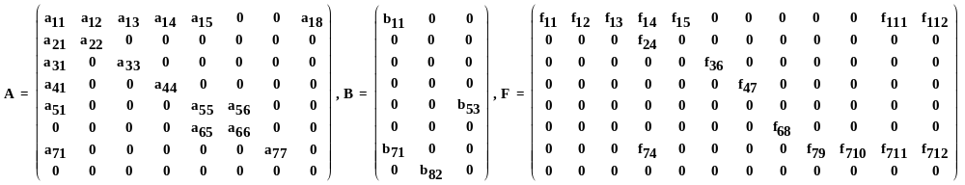
Feedback Strategy 1:
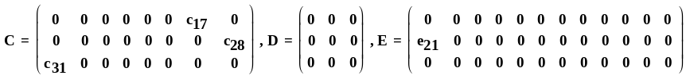
Feedback Strategy 2:
.

Where the constant coefficients in the matrixes are given as follows:
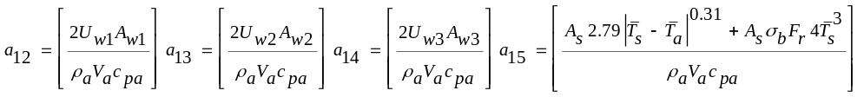
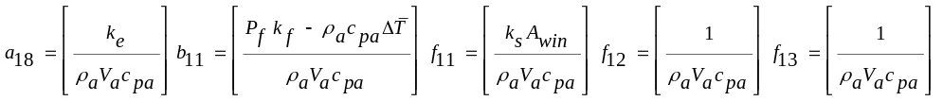

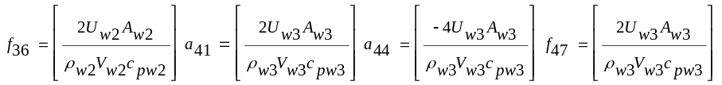

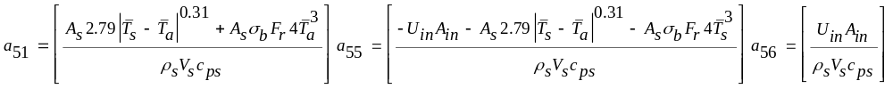
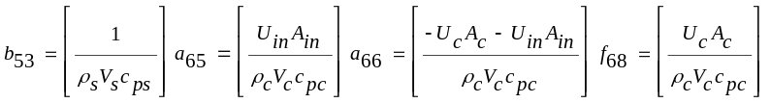
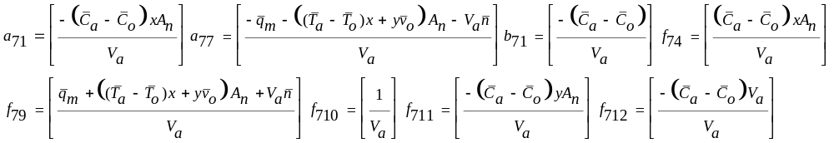
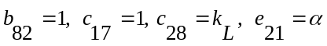

Feedback Strategy 1: 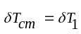 Feedback Strategy 2: 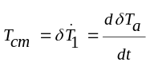
Where, c₃₁=a₁₁, c₃₂=a₁₂, c₃₃=a₁₃, c₃₄=a₁₄, c₃₅=a₁₅, c₃₈=a₁₈, d₃₁=b₁₁, e₃₁=f₁₁, e₃₂=f₁₂, e₃₃=f₁₃, e₃₄=f₁₄, e₃₅=f₁₅, e₃₁₁=f₁₁₁, e₃₁₂=f₁₁₂.

2. Zone geometry

The zone is a classroom on second floor of the building and it has other classrooms on its sides and below on the ground floor. The wall with the windows is the exterior wall, opposite this wall is the interior wall and the two side walls are the partition walls that are identical for this case study. The partition walls are attached to the corridor.

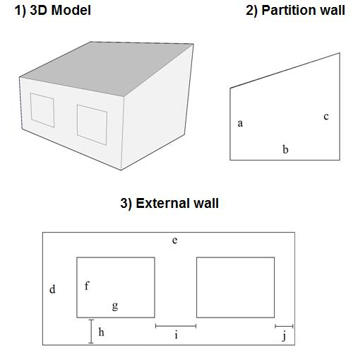

a = 3.658 m, b = 6.983 m, c = 5.852 m, d = 3.658 m, e = 8.593, f = 2.4 m, g = 2.6 m, h = 0.613 m, i = 1.83 m, j = 0.601 m

Fig. 10(x, y & z): Zone geometry and dimensions.

3. Zone properties

Note: This is a lumped capacitance model and thus thickness weighted average for density and specific heat capacity were used for walls. In the case of floor, due to under -floor heating each layer of the floor was modelled separately and thickness weighted average was not used.

Table 1: Properties of the building structural elements

Element | U - Values | Thickness m | Length | average ρ | average c_{p}
External wall | 0.142 | 0.385 | 8.593 | 558.701 | 1050.39
Partition wall | 2.3 | 0.166 | 13.966 | 1274.7 | 1000
Internal wall | 2.81 | 0.153 | 8.593 | 1332.03 | 1000
Floor |  | 0.31 |  | 1796.25 | 1012
Roof | 0.12 | 0.31 |  | 195.16 | 1375.74
window | 1.88 | 0.024

The floor is modelled in more detailed that the other elements thus individual layer properties are as follows:

Table 2: Properties of the construction layers of the floor (outside to inside)

Material | Thickness (m) | K, (W/m K) | ρ (Kg/m³) | Cp (J/kg K) | U value (W/m²K) | category
Screed | 0.065 | 0.41 | 1200.0 | 840.0 | 6.31 | Screed and renders
EPS SLAB | 0.035 | 0.035 | 25.0 | 1400.0 |  | Insulating materials
Concrete | 0.2 | 1.63 | 2300.0 | 1000.0 | 8.15 | concretes

