Approaches to supporting Open Educational Resource projects
R. John Robertson¹, Sheila MacNeill¹, Phil Barker^{2,} Lorna Campbell¹ and Li Yuan³

¹Centre for Academic Practice and Learning Enhancement, University of Strathclyde, ²Institute for Computer Based Learning, Heriot-Watt University, ³Institute for Cybernetic Education, University of Bolton

robert.robertson@strath.ac.uk, s.macneill@strath.ac.uk, lmc@strath.ac.uk, L.Yuan@bolton.ac.uk, philb@icbl.hw.ac.uk

Abstract
This paper examines CETIS experience of supporting a nationwide programme to release Open Educational Resources (the JISC Higher Education Academy UKOER Pilot Programme). We consider how our model of support could inform others and be adapted to encourage sustainable technical support networks for Open Course Ware initiatives. As a national initiative involving universities throughout the UK, the UKOER programme involved a diverse range of OER providers, including individual educators, discipline-based consortia and institutions. Given this diversity it was recognised from the outset that no single technical solution would fit all projects, and therefore no specific tools, descriptive standards, exchange or dissemination mechanisms were mandated (apart from a requirement that the resources produced be represented in a national repository of learning materials). In supporting this programme we have had to address diverse approaches and communities and it is likely that any similar pan-institutional initiative for supporting the release of OERs would face similar challenges.

Our approach to programme support has sought to move from the detail of specific support issues towards underlying support principles; thereby anticipating other issues and promoting good practice.

Our method has been: to provoke conversation through technical presentations and discussion opportunities at meetings or through blog posts; to investigate the technical choices made by individual projects through technical review conversations and record summary details of these conversations publicly online through an interface supporting searching and browsing; and to respond to issues arising from these calls or from project blogs.

In considering how this approach could be used more widely we will look at the challenges of working openly, the organisational overhead of this approach, its adaptability, and the role we think it has played in supporting the management and dissemination of OERs for this programme.

Keywords
UKOER, Project support, OER Communities

Introduction

Programme Scope
The Open Educational Resources Programme is a collaboration between the JISC and the Higher Education Academy in the UK. The Higher Education Funding Council for England (HEFCE) has provided an initial £5.7 million of funding for 29 pilot projects, plus associated support activities, (April 2009 to March 2010) which will explore how to expand the open availability and use of free, high quality online educational resources. The programme will support universities and colleges in exploring processes and policies, intellectual property rights, cultural issues, technical requirements and data management issues associated with the release of existing resources as OERs.

The UK OER programme consists of 29 pilot projects divided into three categories: individual (i.e. personal) projects (8); institutional projects (7) and multi-institutional subject-based consortium projects (14). Along side the 29 pilot projects, support for the programme is being provided by a number of existing JISC services and the Open University (UK) Score project.

This paper will describe the model for technical support provided by JISC CETIS, discuss the key issues raised and outline potential models for supporting future work in this area.

JISC CETIS is one of three JISC Innovation Support Centres (ISC). CETIS’ core remit is to provide advice to the UK Higher and Post-16 Education sectors on the development and use of educational technology and standards. It does this through a number of channels including participating in standards bodies, providing community forums for sharing experiences in using particular technologies and standards and through providing specific support for JISC funded development programmes such as the UKOER programme.

The model of support provided by CETIS for the UKOER programme is based on support models provided to other JISC development programmes. The approach is based around providing a high level overview of the technical approaches, technologies and standards in use across funded programmes. Synthesis, reflection and recommendations for future areas of development can then be produced for a variety of stakeholders.

Programme opportunities / support challenges
Unlike many development programmes, where use of specific technologies and educational standards is central, the UKOER programme took a very open approach to the use of technology and standards. There were no mandated descriptive standards or exchange mechanisms and projects were free to choose the delivery platforms, tools or technologies that best suited them.

Technical guidance for the programme was provided by CETIS, particularly in relation to resource description. (Campbell 2009). A basic set of descriptive requirements was mandated, and the use of syndication for delivery of content was strongly encouraged. Projects also had to agree to deposit all OERs created through the programme into JorumOpen, the UK national repository of teaching and learning materials.

It was felt that this approach would give projects the greatest flexibility to create and disseminate OERs. It also provided an opportunity to assess the effectiveness of a wide variety of approaches without artificial, potentially unsustainable restraints.

The programme also provided a catalyst for the launch of the new JorumOpen service. Previously use of the Jorum repository had required subscription and license agreements.

A programme support plan was created involving a number of existing JISC services and the OU (UK) Score project. This facilitated support for legal, technical and community issues. The support functions were coordinated by JISC programme managers. Many of the key people involved in the support project had previously established working relationships. This was particularly useful for ensuring that there were clear lines of communication between support partners, JISC programme managers and projects.

Support Functions
CETIS provided a number of support functions to the programme. In terms of its wider Innovation Support Centre role, CETIS was involved in the scoping of the programme and providing a rationale for the overall technical approach. CETIS staff were also involved in the project selection process.

During the programme lifecycle, the main role for CETIS was to provide technical support and guidance to the programme, particularly in the area of resource description and general discoverability of resources. CETIS attempted to itemise the individual support functions with the following verbs: steer (the programme development), gather (information from projects), enable (projects to achieve their goals), inform (projects), review and collate (information about the projects' technical choices), connect (projects to each other and other initiatives), represent (the programme to other initiatives), disseminate (information about the programme), and synthesise and critique (the findings from the projects). The following section will describe in detail how this was carried out.

Chosen Approaches

Overview
The support provided by CETIS for the UKOER programme involved engagement with the programme as a whole and with projects individually. Issues that emerged in conversations with individual projects were developed into advice for the whole programme. Emerging common concerns were shared through various disseminations channels including wider programme support team discussions. Notes from conversations with projects were published online and made cross-searchable. These notes subsequently formed the basis for our technical synthesis of the programme. This section provides some more details of the infrastructure CETIS utilized and the support functions to which it relates.

Programme development
Tools used: teleconferencing, email, CETIS blogs, presentations
Support functions: Steer, Inform

During the scoping of the programme CETIS provided advice to JISC on the possible approaches to managing and releasing OERs that the programme could take. This led to a number of blog posts providing the wider community with more information about the technical and resource description requirements of the programme. For example, Campbell (Technical, 2009).

This scoping work was followed by a presentation at the programme briefing day and further blog posts as projects began to consider the approaches they could take. For example, Campbell (Metadata, 2009).

Communicating with Projects
Tools used: Twitter, email, project blogs, newsreaders, Yahoo Pipes, meetings, online conferencing tools.
Support functions: Gather, Inform, Enable

As part of building the wider programme support communication infrastructure there was a general requirement to build and support a number of communication channels.

This involved participation in a number of programme-level activities such as programme meetings, monthly online conferences, and the use of email lists. JISC set up email lists for each strand of projects (individual, institutional, and subject-based consortium) which were restricted to projects and support services. Later in the programme a master list was also set up for all projects and services. This list however, has mainly been used for announcements or news – discussions have remained on the strand lists.

The programme also encouraged the use of Twitter (through specifying a tag #ukoer) and project blogs. Although Twitter users may only represent a portion of the programme it has provided an effective backchannel of information around events and has been a useful way to quickly publicize relevant news. Project blogs were adopted by some projects and a good proportion of those adopters developed quite open working practices, blogging about issues they were discussing and having project discussions online through blogs and comments.

The use of blogs by projects also meant that support services or other projects could use feed readers to monitor the project blogs without visiting all of them. The JISC programme manager for the institutional strand projects (who were largely early adopters of the use of blogs) created a public Netvibes page with the feeds from project blogs. This created a web-based view of the latest news from projects that was available through any web browser .

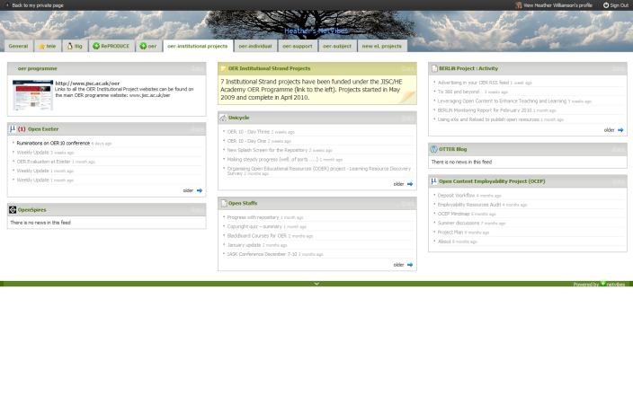
Figure 1: RSS feeds from project blogs in Netvibes

Using Yahoo Pipes, CETIS created a number of custom feeds to filter the combined feeds from the project blogs for particular keywords (such as metadata). Although initially effective, as the projects progressed, their use diminished as the wider value of being aware of all of the posts from the projects increased. However, we believe the ability to easily build custom feeds is useful.

Technical Review Calls
Tools used: Teleconferencing, Skype, Email, PROD (online database)
Support functions: Review, Enable, Inform, Collate, Connect

A key part of CETIS’ direct support for the programme was the technical conversations with projects. Based on the brief description of standards and technologies in project plans, these calls allowed more detailed information about the choices being made by the projects to be recorded.

Calls with each of the 29 projects were arranged by email. Prior to the call, information from the project plan was entered into PROD – CETIS’ online database for recording technical information about projects.

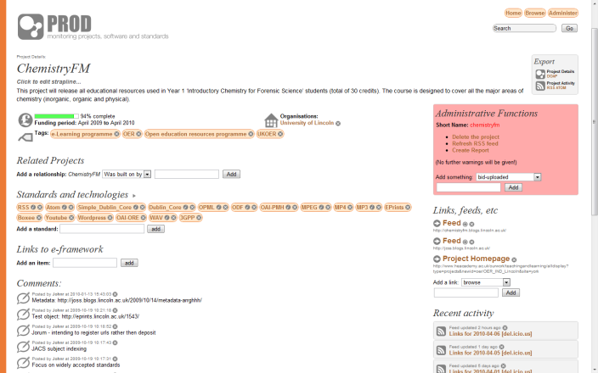
Figure 2: the PROD Interface

Calls typically consisted of two CETIS staff (in different locations) and two or more project staff (often also geographically dispersed). The calls were generally held using a teleconference service. Skype was used occasionally but for multiple participants – sometimes on home, rather than institutional, broadband – the audio quality of Skype hindered the call. One feature of Skype which did prove useful, was the ability to share links in the chat window. When using the teleconference service links were often shared by email, which sometimes resulted in delays. During the calls the CETIS support officer updated the project entry in PROD as the conversation progressed. Many of the conversations produced useful qualitative information and this ensured precise capture of the relevant points. Projects were also able to view and comment on the recorded statements.

PROD entries comprise: descriptive information about each project (programme, partners, websites, feeds, and related projects); information about the technical approaches used (standards, specifications, web2.0 applications, tools, transport protocols, audio and video formats); and free text comments used to record further details about the use of the aforementioned standards and technologies and to record other information about the projects such as the granularity of OERs they are releasing and how they intend to deposit or represent their OERs in JorumOpen.

The calls also provided an opportunity for CETIS staff to encourage technical connections between projects where appropriate and to point out other relevant work. For example, making sure that those producing RSS feeds knew about some of the aggregator services for which could consume and disseminate their feeds.

Following up specific issues
Tools used: email, teleconferencing, CETIS blogs
Support functions: Enable, Review

If particular issues emerged in the course of a technical review call that could not be quickly resolved during the call or if projects blogged about troublesome technical issues, the support team was able to follow these threads up by email or phone call and provide specific advice or suggestions if required. Such issues were also occasionally relayed by programme managers or emerged from the interim progress reports projects provided to JISC.

Typical issues included commenting on application profiles, advising about granularity, and making connections to help projects work through detailed technical support issues.

Ongoing Advice
Tools used: online conferencing, CETIS blogs, CETIS conference.
Support functions: Inform, Enable, Connect, Gather.

Throughout the programme several mechanisms were used to gather feedback from projects, provide ongoing advice about best practice, and highlight areas of work and support under development. CETIS ran two of the scheduled monthly online meetings, hosted using the Elluminate online conferencing tool. The first of these sessions focused on metadata and resource description and the second on resource tracking. These meetings consisted of a presentation, gathering feedback on issues raised through synchronous polls, and text and voice conferencing. The slides from the presentations used in the online conferences are available (Barker, 2009 and 2010).

In addition to these meetings, and building on particular support issues of relevance to the wider programme, and indeed the wider community, CETIS continued to provide advice by blogging about these emerging issues. This builds on an established CETIS practice of blogging on topical technical issues.

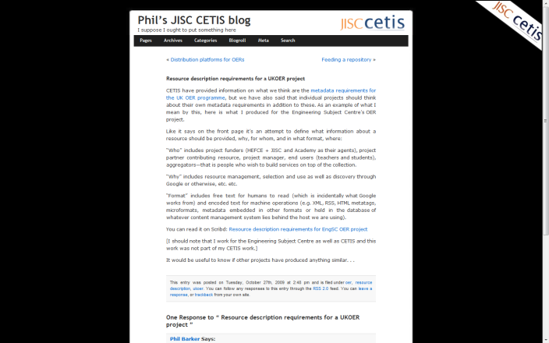
Figure 3: Phil’s JISC CETIS blog

A further point of engagement with the programme was through a workshop session run at the CETIS 2009 conference. This session gathered key issues from projects and subsequently led to blog posts from CETIS and the projects involved. A backchannel for the workshop session was provided by using Twitter, the questions emerging were recorded and blogged unedited immediately (Robertson, Conference, 2009) with a synthesis posted subsequently (Campbell, Roundtable, 2009).

Representing and Promoting
Tools used: PROD
Support functions: Represent, Disseminate

By analysing technical review conversations and ongoing engagement with projects CETIS has been able to gather a comprehensive overview of the technical choices made across the programme. This has enabled CETIS to present an overview of the technical approaches to other interested communities (Robertson, MIT, 2009) and to represent technical issues emerging across the programme to funders such as JISC and to other support services such as JorumOpen.

Synthesis
Tools used: PROD, CETIS blogs, presentations, CETIS wiki.
Support functions: Disseminate, Synthesis, Critique.

As the programme draws to an end CETIS are drawing together information stored in PROD and the blogs about the use of particular standards and technologies in the programme. This information and other relevant references (e.g. relevant blog posts) are being gathered on the CETIS wiki as the first stage of the technical synthesis of the programme. A series of more reflective blog posts will be produced, in addition official documentation including a final project report that will include recommendations for similar programmes in the future. The vast majority of this information, will be freely available to the wider community.

Early reflections on process
As outlined earlier the UKOER programme allowed projects a great deal of flexibility in choosing their technical infrastructure and approaches to resource description. As is described more fully in Robertson et al., (2010) there has been a great deal of diversity in the strategies adopted by projects. This enables the technical synthesis of the programme to explore the affordances of these different approaches and inform any future work in this domain. At this stage it appears all the projects have developed technical approaches that allow them to manage and distribute their materials successfully.

Assessing the effectiveness of the support provided and evaluating how the model might be used elsewhere is of course a different question. CETIS have received positive feedback throughout the programme however, in the context of this paper and presentation, we believe that there is more value in reflecting on what support has actually been provided in relation specific functions and what could or could not be done without a similar model of dedicated programme support.

Steer
The support provided was integrated with the initial scoping of the programme and the technical approach taken. At this stage it appears that the planned approach has worked for the projects and has provided the ouputs the programme sponsors required.

Some support could have been provided without a dedicated project as expertise could be called in as required but this would have additional cost implications. The support project adds an element of continuity in that the expertise that shaped the call continues to be involved in the programme and is able to clarify, reiterate and explain.

Gather
The support provided was to gather information from the individual activities that fed directly into other functions, namely: Inform, Enable, Review, Connect

The widespread use of Twitter and blogs throughout the programme has created an interactive environment for spontaneous discussion and dissemination. This has two drawbacks however. Firstly much of the conversation on Twitter is, to a degree, transitory – in a way that email is not. Secondly, projects and individuals not actively engaging with Twitter of email may be left out of the loop and feel somewhat disengaged from the wider programme.

This function may have been possible without the support project, if communication channels between the projects were used so that projects could become aware of each other’s work. However, technical conversations are more likely to be shared publicly if the informant thinks there is someone “listening” with an active interest. The support project adds active and informed engagement with channels of communication.

Enable
The support provided was:
- all technical questions raised in project interim reports followed up;
- two online and one face to face conference sessions facilitated;
- all relevant conference sessions and briefing days amplified (through twitter coverage and blog commentary);
- blog posts connected to the programme.

This may have been possible without a support project if expert consultants were called in for specific events, though there would be associated cost implications. Projects could, and do, amplify events and write and blog about their work and wider issues. However a dedicated support model allows for more objective commentary.

Although CETIS has considerable expertise in the domain of metadata for learning materials, for some of the innovative approaches adopted by projects in areas around Search Engine Optimization and the APIs for particular Web2.0 applications we have been learning along with the projects. As the projects have progressed, we have been able to help them disseminate and share their experiences and new-found expertise. In this way the support project adds continuity of advice, accumulation of expertise, as well as a consistent bigger picture view, and dedicated time to blog and disseminate.

Inform
The support provided was to inform projects about relevant services, applications and technical developments. The challenge is knowing what is relevant and worth disseminating.

This would only have been possible without a support project if there was particularly active community engagement from the projects within the programme, with suitable channels to facilitate this engagement, and if the projects developed an awareness of what was happening outside the programme. Even then it is likely there would be an increase in the signal-to-noise ratio. The support project adds dedicated resource and staff who are aware of “the bigger picture” and have a programme-wide technical overview.

Review and Collate
The support provided was:
- Technical review conversations held with all the projects.
- Further email exchanges and calls about particular issues.
- Blog posts connected to the programme.

The challenges faced were the administrative overhead of coordinating the technical calls with projects and the chronological spread of the technical review calls. Some calls took place at the beginning of the programme and some towards the end.

This would have been difficult without central co-ordination and a system such as PROD. A technical peer review process could be used, but again there would need to be clear ways to co-ordinate outputs. The support project adds, dedicated tools (e.g. PROD) and provides the dedicated time necessary to complete the task.

Connect
The support provided was to connect projects using similar technological choices. The main challenge was the time lag between technical review calls. Some connections could only me made later in the programme.

To some extent this may have happened without a support project, as projects met serendipitously, however this would need very active community engagement from the projects. A support project adds a central overview and awareness of what is going on across the programme with dedicated staff looking for and making connections.

Represent
The support provided was to liaise with service providers in the OER field, both within the UK and further a field, and to inform them about the activities and concerns of the projects within the UKOER programme.

Without a support project it is unlikely that any individual project would have had a similar influence. The support project adds an objective programme level overview and a recognised point of contact with a program wide remit.

Disseminate
The support provided took the form of presentations given at a number of high profile national and international, scholarly publications, and blog posts connected to the programme.

It is unlikely that any similar level of programme-wide technical synthesis and dissemination would have occurred without a support project. Again, the support project provided an objective programme level overview and a recognised point of contact with a program wide remit.

Synthesise and critique
The support provided was through web based resources, guidance and PROD entries. (Note: a separate general synthesis and evaluation project has been funded to accompany the UKOER programme.)

Without a support project the only realistic way to achieve a programme level technical synthesis would be to commission consultants to undertake one. Having a support project adds continuity throughout the programme lifecycle and specialist technical support for the general synthesis and evaluation project.

General issues, conclusions and open questions

Cost
Despite utilizing existing services and projects, providing a support project such as the one in place for UKOER does have financial implications. Although the costs involved in running support services are mostly staff related (as the infrastructure used was either free or already in place) the service is provided at a cost equivalent to that of another project releasing OERs.

However CETIS, and the programme funders, believe that the value added by a dedicated support project provides a number of valuable outputs and outcomes for the programme to balance forgoing one extra development project. It could also be argued that providing central support is more cost effective than individual projects seeking (and often paying) for similar advice and guidance.

Challenge of openness
The UKOER projects, support projects, and participating institutions have wrestled with the process of applying their understanding of what it means when to make content available under an open licence. Alongside this struggle with open licensing, some projects have engaged with the challenges around working openly. Some projects have embraced the use of blogs as a mechanism to publicly think through some of their project issues; others, however, have engaged with blogs more as a way to disseminate news. Both uses are valuable, but from the point of view of providing support the former is invaluable.

It is undeniable that programmes and projects need private space to discuss issues and the programme has provided a number of fora for this including closed email lists. Although projects can use blogs for public discussion it is surprising that no public list for the discussion of issues around Open Education has been created by the programme.

Open Questions
In many respects, the experimental nature of the UKOER pilot programme has meant that everyone involved has been on a journey of discovery and in many cases almost as many questions have been raised as answered. However, some of the key questions particularly related to our support role and the technical aspects of creating and sharing OERs are summarised below.
- Has the programme enabled a change of culture and practice to allow the facilitated release of OERs by UK HE institutions without seed funding?
- Is more centrally provided funding needed?
- If so, what are the key areas for development?
- How can we ensure that the lessons and experiences of this programme are effectively shared with the wider OER community?
- Is it possible to maintain and grow the sense of community fostered through the programme beyond the funding period without some kind of dedicated co-ordination?

Once the programme has concluded further synthesis will hopefully start to address some of these questions and provide recommendations for moving forwards.

References
Barker, P. and Robertson, R.J. (2009). Metadata and Content Aggregation for UKOER. Accessed 3rd April 2010. Available from: http://www.slideshare.net/philb/metadata-and-content-aggregation-for-ukoer
Barker, P., Robertson, R.J. and Campbell, L. (2010). Resource Tracking for UKOER Accessed 3rd April 2010. Available from: http://www.slideshare.net/philb/resource-tracking-for-ukoer
Campbell, L. (2009). Metadata Guidelines for the OER Programme. Lorna’s JISC CETIS blog. Accessed 3rd April 2010. Available from: http://blogs.cetis.ac.uk/lmc/2009/03/30/metadata-guidelines-for-the-oer-programme/
Campbell, L. (2009) OER Programme Technical Requirements. Lorna’s JISC CETIS blog. Accessed 3rd April 2010. Available from: http://blogs.cetis.ac.uk/lmc/2009/02/03/oer-programme-technical-requirements/
Campbell, L. (2009) Orders from the Roundtable Lorna’s JISC CETIS blog. Accessed 3rd April 2010. Available from: http://blogs.cetis.ac.uk/lmc/2009/11/13/orders-from-the-roundtable/
Robertson, R.J, (2009) JISC and MIT: comparing notes on ed tech. John’s JISC CETIS blog. Accessed 3rd April 2010. Available from: http://blogs.cetis.ac.uk/johnr/2009/12/11/jisc-and-mit-comparing-notes-on-ed-tech/
Robertson, R.J. (2009). Technical challenges for managing Open Educational Resources. John’s JISC CETIS blog. Accessed 3rd April 2010. Available from: http://blogs.cetis.ac.uk/johnr/2009/11/13/technical-challenges-for-managing-open-educational-resources/
Robertson R.J., Campbell,L., Barker, P., Yuan,L. and MacNeill, S. (2010) One Standard to rule them all?: Descriptive Choices for Open Education. Proceedings of OCWC Conference (2010)

http://www.jisc.ac.uk/oer
http://jorum.ac.uk/
http://www.jisc.ac.uk/whatwedo/programmes/elearning/oer/support.aspx
http://www.netvibes.com/hwilliamson#oer
http://PROD.cetis.ac.uk

