FULL PAPERS
Final submission of paper published in ChemPhysChem 10(9-10): 1492-1499. DOI: 10.1002/cphc.200800759

Optical spectroscopic methods for probing the conformational stability of immobilised enzymes
[a] Dr. A. Ganesan, Dr. B. D. Moore, Dr. I. R. Dunkin, Dr. P. J. Halling WestCHEM, Department of Pure and Applied Chemistry
University of Strathclyde
295 Cathedral Street, Glasgow G1 1XL (United Kingdom)
Fax: (+44)141-548-4822
E-mail: p.j.halling@strath.ac.uk
[b] Dr. A. Ganesan, Dr. B. D. Moore
XstalBio Limited
University Avenue, Glasgow G12 8QQ (United Kingdom)
[c] Dr. S. M. Kelly, Dr. N. C. Price
Division of Molecular and Cellular Biology, Faculty of Biomedical and Life Sciences
University of Glasgow
University Avenue, Glasgow G12 8QQ (United Kingdom)
[d] Dr. O. J. Rolinski, Dr. D. J. S. Birch
Department of Physics, SUPA
University of Strathclyde
107 Rottenrow, Glasgow G4 0NG (United Kingdom)
Ashok Ganesan,^{[a, b]} Barry D Moore,^{[a, b]} Sharon M. Kelly,^{[c]} Nicholas C Price,^{[c]} Olaf J Rolinski,^{[d]} David J S Birch,^{[d]} Ian R Dunkin,^{[a]} and Peter J Halling*^{[a]}

We report development of biophysical techniques based on circular dichroism (CD), diffuse reflectance infrared Fourier transform (DRIFT) and tryptophan (Trp) fluorescence to investigate in situ the structure of enzymes immobilised on solid particles. Their applicability is demonstrated using subtilisin Carlsberg (SC) immobilised on silica gel and Candida antartica lipase B immobilised on Lewatit VP.OC 1600 (Novozyme 435).
SC shows nearly identical secondary structure in solution and in the immobilised state as evident from far UV CD spectra and amide I vibration bands. Increased near UV CD intensity and reduced Trp fluorescence suggest a more rigid tertiary structure on the silica surface. After immobilised SC has been inactivated by use in acetonitrile, these techniques reveal: a) almost complete loss of near UV CD signal, suggesting loss of tertiary structure; b) a shift in the amide I vibrational band from 1658 cm⁻¹ to 1632 cm⁻¹, indicating a shift from α-helical structure to β-sheet; c) a substantial blue shift and reduced dichroism in the far UV CD, supporting a shift to β-sheet structure; d) strong increase in Trp fluorescence intensity, which reflects reduced intramolecular quenching with loss of tertiary structure; and e) major change in fluorescence lifetime distribution, confirming a substantial change in Trp environment. DRIFT measurements suggest that pressing KBr discs may perturb protein structure. With the enzyme on organic polymer it was possible to obtain near UV CD spectra free of interference by the carrier material. However, far UV CD, DRIFT and fluorescence measurements showed strong signals from the organic support. In conclusion, the spectroscopic methods described here provide structural information hitherto inaccessible, with their applicability limited by interference from, rather than the particulate nature of, the support material.

Introduction
Enzymes immobilised on surfaces such as particles, films or coated on electrode surfaces find a wide range of applications from biosensors to biocatalysts.^{[1-3]} The utility of an enzyme in a given process is guided by its conformational stability on the surface of carrier. This in turn is governed by numerous factors such as the surface nature of the support material, cross linkers, stabilizers, ionic strength, etc. Usually the conformational stability of the surface bound enzymes is evaluated from their catalytic activity alone, as it is technically not possible to probe their secondary and tertiary structures. Although, extensive studies of activity have been carried out over the last few decades, our understanding of enzyme conformation in the immobilised state is limited. For example, why are some enzymes active on specific carriers while others are not? What are the forces that govern the structural integrity? It is the aim of this research to develop physical (spectroscopic) methods that can directly probe the folded structure of immobilised protein molecules.
The lack of structural information is often a hindrance to the application of an enzyme preparation to a specific process. This is more so in the case of biotransformation, where operational stability is the key factor that determines the use of an enzyme in a catalytic reaction. Industrial biotransformation employing an enzyme either in whole cells or in an isolated state is continuing to burgeon as an alternative route for manufacturing fine chemicals, pharmaceuticals and chiral molecules largely due to its high selectivity and catalytic turnover.^{[4]} Often it is preferable to use enzymes in immobilised form, particularly to allow easy recovery and re-use^{[3]}; however, the application of enzymes in biotransformation is limited by their lack of operational stability under the conditions of use. Because operational stability is often crucial to the economics of biotransformation it is vital to obtain good performance. Many biocatalyst preparations show such poor stability that an application has to be abandoned as unfeasible at an early stage. In the case of poor stability, the usual practice is to carry out empirical screening in an attempt to improve catalytic output. This is because rational identification of how to improve stability is usually impossible, as the mechanism of inactivation is not known. If the mechanisms were known, identification of approaches to improve stability would be much easier. For example, if an inactivating agent has been identified, methods to remove or destroy it in the feed can be designed, or protein engineering can eliminate the target site. Cross-linking the enzyme molecules could in principle reduce instability due to conformational perturbation. Covalent changes involving glycation, disulphide bond formation and peptide cleavage may be eliminated if prior knowledge of their occurrence is available.
In spite of its importance, our knowledge of enzyme conformation in the immobilised state is limited due to the lack of analytical tools that could be applied to large particulate systems in situ. Enzyme structure in solution can be studied using a plethora of techniques such as circular dichroism (CD), fluorescence, Fourier transform infrared (FTIR), Raman optical activity and nuclear magnetic resonance spectroscopies.^{[5-9]} Application of these methods to biocatalyst particles has limitations that require a thorough examination. Firstly, the large particulates of the order of tens to hundreds of microns in diameter contribute significant artefacts due to light scattering, making applications of optical spectroscopic methods difficult if not impossible. Secondly, the carrier materials themselves may introduce background signals due to absorption of the incident radiation, which masks the structural information from the sample. Finally, even if these parameters are optimised the signal to noise (S/N) ratio could be poor, requiring careful design of experiments. In this paper we report the development and applications of novel spectroscopic techniques based on CD, FTIR and intrinsic fluorescence spectroscopy to characterise the structural stability of enzymes immobilised onto particles typically employed in industrial processes. CD spectra of suspensions were measured by using a rotating cell holder to eliminate sample sedimentation and optimising the optical configurations to minimise artefacts due to scattering.^{[10]} Due to the opaque nature of the biocatalyst particles, the diffuse reflectance infrared Fourier transform (DRIFT) spectroscopy technique was employed for acquiring IR spectra. For measuring intrinsic fluorescence both front-face and 90° angle between excitation and emission light paths were employed. The suitability of these methods to probe enzyme conformations in the immobilised state was evaluated using: subtilisin Carlsberg (SC) immobilised onto silica gel particles, and Candida antarctica lipase B immobilised on acrylic resin Lewatit VP.OC 1600 (Novozyme 435).
Results and Discussion
Circular dichroism

CD spectra of proteins provide valuable information about secondary structure and are sensitive to tertiary structural changes. Previous literature on CD measurements of particulate systems was limited to proteins bound to nanoparticles and encapsulated into biomembrane fragments.^{[11-13]} In order to extend the technique for the first time to typical immobilised biocatalyst particles of tens to hundreds of microns in diameter, it was necessary to tackle artefacts associated with particulate sedimentation, differential light scattering and absorption flattening.^{[10]} Particles were kept uniformly dispersed in suspension in the light path using a specially constructed rotating sample cell holder. Differential light scattering was minimised by arranging to place the sample cell very close to the detector. Finally, a semi-empirical method was developed to correct for absorption flattening in the far UV, using the measured sample absorbance spectrum and a single adjustable parameter.
We first studied the CD spectra for our test system of SC immobilised on silica gel.^{[10]} The far UV and near UV CD spectra of SC in a free and immobilised state under various conditions are presented in Figure 1. In solution SC shows negative CD bands at 222 nm and 208 nm with a strong positive band at 190 nm typical of a α/β secondary structure fold that is in agreement with crystal structure data.^{[14]} The corrected CD spectra of SC immobilised on silica gel in buffer pH 7.8 is in agreement with the solution spectra. It should be noted that the far UV CD spectra of biocatalyst preparations reported here were corrected for absorption flattening effects using a single adjustable parameter which forces agreement at 220 nm, but then applies an appropriate correction to all the rest of the spectrum.^{[10]} The view that the secondary structure is essentially unchanged on immobilisation is further supported by the evidence from other spectroscopic methods (see below) and the finding that high catalytic activity is retained.^{[15]} Although the shape of the near UV CD spectrum was identical after immobilisation an increase in amplitude is noted throughout the spectral region. This increase in the chirality of the environment surrounding the aromatic residues Trp, Tyr and Phe in the immobiliseded state probably reflects the greater rigidity of the tertiary structure. Immediately after transferring into ACN of water activity (a_{w}) 0.76) the enzyme conformation essentially remained the same (the minor differences seen in the far UV spectra below 220 nm are due to difference in particulate scattering profile between aqueous and organic media) but the sharp intense Trp 113 band at 295 nm in the near UV CD suggests an even more rigid tertiary structure. The single Trp 113 of SC is solvent exposed in the native conformation (Figure 2) and it appears likely that, on switching to organic media, the environment around this residue changes contributing to enhanced spectral features. After 48 h use in this medium, whereupon almost no catalytic activity remained, the CD spectrum was greatly affected. There was almost no near UV signal, suggesting a complete loss of organised tertiary structure. On the other hand the far UV CD shows a reduced ellipticity with a shift in the negative band to 217 nm. This indicates that the enzyme conformation is transformed from predominantly α-helix in the native state to β-sheets in the inactive state.

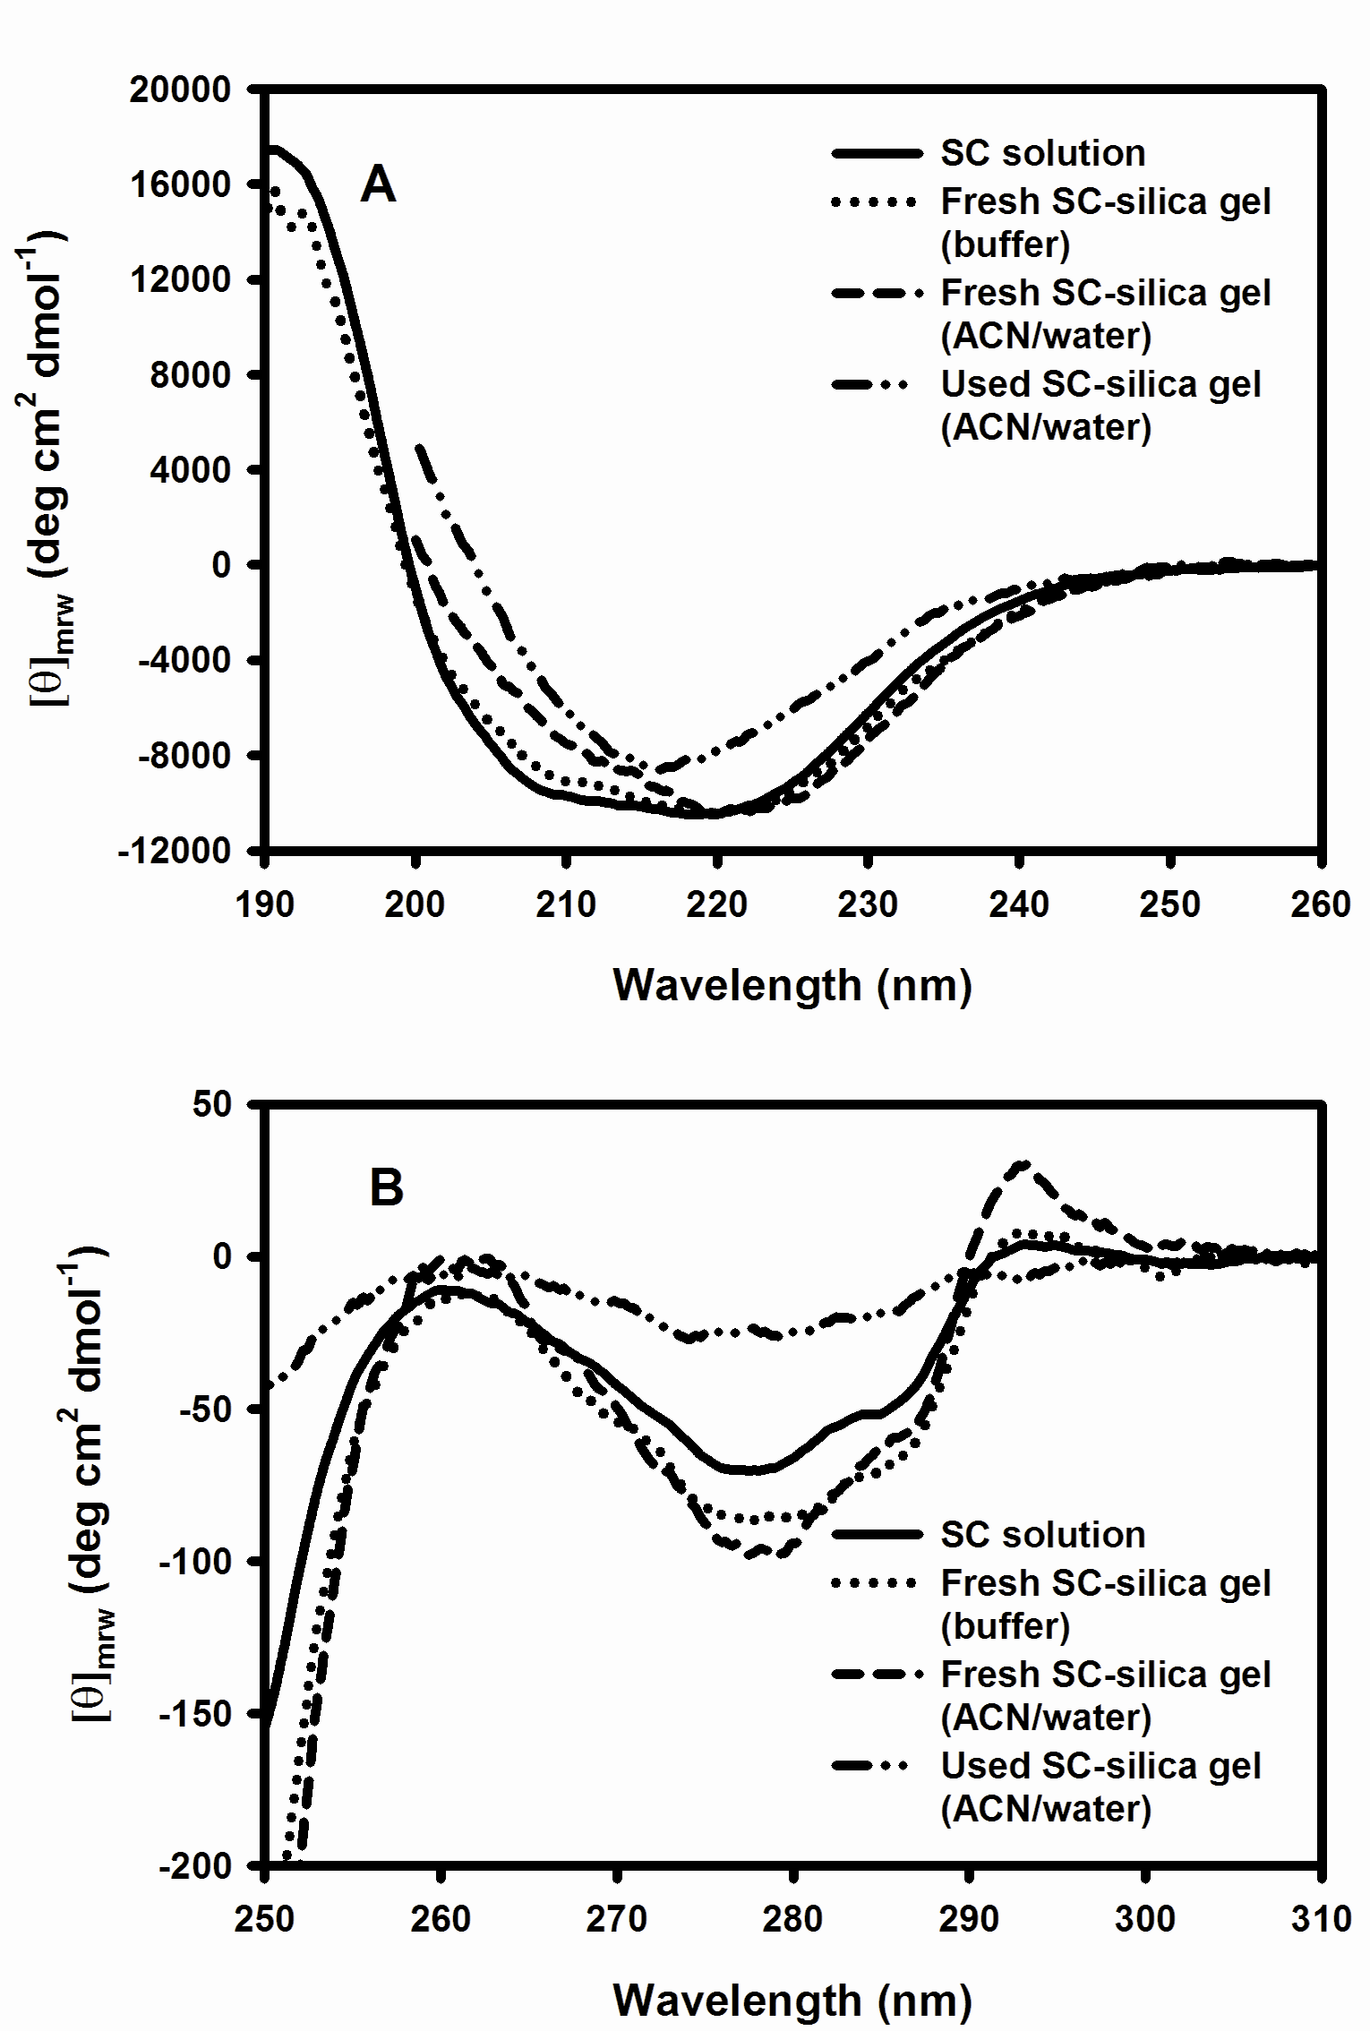

Figure 1. (A) Far UV and (B) near UV CD spectra of SC solution and SC-silica gel suspended in 50 mM Na phosphate buffer pH 7.8 and in ACN/water (a_{w}=0.76). Note the used SC-silica gel was collected from a packed bed reactor after inactivation in organic media for 3 days.

After optimising the methodology we proceeded to investigate the suitability of CD for analysis of industrial grade biocatalyst particles, i.e. Novozyme 435. Figure 3 illustrates the near UV CD spectra of Novozyme 435 in dry cyclohexane. We were unable to measure the far UV CD spectra of this preparation due to strong interference from the carrier material, Lewatit VP.OC 1600, used to immobilise C. antartica lipase B. The polymer support material exhibits dichroism with intense spectral signatures below 250 nm, overlapping the enzyme CD spectra (data not shown), and making structural analysis impossible. However, the near UV CD region was free of polymer absorption and the spectra observed are due to protein bands. Comparison of the C. antartica lipase B solution spectra with that of Novozyme 435 suspended in dry cyclohexane indicates the tertiary structure is altered. Interestingly, mass spectra analysis of the enzymes desorbed from Novozyme 435 indicates the C. antartica lipase B is heavily glycosylated and the sample is heterogeneous in nature.^{[16]} It is not clear whether this has an effect on the enzyme structure.

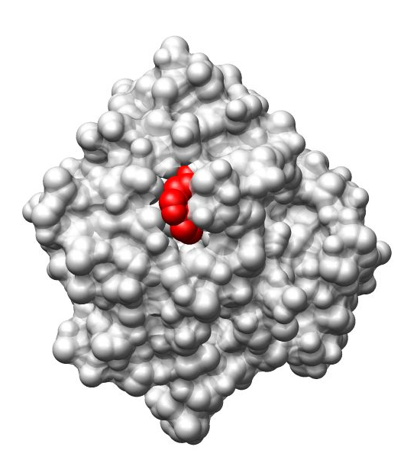

Figure 2. Space fill model of SC showing the solvent accessible single Trp 113 residue (red colour) on the enzyme surface. The molecular graphics image was generated from the atomic co-ordinates (PDB file: 1SBC) using the UCSF Chimera package from the Resource for Biocomputing, Visualization, and Informatics at the University of California.

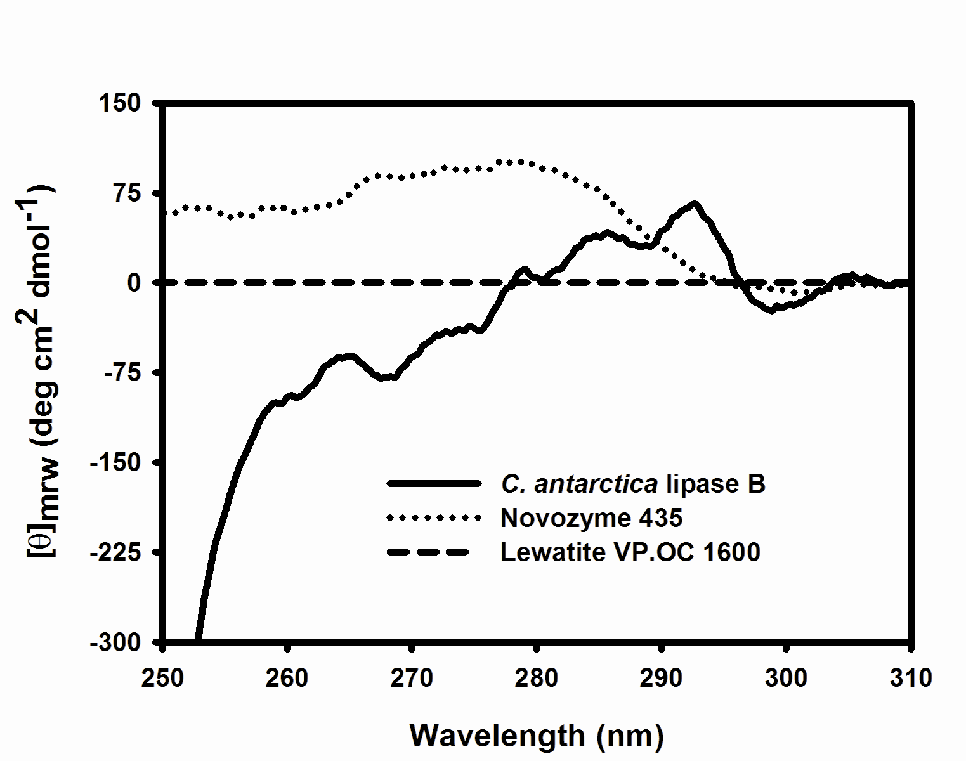

Figure 3. Near UV CD spectra of free C. antarctica lipase B in 50 mM Na phosphate buffer pH 7.8 and after immobilization onto acrylic resin Lewatit VP.OC 1600 (Novozyme 435) suspended in dry cyclohexane. Note the reference spectra of the carrier Lewatit VP.OC 1600 was measured as a suspension in dry cyclohexane.

Diffuse reflectance infrared Fourier transform spectroscopy

Infrared vibrational spectroscopy is another important structural tool for characterising protein conformations in solution, solid state and as suspensions.^{[7,17-19]}. The amide groups in proteins give rise to a total of nine vibrational bands that are classified on the basis of the frequency associated with specific vibration. Of all the bands only the amide I and amide III are sensitive to protein conformation and provide direct information on the secondary structure. In this study we restrict ourselves to the amide I band since strong interference from carrier material below 1300 cm⁻¹ rendered it impossible to measure the amide III band. The amide I band between 1600-1700 cm⁻¹ is primarily due to C=O stretching, coupled slightly with CN stretching, CCN deformation and NH bending. The C=O stretching frequency is sensitive to the H-bonding associated with it, which in turn is determined by the secondary structure such as α-helix, β-sheet, β-turn and random coil. Thus, changes in amide I peak maximum, intensity, shape and width are usually indicative of structural stability. The assignment of amide I frequencies for different structural classes is as follows: bands in the region 1675-1695 cm⁻¹ are due to antiparallel β-sheet, 1660-1670 cm⁻¹ is indicative of 3₁₀-helix, bands in the 1648-1660 cm⁻¹ region are due to α-helix, 1640-1648 cm⁻¹ to unordered structure, 1625-1640 cm⁻¹ to parallel β-sheet and those in the region 1610-1628 cm⁻¹ to aggregated β-sheet.^{[7,17]}

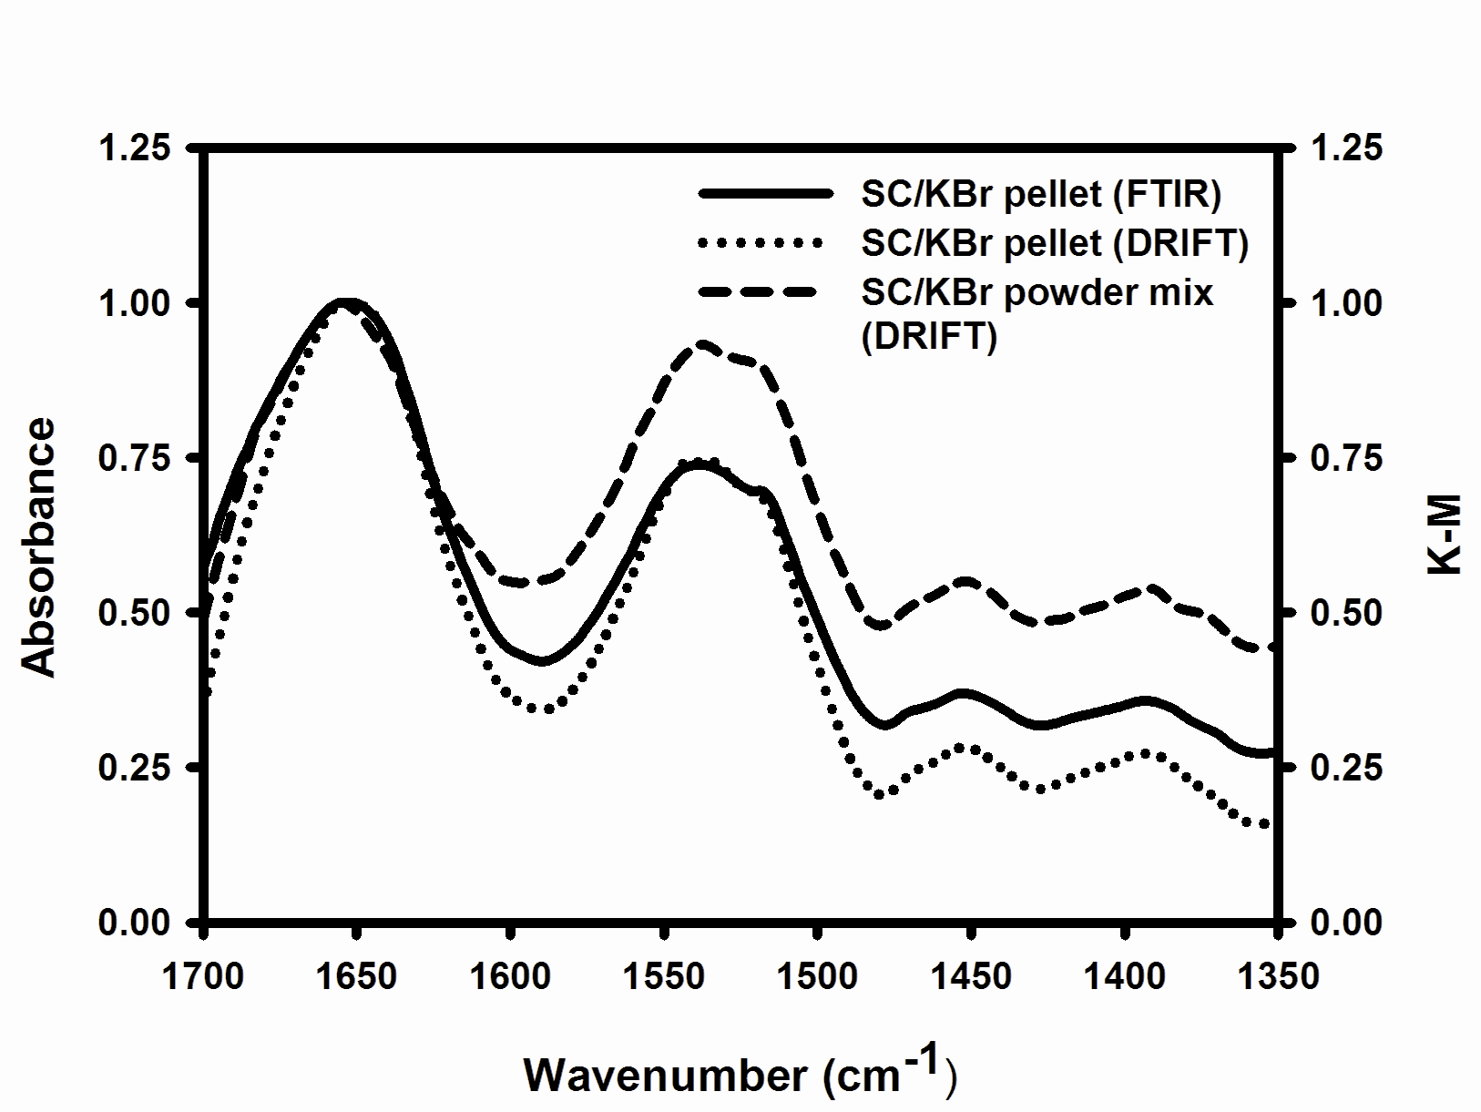

Figure 4. Influence of sample preparation and experimental methods on the infrared spectra of lyophilised SC. The infrared spectra of finely ground SC/KBr powder mixture acquired using DRIFT technique is compared with the transmission mode FTIR and DRIFT spectra of SC pressed into KBr pellets. Note the y-axis on the right represents Kubelka-Munk (K-M) units derived from the percentage reflectance of the samples analyzed using DRIFT technique.

Figure 4 shows the influence of sample preparation and measurement method on the amide I and amide II bands of lyophilised SC. The transmission spectrum was acquired using a pressed SC/KBr pellet of 10 mm diameter and ~1 mm thickness. Subsequently, this pellet was mounted on the top of the DRIFT sample cup and reflectance spectra were measured. The resulting spectra from both these measurements were similar; with amide I band maxima ~ 1655 cm⁻¹ in agreement with literature.^{[19]} This indicates that spectral acquisition employing the DRIFT method has little influence on the measurement outcome. Having confidence in the technique, we proceeded to study DRIFT spectra of the same lyophilised SC preparation simply mixed with finely ground KBr. The peak maxima were identical to the SC/KBr pellet but the amide I/II ratio was found to be lower. In peptides and proteins the intensity ratio of the amide I/II band is reported to show high sensitivity to backbone orientation in films or membrane that can also be affected by conformational perturbation and experimental methodology e.g. transmission or reflectance optics employed for spectral acquisition.^{[20,21]} Since the amide I/II intensity ratios of the SC/KBr pellet analyzed using transmission FTIR and DRIFT are identical we conclude these differences are not due to the difference in experimental methods. This led us to address the question of whether subjecting protein to pressure compression during the KBr pellet formation affects the structural stability. Previous literature on this topic is mainly focused on the shifts in amide I band of protein KBr powder mixtures before and after pressing into KBr pellets, which suggests retention of secondary structure. However, these studies examined the effects of pellet formation on the amide I band only and no information on the amide II vibration is available. For example, Meyer et al^{[22]} reported the major factor affecting the protein conformation is sample hydration state with pellet compression yielding small shifts due to a minor change in secondary structure. Unlike the amide I band structural interpretation based on the amide II band is not straight forward. The amide II mode centred ~1550 cm⁻¹ arises predominantly from the out-of-phase in-plane bending of NH in combination with CN stretching vibrations.^{[7]} Since the NH bending vibrations is sensitive to the backbone conformation and the environment surrounding the amide group the reduced intensity is directly related to the alteration of these parameters during disc compression. A change in backbone conformation would affect the CO stretching vibrations of the amide I band. Since this band is unaffected, we propose that the low amide I/II ratio does not result from structural changes but is more likely to be an effect of environmental perturbation. The amide protons are involved in H-bonding involving N-H⋅⋅⋅O=C and H₂O⋅⋅⋅H-N, which may weaken under compression, thereby contributing to the loss of amide II intensity. It is thus important to be aware of the strengths and weaknesses of the various IR sampling techniques before deriving conclusions about the structural aspects of proteins.

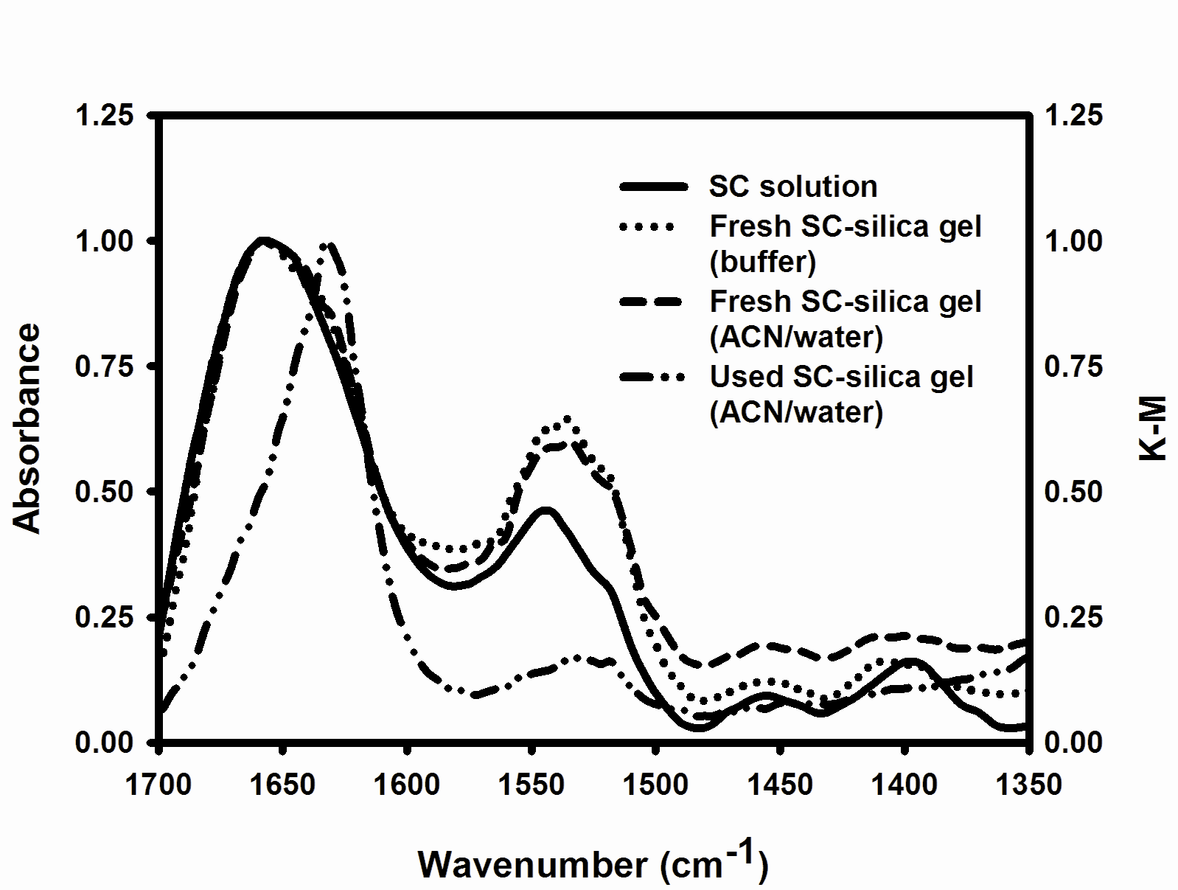

Figure 5. Infrared spectra of SC solution (40 mg ml⁻¹) and dried SC-silica gel mixed with finely ground KBr powder at 1:20 ratio. The fresh and used SC-silica gel were dried at a_{w}=0.11 over saturated lithium chloride solution prior to spectral acquisition. Note the y-axis on the right represents Kubelka-Munk (K-M) units derived from the percentage reflectance of the samples analyzed using DRIFT technique.

Having established a suitable sample preparation method, it was then possible to apply this to the biocatalyst particles. It is necessary to dry the particles to a a_{w} below 0.8, to prevent formation of a liquid phase of saturated KBr solution in the mixture. In this study, drying was achieved under controlled a_{w} by equilibrating the biocatalyst suspension in a sealed vessel containing saturated lithium chloride solution (a_{w} = 0.11) at 30ºC. Figure 5 shows a comparison of amide bands of SC buffer solution and dried SC-silica gel/KBr prepared under various conditions. The retention of the α-helix band at 1658 cm⁻¹ of aqueous SC in the immobilised state indicates no change in enzyme conformation, which is in agreement with the far UV CD results. However, the peak intensity and maxima of amide II bands between the SC in buffer solution, pH 7.8 and in the (dried) immobilised state differ. The amide II mode peak position is sensitive to the H-bonding interactions of the N-H groups with H₂O, and shifts to lower or higher frequencies depending on the sample hydration state.^{[23]} In solution the –NH group is strongly H-bonded to H₂O as manifested by a higher frequency band ~1545 cm⁻¹. Upon drying at low a_{w} the total number of H₂O molecules bound to the amide protons is reduced resulting in the lower frequency shifts to 1536 cm⁻¹ of the SC-silica gel preparation. Thus, the lower frequency amide II mode of fresh SC-silica gel preparations (both aqueous and organic media treated) is due to removal of bound water molecules on drying.
The close agreement of the amide bands of freshly prepared immobilised SC before and after exposure to ACN suggests that organic media treatment has little effect on the structure, thereby supporting the CD results. However, after having been in contact with the organic media for 3 days the amide I band of the used SC-silica gel sample exhibits a low frequency shift to 1632 cm⁻¹ indicating a significant change in conformation. This is consistent with increased formation of β-sheet that is indicated by the far UV CD results. Also, the shifting of the amide II band to 1533 cm⁻¹ with weak intensity provides further evidence of loss of native conformation. Due to the disruption of internal H-bonding interactions of the amide protons with the C=O in the denatured state the strength of N-H bending mode is weakened and shifted to lower frequency. Finally, we also attempted DRIFT measurements on the industrial grade biocatalyst Novozyme 435; however, the carrier Lewatit VP.OC 1600 showed strong absorbance in the spectral region of interest, preventing meaningful measurements of the enzyme structure.

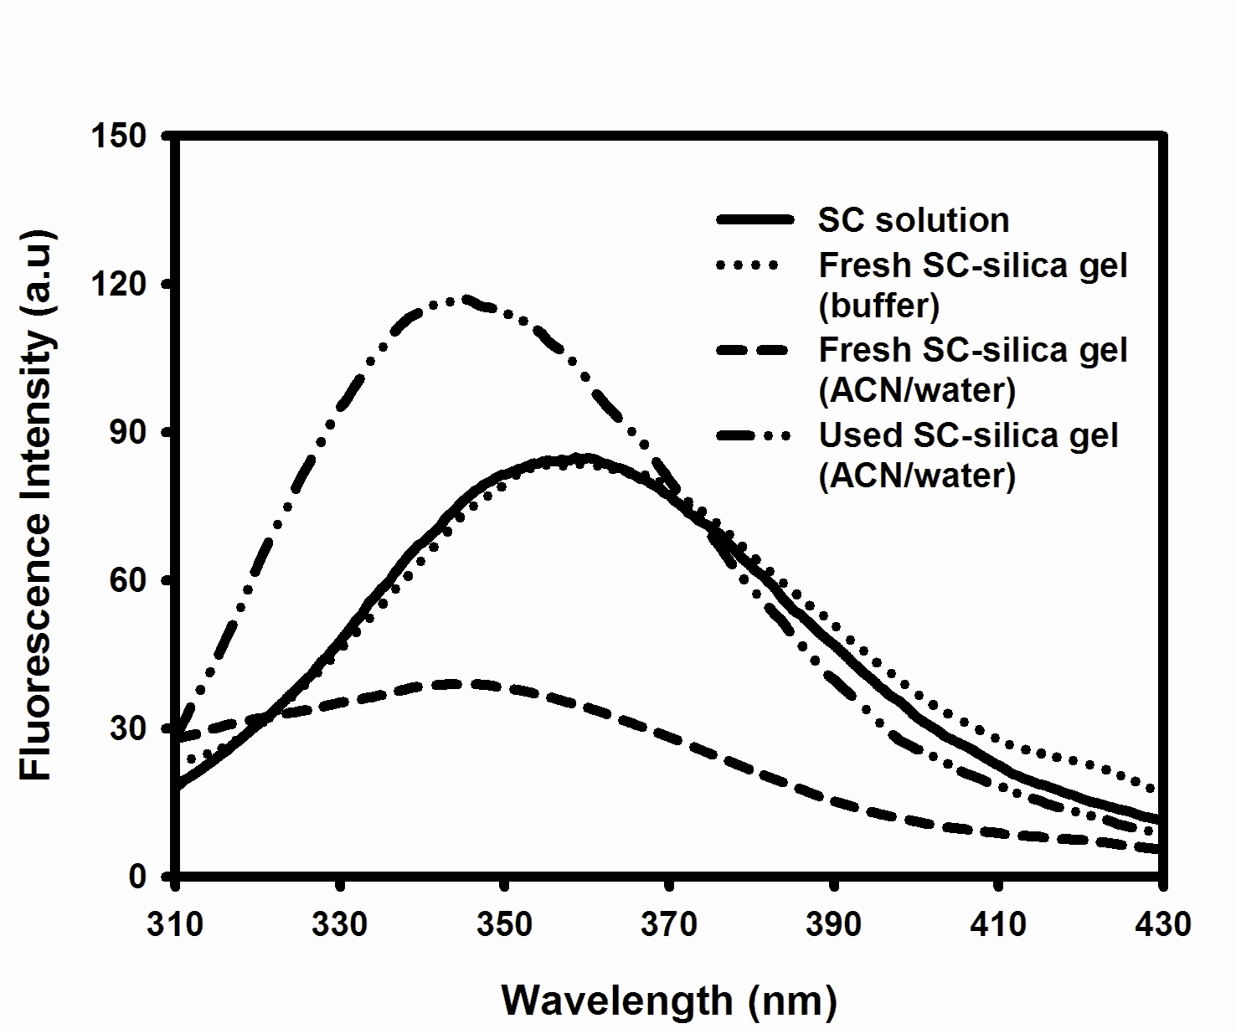

Figure 6. Intrinsic fluorescence spectra of SC solution and SC-silica gel suspended in 50 mM Na phosphate buffer pH 7.8 and in ACN/water (a_{w}=0.76). The used SC-silica gel was collected from a packed bed reactor after inactivation in the organic medium for 3 days.

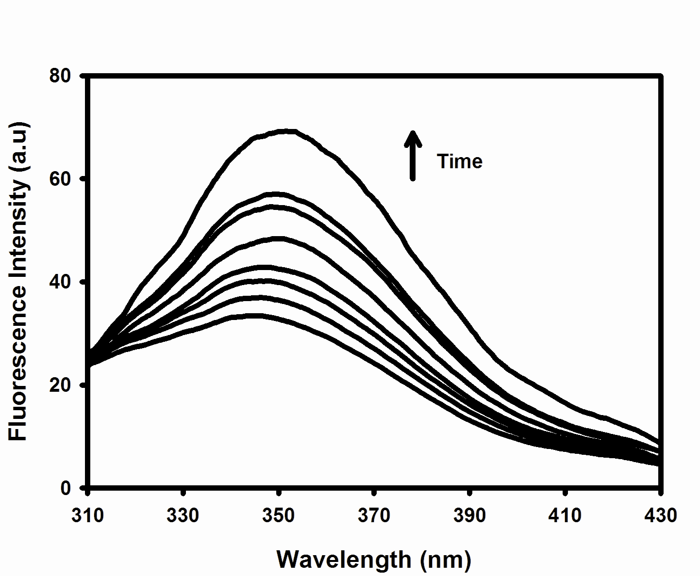

Figure 7. Influence of solvent exposure on the intrinsic fluorescence of SC-silica gel suspended in ACN/water (a_{w} = 0.76). The increase in fluorescence intensity was measured at 30 min interval upon incubating the SC-silica gel in the organic medium.

Intrinsic fluorescence spectroscopy

In Figure 6 the Trp fluorescence spectra of SC solution and SC immobilised on silica gel in aqueous and organic media are presented. The emission maximum of SC in aqueous buffer is at 356 nm, which is close to the observed value for free Trp in water, i.e. 358 nm and agrees with the literature.^{[24]} This is what expected for the solvent accessible indole ring of the single Trp

residue in SC as illustrated in Figure 2. Adsorption of the enzyme on silica gel does not alter the fluorescence maxima as shown in Figure 6. It should be noted that the fluorescence spectra of the free and immobilised SC in aqueous buffer are normalized since the absolute intensities cannot be easily compared due to the high degree of scattering in the suspensions. When the sample was transferred to ACN, there was a blue shift of the fluorescence due to the effect of reduced solvent polarity on the exposed Trp. In addition the fluorescence intensity is reduced immediately after switching into organic media, which is probably due to a combination of solvent effect and change in environment surrounding the Trp 113 residue. However, following prolonged inactivation in organic media, in the enzyme reactor, the used SC-silica gel showed over 3-fold increase in fluorescence. Furthermore, we found that incubating the SC-silica gel preparations in ACN for time >30 min affected the fluorescence emission, and resulted in a gradual increase in intensity with time (Figure 7). These changes suggest that on contact with organic media perturbation of the enzyme tertiary structure occurs, which contributes to the modification of environment surrounding the Trp 113.
In the native conformation the single Trp 113 fluorescence of SC is highly quenched by intramolecular interactions.^{[24]} Fluorescence intensity loss in proteins occurs through excited state homo-Förster resonance energy transfer (FRET) between the Trp-Trp residues and proton/electron transfer mechanism from the indole ring to the surrounding side chains or by peptide backbone quenching.^{[25-27]} FRET is not feasible in SC suggesting interactions with surrounding electron/proton scavengers contribute to excited state quenching. Graphical visualization using the web based STING Millennium package illustrates the residues Ala 48, Phe 50, Ser 109, Thr 116 and Asn 117 are in contact with the Trp 113 in the native conformation. However, only the Asn 117 is capable of quenching the excited state indole ring through an electron transfer mechanism, which contributes to the reduced fluorescence in the native state. Thus, the decrease in fluorescence intensity of freshly prepared SC-silica gel preparations in organic media is due to enhanced intramolecular contacts of Trp 113 due to formation of a more rigid tertiary structure. This is consistent with the conclusion from the near UV CD data (see above), which exhibits prominent Trp band features ~295 nm as a result of enhanced chirality due to more constrained interaction with the surrounding regions of the enzyme. This may be an effect of stripping of the H₂O bound to the enzyme by the organic media contributing to structural alterations on the surface. Denaturation of the enzyme increases the distance to the quenching groups, so that fluorescence is enhanced; happens as is observed on prolonged treatment with ACN. This interpretation is supported by the observations from CD and FTIR, and the rapid loss of catalytic activity in an ACN/water mixture. A similar substantial increase in fluorescence intensity is observed for silica-SC that has been inactivated after continuous operation as a biocatalyst in ACN (Figure 6).
In order to understand the effect of immobilization and solvent treatment on the kinetics of the decay of the excited state of Trp 113 we investigated the fluorescence lifetime of SC. In proteins the Trp fluorescence exhibits complex multiexponential decay kinetics due to the conformational heterogeneity, excited-state relaxation and variation in micro environment surrounding the indole ring.^{[25,28]} Other factors that affect the fluorescence kinetics are peptide backbone quenching and excited state electron/proton transfer with the side chains of residues in close proximity.^{[26,27]} Figure 8 shows the fluorescence lifetime (τ_{i}) distributions of free SC in solution and after immobilisation onto silica gel and suspension in buffer and organic media. A distribution of decay times centred around three mean exponential values describes the decay kinetics irrespective of the sample state. This behaviour of tryptophan is presently thought to be a consequence of the combined effect of the three discrete rotamers of tryptophan^{[28-30]} and solvent interaction in the ¹L_{a} fluorescing state. ^{[31]} The sharpening of the three peaks on immobilisation suggests the rotamers are restricted perhaps due to structural rigidity, which is more pronounced after transferring into organic media. This behaviour parallels what was recently found for rotamers of the single Trp in human serum albumin when stabilised by binding to quercetin.^{[30]}

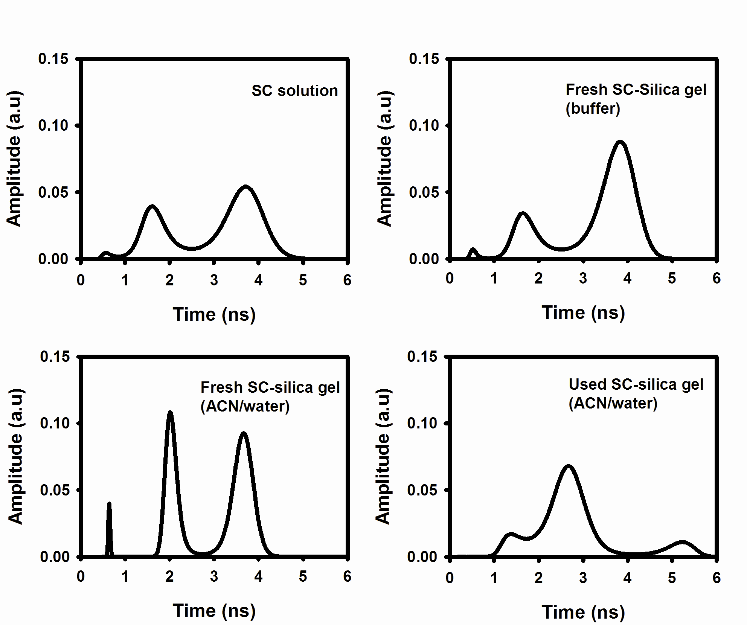

Figure 8. Fluorescence lifetime distributions of SC solution and SC-silica gel suspended in 50 mM Na phosphate buffer pH 7.8 and in ACN/water (a_{w}=0.76). The used SC-silica gel was collected from a packed bed reactor after inactivation in the organic medium for 3 days.

The reduced value τ_{i} of all the three mean decay components suggests that the indole ring is heavily quenched supporting the steady-state intensity measurements. After inactivation in the organic media the used SC-silica gel shows an increase in τ_{i} due to reduced intramolecular interactions as the protein unfolds. Also the broad peak width indicates a large degree of conformational heterogeneity in the sample with a variety of rotamer states. It would potentially be of interest to study how physical confinement and solvent treatment affects the rotational correlation of the solvent accessible Trp. This in turn could provide complementary information on the structural rigidity of the enzyme. However, we experienced difficulties in measuring the fluorescence depolarisation of SC-silica gel preparations due to the high degree of scattering and short rotational correlation time (<100 ps) of the single Trp, which is below the resolution of the instrument used in this study.^{[32]} Finally, we also investigated fluorescence measurements on Novozyme 435; however, the endogenous fluorescence from the support materials themselves was found to be too large to permit meaningful measurements of the intrinsic emission from the enzymes.

Mutually supporting results from the different techniques

It is useful to summarise the various points on which results from the different techniques point to similar conclusions. In each case the detailed discussion appears above, so will not be repeated here.
1. Adsorption of SC onto silica has little effect on conformation, as evidenced by near and far UV CD, the DRIFT amide I band and the fluorescence emission maximum.
2. Immobilisation causes some loss of structural flexibility, as evidenced by near UV CD and fluorescence lifetime distribution.
3. Transfer of the silica-SC to ACN further reduces flexibility, as evidenced by the same measures, and also the reduced fluorescence emission intensity.
4. Immobilised enzyme inactivated by prolonged exposure to ACN has a major shift from α-helix to β-sheet secondary structure, as evidence by CD and DRIFT amide I band.
5. The inactivated enzyme has also completely lost/changed its tertiary structure, as evidenced by near UV CD, and the increased intensity and longer lifetime of fluorescence.

Conclusion

We have described improvements in CD, fluorescence and infrared spectroscopic techniques to enable better characterisation of the conformation of enzymes in the solid-state. These were applied to preparations of SC immobilised on silica gel particles. Overall, the spectroscopic techniques reported here provide complementary information on the structural stability of enzymes immobilised on solid particles. Applying these techniques we were able to probe the structural stability of biocatalyst and identify the mechanisms of poor operational stability in organic media. These methods could also have major application in understanding the in situ structural stability of other systems where proteins are present in relatively large particles, such as: antigen-adjuvant formulations, enzyme suspensions, crystals, protein precipitates and insoluble aggregates. As we have shown in the case of industrial grade biocatalyst Novozyme 435, the main obstacle is not the particulate nature and size but rather the spectral interference from the carrier materials themselves.

Experimental Section

Materials: SC (protease from Bacillus licheniformis, P-5380, Lot 034K1340), silica gel (230-400 mesh), potassium bromide (FTIR grade), were purchased from Sigma Chemicals, UK. N-acetyl-L-tyrosine ethyl ester (Ac-Tyr-OEt) and C. antarctica lipase B were from Fluka Biochemica, UK. Novozyme 435 (Batch L32 0007) was purchased from Sigma chemicals, UK as product of Novozymes. Acrylic resin Lewatit VP.OC 1600 was provided by Bayer Chemicals, Germany.

Preparation of immobilised SC: SC was immobilised on silica gel and the protein loading determined as described.^{[15]} The freshly prepared immobilised enzyme was found to have typically 13 mg protein per gram of conjugate, which fell to 8 mg/g after use in an ACN/water mixture.
A continuous feed micro reactor was used for inactivating the SC-silica gel following transesterification of substrate Ac-Tyr-OEt with PrOH.^{[32]} The inactivated biocatalyst particles were washed with an ACN/water mixture to remove the excess substrate and used within two days.

Circular dichroism: A home-made rotating cell holder fitted into a Jasco J-810 spectropolarimeter was used to obtain CD spectra of biocatalyst suspensions, as described previously.^{[10]} Spectra were corrected for background and absorption flattening effects using a semi-empirical approach based on measured absorbance.^{[10]}

Infrared spectroscopy: The DRIFT spectra were measured on a Fourier transform infrared spectrometer, Perkin Elmer Spectra One, equipped with reflectance optics (Specac Inc, UK). Samples for measuring DRIFT spectra were prepared as follows. The biocatalyst suspensions were filtered using a 0.45 μm filter to remove the excess solvent and dried at a controlled water activity by placing the sample over a sealed container containing saturated lithium chloride salt solutions of a_{w} 0.11 at 30° C. After the water equilibrium was achieved, samples were returned to room temperature and diluted with finely ground KBr powder at a ratio of 1:20 prior to the measurement (this ratio was found optimal in initial trials). Biocatalyst-KBr mixture was packed into the sample cup using a specially designed cylindrical presser, with a flat horizontal surface that slides down above the open top surface of the cup. The presser (weighing 30 g) was carefully placed above the cup with particles filled slightly above the level and allowed to slide under gravity so that excess sample overflows through the 1 mm gap between the presser and the side of the cup. Using this method we were able to acquire reproducible spectra with replicates showing intensities in the amide I region agreeing within 10 percent and peak maxima reproducible to 1 cm⁻¹. In initial trials using the presser provided by the manufacturer we found intensities differed by up to 50 percent, and there was variation in band shapes and relative intensities. All the reflectance spectra reported here are measured from samples packed using our cylindrical presser, and the reproducibility within 10 percent was verified by making at least 3 replicate measurements on different mixtures with KBr prepared from the same biocatalyst batch.
Water vapour exchange between the biocatalyst and surroundings during spectral acquisition was limited by covering the sample with a KBr disc of 10 mm diameter and 1 mm thickness (Medway Optics Ltd, UK). A total of 250 interferograms at a resolution of 4 cm⁻¹ were acquired, averaged and smoothed using 9 point Savitzky-Golay method (available in the instrument software). Spectra were corrected for background absorption using a mixture of KBr and biocatalyst support particles with the same 20:1 mass ratio.
The solution FTIR spectrum of SC (40 mg ml⁻¹) in 20 mM Na-phosphate buffer pH 7.8 was obtained using a demountable liquid cell holder (Sigma-Aldrich) with a 15 μm Teflon spacer sandwiched between CaF₂ windows. Correction for water absorption was performed interactively as described previously.^{[34]} Discs were prepared from lyophilised enzyme powder by mixing with KBr powder (1:200 ratio), grinding in a hand mortar, and pressing at 150 MPa.

Fluorescence spectroscopy: Steady state fluorescence spectra were acquired using Perkin Elmer LS 50B fluorimeter. The spectra reported were an average of 5 scans measured at a scan rate of 100 nm min⁻¹ and bandwidth of 2.5 nm. Trp fluorescence was collected with a 305 nm cut-off filter (WG305, Schott, Germany) placed on the emission window to minimise the scattering artefacts. This filter has 90% or greater transmission for wavelengths greater than 310 nm. Consecutive measurements on at least 3 separate suspensions of the same immobilised enzyme preparation showed reproducible peak maxima and spectral intensities within 3 percent.
Time resolved lifetime studies were performed using IBH 5000U lifetime system lifetime system (Horiba Jobin Yvon IBH, Glasgow) featuring a 295 nm pulsed diode excitation (NanoLED-17) and picosecond single photon detection module (TBX-04) with a spectral response of 185 nm to 650 nm.^{[35]} The excitation light was wavelength selected using a monochromator of bandwidth 4 nm. Fluorescence was collected at “magic angle” (54.7º) at wavelength >325 nm with a WG325 cut-off filter (Schott, Germany) placed on the emission window. The data acquisition was performed using a fluorescence measurement and analysis studio incorporating a IBH DataStation hub. The number of photon counts at the peak was 15000 measured with a channel width of 1024 and time resolution of 113 ps per channel. Intensity decays were analysed by discrete multiexponential fit using IBH decay analysis software (Horiba Jobin-Yvon IBH, Glasgow) and maximum entropy method (MEM) using Quantified Maximum Entropy, MemSys5, Version 1.2 (Maximum Entropy Data Consultants Ltd., Cambridge).
Both a front-face geometry using a triangular cuvette (Hellma UK Ltd) and a 1×1 cm quartz cuvette with the light path normal to two faces at 90º to each other were employed for measurements. Signal to noise (scatter) ratios were found to be better in front-face mode for the steady state measurements, but with 90º faces for the time resolved studies. The particles were stirred during spectral acquisition using a micro magnetic stirrer (Rock Brothers Ltd., Model 300) operating at 500 rpm. Our efforts to measure spectra of a packed bed of particles were not successful due to the very high amounts of scattering on the blue edge of the spectra.

Acknowledgement

This work was supported by a grant from ProBio Faraday Partnership and EPSRC, UK. We thank Mr J. Revie and Dr I. Petry for technical assistance.

[1] Z. P. Aguilar, W. R. Vandaveer, I. Fritsch, Anal. Chem. 2002, 74(14), 3321- 3329.

[2] S. C. Barton, J. Gallaway, Atanassov, Chem. Rev. 2004, 104(10), 4867– 4886.

[3] L. Cao, L. van Langen, R. A. Sheldon, Curr. Opin. Biotech. 2003, 14(4), 387-394.

[4] K. M. Koeller, C. H. Wong, Nature 2001, 409(6817), 232-240.

[5] S. M. Kelly, T. J. Jess, N. C. Price, Biochim. Biophys. Acta. 2005, 1751(2), 119-139.

[6] C. A. Royer, Chem. Rev. 2006, 106(5), 1769-1784.

[7] J. L. R. Arrondo, A. Muga, J. Castresana, F. M. Goni, Prog. Biophys. Molec Biol. 1993, 59, 23-56.

[8] R. Tuma, J. Raman. Spec. 2005, 36, 307-319.

[9] L. E. Kay, J. Magn. Reson. 2005, 173, 193-207.

[10] A. Ganesan, N. C. Price, S. M. Kelly, I. Petry, B. D. Moore, P. J. Halling, Biochim. Biophys. Acta. 2006, 1764, 1119-1125.

[11] S. Koutsopoulos, A. M. Tjeerdsma, J. F. T. Lieshout, J. Van der Oost, W. Norde, Biomacromolecules 2005, 6, 1176-1184.

[12] B. Kranz, J. Burck, M. Franzreb, R. Koster, A. S. Ulrich, J. Coll. Inter. Sci. 2007, 316, 413-419.

[13] N. Sreerama, R. W. Woody, Prot. Sci. 2004, 13, 100-112.

[14] D. J. Neidhart, G. A. Petsko, Prot. Eng. 1988, 2, 271-276.

[15] J. Partridge, P. J. Halling, B. D. Moore, Chem. Commun. 1998, 841-842.

[16] I. Petry, A. Ganesan, A. Pitt, B. D. Moore, P. J. Halling, Biotech. Bioeng. 2006, 95, 984-991.

[17] A. Barth, C. Zscherp, Q. Rev. Biophys. 2002, 35, 369-430.

[18] P. O. Souillac, C. R. Middaugh, J. H. Rytting, Int. J. Pharm. 2002, 235, 207-218.

[19] K. Griebenow, A. M. Klibanov, Biotech. Bioeng. 1997, 53, 351-362.

[20] T. J. Lenk, T. A. Horbett, B. D. Ratner, Langmuir 1991, 7, 1755-1764.

[21] K. P. Ishida, P. R. Griffiths, Appl. Spec. 1993, 47, 584-589.

[22] J. D. Meyer, M. C. Manning, J. F. Carpenter, J. Pharm. Sci. 2004, 93, 496-506.

[23] J. Gradadolnik, Y. Marechal, Biopolymers 2001, 62, 54-67.

[24] R. Swaminathan, G. Krishnamoorthy, N. Periasamy, Biophys. J. 1994, 67, 2013-2023.

[25] Y. Engelborghs, Spectrochim. Acta A 2001, 57, 2255-2270.

[26] Y. Chen, M. D. Barkley, Biochemistry 1998, 37, 9976-9982.

[27] Y. Chen, B. Liu, H. T. Yu, M. D. Barkley, J. Am. Chem. Soc. 1996, 118, 9271-9278.

[28] J. B. A. Ross, H. R. Wyssbrod, R. A. Porter, G. P. Schwartz, C. A. Michaels, W. R. Laws, Biochemistry 1992, 31, 1585-1594.

[29] M. Hellings, M. De Maeyer, S. Verheyden, Q. Hao, E. J. M. Van Damme, W. J. Peumans, Y. Engelborghs, Biophys. J. 2003, 85, 1894-1902.

[30] O. J. Rolinski, A. Martin, D. J. S. Birch, J. Biomed. Optics 2007, 12, 34013-34020.

[31] J. A. Ross, D. M. Jameson, Photochem. Photobiol. Sci. 2008, 7, 1301-1312.

[32] G. S. Lakshmikanth, G. Krishnamoorthy, Biophys. J. 1999, 77, 1100- 1106.

[33] J. F. A. Fernandes, P. J. Halling, Biotechnol. Prog. 2002, 18, 1455-1457.

[34] S. L. Wang, Y. S. Wei, S. Y. Lin, Vib. Spect. 2003, 31, 313-319.

[35] C. D. McGuiness, K. Sagoo, D. McLoskey, D. J. S. Birch, Appl. Phys. Lett. 2005, 86, 261911.

Received: ((will be filled in by the editorial staff))

Published online: ((will be filled in by the editorial staff))

Entry for the Table of Contents (Please choose one layout)

Layout 2:
FULL PAPERS
Structure of immobilised enzymes: We report circular dichroism, infrared and fluorescence spectroscopic methods for characterising in situ structural stability of enzymes immobilised on particles. Applying these methods we show the enzyme subtilisin Carlsberg exhibits similar secondary structure in solution and in immobilised state but rather a rigid tertiary structure on the surface of porous silica gel.  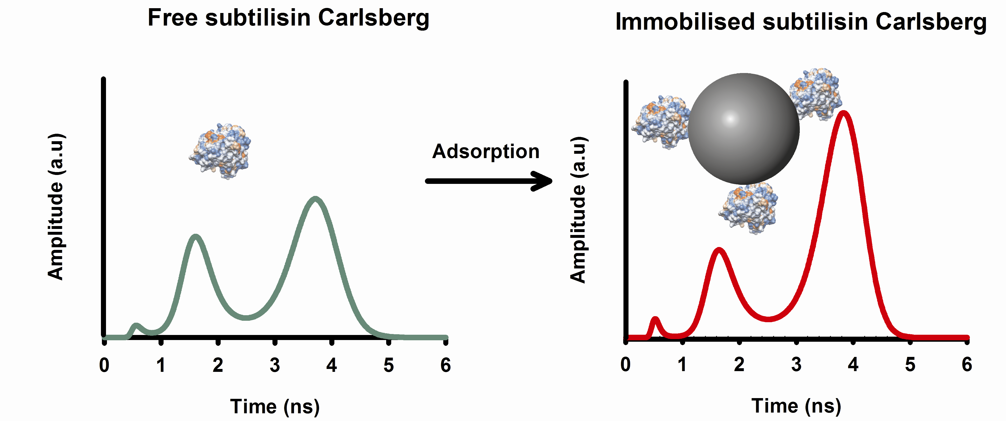 |  | Ashok Ganesan, Barry D Moore, Sharon M. Kelly, Nicholas C Price, Olaf J Rolinski, David J S Birch, Ian R Dunkin, Peter J Halling  Page No. – Page No.  Optical spectroscopic methods for probing the conformational stability of immobilised enzymes

Keywords: Circular dichroism, fluorescence spectroscopy, immobilized proteins, IR spectroscopy, protein structures

