An Experimental and Numerical Analysis of Flow in a ShockWave Power Generator™
Doherty, N., Scanlon, T. J., Stickland, M. T. and Waddell, P.
Department of Mechanical Engineering, University of Strathclyde
Glasgow, G1 1XJ, Scotland
Tel: +44-141-548-2083 / FAX: +44-141-552-5105
E-mail: n.doherty@mecheng.strath.ac.uk

Abstract: This paper describes the use of a rotating all mirror image de-rotator system in collaboration with Particle Image Velocimetry (PIV) to visualize and examine qualitatively the flow patterns within a clear acrylic model of a ShockWave Power Generator™ (SPG™). The authors have been able to obtain the relative velocities of the flow within the SPG™ unit at rotational speeds of 1,000 rpm. Vector maps of the relative flow field in the pertinent areas are presented for this rotational speed. The data are compared with the results of a Computational Fluid Dynamics (CFD) model and appears to show a reasonable correlation.
Keywords: PIV, CFD, Image De-rotator, Cavitation

1. Introduction
The ShockWave Power Generator™ is a device that attempts to harness the energy release from fluid cavitation in a rotating fluid-structure system (Griggs, 1993). The device itself consists of a steel rotor (designed as a cylinder with a number of cavities drilled slightly off the radial angle into the outer cylinder face). The rotor is completely enclosed by a steel cylindrical housing and two endplates as shown in Figure 1. The rotor is secured to a steel shaft and can be driven mechanically by any rotating device (motor, turbine, etc.). The device can operate with the rotor either fully or partially submerged in liquid.
The flow mechanism inducing the cavitation is, as yet, not understood. One theory that has been put forward (Frederick et al) is that, as the rotor rotates, liquid is thrown from the cavities by the centrifugal force, creating a pressure drop within the cavities. When this low pressure force in the cavities exceeds the centrifugal force, the flow is reversed back into the bores. This process is repeated continuously, creating ‘millions of shock waves per minute’. These shock waves in turn induce cavitation bubbles which, upon implosion generate heat that is absorbed by the liquid. No mention is made of vortex formation in the postulated theories and it is in an attempt to better understand the flow physics involved that the authors have chosen to investigate the process using Particle Image Velocimetry (PIV) and Computational Fluid Dynamics (CFD).

No numerical or experimental analyses have been performed on an SPG™ to date. It is the aim of this paper to present the computational results of the numerical solution together with the experimental data from the PIV experiments. The experimental data will provide reassurance on the validity of the computational model. It is more informative to make measurements in a relative frame of reference where the viewer moves with the rotor. This paper presents PIV data taken from a rotating viewpoint and allows comparison of the relative flow patterns in the experimental and computational models.

2. Experimental Work

2.1 Reduced Scale Clear Acrylic Model
The authors have constructed a reduced scale model of the SPG™ unit made entirely of clear acrylic in order to visualize the flow processes occurring. For ease of manufacture and to reduce the amount of polishing of the clear acrylic, the geometry of the model is rather simplified from the original unit. A cross-sectional isometric view of the clear acrylic model is shown in Figure 2, with contrasting colour scheme to facilitate viewing.
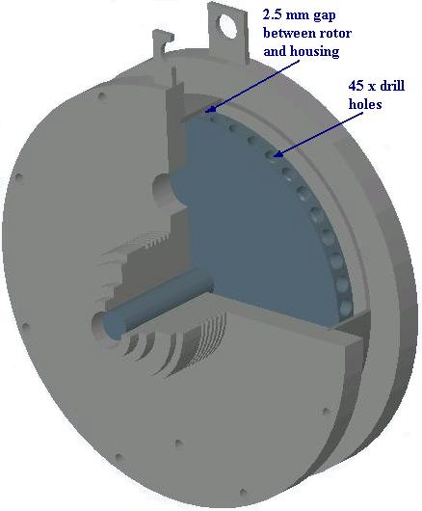

Fig.1 Sectioned Isometric view of a typical ShockWave Power Generator™
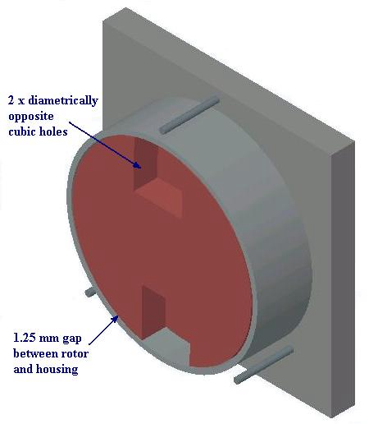

Fig.2 Cross-sectional isometric view of the clear acrylic model SPG™
The holes in the model are larger than those in the original unit in order to assist the visualization of the flow within the holes. Although the geometry of the holes in the rotor of the model are cubic in shape rather than the primarily cylindrical geometry of the boreholes in the original SPG™ unit, all other dimensions and geometries that the authors feel are key to the design of the original unit remain to scale in the design of the model unit. The most noteworthy of these are:
- The gap between the outer radial surface of the rotor and the inner surface of the radial rotor housing is about half that of the original, as the rotor of the model has a radius about half of the radius of the original SPG™ unit.
- The offset angle of the holes from the radial angle is of the same magnitude and direction in the model as it is in the original rotor.
- The distance between the rotor and the walls of the endplates are similar in magnitude and sufficiently far apart such that viscous effects in this region are minimized.
All areas of the clear acrylic model that require optical access have been highly polished.

2.2 Image De-rotation
An image rotator consists of prisms or their mirror equivalents, Swift (1972). A stationary object observed, in transmission or reflection, from such a device will appear to rotate twice for each rotation of the rotator. An image de-rotator is the same device but now caused to rotate at exactly half the speed of the observed, rotating, component. Figure 3 illustrates the effect of observing a rotating object through a pair of mirrors, placed at right angles to each other, as the optics are rotated at exactly half the speed of the rotating object.
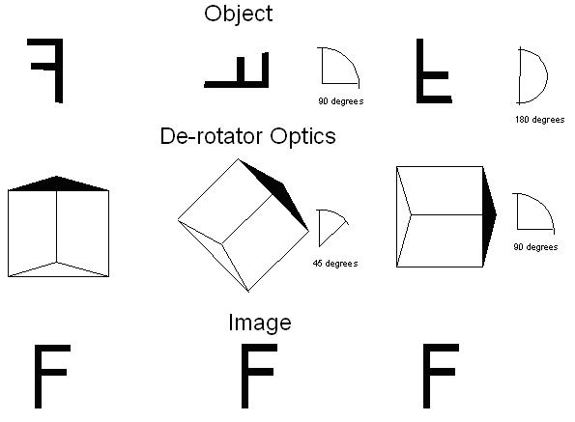

Fig.3 Image De-rotation
The phenomenon of image de-rotation is now observed. A continuously stationary image of the rotating component will be seen when observed through the mirrors provided the de-rotator’s optics rotational axis and the rotational axis of the component are correctly aligned, Sullivan (1972).

The image de-rotator described above has been used to map the instantaneous velocity distribution in the holes of the model SPG unit by the whole field velocity measurement technique Particle Image Velocimetry (PIV). For a general overview of the technique the reader is recommended the review paper by Grant (1997). A more detailed approach to the technique is given in the book by Raffel et al (1998).

The image de-rotator allows the frame of reference of the PIV imaging system to move with the rotating flow and hence produce an image of the entire flow field, as if the camera was rotating at the same speed as the SPG™ unit rotor, and hence reveal the structure of the relative flows hidden by the dominant primary flow field.

Stickland et al (1996) in their paper describe mapping the flow field in a mixed flow impeller by PIV and image de-rotation where the images analysed were acquired by wet film high speed cine. The images were then projected and digitised by a CCD camera attached to a frame grabber in a PC and analysed by autocorrelation. The process was time consuming and tedious. This paper describes the use of a high-speed video with direct, digital, download to a PC for cross correlation analysis. This process was much more efficient and allowed the production of vector maps within minutes rather than the days previously required. The experimental set-up is illustrated in Figure 4. The data generated by this technique was compared with the output of the CFD model.

2.3 CFD Model
The numerical simulations contained in this paper were carried out with the commercial software package FLUENT 5. This code uses the finite volume method and solves the 3-D Navier-Stokes equations. It has the ability to handle unstructured grids, include relative reference frames and make transient calculations with moving meshes.
For the flow calculation itself the pressure-velocity coupling was based on the well-known SIMPLE algorithm. The standard form of the k-ε model has been applied for turbulence closure. Spatial resolution for the convection terms for momentum was based on second order upwinding.
The convergence criterion, based on the global residual error in all cells was reduced to the value of approximately 10⁻³ (three orders of magnitude).

2.4 Experimental Equipment
An annotated photograph of the model SPG™ unit and optics are shown in Figure 4.
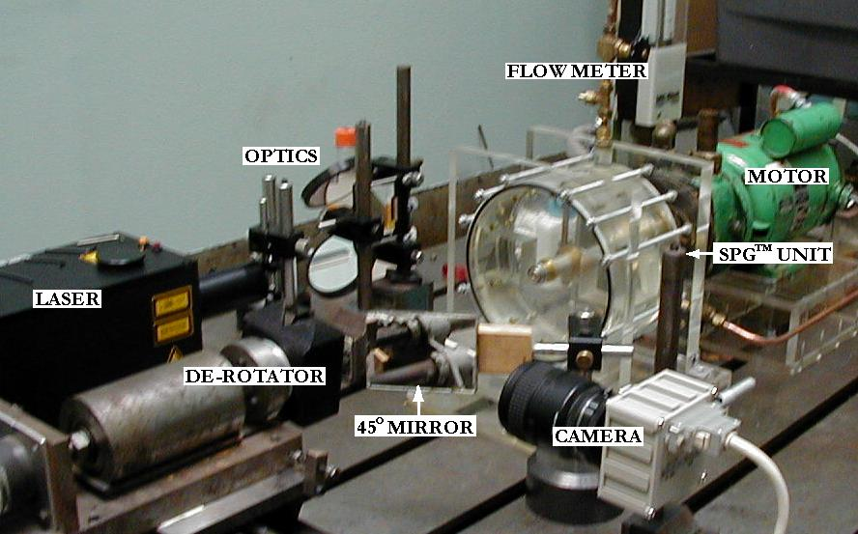

Fig.4 Photograph of experimental rig

The model rotor is 187.5 mm in diameter and 66 mm thick. The two diametrically opposite holes are approximately 50 mm x 50 mm x 50 mm. The radial housing has an inner diameter of 190 mm and the inside distance between the endplates is 115 mm. The flow rate provided by the feed pump was 1.5 litres per minute. The closed circuit loop was connected to a header tank by ¼” piping.
The image de-rotator consisted of two, optically flat, four inch by two inch, front silvered, mirrors formed in a V-groove. The angle between the mirrors was 90° ρ 1χ. The mirror assembly was mounted on a shaft connected to a DC servo motor. The DC servo motor was controlled by a McLennan servo gearbox slaved to a rotational position encoder connected to the motor shaft driving the model rotor. The servo gearbox synchronized the rotation of the rotor and the de-rotator with the de-rotator running at half the speed of the rotor. The rotor was viewed through a mirror placed at 45° to the centreline. A schematic diagram of the experimental rig is shown in Figure 5.

The images of the flow field were captured by a Photron Fastcam Ultima 16 KC. The images were downloaded directly a PC via a SCSI 2 link in .bmp format. The camera was fitted with a 25 mm f1.4 lens. Illumination was by an Nd-YAG Laser. The beam was focused into the test section by an f300 bi-convex lens and spread into a sheet by an f12.7 planar convex cylindrical lens.

Water was used as the test fluid and was seeded with spherical particles of approximately 50 Πm diameter. Sequential images, downloaded from the Fastcam, were analysed by cross correlation using Flowmanager analysis software from Dantec.
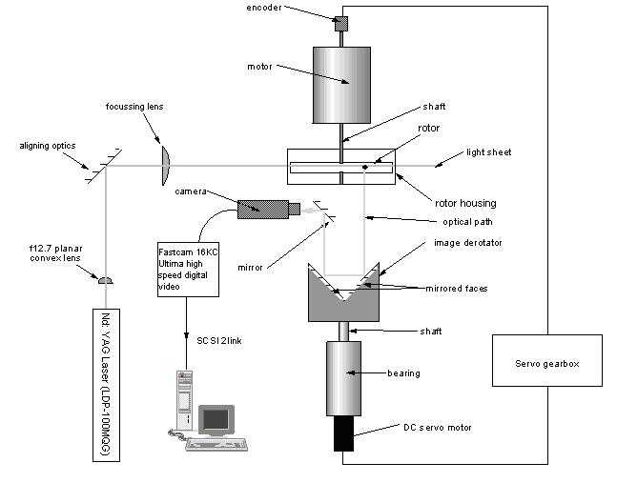

Fig.5 Schematic of experimental rig

3. Results and Discussion
The results shown in this paper are from a series of tests undertaken with a rotor speed of 1000 rpm. Images were acquired at 1000 frames per second with an exposure time of 0.001 seconds. Sequential images, 0.001 seconds apart, were cross correlated. Vector maps are shown from a plane through the centreline of the rotor at a position corresponding to 90° as shown in the small diagram in Figure 6(a).

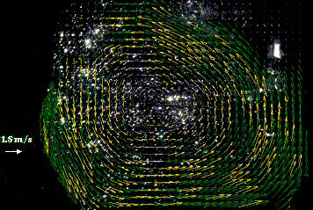
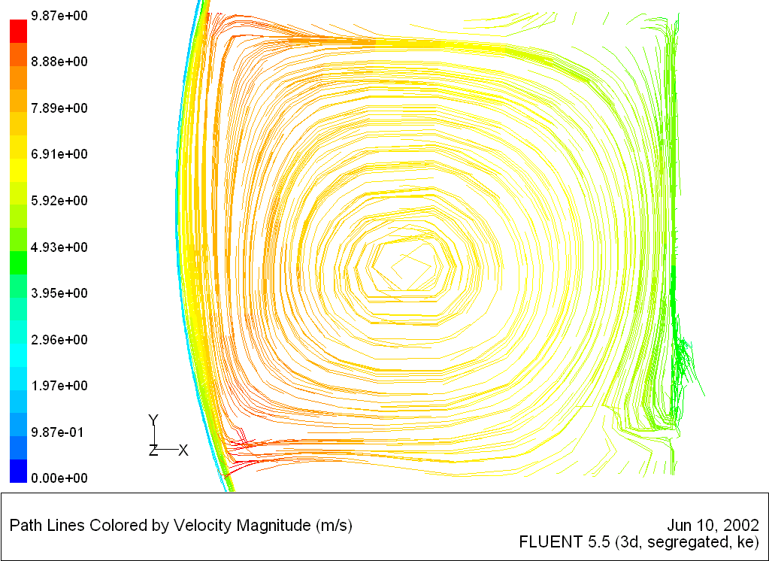

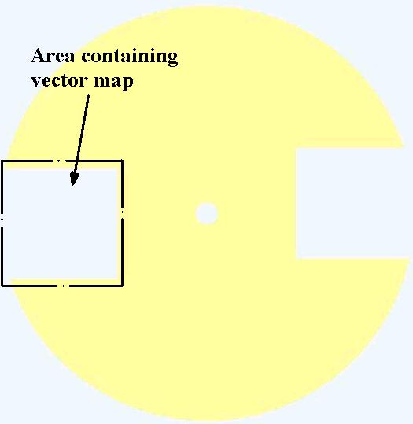

Fig.6(a) Experimental vector plot Fig. 6(b) Numerical path line plot

From Figure 6(a) it may be seen that the primary flow has been completely removed and only the relative flow is evident. The rotor is rotating in the clockwise direction. It may be seen that the computational data, Figure 6(b), and experimental data agree reasonably well. A similar vortex formation is occurring, with separation occurring on the inside wall with an area of recirculation beyond.

4. Conclusions
An all mirror image de-rotator, high speed digital video and PIV have been successfully used, for the first time, to study, qualitatively, the relative flow patterns in a model SPG™ unit. The data acquired agrees reasonably well with the data generated by a CFD simulation of the unit. It is apparent that there is a vortex formation within the holes of the rotor. The low pressure regions towards the centre of each vortex are anticipated to be the areas where the water is cavitating. This theory would perhaps explain why there is no cavitation damage on the rotor or housing itself, as the collapsing cavitation bubbles are kept away from any surfaces by the vortex. With the cavitation bubbles collapsing away from any solid surfaces, the energy released from each collapsing bubble can therefore be absorbed entirely by the water itself, in the form of heat. In future, the authors intend to extend this work to look at different geometry models and with varying flow rates.

References
Couty, Ph., Farhat, M., Avellan, F., 2001, ‘Physical Investigation of a Cavitation Vortex Collapse’, Trans. of CAV2001: Fourth International Symposium on Cavitation.

Frederick, J., Armstead, D., Lien, S., Schmidl, W., Kazem, B., ‘Economic Benefits of Utilizing Controlled Cavitation Technolgy for Black Liquor Oxidation and Heating’, www.hydrodynamics.com.

Grant, I., 1997, ‘Particle Image Velocimetry: A Review’, Proceedings of the IMechE Part C – Journal of Mechanical Engineering Science, Vol. 211, Part 1, pp 55–76.

Griggs, U.S. Patent No. 5188090 (1993).

Raffel, M., Willert, C., Kompenhans, J., 1998, ‘Particle Image Velocimetry: A Practicle Guide’, Springer, ISBN 3-540-63683-8.

Stickland, M., Hooker, A., Mair, L. T., Waddell, P., 1996, Mapping the Velocity Field in a Pump Impeller Using Particle Image Velocimetry and Image Derotation’, Optical Methods and Data Processing in Heat and Fluid Flow, Conference, City University, London, IMechE, April 18–19.

Sullivan, D. L., 1972, ‘Alignment of Rotational Prisms’, Applied Optics, II, No. 9 pp 2028-2032, September.

Swift, D. W., 1972, ‘Image Rotation Devices, A Comparative Survey’, Optics and Laser Technology, IV, pp 175-188.

Waddell, P., White, D., 1975, ‘The Real Time Non-Stroboscopic Examination of Centrifugal Stress on Rotating Photoelastic Discs Utilising an Optical Image Derotation Technique’, Proceedings I.C.O. Conference in Scientific and Industrial Measurement, Tokyo 1974, Published Japanese Journal of Applied Physics Vol. 14, Supplement No. 14/1, pp 505-510.

Waddell, P., 1976, ‘A Stepper-Motor Controlled Image Derotator to Study Transverse Vibrations on Rotating Components’, Proceedings Intl. Conf. On Stepping Motors and Systems, University of Leeds, pp 86-91, July.

